Level 1: Very Basic
1. Display all students.
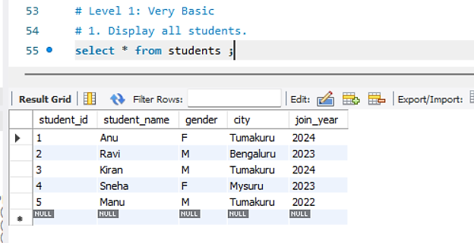
2. Display only student_name and city from students table.
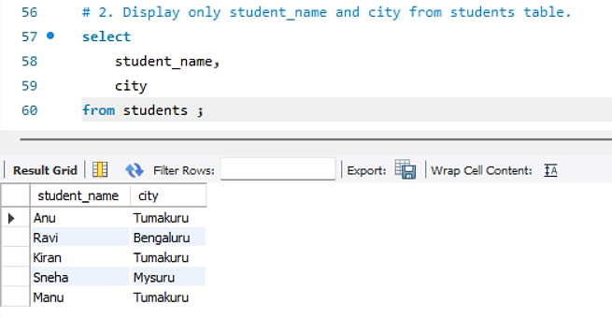

3. Show all courses.
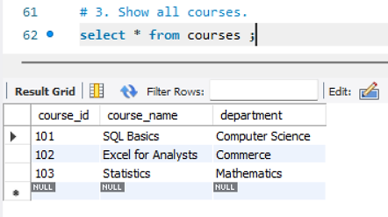
4. Display students who are from Tumakuru.
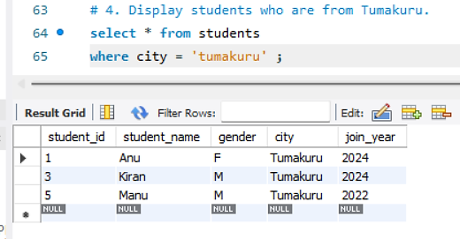
5. Display students who joined in 2024.
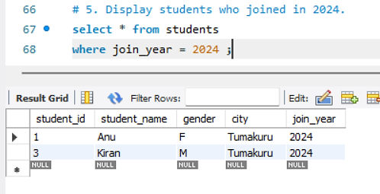

Level 2: Filtering
6. Show students whose gender is F.
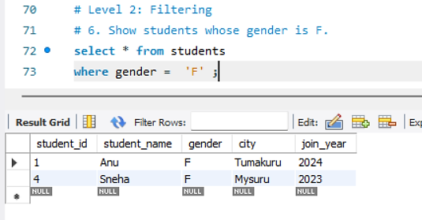
7. Show marks greater than 80.
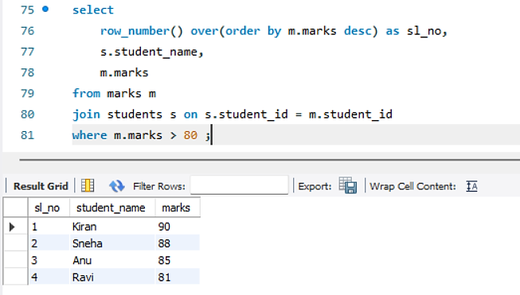

8. Display course names from Commerce department.
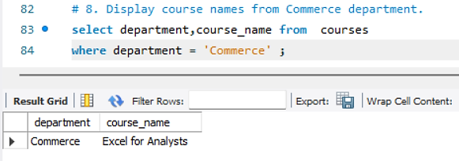
9. Show students who are not from Bengaluru.
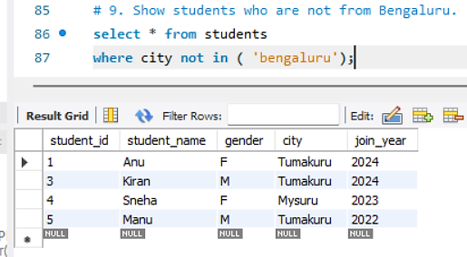
10. Display marks between 70 and 90.
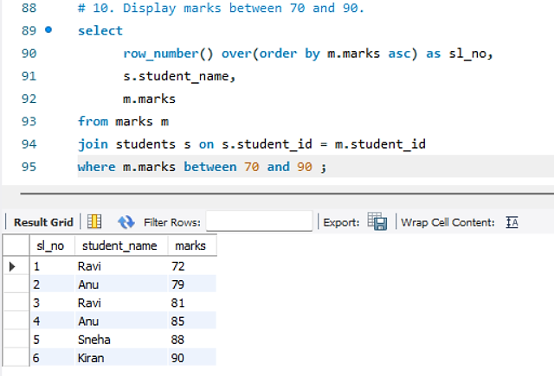
Level 3: Sorting
11. Display all students ordered by student_name ascending.
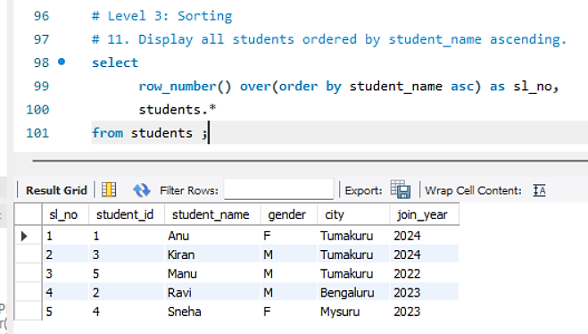
12. Show marks ordered from highest to lowest.
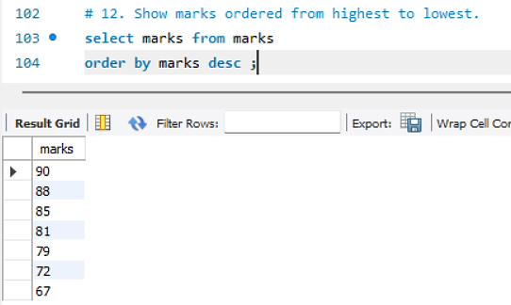
13. Display students ordered by join_year descending.
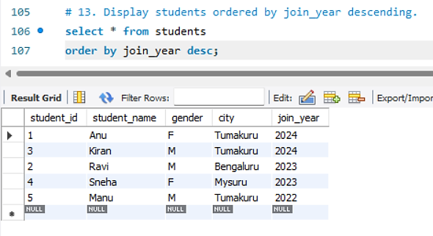
Level 4: Aggregate Basics
14. Find total number of students.
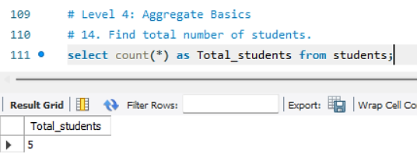
15. Find average marks.
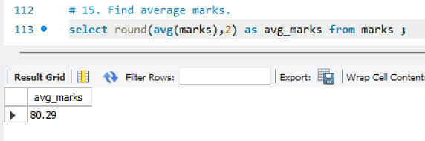
16. Find highest marks.
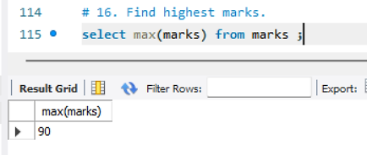
17. Find lowest marks.
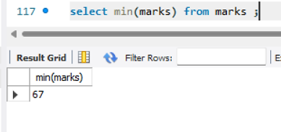
18. Find total marks scored by all students.
