

DESKTOP PUBLISHING PROJECT REPORT

NAME- Hemal Hembram

UID- 23BCA10025

SECTION- 3-B

PROJECT TITLE- Car Magazine

**CONTENTS: -**

1. INTRODUCTION…………………………………………………

The goal of this project is to develop creative skills in designing car magazine that cater to various contexts, keeping in mind the principles of visual hierarchy, color theory, typography, and user engagement. Through this project, participants will learn to use design tools, explore layout strategies, and understand the significance of branding in car magazine creation.

1. OBJECTIVE OF PROJECT……………………………………..

The objective of this project is to design visually appealing and effective car magazine that communicate messages clearly, align with branding goals, and engage the target audience across various digital and print platforms.

1. PROCEDURE OF DESIGNING……………………………..

Followed the right steps for creating car magazine using Adobe photoshop.

1. PROJECT OUTPUT IMAGES…………………………………

Pasted the results of car magazine designing.

1. CONCLUSION………………………………………………….

This project highlights the importance of well-designed car magazine in communication and branding. By applying design principles, creative tools, and layout techniques, participants gain valuable skills to create effective car magazine that capture attention and deliver messages clearly across different platforms.

**Car magazine Design Using Adobe Photoshop**

**Introduction:**

Car magazine design is a creative process that involves combining text, imagery, and graphic elements to communicate messages effectively. It serves various purposes, such as promoting events, advertising products, or spreading awareness. Adobe Photoshop is a powerful tool that allows designers to bring their ideas to life, offering a wide range of features for photo editing, typography, and layout creation.

**Objective:**

The objective of this project is to design a visually appealing car magazine using Adobe Photoshop that effectively communicates a specific message, captures attention, and aligns with the intended theme or purpose.

1. Learning essential car magazine design principles.
2. Mastering Photoshop tools like layers, text, and effects.
3. Designing a car magazine with specific dimensions and resolution.
4. Applying creativity and branding consistency.
5. Exporting the car magazine in formats suitable for web or print.

Steps to Create a Car magazine Using Adobe Photoshop:

Step 1: Set Up the Document

Open Photoshop and create a new document:

Go to File > New.

Set the dimensions to standard magazine cover size (e.g., 8.5 x 11 inches).

Set the resolution to 300 DPI (for print quality).

Choose a white background or any other color that you want for the base layer.

Step 2: Add the Background Image

Import the car image:

Go to File > Place Embedded and select the image of the car or any other background image you want to use.

Resize the image to fit half or part of the document, as in the sample.

Adjust the placement so that the front of the car or the logo is prominent on the left side.

Add a White Rectangle for Text:

Use the Rectangle Tool (shortcut: U) to create a white rectangle covering part of the right side of the cover.

Set the rectangle to the desired width and align it with the image edge to create a split design.

Step 3: Add the Title Text

Add the Magazine Title:

Select the Text Tool (shortcut: T) and type "CAR" in uppercase.

Use a serif font (e.g., Times New Roman) for a sophisticated look. Adjust the font size and position at the top of the cover.

For the word "MAGAZINE," use a bold, sans-serif font (or a fun, hand-drawn style) in orange. Position it below "CAR" and make sure the color stands out.

Align and Position Text:

Adjust the font sizes and positioning of "CAR" and "MAGAZINE" to ensure they’re balanced and eye-catching.

Step 4: Add Headline Text ("Need Some Thrill")

Add Large Headline Text:

Use the Text Tool to type "Need Some Thrill" in three lines, with each word on a new line.

Choose a bold, sans-serif font in a color that complements the background (e.g., dark red or maroon).

Adjust the font size to make the text big enough to cover a significant portion of the right side.

10. REVIEW AND FEEDBACK: -

Review the final car magazine for any design or content errors.

Share the design with stakeholders or team members for feedback and make necessary revisions.

OUTPUT IMAGE: -

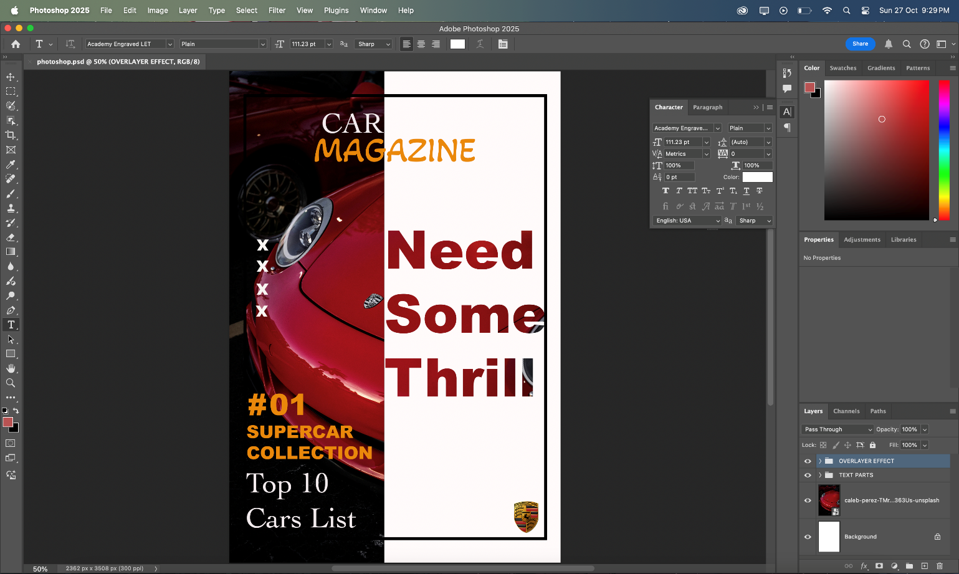

**Conclusion:**  
Designing a car magazine using Adobe Photoshop is a comprehensive process that combines creativity with technical skills. Through this project, users learn how to effectively use tools like typography, imagery, and graphic elements to convey messages in a visually engaging way. The steps covered—ranging from setting up the canvas to applying effects and exporting—ensure a polished final product suitable for both digital and print platforms. This project not only enhances proficiency in Photoshop but also provides valuable insights into design principles, helping participants create professional car magazines that align with the desired theme and purpose.