EXPERIMENT 6
Title | 2D-TRANSFORMATION
Objective | To apply the basic 2D transformations such as translation, Scaling, Rotation,  shearing and reflection for a given 2D object.
Theory | Description: We have to perform 2D transformations on 2D objects. Here we perform transformations on a line segment.  The 2D transformations are:  - Translation  - Scaling  - Rotation  - Reflection  - Shear  - Translation: Translation is defined as moving the object from one position to another position along straight line path.  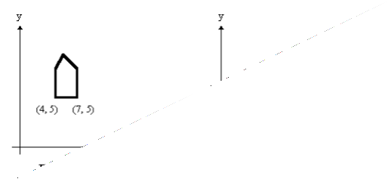  We can move the objects based on translation distances along x and y axis. tx denotes translation distance  along x-axis and ty denotes translation distance along y axis.  Translation Distance: It is nothing but by how much units we should shift the object from one location to another along x, y-axis.  Consider (x,y) are old coordinates of a point. Then the new coordinates of that same point (x’,y’) can be obtained as follows:  X’=x+tx Y’=y+ty  We denote translation transformation as P. we express above equations in  matrix form as:
Name -SHRADDHA GAJANAN DESAI

SE COMPS DIV A ROLL NO 19

CG EXP 6-CSL303
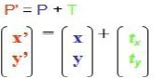

x,y---old coordinates
x’,y’—new coordinates after translation tx,ty—translation distances, T is

2. Scaling: scaling refers to changing the size of the object either by increasing or decreasing. We will increase or decrease the size of the object based on scaling factors along x and y-axis.

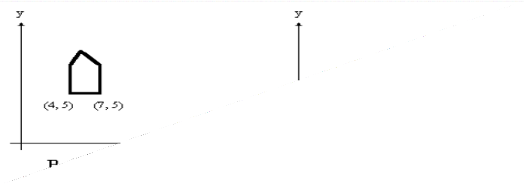
If (x, y) are old coordinates of object, then new coordinates of object after applying scaling transformation are obtained as:
x’=x*sx y’=y*sy.
sx and sy are scaling factors along x-axis and y-axis. we express the above
equations in matrix form as:

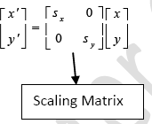
- Rotation: A rotation repositions all points in an object along a circular path in the plane centered at the pivot point. We rotate an object by an angle theta.
New coordinates after rotation depend on both x and y
  - x’ = xcosθ -y sinθ
  - y’ = xsinθ+ ycosθ
or in matrix form:

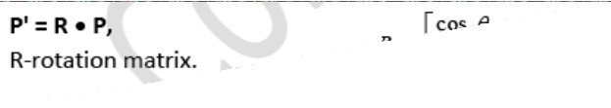

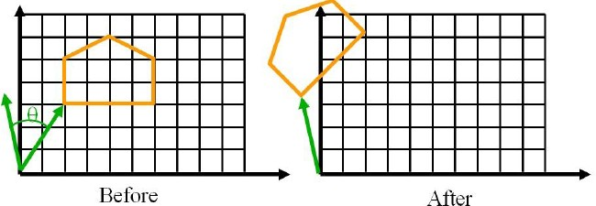

- Reflection: Reflection is nothing but producing mirror image of an object. Reflection can be done just by rotating the object about given axis of reflection with an angle of 180 degrees.

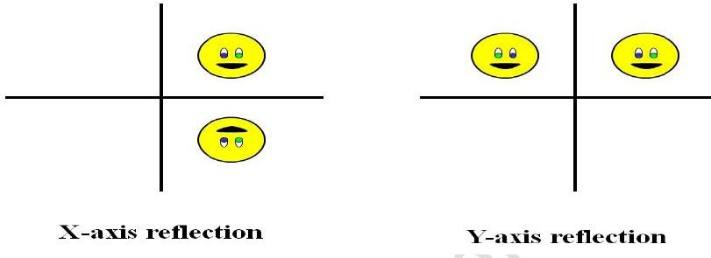
- Shear:
  - Shear is the translation along an axis by an amount that increases linearly with another axis (Y). It produces shape distortions as if objects were composed of layers that are caused to slide over each other.
  - Shear transformations are very useful in creating italic letters and slanted letters from regular letters.
  - Shear transformation changes the shape of the object to a slant position.

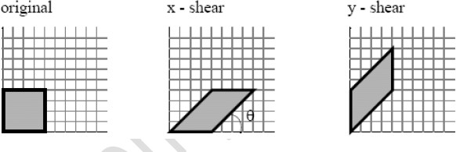

  - Shear transformation is of 2 types:
    - X-shear: changing x-coordinate value and keeping y constant x’=x+shx*y
y’=y
    - Y-shear: changing y coordinates value and keeping x constant x’=x
y’=y+shy*x
shx and shy are shear factors along x and y-axis.
Algorithm | 1. Start

- Read the coordinate values to draw the 2D figure and perform the following steps to achieve the necessary transformations

- Translation : Read the translation vector t_{x} and t_{y} and compute the new position using x₁ = x + t_{x} , y₁ = y + t_{y} and display the new position

- Rotation : Read the rotation angle Θ and compute the new position using the formula x₁ = x Cos Θ – y Sin Θ , y₁ = x Sin Θ + y Cos Θ and display the new position

- Scaling : Read the scaling factor s_{x} and s_{y} and compute the new position using x₁ = x. s_{x} , y₁ = y. s_{y} and display the new position

- Shearing : Shearing is done in x direction and y direction using the factor sh_{x} and sh_{y} for X direction: x₁ = x + sh_{x} (y – yref), y₁ = y & for Y direction x₁ = x , y₁ = sh_{y} (x – xref)

- Reflection : Reflection depends upon the reflection axis . If reflection axis is y = x , then x₁ = y and y₁ = x

- Stop
Program Code | #include<stdio.h> #include<process.h> #include<conio.h> #include<graphics.h> #include<math.h>  void disp(int n,float c[][3])  {  float maxx,maxy; int i; maxx=getmaxx(); maxy=getmaxy(); maxx=maxx/2;  maxy=maxy/2;

i=0;
while(i<n-1)
{
line(maxx+c[i][0],maxy-c[i][1],maxx+c[i+1][0],maxy-c[i+1][1]); i++;
}
i=n-1;
line(maxx+c[i][0],maxy-c[i][1],maxx+c[0][0],maxy-c[0][1]); setcolor(GREEN);
line(0,maxy,maxx*2,maxy); line(maxx,0,maxx,maxy*2); setcolor(WHITE);
}

void mul(int n,float b[][3],float c[][3],float a[][3])
{
int i,j,k; for(i=0;i<n;i++) for(j=0;j<3;j++) a[i][j]=0; for(i=0;i<n;i++)
for(j=0;j<3;j++)
for(k=0;k<3;k++)
{
a[i][j] = a[i][j] + (c[i][k] * b[k][j]);
}
}
void translation(int n,float c[][3],float tx,float ty)
{
int i; for(i=0;i<n;i++)
{
c[i][0]=c[i][0]+tx;
c[i][1]=c[i][1]+ty;
}
}
void scaling(int n,float c[][3],float sx,float sy)
{
float b[10][3],a[10][3]; int i=0,j; for(i=0;i<3;i++) for(j=0;j<3;j++)
b[i][j]=0; b[0][0]=b[0][0] * sx;
b[1][1]=b[1][1] * sy; b[2][2]=1;
mul(n,b,c,a);
setcolor(RED);

disp(n,a);
}
void rotation(int n,float c[][3],float ra)
{
int i=0,j;
float b[10][3],xp,yp,a[10][3]; xp=c[0][0];
yp=c[0][1];
for(i=0;i<3;i++) for(j=0;j<3;j++)
b[i][j]=0; b[0][0]=b[1][1]=cos(ra*3.14/180);
b[0][1]=sin(ra*3.14/180);
b[1][0]=-sin(ra*3.14/180);
b[2][0]=(-xp*cos(ra*3.14/180))+(yp*sin(ra*3.14/180))+xp; b[2][1]=(-xp*sin(ra*3.14/180))-(yp*cos(ra*3.14/180))+yp; b[2][2]=1;
mul(n,b,c,a); setcolor(RED); disp(n,a);
}
void reflection(int n,float c[][3])
{
float b[10][3],a[10][3]; int i=0,ch,j; cleardevice();
printf("\n\t* * MENU * *"); printf("\n\t1) ABOUT X-AXIS"); printf("\n\t2) ABOUT Y-AXIS"); printf("\n\t3) ABOUT ORIGIN"); printf("\t4) ABOUT X=Y"); printf("\n\t5) ABOUT -X=Y"); printf("\n\t6) EXIT"); printf("\n\tENTER YOUR CHOICE : "); scanf("%d",&ch);
clrscr(); cleardevice(); disp(n,c); for(i=0;i<3;i++) for(j=0;j<3;j++)
{
b[i][j]=0; if(i==j) b[i][j]=1;
}
switch(ch)
{
case 1:

b[1][1]=-1;
break;
case 2:
b[0][0]=-1;
break;
case 3:
b[0][0]=-1;
b[1][1]=-1;
break;
case 4:
b[0][0]=0;
b[1][1]=0;
b[0][1]=1;
b[1][0]=1;
break;
case 5:
b[0][0]=0;
b[1][1]=0;
b[0][1]=-1;
b[1][0]=-1;
break;
case 6:
break;
default:
printf("\n\tINVALID CHOICE ! "); break;
}
mul(n,b,c,a); setcolor(RED); disp(n,a);
}
void shearing(int n,float c[][3])
{
float b[10][3],sh,a[10][3]; int i=0,ch,j; cleardevice();
printf("\n\t* * * MENU * * *"); printf("\n\t1) X SHEARING"); printf("\n\t2) Y SHEARING"); printf("\n\t3) EXIT "); printf("\n\tENTER YOUR CHOICE : "); scanf("%d",&ch);
if(ch==3) return;
printf("\n\tENTER THE VALUE for SHEARING: "); scanf("%f",&sh);
clrscr(); cleardevice();
for(i=0;i<3;i++)

for(j=0;j<3;j++)
b[i][j]=0; for(i=0;i<3;i++)
b[i][i]=1; switch(ch)
{
case 1:
b[1][0]=sh;
break;
case 2:
b[0][1]=sh;
break;
case 3:
break;
default:
printf("\n\tINVALID CHOICE ! "); break;
}
mul(n,b,c,a); setcolor(RED); disp(n,a);
}
void main()
{
int i,j,k,cho,n,gd=DETECT,gm; float c[10][3],tx,ty,sx,sy,ra;
initgraph(&gd,&gm,"C:\\turboc3\\bgi"); printf("\nEnter the number of vertices : "); scanf("%d", &n);
for(i=0;i<n;i++)
{
printf("\nEnter the co-ordinates of the %d vertex :",i+1); scanf("%f%f",&c[i][0],&c[i][1]);
c[i][2]=1;
}
do
{
clrscr(); cleardevice();
printf("\n\t\t\t * * * MENU * * *"); printf("\n\t 1) TRANSLATION"); printf("\n\t 2) SCALING "); printf("\n\t 3) ROTATION "); printf("\n\t 4) REFLECTION "); printf("\n\t 5) SHEARING");
printf("\n\t 6) EXIT");
printf("\n\t ENTER YOUR CHOICE: ");
scanf("%d",&cho);

switch(cho)
{
case 1:
printf("\n\tEnter translation factor for X & Y axis :\t"); scanf("%f%f",&tx,&ty);
clrscr(); cleardevice(); setcolor(WHITE); disp(n,c); translation(n,c,tx,ty); setcolor(YELLOW); disp(n,c);
getch(); break;
case 2:
printf("\n\tEnter scaling factor for X & Y axis :\t"); scanf("%f%f",&sx,&sy);
clrscr(); cleardevice(); setcolor(WHITE); disp(n,c); scaling(n,c,sx,sy); getch();
break;
case 3:
printf("\n\n\tEnter the angle of rotation:\t"); scanf("%f",&ra);
clrscr(); cleardevice(); setcolor(WHITE); disp(n,c); rotation(n,c,ra); getch(); break;
case 4:
clrscr(); cleardevice(); setcolor(BLUE); disp(n,c); reflection(n,c); getch();
break;
case 5:
clrscr(); cleardevice(); setcolor(BLUE); disp(n,c); shearing(n,c);
getch();

case 6:
exit(0); break;
default:
printf("\n\tInvalid choice !!"); break;
}
}while(cho!=6); getch(); closegraph();
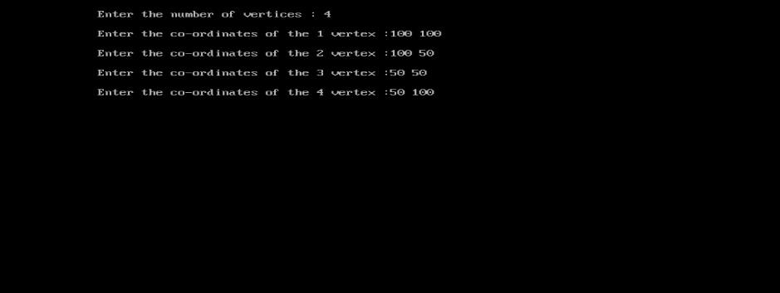
}

Result | 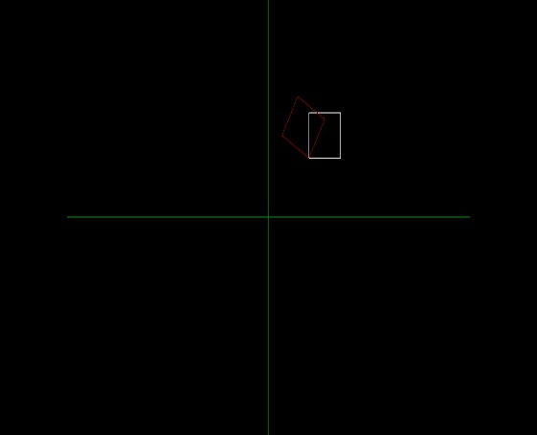  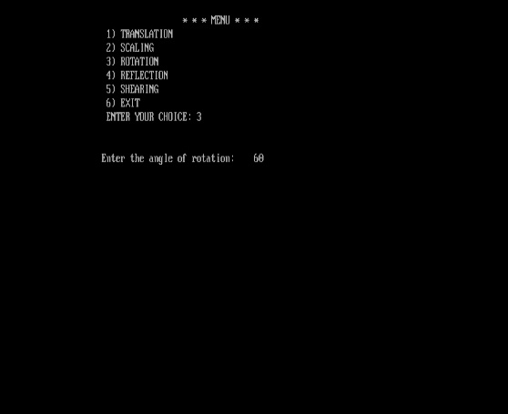

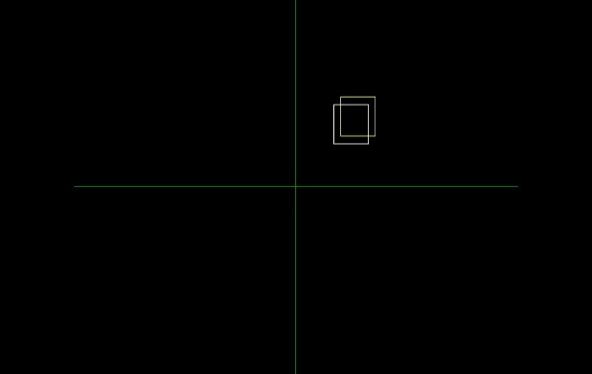
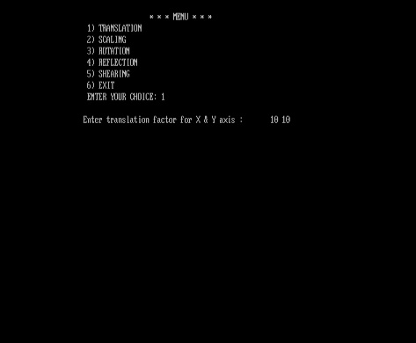

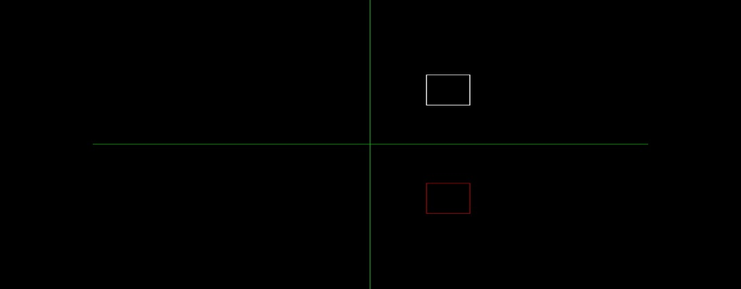
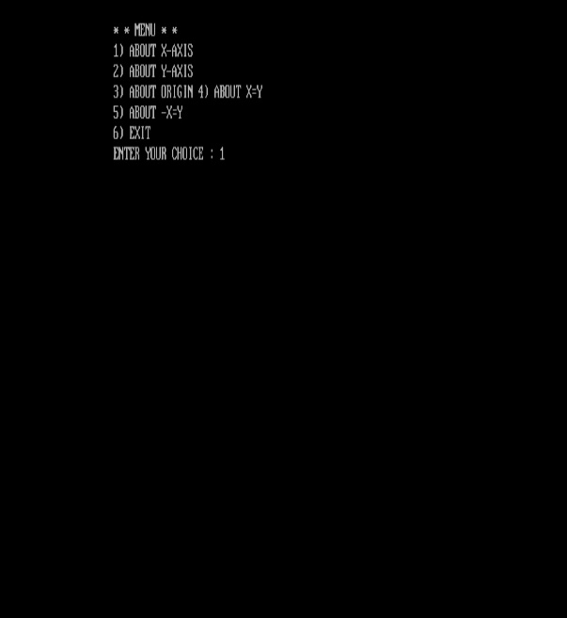
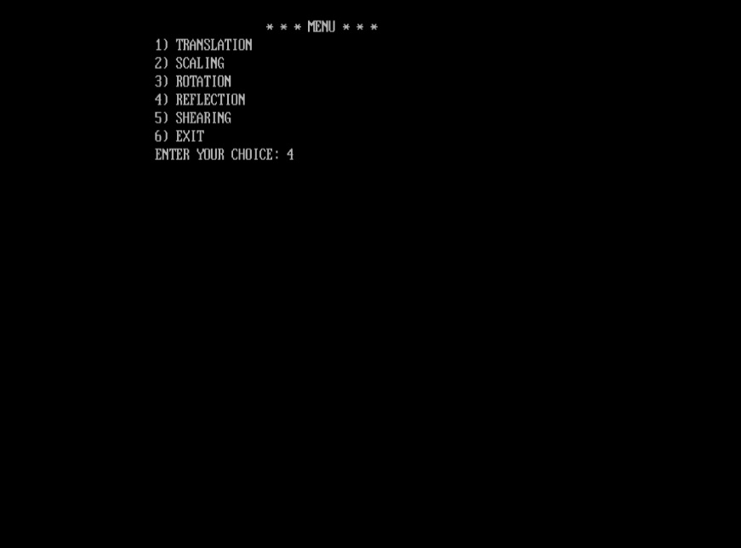
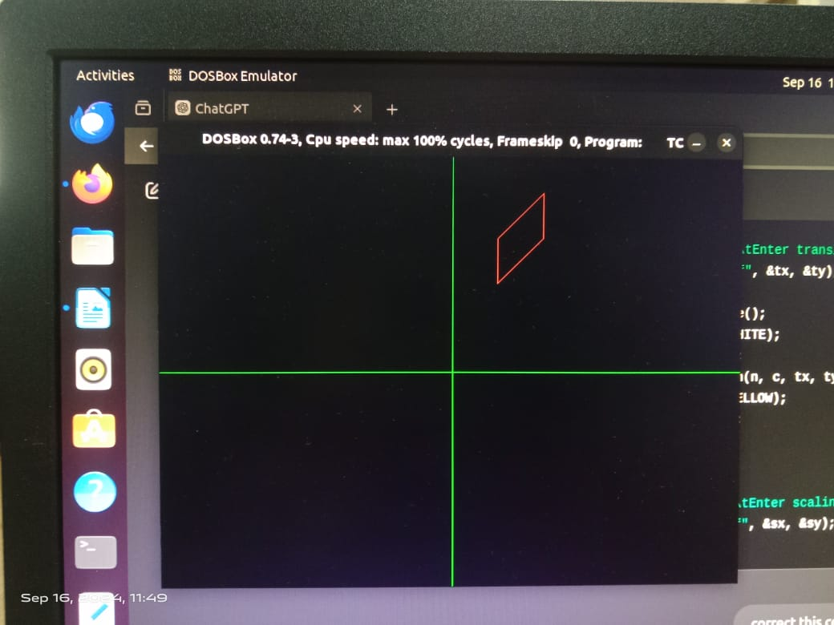
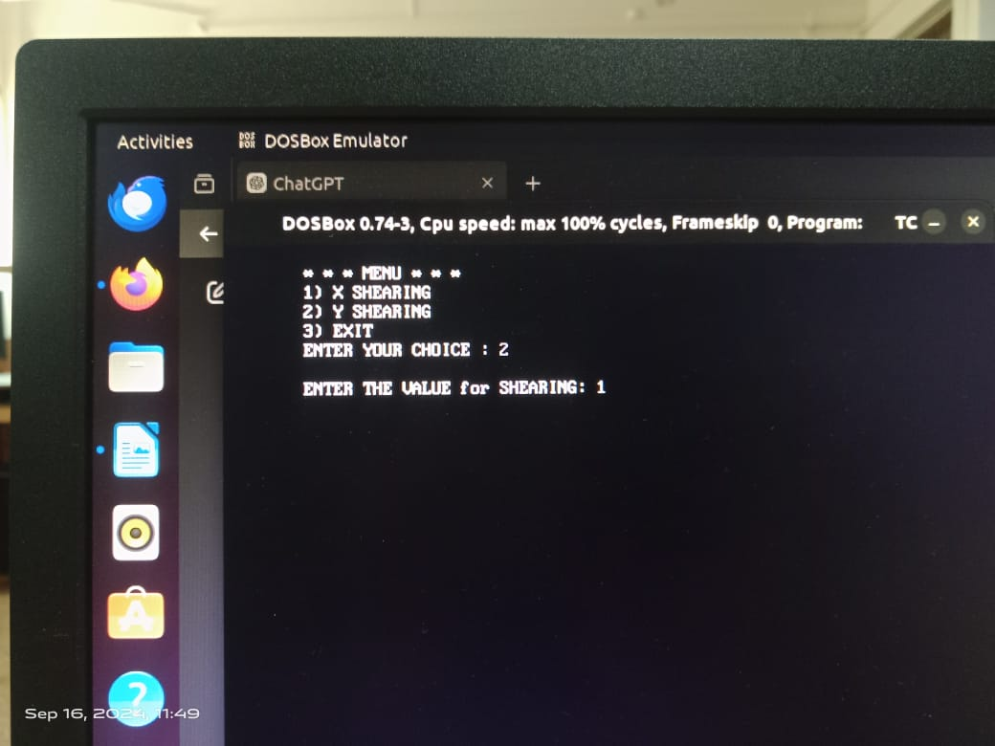

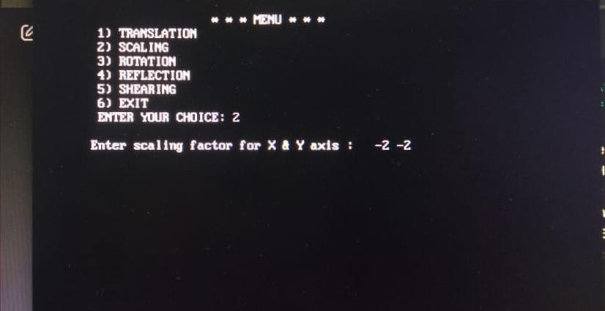
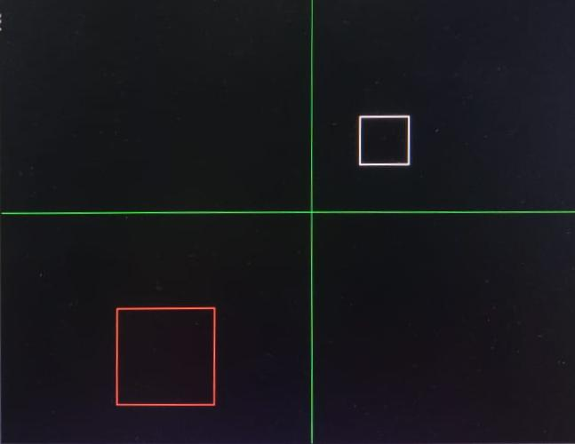

Conclusion | Thus a C program to perform 2D basic transformations such as translation, rotation, scaling, shearing and reflection was written and executed.

