Name -Shraddha Gajanan Desai

SE COMPS DIV A

ROLL NO 19

BATCH -A

CG EXP 5

Title | IMPLEMENTATION OF SCAN LINE FILL ALGORITHM
Objective | To implement the Scan line polygon fill algorithm for coloring a given  object.
Theory | Description:  The basic scan-line algorithm is as follows:  - Find the intersections of the scan line with all edges of the polygon  - Sort the intersections by increasing x coordinate  - Fill in all pixels between pairs of intersections that lie interior to the polygon  Process involved:  The scan-line polygon-filling algorithm involves  - the horizontal scanning of the polygon from its lowermost to its topmost vertex,  - identifying which edges intersect the scan-line,  - and finally drawing the interior horizontal lines with the specified fill color process.  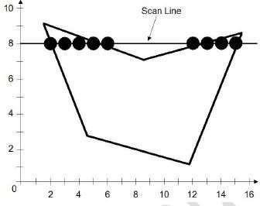
Algorithm | - the horizontal scanning of the polygon from its lowermost to its topmost vertex  - identify the edge intersections of scan line with polygon  - Build the edge table  a. Each entry in the table for a particular scan line contains the

maximum y value for that edge, the x-intercept value (at the lower vertex) for the edge, and the inverse slope of the edge.
- Determine whether any edges need to be splitted or not. If there is need to split, split the
edges.
- Add new edges and build modified edge table.
- Build Active edge table for each scan line and fill the polygon based on intersection of scanline with polygon edges.
Program | #include<stdio.h>
 | #include<conio.h>
 | #include<graphics.h>
 | void main()
 | {
 | int n,i,j,k,gd,gm,dy,dx;
 | int x,y,temp;
 | int a[20][2],xi[20];
 | float slope[20];
 | clrscr();
 | printf("\n\n\tEnter the no. of edges of polygon : ");
 | scanf("%d",&n);
 | printf("\n\n\tEnter the coordinates of polygon :\n\n\n");
 | for(i=0;i<n;i++)
 | {
 | printf("\tX%d Y%d : ",i,i);
 | R("%d%d",&a[i][0],&a[i][1]);
 | }
 | a[n][0]=a[0][0];
 | a[n][1]=a[0][1];
 | detectgraph(&gd,&gm);
 | initgraph(&gd,&gm,"C:\\TC\\BGI");
 | /*- Draw Polygon -*/
 | for(i=0;i<n;i++)
 | {
 | line(a[i][0],a[i][1],a[i+1][0],a[i+1][1]);
 | }
 | getch();
 | for(i=0;i<n;i++)
 | {
 | dy=a[i+1][1]-a[i][1];
 | dx=a[i+1][0]-a[i][0];
 | if(dy==0) slope[i]=1.0;
 | if(dx==0) slope[i]=0.0;
 | if((dy!=0)&&(dx!=0)) /*- Calculate Inverse Slope -*/
 | {
 | slope[i]=(float) dx/dy;

}
}
for(y=0;y<480;y++)
{
k=0;
for(i=0;i<n;i++)
{

if(((a[i][1]<=y)&&(a[i+1][1]>y))||((a[i][1]>y)&&(a[i+1][1]<=y)))
{
xi[k]=(int)(a[i][0]+slope[i]*(y-a[i][1])); k++;
}
}
for(j=0;j<k-1;j++) /*- Arrange x-intersections in order -
*/
for(i=0;i<k-1;i++)
{
if(xi[i]>xi[i+1])
{
temp=xi[i]; xi[i]=xi[i+1]; xi[i+1]=temp;
}
}
setcolor(3); for(i=0;i<k;i+=2)
{
line(xi[i],y,xi[i+1]+1,y); getch();
}
}
}
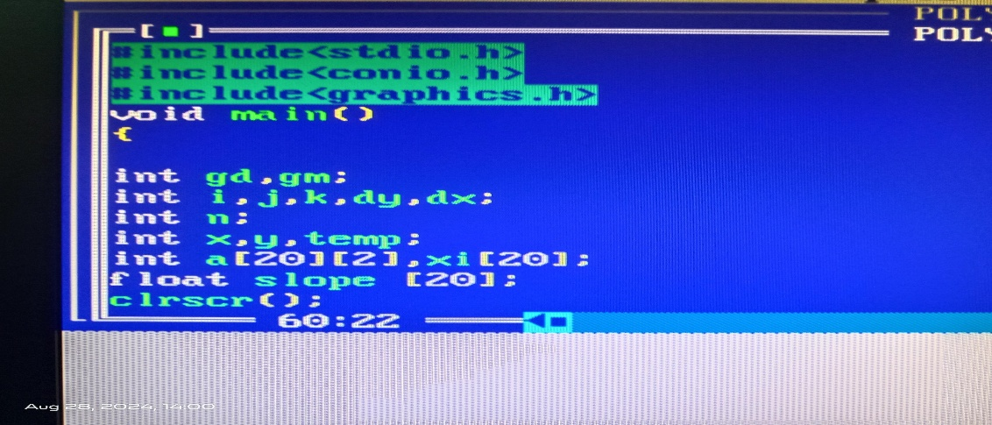

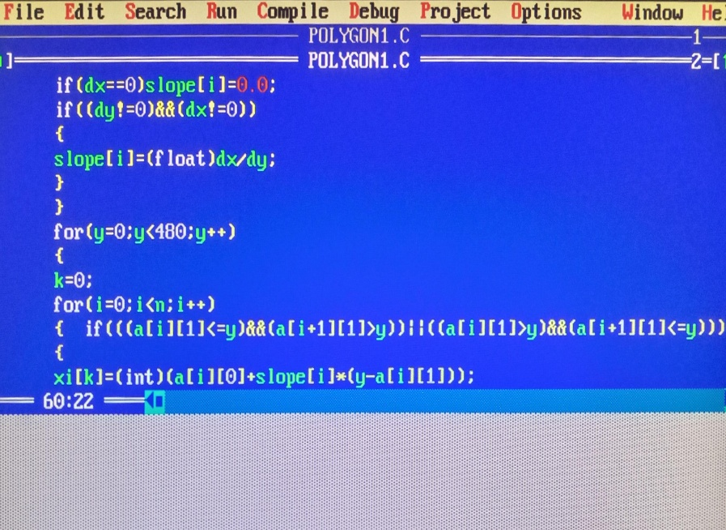
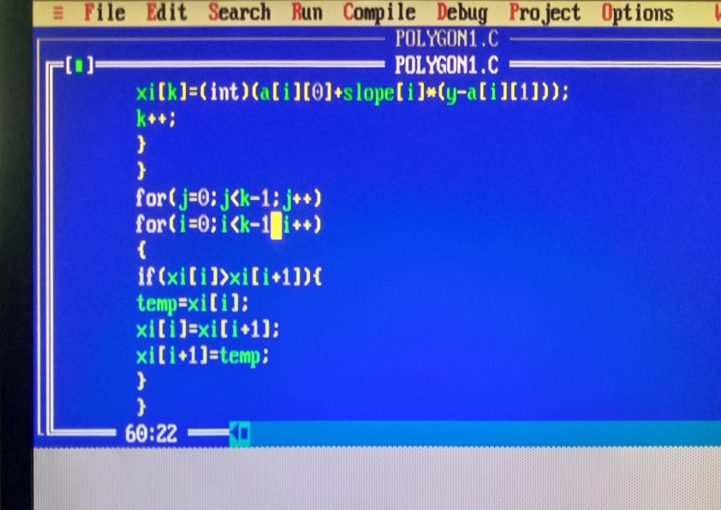
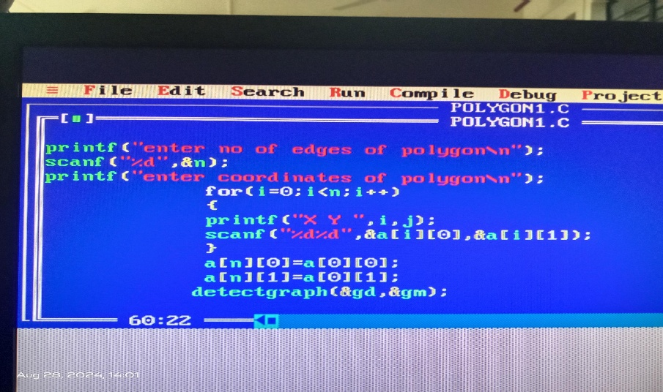
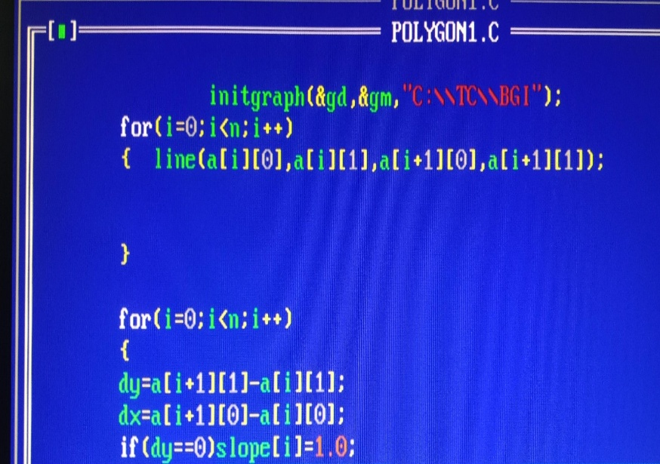

Output | 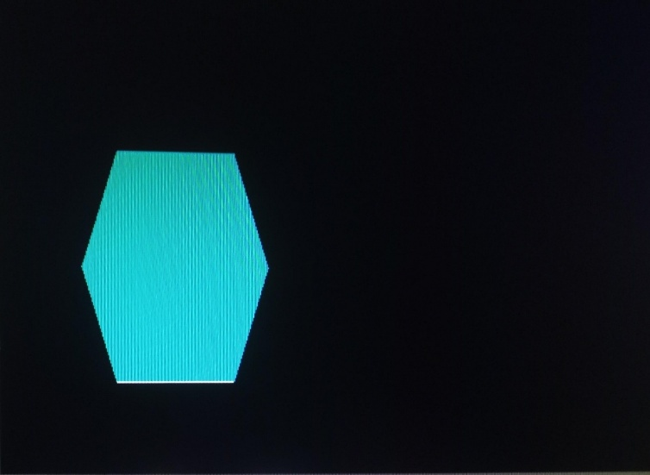  

Conclusion | Thus a C Program to implement Scan line polygon fill algorithm for coloring a given object was written and executed.

