Shraddha Gajanan Desai
SE COMPS A Batch A
Rollno 19

EXPERIMENT 7

Title | IMPLEMENTATION OF COHEN SUTHERLAND LINE CLIPPING AND WINDOW TO VIEWPORT TRANSFORMATION
Objective | To write a C program to implement Cohen Sutherland line clipping algorithm and to perform window to viewport transformation.
Algorithm | The Cohen-Sutherland algorithm uses a divide-and-conquer strategy. The line segment's endpoints are tested to see if the line can be trivally accepted or rejected. If the line cannot be trivally accepted or rejected, an intersection of the line with a window edge is determined and the trivial reject/accept test is repeated. This process is continued until the line is accepted.  To perform the trivial acceptance and rejection tests, we extend the edges of the window to divide the plane of the window into the nine regions. Each end point of the line segment is then assigned the code of the region in which it lies.  - Given a line segment with endpoint and  - Compute the 4-bit codes for each endpoint.  If both codes are 0000,(bitwise OR of the codes yields 0000 ) line lies completely inside the window: pass the endpoints to the draw routine.  If both codes have a 1 in the same bit position (bitwise AND of the codes is not 0000), the line lies outside the window. It can be trivially rejected.  - If a line cannot be trivially accepted or rejected, at least one of the two endpoints must lie outside the window and the line segment crosses a window edge. This line must be clipped at the window edge before being passed to the drawing routine.  - Examine one of the endpoints, say . Read 's 4-bit code in order: Left-to-Right, Bottom-to-Top.  - When a set bit (1) is found, compute the intersection I of the corresponding window edge with the line from to . Replace with I and repeat the algorithm.  Program:  #include<graphics.h>  #include<conio.h>  #include<stdio.h>  #include<math.h>  void main()  {  int rcode_begin[4]={0,0,0,0},rcode_end[4]={0,0,0,0},region_code[4];  int W_xmax,W_ymax,W_xmin,W_ymin,flag=0;  float slope;  int x,y,x1,y1,i, xc,yc;  int gd=DETECT,gm;  initgraph(&gr,&gm,"C:\\tc\\bgi");  printf("\n****** Cohen Sutherland Line Clipping algorithm  ***********");  printf("\n Now, enter XMin, YMin =");  scanf("%d %d",&W_xmin,&W_ymin);  printf("\n First enter XMax, YMax =");  scanf("%d %d",&W_xmax,&W_ymax);  printf("\n Please enter intial point x and y= ");  scanf("%d %d",&x,&y);  printf("\n Now, enter final point x1 and y1= ");  scanf("%d %d",&x1,&y1);  cleardevice();  rectangle(W_xmin,W_ymin,W_xmax,W_ymax);  line(x,y,x1,y1);  line(0,0,600,0);  line(0,0,0,600);  if(y>W_ymax) {  rcode_begin[0]=1; // Top  flag=1 ;  }  if(y<W_ymin) {  rcode_begin[1]=1; // Bottom  flag=1;  }  if(x>W_xmax) {  rcode_begin[2]=1; // Right  flag=1;  }  if(x<W_xmin) {  rcode_begin[3]=1; //Left  flag=1;  }  //end point of Line  if(y1>W_ymax){  rcode_end[0]=1; // Top  flag=1;  }  if(y1<W_ymin) {  rcode_end[1]=1; // Bottom  flag=1;  }  if(x1>W_xmax){  rcode_end[2]=1; // Right  flag=1;  }  if(x1<W_xmin){  rcode_end[3]=1; //Left  flag=1;  }  if(flag==0)  {  printf("No need of clipping as it is already in window");  }  flag=1;  for(i=0;i<4;i++){  region_code[i]= rcode_begin[i] && rcode_end[i] ;  if(region_code[i]==1)  flag=0;  }  if(flag==0)  {  printf("\n Line is completely outside the window");  }  else{  slope=(float)(y1-y)/(x1-x);  if(rcode_begin[2]==0 && rcode_begin[3]==1) //left  {  y=y+(float) (W_xmin-x)*slope ;  x=W_xmin;  }  if(rcode_begin[2]==1 && rcode_begin[3]==0) // right  {  y=y+(float) (W_xmax-x)*slope ;  x=W_xmax;  }  if(rcode_begin[0]==1 && rcode_begin[1]==0) // top  {  x=x+(float) (W_ymax-y)/slope ;  y=W_ymax;  }  if(rcode_begin[0]==0 && rcode_begin[1]==1) // bottom  {  x=x+(float) (W_ymin-y)/slope ;  y=W_ymin;  }  // end points  if(rcode_end[2]==0 && rcode_end[3]==1) //left  {  y1=y1+(float) (W_xmin-x1)*slope ;  x1=W_xmin;  }  if(rcode_end[2]==1 && rcode_end[3]==0) // right  {  y1=y1+(float) (W_xmax-x1)*slope ;  x1=W_xmax;  }  if(rcode_end[0]==1 && rcode_end[1]==0) // top  {  x1=x1+(float) (W_ymax-y1)/slope ;  y1=W_ymax;  }  if(rcode_end[0]==0 && rcode_end[1]==1) // bottom  {  x1=x1+(float) (W_ymin-y1)/slope ;  y1=W_ymin;  }  }  delay(1000);  clearviewport();  rectangle(W_xmin,W_ymin,W_xmax,W_ymax);  line(0,0,600,0);  line(0,0,0,600);  setcolor(RED);  line(x,y,x1,y1);  getch();  closegraph();  }  Output:  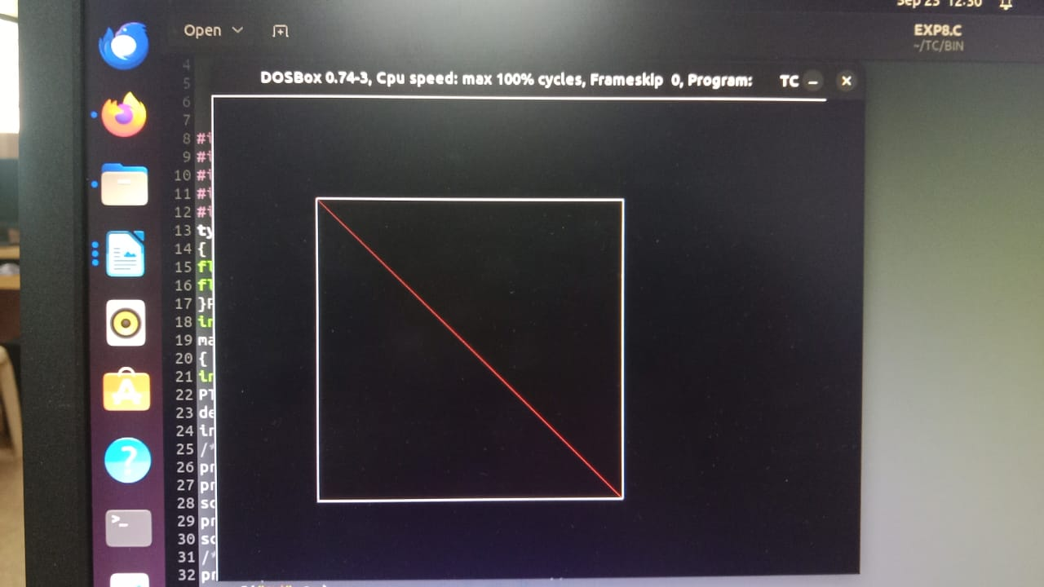  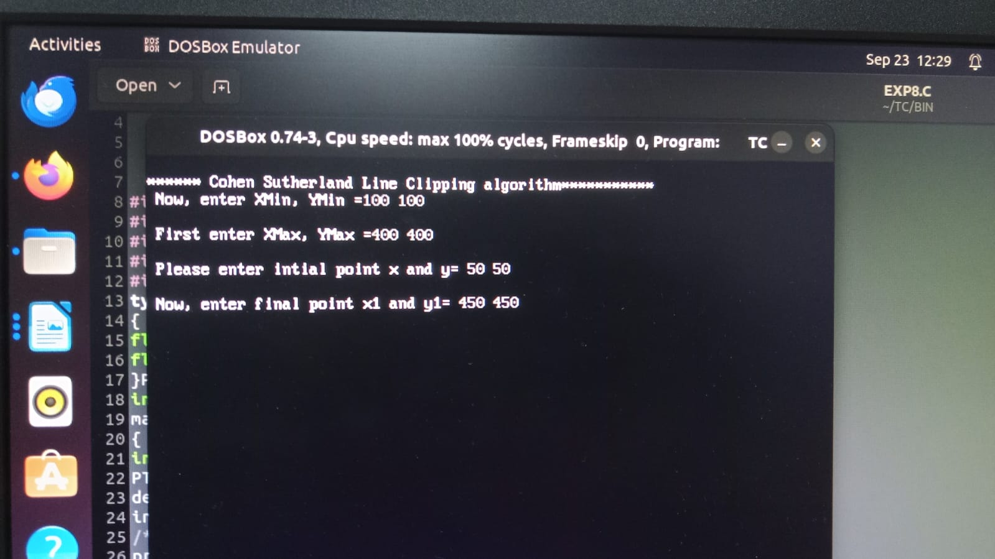
Conclusion | Thus a C program to implement Cohen Sutherland line clipping algorithm and to perform window to viewport transformation was written and executed.

