Name Shraddha Gajanan Desai
SE COMPS DIV A
ROLL NO 19
EXPERIMENT 8

Title | IMPLEMENTATION OF SUTHERLAND – HODGEMAN  POLYGON CLIPPING ALGORITHM
Objective | To write a C program to implement Sutherland – Hodgeman Polygon  clipping algorithm.
Algorithm | - Start  - Get the minimum and maximum coordinates of both window and view port.  - Get the number of sides of a polygon and its corresponding coordinates.  - If the polygon lies within region code window, display it.  - If any one of the polygon side is neither inside nor outside the boundary, find the point of intersection and clip the regions that lies outside the boundary.  - Display the polygon after clipping  - Stop
Program | #include<stdio.h>  #include<graphics.h>  #include<conio.h>  #include<stdlib.h>  #include<math.h>  typedef struct  {  float x;  float y;  }PT;  int n;  main()  {  int i,j,gd,gm;  PT d,p1,p2,p[20],pi1,pi2,pp[20];  detectgraph(&gd,&gm);  initgraph(&gd,&gm,"c:\\tc\\bgi");  /* Read coordinates of clipping window */  printf("/n/n/nProgram for Sutherland-Hodgeman polygon clipping");  printf("/n/n/n/Enter coordinates (left,top) of point1 : ");  scanf("%f %f",&p1.x,&p1.y);  printf("Enter coordinates (right,bottom) of point2 : ");  scanf("%f %f",&p2.x,&p2.y);  /* Enter the number of vertex */  printf("Enter the number of vertex : ");  scanf("%d",&n);  /* Read vertex coordinates of clipping window */  for(i=0;i<n;i++)  {  printf("Enter coordinates of vertex%d : ",i+1);  scanf("%f %f",&p[i].x,&p[i].y);  }  p[i].x = p[0].x;  p[i].y = p[0].y;  cleardevice();  drawpolygon(p,n);  rectangle(p1.x,p1.y,p2.x,p2.y);  getch();  left(p1,p,pp);  right(p2,p,pp);  top(p1,p,pp);  bottom(p2,p,pp);  cleardevice();  rectangle(p1.x,p1.y,p2.x,p2.y);  drawpolygon(p,n);  getch();  closegraph();  }  left(PT p1,PT p[20],PT pp[20])  {  int i,j=0;  for(i=0;i<n;i++)  {  if(p[i].x < p1.x && p[i+1].x >= p1.x)  {  if(p[i+1].x-p[i].x!=0)  {  pp[j].y = (p[i+1].y-p[i].y)/(p[i+1].x-p[i].x)* (p1.x-p[i].x)+p[i].y;  }  else  {  pp[j].y = p[i].y;  }  pp[j].x = p1.x;  j++;  pp[j].x=p[i+1].x;  pp[j].y=p[i+1].y;  j++;  }  if(p[i].x > p1.x && p[i+1].x >= p1.x)  {  pp[j].y = p[i+1].y;  pp[j].x = p[i+1].x;  j++;  }  if(p[i].x > p1.x && p[i+1].x <= p1.x)  {  if(p[i+1].x-p[i].x!=0)  {  pp[j].y = (p[i+1].y-p[i].y)/(p[i+1].x-p[i].x)* (p1.x-p[i].x)+p[i].y;  }  else  {  pp[j].y = p[i].y;  }  pp[j].x = p1.x;  j++;  }  }  for(i=0;i<j;i++)  {  p[i].x = pp[i].x;  p[i].y = pp[i].y;  }  p[i].x = pp[0].x;  p[i].y = pp[0].y;  n=j;  }  right(PT p2,PT p[20],PT pp[20])  {  int i,j=0;  for(i=0;i<n;i++)  {  if(p[i].x > p2.x && p[i+1].x <= p2.x)  {  if(p[i+1].x-p[i].x!=0)  {  pp[j].y = (p[i+1].y-p[i].y)/(p[i+1].x-p[i].x)* (p2.x-p[i].x)+p[i].y;  }  else  {  pp[j].y = p[i].y;  }  pp[j].x = p2.x;  j++;  pp[j].x=p[i+1].x;  pp[j].y=p[i+1].y;  j++;  }  if(p[i].x < p2.x && p[i+1].x <= p2.x)  {  pp[j].y = p[i+1].y;  pp[j].x = p[i+1].x;  j++;  }  if(p[i].x < p2.x && p[i+1].x >= p2.x)  {  if(p[i+1].x-p[i].x!=0)  {  pp[j].y = (p[i+1].y-p[i].y)/(p[i+1].x-p[i].x)* (p2.x-p[i].x)+p[i].y;  }  else  {  pp[j].y = p[i].y;  }  pp[j].x = p2.x;  j++;  }  }  for(i=0;i<j;i++)  {  p[i].x = pp[i].x;  p[i].y = pp[i].y;  }  p[i].x = pp[0].x;  p[i].y = pp[0].y;  n=j;  }  top(PT p1,PT p[20],PT pp[20])  {  int i,j=0;  for(i=0;i<n;i++)  {  if(p[i].y < p1.y && p[i+1].y >= p1.y)  {  if(p[i+1].y-p[i].y!=0)  {  pp[j].x = (p[i+1].x-p[i].x)/(p[i+1].y-p[i].y)* (p1.y-p[i].y)+p[i].x;  }  else  {  pp[j].x = p[i].x;  }  pp[j].y = p1.y;  j++;  pp[j].x=p[i+1].x;  pp[j].y=p[i+1].y;  j++;  }  if(p[i].y > p1.y && p[i+1].y >= p1.y)  {  pp[j].y = p[i+1].y;  pp[j].x = p[i+1].x;  j++;  }  if(p[i].y > p1.y && p[i+1].y <= p1.y)  {  if(p[i+1].y-p[i].y!=0)  {  pp[j].x = (p[i+1].x-p[i].x)/(p[i+1].y-p[i].y)* (p1.y-p[i].y)+p[i].x;  }  else  {  pp[j].x = p[i].x;  }  pp[j].y = p1.y;  j++;  }  }  for(i=0;i<j;i++)  {  p[i].x = pp[i].x;  p[i].y = pp[i].y;  }  p[i].x = pp[0].x;  p[i].y = pp[0].y;  n=j;  }  bottom(PT p2,PT p[20],PT pp[20])  {  int i,j=0;  for(i=0;i<n;i++)  {  if(p[i].y > p2.y && p[i+1].y <= p2.y)  {  if(p[i+1].y-p[i].y!=0)  {  pp[j].x = (p[i+1].x-p[i].x)/(p[i+1].y-p[i].y)* (p2.y-p[i].y)+p[i].x;  }  else  {  pp[j].x = p[i].x;  }  pp[j].y = p2.y;  j++;  pp[j].x=p[i+1].x;  pp[j].y=p[i+1].y;  j++;  }  if(p[i].y < p2.y && p[i+1].y <= p2.y)  {  pp[j].y = p[i+1].y;  pp[j].x = p[i+1].x;  j++;  }  if(p[i].y < p2.y && p[i+1].y >= p2.y)  {  if(p[i+1].y-p[i].y!=0)  {  pp[j].x = (p[i+1].x-p[i].x)/(p[i+1].y-p[i].y)* (p2.y-p[i].y)+p[i].x;  }  else  {  pp[j].x = p[i].x;  }  pp[j].y = p2.y;  j++;  }  }  for(i=0;i<j;i++)  {  p[i].x = pp[i].x;  p[i].y = pp[i].y;  }  p[i].x = pp[0].x;  p[i].y = pp[0].y;  n=j;  }  drawpolygon(PT x[20],int n)  {  int i;  for(i=0;i<n-1;i++)  {  line(x[i].x,x[i].y,x[i+1].x,x[i+1].y);  }  line(x[i].x,x[i].y,x[0].x,x[0].y);  }

Output | 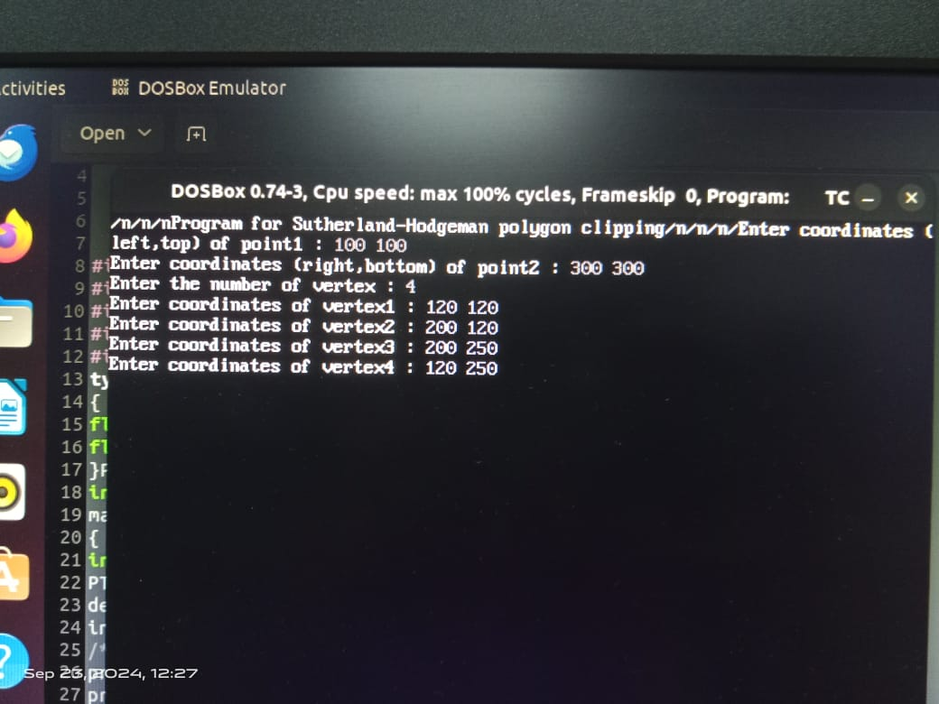  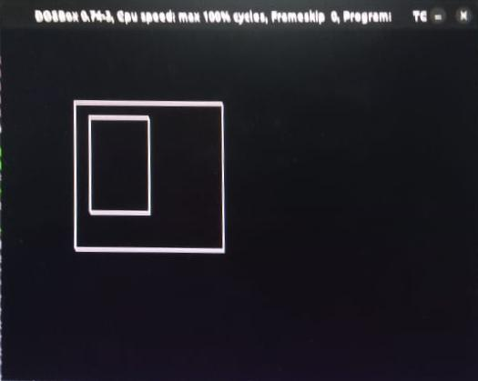
Conclusion | The Sutherland-Hodgman polygon clipping algorithm is a reliable and efficient method for clipping polygons against rectangular clipping regions. Its simplicity, robustness, and wide range of applications make it a fundamental algorithm in computer graphics and geometric computing

