EXPERIMENT NO: 6

Name of the student: Shraddha Gajanan Desai Roll No: 18
Division: A Batch: A
Date of Performance: 10/03/2026 Date of Submission:15/03/2026

Aim of the  Experim ent: | To simulate and understand the working of a SQL Injection attack on a vulnerable web application.
Learning Objectiv es: | - To understand the concept of SQL Injection attacks.  - To analyze how improper input validation can compromise database security.  - To observe how attackers bypass authentication using malicious SQL queries.
Lab Outcome s: | Student will able to  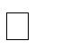  - Understand common web application vulnerabilities.    - Demonstrate how SQL Injection can be used to gain unauthorized access to a database.    - Apply preventive techniques to secure web applications against SQL Injection attacks.
Tools &  Software  Required  : | - XAMPP / WAMP Server  - MySQL Database  - Web Browser  - PHP
Theory: | SQL Injection (SQLi)  SQL Injection is a type of vulnerability that occurs when an attacker can interfere with the queries that an application makes to its database. It typically allows an attacker to view data they are not normally able to retrieve. This can include data belonging to other users, or any other data that the application itself can access.  Authentication Bypass  In an Authentication Bypass, attackers use malicious SQL queries to trick the application into logging them in without a valid password.  • For example, using a tautology like ' OR '1'='1 creates a logical condition that is always true.

- When the database evaluates this, the WHERE clause becomes true for the first user in the table (usually the admin), granting the attacker access.
Input Validation
Input Validation is the process of ensuring that a program operates on clean, correct, and useful data.
- The experiment demonstrates how improper input validation can compromise database security.
- When user-supplied data is directly concatenated into a SQL command without being sanitized or "escaped," the data can be misinterpreted by the database as part of the command itself.
Algorith m: | Step 1: Install and start XAMPP/WAMP server and run Apache and MySQL services.  Step 2: Create a database using MySQL.  CREATE DATABASE securitylab;  USE securitylab;  Step 3: Create a table for storing user credentials.  CREATE TABLE users(  id INT(4)PRIMARY KEY ,username VARCHAR(50), password VARCHAR(50)  );  Step 4: Insert sample data.  INSERT INTO users(username,password) VALUES('admin','admin123'); Step 5:Create a login form (login.html).  <html>  <head><title>SQL ENJECTION</title></head>  <body>  <form action="login.php" method="post">  Username: <input type="text" name="username"><br><br>  Password: <input type="text" name="password"><br><br>  <input type="submit" value="Login">  </form>  </body>
</html>
Step 6: Create a vulnerable PHP login script (login.php).
<?php
$conn = mysqli_connect("localhost","root",""," securitylab "); if(!$conn){ die("Connection failed: " . mysqli_connect_error()); }
$username = $_POST['username'];
$password = $_POST['password'];
$sql = "SELECT * FROM users WHERE username='$username' AND password='$password'";
$result = mysqli_query($conn, $sql); if(!$result){ die("Query Error: " . mysqli_error($conn));
}
if(mysqli_num_rows($result) > 0){ echo "<h2 style='color:green;'>Login Successful</h2>"; $allData = mysqli_query($conn, "SELECT * FROM users"); echo "<h3>All Users Table Data:</h3>"; echo "<table border='1' cellpadding='10'>"; echo "<tr><th>ID</th><th>Username</th><th>Password</th></tr>"; while($row = mysqli_fetch_assoc($allData)){ echo "<tr>"; echo "<td>".$row['id']."</td>"; echo "<td>".$row['username']."</td>";
echo "<td>".$row['password']."</td>"; echo "</tr>"; } echo "</table>";} else { echo "<h2 style='color:red;'>Invalid Credentials</h2>"
;}
echo "<br><br><b>Generated Query:</b> " . $sql; mysqli_close($conn);
?>
Step 7: Run the login page in the browser.
http://localhost/login.html
Step 8:
Enter valid credentials:admin / admin123
Step 9: Perform SQL Injection by entering:
- Username: admin Password: ' OR '1'='1
- Username: admin' -- Password: anything

 | Step 10: Observe that the login is successful even without the correct password.
Program  : | Login.html  <!DOCTYPE html>  <html>  <head>  <title>SQL ENJECTION</title>  </head>  <body>  <div style="font-weight: bold; margin-bottom: 20px;">  Name: Hemal Bhirud &nbsp;&nbsp;&nbsp;&nbsp; Roll No. 09 </div>  <form action="login.php" method="post">  Username: <input type="text" name="username"><br><br>  Password: <input type="text" name="password"><br><br>  <input type="submit" value="Login">  </form>  </body>  </html>  Applications.html  <!DOCTYPE html PUBLIC "-//W3C//DTD XHTML 1.0 | Transitional//EN"
"http://www.w3.org/TR/xhtml1/DTD/xhtml1-transitional.dtd">
<html xmlns="http://www.w3.org/1999/xhtml">
<head>
<meta http-equiv="Content-Type" content="text/html; charset=utf-8" />
<title>Bitnami: Open Source. Simplified</title>
<link href="bitnami.css" media="all" rel="Stylesheet" type="text/css" />
<link href="/dashboard/stylesheets/all.css" rel="stylesheet" type="text/css" />

</head>
<body>
<div class="contain-to-grid">
<nav class="top-bar" data-topbar>
<ul class="title-area">
<li class="name">
<h1><a href="/dashboard/index.html">Apache Friends</a></h1>
</li>
<li class="toggle-topbar menu-icon">
<a href="#">
<span>Menu</span>
</a>
</li>
</ul>

<section class="top-bar-section">
<!-- Right Nav Section -->
<ul class="right">
<li class="active"><a href="/applications.html">Applications</a></li>
<li class=""><a href="/dashboard/faq.html">FAQs</a></li>
<li class=""><a href="/dashboard/howto.html">HOW-TO Guides</a></li>
<li class=""><a target="_blank" href="/dashboard/phpinfo.php">PHPInfo</a></li>
<li class=""><a href="/phpmyadmin/">phpMyAdmin</a></li>
</ul>
</section>
</nav>
</div>
<div id="wrapper">
<div class="hero">
<div class="row">
<div class="large-12 columns">
<p>Apache Friends and Bitnami are cooperating to make dozens of open source applications available on XAMPP, for free. Bitnami-packaged applications include Wordpress, Drupal, Joomla! and dozens of others and can be deployed with one-click installers. Visit the <a
href="https://bitnami.com/xampp?utm_source=bitnami&utm_medium=installer&utm_ca mpaign=XAMPP%2BModule" target="_blank">Bitnami XAMPP page</a> for details on the currently available apps.</p><br/>
<p>Check out our <a href="https://www.apachefriends.org/bitnami_for_xampp.html" target="_blank" >Bitnami for XAMPP Start Guide</a> for more information about the applications installed.</p>
</div>
</div>
</div>
<div id="lowerContainer" class="row">
<div id="content" class="large-12 columns">
<!-- @@BITNAMI_MODULE_PLACEHOLDER@@ -->
</div>
</div>
</div>
<footer>
<div class="row">
<div class="large-12 columns">
<div class="row">
<div class="large-8 columns">
<ul class="social">
<li class="twitter"><a href="https://twitter.com/apachefriends">Follow us on Twitter</a></li>
<li class="facebook"><a href="https://www.facebook.com/we.are.xampp">Like us on Facebook</a></li>
<li class="google"><a href="https://plus.google.com/+xampp/posts">Add us to your G+ Circles</a></li>
</ul>

<ul class="inline-list">
<li><a href="https://www.apachefriends.org/blog.html">Blog</a></li>
<li><a href="https://www.apachefriends.org/privacy_policy.html">Privacy Policy</a></li>
<li>
<a target="_blank" href="http://www.fastly.com/"> CDN provided by
<img width="48" data-2x="/dashboard/images/fastly-logo@2x.png" src="/dashboard/images/fastly-logo.png" />
</a>
</li>
</ul>
</div>
<div class="large-4 columns">
<p class="text-right">Copyright (c) 2015, Apache Friends</p>
</div>
</div>
</div>
</div>
</footer>
</body>
</html>

Login.php <?php echo "<h2>Name: Hemal Bhirud &nbsp;&nbsp;&nbsp;&nbsp; Roll No. 09</h2>";

$conn = mysqli_connect("localhost", "root", "", "securitylab");

if (!$conn) { die("Connection failed: " . mysqli_connect_error()); }

$username = $_POST['username'];
$password = $_POST['password'];

// SECURE METHOD: Using Prepared Statements
$stmt = $conn->prepare("SELECT * FROM users WHERE username=? AND password=?");
$stmt->bind_param("ss", $username, $password);
$stmt->execute();
$result = $stmt->get_result();

if ($result->num_rows > 0) { echo "<h2 style='color:green;'>Login Successful (Secure Mode)</h2>";

$allData = mysqli_query($conn, "SELECT * FROM users"); echo "<h3>All Users Table Data:</h3>"; echo "<table border='1' cellpadding='10'>"; echo "<tr><th>ID</th><th>Username</th><th>Password</th></tr>"; while ($row = mysqli_fetch_assoc($allData)) {
echo
"<tr><td>".$row['id']."</td><td>".$row['username']."</td><td>".$row['password']."</td>
</tr>";
}
echo "</table>";

} else { echo "<h2 style='color:red;'>Invalid Credentials</h2>"; echo "<p>The SQL Injection attack was blocked by the prepared statement.</p>"; }

mysqli_close($conn);
?>

Output: | XAMPP Services Running  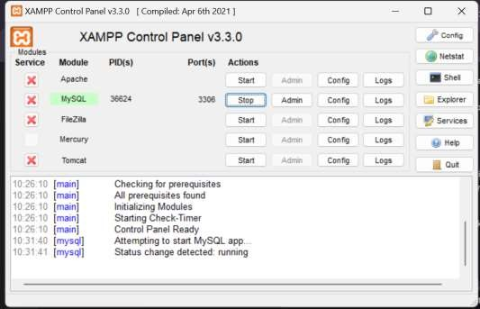

Database and Table Creation

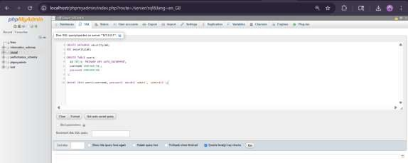

Login Page Interface
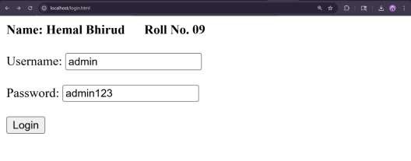
Valid Admin Login Result
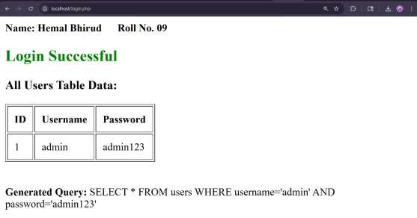

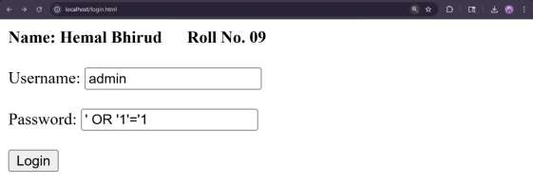

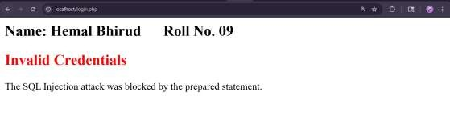

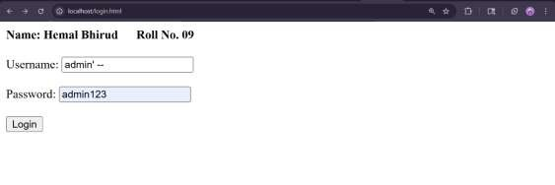

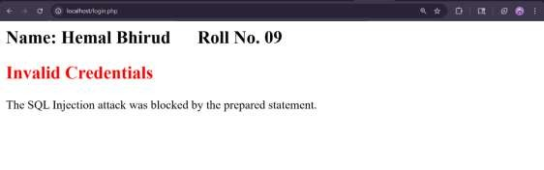

Conclusi on: | In this experiment, I successfully simulated and analyzed a SQL Injection attack on a vulnerable web application. Through the initial implementation, I observed that improper input validation allows attackers to bypass authentication by using malicious payloads like ' OR '1'='1 or commenting out logic with --. These inputs manipulate the generated SQL query, causing the database to grant unauthorized access.  To secure the application, I modified the PHP login script to implement Prepared Statements and Parameterized Queries. After executing these changes, previous attack inputs failed to bypass security, as the database treated the malicious strings as literal data rather than executable commands. This experiment demonstrates that Secure Coding techniques are essential for protecting database integrity and preventing common web vulnerabilities.

