**CHENNAI INSTITUTE OF TECHNOLOGY**

**(AUTONOMOUS)**

Sarathy Nagar, Kundrathur, Chennai-600069

*Approved by AICTE and Affiliated to Anna University, Chennai*

**INFORMATION TECHNOLOGY**

**CLOUD ENGINEER INTERNSHIP**



A Report on Internship

By

HEMALALITHA M

22IT036

Information Technology

**MAY 2024**

**CHENNAI INSTITUTE OF TECHNOLOGY**

**CHENNAI-69**



**Vision of the Institute:**

To be an eminent centre for Academia, Industry and Research by imparting knowledge, relevant practices and inculcating human values to address global challenges through novelty and sustainability.

**Mission of the Institute:**

**IM1**.To create next generation leader by effective teaching learning methodologies and instil scientific spark in them to meet the global challenges.

**IM2**.To transform lives through deployment of emerging technology, novelty and sustainability.

**IM3**.To inculcate human values and ethical principles to cater the societal needs.

**IM4**.To contributes towards the research ecosystem by providing a suitable, effective platform for interaction between industry, academia and R &D establishments.

**IM5**.To nurture incubation centres enabling structured entrepreneurship and start-ups.



**Vision of the Department**:

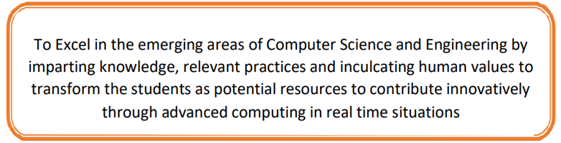

**Mission of the Department**:

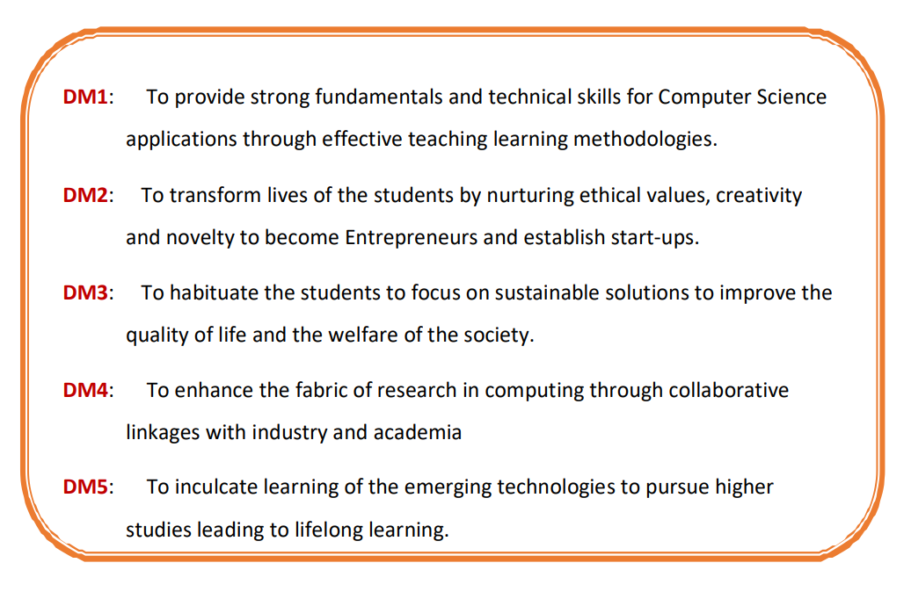

**CHENNAI INSTITUTE OF TECHNOLOGY**

*An Autonomous Institute*

**CHENNAI-69**



**CERTIFICATE**

This is to certify that the “**Internship Report**” Submitted by **Hemalalitha M (Reg no: 22IT036)** is the work done by him/her and submitted during the academic year **2023-2024**, in partial fulfilment of the requirements for the award of the degree of **BACHELOR OF TECHNOLOGY** in **INFORMATION TECHNOLOGY**, at **Avohi Info Tech.**

*Submitted for the End Semester Examination for Internship Held on ...……………...…*

|  |  |
| --- | --- |
| **Dr. A. R. KAVITHA, M.E., Ph.D.**,  **Head of the Department** | **Department Internship Coordinator** |
| **Internal Examiner**  **Date: - …………….** | **External Examiner**  **Date: -……….…...** |

|  |  |
| --- | --- |
|  |  |

**Internship Review Evaluation/Comments**

|  |  |  |  |
| --- | --- | --- | --- |
| **Sl No.** | **Criterion** | **Max. Marks** | **Marks Allotted** |
| 1. | Regularity in maintenance of the diary. | 10 |  |
| 2. | Adequacy & quality of information recorded | 10 |  |
| 3. | Drawings, sketches and data recorded | 10 |  |
| 4. | Thought process and recording techniques used | 05 |  |
| 5. | Organization of the information | 05 |  |
| 6. | Originality of the Internship Report | 10 |  |
| 7. | Adequacy and purposeful write-up of the Internship Report | 10 |  |
| 8. | Organization, format, drawings, sketches, style, language etc. of the Internship Report | 10 |  |
| 9. | Practical applications, relationships with basic theory and concepts | 10 |  |
| 10. | Presentation Skills | 20 |  |
| **Total** | | 100 |  |
| External Internship Advisor's Name:  Company: Avohi Info Tech  Date: Signature | | |  |

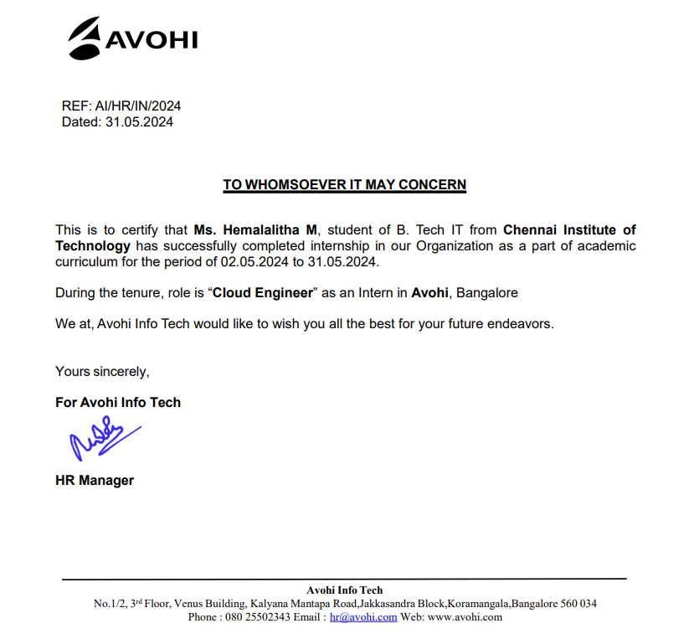

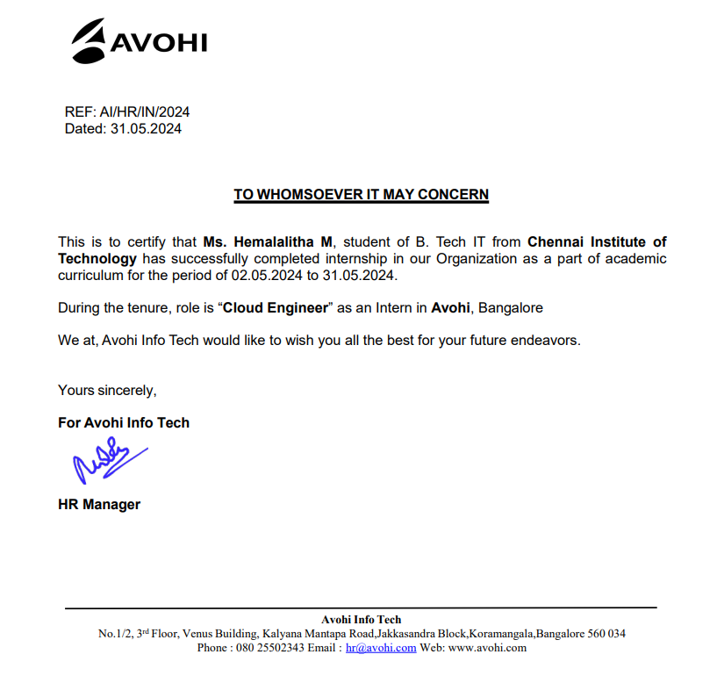





**ACKNOWLEDGEMENT**

First, I would like to thank **N. RAKESH KUMAR, HR Manager**, of **Avohi Info Tech, Bangalore** for giving me the opportunity to do an internship within the organization.

I also would like all the people who worked along with me at **Avohi Info Tech, Bangalore** with their patience and openness they created an enjoyable working environment.

It is indeed with a great sense of pleasure and immense sense of gratitude that I acknowledge the help of these individuals.

I am highly indebted to our Chairman **Shri. P. SRIRAM** and Principal **Dr. A. RAMESH, M.E., Ph.D**, for the facilities provided to accomplish this internship.

I would like to thank my Head of the Department **Dr. A. R. KAVITHA, M.E., Ph.D.**, for his constructive criticism throughout my internship.

I am extremely great full to my department staff members and friends who helped me in successful completion of this internship.

HEMALALITHA M

22IT036

**PREFACE**

I student of Department name require to do an Industrial Internship to enhance my knowledge. The purpose of Industrial Internship is to acquaint the students with practical application of theoretical concept taught to me during my course period.

It was a great opportunity to have close comparison of theoretical concept in practical field. This report may depict deficiencies on my part but still it is an account of my effort.

The output of my analysis is summarised in a shape of Industrial Internship the content of report shows the details of sequence of these. This is my Industrial Internship report which I have prepared for the sake of my Second year Industrial Internship. Being an engineer, I should help the society for inventing something new by utilising my knowledge which can help them to solve their problem so for this I am working in Avohi Info Tech.

**ABSTRACT**

My one-month internship at Avohi Info Tech, a prominent service providing company, provided a comprehensive and immersive learning experience in the Cloud Technology. Throughout the internship, I delved into key technologies and tools that form the backbone of Cloud, including Virtualization, Migration, Containerization, Orchestration, Automation and Infrastructure as Code (IaC).

The internship opportunity provided me with hands-on experience in a cutting-edge technological environment. As a leading provider in cloud solutions, Avohi Info Tech is committed to fostering the growth and development of future talent in the field. During this internship, I collaborated with experienced professionals on real-world projects aimed at optimizing cloud infrastructure, enhancing scalability, and ensuring robust security measures. Through mentorship and structured learning, I deepened my understanding of cloud architecture, deployment strategies, and industry best practices.

**CONTENTS**

|  |  |  |
| --- | --- | --- |
|  | **Content** |  |
| **Chapter No** | **Title** | **Page No.** |
| 1 | Introduction | 11 |
| 2 | About the Company | 12 |
| 3 | About the Company Environment and Team | 12 |
| 4 | About the Technology | 13 |
| 5 | Benefits of the Technology | 17 |
| 6 | Tools Learned | 18 |
| 7 | Weekly Overview of Course Activities | 21 |
| 8 | Projects | 23 |
| 9 | Conclusion | 35 |
| 10 | Program Outcomes | 36 |

**INTRODUCTON**

Over the course of 1 month at **Avohi Info Tech**, I had the privilege of delving into the intricacies of modern Cloud technologies, gaining hands-on experience that goes beyond the theoretical foundations of my academic studies**.**

At the core of this enriching experience were key learning pillars, including Understanding of Cloud Computing Concepts, Knowledge of Cloud Platforms, Migrations, Virtualization and Containerization, Networking Fundamentals, Security Principles, Scripting and Automation, Monitoring and Performance Management, Troubleshooting Skills and Continuous Learning and Adaptability.

This internship provided a unique opportunity to immerse myself in various facets of cloud engineering, offering exposure to industry best practices, collaborative workflows, and cutting-edge tools.

**ABOUT THE COMPANY**

Avohi Info Tech is a hub of artistic brilliance and strategic thinking. They provide specialized education in the fields of AI & ML, Mobile Applications, Internet of Things, DevOps, Big Data and Analytics, Web Technologies and Testing. They bring a unique blend of creativity and functionality to every project.

Their dedicated team of skilled professionals collaborates closely with clients, ensuring that each design is a bespoke reflection of their vision. What sets them apart is their commitment to creative excellence, a client-centric approach, and a relentless pursuit of innovation.

They embark on each project with a commitment to understanding the client’s unique vision, ensuring that their designs not only meet but exceed their expectations. Their portfolio speaks volumes about their ability to translate ideas into visually compelling narratives.

**ABOUT THE COMPANY ENVIRONMENT AND TEAM**

The collaborative atmosphere at **Avohi Info Tech** had been instrumental in shaping a positive and conducive learning environment throughout my internship. From the outset, I found myself immersed in a culture that fosters innovation, continuous learning, and open communication**.**

The mentorship I received from senior members of the team played a pivotal role in my professional development. Their guidance and constructive feedback were invaluable in refining my technical skills and navigating the intricacies of real-world Cloud Engineering challenges. Regular code reviews and pair programming sessions allowed for a hands-on learning experience, emphasizing the importance of writing maintainable and scalable code.

**ABOUT THE TECHNOLOGY**

* **Virtualization:**

Virtualization in cloud engineering involves the abstraction of computing resources such as virtual machines (VMs), storage, and networks, enabling multiple virtual instances to run independently on a single physical server or across a distributed infrastructure. This abstraction is facilitated by hypervisors (such as VMware or Hyper-V) for VMs or containerization technologies (like Docker or Kubernetes) for applications, allowing efficient resource utilization, scalability, and flexibility.

* **Migration:**

Migration in cloud engineering refers to the process of transferring applications, data, and IT processes from on-premises infrastructure or one cloud environment to another, typically to achieve better scalability, efficiency, or cost-effectiveness. It involves careful planning, assessment of existing systems, and often entails re-architecting applications to leverage cloud-native features. Key considerations include data integrity, security, and minimizing downtime during the transition. Cloud migration strategies can range from lift-and-shift approaches for rapid deployment to more complex re-factorings that optimize applications for cloud-native environments.

* **Networking:**

Networking in cloud engineering refers to the critical infrastructure and protocols that facilitate communication and data exchange between cloud services, users, and devices. It encompasses the design, implementation, and management of virtual networks, load balancers, firewalls, and other networking components within cloud environments. Efficient networking is essential for ensuring reliable performance, scalability, and security of cloud applications and services.

* **Storage:**

Storage in cloud engineering refers to the provision and management of data storage resources within cloud environments. It involves leveraging scalable, flexible, and cost-effective storage solutions to accommodate varying workloads and data types. Cloud storage services offer options such as object storage (e.g., Amazon S3, Google Cloud Storage) for unstructured data, block storage (e.g., Amazon EBS, Azure Disk Storage) for virtual machine storage, and file storage (e.g., Amazon EFS, Azure Files) for shared file systems.

* **Compute:**

Compute in cloud engineering refers to the provisioning and management of virtualized computing resources within cloud environments. It encompasses the deployment and scaling of virtual machines (VMs), containers, and serverless computing instances to execute applications and processes. Cloud compute services, such as Amazon EC2, Google Compute Engine, and Microsoft Azure Virtual Machines, offer flexibility in choosing computing power, memory, and storage configurations based on workload requirements.

* **Security:**

Security in cloud engineering refers to the comprehensive practices and measures employed to protect cloud-based resources, data, and applications from unauthorized access, breaches, and threats. It encompasses a range of strategies including identity and access management (IAM), encryption, network security controls, vulnerability management, and compliance adherence. Cloud engineers implement robust security frameworks and configurations across cloud environments (public, private, or hybrid) to mitigate risks and ensure data confidentiality, integrity, and availability.

* **Monitoring and Management:**

Monitoring and management in cloud engineering involves the continuous oversight and optimization of cloud resources and services to ensure performance, availability, and cost-effectiveness. Cloud engineers utilize monitoring tools and platforms to gather real-time data on various metrics such as CPU usage, network traffic, storage capacity, and application performance. This data helps in proactive identification of issues, performance bottlenecks, and security incidents, enabling timely interventions and improvements.

* **Database Services:**

Database services in cloud engineering refer to the managed database solutions offered by cloud providers that allow organizations to store, manage, and access structured data efficiently. These services eliminate the need for organizations to manage the underlying hardware and software infrastructure traditionally associated with databases. Cloud database services, such as Amazon RDS, Google Cloud SQL, and Azure SQL Database, support various relational (SQL) and non-relational (NoSQL) database types, offering scalability, high availability, and automated backups.

* **Serverless Computing:**

Serverless computing in cloud engineering is a paradigm where cloud providers manage the infrastructure required to run applications, allowing developers to focus solely on writing code without worrying about provisioning, scaling, or maintaining servers. In serverless architecture, applications are broken down into small, event-driven functions that are executed in response to triggers or events such as HTTP requests, database changes, or file uploads. Cloud providers like AWS Lambda, Azure Functions, and Google Cloud Functions handle the provisioning and scaling of resources automatically, charging only for the actual compute time consumed by the functions.

**BENEFITS OF THE TECHNOLOGY**

* **Scalability**: Cloud technologies enable automatic scaling of resources based on demand, allowing applications to handle varying workloads without manual intervention. This scalability supports business growth and agility by ensuring resources are available when needed and reducing costs during periods of lower demand.
* **Flexibility**: Cloud technologies provide a wide range of services and deployment models (public, private, hybrid) to accommodate diverse workload requirements and IT strategies. This flexibility allows organizations to choose the best-fit solutions for their specific needs, whether it's compute power, storage capacity, or networking capabilities.
* **Cost Efficiency**: Cloud technologies often operate on a pay-as-you-go or subscription model, reducing upfront costs associated with hardware procurement and maintenance. Additionally, scalability and resource optimization in cloud environments help minimize unnecessary expenses, making cloud solutions cost-effective for both startups and large enterprises.
* **Resilience and Reliability**: Cloud technologies offer built-in redundancy and failover mechanisms across multiple data centers and regions, ensuring high availability and reliability of services. This resilience helps mitigate risks associated with hardware failures, natural disasters, or other disruptions.
* **Innovation and Competitive Advantage**: Cloud technologies enable rapid experimentation and deployment of new features and services, fostering innovation and driving competitive advantage in the market. Cloud engineering practices support continuous integration and delivery (CI/CD), enabling organizations to innovate quickly and respond to market changes effectively.

**TOOLS LEARNED**

**TERRAFORM:**

Terraform is an open-source Infrastructure as Code (IaC) tool developed by HashiCorp. It allows users to define and manage infrastructure resources declaratively using a simple, human-readable configuration language. Here are four key attributes of Terraform:

1. **Declarative Configuration Language**: Terraform uses a declarative syntax called HashiCorp Configuration Language (HCL) or JSON, which allows users to describe the desired state of their infrastructure. This means you specify what resources you want (e.g., virtual machines, networks, databases) and how they should be configured, rather than scripting the steps to achieve that state.
2. **Infrastructure as Code (IaC)**: Terraform treats infrastructure as code, enabling automation and versioning of infrastructure changes. Infrastructure definitions are stored in files that can be managed, versioned, and shared using version control systems like Git.
3. **Multi-Cloud and Multi-Provider Support**: One of Terraform's strengths is its ability to manage infrastructure across multiple cloud providers (e.g., AWS, Azure, Google Cloud) and even on-premises environments (e.g., VMware, OpenStack).
4. **Resource Graph and Dependency Management**: Terraform builds a dependency graph of infrastructure resources specified in its configuration files. It understands relationships between resources and ensures that they are created and managed in the correct order.

**DOCKER:**

Docker is a platform and toolset designed to simplify the creation, deployment, and management of applications using containers. Containers are lightweight, portable, and self-sufficient environments that package an application and its dependencies, ensuring consistency across different computing environments.

Here are four key attributes of Docker:

1. **Containerization**: Docker enables application containerization, allowing developers to encapsulate applications and their dependencies into containers. Containers provide isolation and consistency by packaging everything needed to run an application (code, runtime, libraries, and configurations) into a single unit.
2. **Image-Based Packaging**: Docker uses images as the basis for containers. An image is a read-only template that contains a snapshot of an application's environment at a specific point in time. Docker images are built from a Dockerfile, which specifies the instructions for creating the image. Images can be versioned, shared, and reused, promoting consistency and repeatability in application deployment and scaling.
3. **Layered File System**: Docker employs a layered file system for images, known as Union File System (UnionFS). Each layer in the file system represents a Dockerfile instruction or changes made to the image. This layered approach optimizes storage and network transfer by reusing common layers across multiple images.
4. **Container Orchestration**: Docker includes tools for container orchestration, such as Docker Swarm and integration with Kubernetes. Container orchestration simplifies the management of containerized applications at scale by automating tasks like deployment, scaling, load balancing, and health monitoring.

**KUBERNETES:**

Kubernetes is an open-source container orchestration platform originally developed by Google and now maintained by the Cloud Native Computing Foundation (CNCF). It automates the deployment, scaling, and management of containerized applications and services across clusters of nodes.

Here are four key attributes of Kubernetes:

1. **Container Orchestration**: Kubernetes simplifies and automates the deployment and management of containers. It schedules containers onto nodes in a cluster, ensuring that applications are running at desired states and scales containers up or down based on resource utilization or defined policies.
2. **Declarative Configuration**: Kubernetes uses declarative YAML manifests to define the desired state of applications, services, and infrastructure components. Users specify the configuration details such as container images, resource requirements (CPU, memory), networking rules, and deployment strategies
3. **Service Discovery and Load Balancing**: Kubernetes provides built-in service discovery and load balancing mechanisms. Services abstract away the complexity of individual container IPs and ports, enabling applications to discover and communicate with each other across different nodes within the cluster. Load balancing distributes incoming traffic across multiple instances of an application for improved performance and reliability.
4. **Automatic Scaling and Self-Healing**: Kubernetes supports automatic scaling of applications based on CPU or custom metrics. Horizontal Pod Autoscaling (HPA) dynamically adjusts the number of replica pods in response to changing resource demands, ensuring optimal performance and efficient resource utilization.

**WEEKLY OVERVIEW OF INTERNSHIP ACTIVITIES**

|  |  |  |  |
| --- | --- | --- | --- |
| **1st Week** | **Date** | **Day** | **Work done** |
| **02.05.24** | Thursday | Introduction to Cloud Computing |
| **03.05.24** | Friday | Cloud Service Models (IaaS, PaaS, SaaS) |
| **06.05.24** | Monday | Cloud Deployment Models (Public, Private, Hybrid) |
| **07.05.24** | Tuesday | Major Cloud Providers (AWS, Azure, Google Cloud) |
| **08.05.24** | Wednesday | Setting Up Cloud Accounts and Free Tier |

|  |  |  |  |
| --- | --- | --- | --- |
| **2nd Week** | **Date** | **Day** | **Work done** |
| **09.05.24** | Thursday | Virtual Machines (EC2, VMs) |
| **10.05.24** | Friday | Containers and Container Orchestration (Docker, Kubernetes) |
| **13.05.24** | Monday | Serverless Computing (AWS Lambda, Azure Functions) |
| **14.05.24** | Tuesday | Cloud Storage (S3, Azure Blob Storage) |
| **15.05.24** | Wednesday | Networking in the Cloud (VPCs, Subnets, Security Groups) |

|  |  |  |  |
| --- | --- | --- | --- |
| **3rd Week** | **Date** | **Day** | **Work done** |
| **16.05.24** | Thursday | Identity and Access Management (IAM) |
| **17.05.24** | Friday | Database Services (RDS, DynamoDB, Azure SQL Database) |
| **20.05.24** | Monday | Data Warehousing and Analytics (Redshift, BigQuery) |
| **21.05.24** | Tuesday | Monitoring and Logging (CloudWatch, Azure Monitor) |
| **22.05.24** | Wednesday | Load Balancing and Auto-Scaling |

|  |  |  |  |
| --- | --- | --- | --- |
| **4th Week** | **Date** | **Day** | **Work done** |
| **23.05.24** | Thursday | Security Best Practices in the Cloud |
| **24.05.24** | Friday | Backup and Disaster Recovery Strategies |
| **27.05.24** | Monday | DevOps Practices in the Cloud |
| **28.05.24** | Tuesday | Infrastructure as Code (IaC) with Terraform or  CloudFormation |
| **29.05.24** | Wednesday | Continuous Integration and Continuous Deployment (CI/CD) |

|  |  |  |  |
| --- | --- | --- | --- |
| **5th Week** | **Date** | **Day** | **Work done** |
| **30.05.24** | Thursday | Microservices Architecture |
| **31.05.24** | Friday | Emerging Trends in Cloud Computing (Edge Computing, Quantum Computing) |

PROJECT

# Migrate On-Prem VMware Virtual Machines to Azure

1. **Reasons for Migrate to Public Cloud:**
   * Cost savings
   * Scalability and Reliability
   * Increased security and compliance
   * Improved performance
   * Accessibility from anywhere in the world.

# Reason for choosing Azure as the cloud provider:

Client’s official cloud provider is Microsoft Azure. When migrating Windows Server or SQL Server on-premises workloads to Microsoft Azure, Azure Hybrid Benefit allows our client to use their existing licenses covered by Software Assurance (SA) or other subscriptions in Azure. By bringing both Windows and SQL Server licenses with SA to Azure, client can save up to 85 percent compared to pay-as-you-go pricing.

# Tools/Technologies Used:

|  |  |
| --- | --- |
| Microsoft Azure | One of the leading Public Cloud Provider |
| Azure Migrate | Azure Migrate is the platform used by Microsoft Azure Migration Services to help organizations discover, assess, size, and migrate private and public cloud workloads to Azure. |
| VMware vCenter | VMware vCenter is an advanced server management software. |
| Service Now | Ticketing tool |

1. **Choosing the source Virtual machines (VMs):**

Client has raised a RFS (Request for service) in their ticketing tool

“Service Now”. It has all the VMs that need to be migrating to Azure.

# Preparing for Migration:

Microsoft Azure recommends dividing the migration into four key steps, including:

* + Assess
  + Migrate
  + Optimize
  + Secure and Manage

By following this structured approach, we can perform our migration from on-prem to the Azure cloud.

The two main tools in “Azure Migrate” are,

* Azure Migrate: Discovery and Assessment
* Azure Migrate: Server Migration

**Assess Phase:** Running discovery and assessment tool to evaluate on-premises VMs running in VMware for migration readiness, sizing requirements, cost, and dependencies.

The discovery and assessment tool uses lightweight appliance software that runs on-premises to gather and send the required data to Azure. In addition to server discovery, the appliance collects server configuration and performance metadata for assessments and discovers installed software, ASP.NET web apps, SQL Server instances, and databases.

The discovery and assessment tool uses lightweight appliance software that runs on-premises to gather and send the required data to Azure. In addition to server discovery, the appliance collects server configuration and performance metadata for assessments and discovers installed software, ASP.NET web apps, SQL Server instances, and databases. The appliance discovery is agentless—nothing gets installed on the discovered servers

The server migration tool helps organizations with the actual migration of on- premises VMware VMs, Hyper-V VMs, physical servers, and public cloud VMs (AWS, GCP).

Server migration uses a replication appliance to migrate agent-based VMware VMs, physical servers, and public cloud VMs to Azure. In addition to the appliance, these migrations require the deployment of replication servers to replicate data to Azure and migrate workloads.

# Azure Migrate Setup

* Sign into the Azure portal, select All Services, and search for Azure Migrate.
* Click Create a migration project, then:
* Choose the subscription.
* Create a new Resource Group as “Prod_RG
* Specify the name of the project as “VM-Migration-Phase1” and preferred geography as “Europe”
* Click Create.

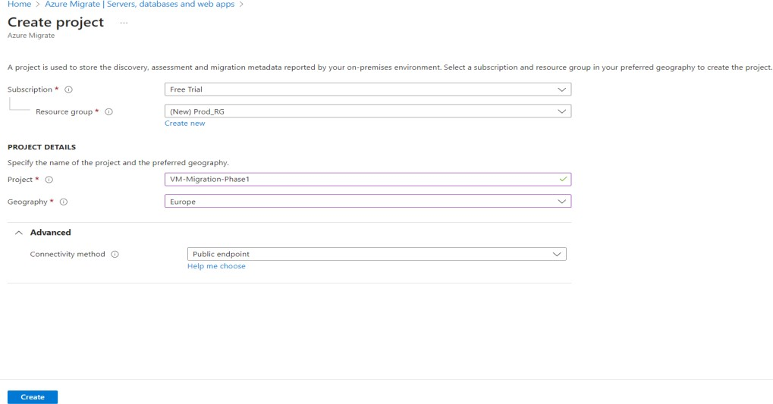

We can see this confirmation once it has been created,

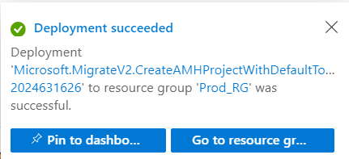

Azure Migrate projects start with the native Microsoft assessment and migration tools: Azure Migrate: Discovery and Assessment and Azure Migrate: Server Migration. To add more assessment tools to your project, click on Click here under the assessment tools section. To add more migration tools to your project, click on Click here under the migration tools section.

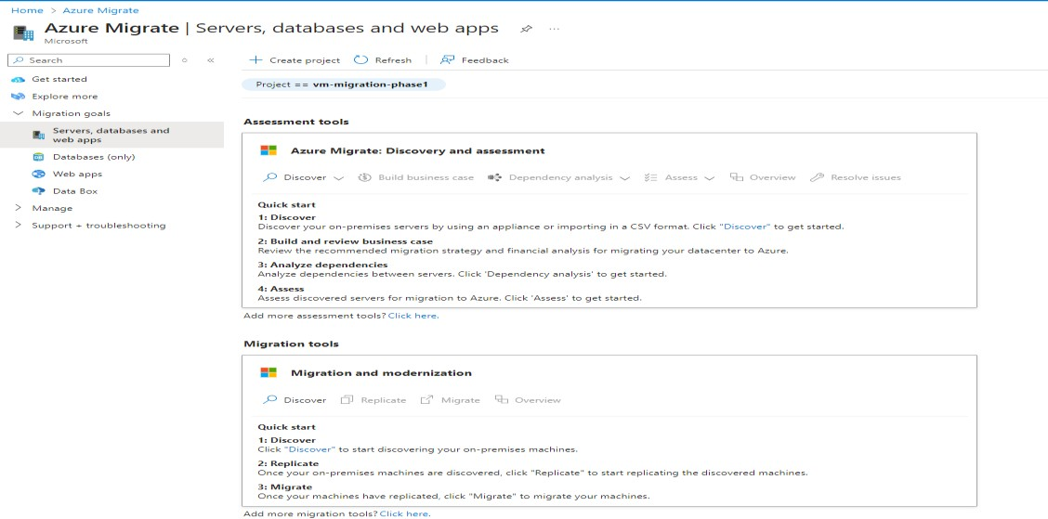

Click Discover and choose “Using appliance”

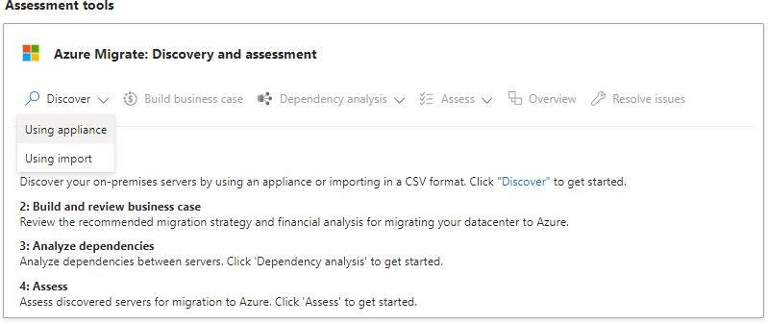

Since our source servers are in VMware, select “Yes, with VMware vSphere Hypervisor” option.

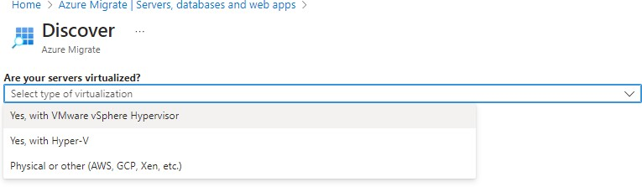

Generate the Project Key,

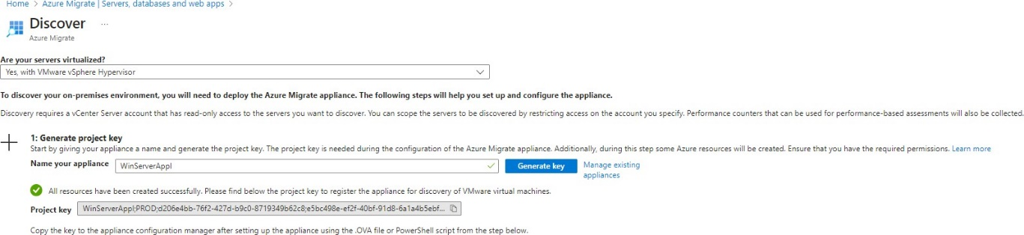

Download Azure migrate appliance



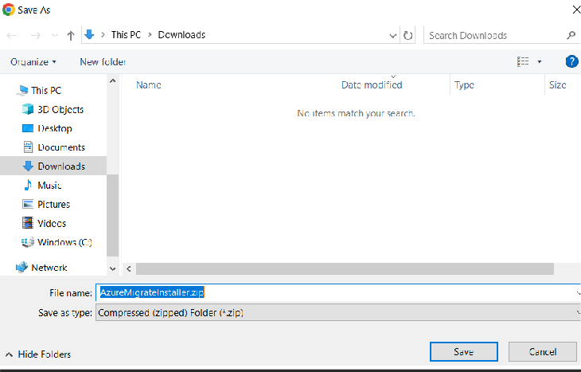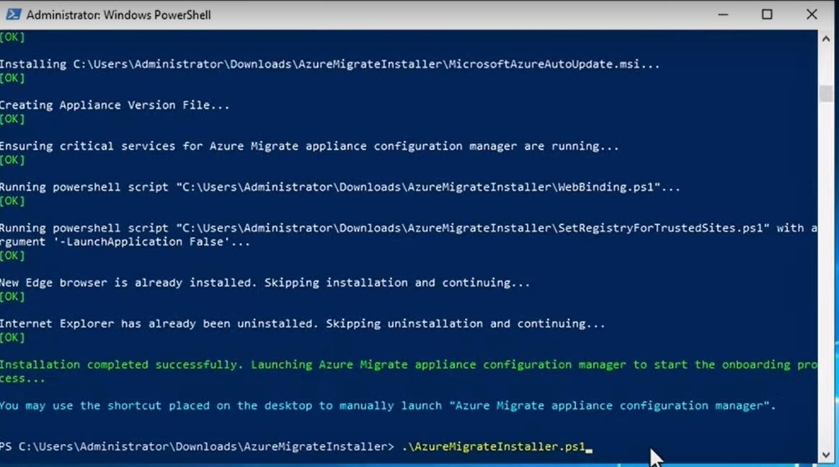

It configures the VM for discovery and assessment.

Once the script is completed now, we can see the “Azure Migrate Appliance Configure Manager” icon in the Desktop,

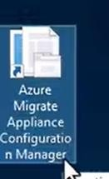

Click the icon to open “Azure Migrate Appliance Configure Manager” in the browser,

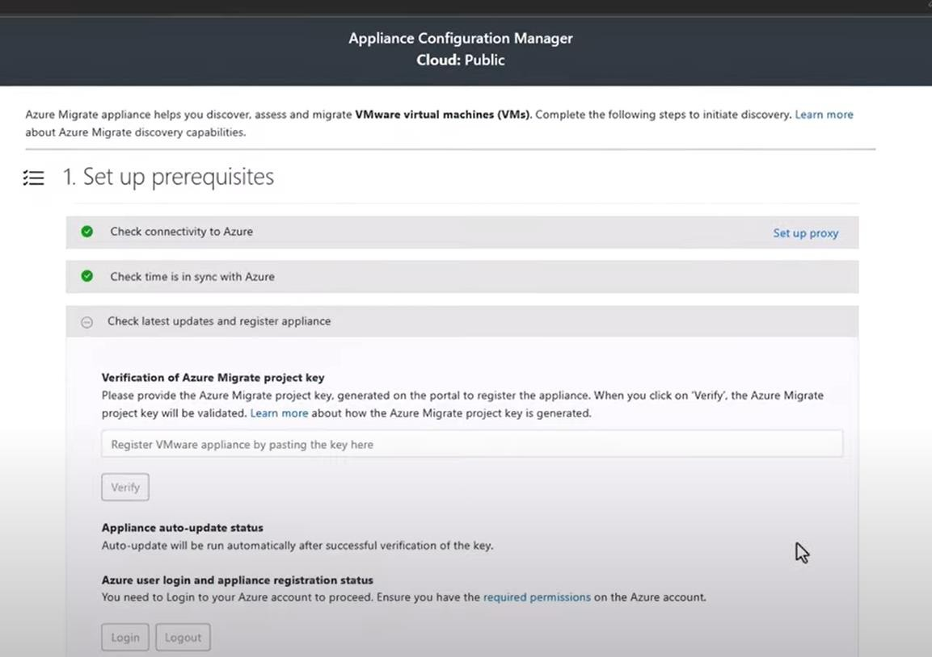

Enter the Project key here and click “verify”.

Once the validation is done then we need to supply the vCenter details,

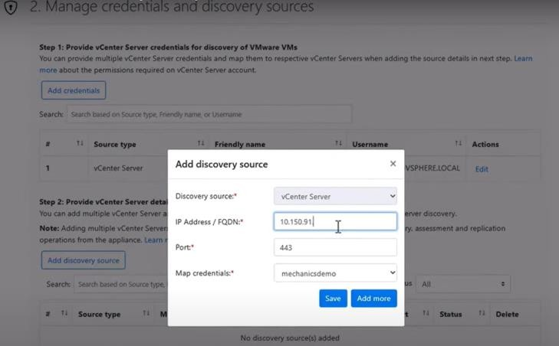

Then start discovery by clicking the “Start Discovery” button,

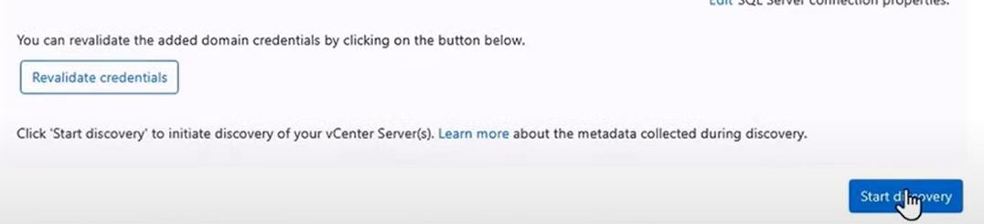

**Note:** We have to wait for 24 hours to get the proper discovery of the on-prem environment.

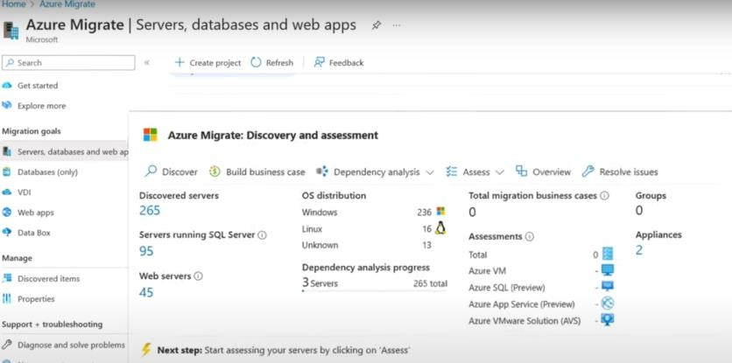

Click the “Discovered servers” to see the details of each VMs. Click the “Build business case” and supply the values,

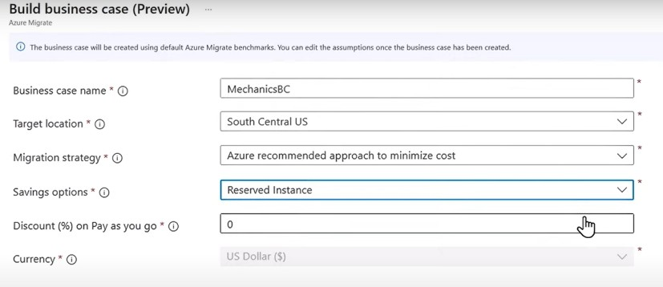

It will take some time and give us the estimates and cost breakdown.

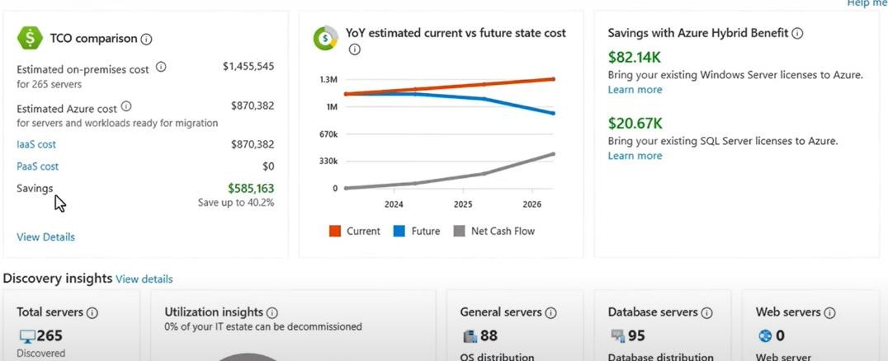

Next click “Assess”, and choose the VMs and create assessment

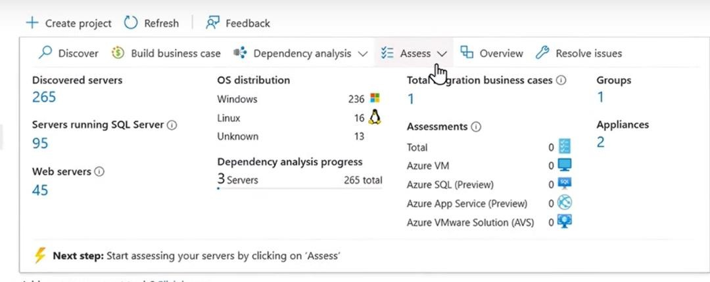

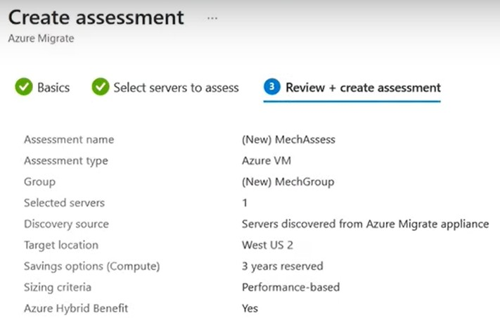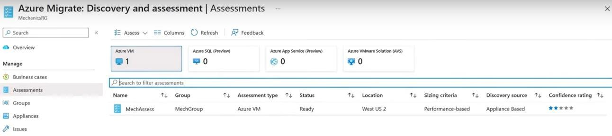

Click the Assessment name and it will show the following result with monthly cost estimate.

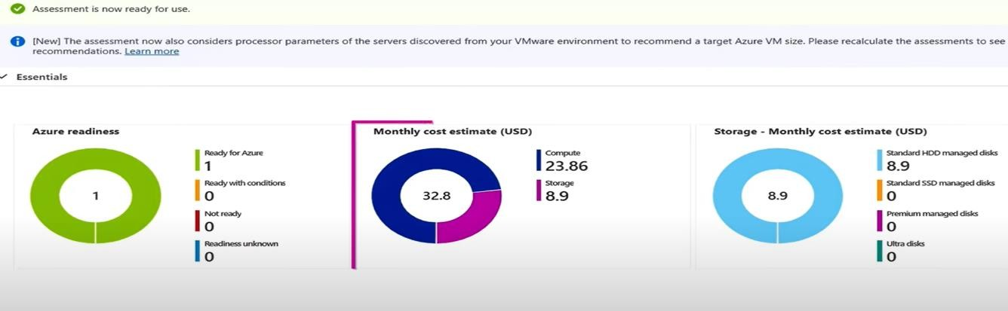

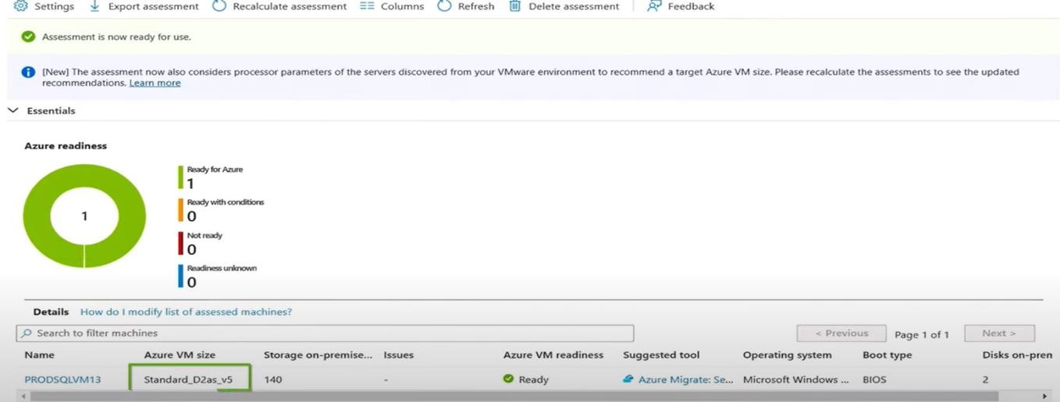In Azure readiness, we can see the recommended size of the VM.

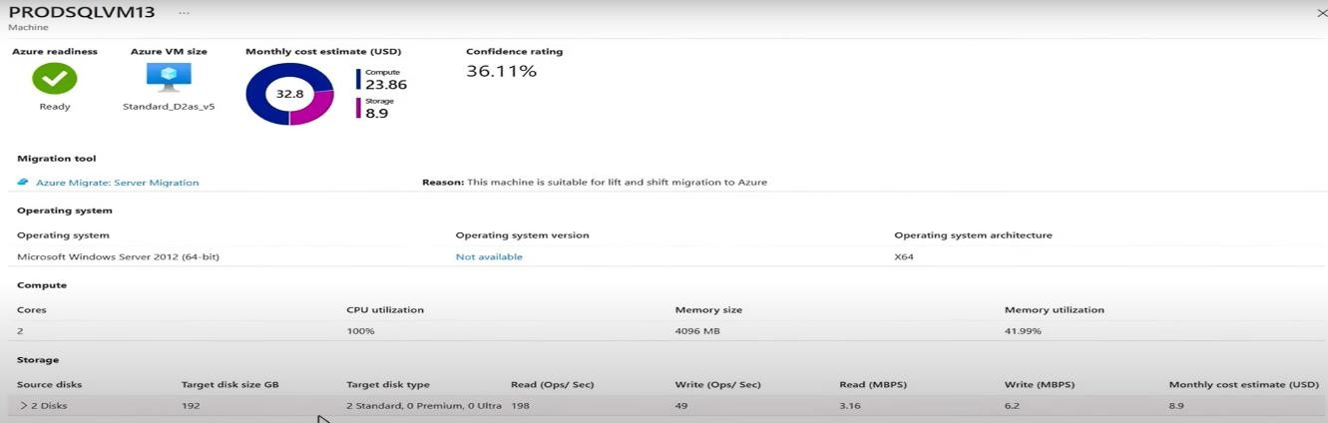Once we have confirmed the server is ready to migrate, the next step is to replicate it into Azure

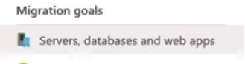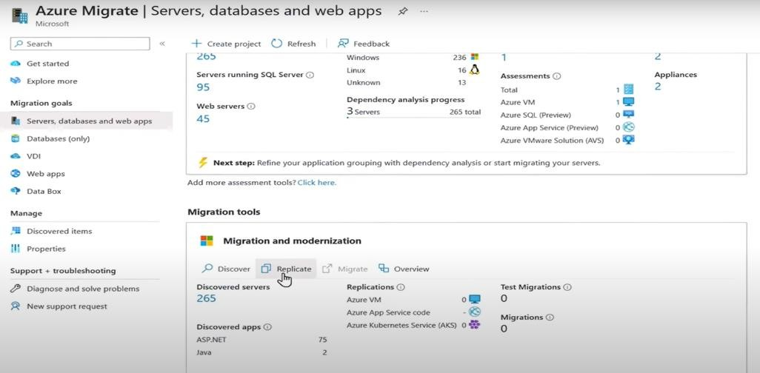Click the “Servers, databases and web apps” from the left side panel,

Click “Replicate” and select the right values in the next prompt, and click “Continue”

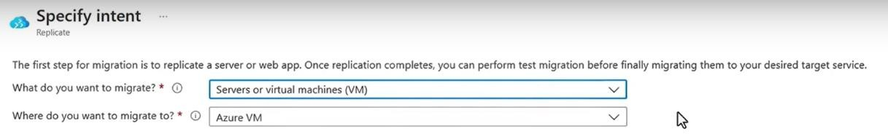

Fill all the values under each title,

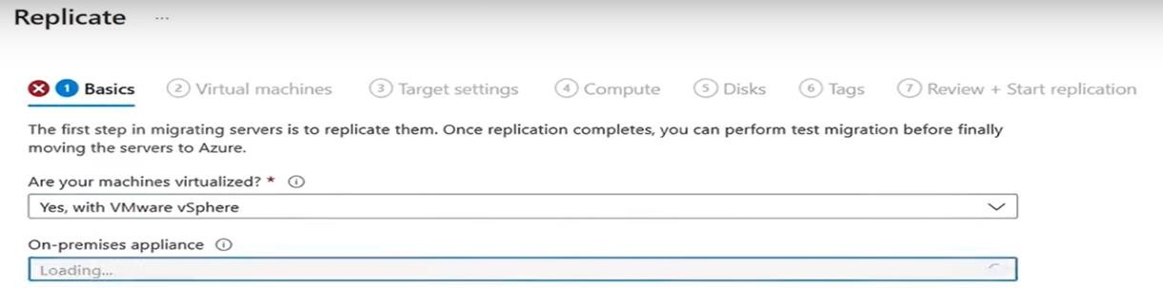

After supplying all the values then click “Replicate”



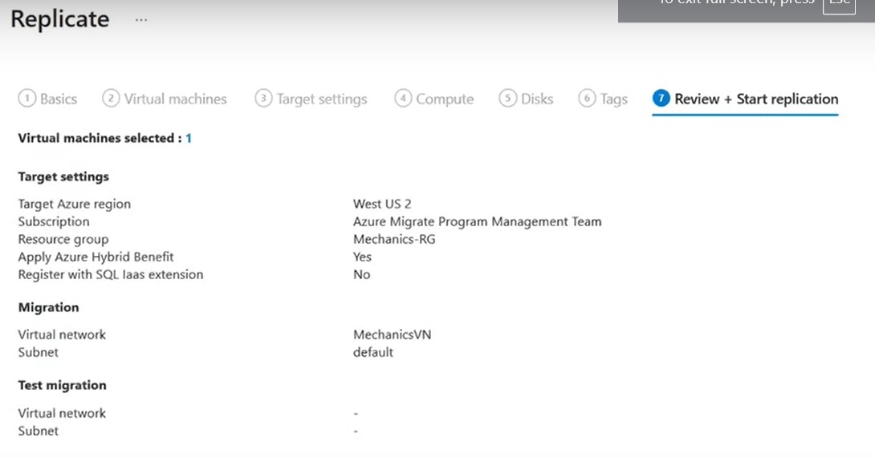

It will take some time and shows the status,

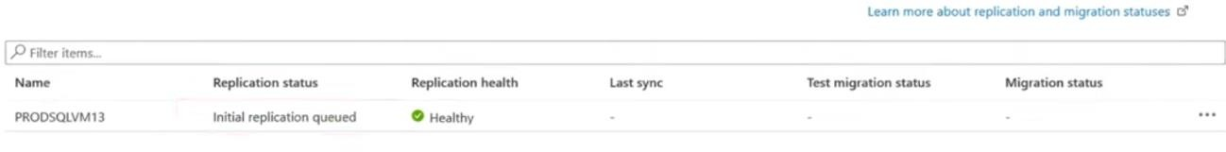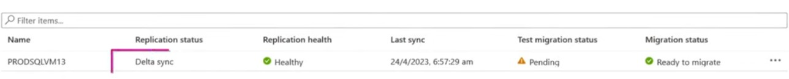

After the initial replication, the process will make delta replication to keep everything in sync.

**Test Migration Phase:**

Next, we have to run the “Test Migration” to ensure that everything works as expected.

Select the “Test Migration” button, Choose the VM and Click “Test Migration”,

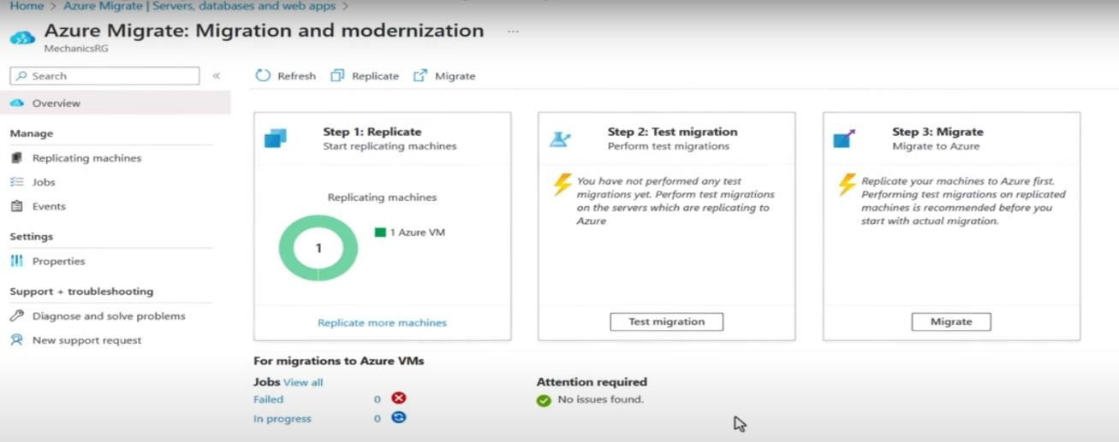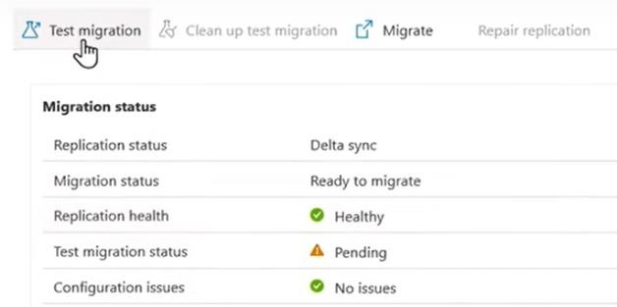

Choose the right “Virtual Network”, “Network Interfaces” and “Subnet”. And Click “Test Migration” button.

In few mins we can see the migrated virtual machine running in Azure in the resource group we specified.

Note: We can see the name of the virtual machine have “**-test**” as a suffix.

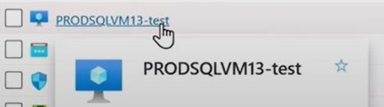

It is to make sure that the source virtual machine is not affected by the migration process, and it is still running.

Now our migration has been verified.

**Migrate Phase:**

The final step is to migrate the virtual machine to Production.

Select and click “Migrate”

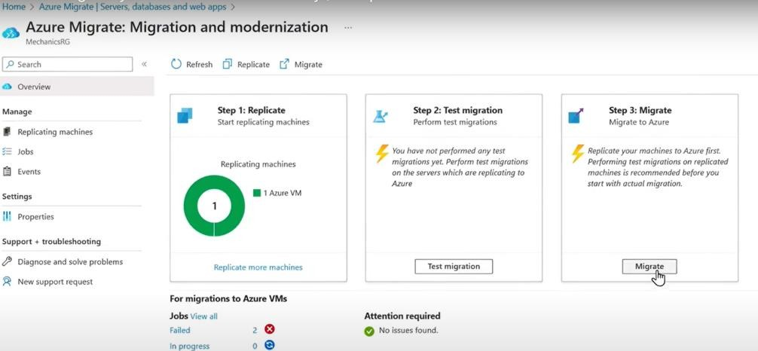

It will prompt for shutdown the machine before migration to minimize data loss, so select “Yes” and choose the VM from the list and click “Validate” button.

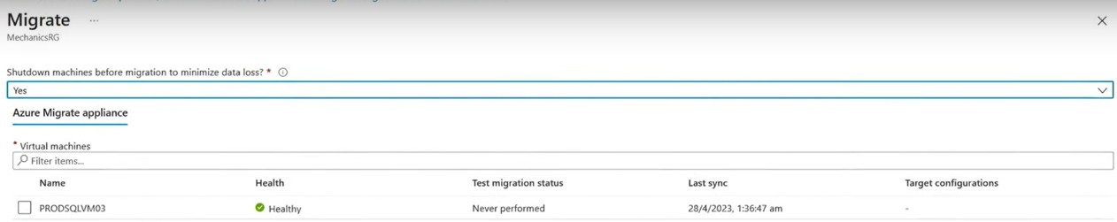

We can check the status here,

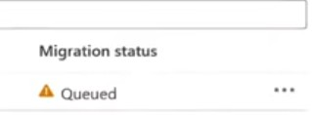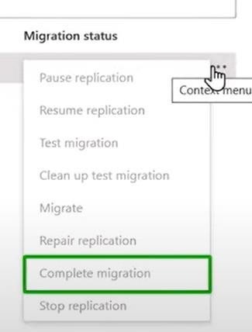

**Migrated VM in Azure Portal:** 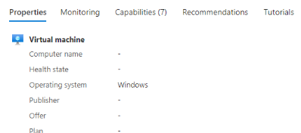

**CONCLUSION**

In conclusion, my internship experience at Avohi Info Tech in cloud engineering has been both enriching and transformative, providing me with valuable insights into the dynamic world of cloud technologies. Over the course of the internship, I had the opportunity to delve into various aspects of cloud tools and automations, honing my skills and gaining practical experience that goes beyond the realms of classroom learning.

One of the key highlights of my internship was the in-depth exposure to Cloud Computing Concepts, Knowledge of Cloud Platforms, Virtualization and Containerization, Networking Fundamentals, Security Principles, Scripting and Automation, Monitoring and Performance Management, Troubleshooting Skills.

My proficiency in various Cloud Platforms underwent substantial growth during the internship, as I worked on diverse projects that demanded a comprehensive skill set. The practical application of these languages in real-world scenarios has significantly enhanced my ability to assist with security practices, learn and assist in writing Infrastructure as Code scripts and to collaborate on Projects.

Furthermore, I've learned the importance of user-centric design and accessibility standards, ensuring that the websites I develop are not only aesthetically pleasing but also inclusive and functional for users with diverse needs.

In conclusion, this internship has not only equipped me with technical skills but has also instilled in me a sense of adaptability, problem-solving, and continuous learning—the cornerstones of a successful career in cloud engineering. I am grateful for the support and guidance provided by Mr. Rakesh Kumar, and I look forward to applying the knowledge and experiences gained during this internship to future endeavours in the ever-evolving field of cloud engineering.

**PO & PSO Attainment**

| **PO.No** | **Graduate Attribute** | **Attained** | **Justification** |
| --- | --- | --- | --- |
| **PO 1** | **Engineering knowledge** | Yes | The Engineering Knowledge has been successfully gained |
| **PO 2** | **Problem analysis** | Yes | Analysis is done on current problem or opportunity. |
| **PO 3** | **Design/Development of solutions** | Yes | Scripts, configurations and applications are developed. |
| **PO 4** | **Conduct investigations of complex problems** | Yes | Investigations were done on the problems options that people wanted. |
| **PO 5** | **Modern Tool usage** | Yes | Infrastructure as Code (IaC), Containerization and Orchestration and Configuration Management tools are used. |
| **PO 6** | **The Engineer and society** | Yes | The solution is made to help the society |
| **PO 7** | **Environment and Sustainability** | No | There were no applications or lessons about environment and sustainability |
| **PO 8** | **Ethics** | Yes | This could involve ensuring fair work ethics and deliver the best possible solution |
| **PO 9** | **Individual and team work** | Yes | This could involve individual contributions to the codebase, collaboration with others during the development process, and effective communication within the team |
| **PO 10** | **Communication** | Yes | This could involve clear and concise user interfaces, effective error handling, and timely notifications to users regarding their orders or any updates. |
| **PO 11** | **Project management and finance** | Yes | This could include managing the project by tracking it every now and then by maintaining and specific project tracker and analysing the financial needs if applicable |
| **PO 12** | **Life-long learning** | Yes | This could involve keeping up with the latest technologies and best practices in development, incorporating user feedback to improve, and striving for personal and professional growth |

| **PSO.No** | **Graduate Attribute** | **Attained** | **Justification** |
| --- | --- | --- | --- |
| **PSO 1** | To analyse, design and develop solutions by applying the concepts of Robotics for societal and industrial needs. | No | There are not any applications of concepts of robotics yet. |
| **PSO 2** | To create innovative ideas and solutions for real time problems in Manufacturing sector by adapting the automation tools and technologies. | No | There are no applications of automation tools and technologies yet in this internship. |