**Integration Solution Design**

**Board Integration**

**Department for Education**

**Version 0.4, 2022-05-12**

Table of contents

**1.** **Document Control** 4

**1.1.** **Version History** 4

**1.2.** **Review history** 4

**1.3.** **Approvers** 5

**2.** **Introduction** 6

**2.1.** **Audience** 6

**2.2.** **References** 6

**2.3.** **In Scope** 6

**2.4.** **Out of Scope** 6

**2.5.** **Assumptions/Risks/Constraints** 7

**2.6.** **Design Decisions** 7

**3.** **Business Context** 8

**3.1.** **Business Process Overview** 8

**3.2.** **Functional Requirements** 9

**4.** **Technical Design** 10

**4.1.** **Overview** 10

**4.2.** **Logical View** 10

**API-Led Diagram** 11

**4.3.** **Sequence Diagram** 12

**4.3.** **API Resource(s) Table** 13

**5.** **Non-Functional Requirements** 16

**5.1.** **Security** 16

**5.2.** **Performance** 17

Response Times 17

Throughput 17

Policies related to performance 18

**5.3.** **Logging and Auditing** 18

**5.4.** **Alerts** 18

**5.5.** **Monitoring Dashboards** 19

**5.6.** **Availability.** 20

**5.7.** **Scalability** 20

**5.8.** **Reliability** 20

**5.9.** **Caching** 21

**5.10.** **Support and Maintenance Considerations** 21

**6.** **Board Experience API** 21

**6.1.** **Mule Application Details** 21

**6.2.** **Resources** 22

**7.** **Financial Process API** 23

**7.1.** **Mule Application Details** 23

**7.2.** **Resources** 24

**8.** **CEDS DB System API** 25

**8.1.** **Mule Application Details** 25

**8.2.** **Resources** 26

9. EMS DB System API 27

**9.1.** **Mule Application Details** 27

**9.2.** **Resources** 28

**10.** **Masterpiece DB System API** 29

**10.1.** **Mule Application Details** 29

**10.2.** **Resources** 30

**11.** **Quality Assurance Guidance** 31

**11.1.** **Integration Test Guidance** 31

**11.1.** **Positive Integration Test Cases (Guidance only)** 31

**11.1.** **Negative Integration Test Cases (Guidance only)** 32

**12.** **Deployment Pre-requisites** 32

**12.1.** **Mule Components** 32

**12.2.** **Non-Mule Components** 33

**12.2.** **Board** 33

**12.2.** **CEDS Database** 33

**12.2.** **MP Database** 33

**12.2.** **EMS Database** 33

**12.2.** **IMD Database** 33

**12.2.** **Email SMTP** 33

**12.2.** **Interdependencies** 33

# **Document Control**

## **Version History**

|  |  |  |  |
| --- | --- | --- | --- |
| **Version** | **Date** | **Author** | **Description** |
| 0.1 | 2022-01-24 | Hemalata Yavarna | Initial version |
| 0.2 | 2022-02-14 | Hanit Singh Grover | Updated Section 6,7,8,9,10, 4.2,4.3 |
| 0.3 | 2022-03-02 | Steven Revill | Lots of updates and diagram |
| 0.4 | 2022-03-02 | Hemalata Yavarna | Updates on Diagram and Contents based on the Parent Child Flow |

## **Review history**

|  |  |  |  |
| --- | --- | --- | --- |
| **Version** | **Date** | **Reviewer** | **Comments (if any)** |
| 0.1 |  | Steven Revill |  |
| 0.2 | 28/02/2022 | Claudia Kralik | Reviewed the document and added my comments where appropriate.  At the time of the review the document was still in draft format, some sections haven’t been populated and the format style of the document hasn’t been finalised.  I provided my feedback based on the information available at the time in the document. Happy to do a follow-up review once all sections have been filled out. |

## **Approvers**

|  |  |  |  |
| --- | --- | --- | --- |
| **Date** | **Approver(s)** | **Role** | **Comments (if any)** |
| YYYY-MM-DD | Zac Anstee |  |  |

# **Introduction**

This document defines the technical components required to implement the proposed Board API/Integration solution.

## **Audience**

This document’s audience primarily includes architects, consultants, and developers and testers engaged in architecting, designing, developing, and testing Board integration solutions.

## **References**

|  |  |  |
| --- | --- | --- |
| **S. No.** | **Document** | **Version/Date** |
| 1 |  |  |

## **In Scope**

|  |  |
| --- | --- |
| **S. No.** | **Description** |
| 1 | The trial balance data is securely sent to the Board application when requested from the three identified source systems, namely: EMS, CEDS and the Masterpiece SQL Databases. |
| 2 | As Board cannot handle large data, a concept of pagination is added for sending chunks of data on multiple requests. i.e., Board will send multiple requests for pagination and accordingly API will response with paginated data. |
| 3 | The user will have the ability to drill down through to the source systems to retrieve transaction data on demand by invoking transaction flow and passing respective source-system, reporting-unit, year, and multiple object-code. |
| 4 | Some data mapping logics are introduced in the flows to accommodate with board data validation. |
| 5 | In one of the mapping logics, we pull data from IDM DB but as the values keeps updating, we also need to update the data in the DB. We have implemented an Interface to update this table where board invokes the Get Trigger method, and our APIs pulls the data from Board External API which has the latest data and uploads the same to the DB. |

## **Out of Scope**

|  |  |
| --- | --- |
| **S. No.** | **Description** |
| 1 | Any changes with respect to the Databases used to fetch data or Board Application. |
| 2 | Flow migration from CEDS to EMS, if the schools are still existing in CEDS then both the data will be sent to board. |
| 3 | Those areas not listed in scope as well as those above are out of scope for the current project. |

## **Assumptions/Risks/Constraints**

|  |  |  |
| --- | --- | --- |
| **S. No.** | **Description** | **Comments** |
| 1 | The data present in the databases consumed by the API are correct and up to date. |  |
| 2 | The authentication between the systems will not change and if it does the respective team is notified before. |  |
| 3 | As the size of the data is very high the business understands that there will be an impact on the response time. |  |
| 4 | No changes will be required at the API level once all the schools have migrated to EMS. |  |
| 5 | The Data present behind the External Board API is up to date. |  |

## **Design Decisions**

|  |  |  |  |
| --- | --- | --- | --- |
| **S. No.** | **Description** | **Decision** | **Participants** |
| 1 | Pagination added for sending the data in chunks to board | Approved |  |
| 2 | A Get Trigger flow has been created to update the parent-child lookup as required by the authorised finance users. | Approved |  |

# **Business Context**

The business requires a solution to display trial balance and transactional data from the Department’s downstream systems of EMS, CEDS and Masterpiece in an automated way to reduce the current manual process of aggerating the data.

## **Business Process Overview**

Solution Architecture

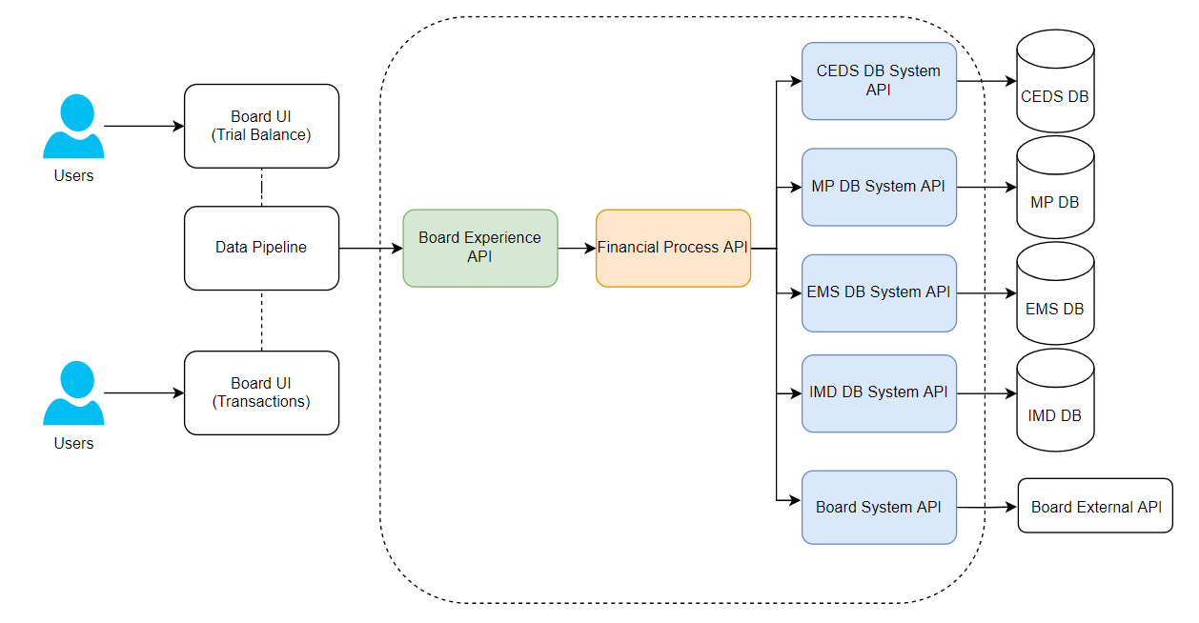

## **Functional Requirements**

For in-depth details on the functional requirement please refer to the below link:

[*Functional Requirements*](https://schoolssaedu.sharepoint.com/:x:/r/sites/IntegrationTeam/Shared%20Documents/BOARD%20-%20Trial%20Balance%20and%20Transactional%20Data/Finance%20-%20Trial%20Balance%20%26%20Transactions/Requirements/Requirements%20for%20Acceptance_FinanceIntegration.xlsx?d=w2d95c343cdea4485b91bd6dd30ad5b1e&csf=1&web=1&e=QmnHuk)

# **Technical Design**

The design comprises of implementing 9 MuleSoft APIs, System APIs for each system, process API for integrating these system APIs to get the trial balance and transactions data, experience API for the board system and error and notification APIs for handling the error scenarios.

## **Overview**

High level view Block Diagram of Message Flows

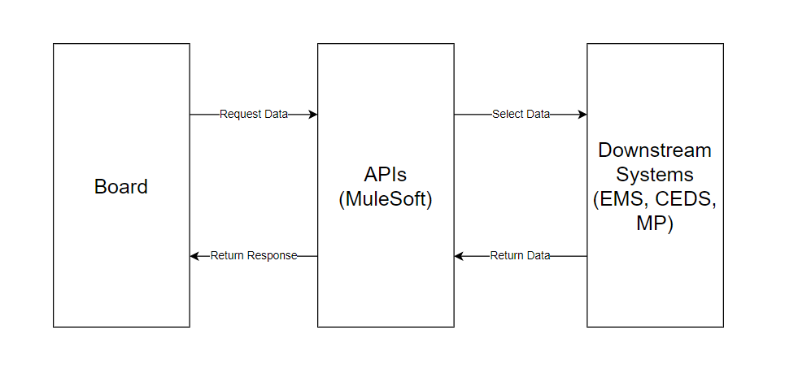

## **Logical View**

Board Experience API is designed to serve Board requests.

API Identification

* Board Experience API
* Financial Process API
* CEDS DB System API
* Masterpiece DB System API
* EMS DB System API
* Error API
* Email Gateway API
* Integration Master Data DB System API
* Board System API

### **API-Led Diagram**

*Illustration purpose only

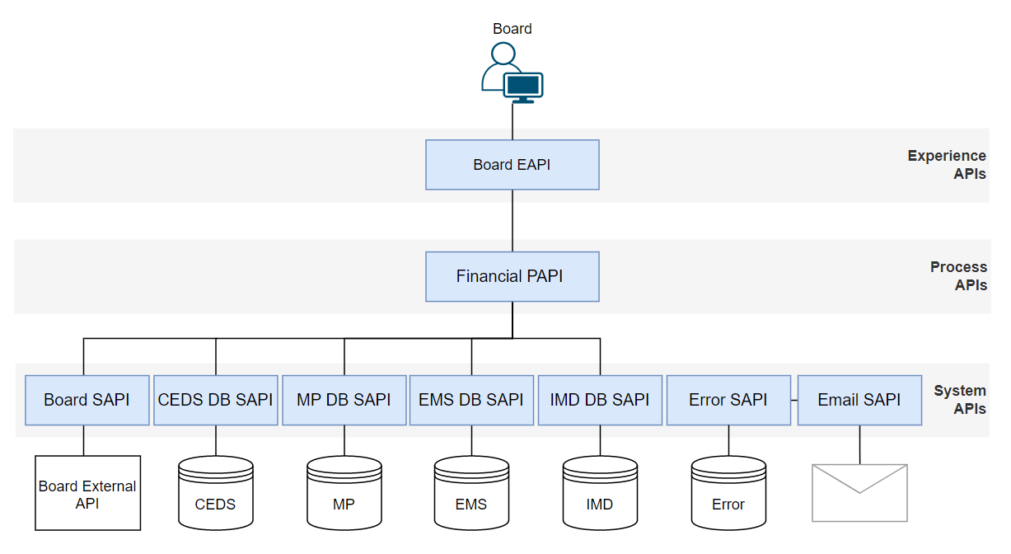



## **Sequence Diagram**

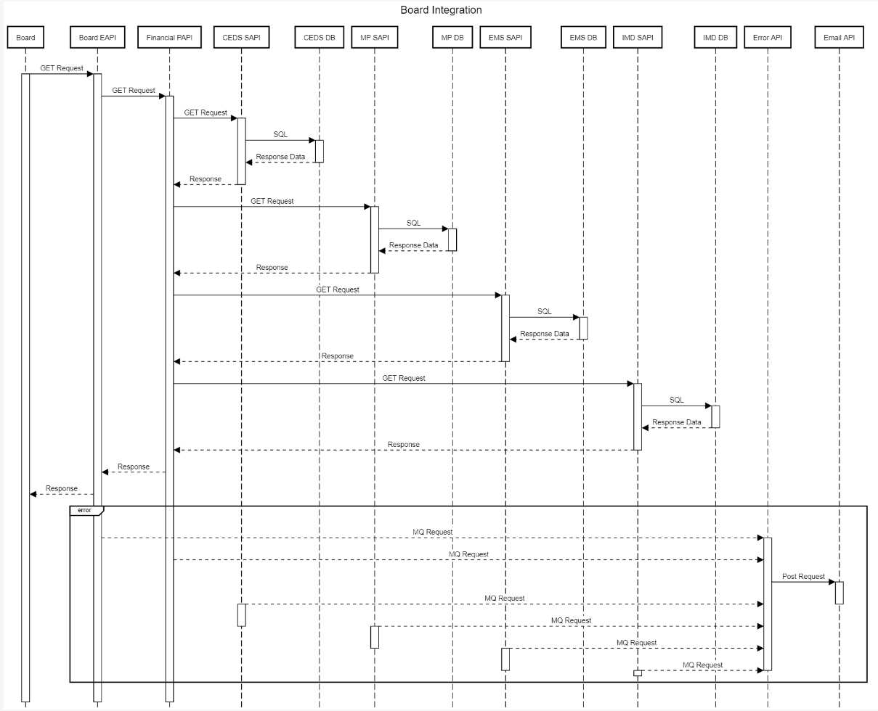

Trial Balance and Transactions Sequence Diagram

Script Path: [SequenceDiagramScript](https://schoolssaedu.sharepoint.com/:t:/r/sites/IntegrationTeam/Shared%20Documents/BOARD%20-%20Trial%20Balance%20and%20Transactional%20Data/Finance%20-%20Trial%20Balance%20%26%20Transactions/Analysis%20and%20Design/TB_DT_InterfaceSequenceDiagramScript.txt?csf=1&web=1&e=HzIiDx)

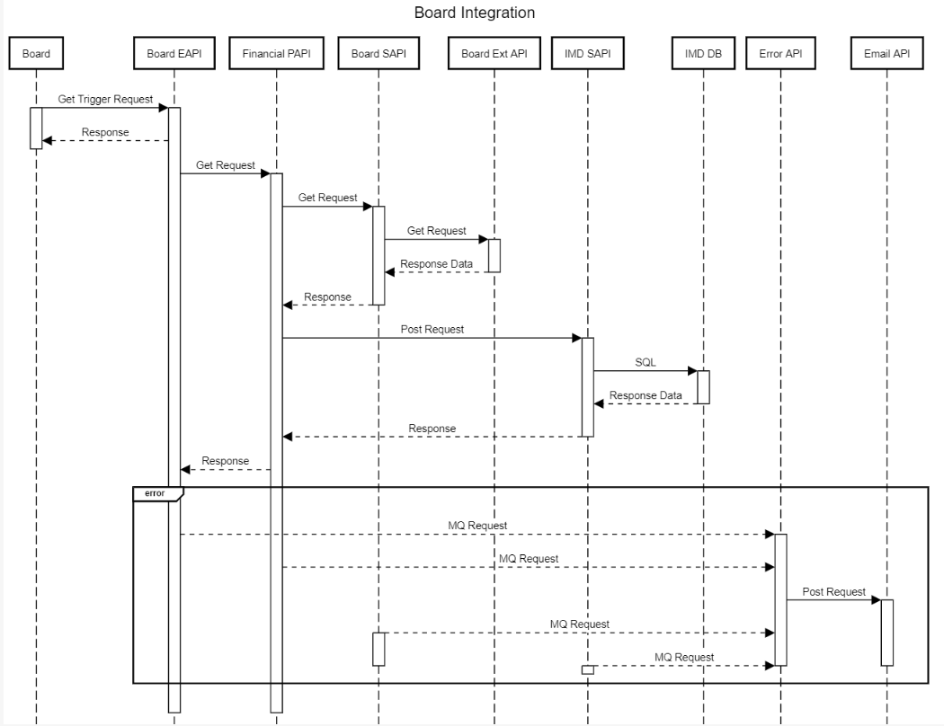

Parent Child Sites Update Sequence Diagram

Script Path: [SequenceDiagramScript](https://schoolssaedu.sharepoint.com/:t:/r/sites/IntegrationTeam/Shared%20Documents/BOARD%20-%20Trial%20Balance%20and%20Transactional%20Data/Finance%20-%20Trial%20Balance%20%26%20Transactions/Analysis%20and%20Design/ParentChildSitesUpdateSequencediagramScript.txt?csf=1&web=1&e=zbAG6k)

**Sequence Flow Details**

Trial Balance Flow Details:

* Board sends a GET request to Board EAPI on /reports/trail-balance
* The Board EAPI validates the request and forwards it onto the Financial PAPI on /reports/trail-balance
* The Financial PAPI constructs a request to the 3 SAPIs
* The Masterpiece SAPI validates the request and invokes the SQL Select to retrieve the Trial Balance data from the view
* The EMS SAPI validates the request and invokes the SQL Select to retrieve the Trial Balance data from the view
* The CEDS SAPI validates the request and invokes the SQL Stored procedure to retrieve the Trial Balance data
* The Financial PAPI invokes a request to the IMD SAPI
* The IMD SAPI invokes the SQL Select to retrieve the child parent site mapping data
* The Financial PAPI aggregates and filters the data, performs the child parent site mapping, this data is returned to the Board EAPI
* The Board EAPI returns the data to the Board client
* If an error occurs, the error is sent to the Error API and an email is sent.

Transactions Flow Details:

* Board sends a GET request to Board EAPI on /reports/trail-balance/transactions
* The Board EAPI validates the request and forwards it onto the Financial PAPI on /reports/trail-balance/transactions
* The Financial PAPI constructs a request to the 3 SAPIs
* The Masterpiece SAPI validates the request and invokes the SQL Select to retrieve the Transactions data from the view
* The EMS SAPI validates the request and invokes the SQL Select to retrieve the Transactions data from the view
* The CEDS SAPI validates the request and invokes the SQL Select to retrieve the Transactions data from the view
* The Financial PAPI aggregates and filters the data, the data is then returned to the Board EAPI
* The Board EAPI returns the data to the Board client
* If an error occurs, the error is sent to the Error API and an email is sent.

Child Parent Site Update Flow Details:

* Board sends a GET request to Board EAPI on mappings/trigger-board-child-parent-sites
* The Board EAPI validates the request and forwards it onto the Financial PAPI on /mappings/child-parent-sites, the Board EAPI returns a 202 Accepted response to the Board client.
* The Financial PAPI calls the Board SAPI to fetch the payload from Board System,
* The Financial PAPI forwards the payload to the IMD DB SAPI.
* The IMD DB SAPI receives the data, deletes the data from the [Integration_Master_Data].[finmeta].[Site_Mapping] table, then inserts the new data into the table.
* If an error occurs, the error is sent to the Error API and an email is sent also the transaction is rolled back.

### **API Resource(s) Table**

|  |  |  |
| --- | --- | --- |
| **APIs** | **Resources** | **Description** |
| Board Experience API | GET  /health | API resource to get the health report of the API |
| GET  /reports/trial-balance | API resource to get the trial balance data from all the 3 systems, EMS, CEDS and Masterpiece |
| GET  /reports/trial-balance/transactions | API resource to get the drill through data for any one of the source systems |
| GET  /mappings/trigger-board-child-parent-sites | API resource to get the trigger to pull the latest parent-child sites from Board |
| Financial Process API | GET  /health | API resource to get the health report of the API |
| GET  /reports/trial-balance | API resource to get the trial balance data from all the 3 systems, EMS, CEDS and Masterpiece |
| GET  /reports/trial-balance/transactions | API resource to get the drill through data for any one of the source systems |
| GET  /mappings/child-parent-sites | API resource to pull the latest parent-child sites from Board |
| CEDS DB System API | GET  /health | API resource to get the health report of the API |
| GET  /reports/trial-balance | API resource to get the trial balance data from all the CEDS DB |
| GET  /reports/trial-balance/transactions | API resource to get the drill through data for CEDS DB |
| EMS DB System API | GET  /health | API resource to get the health report of the API |
| GET  /reports/trial-balance | API resource to get the trial balance data from all the EMS DB |
| GET  /reports/trial-balance/transactions | API resource to get the drill through data for EMS DB |
| Masterpiece DB System API | GET  /health | API resource to get the health report of the API |
| GET  /reports/trial-balance | API resource to get the trial balance data from all the Masterpiece DB |
| GET  /reports/trial-balance/transactions | API resource to get the drill through data for Masterpiece DB |
| IMD(Integration Master Data) DB API | GET  /health | API resource to get the health report of the API |
| GET  /mappings/child-parent-sites | API resource to pull the parent-child sites from IMD DB |
| POST  /mappings/child-parent-sites | API resource to delete and insert the latest parent-child sites from Board |
| Board System API | GET  /health | API resource to get the health report of the API |
| GET  /mappings/child-parent-sites | API resource to pull the parent-child sites from Board External API |
| Email Gateway API | GET  /reports/trial-balance | API resource to get the trial balance data from all the EMS DB |
| GET  /reports/trial-balance/transactions | API resource to get the drill through data for EMS DB |

# **Non-Functional Requirements**

This section captures the non-functional requirements of all APIs related to the use-case(s)/solution.

## **Security**

|  |  |  |
| --- | --- | --- |
| **Authentication** | | |
| S.No | API Name | Authentication Type/Policy |
| 1 | Board Experience API | Client Id enforcement via Basic Authentication |
| 2 | Financial Process API | *NA (Not directly accessible outside IDP end)* |
| 3 | CEDS DB System API | *NA (Not directly accessible outside IDP end)* |
| 4 | MP DB System API | *NA (Not directly accessible outside IDP end)* |
| 5 | EMS DB System API | *NA (Not directly accessible outside IDP end)* |
| 6. | Error API | *NA (Not directly accessible outside IDP end)* |
| 7. | IMD DB System API | *NA (Not directly accessible outside IDP end)* |
| 8. | Board System API | *NA (Not directly accessible outside IDP end)* |
| 9. | Email Gateway API | *NA (Not directly accessible outside IDP end)* |

|  |  |  |
| --- | --- | --- |
| **Authorization** | | |
| S.No | API Name | Authorization Scopes |
| 1 | Board Experience API | Basic Authentication via mule spring authorisation filter |

|  |  |  |
| --- | --- | --- |
| **Other Security Policies** | | |
| S.No | API Name | Policy |
| 1 | All APIs, DB connections, Authentication (Board Experience API) , JMS Connection | Secured Encryption |
| 2 | OPC Connector | Gateway Router for MuleSoft IDP Internal Applications i.e. Board (is an External –Non Department Application) must make request via OPC. |

## **Performance**

API end point performance will be measured in response time of individual API requests from receipt of request to delivery of response.

#### Response Times

|  |  |  |  |
| --- | --- | --- | --- |
| **Response Times** | | | |
| S.No | API Name | Response Time (95%) | Comments |
| 1 | Trial Balance Interface | 2 minute 30 seconds | For each call it takes approx. this time. If the total records are split between few calls the response time will be multiple of the times the API has been called. |
| 2 | Financial Process API | 1 minute 30 seconds | For each call it takes approx. this time. If the total records are split between few calls the response time will be multiple of the times the API has been called. |
| 3 | Parent Child Sites Interface | 5 seconds |  |

#### Throughput

NA

#### Policies related to performance

|  |  |  |  |
| --- | --- | --- | --- |
| **Policies** | | | |
| S.No | API Name | Policy | Details |
| *1* | *Board Experience API* | *OPC Routing Policies* | TBC |
| *2* | *System APIs* | *Database User Invocation Policies* | TBC |
| *3* | *Board System APIs* | *0Auth 2.0 Authentication* |  |

## **Logging and Auditing**

Default IDP Logging via the OCP logs and the Error System API.

## **Alerts**

The Error API sends a request to the Email gateway to create an email notification to the respective team in case of any error.

|  |  |  |  |
| --- | --- | --- | --- |
| **Alerts** | | | |
| S.No | Alert Name | Alert Type | Details |
| 1 | Error Email | *Email* | *Sample:*  Error Occurred in the Board Experience API (UAT)  Hello,  This is an email to notify you that an error has been detected. Please find below the details of the error:  {  “code”: “ERROR”,  “description”: “An error occurred because of bad request”,  “correlationId”: “b5151830-a027-11ec-91c1-0a580a800583”,  “additionalDetails”: “Required query parameter page not specified”  }    This is an automatically generated email – please do not reply to it. Kindly reach out to the Integration Team for support.    Regards,  Integration Team |

## **Monitoring Dashboards**

Not applicable for IDP

|  |  |  |  |
| --- | --- | --- | --- |
| **Dashboards** | | | |
| S.No | API Name | Type | End-point URL |
| 1 |  |  |  |
| 2 |  |  |  |

|  |  |  |  |
| --- | --- | --- | --- |
| **Health-check/Ping end-point** | | | |
| S.No | API Name | Type | End-point URL |
| 1 | Board EAPI | *Health* | */health* |
| 2 | Financial PAPI | Health | */health* |
| 3 | EMS DB SAPI | Health | */health* |
| 4 | CEDS DB SAPI | Health | */health* |
| 5 | MP DB SAPI | Health | */health* |
| 6 | EMS DB SAPI | Health | */health* |
| 7 | IMD DB SAPI | Health | */health* |
| 8 | Board System API | Health | */health* |
| 9 | Email SAPI | Health | */health* |

## **Availability.**

Default availability for the IDP platform.

## **Scalability**

Not applicable for IDP – default worker configuration will be used.

## **Reliability**

* Board Experience API
  + Standard Reconnection Strategy:
    - Frequency: 5000ms
    - Reconnection Attempts: 3
* Financial Process API
  + Standard Reconnection Strategy:
    - Frequency: 5000ms
    - Reconnection Attempts: 3
* CEDS DB System API
  + Standard Reconnection Strategy:
    - Frequency: 5000ms
    - Reconnection Attempts: 3
* EMS DB System API
  + Standard Reconnection Strategy:
    - Frequency: 5000ms
    - Reconnection Attempts: 3
* MP DB System API
  + Standard Reconnection Strategy:
    - Frequency: 5000ms
    - Reconnection Attempts: 3
* IMD DB System API
  + Standard Reconnection Strategy:
    - Frequency: 5000ms
    - Reconnection Attempts: 3
* Board System API
  + Standard Reconnection Strategy:
    - Frequency: 5000ms
    - Reconnection Attempts: 3

## **Caching**

*Not Applicable.*

## **Support and Maintenance Considerations**

*TBC*

# **Board Experience API**

## **Mule Application Details**

|  |  |  |
| --- | --- | --- |
| **API Overview** | | |
| S.No | Property | Details |
| 1 | API Technical Name | ***board-experience-api*** |
| 2 | API Business Name | ***Board Experience API*** |
| 3 | Purpose of the API | To be the first point of interaction for the Board application and fetch and return the required trial balance and transactions data. |
| 4 | API Contract (RAML/OAS/WSDL) | *RAML 1.0* |
| 5 | Data Mapping document | [*Mapping Document*](https://schoolssaedu.sharepoint.com/:x:/r/sites/IntegrationTeam/Shared%20Documents/BOARD%20-%20Trial%20Balance%20and%20Transactional%20Data/Finance%20-%20Trial%20Balance%20%26%20Transactions/Analysis%20and%20Design/Board_Integration_Data%20Mapping_v1.xlsx?d=w5d4305d2b4cd4968a814df1d2c3b2db3&csf=1&web=1&e=E7ppoV) |
| 6 | API Deploy Name (Non-prod) | ***board-experience-api*** |
| 7 | API Deploy Name (Prod) | ***board-experience-api*** |
| 8 | Target Consumers (optional) | ***Board App*** |
| 9 | Connection APIs/Systems(optional) | ***financial-process-api*** |
| 10 | Execution Frequency (optional) | *Trial Balance - Once a day (potentially overnight)*  *Transactions - Real Time Requests* |
| 11 | Expected Benefits (optional) |  |
| 12 | Source Code Repo | [d4e / idp / ict / ict-reform / board-system / board-experience-api · GitLab (edudom02.sa.gov.au)](https://gitlab.idp.edudom02.sa.gov.au/d4e/idp/ict/ict-reform/board-system/board-experience-api) |

## **Resources**

|  |  |  |  |  |
| --- | --- | --- | --- | --- |
|  | | | | |
| S.No | Resource Name | Supported Methods | Query Params | Description |
| 1 | reports/trial-balance/ | *GET* | ***year*** *– GL Balance year*  ***Period*** *– GL Balance Year’s Month*  ***page*** *- The Page Number of the list of Records*  ***limit*** *- Number of Records present in each Page* | *Fetches trial balance data*  *Sample Response:*  *src/main/resources/api/examples/trial-balance-api-example.json* |
| 2 | reports/trial-balance/transactions/ | GET | ***source-system*** *- The Source System - Permutations of [CEDS, MP, EMS]*  ***reporting-unit*** *- The Reporting Unit (site ID or school ID)*  ***year*** *– Fiscal year*  ***object-code*** *– The Object code.*  *IC and Related Parties – only applicable to MP, returns the School ID/Site ID associated with a transaction*  ***page*** *- The Page Number of the list of Records*  ***limit*** *- Number of Records present in each Page* | *Fetches transaction data from a trial balance data*  *Sample Response:*  *src/main/resources/api/examples/transactions-example.json* |
| 3 | /mappings/trigger-board-child-parent-sites | *GET* | ***N/A*** | *Fetches Parent-Child Sites data from Board System API*  *src/main/resources/api/examples/mapping-child-parent-sites-response.json* |

# **Financial Process API**

## **Mule Application Details**

|  |  |  |
| --- | --- | --- |
| **API Overview** | | |
| S.No | Property | Details |
| 1 | API Technical Name | ***financial-process-api*** |
| 2 | API Business Name | ***Financial Process API*** |
| 3 | Purpose of the API | ***Process APi for Financial Information*** |
| 4 | API Contract (RAML/OAS/WSDL) | *RAML 1.0* |
| 5 | Data Mapping document | [*Mapping Document*](https://schoolssaedu.sharepoint.com/:x:/r/sites/IntegrationTeam/Shared%20Documents/BOARD%20-%20Trial%20Balance%20and%20Transactional%20Data/Finance%20-%20Trial%20Balance%20%26%20Transactions/Analysis%20and%20Design/Board_Integration_Data%20Mapping_v1.xlsx?d=w5d4305d2b4cd4968a814df1d2c3b2db3&csf=1&web=1&e=E7ppoV) |
| 6 | API Deploy Name (Non-prod) | ***financial-process-api*** |
| 7 | API Deploy Name (Prod) | ***financial-process-api*** |
| 8 | Target Consumers (optional) | ***board-experience-api*** |
| 9 | Connection APIs/Systems(optional) | ***ceds-db-system-api***  ***ems-db-system-api***  ***mp-db-system-api***  ***Imd-db-system-api*** |
| 10 | Execution Frequency (optional) | *Real-time API* |
| 11 | Expected Benefits (optional) |  |
| 12 | Source Code Repo | [d4e / idp / ict / ict-reform / financial / financial-process-api · GitLab (edudom02.sa.gov.au)](https://gitlab.idp.edudom02.sa.gov.au/d4e/idp/ict/ict-reform/financial/financial-process-api) |

## **Resources**

|  |  |  |  |  |
| --- | --- | --- | --- | --- |
| S.No | Resource Name | Supported Methods | Query Params | Description |
| 1 | reports/trial-balance/ | *GET* | ***year*** *– GL Balance year*  ***Period*** *– GL Balance Year’s Month*  ***page*** *- The Page Number of the list of Records*  ***limit*** *- Number of Records present in each Page* | *Fetches trial balance data*  *Sample Response:*  *src/main/resources/api/examples/financial-process-api-trial-balance-example.json* |
| 2 | reports/trial-balance/transactions/ | GET | ***source-system*** *- The Source System - Permutations of [CEDS, MP, EMS]*  ***reporting-unit*** *- The Reporting Unit*  ***year*** *– Fiscal year*  *object-code – The Object code.*  ***page*** *- The Page Number of the list of Records*  ***limit*** *- Number of Records present in each Page* | *Fetches transaction data from a trial balance data*  *Sample Response:*  *src/main/resources/api/examples/financial-process-api-transactions-example.json* |
| 3 | /mappings/child-parent-sites | *GET* | ***N/A*** | *Fetches Parent-Child Sites data from Board System API*  *src/main/resources/api/examples/post-child-parent-site-mapping-example.json* |
| 4 | /mappings/child-parent-sites | *GET* | ***N/A*** | *Fetches Parent-Child Sites data to IMD DB*  *src/main/resources/api/examples/post-child-parent-site-mapping-example.json* |
| 5 | /mappings/child-parent-sites | POST | ***N/A*** | *Pushes Parent-Child Sites data to IMD DB*  *Sample Response:*  *src/main/resources/api/examples/mapping-child-parent-sites-response.json* |

# **CEDS DB System API**

## **Mule Application Details**

|  |  |  |
| --- | --- | --- |
| **API Overview** | | |
| S.No | Property | Details |
| 1 | API Technical Name | ***ceds-db-system-api*** |
| 2 | API Business Name | ***CEDS DB System API*** |
| 3 | Purpose of the API | ***SYSTEM API for CEDS Database*** |
| 4 | API Contract (RAML/OAS/WSDL) | *RAML 1.0* |
| 5 | Data Mapping document | [*Mapping Document*](https://schoolssaedu.sharepoint.com/:x:/r/sites/IntegrationTeam/Shared%20Documents/BOARD%20-%20Trial%20Balance%20and%20Transactional%20Data/Finance%20-%20Trial%20Balance%20%26%20Transactions/Analysis%20and%20Design/Board_Integration_Data%20Mapping_v1.xlsx?d=w5d4305d2b4cd4968a814df1d2c3b2db3&csf=1&web=1&e=E7ppoV) |
| 6 | API Deploy Name (Non-prod) | ***ceds-db-system-api*** |
| 7 | API Deploy Name (Prod) | ***ceds-db-system-api*** |
| 8 | Target Consumers (optional) | ***financial-process-api*** |
| 9 | Connection APIs/Systems(optional) | *CEDS Database* |
| 10 | Execution Frequency (optional) | *Real-time* |
| 11 | Expected Benefits (optional) |  |
| 12 | Source Code Repo | [d4e / idp / ict / ict-reform / ceds-database / ceds-db-system-api · GitLab (edudom02.sa.gov.au)](https://gitlab.idp.edudom02.sa.gov.au/d4e/idp/ict/ict-reform/ceds-database/ceds-db-system-api) |

## **Resources**

|  |  |  |  |  |
| --- | --- | --- | --- | --- |
| S.No | Resource Name | Supported Methods | Query Params | Description |
| 1 | reports/trial-balance/ | *GET* | ***year*** *– GL Balance year*  ***Period*** *– GL Balance Year’s Month*  ***page*** *- The Page Number of the list of Records*  ***limit*** *- Number of Records present in each Page* | *Fetches trial balance data*  *Sample Response:*  *src/main/resources/api/examples/ceds-db-api-transactions-example.json* |
| 2 | reports/trial-balance/transactions/ | GET | ***source-system*** *- The Source System - Permutations of [CEDS, MP, EMS]*  ***reporting-unit*** *- The Reporting Unit*  ***year*** *– Fiscal year*  *object-code – The Object code.*  ***page*** *- The Page Number of the list of Records*  ***limit*** *- Number of Records present in each Page* | *Fetches transaction data from a trial balance data*  *Sample Response:*  *src/main/resources/api/examples/ceds-db-api-transactions-example.json* |

# **EMS DB System API**

## **Mule Application Details**

|  |  |  |
| --- | --- | --- |
| **API Overview** | | |
| S.No | Property | Details |
| 1 | API Technical Name | ***ems-db-system-api*** |
| 2 | API Business Name | ***EMS Database System API*** |
| 3 | Purpose of the API | ***System API to connect to EMS Database*** |
| 4 | API Contract (RAML/OAS/WSDL) | *RAML 1.0* |
| 5 | Data Mapping document | [*Mapping Document*](https://schoolssaedu.sharepoint.com/:x:/r/sites/IntegrationTeam/Shared%20Documents/BOARD%20-%20Trial%20Balance%20and%20Transactional%20Data/Finance%20-%20Trial%20Balance%20%26%20Transactions/Analysis%20and%20Design/Board_Integration_Data%20Mapping_v1.xlsx?d=w5d4305d2b4cd4968a814df1d2c3b2db3&csf=1&web=1&e=E7ppoV) |
| 6 | API Deploy Name (Non-prod) | *ems-db-system-api* |
| 7 | API Deploy Name (Prod) | *ems-db-system-api* |
| 8 | Target Consumers (optional) | *financial-process-api* |
| 9 | Connection APIs/Systems(optional) | *EMS Database* |
| 10 | Execution Frequency (optional) | *Real-time* |
| 11 | Expected Benefits (optional) |  |
| 12 | Source Code Repo | [d4e / idp / ict / ict-reform / ems-database / ems-db-system-api · GitLab (edudom02.sa.gov.au)](https://gitlab.idp.edudom02.sa.gov.au/d4e/idp/ict/ict-reform/ems-database/ems-db-system-api) |

## **Resources**

|  |  |  |  |  |
| --- | --- | --- | --- | --- |
| S.No | Resource Name | Supported Methods | Query Params | Description |
| 1 | reports/trial-balance/ | *GET* | ***year*** *– GL Balance year*  ***Period*** *– GL Balance Year’s Month*  ***page*** *- The Page Number of the list of Records*  ***limit*** *- Number of Records present in each Page* | *Fetches trial balance data*  *Sample Response:*  *src/main/resources/api/examples/ems-db-api-trial-balance-example.json* |
| 2 | reports/trial-balance/transactions/ | GET | ***source-system*** *- The Source System - Permutations of [CEDS, MP, EMS]*  ***reporting-unit*** *- The Reporting Unit*  ***year*** *– Fiscal year*  *object-code – The Object code.*  ***page*** *- The Page Number of the list of Records*  ***limit*** *- Number of Records present in each Page* | *Fetches transaction data from a trial balance data*  *Sample Response:*  *src/main/resources/api/examples/ems-db-api-transactions-example.json* |

# **Masterpiece DB System API**

## **Mule Application Details**

|  |  |  |
| --- | --- | --- |
| **API Overview** | | |
| S.No | Property | Details |
| 1 | API Technical Name | ***masterpiece-db-system-api*** |
| 2 | API Business Name | ***Masterpiece DB System API*** |
| 3 | Purpose of the API | ***System API to connect to Masterpiece Database*** |
| 4 | API Contract (RAML/OAS/WSDL) | *RAML 1.0* |
| 5 | Data Mapping document | [*Mapping Document*](https://schoolssaedu.sharepoint.com/:x:/r/sites/IntegrationTeam/Shared%20Documents/BOARD%20-%20Trial%20Balance%20and%20Transactional%20Data/Finance%20-%20Trial%20Balance%20%26%20Transactions/Analysis%20and%20Design/Board_Integration_Data%20Mapping_v1.xlsx?d=w5d4305d2b4cd4968a814df1d2c3b2db3&csf=1&web=1&e=E7ppoV) |
| 6 | API Deploy Name (Non-prod) | ***masterpiece-db-system-api*** |
| 7 | API Deploy Name (Prod) | ***masterpiece-db-system-api*** |
| 8 | Target Consumers (optional) | *Financial-process-api* |
| 9 | Connection APIs/Systems(optional) | *Masterpiece Database* |
| 10 | Execution Frequency (optional) | *Real-time* |
| 11 | Expected Benefits (optional) |  |
| 12 | Source Code Repo | [d4e / idp / ict / ict-reform / masterpiece-database / masterpiece-db-system-api · GitLab (edudom02.sa.gov.au)](https://gitlab.idp.edudom02.sa.gov.au/d4e/idp/ict/ict-reform/masterpiece-database/masterpiece-db-system-api) |

## **Resources**

|  |  |  |  |  |
| --- | --- | --- | --- | --- |
| S.No | Resource Name | Supported Methods | Query Params | Description |
| 1 | reports/trial-balance/ | *GET* | ***year*** *– GL Balance year*  ***Period*** *– GL Balance Year’s Month*  ***page*** *- The Page Number of the list of Records*  ***limit*** *- Number of Records present in each Page* | *Fetches trial balance data*  *Sample Response:*  *src/main/resources/api/examples/masterpiece-db-api-trial-balance-example.json* |
| 2 | reports/trial-balance/transactions/ | GET | ***source-system*** *- The Source System - Permutations of [CEDS, MP, EMS]*  ***reporting-unit*** *- The Reporting Unit*  ***year*** *– Fiscal year*  *object-code – The Object code.*  ***page*** *- The Page Number of the list of Records*  ***limit*** *- Number of Records present in each Page* | *Fetches transaction data from a trial balance data*  *Sample Response:*  *src/main/resources/api/examples/masterpiece-db-api-transactions-example.json* |

# **IMD DB System API**

## **Mule Application Details**

|  |  |  |
| --- | --- | --- |
| **API Overview** | | |
| S.No | Property | Details |
| 1 | API Technical Name | ***imd-db-system-api*** |
| 2 | API Business Name | ***Integration Master Data DB System API*** |
| 3 | Purpose of the API | ***System API to connect to IMD Database*** |
| 4 | API Contract (RAML/OAS/WSDL) | *RAML 1.0* |
| 5 | Data Mapping document | [*Mapping Document*](https://schoolssaedu.sharepoint.com/:x:/r/sites/IntegrationTeam/Shared%20Documents/BOARD%20-%20Trial%20Balance%20and%20Transactional%20Data/Finance%20-%20Trial%20Balance%20%26%20Transactions/Analysis%20and%20Design/Board_Integration_Data%20Mapping_v1.xlsx?d=w5d4305d2b4cd4968a814df1d2c3b2db3&csf=1&web=1&e=E7ppoV) |
| 6 | API Deploy Name (Non-prod) | ***imd-db-system-api*** |
| 7 | API Deploy Name (Prod) | ***imd-db-system-api*** |
| 8 | Target Consumers (optional) | *Financial-process-api* |
| 9 | Connection APIs/Systems(optional) | *Integration Master Data Database* |
| 10 | Execution Frequency (optional) | *Real-time* |
| 11 | Expected Benefits (optional) |  |
| 12 | Source Code Repo | [d4e / idp / ict / ict-reform / integration-master-data / integration-master-data-db-system-api · GitLab (edudom02.sa.gov.au)](https://gitlab.idp.edudom02.sa.gov.au/d4e/idp/ict/ict-reform/masterpiece-database/masterpiece-db-system-api) |

## **Resources**

|  |  |  |  |  |
| --- | --- | --- | --- | --- |
| S.No | Resource Name | Supported Methods | Query Params | Description |
| 1 | /mappings/child-parent-sites | *GET* | ***N/A*** | *Fetches parent-child sites data*  *Sample Response:*  *src/main/resources/api/examples/mapping-child-parent-sites-response.json* |
| 2 | /mappings/child-parent-sites | POST | ***N/A*** | *Inserts parent-child sites data*  *Sample Request: src/main/resources/api/examples/mapping-child-parent-sites-response.json*  *Sample Request: src/main/resources/api/examples/mapping-child-parent-sites-response.json* |

# **Board System API**

## **Mule Application Details**

|  |  |  |
| --- | --- | --- |
| **API Overview** | | |
| S.No | Property | Details |
| 1 | API Technical Name | ***board-system-api*** |
| 2 | API Business Name | ***Board System API*** |
| 3 | Purpose of the API | ***System API to connect to Board External API*** |
| 4 | API Contract (RAML/OAS/WSDL) | *RAML 1.0* |
| 5 | Data Mapping document | [*Mapping Document*](https://schoolssaedu.sharepoint.com/:x:/r/sites/IntegrationTeam/Shared%20Documents/BOARD%20-%20Trial%20Balance%20and%20Transactional%20Data/Finance%20-%20Trial%20Balance%20%26%20Transactions/Analysis%20and%20Design/Board_Integration_Data%20Mapping_v1.xlsx?d=w5d4305d2b4cd4968a814df1d2c3b2db3&csf=1&web=1&e=E7ppoV) |
| 6 | API Deploy Name (Non-prod) | ***board -system-api*** |
| 7 | API Deploy Name (Prod) | ***board -system-api*** |
| 8 | Target Consumers (optional) | *Financial-process-api* |
| 9 | Connection APIs/Systems(optional) | *Board External API* |
| 10 | Execution Frequency (optional) | *Real-time* |
| 11 | Expected Benefits (optional) |  |
| 12 | Source Code Repo | [d4e / idp / ict / ict-reform / board-system/board-system-api · GitLab (edudom02.sa.gov.au)](https://gitlab.idp.edudom02.sa.gov.au/d4e/idp/ict/ict-reform/masterpiece-database/masterpiece-db-system-api) |

## **Resources**

|  |  |  |  |  |
| --- | --- | --- | --- | --- |
| S.No | Resource Name | Supported Methods | Query Params | Description |
| 1 | /mappings/child-parent-sites | *GET* | ***N/A*** | *Fetches parent-child sites data*  *Sample Response Path:*  *src/main/resources/api/examples/board-system-api-parent-child-sites-example.json* |

# **Quality Assurance Guidance**

This section captures the QA related details for all the Mule Applications related to the use-case(s)/solution.

## **Integration Test Guidance**

This section covers integration tests associated with the overall solution/use-case.

Link: [Board Integration Test Plan](https://schoolssaedu.sharepoint.com/:x:/r/sites/IntegrationTeam/Shared%20Documents/BOARD%20-%20Trial%20Balance%20and%20Transactional%20Data/Finance%20-%20Trial%20Balance%20%26%20Transactions/Testing/Generic%20Testing/Board_TestPlan.xlsx?d=wd5a3af46b5d541068172dacde1e97b53&csf=1&web=1&e=d5RmvC)

### **Positive Integration Test Cases (Guidance only)**

|  |  |  |
| --- | --- | --- |
| **Positive Test Cases** | | |
| S.No | Name | Details |
| 1 | Trial Balance Response validation | Check the response contains correct data payload |
| 2 | Transaction Response validation | Check the response contains the correct data payload |
| 3 | Child Parent Child Site Mapping validation | Check the response is correct and the data in the IMD DB has been updated successfully. |

### **Negative Integration Test Cases (Guidance only)**

|  |  |  |
| --- | --- | --- |
| **Negative Test Cases** | | |
| S.No | Name | Details |
| 1 | Invalid input | *Check the API is giving proper 4xx or 5xx code.* |
| 2 | System unavailable | *Check the API is returning appropriate error message.* |

# **Deployment Pre-requisites**

This section describes the prerequisites to be able to deploy the APIs.

Link: [Production Release Plan](https://schoolssaedu.sharepoint.com/:x:/r/sites/IntegrationTeam/Shared%20Documents/BOARD%20-%20Trial%20Balance%20and%20Transactional%20Data/Finance%20-%20Trial%20Balance%20%26%20Transactions/PROD-Release/Board_Intgration_APIs_Prod_Deployment_Implementation_Plan.xlsx?d=w3e890aee03614c60b3933bdd4cd5dadf&csf=1&web=1&e=I9yGy0)

## **Mule Components**

* Board OCP Route Timeout increased to 300s

## **Non-Mule Components**

### **Board**

* Endpoint URL: host, port, resource name, method
* Authentication Details

### **12.2.2 CEDS Database**

* Username and password supplied for the DB
* User has the correct permissions
* Stored procedure and view are deployed to each environment

### **MP Database**

Username and password supplied for the DB

* User has the correct permissions
* View is deployed to each environment

### **EMS Database**

* Username and password supplied for the DB
* User has the correct permissions
* View is deployed to each environment

### **IMD Database**

* Username and password supplied for the DB
* User has the correct permissions
* Table changes are deployed to each environment

### **Board External API**

* OAuth 2.0 authentication used. User-id and Secret key is supplied to the token URL to get the bearer token which is used for authenticating the parent-child sites URL to fetch the data.
* User has the correct permissions
* Data changes are deployed in both the Test and Prod environment

### **Email SMTP**

* SMTP has been updated to allow IPs from the IDP infrastructure

### **Interdependencies**

n/a