Training Assistant Web Application
High-Level Design Document
v0.01

Confidential

Robosoft Technologies Pvt. Ltd.
Registered & Corporate Office
217, N.H.66, Santhekatte
New Udupi – 576 105
Karnataka, India
Tel: +91 820 2593930
Fax: +91 820 2593900

Document Revision History

Date | Version | Authors | Reviewed By | Approved By | Brief Description
06/02/21 | 0.01 | Hemalatha |  | - | Initial draft

Contents

1. High-Level Design 3
1.1 Introduction 3
1.1.1 Purpose 3
1.1.2 Scope 3
1.1.3 Audience 3
1.1.4 References 3
1.1.5 Terms and Abbreviations 3
1.2 Software Product Overview 3
1.3 Design Considerations 3
1.3.1 Assumptions and dependencies 3
1.3.2 Development methods 3
1.3.3 General constraints 3
1.4 Architectural Strategies 3
1.5 Software Product Architecture 3
1.6 Component Architecture 3
1.7 Bibliography 3
2. Reference 3

Figures
Fig.1 Solution details..............................................................................................................................5
Fig.2 Client-server pattern......................................................................................................................6
Fig.3 Data flow Daigram.........................................................................................................................7
Fig.4 Database structure........................................................................................................................7

High-Level Design

Introduction:

Purpose:
The purpose of this document is to build web application in order to assist the HR team to manager the tasks like identifying and maintaining a list of training, inviting the employees for a training, providing the details of training to the participants and other related tasks. Also this application allows managers to view their team members training details and employees to accept/reject any training and view their training details.

Scope:
The purpose of the Training Assistant Web Application is to ease HR management team and to create a convenient and easy-to-use application for HR to create the training, inviting the candidates for training and tracking the associated metrics.

The system is based on a relational database with its user management and Training allocation functions. We will have a database server supporting thousands of users as well as hundreds of courses conducted by various trainers. Above all, we hope to provide a comfortable user experience along with the best Knowledge transfer.

Audience:
This project is a prototype for the HR management system and it is restricted within the Robosoft company. This has been implemented under the guidance of technical architects. This project is useful for the HR management team and as well as to the Managers/Trainees.

References:
Spring Boot
MySQL

Terms and Abbreviations:

API – Application Programming Interface
QA – Quality Analyzt
SQL - Structured Query Language
DB - Database
HR – Human Resource
PK – Primary Key
FK – Foriegn Key
TCP/IP - Transmission Control Protocol/Internet Protocol

Software Product Overview:

Training Assistant Web Application allows 3 different kinds of users:
- Administrators( HR team) should be able to do the following functions
add new candidates
create new training
Edit the training details
View all employee details
invite candidates for new training

- Managers should be able to do the following functions
view the training conducted for their team members
add additional training to their team members

- Trainees should be able to do the following functions
View Employee details
Accept/Reject the training

This application stores the employee details like name, email id, employee Id, designation and attended trainings details.

Design Considerations:

Assumptions and dependencies:

Let us assume that this is a HR management system and it is used to train the freshers and the employees based on the required domain and cross train the resource.

Development methods:

The Web Portal shall support English language only and will be in online mode and server side developed will be based on Spring boot framework(micro service methodology).

Solution details:
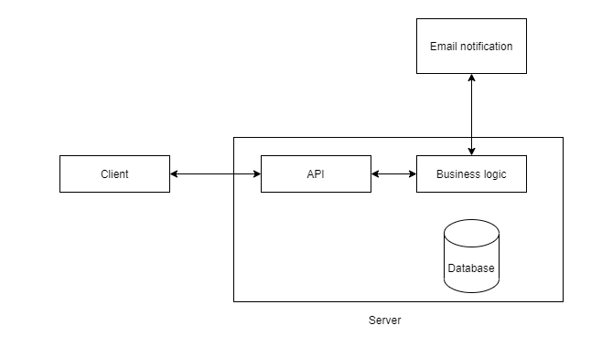
fig.1 – Solution details

Server API will communicate with business logic which in turn connect to the Database and hooks with third party functionality.

Source Code Management:
Features planned for the sprint are developed in their respective branches. Once the application is developed & tested, a merge/pull request is made to development branch. Functionality will be pushed to Dev region for QA testing.

Database management:
store sensitive data in encyted formatts.

Testing Process:
Testing approach consists of a series of different tests that will fully verify the solution against the requirements.

General constraints:

- Programming language - Java, ReactJs, sql
- Operating system or platforms supported - It must work on Windows, or Linux, or iOS and microsoft edge
- Use of a specific library or framework - Spring boot library for caching data, security related logic etc..

Architectural Strategies:

Development follow Client-server pattern architecture. This pattern consists of two parties - a server and multiple clients. The server component will provide services to multiple client components. Clients request services from the server and the server provides relevant services to those clients. Furthermore, the server continues to listen to client requests.

Usage: Online applications such as email, document sharing and banking.
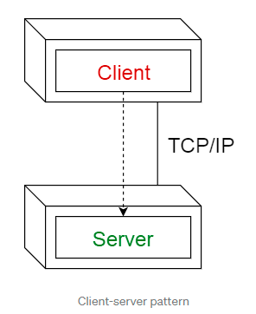
Fig.2 Client-server pattern

Software Product Architecture:

Data flow daigram for training assistant web appliaction can be referred by both client and server side engineers.

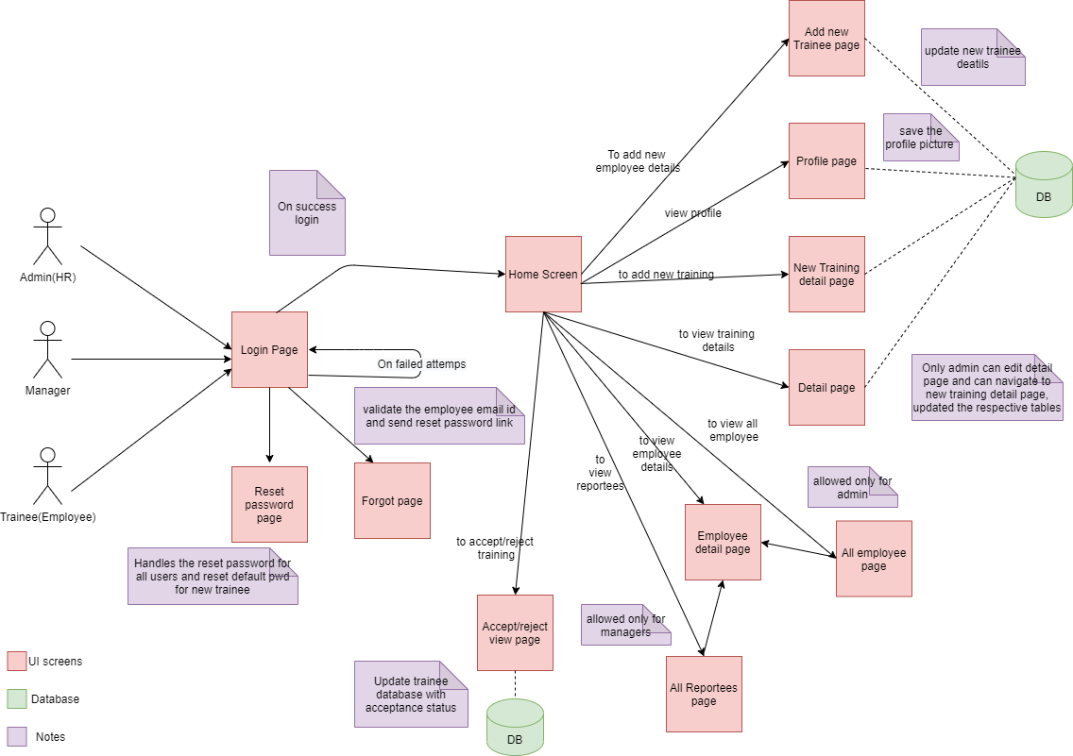

Fig.3 Data flow Daigram

Component Architecture

Database Strucure:

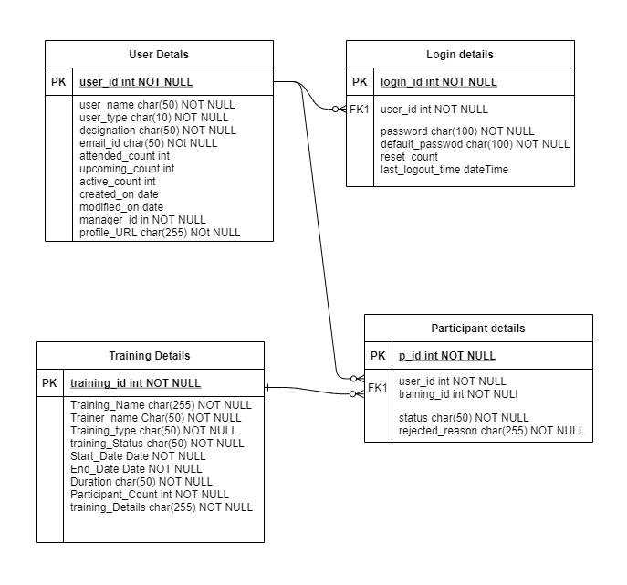
Fig.4 Database structure

Bibliography:

Spring Boot
MySQL

Reference
Server API list has been added git repository for this Project

