Personalized Music Recommendation System

Project Overview
Project Title
Personalized Music Recommendation System

Problem Statement
Users have access to thousands of songs on music platforms, making it difficult to find songs that match their interests. A personalized recommendation system can analyze a user's music preferences and suggest suitable songs.

Brief Description of the Project
This project is a simple music recommendation system inspired by Spotify's Discover Weekly. It takes the user's favorite music artist as input and recommends songs associated with that artist. The system is implemented using Python and demonstrates the basic concept of personalized recommendations.

Objectives & Proposed Solution

Project Objectives
- To recommend songs based on user preferences.
- To provide personalized music suggestions.
- To demonstrate the basic working of a recommendation system.
- To make song discovery easier for users.

How the Agentic AI Solution Works
The system collects the user's preferred artist as input and compares it with a predefined collection of artists and songs. Based on the matching preference, it displays recommended songs.
Working flow: User Input → Analyze Preference → Match Artist → Recommend Songs Key Features
- Simple and easy-to-use interface.
- Accepts different combinations of uppercase and lowercase input.
- Provides personalized song recommendations.
- Fast response.
- Can be extended with real user listening data.

Implementation & Results

Technologies/Tools Used
- Programming Language: Python
- Platform: Google Colab
- Concept: Music Recommendation System
- Data Structure: Python Dictionary
- Input Method: User input

Working Process
- The system stores artists and their songs in a Python dictionary.
- The user enters their favorite artist.
- The input is converted into lowercase to avoid case-sensitivity errors.
- The system searches for the artist in the dataset.
- If the artist is found, the corresponding songs are displayed.
- If the artist is not found, an error message is displayed.

Python Code
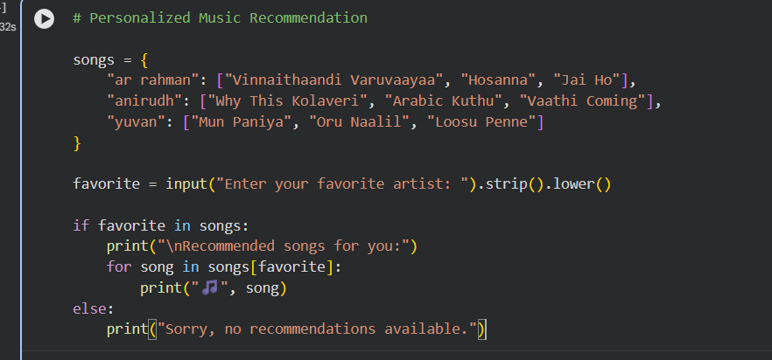

Screenshots/Output
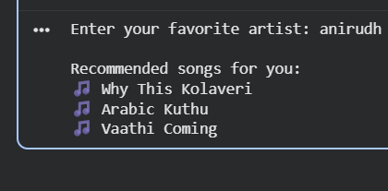

The Google Colab screenshot showing the program execution can be added to this section. Results Achieved
The system successfully accepts the user's preferred artist and provides relevant song recommendations.
It also handles uppercase and lowercase artist names correctly.

Conclusion & Future Scope

Project Conclusion
The Personalized Music Recommendation System demonstrates how user preferences can be used to provide customized music recommendations. The project successfully implements the basic concept of a recommendation system using Python.

Challenges Faced
- Handling uppercase and lowercase user input.
- Maintaining the song dataset.
- Providing recommendations when the artist is not available.

Future Enhancements
- Use real Spotify/user listening data.
- Recommend songs based on listening history.
- Use Machine Learning for better recommendations.
- Consider song genres, artists, and user ratings.
- Add a graphical user interface.
- Connect with a music streaming API.
- Provide weekly personalized recommendations similar to Discover Weekly.

References
- Python documentation
- Google Colab
- Recommendation System concepts
- Spotify Discover Weekly concept

