INTERNSHIP PROJECT REPORT
CLOUD RESOURCE PROVISIONING
AND USAGE MONITORING PORTAL
Project ID • EDUPCCP045

PROJECT INFORMATION | DETAILS
Student Name | Hemalatha S
Internship Domain | Cloud Computing
Organization | Eduphoenix Solutions / Eduphoenix Pvt. Ltd.
Project Type | Full-Stack Web Application
Frontend | React.js
Backend | Node.js + Express.js
Database | PostgreSQL
Security | JWT + bcrypt

Prepared for Internship Project Evaluation and Record Purposes

DECLARATION
I hereby declare that this report presents the work carried out for the internship project titled “Cloud Resource Provisioning and Usage Monitoring Portal”. The implementation, testing, and documentation described in this report are prepared for internship project evaluation and record purposes.

FIELD | DETAILS
Student Name | Hemalatha S
Project ID | EDUPCCP045
Domain | Cloud Computing

Student Signature: ______________________________

TABLE OF CONTENTS
01 Abstract
02 Introduction
03 Problem Statement
04 Objectives
05 Scope of the Project
06 Existing System
07 Proposed System
08 Technology Stack
09 System Requirements
10 System Modules
11 System Architecture
12 Database Design
13 User Interface Design
14 Implementation
15 Testing
16 Results and Screenshots
17 Advantages and Limitations
18 Future Enhancements
19 Conclusion
20 References
A Appendix A – Project Submission Checklist

1. ABSTRACT
Cloud Resource Provisioning and Usage Monitoring Portal is a full-stack web application designed to manage cloud resource requests through a controlled request, review, approval, allocation, and monitoring workflow. The system provides separate functionality for Cloud Users and Administrators. Cloud Users can submit and track resource requests, while Administrators can review requests, approve or reject them, manage resource records, and monitor usage. The application also includes notifications, reports, audit records, and login history. The implementation uses React.js for the frontend, Node.js with Express.js for the backend, PostgreSQL for data storage, and JWT with bcrypt for authentication and password protection.

2. INTRODUCTION
Cloud computing provides flexible access to computing resources such as virtual machines, storage, databases, containers, and functions. Managing such resources requires controlled access, request approval, tracking, and visibility into resource usage. This project demonstrates these concepts through a web-based portal that connects a React frontend, an Express backend, and a PostgreSQL database.

3. PROBLEM STATEMENT
Manual or unstructured cloud resource management can make it difficult to track who requested a resource, what was requested, whether it was approved, and how allocated resources are monitored. A centralized portal is required to organize resource requests, approval decisions, resource records, monitoring information, notifications, reports, and audit history.

4. OBJECTIVES
- Develop a functional web-based portal for cloud resource request and management.
- Provide secure authentication and role-based access for Cloud Users and Administrators.
- Implement pending, approved, and rejected request states.
- Track provider, CPU, memory, storage, and resource status.
- Provide monitoring information for resource health and usage.
- Maintain notifications, reports, audit logs, and login history.
- Test integrated frontend, backend, database, and access-control workflows.

5. SCOPE OF THE PROJECT
- Resource request submission and tracking.
- Administrator review, approval, and rejection.
- Resource management and monitoring.
- Role-based access control.
- Notifications, reports, and audit information.
- AWS, Microsoft Azure, and Google Cloud as provider records.
The project is an academic/educational implementation. Live production provisioning through commercial cloud-provider APIs is treated as a future enhancement rather than represented as a completed feature.

6. EXISTING SYSTEM
A basic or manual resource-management process may rely on separate communication channels and spreadsheets, making approval status, resource ownership, usage information, and audit history difficult to maintain consistently.
- Limited central visibility of resource requests.
- Manual tracking can produce inconsistent records.
- Approval history can be difficult to trace.
- Monitoring and reporting may be separated from request management.

7. PROPOSED SYSTEM
The proposed portal centralizes resource requests, administrative approval, resource records, monitoring, notifications, reports, and audit information in one application. Role-based access protects administrative actions.
- Centralized resource request workflow.
- Secure authentication and authorization.
- Admin approval/rejection workflow.
- Resource tracking and monitoring.
- Reports and notifications.
- Audit and login history.

8. TECHNOLOGY STACK
TECHNOLOGY | PURPOSE
React.js | Frontend interface and dashboard development
Node.js | Backend JavaScript runtime
Express.js | REST API and backend routing
PostgreSQL | Relational database
JWT | Authentication and token-based access
bcrypt | Password hashing
Postman | API testing
Visual Studio Code | Development environment

9. SYSTEM REQUIREMENTS

9.1 Software Requirements
- Node.js and npm
- PostgreSQL and pgAdmin
- Visual Studio Code
- Modern web browser
- Postman

9.2 Hardware Requirements
- Computer/laptop capable of running Node.js and PostgreSQL
- Minimum 4 GB RAM recommended
- Sufficient storage for source code, database, dependencies, and documentation

10. SYSTEM MODULES
MODULE | DESCRIPTION
Authentication | JWT-based authenticated access with bcrypt password hashing.
Dashboard | High-level view of requests, resources, and monitoring information.
Resource Requests | Cloud Users submit and track resource requests.
Admin Request Management | Administrators review, approve, or reject requests.
Resource Management | Displays managed/allocated resource records and status.
Monitoring | Displays usage and resource health information.
Reports | Provides resource/request-related reporting information.
Notifications | Displays system notifications and unread notification status.
Audit & Login History | Maintains traceability of important actions and login activity.

11. SYSTEM ARCHITECTURE
The application follows a three-layer full-stack architecture. The React frontend communicates with the Node.js/Express backend through REST APIs. The backend validates requests, applies authentication and authorization rules, performs business logic, and communicates with PostgreSQL for persistent storage.

FIGURE 1 • SYSTEM ARCHITECTURE DIAGRAM
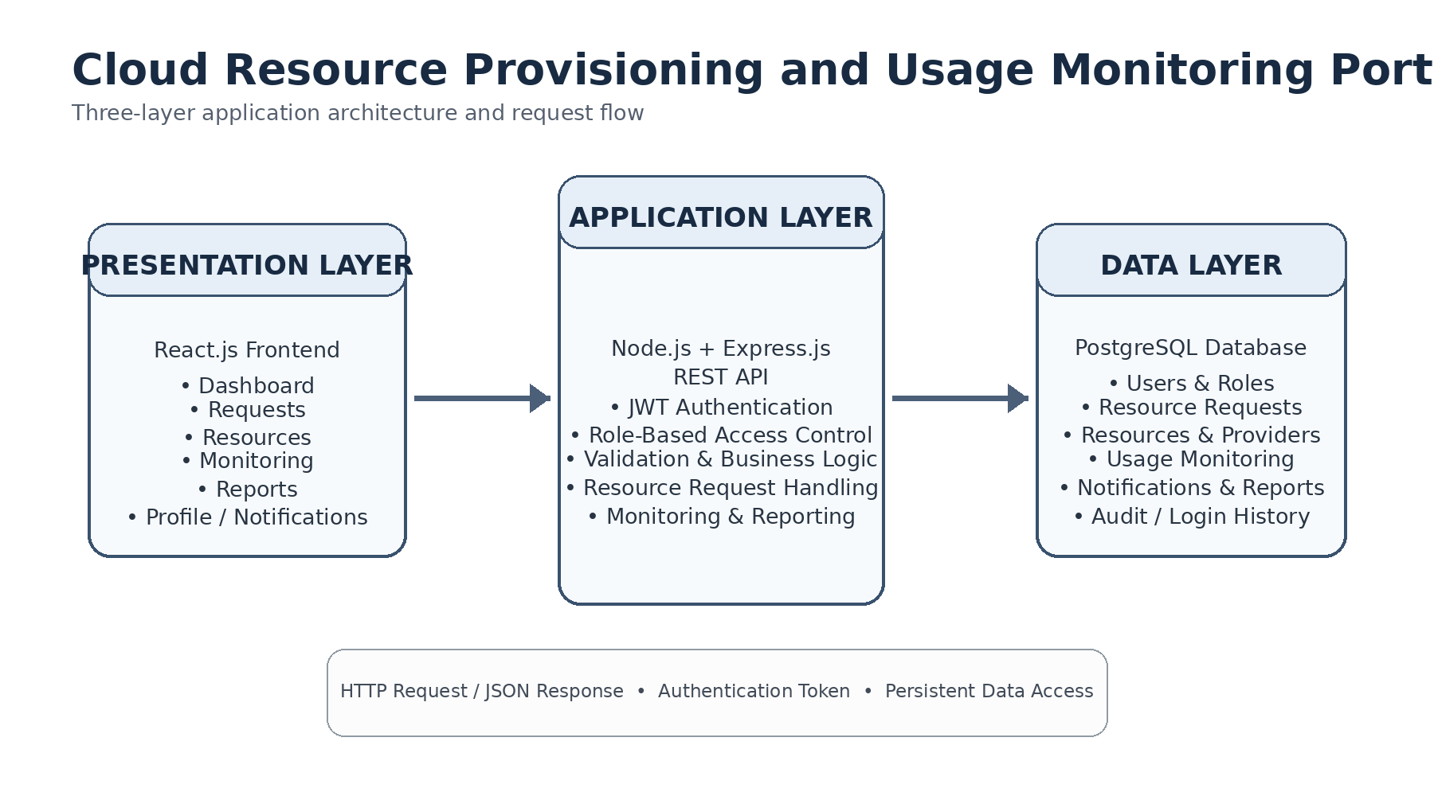
React.js → Node.js/Express REST API → PostgreSQL with JWT authentication and role-based access control.

12. DATABASE DESIGN
PostgreSQL is used as the primary relational database. The database contains entities for users, roles, permissions, requests, resources, providers, resource types, monitoring, notifications, reports, costs, audit logs, and login history.
TABLE | PURPOSE
users | User accounts and role-related information
roles | Application roles
permissions | Available permissions
role_permissions | Maps roles to permissions
resource_requests | Resource requests and approval status
resources | Allocated/managed resource records
resource_types | Resource categories
cloud_providers | Cloud provider records
usage_monitoring | Usage and health information
notifications | User notifications
reports | Report-related information
resource_cost | Resource cost-related information
audit_logs | Application activity
login_history | Login activity

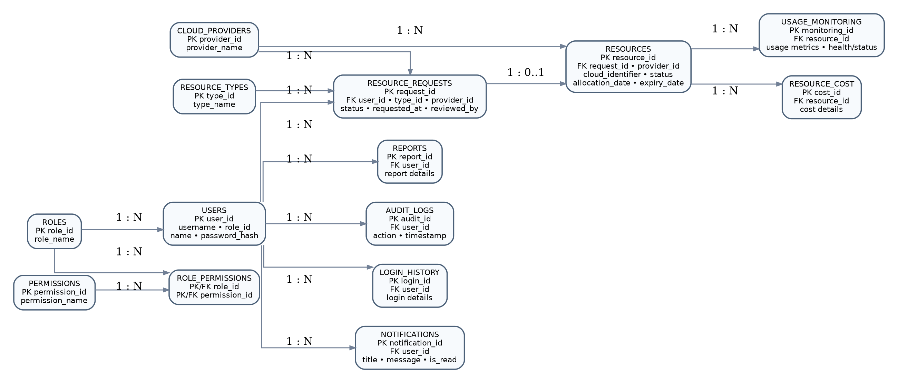
Logical relationship view of the main PostgreSQL entities used by the portal.
FIGURE 2 • ENTITY RELATIONSHIP / DATABASE DESIGN DIAGRAM

13. USER INTERFACE DESIGN
The interface is organized around a dashboard and sidebar navigation. The main sections include Dashboard, Requests, Resources, Monitoring, and Reports, together with profile/logout and notification access.
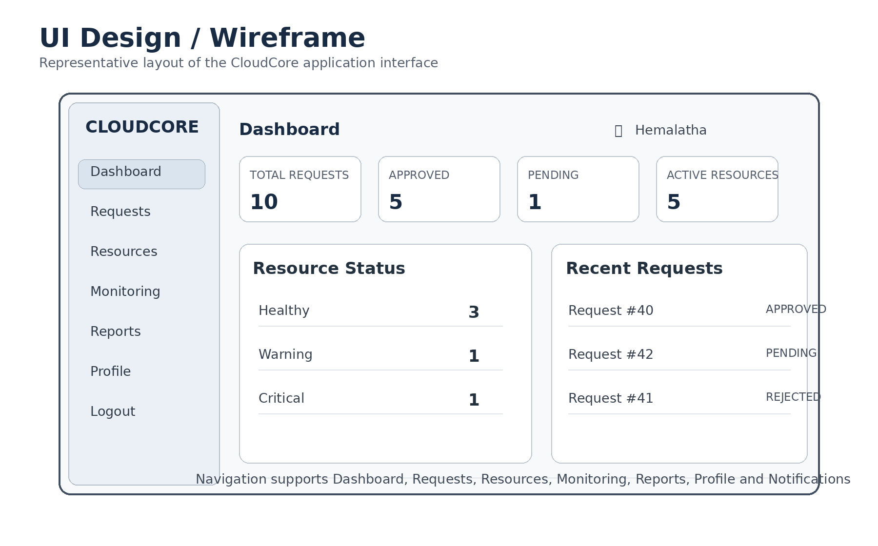
Representative application layout showing navigation, dashboard metrics and operational panels.
FIGURE 3 • UI DESIGN / WIREFRAME

14. IMPLEMENTATION

14.1 Frontend
The frontend is implemented using React.js and provides pages/components for authentication, dashboard, requests, resources, monitoring, reports, profile management, and notifications. Axios is used for backend API communication, with JWT bearer tokens for authenticated requests.

14.2 Backend
The backend is implemented using Node.js and Express.js. REST APIs handle authentication, resource requests, administrative actions, resources, monitoring, notifications, and reports. Authorization checks protect administrator-only operations.

14.3 Database Integration
PostgreSQL stores the application data and supports the CRUD operations required by the application workflows. SQL scripts and the final database backup can be included with the project ZIP.

15. TESTING
Testing covered authentication, authorization, request management, resource management, monitoring, notifications, reports, and API workflows. Postman was used for API verification.
TEST AREA | VERIFICATION
Authentication | Valid and invalid login behaviour
Authorization | Admin-only operations blocked for non-admin users
Request Creation | Cloud User can submit a resource request
Approval Workflow | Administrator can approve/reject a request
Resource Allocation | Approved request represented in resource records
Monitoring | Usage/health information displayed
Notifications | Notification response handled
Reports | Report data displayed correctly

FIGURE 4 • TESTING EVIDENCE / API TEST RESULTS
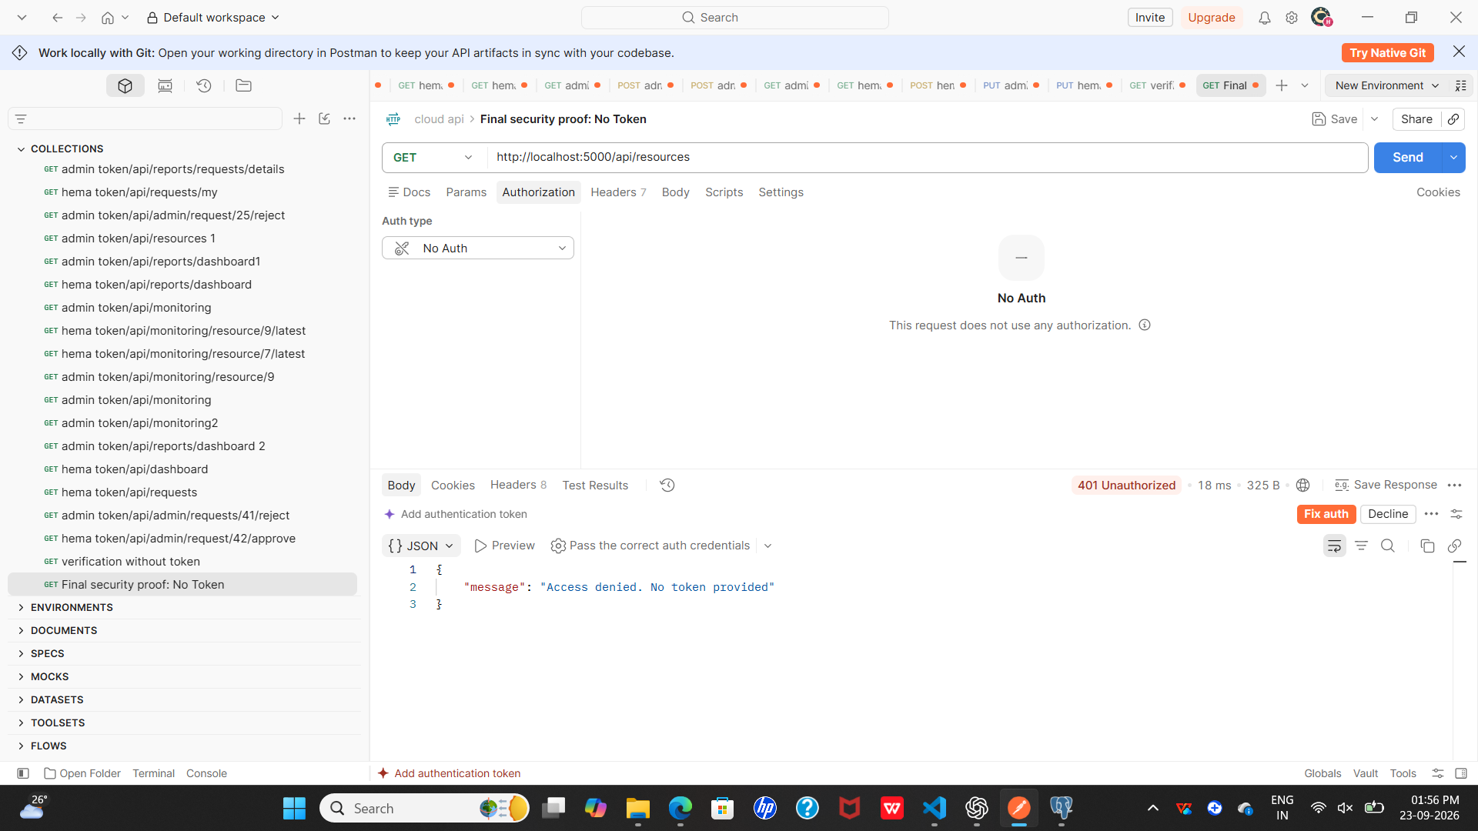

16. RESULTS AND SCREENSHOTS
The following sections are intentionally editable. Replace each placeholder with the corresponding final screenshot from the 11_Screenshots folder. Additional screenshot boxes can be copied if required.
FIGURE 5 • LOGIN / AUTHENTICATION SCREEN
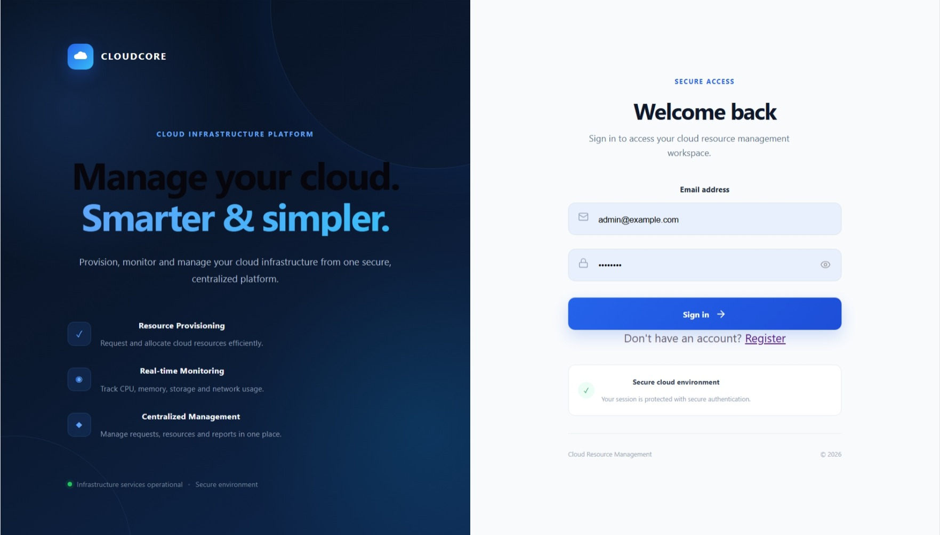

FIGURE 6 • DASHBOARD – PROJECT AND RESOURCE SUMMARY
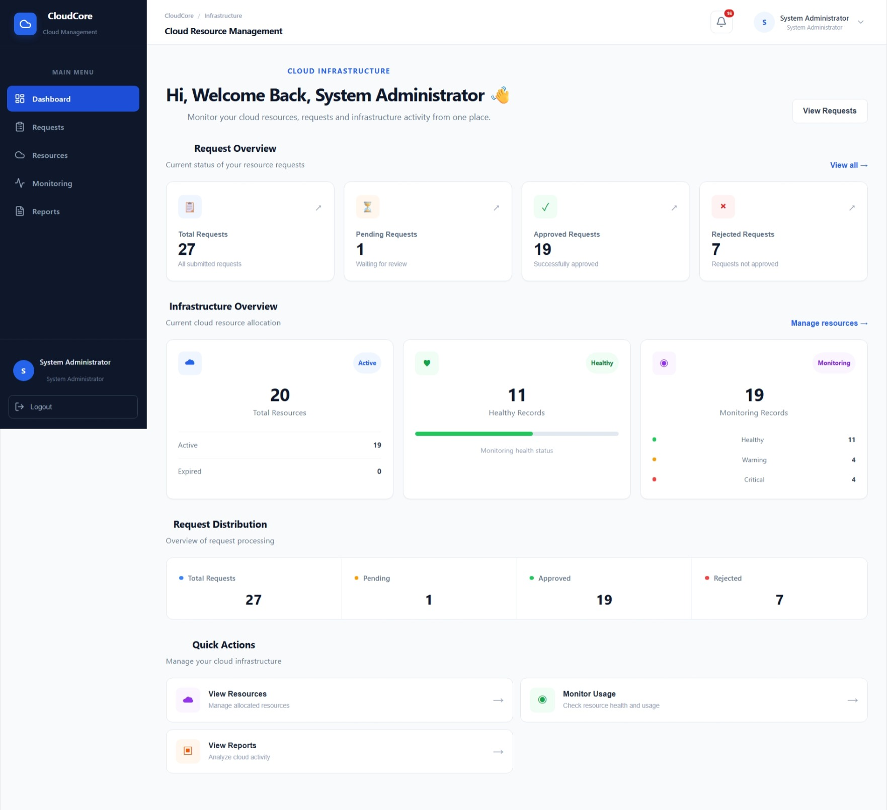

FIGURE 7 • CLOUD USER – REQUESTS PAGE
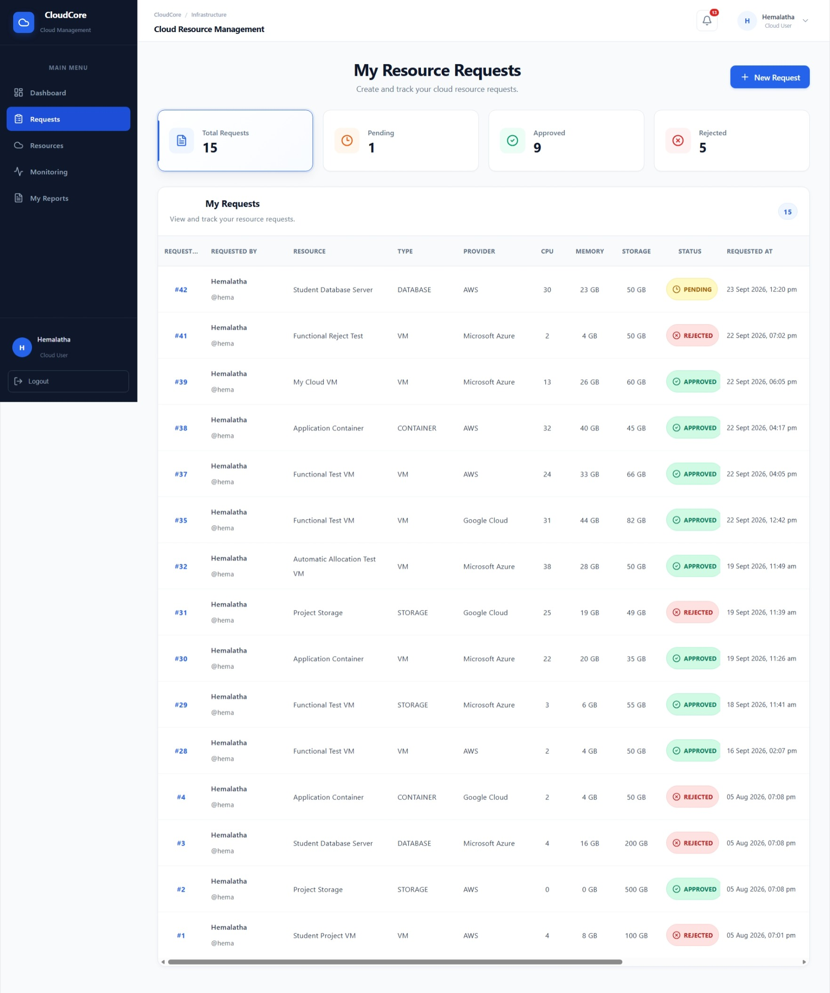

FIGURE 8 • REQUEST #40 – APPROVED REQUEST DETAILS
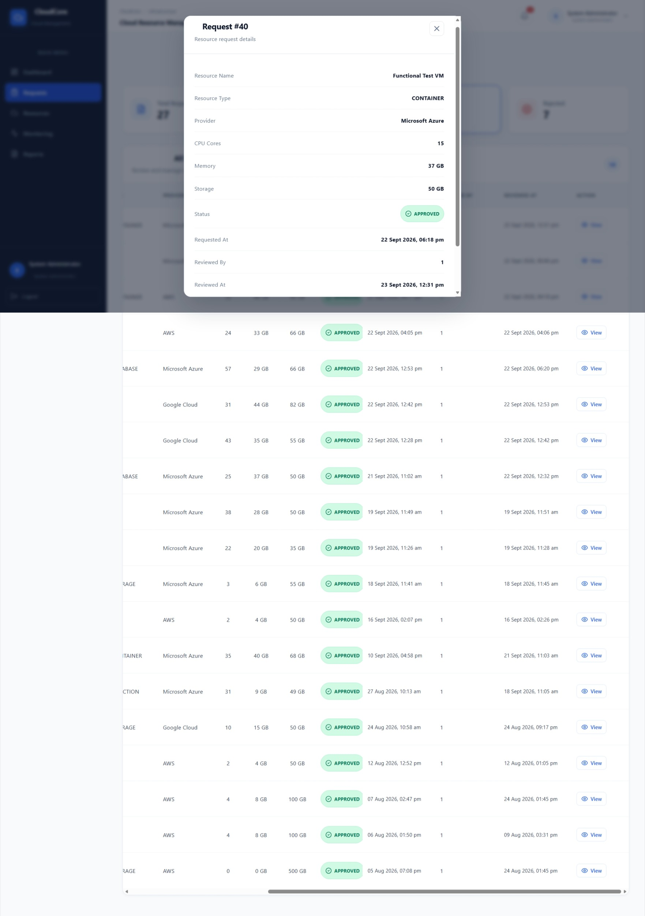

FIGURE 9 • ADMIN – REQUESTS PAGE WITH STATUSES
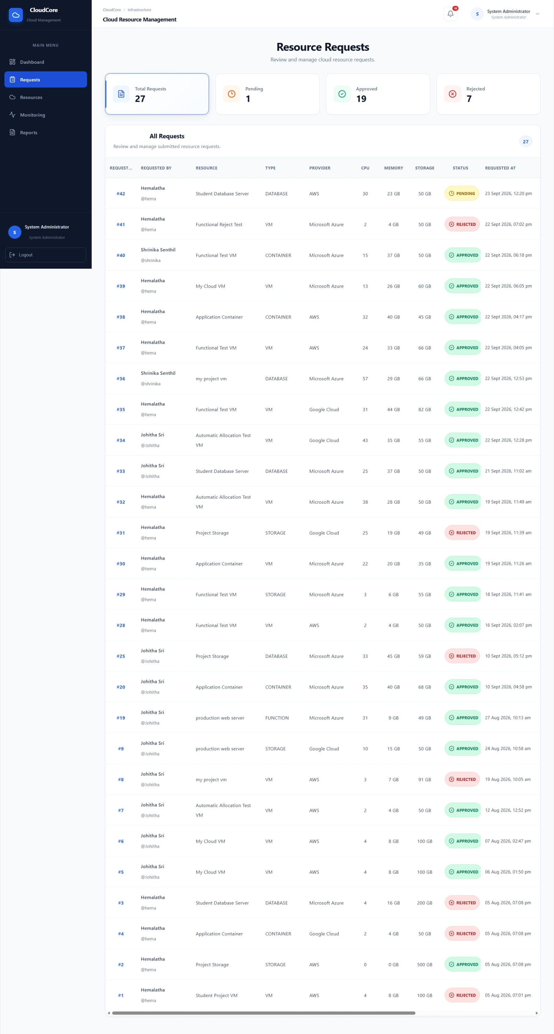

FIGURE 10 • REQUEST #42 – PENDING REQUEST DETAILS
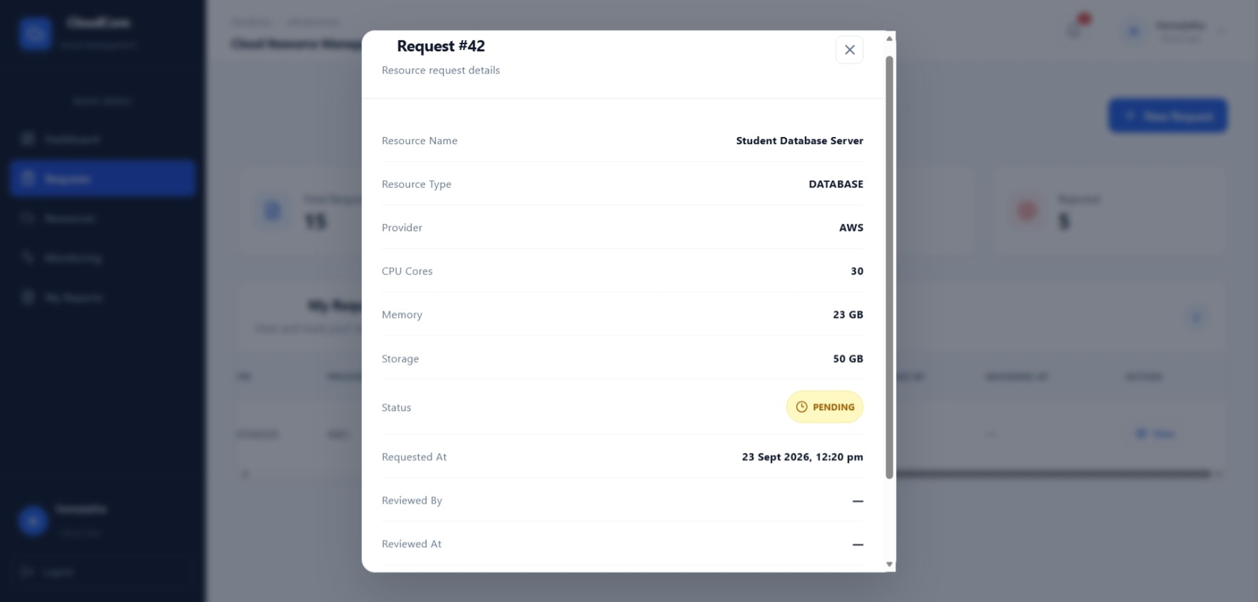

FIGURE 11 • RESOURCES PAGE
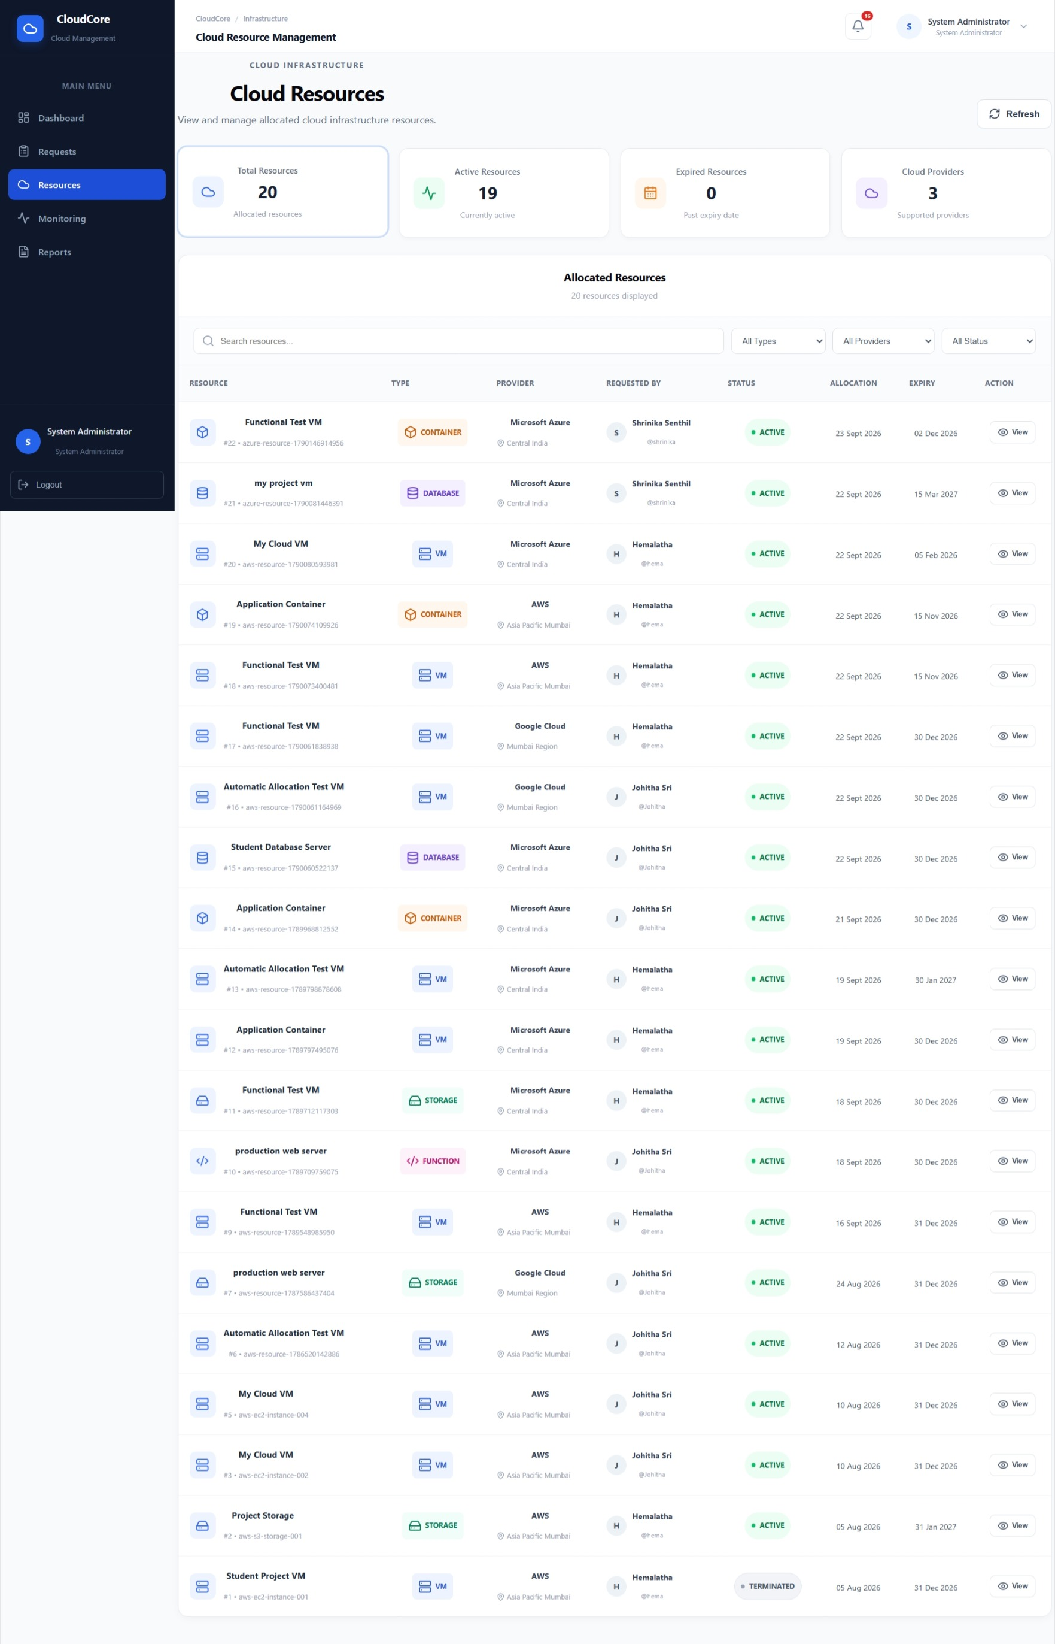

FIGURE 12 • MONITORING PAGE – RESOURCE HEALTH / USAGE
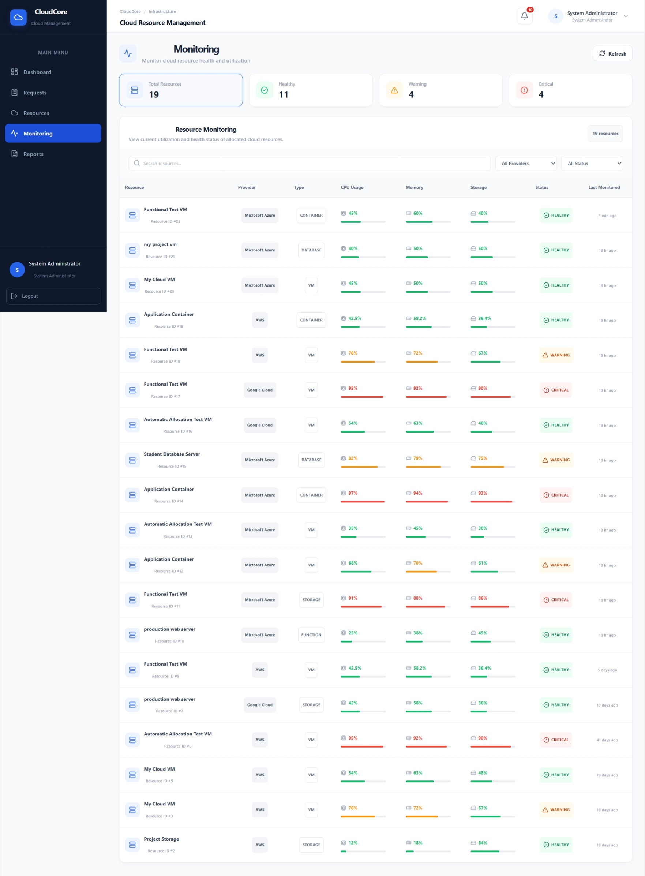

FIGURE 13 • REPORTS PAGE
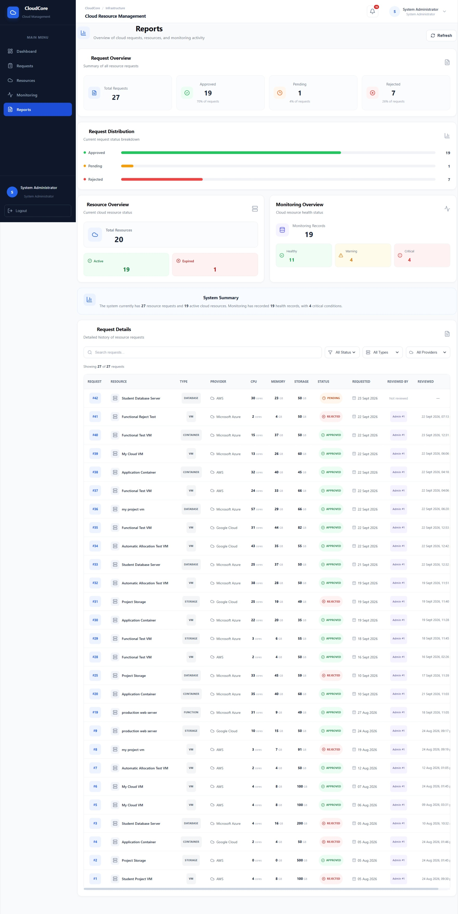

FIGURE 14 • NOTIFICATIONS / PROFILE / FINAL APPLICATION SCREEN
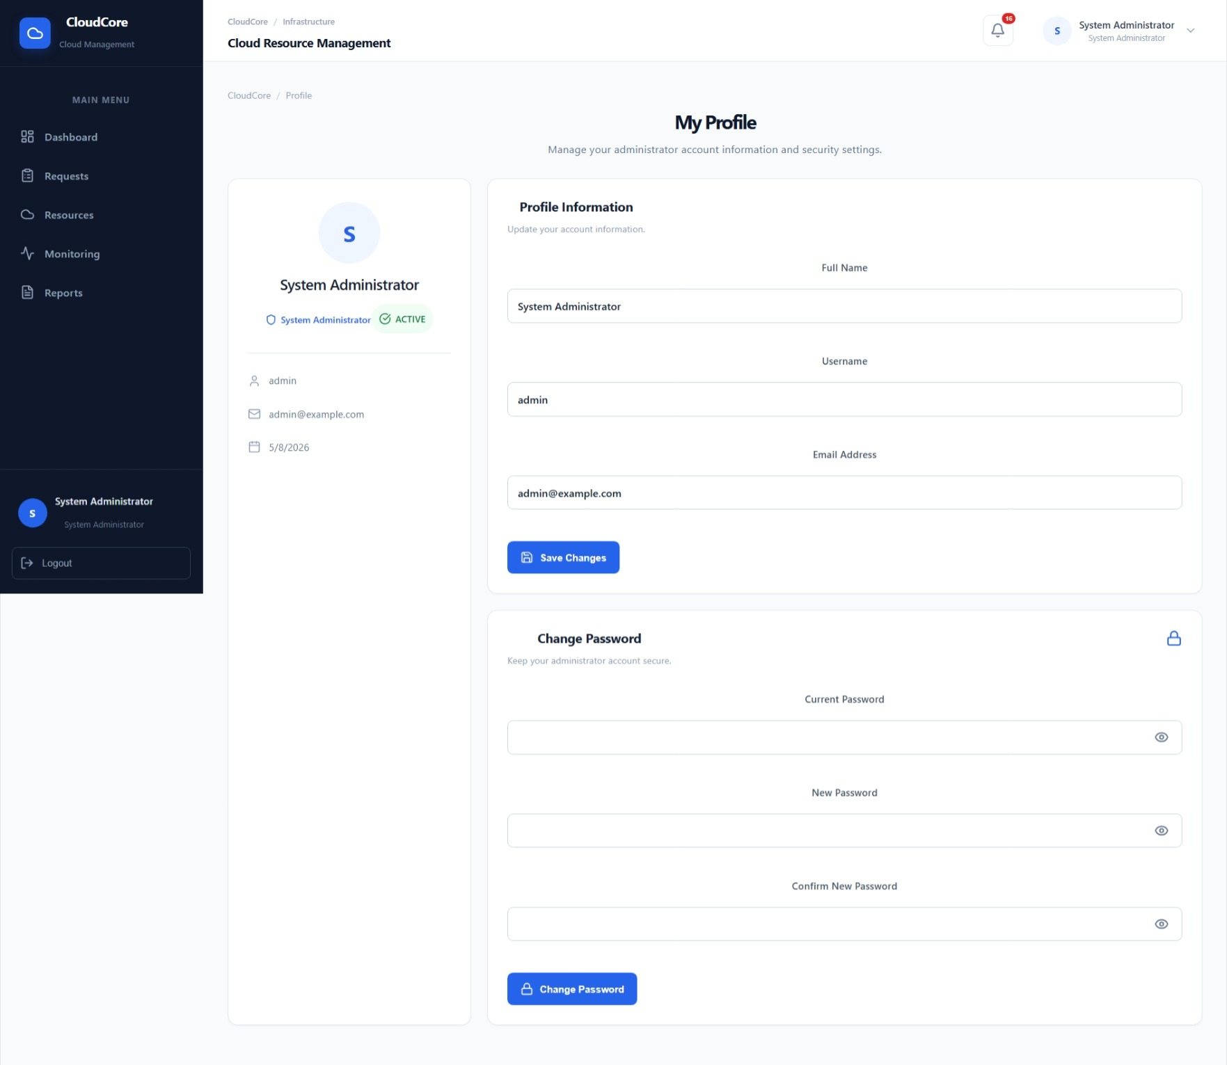

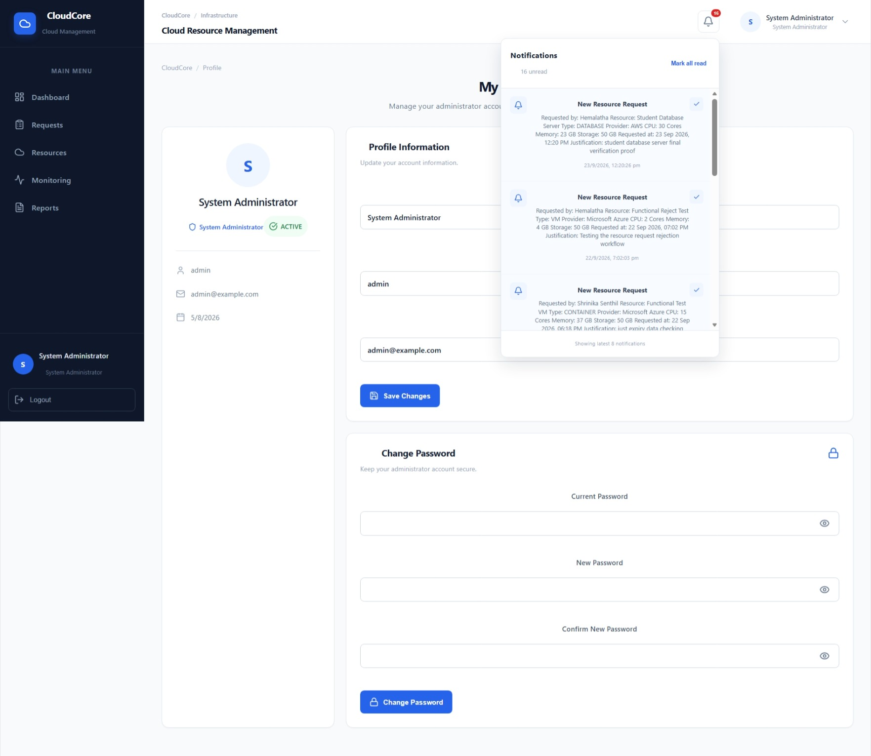

17. ADVANTAGES AND LIMITATIONS

17.1 Advantages
- Centralizes resource request and management activities.
- Provides role-based access and protected administrative operations.
- Improves visibility of request and resource status.
- Provides monitoring, reporting, notification, and audit features.
- Uses a structured relational database.

17.2 Limitations
- The current project is an academic implementation rather than a production cloud platform.
- Live automated provisioning through AWS/Azure/Google Cloud APIs is not represented as a completed feature.
- Production deployment would require additional security, observability, and scalability controls.

18. FUTURE ENHANCEMENTS
- Live AWS, Microsoft Azure, and Google Cloud API integration.
- Automated cloud resource provisioning and deprovisioning.
- Advanced cost optimization and usage forecasting.
- Auto-scaling and policy-based resource controls.
- Production cloud deployment.
- Centralized observability, logging, and alerting.
- Load balancing and multi-instance deployment.

19. CONCLUSION
The Cloud Resource Provisioning and Usage Monitoring Portal provides a practical implementation of cloud resource management concepts through a full-stack web application. It combines React.js, Node.js/Express.js, PostgreSQL, JWT, and bcrypt to implement authentication, request workflows, approval gating, resource management, monitoring, notifications, reporting, and audit-related functionality. The completed implementation provides a foundation that can be extended with live cloud-provider APIs and production-oriented cloud infrastructure.

20. REFERENCES
- Microsoft Azure Documentation
- React.js Documentation
- Node.js Documentation
- Express.js Documentation
- PostgreSQL Documentation
- JWT Documentation
- Postman Documentation
- EDUPCCP045 – Cloud Resource Provisioning and Usage Monitoring Portal project document

APPENDIX A – PROJECT SUBMISSION CHECKLIST
- Latest frontend source code included.
- Latest backend source code included.
- Database SQL/backup included.
- README/setup instructions included.
- Project report included.
- Screenshots included.
- Testing evidence included.
- No real passwords, API secrets, or .env credentials included.

