NAME:R.Hemalatha ID:2400030211 Section:59

→#SKILL - 13 ⎝ Deployment of Full-Stack Application (Spring Boot + React)
→Project structure
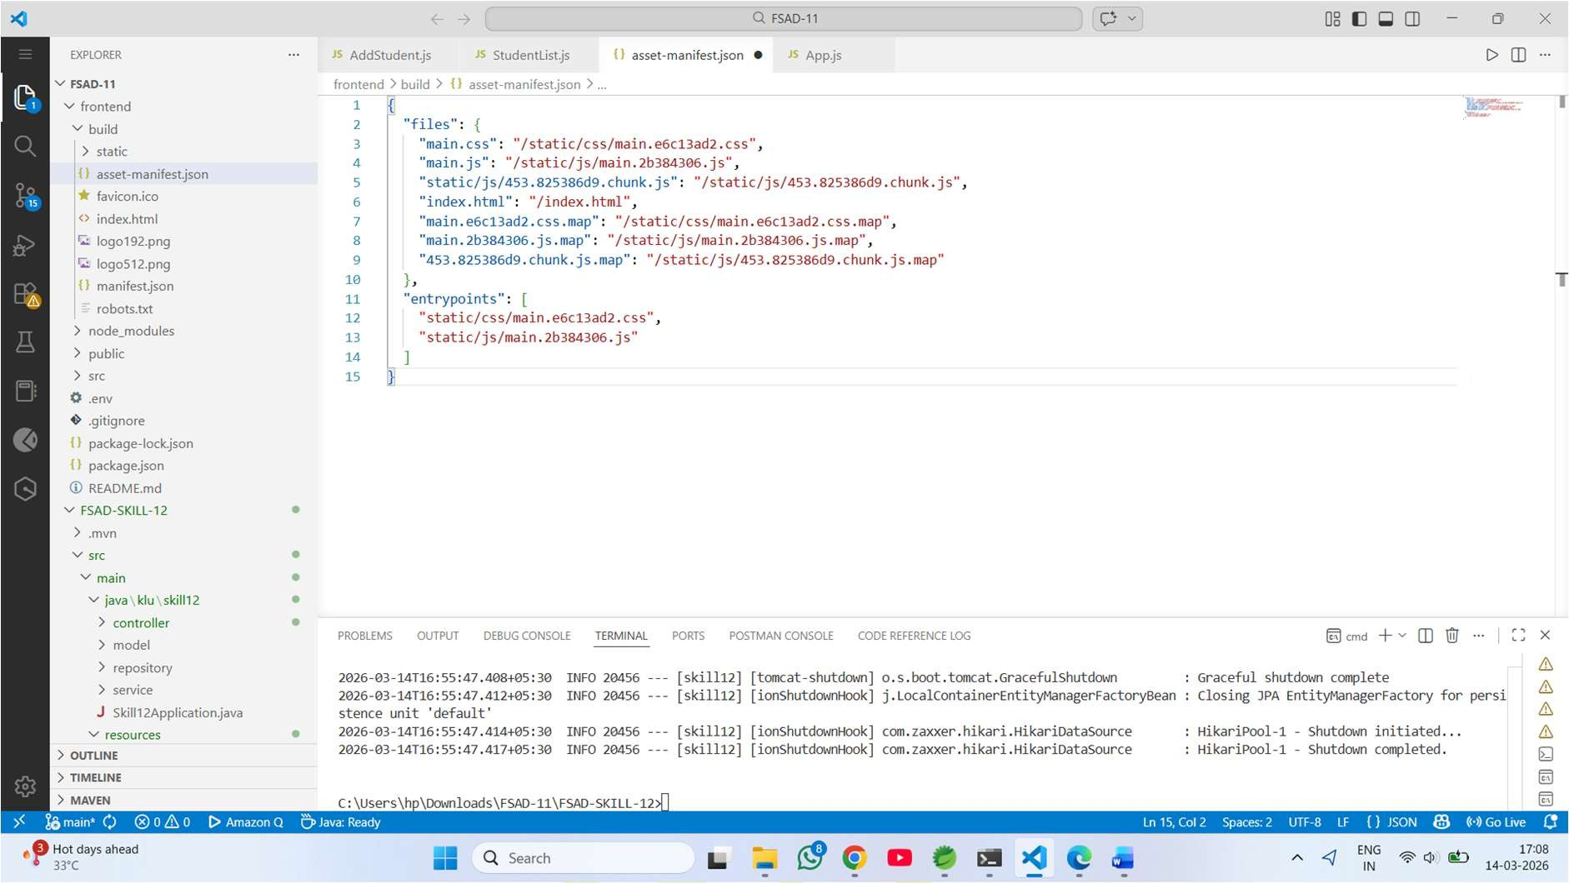
→Output
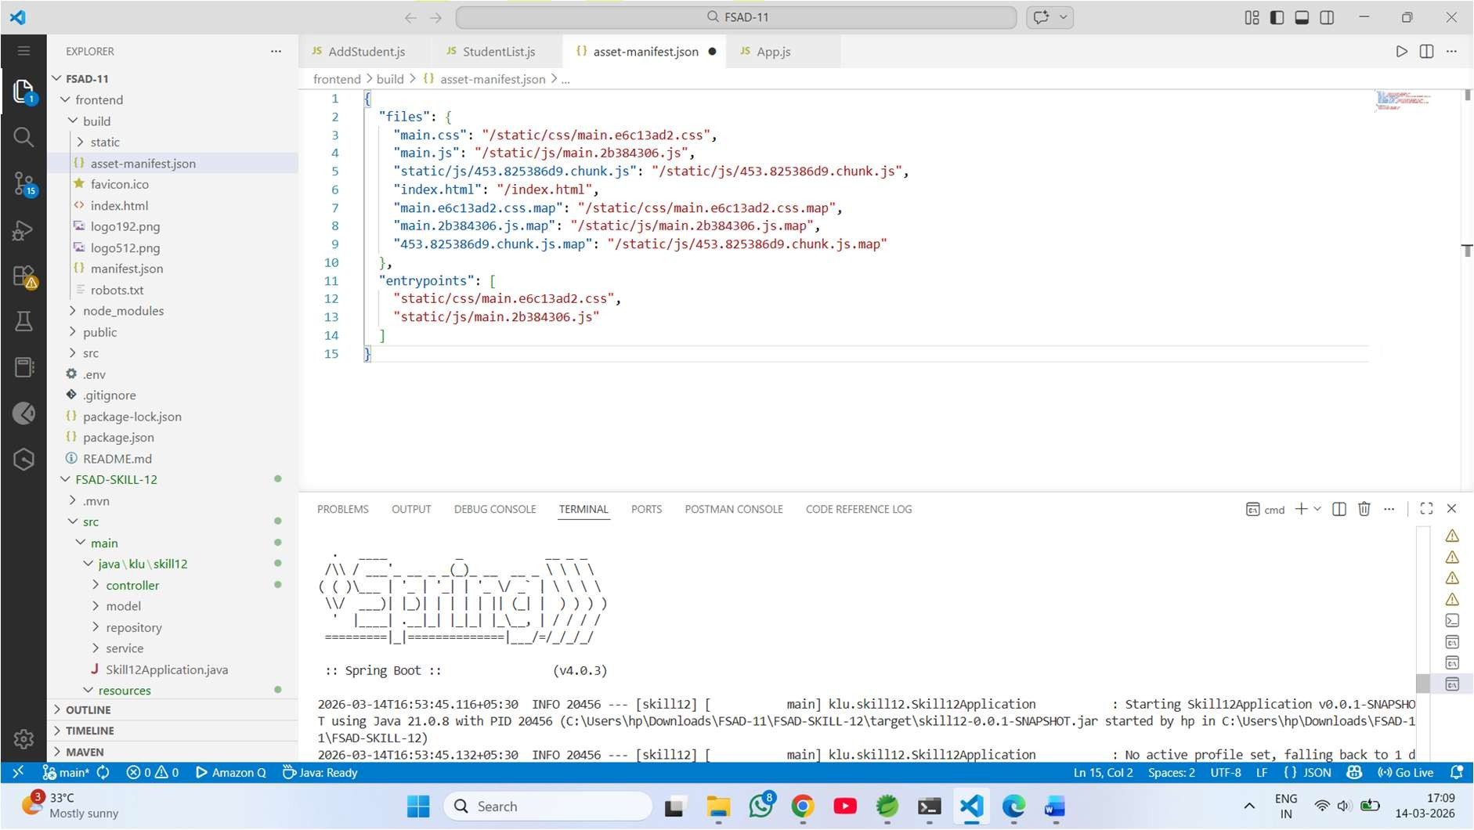

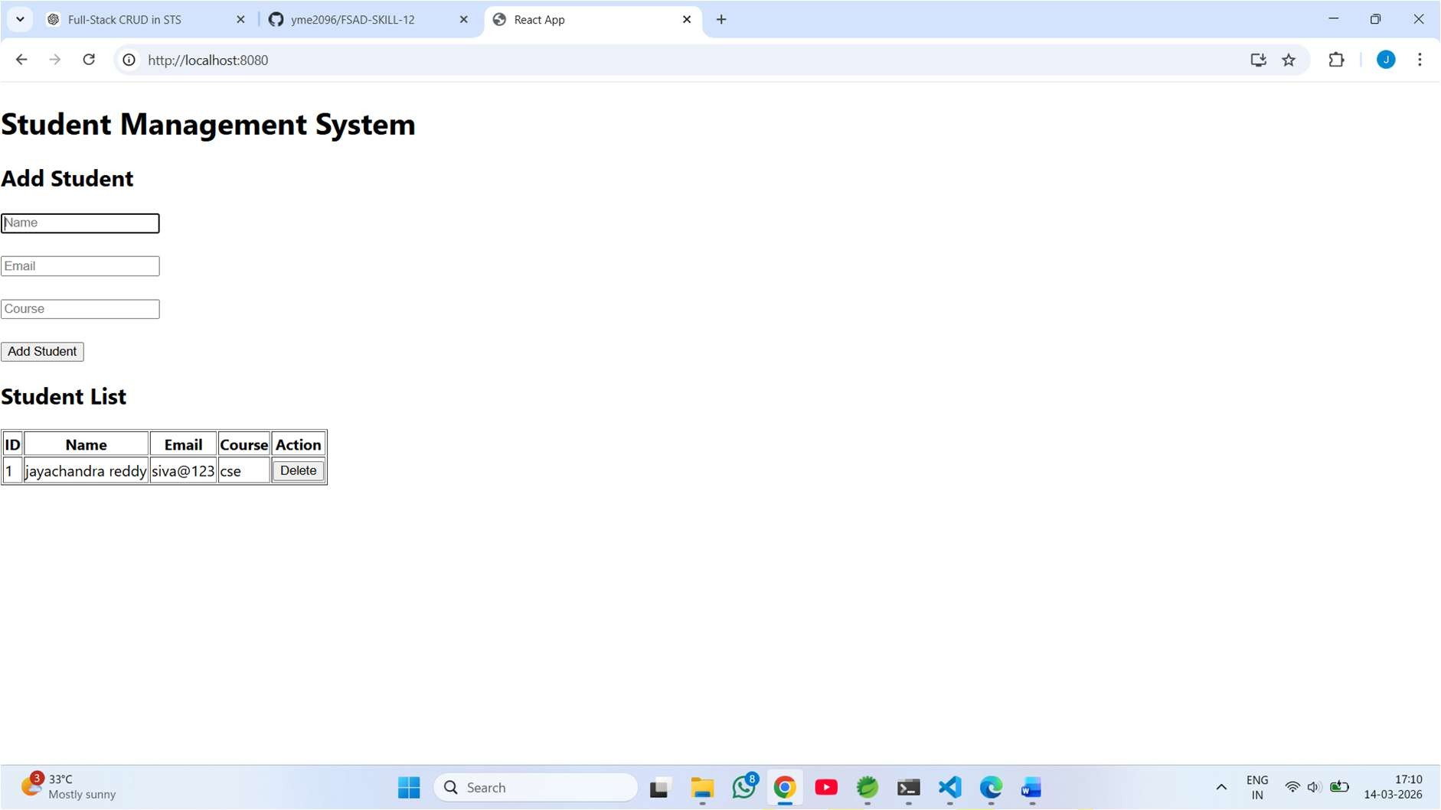
→Deleted
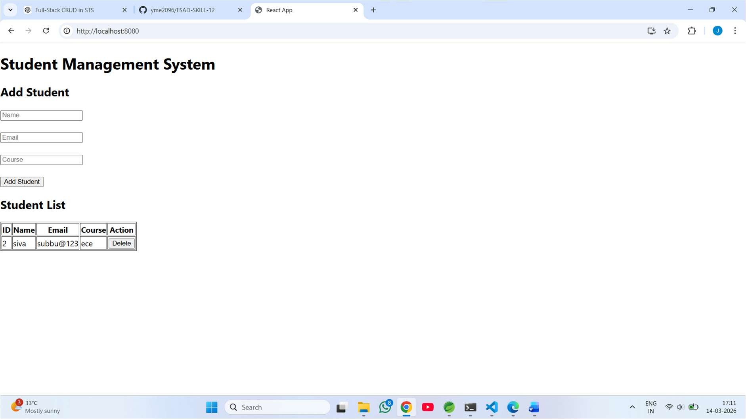
→Github Repository: https://github.com/hemalatharachakonda/2400030211-Skill_experiments.git

