PROJECT AND TEAM INFORMATION

Project Title

ResolveAI

Student / Team Information
Team Name: | Web coders
Team member 1 (Team Lead)  ( Saniya, 2319504, 230122509, ishukhatri432@gmail.com) | 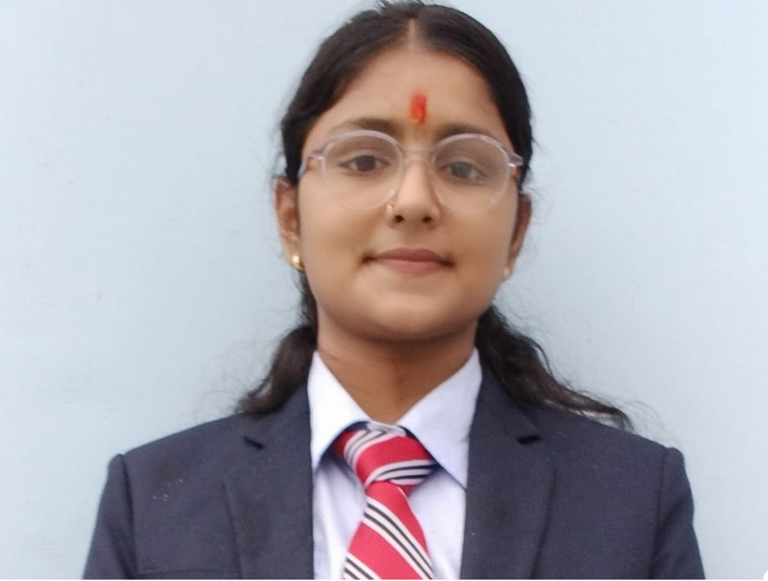
Team member 2  ( Ansh, Bhandari, 2318401, 23011274, ansh02506@gmail.com) | 
Team member 3  ( Hemal, Badola, 2318854, 230114846, badolahemal@gmail.com) | 
Team member 4  ( Janvi Semwal, 2318907, 23022249, janvisemwal77@gmail.com) | 

Motivation (1 pt)

In many institutions and organizations, complaint handling is still performed manually through handwritten applications, emails, or basic online forms. Students and employees often have to write applications by hand and submit them to the concerned office, where they are processed manually. This traditional approach frequently leads to delays, misplacement of applications, incorrect routing of complaints, and lack of proper tracking. Additionally, users may not always know which department is responsible for their issue, resulting in complaints being submitted to the wrong authority and causing inefficiency in resolution. As the number of complaints increases, managing them manually becomes more difficult and time-consuming for administrators.
With the rapid advancement of Artificial Intelligence and Natural Language Processing (NLP), it is now possible to automate complaint analysis by understanding the content of the complaint itself rather than relying on manual sorting or user selection. AI-based systems can process large volumes of complaint text efficiently and categorize them accurately into the appropriate departments. This reduces human error, speeds up processing, and ensures that issues are addressed in a timely manner.
The motivation behind this project is to design and develop an intelligent web-based complaint management system that reduces manual effort, improves response time, and ensures that complaints are automatically directed to the correct department. The system will also enhance transparency by enabling proper tracking of complaints and monitoring their resolution status.

state of the Art / Current solution (1 pt)

Currently, most institutions handle complaints through handwritten applications, emails, or basic online portals where users manually select the concerned department. These methods depend heavily on human intervention for sorting, forwarding, and tracking complaints. As a result, the process is time-consuming and prone to errors such as misclassification, delays in response, and loss of important information. In many cases, users are unaware of the correct department, which further slows down resolution.
Existing systems mainly act as simple complaint collection platforms and do not incorporate Artificial Intelligence to analyze the actual content of complaints. Due to the absence of automation and intelligent prioritization, these systems become inefficient when managing a large volume of complaints and fail to ensure timely resolution and transparency.

Project Goals and Milestones (2 pts)

Project Goals
The primary goal of this project is to develop an AI-based web application that automatically categorizes complaints into the appropriate department using Natural Language Processing. The system aims to reduce manual effort, improve accuracy in complaint routing, provide priority handling for frequently reported issues, and enable efficient tracking of complaint status. Additionally, the project seeks to demonstrate the integration of AI with web development technologies to solve real-world administrative problems.

Milestones
Phase 1 — Requirement Analysis & Design
- Problem identification
- Literature review / current system study
- Finalizing features and technology stack
Phase 2 — System Development
- Frontend development (complaint submission interface)
- Backend development (APIs, database integration)
- AI model development for complaint classification
Phase 3 — Integration & Testing
- Integrating AI model with web application
- Testing system functionality and accuracy
- Fixing errors and improving performance
Phase 4 — Deployment & Documentation
- Final system implementation
- Preparing project report and presentation

Project Approach (3 pts)

To develop the AI Complaint Categorisation System, we will follow a structured and systematic approach.
First, we will conduct requirement analysis to understand common types of complaints such as academic issues, infrastructure problems (e.g., washroom maintenance), technical issues (e.g., lab internet connectivity), hostel concerns, and administrative matters. Based on this analysis, we will define complaint categories and design priority rules, especially for handling duplicate or similar complaints submitted by multiple students.
The system will include two main frontend dashboards:
- User Dashboard (Student Panel):
Students will be able to register/login, submit complaints, track complaint status, and receive updates. The interface will be simple and user-friendly.
- Admin Dashboard:
Administrators will be able to view automatically categorized complaints, filter them by category, monitor priority levels, detect duplicate complaints, and analyze frequently reported issues.
For implementation, we will use Python for backend development. Machine Learning and Natural Language Processing (NLP) techniques will be applied using libraries such as scikit-learn, TensorFlow, and NLTK for text preprocessing and classification.
The frontend will be developed using HTML, CSS, and JavaScript, and the backend framework will use Flask or Django. A database such as MySQL or MongoDB will be used to securely store complaint data.
Finally, the system will be tested and evaluated to ensure accuracy, efficiency, and reliability.

System Architecture (High Level Diagram)(2 pts)
(Provide an overview of the system, identifying its main components and interfaces in the form of a diagram using a tool of your choice).
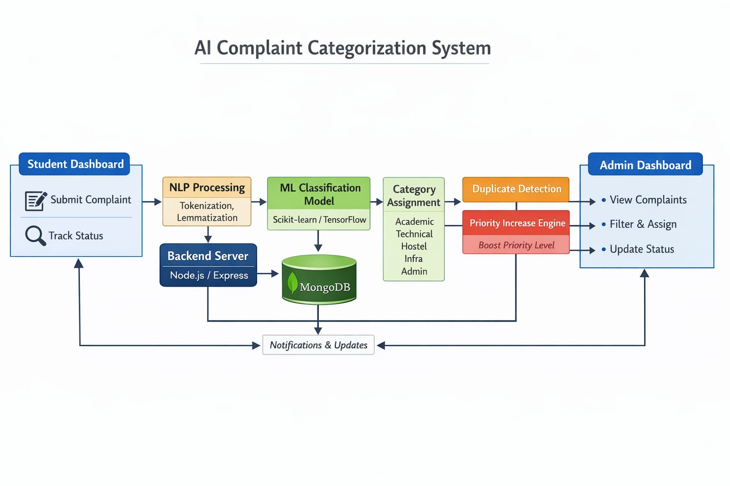

Project Outcome / Deliverables (1 pts)

The outcome of this project will be a functional AI-based web application that automatically categorizes complaints into the appropriate departments using Natural Language Processing. The system will provide a user interface for complaint submission, an automated categorization mechanism, priority assignment for frequently reported issues, and a dashboard for tracking complaint status. The deliverables will include the developed application, AI model, project documentation, and presentation demonstrating the system’s functionality

Assumptions
The proposed system assumes that users will submit complaints in text form through the web interface and that the complaint descriptions will contain sufficient information for accurate categorization. It is also assumed that predefined departments and categories are already established within the institution. The AI model is expected to be trained on a representative dataset of sample complaints to achieve reasonable accuracy. Additionally, the system assumes reliable internet connectivity and access to the web application for both users and administrator.

References

• Jurafsky, D., & Martin, J. H. (2023). Speech and Language Processing. Pearson Education.
(Reference for Natural Language Processing concepts)
• Géron, A. (2019). Hands-On Machine Learning with Scikit-Learn, Keras, and TensorFlow. O’Reilly Media.
(Reference for Machine Learning model development)
• scikit-learn Documentation.
https://scikit-learn.org/stable/
(Used for text classification and machine learning algorithms)
• TensorFlow Documentation.
https://www.tensorflow.org/
(Used for deep learning and model training concepts)
• NLTK Documentation.
https://www.nltk.org/
(Used for text preprocessing and NLP techniques)

