Guided Capstone Project Report

Introduction
Big Mountain Resort wants to understand how its ticket pricing compares to other ski resorts and how facility improvements could affect the market-supported price. The goal of this analysis is to provide data-driven recommendations for ticket pricing and potential facility upgrades. Accurate pricing helps the resort remain competitive while maximizing revenue.

Data Wrangling
We used data from multiple ski resorts including Big Mountain, covering features such as:
- Adult weekend ticket price
- Number of runs
- Vertical drop
- Total chairs
- Snow-making area
- Longest run
- Skiable terrain area
Data cleaning and preprocessing steps:
- Missing or invalid values were filtered out.
- Big Mountain’s data was treated separately for scenario modeling.
- Features were prepared for modeling (e.g., numeric types ensured, scaled as needed).

Exploratory Data Analysis (EDA)
Initial analysis showed:
- Big Mountain’s current ticket price falls in the mid-to-high range compared to other resorts, suggesting it is already competitively positioned.
- In Montana, Big Mountain sits slightly above average for ticket price and facilities.
- Plots like plot_compare('AdultWeekend', 'Adult weekend ticket price ($)') helped visualize Big Mountain against competitors.
Figure 1: Big Mountain ticket price vs. other resorts
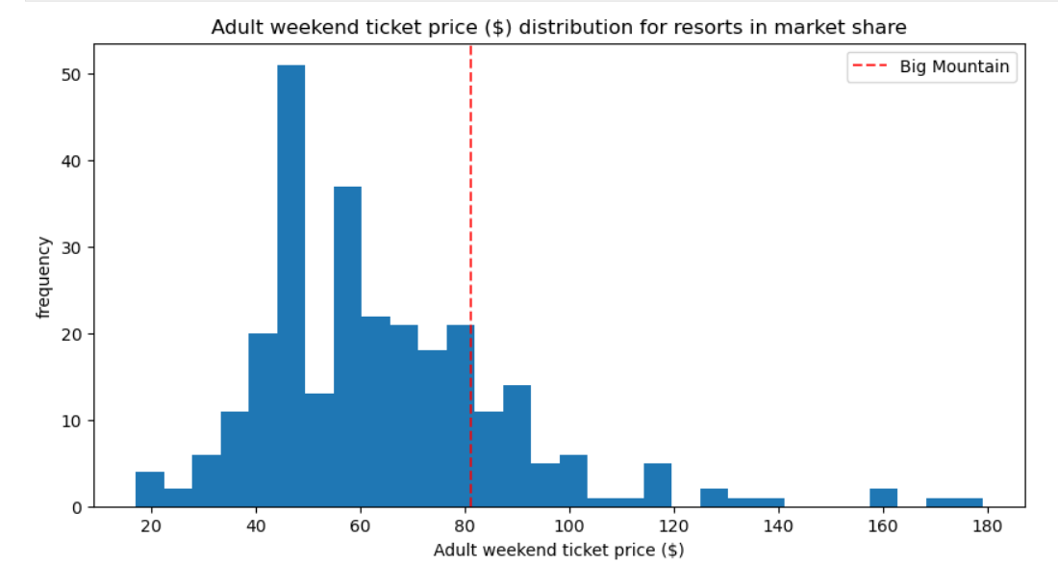

Modeling Approach
We tested two models:
- Linear Regression – simple, interpretable
- Random Forest Regression – better predictive performance
Model selection: Random forest was chosen because cross-validation RMSE showed superior accuracy. Feature importance analysis highlighted:
- Number of runs
- Vertical drop
- Total chairs
Other features like longest run had less impact.

Scenario Analysis & Findings
We modeled multiple scenarios for facility changes:
Scenario | Changes | Predicted Ticket Price Increase | Predicted Seasonal Revenue Increase
Scenario 2 | +1 Run, +150 Vertical Drop, +1 Chair | Positive Increase | Increase in revenue
Scenario 3 | Scenario 2 + 2 Acres Snow-making | Slight additional increase | Slight revenue increase
Scenario 6 | +0.2 mi Longest Run, +4 Acres Snow-making | Minimal impact | Minimal change
- Scenario 2 has the largest positive effect on ticket price and revenue.
- Scenario 3 gives a small additional boost.
- Scenario 6 shows minimal impact because longest run is less important in the model.
Figure 2: Predicted ticket price changes by scenario
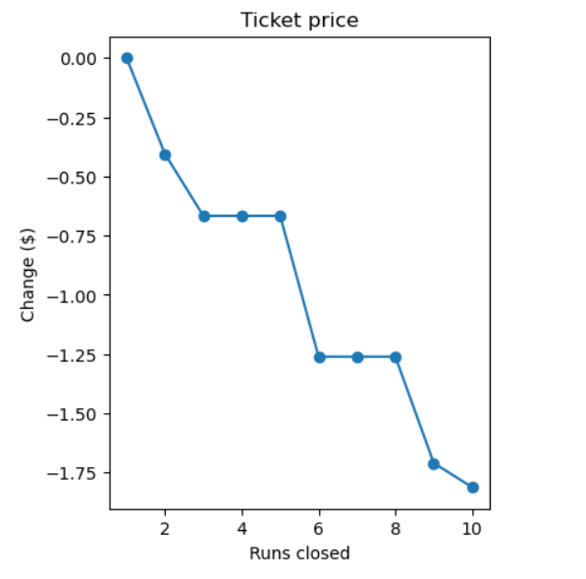
Figure 3: Predicted revenue changes by scenario
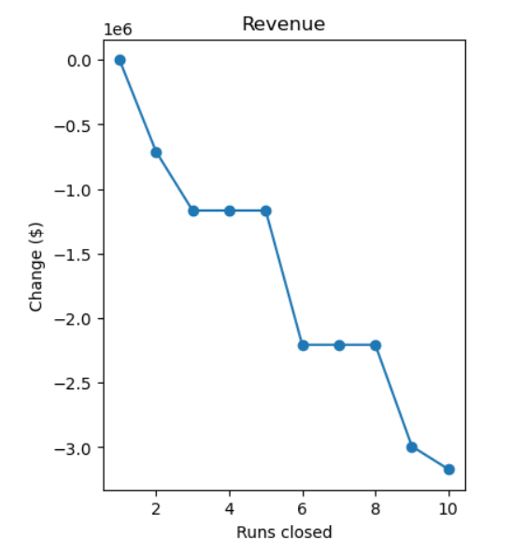

Pricing Recommendations
- Small facility upgrades (Scenario 2) could justify modest ticket price increases.
- Additional operating costs (e.g., new chair lift) can be offset by increased ticket revenue.
- Changes should be tested gradually:
  - Open or close a few runs first
  - Add small snow-making areas
  - Monitor visitor response
Overall, Scenario 2 appears the most promising, while other scenarios could be tested selectively. A practical price increase range can be estimated based on the modeled scenarios and facility improvements.

Conclusion
Overall, this analysis gives Big Mountain actionable guidance for pricing and facility decisions, supported by predictive modeling and scenario analysis. Scenario modeling indicates that carefully planned upgrades can increase both ticket price and revenue without taking unnecessary risks.

