MANDAPALLI HEMA

ASSIGNMENT-2

Created a data base with persondetails name and Delete command is used to delete the persondetails database:

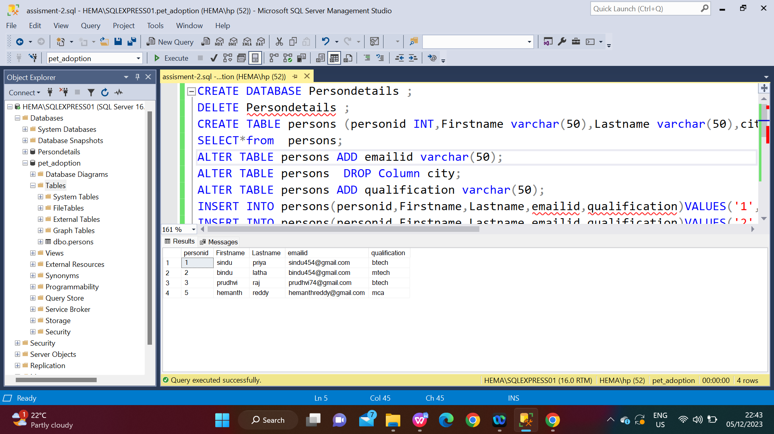

CREATE TABLE is used to create the table with the name of persons

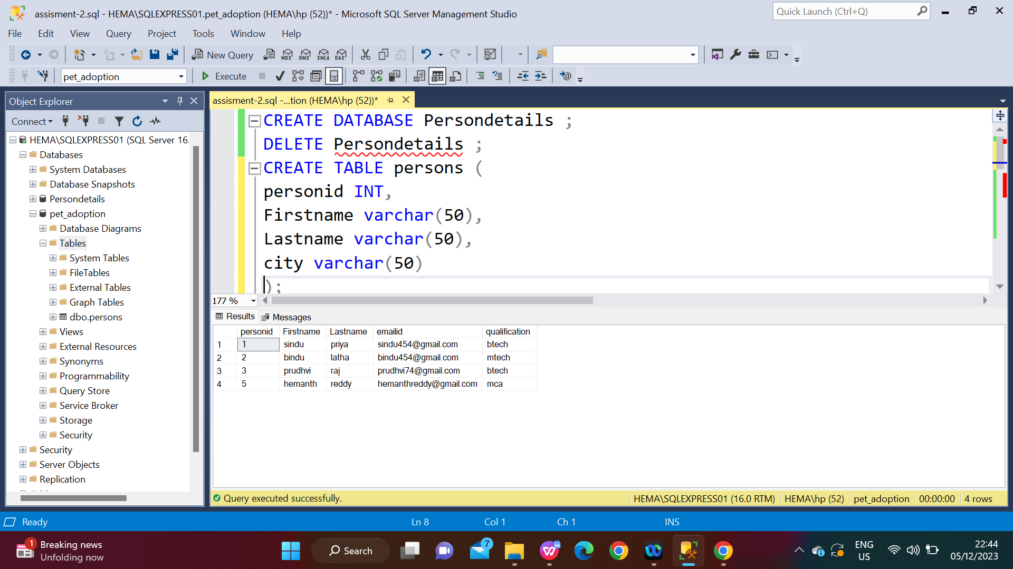

ALTER and ADD command is to to add the emailid column to the persons table, INSERT command is used to insert the details of the persons table and SELECT command is used to display thetable.

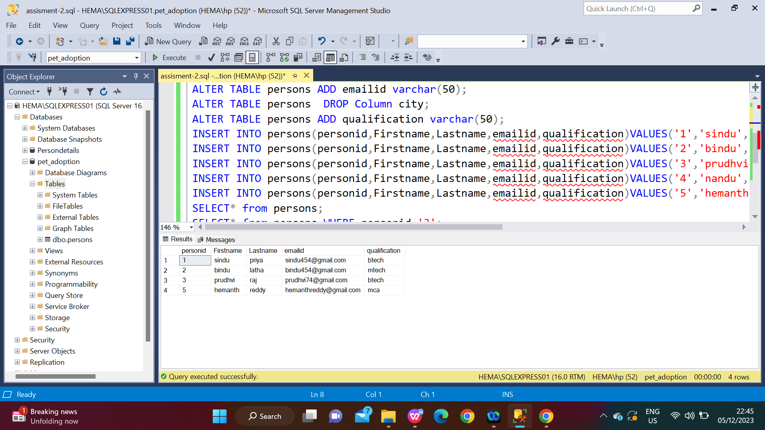

SELECT AND WHERE command is used to display the 3rd id of the persons table.SELECT and FORM is used to display the table with names.

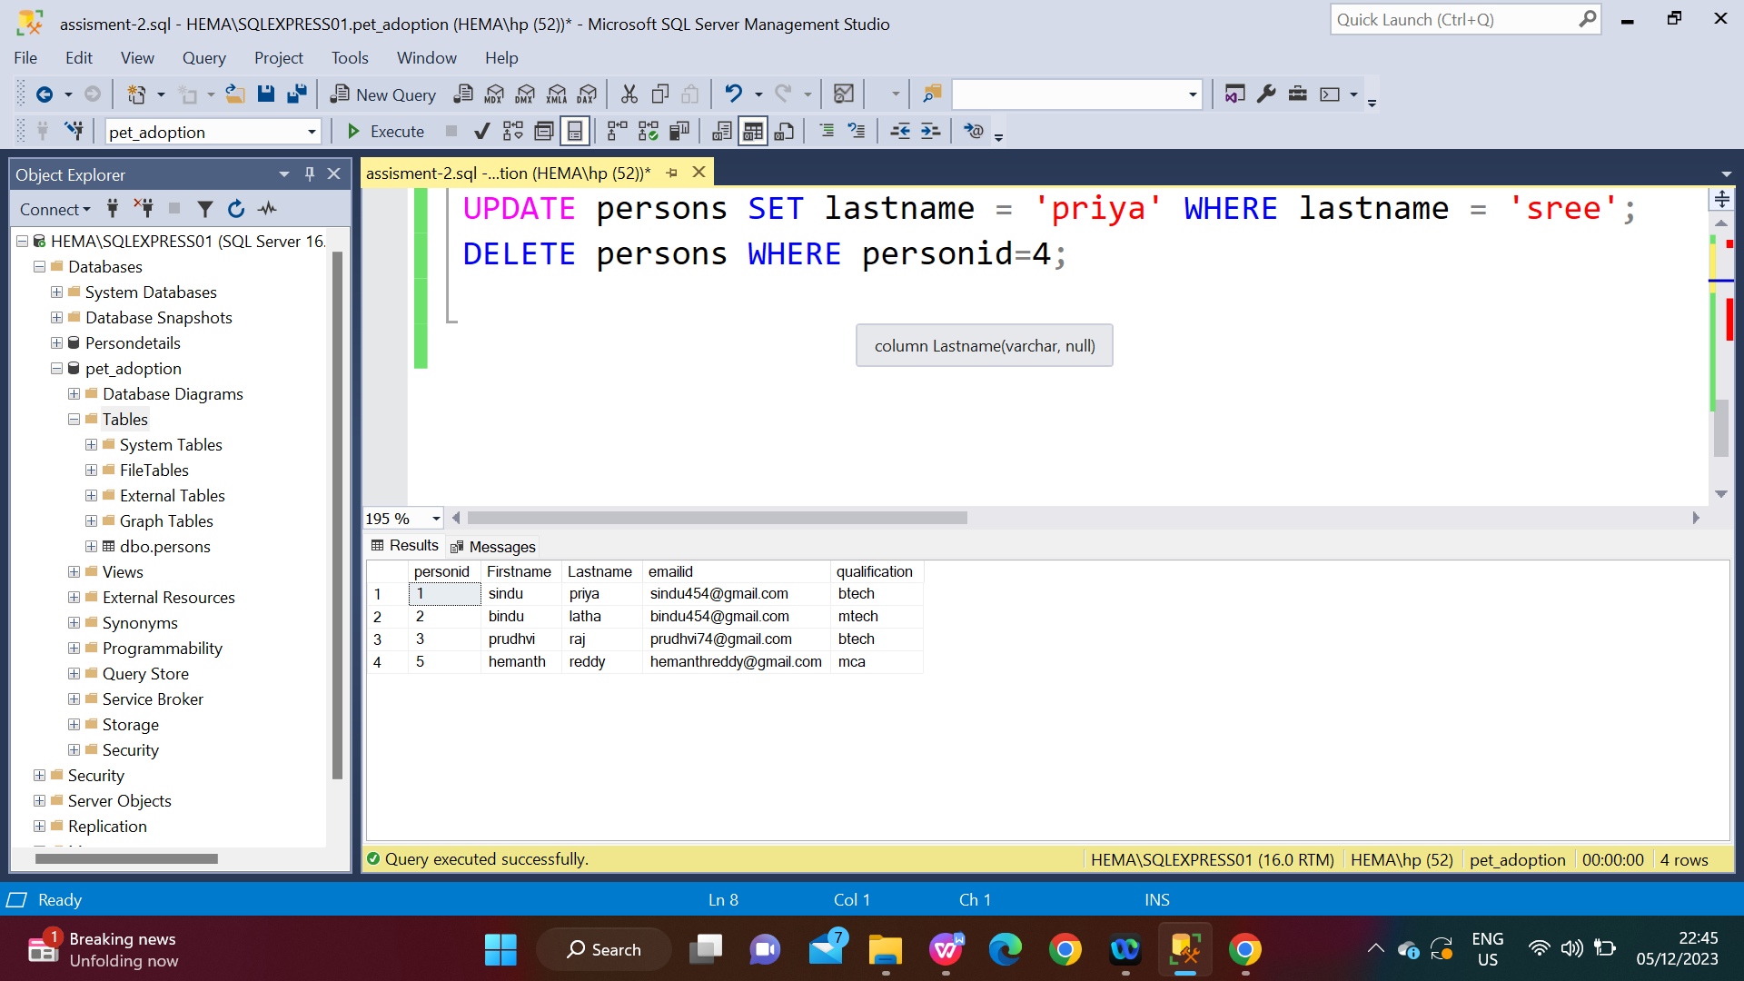

UPDATE and SET is used to update the sindu sree name with sindupriya and DELETE and WHERE is used to delete the 4th column in the persons table.

