MANDAPALLI HEMA

ASSESSMENT-22

Create an Azure Databricks service:

1.Sign in to the Azure portal and click on Create a resource and type databricks in the search box.

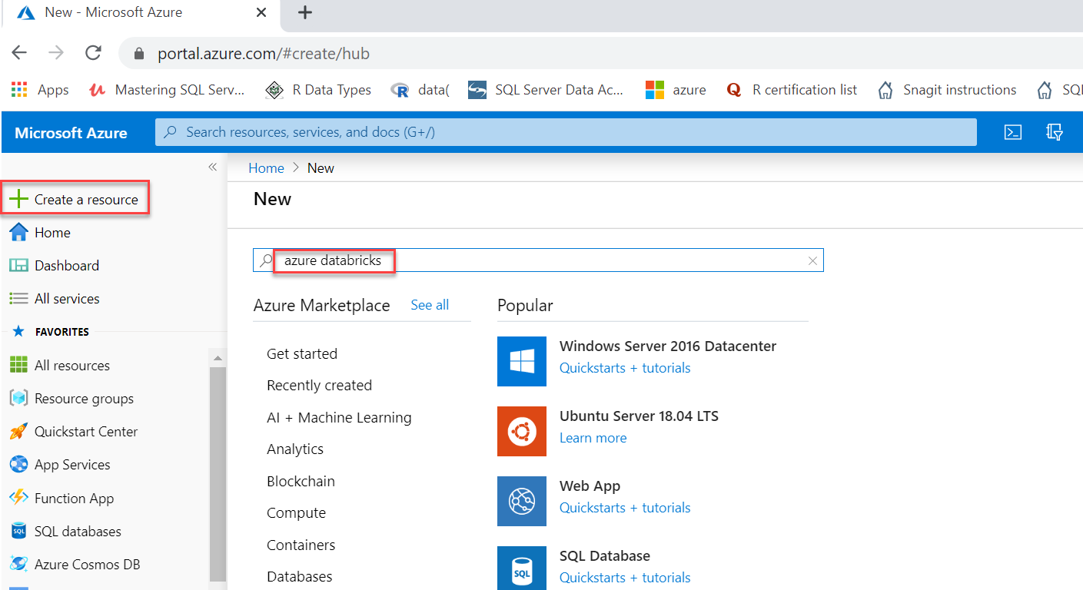

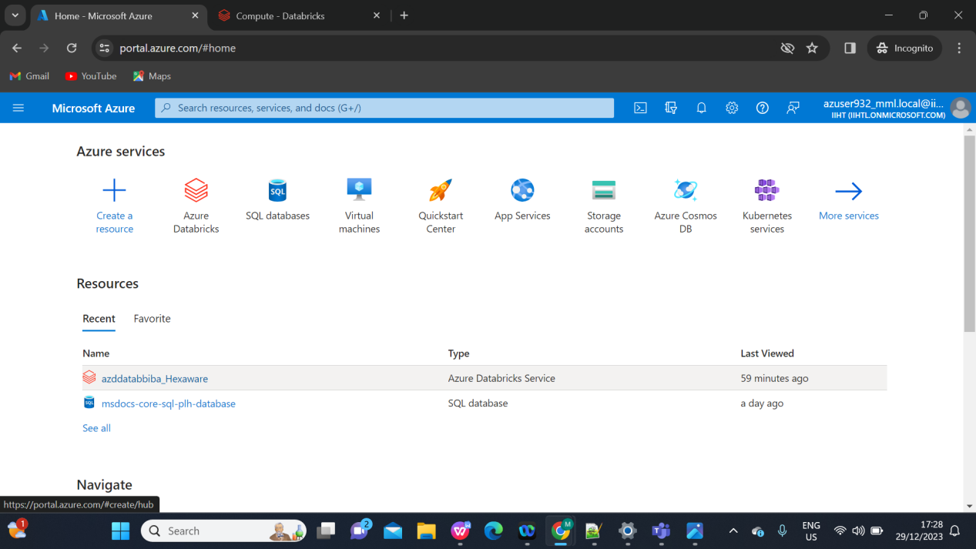

Then we have to create a workspace and Click on ”lanch workspace’ to open the Azure Databricks portal.

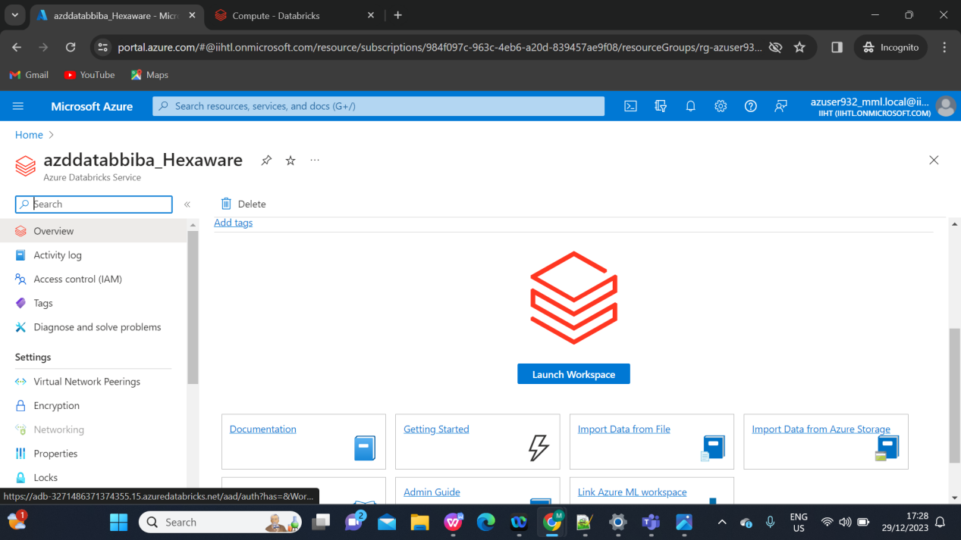

After launching the workspace ,go to compute and click on cluster to create new cluster :

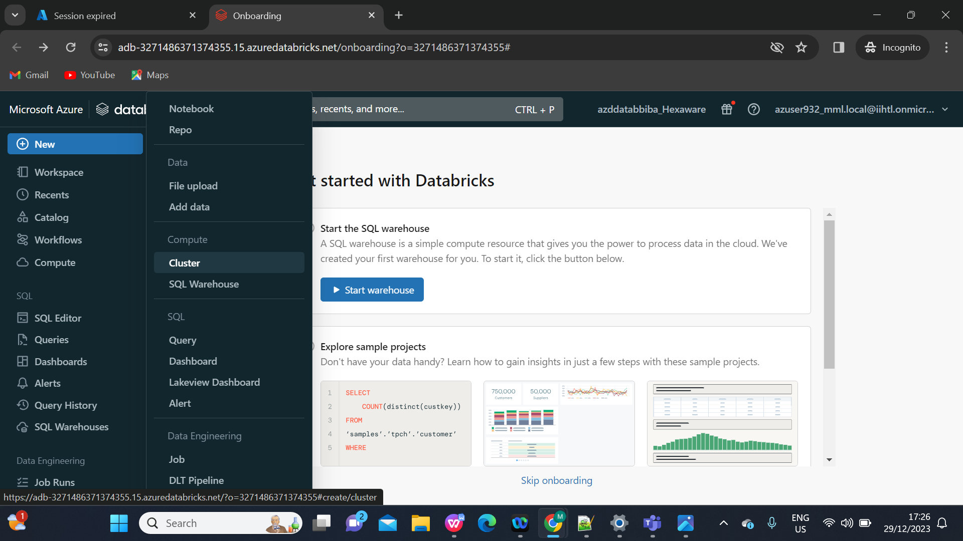

Create and attach a new compute resource:

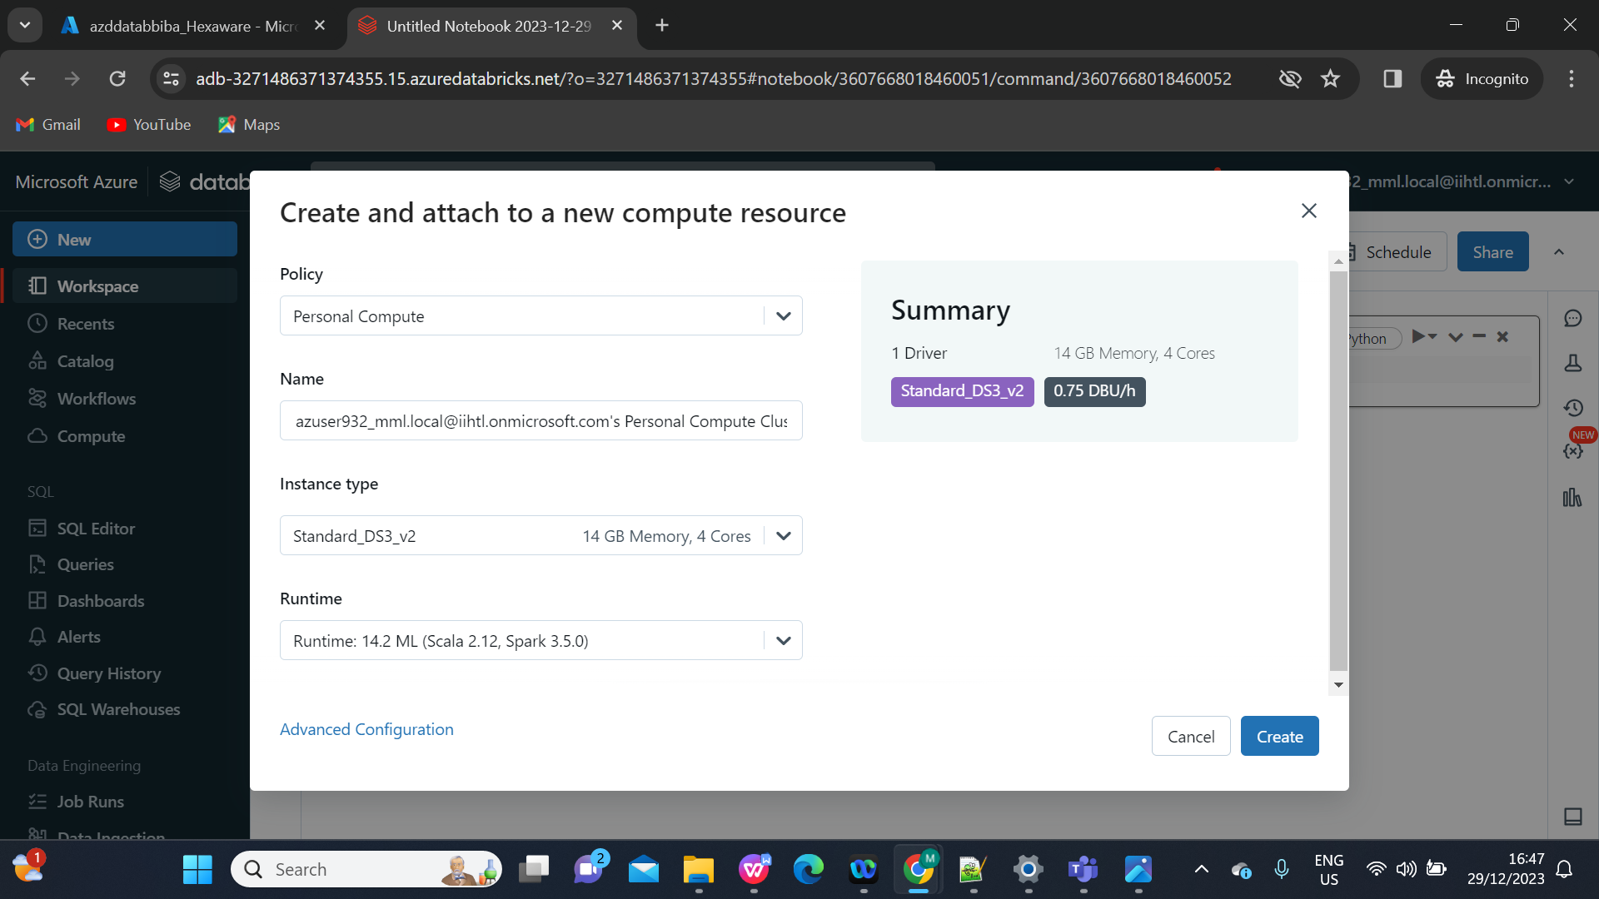Give the program and run it:

