MANDAPALLI HEMA

ASSIGNMENT-2

1. PYTHON MODULES:modules allows to break the code into small,logical units that can easily managed and tested.

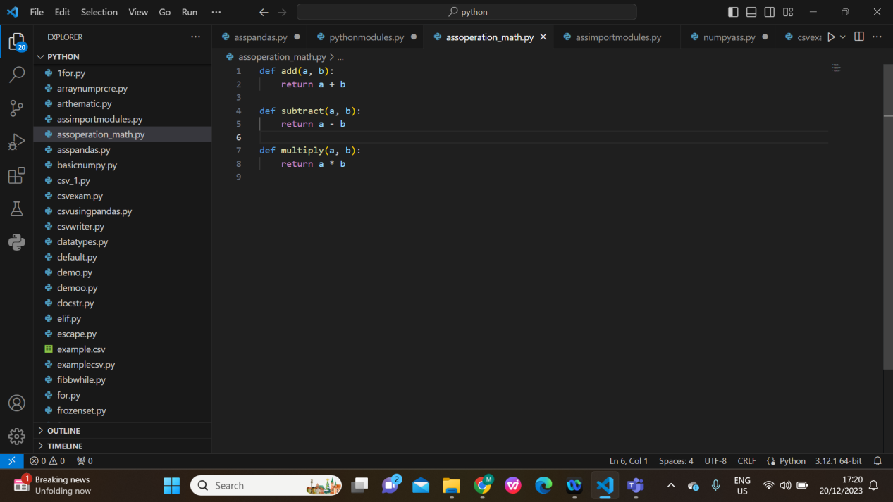

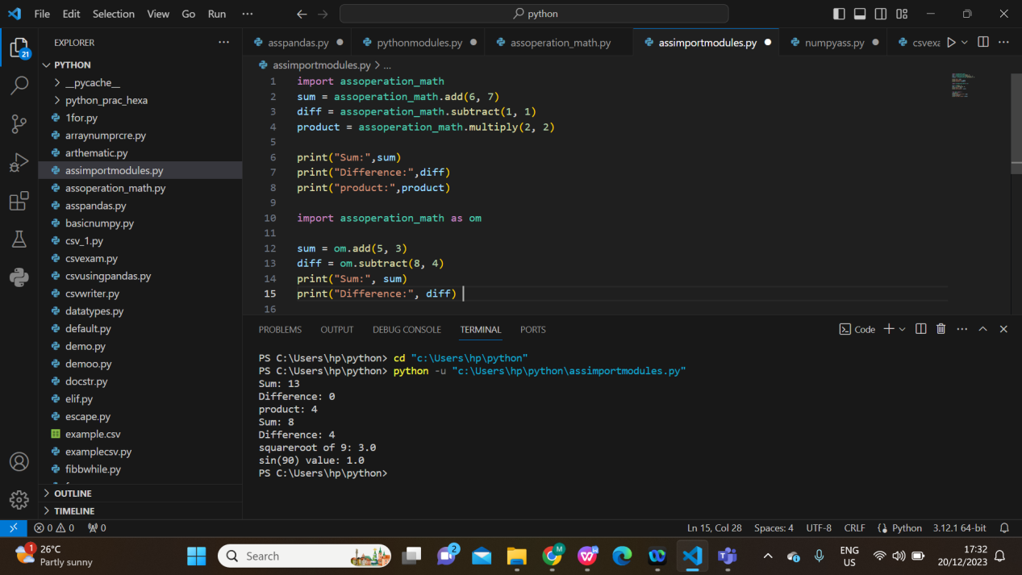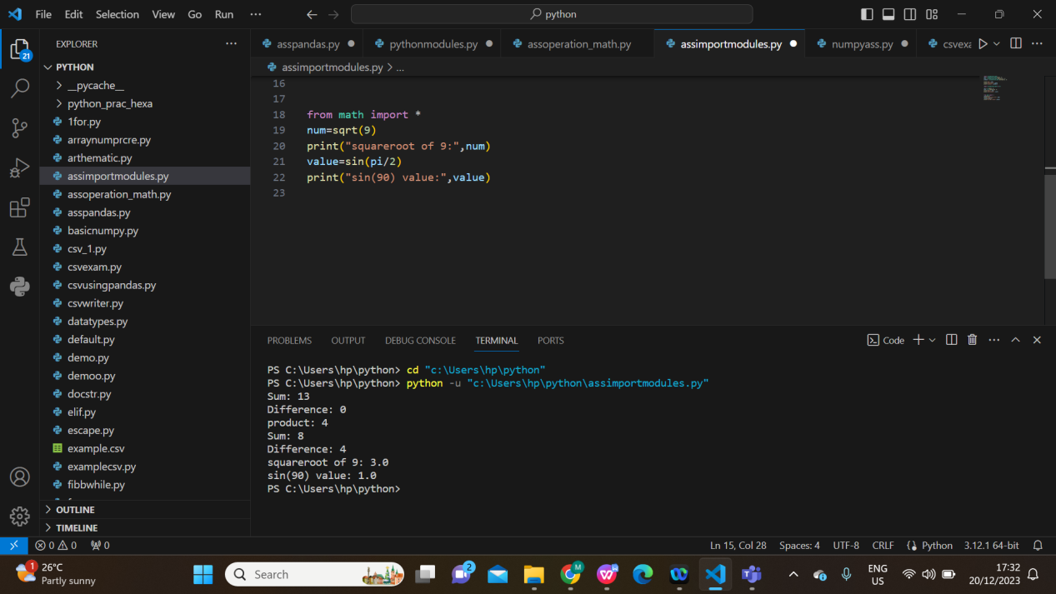

1. PANDAS AND NUMPY:

\*numpy is a fundamental package for numerical computing in Python. It provides support for large, multi-dimensional arrays and matrices, along with mathematical functions to operate on these arrays.

\*Pandas is a powerful data manipulation and analysis library. It provides data structures like Series and DataFrame for efficient manipulation and analysis of structured data

1. 