CSA1007 – SOFTWARE ENGINEERING
Assignment Report
Smart Electricity Grid Load Balancing System
A Distributed Platform for Real-Time Grid Monitoring, Demand Forecasting and Load Optimization
Submitted by
Name: Panuganti hemanth
Register Number: 192325088
Submitted to
Course Code: CSA1007
Course Name: Software Engineering
Faculty Name: Dr. P. Subramanian

Table of Contents
Table of Contents 1
1. Introduction 1
2. Industry Context 1
3. Problem Statement 1
4. Objectives 1
5. Scope of the Project 1
6. Feasibility Study 1
Technical Feasibility 1
Economic Feasibility 1
Operational Feasibility 1
Schedule Feasibility 1
7. Software Development Life Cycle (SDLC) Model 1
8. Requirement Analysis 1
Functional Requirements 1
Non-Functional Requirements 1
9. System Architecture 1
Layer Descriptions 1
10. Data Flow Diagram (DFD) 1
Level 0 (Context Diagram) 1
Level 1 (Major Processes) 1
11. Database Design (Entity-Relationship Model) 1
12. UML Diagrams 1
Use Case Diagram — Actors and Use Cases 1
Class Diagram — Core Classes 1
13. Proposed Technology Stack 1
14. Testing Strategy 1
15. Expected Outcomes 1
16. Conclusion 1
17. References 1

1. Introduction
Electricity grids are undergoing a rapid transformation driven by the growth of renewable energy sources, electric vehicles, and distributed generation units. This shift has significantly increased the complexity of maintaining a continuous balance between power generation and consumption. Traditional grid monitoring systems are largely reactive in nature — they respond to demand fluctuations only after they occur, which increases the risk of outages, voltage instability, and inefficient energy distribution.
This report presents the design of a Smart Electricity Grid Load Balancing System, a distributed software platform that proactively monitors, forecasts, and balances electrical loads across regions by integrating data from smart meters, substations, renewable energy plants, and weather services.

2. Industry Context
Power utilities must continuously balance electricity generation and consumption to maintain stable grid operations. The rapid growth of renewable energy sources, electric vehicles, and distributed power generation has increased the complexity of load management. Utility providers therefore require intelligent platforms capable of forecasting energy demand, monitoring grid performance, and dynamically balancing electrical loads across regions to avoid outages and inefficiencies.

3. Problem Statement
Design and develop a distributed Smart Electricity Grid Load Balancing System that continuously collects data from smart meters, substations, renewable energy plants, and weather services. The platform should predict energy demand, optimize power distribution, detect overload conditions, notify grid operators of abnormalities, and generate detailed consumption analytics for operational planning.

4. Objectives
- Monitor grid performance in real time across substations and distribution zones.
- Predict energy demand using historical consumption patterns and weather data.
- Optimize power distribution dynamically across regions and renewable sources.
- Detect overload conditions and abnormal grid behaviour proactively.
- Generate detailed energy consumption analytics for operational planning.

5. Scope of the Project
The system covers real-time data acquisition from field devices, communication and ingestion of high-volume sensor streams, short-term and medium-term demand forecasting, automated load balancing recommendations, overload/fault alerting, and analytics dashboards for grid operators. The scope excludes physical hardware manufacturing (smart meters, IoT sensors) and focuses purely on the software platform that consumes data from such devices via standard protocols.

6. Feasibility Study

Technical Feasibility
The system relies on mature, widely adopted technologies — message brokers (Kafka/MQTT), time-series databases, stream processing engines (Spark/Flink), and machine learning frameworks for forecasting. All components have proven scalability for utility-grade deployments, making the project technically feasible.

Economic Feasibility
Cloud-based deployment with pay-as-you-scale infrastructure keeps upfront costs low. Reduced outage frequency and optimized generation scheduling are expected to offset operational costs within a reasonable payback period, making the project economically viable for utility providers.

Operational Feasibility
Grid operators already work with SCADA-like dashboards, so the transition to a modernized analytics-driven interface requires moderate training. Role-based dashboards and automated alerts reduce the operational burden rather than increasing it.

Schedule Feasibility
Using an incremental Agile approach, core monitoring and alerting modules can be delivered early, with forecasting and optimization modules layered in subsequent iterations, allowing the project to be delivered within an academic-project or pilot-deployment timeframe.

7. Software Development Life Cycle (SDLC) Model
An Incremental Agile model is recommended for this project. Grid monitoring, forecasting, and optimization are naturally separable increments — each can be developed, tested, and deployed independently while delivering usable value early (e.g., real-time monitoring first, followed by predictive analytics and automated optimization). Agile sprints also allow the system to adapt to evolving utility regulations and changing renewable-integration requirements.
Phase | Key Activities
Requirement Gathering | Interviews with grid operators, review of smart-meter and SCADA data formats
Design | Architecture, database schema, API contracts, ML model selection
Implementation (Sprints) | Incremental delivery: data ingestion → monitoring → forecasting → optimization → analytics
Testing | Unit, integration, load, and failover testing on simulated grid data
Deployment | Phased rollout per region/substation with rollback support
Maintenance | Continuous model retraining, monitoring, and patching

. Requirement Analysis

Functional Requirements
ID | Requirement | Description
FR-1 | Data Acquisition | Collect real-time data from smart meters, substations, renewable plants, and weather APIs.
FR-2 | Grid Monitoring | Continuously display voltage, frequency, current load, and generation levels per region.
FR-3 | Demand Forecasting | Predict short-term (hourly) and medium-term (daily/weekly) energy demand using ML models.
FR-4 | Load Optimization | Recommend/execute redistribution of load across substations and renewable sources.
FR-5 | Overload Detection | Detect threshold breaches and abnormal patterns indicating overload or fault risk.
FR-6 | Alerting & Notification | Notify grid operators via dashboard, SMS, or email when anomalies are detected.
FR-7 | Analytics & Reporting | Generate consumption trends, peak-demand reports, and renewable-contribution analytics.
FR-8 | User & Access Management | Role-based access for operators, analysts, and administrators.

Non-Functional Requirements
ID | Requirement | Description
NFR-1 | Scalability | Support ingestion from millions of smart meters across multiple regions.
NFR-2 | Availability | 99.9% uptime; system must remain operational during peak load events.
NFR-3 | Latency | Overload alerts must be generated within 5 seconds of anomaly detection.
NFR-4 | Security | End-to-end encryption of telemetry data; role-based access control; audit logging.
NFR-5 | Fault Tolerance | No single point of failure; automatic failover for critical services.
NFR-6 | Interoperability | Support standard protocols: MQTT, DNP3, IEC 61850, REST/JSON APIs.
NFR-7 | Maintainability | Modular microservice architecture enabling independent updates.

9. System Architecture
The system follows a layered, distributed microservices architecture consisting of five layers: the Data Source Layer, the Communication/Ingestion Layer, the Processing & Intelligence Layer, the Storage Layer, and the Application Layer. Each layer can be scaled independently, ensuring the platform can handle utility-scale data volumes.
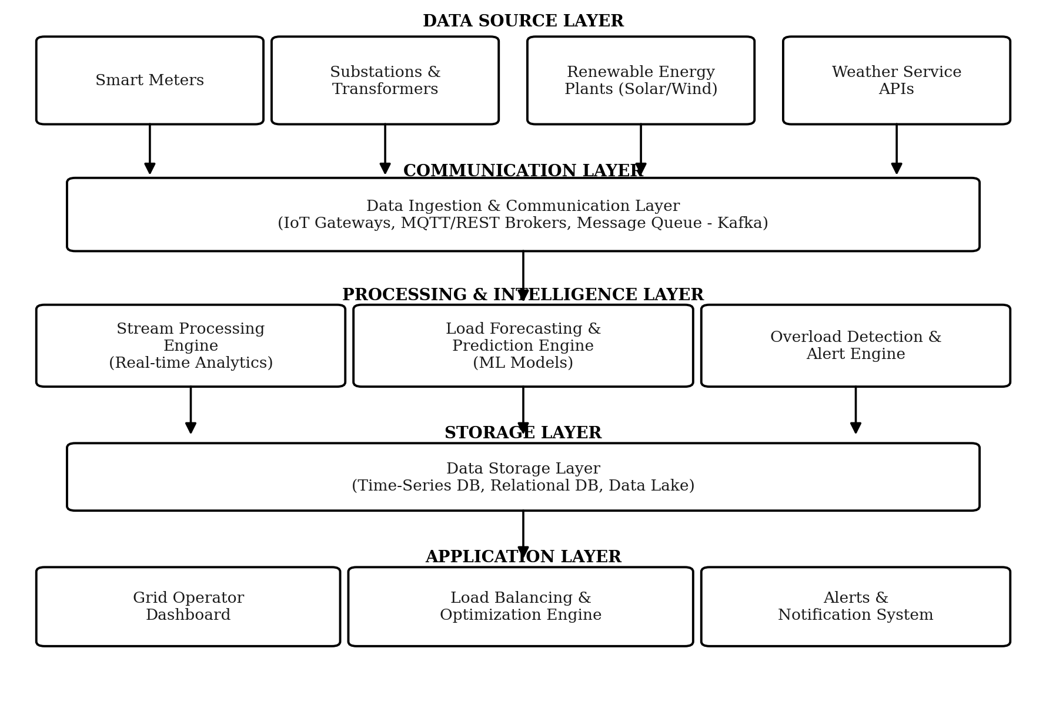
Figure 1: System Architecture of the Smart Grid Load Balancing System

Layer Descriptions
- Data Source Layer: Smart meters, substations/transformers, renewable plants, and weather service APIs act as data producers.
- Communication Layer: IoT gateways and message brokers (MQTT/Kafka) handle high-throughput, low-latency ingestion of telemetry.
- Processing & Intelligence Layer: Stream processing engines compute real-time metrics; ML-based forecasting engines predict demand; rule/anomaly engines detect overloads.
- Storage Layer: Time-series databases store telemetry (e.g., InfluxDB/TimescaleDB); relational databases store operator/asset metadata; a data lake retains raw data for retraining models.
- Application Layer: Operator dashboards, the load-balancing/optimization engine, and the alerting/notification subsystem.

10. Data Flow Diagram (DFD)

Level 0 (Context Diagram)
At Level 0, the entire Smart Grid Load Balancing System is represented as a single process that exchanges data with four external entities:
External Entity | Data Flow into System | Data Flow out of System
Smart Meters | Consumption readings | Configuration/commands
Substations | Voltage, current, frequency data | Load-redistribution commands
Renewable Plants | Generation output data | Curtailment/dispatch signals
Weather Services | Forecast data (temperature, wind, solar irradiance) | —
Grid Operator | Manual overrides, acknowledgements | Alerts, dashboards, reports

Level 1 (Major Processes)
The Level 1 DFD decomposes the system into its five core processes, each with its own data store:
Process | Input | Output | Data Store
1.0 Data Ingestion | Raw telemetry | Normalized data stream | D1: Raw Telemetry Store
2.0 Grid Monitoring | Normalized data | Live status metrics | D2: Live Metrics Store
3.0 Demand Forecasting | Historical + weather data | Demand forecast | D3: Forecast Store
4.0 Load Optimization | Forecast + live metrics | Redistribution plan | D4: Optimization Log
5.0 Overload Detection & Alerting | Live metrics | Alerts/notifications | D5: Alert Log

11. Database Design (Entity-Relationship Model)
The key entities and their relationships in the system's relational/time-series data model are summarized below.
Entity | Key Attributes | Relationship
SmartMeter | meter_id (PK), region_id (FK), install_date, status | Belongs to one Region; generates many Readings
Reading | reading_id (PK), meter_id (FK), timestamp, consumption_kWh | Many readings per SmartMeter
Substation | substation_id (PK), region_id (FK), capacity_MW | Belongs to one Region; has many LoadRecords
Region | region_id (PK), name, total_capacity_MW | One Region has many Substations/Meters
RenewablePlant | plant_id (PK), type, region_id (FK), capacity_MW | Belongs to one Region; generates GenerationRecords
ForecastRecord | forecast_id (PK), region_id (FK), forecast_time, predicted_load | Belongs to one Region
Alert | alert_id (PK), substation_id (FK), type, severity, timestamp | Raised for one Substation/Region
Operator | operator_id (PK), name, role, region_id (FK) | Manages one or more Regions

12. UML Diagrams

Use Case Diagram — Actors and Use Cases
Actor | Use Cases
Grid Operator | View live dashboard, Acknowledge alerts, Override optimization recommendation, Generate reports
System Administrator | Manage user access, Configure thresholds, Onboard new meters/substations
Data Analyst | Query historical analytics, Export consumption reports, Evaluate forecast accuracy
Forecasting Engine (system actor) | Generate demand forecast, Update model with new data
Optimization Engine (system actor) | Compute load redistribution plan, Trigger overload alert

Class Diagram — Core Classes
Class | Key Attributes | Key Operations
GridMonitor | regionId, currentLoad, status | collectData(), updateMetrics(), getStatus()
DemandForecaster | modelVersion, forecastHorizon | trainModel(), predictDemand(), evaluateAccuracy()
LoadOptimizer | optimizationStrategy | computeRedistribution(), applyPlan(), rollback()
OverloadDetector | thresholdConfig | detectAnomaly(), raiseAlert()
NotificationService | channelConfig | sendAlert(), sendReport()
AnalyticsEngine | reportTemplates | generateReport(), exportData()
In addition to the above, a Sequence Diagram would depict the flow: SmartMeter → DataIngestion → GridMonitor → OverloadDetector → NotificationService → GridOperator, showing the real-time path from data capture to operator alert. An Activity Diagram for the forecasting workflow would show: collect historical data → preprocess → train/update model → generate forecast → feed to LoadOptimizer.

13. Proposed Technology Stack
Layer | Technology Options
Communication/Ingestion | MQTT, Apache Kafka, REST/gRPC APIs
Stream Processing | Apache Spark Streaming, Apache Flink
Forecasting/ML | Python, TensorFlow/PyTorch, Prophet, scikit-learn
Storage | InfluxDB/TimescaleDB (time-series), PostgreSQL (relational), Amazon S3 / Data Lake
Backend Services | Java Spring Boot / Node.js microservices, Docker, Kubernetes
Frontend Dashboard | React.js, D3.js/Chart.js for visualization
Notification | Twilio (SMS), SMTP (Email), WebSocket push notifications
Cloud/Deployment | AWS / Azure / GCP with auto-scaling and multi-region deployment

14. Testing Strategy
- Unit Testing: Individual modules (forecasting, optimization, alerting) tested in isolation with mock data.
- Integration Testing: Verify end-to-end data flow from ingestion through to dashboard/alerts.
- Load & Stress Testing: Simulate peak-demand scenarios with millions of concurrent meter readings.
- Failover Testing: Validate system behaviour during node/service failures to ensure no single point of failure.
- Model Validation: Backtest forecasting models against historical demand data to measure accuracy (e.g., MAPE).
- User Acceptance Testing (UAT): Grid operators validate dashboard usability and alert relevance.

15. Expected Outcomes
- Improved grid stability through proactive, real-time monitoring.
- Reduced power outages via early overload detection and automated alerts.
- Better renewable integration through generation-aware load optimization.
- Lower operational costs from optimized power distribution and reduced downtime.
- Accurate demand forecasting enabling better operational and capacity planning.

16. Conclusion
The proposed Smart Electricity Grid Load Balancing System addresses the growing complexity of modern power grids by shifting from reactive to proactive grid management. By combining real-time monitoring, machine-learning-based demand forecasting, automated load optimization, and robust alerting, the platform enables utility providers to improve grid stability, better integrate renewable energy, and reduce operational costs — directly meeting the objectives and expected outcomes outlined in this report.

17. References
1. IEEE Standards Association — IEC 61850 Communication Networks and Systems for Power Utility Automation.
2. U.S. Department of Energy — Smart Grid System Report.
3. Apache Software Foundation — Kafka and Spark Streaming Documentation.
4. Sommerville, I. — Software Engineering, 10th Edition, Pearson Education.

