**Curriculum vitae**

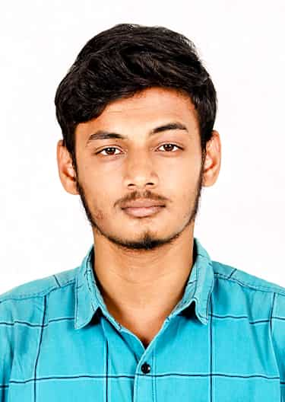Hemananth U

**131/50, E.S.I. Main Road, Salem Camp, Mettur, Salem, Tamil Nadu - 636456. [hemananthu.13@gmail.com](mailto:hemananthu.13@gmail.com)**

**+91 9952630181**

**[LinkedIn](https://www.linkedin.com/in/hemananth13/)**

**DOB: 14/09/2001**

# Professional Summary:

## Driven and detail-oriented cloud engineer with expertise in AWS cloud services, including EC2, S3, Lambda, and API Gateway, as well as hands-on experience in server-less computing and AI-based applications. Certified AWS Solutions Architect and Data Engineer with a strong foundation in Python, Java, and database technologies. Skilled in designing and implementing scalable, efficient, and innovative cloud solutions, with a proven track record in problem-solving and project execution. Adept at teamwork and continuous learning, with a commitment to leveraging cutting-edge technology to achieve business objectives.

## 

**Experience:**

**Associate Engineer - Technology, Virtusa Consulting Services Pvt Ltd (Jan 2024 - Present)**

**- Collaborated with cross-functional teams to design and deliver a server-less cloud-based Attendance Management System.**

**- Utilized AWS services like S3, Lambda, Rekognition, and DynamoDB to implement efficient application workflows.**

**- Developed and deployed REST APIs through AWS API Gateway to seamlessly integrate with attendance data storage.**

**- Demonstrated commitment to professional growth by attaining AWS Certified Solutions Architect and Data Engineer certifications during the role.**

**- Ensured robust back-end architecture and optimization, contributing to enhanced user experience and reliability.**

**Intern-Delivery at Virtusa Consulting Services Pvt Ltd (Jan 3, 2023 - Mar 30, 2023)**

**- Acquired proficiency in AWS cloud services and successfully achieved the AWS Certified Solutions Architect Associate certification.**

**- Assisted in back-end development tasks and actively contributed to team-based projects.**

**- Gained practical exposure to cloud computing concepts and their application in a professional environment.**

# Skill set:

# **Programming Languages: - Python - Java - SQL**

**Cloud & AWS Services: - AWS EC2 - AWS S3 - AWS Lambda - AWS DynamoDB**

**Database Technologies: - SQL - MongoDB**

**Version Control: - Git / GitHub**

**Additional Skills: - Problem-Solving - Teamwork - Adaptability - Attention to Detail**

**Certifications:**

**- AWS Data Engineer Associate (DEA-C01), 2024: Valid until 2027.**

**- AWS Certified Solutions Architect (SAA-C03), 2023: Valid until 2026.**

**- Oracle Cloud Infrastructure 2024 Generative AI Certified Professional: Valid until 2026.**

# Education:

## Bachelor of Engineering in Robotics and Automation

**Sri Ramakrishna Engineering College (SREC), Coimbatore (2020 – 2023)**

**CGPA: 7.82 (first-class graduate)**

## Diploma in Electrical and Electronics Engineering

**M.I.T. Polytechnic College, Mettur (2017 – 2020)**

**Percentage: 89 (first-class honors with distinction)**

## SSLC

**St. Mary's Matriculation Higher Secondary School, Mettur (2016 – 2017)**

**Percentage: 69.4**

# Declaration: **I hereby declare that the information furnished by me in the above document is correct and accurate to the best of my knowledge.**

**Place:**

**Date: (Signature)**