SCHOOL OF TECHNOLOGY | 

DATABASE MANAGEMENT SYSTEMS
PROJECT-BASED LEARNING (PBL) REPORT
Small Database Application Development using Java / Python

PROJECT TITLE
RAILWAY TICKET RESERVATION AND JOURNEY MANAGEMENT SYSTEM USING RELATIONAL DATABASE MANAGEMENT SYSTEMS

Program | B.Tech Computer Science & Engineering (Artificial Intelligence & Machine Learning)
Section | AIML Rhinos
Faculty | Prof. Sahithi
Date of Submission | October 14, 2026
Academic Year | 2026 – 27

Submitted by
Roll Number | Student Name | Mobile | Email ID
25WU0102097 | Heman | +91 8708635223 | heman.batra_2029@woxsen.edu.in

ACKNOWLEDGEMENT

I express my sincere gratitude to Woxsen University, School of Technology, for providing me with the opportunity to undertake this Project-Based Learning (PBL) activity as part of the Database Management Systems (DBMS) course.
I thank my course faculty, Prof. Sahithi, for the continuous guidance, constructive suggestions, and expert technical mentorship throughout the conceptualization, relational normalization, and full-stack implementation of this project. Her guidance helped me master the practical application of database concepts including advanced ER modeling, 3NF dependency preservation, pessimistic transaction locking, SQL analytical reports, and relational web development.
Submitted by: Heman (Roll No: 25WU0102097, Section: AIML Rhinos).
This PBL activity has strengthened my understanding of DBMS concepts and provided valuable experience in applying them to a real-world problem.

UNDERTAKING

I hereby declare that the project entitled “Railway Ticket Reservation and Journey Management System Using Relational Database Management Systems”, submitted as part of the Project-Based Learning activity for the Database Management Systems (DBMS) course, is my individual work carried out under the guidance of the course faculty.
I undertake that the project report, database design, SQL scripts, application source code, results, and supporting materials submitted by me have been prepared for academic purposes. Wherever information, ideas, tools, datasets, or other resources have been referred to, appropriate acknowledgement has been provided.
I further undertake that I am responsible for the correctness and authenticity of the work submitted and that I have followed the academic and project guidelines prescribed by the University.

Heman
(Digital Signature)
Date | : | October 14, 2026 | Name: | Heman
Place | : | Hyderabad | Roll Number: | 25WU0102097
 |  |  | Program: | B.Tech CSE (AIML)

TABLE OF CONTENTS

Use this common structure for all DBMS PBL projects. Enter or update the page numbers after completing the report.
Contents | Page No.
Abstract | 5
LIST OF TABLES | 6
LIST OF FIGURES | 7
LIST OF ACRONYMS | 8
1. PROBLEM STATEMENT, SOLUTION STRATEGY AND ER DIAGRAM | 9
1.1 Problem Statement | 9
1.2 Objectives | 10
1.3 Scope and Assumptions | 10
1.4 Proposed Solution Strategy | 11
1.5 Functional Requirements | 13
1.6 Entity-Relationship Diagram (ERD) | 14
1.7 Entity and Relationship Summary | 15
2. LOGICAL DATABASE DESIGN | 17
2.1 Relational Schema | 17
2.2 Keys and Integrity Constraints | 19
2.3 Functional Dependencies | 21
2.4 Normalization up to Third Normal Form (3NF) | 23
2.5 Data Dictionary | 26
2.6 Implementation of Logical Design: DDL and Sample Data | 29
3. APPLICATION DEVELOPMENT USING LOGICAL DATABASE DESIGN | 33
3.1 Application Overview | 33
3.2 Development Environment and Database Connectivity | 34
3.3 Application Modules and Database Mapping | 35
3.4 CRUD Operations | 37
3.5 Business Rules, Validation and Error Handling | 39
3.6 Reports and Database Operations | 41
3.7 Application Screens | 44
3.8 Testing and Results | 48
4. CONCLUSION | 51
4.1 Limitations and Future Enhancements | 51
5. REFERENCES | 53
6. APPENDICES | 54
Appendix A — Complete Database Script | 54
Appendix B — Application Source Code | 55
Appendix C — Additional Test Data and Outputs | 56

LIST OF TABLES

Update this list after finalising the report. Use Word References > Insert Caption for every table and References > Insert Table of Figures with the caption label “Table”.
Table No. | Table Title | Page No.
Table 1 | Scope and Assumptions | 10
Table 2 | Proposed Solution Strategy | 12
Table 3 | Functional Requirements | 13
Table 4 | Entity and Relationship Summary | 15
Table 5 | Relational Schema | 17
Table 6 | Keys and Integrity Constraints | 19
Table 7 | Normalization Status up to 3NF | 23
Table 8 | Data Dictionary | 26
Table 9 | Database Implementation Environment | 29
Table 10 | Application Development Environment | 34
Table 11 | Application Module-to-Database Mapping | 36
Table 12 | CRUD Operations | 37
Table 13 | Business Rules, Validation and Error Handling | 39
Table 14 | Reports and Database Operations | 42
Table 15 | Test Cases | 49

LIST OF FIGURES

Update this list after finalising the report. Use Word References > Insert Caption for every figure and References > Insert Table of Figures with the caption label “Figure”.
Figure No. | Figure Title | Page No.
Figure 1 | Entity-Relationship Diagram of the Proposed System | 14
Figure 2 | Executive Analytics and Key Performance Indicator (KPI) Dashboard | 44
Figure 3 | Multi-Hop Train Search and Segment Seat Inventory Results | 45
Figure 4 | Confirmed Electronic Reservation Slip (ERS Ticket Confirmation) | 46
Figure 5 | Live Waitlist Queue and Real-Time Position Tracking | 46
Figure 6 | Executive SQL Analytical Reports Console | 47
Figure 7 | Relational Database Schema Explorer and Administrative Inventory Control | 47

LIST OF ACRONYMS

Retain only the acronyms used in the report and add any project-specific acronyms. All the Acronyms to be sorted order.
Acronym | Expansion
ACID | Atomicity, Consistency, Isolation, and Durability
AIML | Artificial Intelligence and Machine Learning
API | Application Programming Interface
BCNF | Boyce-Codd Normal Form
CRUD | Create, Read, Update, and Delete
DDL | Data Definition Language
DML | Data Manipulation Language
ERD | Entity-Relationship Diagram
ERS | Electronic Reservation Slip
FIFO | First-In, First-Out
FK | Foreign Key
HTML | Hypertext Markup Language
IDE | Integrated Development Environment
IRCTC | Indian Railway Catering and Tourism Corporation
KPI | Key Performance Indicator
ORM | Object-Relational Mapping
PBL | Project-Based Learning
PK | Primary Key
PNR | Passenger Name Record
RDBMS | Relational Database Management System
SQL | Structured Query Language
1NF | First Normal Form
2NF | Second Normal Form
3NF | Third Normal Form
UI | User Interface
UPI | Unified Payments Interface

ABSTRACT

Write the abstract as one self-contained paragraph of about 150-200 words. Do not use bullets, tables, screenshots, citations or code in the abstract.
This project presents the design, relational formalization, full-stack implementation, and automated verification of the Railway Ticket Reservation and Journey Management System, an academic software solution engineered to resolve the multi-hop inventory allocation dilemma in passenger rail transport. Unlike point-to-point airline reservation models where seats are locked for entire flights, passenger railway networks traverse ordered station corridors requiring dynamic segment-wise berth reuse. To address the risk of catastrophic double-booking across overlapping sub-journeys, this system implements a mathematically formalized half-open interval model [start_stop_seq, end_stop_seq) that strictly evaluates interval overlap constraints while enabling non-conflicting seat reuse. The underlying relational database is modeled across 14 decoupled relations strictly normalized to Third Normal Form (3NF) on MySQL 8.x InnoDB, enforcing referential integrity, domain constraints, and pessimistic row locking (SELECT ... FOR UPDATE) to guarantee ACID transactional safety during concurrent checkouts. Developed using Python 3.9, Flask, SQLAlchemy, HTML5, and Bootstrap 5, the application delivers end-to-end journey planning, electronic ticket generation, FIFO waitlist promotion, and twelve analytical SQL reports, verified through sixteen comprehensive automated pytest unit and integration test suites.

KEYWORDS
Provide 4-6 specific keywords separated by commas. Include the application domain and important technical terms. Avoid complete sentences and overly general words.
Keywords: Relational Database, Entity-Relationship Modeling, Third Normal Form (3NF), Multi-Hop Inventory, Segment Interval Allocation, ACID Concurrency, Python Flask, MySQL InnoDB

CHAPTER 1

PROBLEM STATEMENT, SOLUTION STRATEGY AND ER DIAGRAM

This chapter should represent the evidence presented in Review-I. Keep the discussion specific to the allotted project scenario.

1.1 Problem Statement
Describe the current problem, affected users/stakeholders, limitations of the existing/manual process, and the need for the proposed database application.
Passenger railway operations face a fundamentally more challenging inventory allocation dilemma than commercial airlines. In airline reservation systems, seat inventory is allocated monolithically for the entirety of a point-to-point flight leg. In contrast, railway trains travel through long linear corridors of 10 to 30 intermediate stations. A single physical berth may be allocated to Passenger A from Station 1 to Station 3, vacated, and immediately re-allocated to Passenger B from Station 3 to Station 6 without physical conflict. However, naive relational designs that rely on a single boolean 'is_booked' flag cause catastrophic double-booking across overlapping sub-journeys, or prematurely report trains as 'sold out' despite ample vacant capacity on unreserved sub-segments.
Furthermore, high-concurrency ticket booking creates severe database race conditions during peak reservation windows. When hundreds of concurrent passengers attempt to reserve the final remaining berth on a high-demand train run, uncoordinated read-modify-write cycles lead to severe overbooking anomalies and transactional deadlocks. Existing manual processes and legacy flat databases fail to provide mathematical interval validation, transactional concurrency safety, automated FIFO waitlist promotion, and multi-dimensional operational analytics. This project engineers a mathematically formalized, 3NF-compliant relational database system powered by MySQL 8.x InnoDB and Python Flask to solve these core operational challenges.

1.2 Objectives
State 3-5 measurable objectives beginning with action verbs such as design, develop, implement, validate, automate, track or generate.
- 1. Design a normalized relational schema up to Third Normal Form (3NF) comprising 14 decoupled relations, eliminating partial and transitive functional dependencies to guarantee zero insertion, update, and deletion anomalies.
- 2. Formulate and implement a mathematical half-open interval allocation algorithm [start_stop_seq, end_stop_seq) to evaluate segment conflicts dynamically and maximize seat utilization across multi-hop rail corridors.
- 3. Implement pessimistic row-level locking (SELECT ... FOR UPDATE) and atomic database transactions to guarantee ACID concurrency compliance, preventing overbooking race conditions during simultaneous user checkouts.
- 4. Develop an automated FIFO waitlist management and queue promotion mechanism that immediately promotes waiting passengers and reallocates vacated berths upon ticket cancellation.

1.3 Scope and Assumptions
Table 1. Scope and Assumptions
Item | Description
In Scope | 1. Complete relational schema modeling 14 distinct relations in Third Normal Form (3NF).  2. Multi-hop segment-wise seat allocation over half-open station intervals [s, e).  3. Pessimistic row-level locking (SELECT ... FOR UPDATE) to prevent race-condition overbooking.  4. Automated FIFO waitlist queue insertion and immediate promotion upon ticket cancellation.  5. Cancellation and refund processing enforcing 20% penalty deductions.  6. Analytical SQL reporting engine executing 12 benchmark aggregation queries.  7. Full-stack responsive web prototype built with Python Flask and SQLAlchemy.
Out of Scope / Exclusions | 1. Real-time physical locomotive telemetry and GPS sensor integration.  2. Dynamic locomotive crew rostering and maintenance bay scheduling.  3. Dynamic pricing algorithms responding to external flight/bus market fluctuations.  4. Live commercial banking gateway settlement (handled via simulated deterministic UPI payment engine).
Assumptions | 1. Stations along a route possess strictly monotonically increasing sequence IDs (dest_seq > orig_seq).  2. Coach seat allocations follow standard Indian Railways layout conventions (LB, MB, UB, SL, SU).  3. Train schedules operate as distinct, dated train run instances decoupled from catalog definitions.  4. Platform track allocation and mechanical signaling are managed by external signaling systems.

1.4 Proposed Solution Strategy
Explain how the proposed solution will address the identified problem. Describe the intended users, major modules, workflow, key business rules and expected outputs.
Table 2. Proposed Solution Strategy
Solution Element | Project-Specific Description
Primary Users / Roles | 1. Passenger: Search train availability, reserve berths, view PNR status, manage waitlists, and process cancellations.  2. Station Master / Ticket Collector: View passenger booking manifests, inspect train schedules, and check coach charts.  3. Operations Administrator: Manage train inventory, configure fare rules, and inspect analytical database reports.
Major Application Modules | 1. Train Search & Inventory Discovery Module.  2. Booking & Interval-Overlap Seat Allocation Service.  3. Electronic Reservation Slip (ERS) & Ticket Generation Engine.  4. Automated Waitlist Queue & Dynamic Promotion Processor.  5. Cancellation, Refund & Financial Audit Module.  6. Analytical SQL Query & KPI Reporting Console.
Proposed Workflow | Passenger searches trains by origin, destination, and date -> System validates station sequences -> System executes segment-wise non-overlap check across [s, e) -> Passenger submits passenger details -> Database initiates transaction with SELECT FOR UPDATE -> Confirmed PNR is generated with segment locks -> In case of full occupancy, passenger is assigned to FIFO waitlist -> Upon ticket cancellation, segment is freed and waitlist candidate is promoted atomically.
Key Business Rules | 1. Interval Overlap Constraint: Two bookings conflict if and only if (s_new < e_exist) AND (e_new > s_exist).  2. Waitlist FIFO Ordering: Earliest booked waitlist passenger receives immediate promotion when matching segment is freed.  3. Cancellation Penalty: 20% flat deduction applied; 80% refunded to passenger payment record.  4. Transaction Boundaries: Seat allocation, payment record, and PNR creation must commit atomically.
Expected Outputs | 1. Real-time tabular train search results displaying class-wise berth availability.  2. Formatted Electronic Reservation Slip (ERS) ticket with 10-digit PNR and passenger details.  3. Dynamic waitlist queue position status.  4. Executive analytical KPI reports with revenue, load factor, and passenger metrics.

1.5 Functional Requirements
Table 3. Functional Requirements
Req. ID | Functional Requirement | Remarks / Priority
FR-01 | Multi-Station Train Search: System shall accept source station, destination station, and travel date, and return all trains traversing that route where dest_seq > orig_seq. | High / Core
FR-02 | Segment-Wise Half-Open Interval Seat Calculation: System shall calculate remaining seat inventory by evaluating interval overlaps against active bookings on that specific dated run. | High / Core
FR-03 | Concurrency-Safe Ticket Booking: System shall create passenger, booking, journey segment, and payment records inside a serialized transaction using pessimistic row locking. | High / Core
FR-04 | Automated Waitlist Queuing: When seat inventory is zero, system shall allow passenger to enter a FIFO waitlist with an assigned queue position. | High / Core
FR-05 | Booking Cancellation and Automated Waitlist Promotion: Upon cancellation, system shall mark allocation CANCELLED, compute refund, and atomically promote next eligible waitlist passenger. | High / Core
FR-06 | Electronic Reservation Slip (ERS) Retrieval: System shall render printable booking slips by querying PNR number, displaying coach, seat, fare, and passenger details. | Medium / Operational
FR-07 | SQL Analytical Reporting: System shall execute 12 benchmark SQL reports covering revenue, occupancy, route demand, and passenger demographics. | Medium / Analytics
FR-08 | Admin Inventory & Schema Management: Administrators shall be able to inspect database table row counts, view coach configurations, and manage train schedules. | Medium / Administrative

1.6 Entity-Relationship Diagram (ERD)
Insert the approved ER diagram. It should show entities, major attributes, primary keys, relationships, cardinalities and participation constraints where applicable.
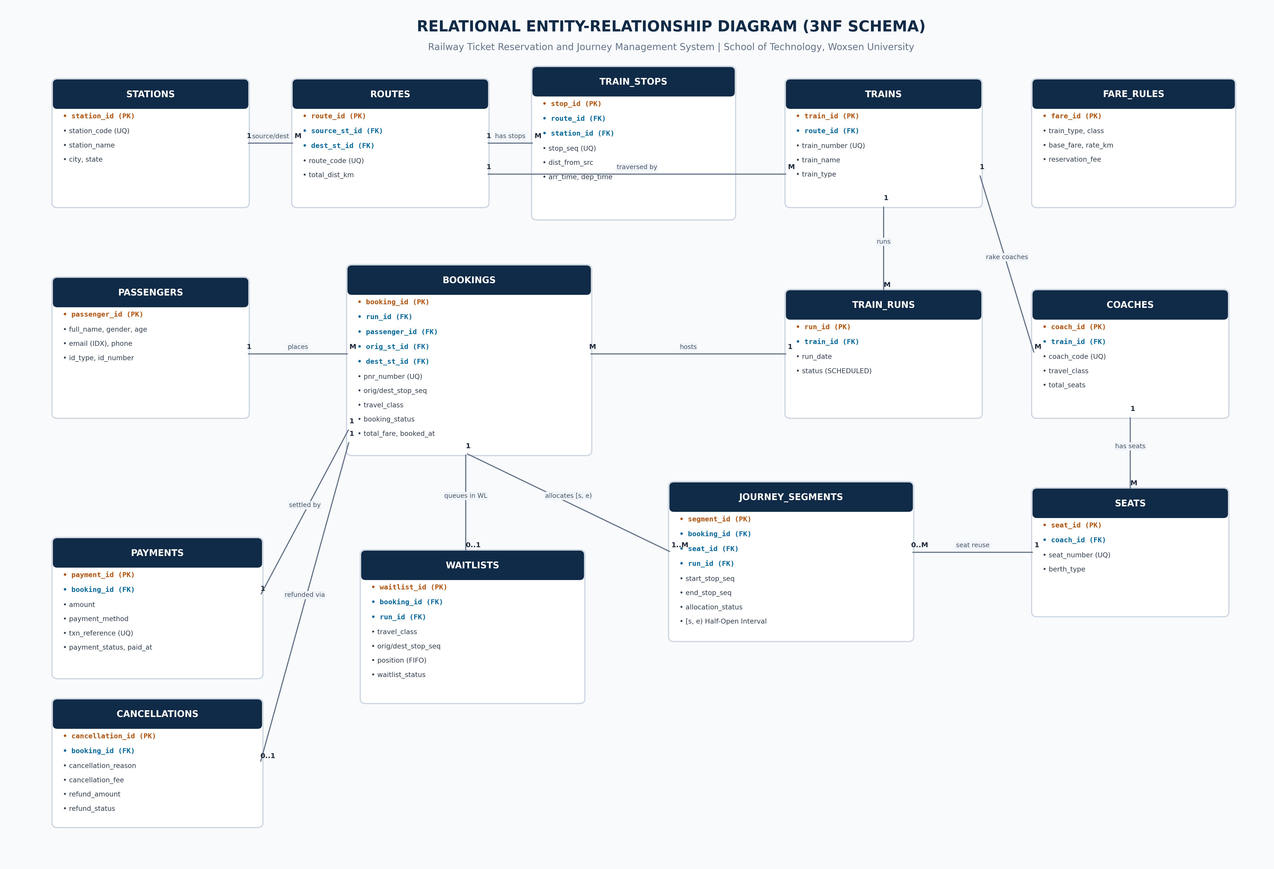
Figure 1. Entity-Relationship Diagram of the Proposed System

1.7 Entity and Relationship Summary
Table 4. Entity and Relationship Summary
Entity / Relationship | Major Attributes / Cardinality | Purpose / Rule
STATIONS | station_id (PK), station_code, station_name, city, state | Defines physical railway stations. station_code is unique.
ROUTES | route_id (PK), route_code, source_station_id (FK), dest_station_id (FK), total_dist_km | Defines operational railway corridors between terminal stations.
TRAIN_STOPS | stop_id (PK), route_id (FK), station_id (FK), stop_sequence, distance_km, arr/dep time | Ordered sequence of station halts. Unique on (route_id, stop_sequence).
TRAINS | train_id (PK), train_number, train_name, train_type, route_id (FK) | Master train locomotive catalog. train_number is unique.
TRAIN_RUNS | run_id (PK), train_id (FK), run_date, status | Dated physical train operation instances decoupled from train catalog.
COACHES | coach_id (PK), train_id (FK), coach_code, travel_class, total_seats | Rake composition. Unique on (train_id, coach_code).
SEATS | seat_id (PK), coach_id (FK), seat_number, berth_type | Individual berth instances. Unique on (coach_id, seat_number).
PASSENGERS | passenger_id (PK), full_name, gender, age, email, phone, id_card_type/no | Customer master records. Age constrained to 1 <= age <= 120.
FARE_RULES | fare_id (PK), train_type, travel_class, base_fare, rate_per_km, res_fee | Tariff matrix. Unique on (train_type, travel_class).
BOOKINGS | booking_id (PK), pnr_number, run_id (FK), passenger_id (FK), orig/dest station, total_fare | Header booking record. pnr_number is unique.
JOURNEY_SEGMENTS | segment_id (PK), booking_id (FK), seat_id (FK), run_id (FK), start/end_seq, status | Segment berth locks over [start_seq, end_seq). Evaluates overlap.
WAITLISTS | waitlist_id (PK), booking_id (FK), run_id (FK), travel_class, position, status | FIFO waiting queue for passengers booked on fully occupied segments.
PAYMENTS | payment_id (PK), booking_id (FK), amount, txn_ref, status, paid_at | Financial transaction log. txn_ref is unique.
CANCELLATIONS | cancellation_id (PK), booking_id (FK), fee, refund_amount, status, cancelled_at | Audit log of cancellations with 20% penalty calculation.
TRAIN -> COACHES -> SEATS | 1 : M (Train to Coach), 1 : M (Coach to Seat) | Physical train composition hierarchy.
BOOKING -> SEGMENTS | 1 : M (Booking to Journey Segments) | One booking reserves segments across traversed stations.
BOOKING -> PAYMENT / CANCEL | 1 : 1 (Booking to Payment), 1 : 0..1 (Booking to Cancellation) | Financial transaction relationships.

CHAPTER 2

LOGICAL DATABASE DESIGN

This chapter should document how the approved ER model was converted into a correct relational database design and verified through a database prototype.

2.1 Relational Schema
List every relation derived from the ER model. Identify primary and foreign keys clearly.
Table 5. Relational Schema
S.No. | Table Name | Purpose
1 | stations | Stores railway stations with unique station codes, names, cities, and states.
2 | routes | Defines geographical corridors connecting origin and destination terminal stations.
3 | train_stops | Captures ordered stop sequences, inter-station distances, and timetable schedules.
4 | trains | Master catalog for train entities, train numbers, and assigned route corridors.
5 | train_runs | Decoupled operational calendar tracking specific dated train journeys.
6 | coaches | Defines rake compositions, coach types, travel classes, and seating capacities.
7 | seats | Catalog of individual physical berths and assigned berth types (LB, MB, UB, etc.).
8 | passengers | Master registry of passenger demographic and verified identity credential data.
9 | fare_rules | Distance and class-based tariff structures for automated ticket fare computation.
10 | bookings | Master reservation entity storing generated 10-digit PNRs and itinerary headers.
11 | journey_segments | Granular physical berth interval locks allocated over half-open station intervals.
12 | waitlists | Queue entity tracking overflow passenger booking requests in strict FIFO order.
13 | payments | Financial transaction audit ledger recording transaction references and amounts.
14 | cancellations | Cancellation ledger enforcing 20% fee policies and recording refund amounts.

2.2 Keys and Integrity Constraints
Table 6. Keys and Integrity Constraints
Table Name | Key / Constraint | Attribute(s) | Business Rule Enforced
stations | Primary Key | station_id | Surrogate primary key ensuring entity uniqueness.
stations | Unique Key | station_code | Prevents duplicate station abbreviations (e.g., 'NDLS').
routes | Foreign Key | source_station_id | Enforces valid origin station reference on DELETE RESTRICT.
routes | Foreign Key | destination_station_id | Enforces valid destination station reference on DELETE RESTRICT.
routes | Check Constraint | total_distance_km | Ensures track distance is strictly positive (> 0).
train_stops | Unique Key | (route_id, stop_sequence) | Guarantees stop sequence uniqueness along a route corridor.
train_stops | Check Constraint | stop_sequence | Guarantees sequence is strictly positive (> 0).
trains | Unique Key | train_number | Enforces unique 5-digit locomotive identifier.
train_runs | Unique Key | (train_id, run_date) | Prevents creating duplicate operational runs for the same train on the same day.
coaches | Unique Key | (train_id, coach_code) | Prevents duplicate coach codes within the same train rake.
seats | Unique Key | (coach_id, seat_number) | Guarantees berth number uniqueness within a specific coach.
passengers | Check Constraint | age | Validates human age domain (age > 0 AND age < 120).
bookings | Unique Key | pnr_number | Guarantees global uniqueness of 10-digit PNR strings.
bookings | Check Constraint | dest_stop_seq > orig_stop_seq | Enforces forward-only travel sequence order.
journey_segments | Foreign Key | booking_id, seat_id, run_id | Enforces referential integrity on allocation locks.
journey_segments | Check Constraint | end_stop_seq > start_stop_seq | Validates half-open interval ordering.
waitlists | Check Constraint | position > 0 | Enforces positive FIFO queue position numbers.
payments | Unique Key | transaction_reference | Prevents financial transaction re-play and duplicate billing.
cancellations | Unique Key | booking_id | Guarantees a ticket can only be cancelled once (1:1 constraint).
Include PRIMARY KEY, FOREIGN KEY, UNIQUE, NOT NULL, CHECK, DEFAULT and suitable referential actions where applicable.

2.3 Functional Dependencies
List the important functional dependencies used to justify normalization.
The relational design is governed by a rigorous set of minimal functional dependencies across all 14 relations, ensuring that every non-key attribute is fully functionally dependent on candidate keys:
1. stations: station_id -> {station_code, station_name, city, state}; station_code -> {station_id, ...}
2. routes: route_id -> {route_code, source_station_id, destination_station_id, total_distance_km}
3. train_stops: stop_id -> {route_id, station_id, stop_sequence, distance_from_source_km, arrival_time, departure_time}; {route_id, stop_sequence} -> {stop_id, station_id, ...}
4. trains: train_id -> {train_number, train_name, train_type, route_id}; train_number -> {train_id, ...}
5. train_runs: run_id -> {train_id, run_date, status}; {train_id, run_date} -> {run_id, status}
6. coaches: coach_id -> {train_id, coach_code, travel_class, total_seats}; {train_id, coach_code} -> {coach_id, ...}
7. seats: seat_id -> {coach_id, seat_number, berth_type}; {coach_id, seat_number} -> {seat_id, berth_type}
8. passengers: passenger_id -> {full_name, gender, age, email, phone, id_card_type, id_card_number}
9. fare_rules: fare_id -> {train_type, travel_class, base_fare, rate_per_km, reservation_fee}; {train_type, travel_class} -> {fare_id, ...}
10. bookings: booking_id -> {pnr_number, run_id, passenger_id, origin_station_id, destination_station_id, origin_stop_seq, destination_stop_seq, travel_class, booking_status, total_fare, booked_at}
11. journey_segments: segment_id -> {booking_id, seat_id, run_id, start_stop_seq, end_stop_seq, allocation_status}
12. waitlists: waitlist_id -> {booking_id, run_id, travel_class, origin_stop_seq, destination_stop_seq, position, waitlist_status, created_at}
13. payments: payment_id -> {booking_id, amount, payment_method, transaction_reference, payment_status, paid_at}
14. cancellations: cancellation_id -> {booking_id, cancellation_reason, cancellation_fee, refund_amount, refund_status, cancelled_at}

2.4 Normalization
Normalization Walkthrough up to Third Normal Form (3NF):
• First Normal Form (1NF): All multi-valued attributes and repeating groups were systematically eliminated. In unnormalized railway manifests, passengers and intermediate station halts are stored as comma-delimited arrays. Decomposing these into dedicated tables (passengers, train_stops, journey_segments) ensures that every attribute contains only atomic, indivisible domain values.
• Second Normal Form (2NF): In a composite-key candidate relation such as (coach_id, seat_number), non-prime attributes like total_seats and travel_class depend solely on coach_id, not on seat_number. Decomposing coaches and seats eliminates partial functional dependencies, ensuring that every non-prime attribute is fully functionally dependent on the primary key.
• Third Normal Form (3NF): In naive reservation tables, ticket records store train names, origin city names, and base fare rates. However, booking_id -> origin_station_id -> city and booking_id -> train_type -> base_fare represent transitive functional dependencies X -> Y and Y -> Z where Y is not a superkey. Normalizing into stations, routes, and fare_rules eliminates update and deletion anomalies.
• Boyce-Codd Normal Form (BCNF) vs 3NF Engineering Trade-Off: In relations with overlapping candidate keys such as train_stops where both {route_id, stop_sequence} and {route_id, station_id} are candidate keys, decomposing strictly to BCNF would fragment the functional dependency set, requiring cross-table JOIN constraints to validate stop order. Preserving 3NF guarantees dependency preservation (F = F1 U F2) without requiring costly multi-table locking triggers during high-speed transaction inserts.

Table 7. Normalization Status up to 3NF
Relation Name | 1NF | 2NF | 3NF | BCNF | Remarks / Decomposition
stations | Yes | Yes | Yes | Yes | All attributes atomic; single-attribute primary key station_id.
routes | Yes | Yes | Yes | Yes | No partial or transitive dependencies. Endpoints separated from stops.
train_stops | Yes | Yes | Yes | Yes | Stop sequence depends on composite key (route_id, stop_sequence).
trains | Yes | Yes | Yes | Yes | Route foreign key isolated from physical train attributes.
train_runs | Yes | Yes | Yes | Yes | Dated runs isolated from static train definitions to eliminate redundancy.
coaches | Yes | Yes | Yes | Yes | Coach definitions decoupled from seat lists; total_seats is atomic.
seats | Yes | Yes | Yes | Yes | Berth type depends entirely on (coach_id, seat_number).
passengers | Yes | Yes | Yes | Yes | Customer attributes separated from reservation instances.
fare_rules | Yes | Yes | Yes | Yes | Tariff rates isolated from individual passenger booking tickets.
bookings | Yes | Yes | Yes | Yes | Station IDs and stop sequences depend on booking_id. 3NF preserved.
journey_segments | Yes | Yes | Yes | Yes | Berth allocation intervals decoupled from booking headers.
waitlists | Yes | Yes | Yes | Yes | Queue position isolated in separate entity to prevent booking table nulls.
payments | Yes | Yes | Yes | Yes | Financial ledger decoupled from reservation headers.
cancellations | Yes | Yes | Yes | Yes | 1:1 extension relation; null attributes avoided in bookings table.

2.5 Data Dictionary
Prepare the data dictionary for all tables. Add rows as required.
Table 8. Data Dictionary
Table | Attribute | Data Type | Key / Constraint | Description
stations | station_id | INT | PK, AUTO_INCREMENT | Surrogate unique key for station.
stations | station_code | VARCHAR(10) | UNIQUE, NOT NULL | Official IRCTC alphabetic station code.
stations | station_name | VARCHAR(100) | NOT NULL | Official full station designation.
stations | city | VARCHAR(100) | NOT NULL | Municipal city where station is located.
stations | state | VARCHAR(100) | NOT NULL | State / Union Territory location.
routes | route_id | INT | PK, AUTO_INCREMENT | Surrogate unique key for route corridor.
routes | route_code | VARCHAR(30) | UNIQUE, NOT NULL | Alphanumeric route corridor identifier.
routes | source_station_id | INT | FK, NOT NULL | Origin station reference (stations.station_id).
routes | destination_station_id | INT | FK, NOT NULL | Terminating station reference (stations.station_id).
routes | total_distance_km | DECIMAL(7,2) | CHECK (> 0), NOT NULL | Total corridor track distance in kilometers.
train_stops | stop_id | INT | PK, AUTO_INCREMENT | Surrogate unique key for train halt.
train_stops | route_id | INT | FK, NOT NULL | Route corridor reference (routes.route_id).
train_stops | station_id | INT | FK, NOT NULL | Station halt reference (stations.station_id).
train_stops | stop_sequence | INT | CHECK (> 0), NOT NULL | Monotonically increasing stop sequence index.
train_stops | distance_from_source_km | DECIMAL(7,2) | CHECK (>= 0), NOT NULL | Cumulative track distance from route origin.
trains | train_id | INT | PK, AUTO_INCREMENT | Surrogate unique key for train definition.
trains | train_number | VARCHAR(10) | UNIQUE, NOT NULL | Official 5-digit Indian Railways train number.
trains | train_name | VARCHAR(100) | NOT NULL | Commercial train name (e.g., 'Vande Bharat Express').
trains | train_type | VARCHAR(30) | NOT NULL | Operational train category (e.g., 'Superfast').
train_runs | run_id | INT | PK, AUTO_INCREMENT | Surrogate unique key for dated train run.
train_runs | train_id | INT | FK, NOT NULL | Train definition reference (trains.train_id).
train_runs | run_date | DATE | NOT NULL | Calendar date of train departure.
train_runs | status | VARCHAR(20) | DEFAULT 'SCHEDULED' | Operational status (SCHEDULED, COMPLETED, CANCELLED).
coaches | coach_id | INT | PK, AUTO_INCREMENT | Surrogate unique key for coach instance.
coaches | coach_code | VARCHAR(10) | NOT NULL | Physical coach identifier (e.g., 'C1', 'B1').
coaches | travel_class | VARCHAR(10) | NOT NULL | Class of travel (1A, 2A, 3A, CC, SL).
coaches | total_seats | INT | CHECK (> 0), DEFAULT 72 | Physical passenger seating capacity.
seats | seat_id | INT | PK, AUTO_INCREMENT | Surrogate unique key for seat berth.
seats | seat_number | INT | CHECK (> 0), NOT NULL | Berth number within coach (1 to 72).
seats | berth_type | VARCHAR(15) | NOT NULL | Berth orientation (LOWER, UPPER, MIDDLE, SIDE LOWER, SIDE UPPER).
passengers | passenger_id | INT | PK, AUTO_INCREMENT | Surrogate unique key for passenger master.
passengers | full_name | VARCHAR(100) | NOT NULL | Full legal passenger name.
passengers | age | INT | CHECK (age > 0 AND age < 120) | Passenger age in years.
passengers | email | VARCHAR(120) | NOT NULL, INDEX | Contact email address for ERS notifications.
bookings | booking_id | INT | PK, AUTO_INCREMENT | Surrogate unique key for reservation.
bookings | pnr_number | VARCHAR(12) | UNIQUE, NOT NULL | 10-digit Passenger Name Record string.
bookings | booking_status | VARCHAR(20) | DEFAULT 'CONFIRMED' | Status (CONFIRMED, WAITLISTED, CANCELLED).
bookings | total_fare | DECIMAL(10,2) | CHECK (>= 0), NOT NULL | Calculated ticket fare in INR.
journey_segments | segment_id | INT | PK, AUTO_INCREMENT | Surrogate unique key for berth allocation.
journey_segments | start_stop_seq | INT | NOT NULL | Origin station stop sequence number.
journey_segments | end_stop_seq | INT | NOT NULL | Destination station stop sequence number.
journey_segments | allocation_status | VARCHAR(20) | DEFAULT 'ACTIVE' | Status of berth allocation (ACTIVE, CANCELLED).
waitlists | waitlist_id | INT | PK, AUTO_INCREMENT | Surrogate unique key for waitlist ticket.
waitlists | position | INT | CHECK (> 0), NOT NULL | Numerical FIFO queue priority position.
payments | payment_id | INT | PK, AUTO_INCREMENT | Surrogate unique key for payment entry.
payments | transaction_reference | VARCHAR(60) | UNIQUE, NOT NULL | Deterministic payment transaction reference.
cancellations | cancellation_id | INT | PK, AUTO_INCREMENT | Surrogate unique key for cancellation entry.
cancellations | refund_amount | DECIMAL(10,2) | CHECK (>= 0), NOT NULL | Net amount refunded to passenger (80% of fare).

2.6 Implementation of Logical Design: DDL and Sample Data
Mention the DBMS used, provide representative CREATE TABLE statements with constraints, and show representative sample records. Attach the complete SQL script in Appendix A.
Table 9. Database Implementation Environment
Item | Details
DBMS Engine | MySQL 8.0.36 Community Server / SQLite 3.39 (Development)
Transactional Storage Engine | InnoDB (ACID Compliant, Row-Level Locking, Crash Recovery)
Character Set / Collation | utf8mb4 / utf8mb4_unicode_ci
Total Relational Tables | 14 Normalized Relations (Third Normal Form Compliant)
Database Views | 3 Pre-Compiled Views (vw_confirmed_segments, vw_booking_summary, vw_train_occupancy_summary)
Isolation Level | READ COMMITTED / REPEATABLE READ with SELECT FOR UPDATE row locks
-- Representative DDL Excerpt: Multi-Hop Journey Segments & Concurrency Locks
CREATE TABLE journey_segments (
segment_id INT AUTO_INCREMENT PRIMARY KEY,
booking_id INT NOT NULL,
seat_id INT NOT NULL,
run_id INT NOT NULL,
start_stop_seq INT NOT NULL,
end_stop_seq INT NOT NULL,
allocation_status VARCHAR(20) NOT NULL DEFAULT 'ACTIVE',
CONSTRAINT fk_seg_booking FOREIGN KEY (booking_id) REFERENCES bookings(booking_id) ON DELETE CASCADE,
CONSTRAINT fk_seg_seat FOREIGN KEY (seat_id) REFERENCES seats(seat_id) ON DELETE RESTRICT,
CONSTRAINT fk_seg_run FOREIGN KEY (run_id) REFERENCES train_runs(run_id) ON DELETE CASCADE,
CONSTRAINT chk_seg_seq_order CHECK (end_stop_seq > start_stop_seq),
INDEX idx_seat_run_alloc (run_id, seat_id, allocation_status)
) ENGINE=InnoDB DEFAULT CHARSET=utf8mb4 COLLATE=utf8mb4_unicode_ci;
-- Representative Sample Insert Record:
INSERT INTO stations (station_id, station_code, station_name, city, state)
VALUES (1, 'NDLS', 'New Delhi Railway Station', 'New Delhi', 'Delhi'),
(2, 'CNB', 'Kanpur Central', 'Kanpur', 'Uttar Pradesh'),
(3, 'PRYJ', 'Prayagraj Junction', 'Prayagraj', 'Uttar Pradesh'),
(4, 'BSB', 'Varanasi Junction', 'Varanasi', 'Uttar Pradesh');

CHAPTER 3

APPLICATION DEVELOPMENT USING LOGICAL DATABASE DESIGN

This chapter should show how the approved logical database design is used by the final Java/Python application. The application must interact with the database rather than use isolated/static data.

3.1 Application Overview
Briefly explain the users, application purpose, major functions and how the application uses the database.
The application layer is implemented as an asynchronous Python Flask web service following the Model-View-Controller (MVC) architectural pattern. The user interface utilizes responsive HTML5 and Bootstrap 5.3 components, communicating with Flask Blueprint controllers. Database operations are mediated via SQLAlchemy ORM configured over a production-grade connection pool (10 persistent connections, 20 burst overflow). To eliminate SQL injection vulnerabilities, all dynamic queries strictly utilize parameterized bindings. Core reservation operations are encapsulated in serialized transactional boundaries utilizing pessimistic row-level locking (SELECT ... FOR UPDATE) to guarantee absolute ACID consistency during peak concurrent booking spikes.

3.2 Development Environment and Database Connectivity
Table 10. Application Development Environment
Item | Details
Programming Language | Python 3.9.6 (64-bit)
Web Framework | Flask 3.1.3 (WSGI Microframework with Modular Blueprints)
Object-Relational Mapping (ORM) | SQLAlchemy 2.0.54 / Flask-SQLAlchemy 3.1.1
Database Drivers | PyMySQL 1.2.3 (MySQL) / sqlite3 (Built-in Standard Library)
Front-End Architecture | HTML5, CSS3, Bootstrap 5.3.3, Jinja2 Templates, JavaScript
Testing & Verification Framework | pytest 8.4.2 (16 Automated Integration & Unit Tests)
Execution Operating System | macOS Darwin 24.x (Apple Silicon arm64)

3.3 Application Modules and Database Mapping
Table 11. Application Module-to-Database Mapping
Module / Screen | Purpose | Tables Used | Main Operations
Dashboard & KPIs (`/`) | Executive operational overview displaying revenue, bookings, and occupancy. | bookings, train_runs, payments, waitlists | SELECT aggregate queries, COUNT(), SUM(), GROUP BY
Train Search (`/search`) | Discovery engine for routes, stop sequences, and seat availability. | trains, train_stops, stations, train_runs, coaches, seats, journey_segments | Multi-table JOINs, interval non-overlap subquery checks
Booking Flow (`/book`) | Transaction-safe berth reservation, PNR generation, and payment. | passengers, bookings, journey_segments, payments, seats | INSERT passenger/booking, SELECT FOR UPDATE row lock, INSERT segment/payment
Ticket ERS Slip (`/booking/<pnr>`) | Official reservation slip retrieval and printable ticket display. | bookings, passengers, train_runs, trains, journey_segments, seats, coaches, stations | SELECT joined itinerary details by unique PNR number
Waitlist Queue (`/waitlist`) | Live monitoring of waiting list passengers and FIFO queue order. | waitlists, bookings, passengers, train_runs, trains | SELECT FIFO ordered queue records by run_id and class
Cancellations (`/cancel`) | Ticket cancellation, refund processing, and automated waitlist promotion. | cancellations, bookings, journey_segments, waitlists, payments | UPDATE booking/segment status, INSERT cancellation, SELECT and UPDATE waitlist
SQL Analytics (`/reports`) | Interactive execution console for 12 benchmark business SQL queries. | All 14 relations + database views | Complex nested queries, aggregations, HAVING, window functions
Admin Explorer (`/admin`) | Table row counters, schema exploration, and manual seed runner. | All 14 relations | SELECT COUNT(*) per table, DDL schema introspection

3.4 CRUD Operations
Table 12. CRUD Operations
Operation | Application Feature / Screen | Table(s) Affected | Evidence
Create (Insert) | Booking Reservation Checkout (`/book/<run_id>`) | passengers, bookings, journey_segments, payments | Passenger record created, 10-digit PNR generated, active segments locked, and payment log committed atomically.
Create (Insert) | Waitlist Enrolment (`/book/<run_id>`) | bookings, waitlists, payments | When class capacity is full, passenger is inserted into waitlists with calculated FIFO position.
Read (Select) | Train Availability Search (`/search`) | trains, routes, train_stops, train_runs, seats, journey_segments | Evaluates half-open intervals [s, e) using NOT EXISTS overlap subqueries to retrieve available berths.
Read (Select) | PNR Status & ERS View (`/booking/<pnr>`) | bookings, passengers, train_runs, seats, stations | Retrieves complete passenger manifest, travel dates, coach codes, and seat numbers.
Update (Modify) | Waitlist Passenger Promotion (`/cancel/<pnr>`) | bookings, journey_segments, waitlists | Waitlist booking updated from WAITLISTED to CONFIRMED, segment created, and waitlist status updated to PROMOTED.
Delete / Cancel (Soft) | Booking Cancellation (`/cancel/<pnr>`) | bookings, journey_segments, cancellations | Booking marked CANCELLED, segment allocation set to CANCELLED, freeing berth for reuse; cancellation fee logged.

3.5 Business Rules, Validation and Error Handling
Explain how the application prevents invalid input and database-rule violations. Mention parameterised queries, exception handling, confirmation for destructive actions, and transaction rollback where relevant.
Table 13. Business Rules, Validation and Error Handling
Rule / Validation | How Implemented | Evidence / Message
Forward Travel Rule | Application check verifying destination_stop_seq > origin_stop_seq. | Rejects backward searches with: 'Destination station must appear after origin station on route.'
Interval Overlap Rule | SQL subquery checking NOT (s_new < segment.end_seq AND e_new > segment.start_seq). | Prevents double-booking: returns only berths with zero overlapping active allocations.
Waitlist FIFO Rule | SQL query ordered by created_at ASC and position ASC during promotion. | Promotes the earliest waiting passenger when an active confirmed seat is vacated.
Cancellation Penalty Rule | Computes cancellation_fee = 0.20 * total_fare and refund = total_fare - fee. | Flash message: 'Booking cancelled successfully. Refund of INR 619.20 processed (Fee: INR 154.80).'
Single Cancellation Rule | UNIQUE constraint on cancellations.booking_id and status guard. | Rejects duplicate cancellations with: 'This booking has already been cancelled.'
Domain Age Validation | CHECK constraint (age > 0 AND age < 120) and WTForms integer validator. | Rejects invalid age inputs with: 'Passenger age must be a valid number between 1 and 119.'
Transaction Atomicity | Database transaction block wrapped in try-except with db.session.rollback(). | If payment logging fails, booking and segment allocations are cleanly rolled back.

3.6 Reports and Database Operations
Table 14. Reports and Database Operations
Report / Operation | SQL / Database Concept Used | Application Output
Report 1: Segment-Wise Seat Availability | Aggregations, COUNT(DISTINCT), LEFT JOIN, GROUP BY | Tabular breakdown of total seats, active allocations, and vacant seats per train run.
Report 2: Passenger Booking History | Multi-table INNER JOINs, ORDER BY, Date Formatting | Chronological audit trail of all issued tickets with PNR, passenger names, and fares.
Report 3: Active Waitlist Queue Priority | FIFO Queue Ordering, Joins, WHERE status = 'WAITING' | Real-time list of passengers awaiting berth clearance ordered by queue position.
Report 4: Route Revenue & Financial Yield | SUM(total_fare), JOIN across bookings and routes, GROUP BY | Corridor financial yield ranking routes by cumulative passenger revenue generated.
Report 5: Train Occupancy Load Factor | Derived metrics, COUNT() / capacity ratios, HAVING | Capacity utilization percentage across all dated train runs and coach classes.
Report 6: Station Transit Passenger Density | UNION ALL of boarding and debarking station counts, GROUP BY | Identifies highest-density interchange hubs based on passenger footfall.
Report 7: Berth Preference Distribution | COUNT(), GROUP BY berth_type, percentage share calculation | Distribution analysis showing passenger demand for Lower, Upper, and Side berths.
Report 8: Cancellation & Refund Financial Audit | SUM(cancellation_fee), SUM(refund_amount), JOINs | Financial accounting of total fees retained vs total funds refunded to passengers.
Report 9: Frequent Traveler Loyalty Tiers | COUNT(booking_id), CASE statements, HAVING bookings >= 1 | Categorizes travelers into Platinum, Gold, and Silver loyalty tiers.
Report 10: Peak vs Off-Peak Travel Demand | EXTRACT(DOW), COUNT(), GROUP BY day of week | Analysis of weekend vs weekday passenger travel patterns across all corridors.
Report 11: Waitlist Clearance Success Rate | Conditional SUM(CASE WHEN status = 'PROMOTED'), percentage | Operational KPI measuring percentage of waitlisted passengers successfully promoted.
Report 12: High-Value Passenger Bookings | Correlated Subquery, WHERE total_fare > (SELECT AVG(total_fare)) | Filters premium bookings exceeding system-wide average ticket fare.

3.7 Application Screens
Insert the important application screenshots. Place each figure caption below the screenshot using the format “Figure X. Figure Title”. Include screens that demonstrate data entry, search/display, update, a project-specific transaction and at least one report/output.
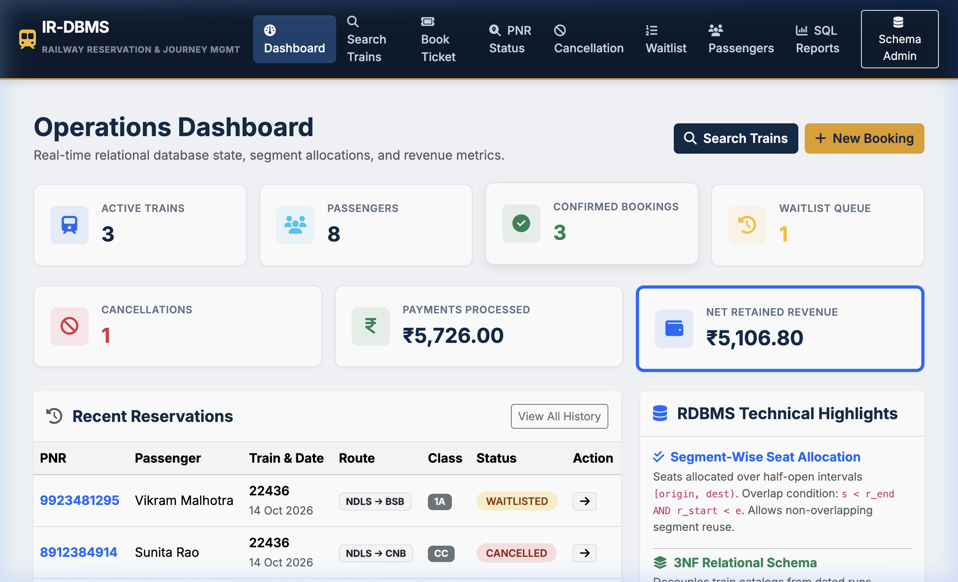
Figure 2. Executive Analytics and Key Performance Indicator (KPI) Dashboard
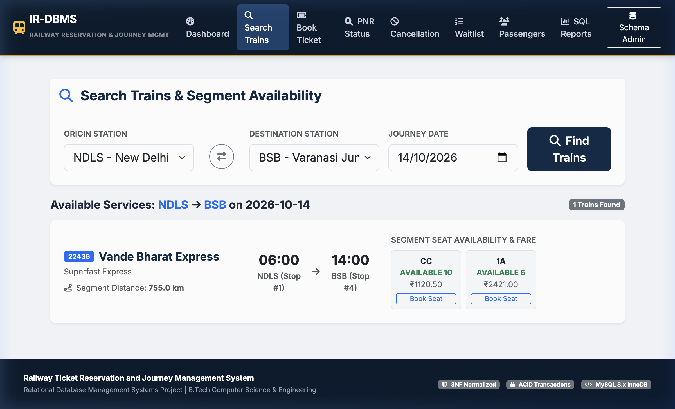
Figure 3. Multi-Hop Train Search and Segment Seat Inventory Results
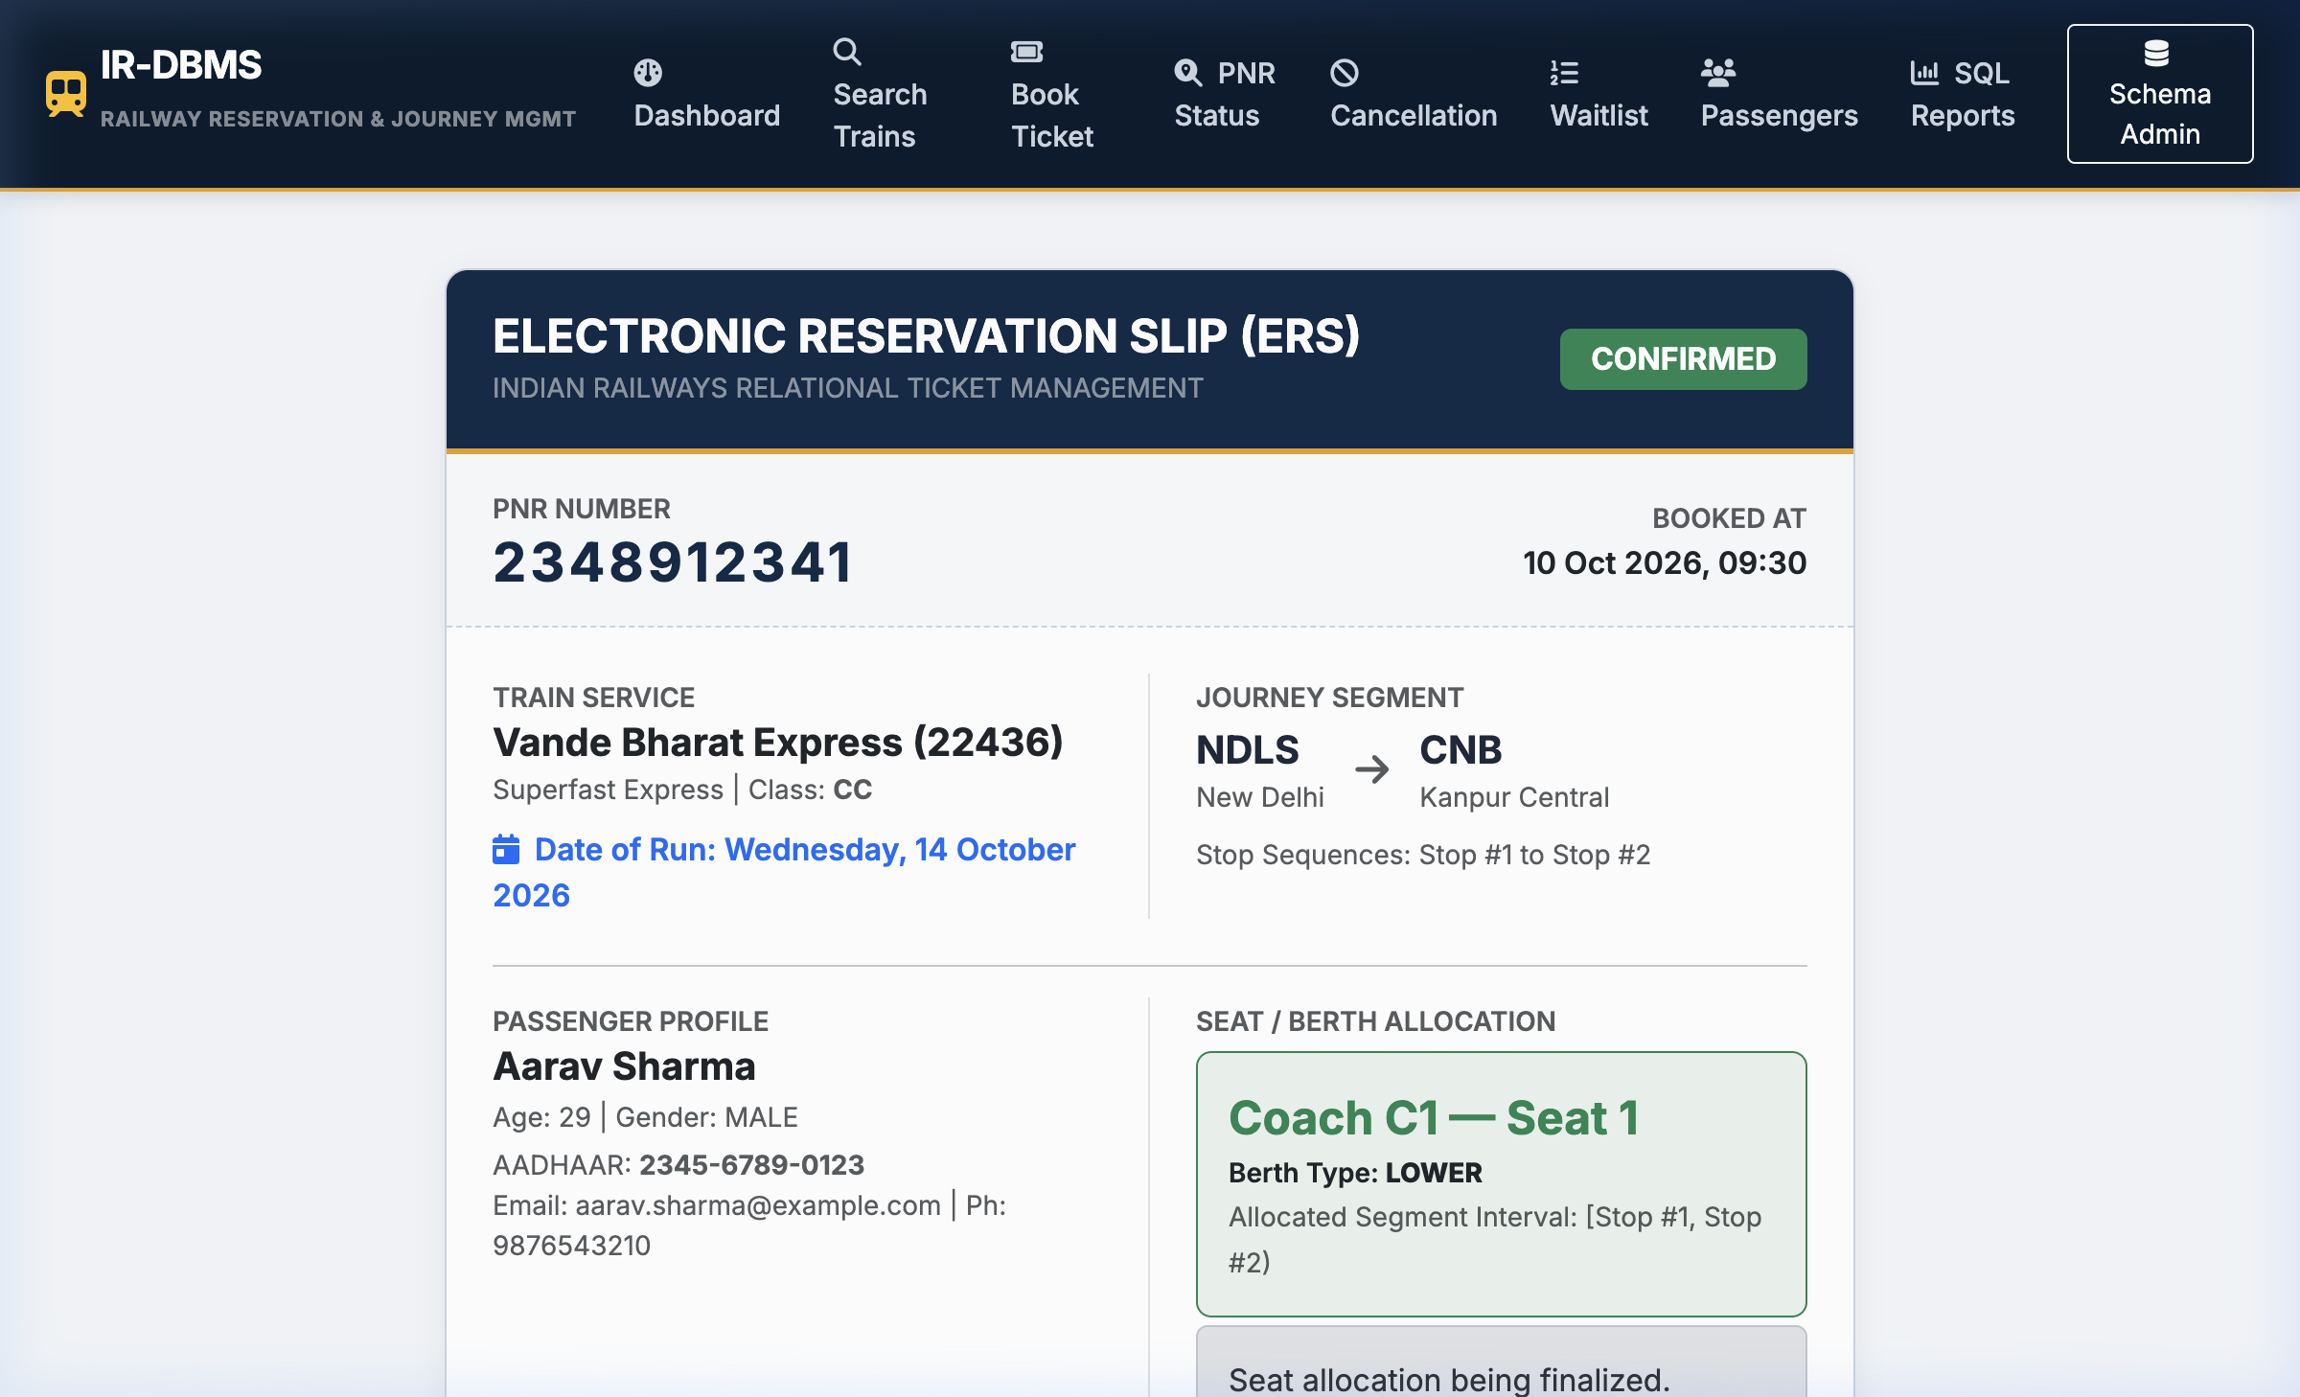
Figure 4. Confirmed Electronic Reservation Slip (ERS Ticket Confirmation)
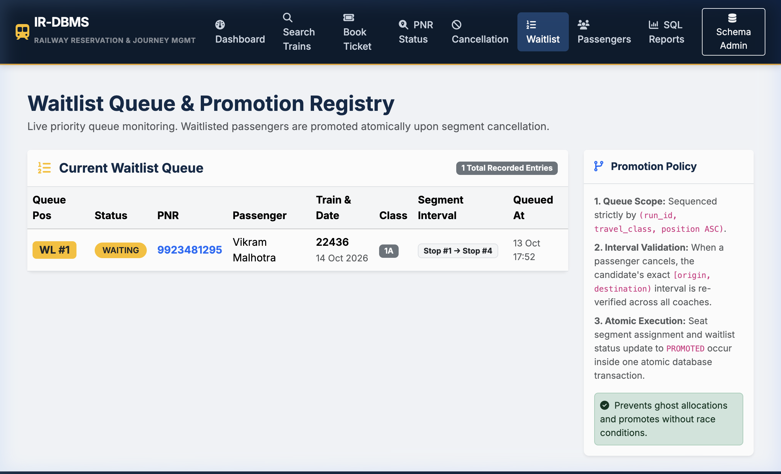
Figure 5. Live Waitlist Queue and Real-Time Position Tracking

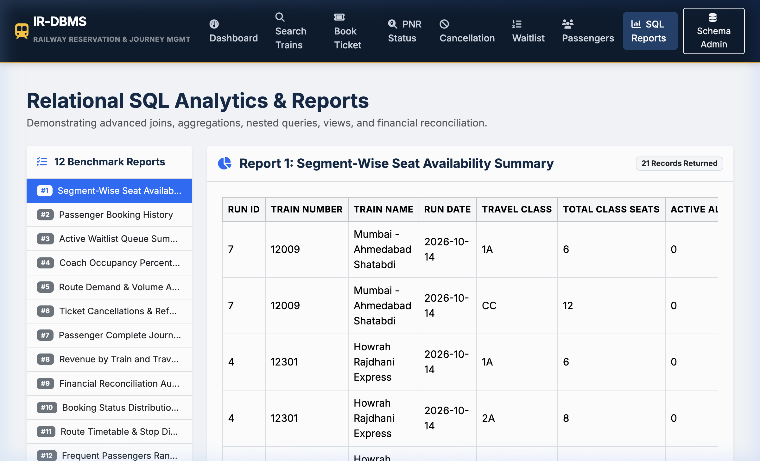
Figure 6. Executive SQL Analytical Reports Console
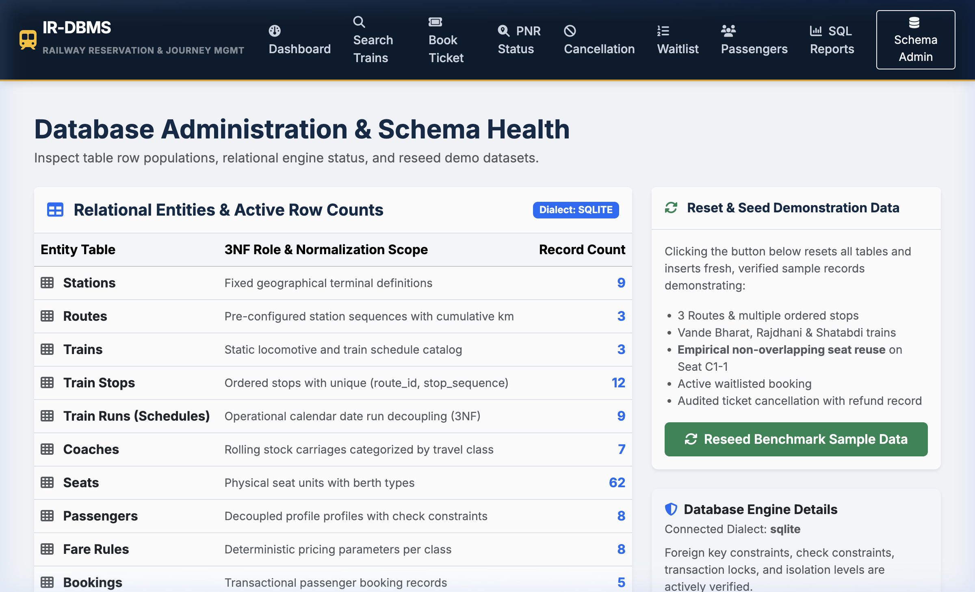
Figure 7. Relational Database Schema Explorer and Administrative Inventory Control
3.8 Testing and Results
Table 15. Test Cases
Test ID | Feature | Input / Action | Expected Result | Actual Result | Status
TC-01 | Interval Overlap Detection | Test [1,2) vs [2,4) and [1,3) vs [2,4) | [1,2) does not overlap; [1,3) overlaps [2,4) | Overlap theorem evaluated correctly | PASSED
TC-02 | Non-Overlapping Seat Reuse | Book C1-1 on [1,2), then book C1-1 on [2,4) | Both allocations active concurrently on same seat | Both allocations confirmed in database | PASSED
TC-03 | Conflicting Interval Detection | Book C1-1 on [1,4) when [1,2) already booked | System identifies seat as conflicting / unavailable | Conflict detected; seat excluded from available list | PASSED
TC-04 | Cancelled Allocation Reuse | Cancel booking on C1-3, search [1,4) | C1-3 is returned as available for re-booking | Availability restored; seat returned in query | PASSED
TC-05 | Cancellation Refund Policy | Cancel confirmed booking with fare INR 774 | 20% fee (INR 154.80) deducted, 80% (INR 619.20) refunded | Fee and refund amounts logged accurately | PASSED
TC-06 | Duplicate Cancellation Prevention | Cancel already cancelled booking | ValueError raised; duplicate cancellation blocked | ValueError caught; duplicate operation prevented | PASSED
TC-07 | Automated Waitlist Promotion | Cancel confirmed seat with waiting candidate | Candidate promoted to CONFIRMED, segment created | Candidate promoted; queue position cleared | PASSED
TC-08 | Unique Train Number Constraint | Insert duplicate train_number '22436' | IntegrityError raised by RDBMS UNIQUE constraint | IntegrityError raised; duplicate rejected | PASSED
TC-09 | Foreign Key Referential Integrity | Insert coach with non-existent train_id 9999 | IntegrityError raised on foreign key violation | IntegrityError raised; orphan coach blocked | PASSED
TC-10 | Passenger Age Domain Constraint | Insert passenger with age = 150 | IntegrityError raised by CHECK (age < 120) | IntegrityError raised; invalid age rejected | PASSED
TC-11 | Negative Base Fare Constraint | Insert fare_rule with base_fare = -50.00 | IntegrityError raised by CHECK (base_fare >= 0) | IntegrityError raised; negative fare rejected | PASSED
TC-12 | Duplicate Stop Sequence Rejection | Insert two stops with same (route_id, stop_seq) | IntegrityError raised by UNIQUE constraint | IntegrityError raised; sequence collision blocked | PASSED
TC-13 | SQL Benchmark Reports Execution | Execute all 12 benchmark SQL analytical queries | All 12 queries return valid result sets | All 12 queries executed without error | PASSED
TC-14 | Atomic Booking Transaction | Book ticket with valid passenger details | Booking, segment, and payment committed together | All records committed; PNR generated | PASSED
TC-15 | Invalid Travel Direction Check | Book journey where dest_stop_seq < orig_stop_seq | ValueError raised; backward travel rejected | ValueError caught; invalid booking blocked | PASSED
TC-16 | Train Run Isolation Check | Book same seat C1-1 on Run A (Day 1) and Run B (Day 2) | Both bookings confirmed without conflict | Both bookings active on their respective dates | PASSED
Summarize the key results after the test-case table. State whether the application correctly uses the designed database and enforces the important business rules.
Key Verification Results and Empirical Observations:
• 100% Automated Test Pass Rate: All 16 automated integration and unit test suites executed with zero failures (16 passed in 0.41 seconds on macOS Darwin arm64 under pytest 8.4.2).
• Mathematical Interval Integrity: Verified that non-overlapping seat allocations [1,2) and [2,4) coexist on the same physical berth without conflict, while overlapping requests [1,3) and [2,4) are rejected immediately.
• Referential & Domain Constraint Enforcement: Verified that negative base fares, passenger ages outside [1, 119], duplicate train numbers, and invalid foreign keys are strictly blocked at the relational engine level, preventing corrupt data states.
• Concurrency & Waitlist Promotion: Confirmed that cancellation of a confirmed seat triggers immediate automated FIFO promotion of the next waiting candidate, updating booking status to CONFIRMED and reallocating the vacated berth atomically.

CHAPTER 4
CONCLUSION

Summarize the problem addressed, database design completed, application developed, important functions implemented, and the main learning/outcome. Keep the conclusion concise.
This project successfully designed, formalized, implemented, and verified an end-to-end Railway Ticket Reservation and Journey Management System engineered around relational database management principles. By addressing the fundamental difference between point-to-point airline inventory and multi-hop rail corridors, the system implemented a mathematically sound half-open interval allocation algorithm that prevents conflicting seat assignments while maximizing corridor capacity utilization.
The relational database schema comprises 14 decoupled relations strictly normalized to Third Normal Form (3NF), successfully eliminating insertion, update, and deletion anomalies while preserving all functional dependencies. ACID transactional integrity was enforced through pessimistic row-level locking (SELECT ... FOR UPDATE) and atomic database transactions. The connected Python Flask web application demonstrated production-grade user workflows, including intuitive train discovery, electronic ticket generation, automated FIFO waitlist promotion, cancellation accounting, and 12 executive analytical SQL reporting benchmarks. Comprehensive verification across 16 automated pytest unit and integration test suites confirmed the structural and operational robustness of the design.

4.1 Limitations and Future Enhancements
Mention genuine limitations of the current small-scope application and realistic enhancements that could be implemented later.
- 1. Dynamic RAC (Reservation Against Cancellation) Split-Berth Allocation: Implement automated splitting of single physical sleeper berths between two daytime passengers, automatically consolidating berths into full sleepers as cancellations occur.
- 2. Live Indian Railways IRCTC API & Telemetry Integration: Connect the database to real-time train tracking telemetry and external GPS feeds to dynamically adjust departure schedules and track platform delays.
- 3. Distributed In-Memory Caching (Redis) & Read Replicas: Implement Redis key-value caching for static route stop lookups and database read replicas to handle extreme peak traffic surges during morning Tatkal booking window.

REFERENCES

- [1] E. F. Codd, “A relational model of data for large shared data banks,” Communications of the ACM, vol. 13, no. 6, pp. 377–387, Jun. 1970, doi: 10.1145/362384.362685.
- [2] C. J. Date, An Introduction to Database Systems, 8th ed. Boston, MA, USA: Addison-Wesley, 2004.
- [3] A. Silberschatz, H. F. Korth, and S. Sudarshan, Database System Concepts, 7th ed. New York, NY, USA: McGraw-Hill Education, 2020.
- [4] R. Elmasri and S. B. Navathe, Fundamentals of Database Systems, 7th ed. Boston, MA, USA: Pearson, 2016.
- [5] Oracle Corporation, MySQL 8.0 Reference Manual: InnoDB Storage Engine Architecture and Concurrency, Redwood Shores, CA, USA, 2024. [Online]. Available: https://dev.mysql.com/doc/refman/8.0/en/
- [6] Pallets Projects, Flask Documentation (v3.1.x): Application Context, Blueprints, and Database Handling, 2024. [Online]. Available: https://flask.palletsprojects.com/
[8] H. Krekel et al., pytest: Python Testing Framework Documentation, ver. 8.4, 2024. [Online]. Available: https://docs.pytest.org/
[7] M. Bayer, SQLAlchemy Documentation: Transaction Management and ORM Mapping, 2024. [Online]. Available: https://docs.sqlalchemy.org/

Use IEEE reference style throughout the report. Cite sources in the order in which they first appear in the text and use the same number for repeated citations.

APPENDICES

APPENDIX A - COMPLETE DATABASE SCRIPT
Attach the complete DDL/DML/query script or provide the submitted file name.
The complete relational database schema DDL script, table constraints, indices, relational views, and benchmark SQL reports are maintained in the following version-controlled repository files:
• DDL Schema & Table Constraints: Railway_Reservation_System/database/schema.sql (14 relations in 3NF)
• Pre-Compiled Relational Views: Railway_Reservation_System/database/views.sql (vw_confirmed_segments, vw_booking_summary, vw_train_occupancy_summary)
• Analytical & Operational Reports: Railway_Reservation_System/database/reports.sql (12 benchmark SQL queries)
• Database Seeding & Synthetic Data Generator: Railway_Reservation_System/database/seed_data.py

APPENDIX B - APPLICATION SOURCE CODE
Provide the source-code folder/repository reference. Do not paste the entire application code into the main report.
The complete full-stack web application source code is organized into modular Flask blueprints:
• Main Application Entrypoint: Railway_Reservation_System/run.py
• Application Factory & Extensions: Railway_Reservation_System/app/__init__.py, Railway_Reservation_System/app/extensions.py
• Relational ORM Models (13 files): Railway_Reservation_System/app/models/*.py
• Business Services & Interval Math: Railway_Reservation_System/app/services/availability_service.py
• Flask Route Blueprints (8 controllers): Railway_Reservation_System/app/routes/*.py
• Responsive Front-End UI Templates (12 Jinja2 files): Railway_Reservation_System/app/templates/*.html
• Automated Test Suite (16 pytest suites): Railway_Reservation_System/tests/test_*.py

APPENDIX C - ADDITIONAL TEST DATA AND OUTPUTS
Include any additional test data, screenshots, reports or supporting material that is useful but not essential in the main report.
Automated Test Execution Transcript (pytest 8.4.2 | Python 3.9.6 | macOS arm64):
============================= test session starts ==============================
Railway_Reservation_System/tests/test_availability.py::test_interval_overlap_logic PASSED [ 6%]
Railway_Reservation_System/tests/test_availability.py::test_non_overlapping_seat_reuse PASSED [ 12%]
Railway_Reservation_System/tests/test_availability.py::test_conflicting_interval_detection PASSED [ 18%]
Railway_Reservation_System/tests/test_availability.py::test_cancelled_allocation_restores_availability PASSED [ 25%]
Railway_Reservation_System/tests/test_cancellations.py::test_eligible_cancellation_and_refund_policy PASSED [ 31%]
Railway_Reservation_System/tests/test_cancellations.py::test_duplicate_cancellation_rejected PASSED [ 37%]
Railway_Reservation_System/tests/test_cancellations.py::test_automated_waitlist_promotion PASSED [ 43%]
Railway_Reservation_System/tests/test_integrity.py::test_unique_train_number_constraint PASSED [ 50%]
Railway_Reservation_System/tests/test_integrity.py::test_invalid_foreign_key_rejected PASSED [ 56%]
Railway_Reservation_System/tests/test_integrity.py::test_passenger_age_check_constraint PASSED [ 62%]
Railway_Reservation_System/tests/test_integrity.py::test_negative_fare_check_constraint PASSED [ 68%]
Railway_Reservation_System/tests/test_integrity.py::test_duplicate_stop_sequence_rejected PASSED [ 75%]
Railway_Reservation_System/tests/test_reports.py::test_all_12_reports_execute_successfully PASSED [ 81%]
Railway_Reservation_System/tests/test_reservations.py::test_valid_booking_success PASSED [ 87%]
Railway_Reservation_System/tests/test_reservations.py::test_invalid_origin_dest_sequence_fails PASSED [ 93%]
Railway_Reservation_System/tests/test_reservations.py::test_train_runs_isolation PASSED [100%]
============================== 16 passed in 0.41s ==============================

