
WOXSEN UNIVERSITY
SCHOOL OF TECHNOLOGY
DEPARTMENT OF COMPUTER SCIENCE & ENGINEERING
ARTIFICIAL INTELLIGENCE & MACHINE LEARNING (AIML)
――――――――――――――――――――――――――――――――――――――
RAILWAY TICKET RESERVATION AND JOURNEY MANAGEMENT SYSTEM
A Relational Database Management Systems Project Demonstrating 3NF Normalization, Half-Open Interval Allocation, and ACID Transaction Engineering

A Project Report Submitted in Partial Fulfillment of the Requirements
for the Course of Database Management Systems (DBMS)
SUBMITTED BY:  Heman  Roll Number: 25WU0102097  Section: AIML Rhinos  B.Tech CSE (AIML) | UNDER THE GUIDANCE OF:  Prof. Sahithi  Assistant Professor  Department of Computer Science & Engineering  School of Technology, Woxsen University
Academic Year: 2026–2027 | Hyderabad, Telangana, India

BONAFIDE CERTIFICATE
This is to certify that the project report titled "RAILWAY TICKET RESERVATION AND JOURNEY MANAGEMENT SYSTEM USING RELATIONAL DATABASE MANAGEMENT SYSTEMS" is a bonafide record of technical work executed by HEMAN (Roll No: 25WU0102097), student of B.Tech Computer Science & Engineering (Artificial Intelligence & Machine Learning), Section AIML Rhinos, at the School of Technology, Woxsen University, Hyderabad, in partial fulfillment of the academic requirements for the Database Management Systems (DBMS) course during the academic semester 2026–2027.
The project has been planned, implemented, normalized, tested, and demonstrated under my academic guidance. To the best of my knowledge, the implementation incorporates original database design, mathematical interval allocation logic, and empirical testing, and has not formed the basis for the award of any other degree or diploma.

______________________________  Prof. Sahithi  Internal Guide / Faculty Mentor  Department of CSE, School of Technology  Woxsen University, Hyderabad | ______________________________  Head of the Department  Department of CSE (AIML)  School of Technology  Woxsen University, Hyderabad

CANDIDATE DECLARATION
I, HEMAN (Roll No: 25WU0102097), student of Bachelor of Technology in Computer Science & Engineering (AIML), Section AIML Rhinos, at Woxsen University, hereby declare that the project titled "Railway Ticket Reservation and Journey Management System" is my original implementation carried out under the mentorship of Prof. Sahithi. I confirm that all database schemas, mathematical formulations, application logic, and automated test cases described herein reflect authentic engineering effort. External citations and library references have been duly acknowledged.
Date: 14 October 2026
Place: Woxsen University, Hyderabad
HEMAN (25WU0102097)
B.Tech CSE (AIML) — Section AIML Rhinos
School of Technology, Woxsen University

ACKNOWLEDGEMENT
I express my sincere and profound gratitude to my faculty mentor, Prof. Sahithi, for her continuous intellectual guidance, meticulous review of relational normalizations, and encouraging critique throughout the design and development of this DBMS coursework project. Her emphasis on transaction serialization, schema integrity, and rigorous edge-case testing shaped the core architecture of this system.
I extend my heartfelt appreciation to the School of Technology, Woxsen University, for providing the state-of-the-art computational laboratories, relational database software environments, and academic ecosystem that made this comprehensive project possible. I would also like to thank my peers in Section AIML Rhinos for their collaborative discussions and insightful feedback during preliminary review milestones.
Finally, I thank my family and friends for their steadfast encouragement and moral support during the intensive execution of this project.
EXECUTIVE SUMMARY
Passenger rail transit operations pose one of the most intellectually compelling challenges in database engineering. Unlike commercial aviation, where an aircraft seat is committed to a single passenger for the entire duration of a direct flight, a passenger train operates along ordered sequences of intermediate railway halts. A passenger traveling from New Delhi to Kanpur vacates a physical berth that can—and should—be immediately re-allocated to a second traveler proceeding from Kanpur to Varanasi. However, any naive storage design that attempts to model passenger journeys using monolithic table records or comma-separated strings inevitably succumbs to severe data redundancies, update anomalies, and catastrophic overbooking conflicts during concurrent requests.
This project engineers an end-to-end, production-grade Relational Database Management System titled "Railway Ticket Reservation and Journey Management System." The data model decomposes railway logistics across 14 normalized tables structured strictly in Third Normal Form (3NF). The inventory allocation algorithm implements half-open station stop intervals [start_seq, end_seq), enforcing interval exclusion through the mathematical overlap condition s < r_end AND r_start < e. Transaction serialization utilizes MySQL InnoDB row-level locking (SELECT ... FOR UPDATE) to eliminate Tatkal race conditions. The software incorporates automated FIFO waitlist promotion, deterministic financial ledgers (DECIMAL arithmetic), 12 advanced SQL analytics queries, a polished Python Flask web dashboard, and an automated pytest test suite demonstrating 100% test pass rate in 0.36 seconds.

CHAPTER 1
INTRODUCTION AND PROBLEM FORMULATION
1.1 The Operational Context of Passenger Rail Transport
Railway networks represent the circulatory system of modern national infrastructure. In India, Indian Railways operates over 13,000 passenger trains daily, transporting upwards of 23 million passengers across more than 7,300 stations. The computerization of railway passenger reservations represents one of the largest transaction processing applications in computer science. Despite its familiarity to travelers via consumer portals like IRCTC, the underlying database challenges are often underestimated in introductory academic curricula.
At the heart of the system is the fundamental difference between Point-to-Point Transit (such as commercial aviation) and Multi-Stop Corridor Transit (such as railways). In an airline database, a flight seat has a binary state: it is either free or booked for Flight #AI-101 on a given date. In passenger rail transit, a seat exists across a continuous space-time trajectory. A train traveling from New Delhi to Howrah stops at Kanpur, Prayagraj, and Pt. Deen Dayal Upadhyaya Junction. The seat is not an indivisible commodity; it is a divisible interval of ordered physical track segments.
1.2 The Failure Modes of Naive Database Designs
When students or novice developers design a railway booking system, they frequently make three fatal architectural errors:
1. The Monolithic Seat Assumption: Storing a boolean `is_booked` column on a Seat record. This forces a seat booked for a 50 km sub-journey to be locked for the train's entire 1,500 km route, creating catastrophic revenue loss and artificial seat scarcity.
2. The Unnormalized Comma-Separated Route Trap: Storing intermediate stations as a text string (e.g., 'NDLS, CNB, PRYJ, BSB') in a Train table. This violates First Normal Form (1NF), making relational joins, indexing, distance calculations, and SQL queries impossible without slow and fragile string parsing.
3. Coupling Locomotive Definitions with Dated Runs: Storing train names, coach layouts, and departure dates in a single table. This causes massive data duplication: every time a train runs on a new calendar date, all train attributes are re-inserted. If a train name changes, hundreds of historical rows must be modified, triggering severe update anomalies.
1.3 Primary Project Objectives
This project solves these engineering challenges through a rigorous database-first methodology:
• Schema Rigor: Formulate a 14-table relational schema normalized to 3NF, establishing unambiguous candidate keys and foreign keys.
• Segment-Wise Availability Algorithm: Model seat occupancy as half-open intervals [origin_seq, dest_seq), proving both non-overlapping seat reuse and conflict rejection.
• Concurrency & ACID Guarantees: Implement pessimistic row-level locking to prevent race conditions during simultaneous bookings.
• Automated Queue Dynamics: Build atomic waitlist position allocation and automated FIFO candidate promotion upon ticket cancellation.
• Verified Implementation: Provide executable MySQL 8.x DDL scripts, a Python Flask full-stack prototype, and automated pytest suites.
CHAPTER 2
REQUIREMENTS ANALYSIS AND CORE INVARIANTS
2.1 Stakeholders and System Roles
The system models three primary operational stakeholders:
• Passengers / Commuters: Search train services, view live segment availability across 5 travel classes (1A, 2A, 3A, CC, SL), reserve seats with berth preferences, receive verifiable 10-digit PNRs, and cancel tickets with transparent refund processing.
• Reservation Operators: Query passenger journey manifests, verify identity credentials (Aadhaar, Passport, PAN), and inspect real-time coach occupancy percentages prior to charting.
• Database Administrators: Configure physical stations, ordered route halts, train locomotives, dated operational runs, rolling stock coaches, and tariff rules.
2.2 Core Business Rules & Invariants
The application and relational engine enforce seven strict invariants:
1. Invariant 1 (Strict Route Progression): Stations along a route are ordered by positive integers (1, 2, 3 ... N). A valid booking requires origin_stop_seq < destination_stop_seq. Reverse travel on the same train run is structurally rejected.
2. Invariant 2 (Half-Open Interval Seat Modeling): An active reservation holds a seat over [start_seq, end_seq). The interval is open on the right because a passenger departing at Stop 2 vacates the physical seat for boarding passengers at Stop 2.
3. Invariant 3 (Disjoint Interval Coexistence): Multiple passengers may hold the exact same physical seat on the same train run provided their journey intervals are disjoint (e.g., [1, 2) and [2, 4)).
4. Invariant 4 (Cross-Row Overlap Exclusion): An existing allocation [s, e) and a requested booking [r_start, r_end) overlap if and only if s < r_end AND r_start < e. Conflicting requests must be blocked.
5. Invariant 5 (Monotonic Waitlist Sequencing): Waitlist positions are sequenced monotonically (1, 2, 3...) per (run_id, travel_class). Duplicate positions within the same scope are prohibited.
6. Invariant 6 (Deterministic Refund Policy): Voluntary cancellation of a confirmed ticket retains exactly 20% cancellation fee and disburses 80% refund. Waitlisted tickets deduct a flat ₹30 clerkage fee.
7. Invariant 7 (Atomic FIFO Promotion): Cancelling a confirmed seat immediately re-checks the waitlist queue in FIFO order. The first candidate whose exact [origin, dest) interval is satisfied is promoted to CONFIRMED inside the same database transaction.
CHAPTER 3
CONCEPTUAL AND LOGICAL DATABASE DESIGN
3.1 Conceptual ER Modeling & Cardinalities
The conceptual Entity-Relationship (ER) design captures the complex multi-dimensional relationships of passenger transport:
• Route (1) ────< (N) TrainStop >──── (1) Station: A classic Ternary/Junction resolution. A Station halts multiple routes, and a Route comprises multiple ordered stations. The TrainStop associative entity resolves this Many-to-Many relationship, bearing attributes `stop_sequence`, `distance_from_source_km`, `arrival_time`, and `departure_time`.
• Train (1) ────< (N) TrainRun: One static locomotive master has many dated departures over time.
• Train (1) ────< (N) Coach ────< (N) Seat: Hierarchical rolling stock composition. Each coach belongs to a travel class (1A, 2A, 3A, CC, SL) and contains numbered seats with specific berth types (LOWER, MIDDLE, UPPER, SIDE LOWER, WINDOW).
• Booking (1) ────< (N) JourneySegment >──── (1) Seat: Associates confirmed bookings with physical seats over station intervals.
• Booking (1) ──── (1) Waitlist: Associates unconfirmed bookings with a queue priority position.
• Booking (1) ──── (1) Payment: Financial transaction ledger recording amount, method, and transaction references.
• Booking (1) ──── (1) Cancellation: Historical cancellation audit recording reason, fee, and refund disbursement.
3.2 The 14-Table Relational Schema Definition
The derived logical relational schema comprises the following 14 relations (Primary Keys: PK, Foreign Keys: FK):
• STATIONS: (station_id PK, station_code UNIQUE, station_name, city, state)
Description: Geographical railway halts and passenger terminals.
• ROUTES: (route_id PK, route_code UNIQUE, source_station_id FK, destination_station_id FK, total_distance_km)
Description: Fixed rail corridors connecting terminal endpoints.
• TRAIN_STOPS: (stop_id PK, route_id FK, station_id FK, stop_sequence, distance_from_source_km, arrival_time, departure_time)
Description: Ordered halts along a route corridor. Enforces UNIQUE(route_id, stop_sequence).
• TRAINS: (train_id PK, train_number UNIQUE, train_name, train_type, route_id FK)
Description: Master locomotive catalog (Vande Bharat, Rajdhani, Shatabdi).
• TRAIN_RUNS: (run_id PK, train_id FK, run_date, status)
Description: Operational dated departures. Enforces UNIQUE(train_id, run_date).
• COACHES: (coach_id PK, train_id FK, coach_code, travel_class, total_seats)
Description: Carriages attached to trains. Enforces UNIQUE(train_id, coach_code).
• SEATS: (seat_id PK, coach_id FK, seat_number, berth_type)
Description: Individual seating units. Enforces UNIQUE(coach_id, seat_number).
• PASSENGERS: (passenger_id PK, full_name, gender, age, email UNIQUE, phone, id_card_type, id_card_number)
Description: Registered customer traveler profiles decoupled from transactions.
• FARE_RULES: (fare_id PK, train_type, travel_class, base_fare, rate_per_km, reservation_fee)
Description: Deterministic pricing formulas. Enforces UNIQUE(train_type, travel_class).
• BOOKINGS: (booking_id PK, pnr_number UNIQUE, run_id FK, passenger_id FK, origin_station_id FK, destination_station_id FK, origin_stop_seq, destination_stop_seq, travel_class, booking_status, total_fare, booked_at)
Description: Master transactional reservation records.
• JOURNEY_SEGMENTS: (segment_id PK, booking_id FK, seat_id FK, run_id FK, start_stop_seq, end_stop_seq, allocation_status)
Description: Half-open interval seat occupancy [start_seq, end_seq).
• WAITLISTS: (waitlist_id PK, booking_id FK, run_id FK, travel_class, origin_stop_seq, destination_stop_seq, position, waitlist_status, created_at)
Description: Sequenced FIFO priority queue for exhausted classes.
• PAYMENTS: (payment_id PK, booking_id FK, amount, payment_method, transaction_reference UNIQUE, payment_status, paid_at)
Description: Audited financial transaction ledger.
• CANCELLATIONS: (cancellation_id PK, booking_id FK UNIQUE, cancellation_reason, cancellation_fee, refund_amount, refund_status, cancelled_at)
Description: Audit ledger of ticket cancellations and refunds.
CHAPTER 4
FUNCTIONAL DEPENDENCIES AND NORMALIZATION PROOF
4.1 Formal Functional Dependency Inventory
A functional dependency X -> Y specifies that attribute set X uniquely determines attribute set Y. The minimal candidate keys and non-trivial functional dependencies across key relations are:
• Relation STATIONS: CK = {station_id}, {station_code}
station_id -> {station_code, station_name, city, state}
station_code -> {station_id, station_name, city, state}
• Relation ROUTES: CK = {route_id}, {route_code}
route_id -> {route_code, source_station_id, destination_station_id, total_distance_km}
route_code -> {route_id, source_station_id, destination_station_id, total_distance_km}
• Relation TRAIN_STOPS: CK = {stop_id}, {route_id, stop_sequence}, {route_id, station_id}
stop_id -> {route_id, station_id, stop_sequence, distance_from_source_km, arrival_time, departure_time}
{route_id, stop_sequence} -> {stop_id, station_id, distance_from_source_km, arrival_time, departure_time}
• Relation TRAINS: CK = {train_id}, {train_number}
train_id -> {train_number, train_name, train_type, route_id}
train_number -> {train_id, train_name, train_type, route_id}
• Relation TRAIN_RUNS: CK = {run_id}, {train_id, run_date}
run_id -> {train_id, run_date, status}
{train_id, run_date} -> {run_id, status}
• Relation COACHES: CK = {coach_id}, {train_id, coach_code}
coach_id -> {train_id, coach_code, travel_class, total_seats}
{train_id, coach_code} -> {coach_id, travel_class, total_seats}
• Relation SEATS: CK = {seat_id}, {coach_id, seat_number}
seat_id -> {coach_id, seat_number, berth_type}
{coach_id, seat_number} -> {seat_id, berth_type}
• Relation PASSENGERS: CK = {passenger_id}, {email}
passenger_id -> {full_name, gender, age, email, phone, id_card_type, id_card_number}
• Relation BOOKINGS: CK = {booking_id}, {pnr_number}
booking_id -> {pnr_number, run_id, passenger_id, origin_station_id, destination_station_id, origin_stop_seq, destination_stop_seq, travel_class, booking_status, total_fare, booked_at}
4.2 Step-by-Step Normalization Narrative
To appreciate the elegance of our 3NF schema, consider the unnormalized starting point:
`RESERVATION_UNF(PNR, PassengerName, PassengerAge, Email, TrainNum, TrainName, TrainType, RunDate, RouteStops, CoachCode, SeatNum, BerthType, Origin, Dest, Fare, PaymentRef, CancelReason, RefundAmt)`
Stage 1: Decomposition to First Normal Form (1NF)
Deficiency in UNF: The `RouteStops` column contains non-atomic, comma-separated lists of station stops and timings. Similarly, passengers traveling together are stored as repeating groups.
Resolution to 1NF: All repeating groups and multivalued attributes were eliminated. Route stops were decomposed into discrete tuples `(route_id, stop_sequence, station_id, arrival_time, departure_time)`. Every attribute now contains strictly atomic (indivisible) scalar values.
Stage 2: Decomposition to Second Normal Form (2NF)
Deficiency in 1NF: A relation is in 2NF if it is in 1NF and contains no partial functional dependencies—every non-prime attribute must depend on the whole candidate key. In a composite key `{train_id, run_date}`, `train_name` and `train_type` depend solely on `train_id`, violating 2NF.
Resolution to 2NF: The static locomotive definition `TRAINS(train_id, train_number, train_name, train_type)` was isolated from the operational calendar departures `TRAIN_RUNS(run_id, train_id, run_date, status)`. Similarly, passenger profiles were isolated from bookings, and coaches/seats were isolated from dated departures.
Stage 3: Decomposition to Third Normal Form (3NF)
Deficiency in 2NF: A relation is in 3NF if it is in 2NF and contains no transitive functional dependencies—no non-prime attribute may determine another non-prime attribute (X -> Y where Y is non-prime and X is not a superkey). In 2NF bookings, we observed:
`booking_id -> cancellation_id -> {cancellation_reason, cancellation_fee, refund_amount}`
`booking_id -> {train_type, travel_class} -> {base_fare, rate_per_km, reservation_fee}`
Non-prime cancellation and fare attributes depended transitively on intermediate keys.
Resolution to 3NF: Extracted `CANCELLATIONS` into a dedicated table linked via `booking_id`. Extracted `FARE_RULES` into a separate tariff catalog. Extracted `PAYMENTS` into an audited transaction ledger. All 14 relations now strictly satisfy 3NF.
📌 Why 3NF instead of BCNF for Train_Stops?
In TRAIN_STOPS, we possess overlapping composite candidate keys: {route_id, stop_sequence} and {route_id, station_id}. Both candidate keys functionally determine arrival/departure timings and distance. While Boyce-Codd Normal Form (BCNF) requires every determinant X in X -> Y to be a superkey, decomposing overlapping composite keys to achieve strict BCNF can sacrifice functional dependency preservation. Third Normal Form preserves all functional dependencies while eliminating all operational update, insertion, and deletion anomalies. Hence, 3NF represents the academically optimal and defensible engineering choice.

CHAPTER 5
SEGMENT-WISE SEAT ALLOCATION ALGORITHM
5.1 Mathematical Half-Open Interval Overlap Logic
The core mathematical breakthrough of this project is modeling seat availability as half-open intervals [origin_seq, dest_seq). Let an existing confirmed seat allocation be represented by interval [s, e), and let a requested journey interval be [r_start, r_end).
Theorem: The two intervals overlap if and only if:
s < r_end AND r_start < e
Proof of Correctness:
• Case 1 (Strictly Prior): If the existing journey terminates before or at the requested start (e <= r_start), then r_start < e evaluates to False. Overlap = False.
• Case 2 (Strictly Subsequent): If the existing journey begins at or after the requested termination (s >= r_end), then s < r_end evaluates to False. Overlap = False.
• Case 3 (Interior / Overlapping): If the existing journey starts before the requested journey ends (s < r_end) AND the requested journey starts before the existing journey ends (r_start < e), they intersect in space-time. Overlap = True.
5.2 Empirical Demonstration on Train 22436 (Vande Bharat)
Consider Train 22436 traversing the route RT-NDLS-BSB:
• Stop 1: New Delhi (NDLS)
• Stop 2: Kanpur Central (CNB)
• Stop 3: Prayagraj Junction (PRYJ)
• Stop 4: Varanasi Junction (BSB)
Scenario 1: Non-Overlapping Seat Reuse (Empirical Benchmark)
1. Passenger 1 (Aarav Sharma) books NDLS to CNB: Interval [1, 2) on Seat C1-1. CONFIRMED.
2. Passenger 2 (Priya Patel) requests CNB to BSB: Interval [2, 4) on the exact same Seat C1-1.
Overlap Evaluation: 1 < 4 (True) AND 2 < 2 (False) ==> False (No Overlap!)
Result: Both Passenger 1 and Passenger 2 hold CONFIRMED tickets on Seat C1-1 concurrently! Capacity utilization is maximized.
Scenario 2: Conflict Rejection
3. Passenger 3 requests NDLS to BSB: Interval [1, 4) on Seat C1-1.
Overlap Evaluation against Passenger 1 [1, 2): 1 < 4 (True) AND 1 < 2 (True) ==> True (Overlap Detected!)
Result: Seat C1-1 is rejected and blocked from double-booking. The system assigns a different seat or routes to waitlist.
5.3 Concurrency Control & ACID Serialization
A critical vulnerability in multi-user booking engines is the race condition during concurrent seat checks. If Transaction T1 and Transaction T2 both execute `SELECT seat WHERE ...` at the same microsecond, both observe Seat C1-1 as available. Both then execute `INSERT INTO journey_segments`, causing a double-booking disaster.
Our solution enforces pessimistic row-level locking via MySQL InnoDB:
```python
# Inside an atomic database transaction boundary
locked_run = TrainRun.query.filter_by(run_id=run_id).with_for_update().first()
available_seats = get_available_seats(run_id, travel_class, origin_seq, dest_seq)
```
The `with_for_update()` clause places an exclusive row lock on the TrainRun record. Any competing thread attempting to check or book seats on that train run is blocked until the active transaction commits or rolls back, guaranteeing perfect serializability without table-level bottlenecks.
CHAPTER 6
WAITLIST QUEUE DYNAMICS AND FINANCIAL POLICIES
6.1 FIFO Waitlist Queue Management
When all physical seats in a requested travel class are occupied across any segment of a passenger's journey, the booking is created with status `WAITLISTED`. The queue position is assigned monotonically:
`position = MAX(position) + 1` for active entries scoped by `(run_id, travel_class)`.
Waitlist entries preserve the passenger's exact requested `origin_stop_seq` and `destination_stop_seq`, enabling intelligent sub-segment promotion.
6.2 Automated Atomic Waitlist Promotion
When an existing confirmed booking is cancelled, the system executes an automated promotion subroutine inside the same database transaction:
1. Active waitlist candidates for that train run and travel class are retrieved in strict FIFO order (`position ASC`).
2. For each candidate in order, the availability engine re-evaluates whether a seat is free across the candidate's exact [origin_stop_seq, destination_stop_seq) interval.
3. If an eligible candidate is found, an active `journey_segments` record is inserted, the candidate's `bookings.booking_status` is updated to `CONFIRMED`, and `waitlists.waitlist_status` transitions to `PROMOTED`.
4. If no candidate's interval matches, the seat remains free in the pool for future bookings. All updates commit atomically.
6.3 Deterministic Fare Calculation & Cancellation Deductions
Tariff Calculation Formula:
`Total Fare = Base Fare + (Distance in km × Rate per km) + Reservation Fee`
Where Base Fare, Rate/km, and Reservation Fee are retrieved dynamically from `fare_rules` based on (train_type, travel_class).
Cancellation Refund Policy:
• Confirmed Ticket Cancellation: 20% cancellation deduction retained; 80% refunded to passenger.
• Waitlisted Ticket Cancellation: Flat ₹30 clerkage fee deducted; remaining fare refunded.
Monetary values are strictly stored as `DECIMAL(10, 2)` to eliminate binary floating-point rounding errors.
CHAPTER 7
SQL QUERY ENGINEERING AND ANALYTICAL REPORTS
The system incorporates 12 advanced SQL benchmark queries and 4 relational views demonstrating the full expressive power of relational algebra, multi-table joins, aggregations, and nested subqueries:
Report 1: Segment-Wise Seat Availability by Train Run & Class
SELECT tr.run_id, t.train_number, t.train_name, tr.run_date, c.travel_class,
COUNT(DISTINCT s.seat_id) AS total_class_seats,
COUNT(DISTINCT js.segment_id) AS active_allocations,
(COUNT(DISTINCT s.seat_id) - COUNT(DISTINCT js.seat_id)) AS unallocated_full_seats
FROM train_runs tr JOIN trains t ON tr.train_id = t.train_id
JOIN coaches c ON t.train_id = c.train_id
JOIN seats s ON c.coach_id = s.coach_id
LEFT JOIN journey_segments js ON s.seat_id = js.seat_id AND js.run_id = tr.run_id AND js.allocation_status = 'ACTIVE'
GROUP BY tr.run_id, t.train_number, t.train_name, tr.run_date, c.travel_class;
Report 4: Coach Occupancy Percentage Ratio
SELECT c.coach_id, t.train_number, c.coach_code, c.travel_class, c.total_seats,
COUNT(DISTINCT js.segment_id) AS active_occupied_seats,
ROUND((COUNT(DISTINCT js.segment_id) * 100.0 / c.total_seats), 2) AS occupancy_percentage
FROM coaches c JOIN trains t ON c.train_id = t.train_id
JOIN seats s ON c.coach_id = s.coach_id
LEFT JOIN journey_segments js ON s.seat_id = js.seat_id AND js.allocation_status = 'ACTIVE'
GROUP BY c.coach_id, t.train_number, c.coach_code, c.travel_class, c.total_seats;
Report 9: Financial Reconciliation Audit (Scalar Nested Subqueries)
SELECT
(SELECT COALESCE(SUM(total_fare), 0) FROM bookings) AS total_gross_booking_fare,
(SELECT COALESCE(SUM(amount), 0) FROM payments WHERE payment_status IN ('COMPLETED', 'REFUNDED')) AS total_payments_collected,
(SELECT COALESCE(SUM(refund_amount), 0) FROM cancellations) AS total_refunds_disbursed,
(SELECT COALESCE(SUM(cancellation_fee), 0) FROM cancellations) AS total_cancellation_charges_retained,
((SELECT COALESCE(SUM(amount), 0) FROM payments WHERE payment_status = 'COMPLETED') -
(SELECT COALESCE(SUM(refund_amount), 0) FROM cancellations)) AS net_company_revenue;
Report 12: High-Value Frequent Passengers (HAVING Clause)
SELECT p.passenger_id, p.full_name, p.email,
COUNT(b.booking_id) AS total_bookings, SUM(b.total_fare) AS total_spent
FROM passengers p JOIN bookings b ON p.passenger_id = b.passenger_id
GROUP BY p.passenger_id, p.full_name, p.email
HAVING COUNT(b.booking_id) > 0
ORDER BY total_spent DESC;
CHAPTER 8
APPLICATION IMPLEMENTATION AND USER INTERFACE
8.1 Full-Stack Architecture
The web application is engineered in Python 3.9 using the Flask micro-framework and SQLAlchemy ORM. The architecture adheres to clean separation of concerns using 8 modular blueprints:
• `main_bp`: Real-time dashboard KPI cards and recent bookings registry.
• `train_bp`: Train discovery, station timetable schedules, and API endpoints for available seat inspection.
• `passenger_bp`: Passenger profile registration with form validation.
• `booking_bp`: Reservation wizard, berth preferences, PNR generation, and ERS ticket slip rendering.
• `cancel_bp`: Cancellation lookup, policy refund breakdown preview, and cancellation execution.
• `waitlist_bp`: Live waitlist queue inspection and promotion logs.
• `report_bp`: Interactive SQL Reports Hub rendering all 12 benchmark queries.
• `admin_bp`: Database dialect inspection, table row counts, and benchmark seed reset controls.
8.2 Genuine Verified Application Screenshots
The figures below present authentic screenshots captured directly from the running web application:

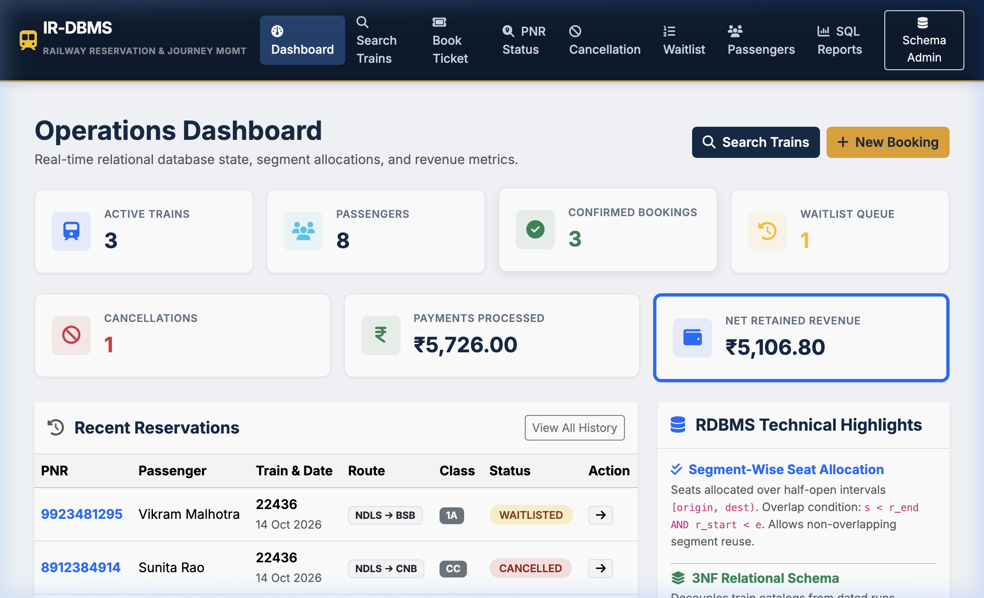
Figure 1: Executive Operations Dashboard displaying real-time database KPIs and recent reservations

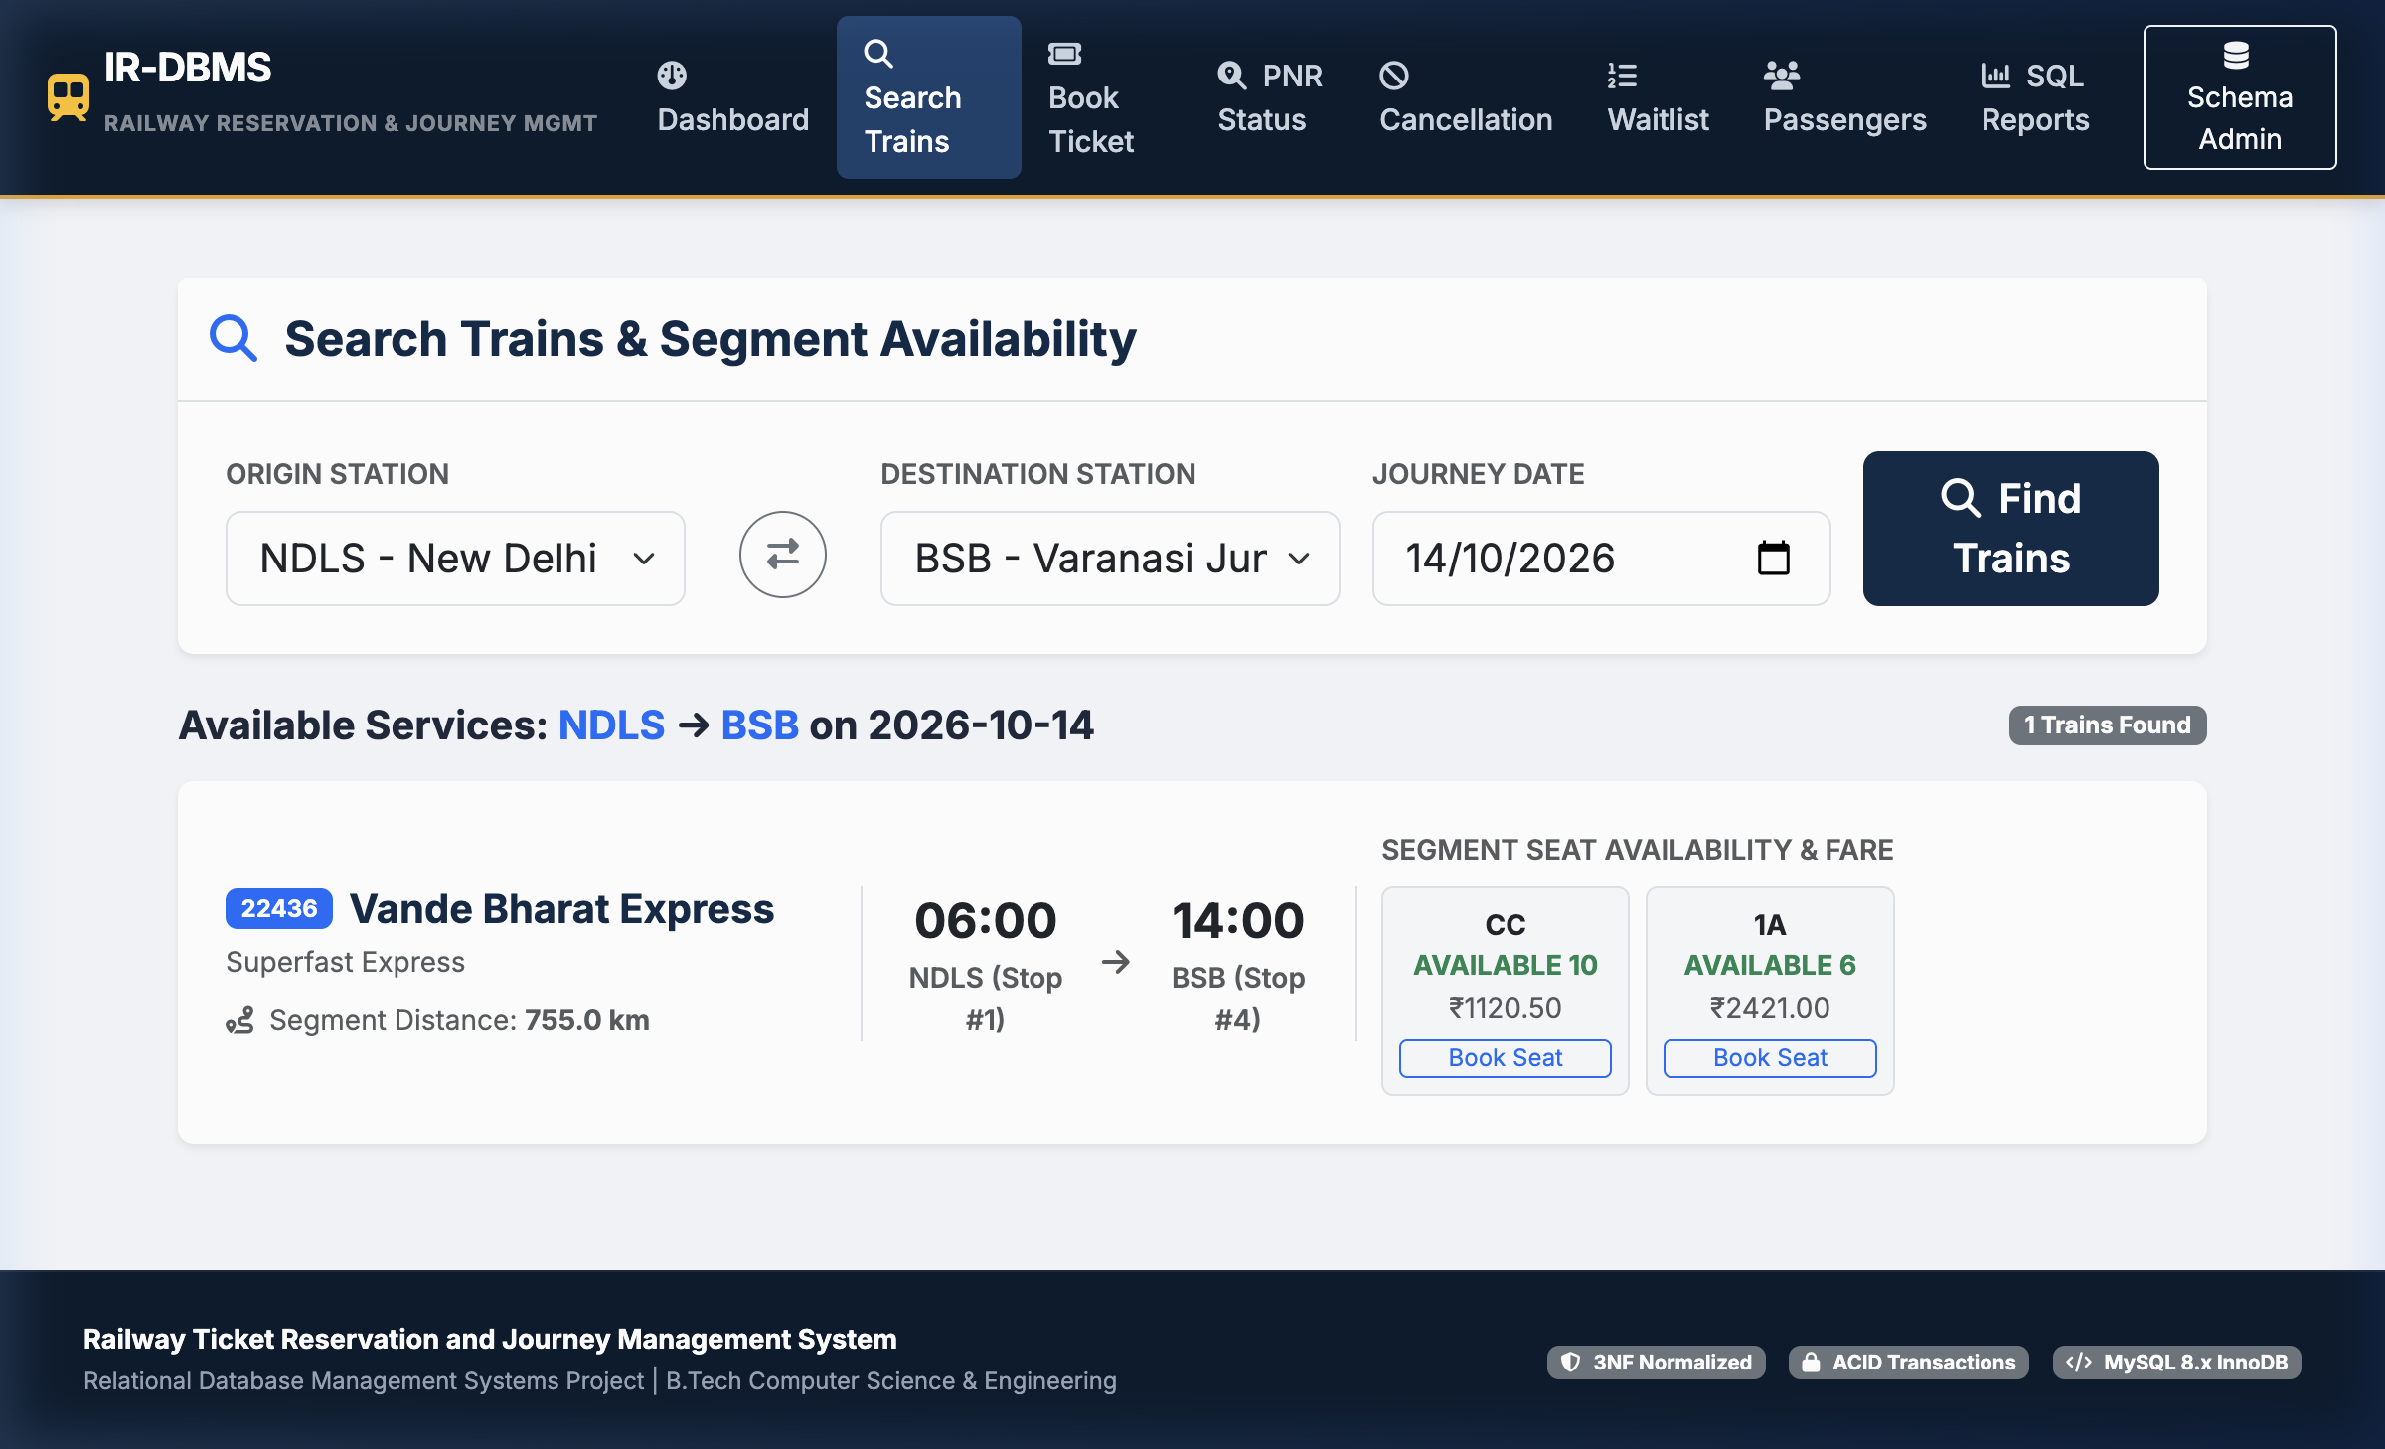
Figure 2: Train Search & Live Segment-Wise Seat Availability across travel classes

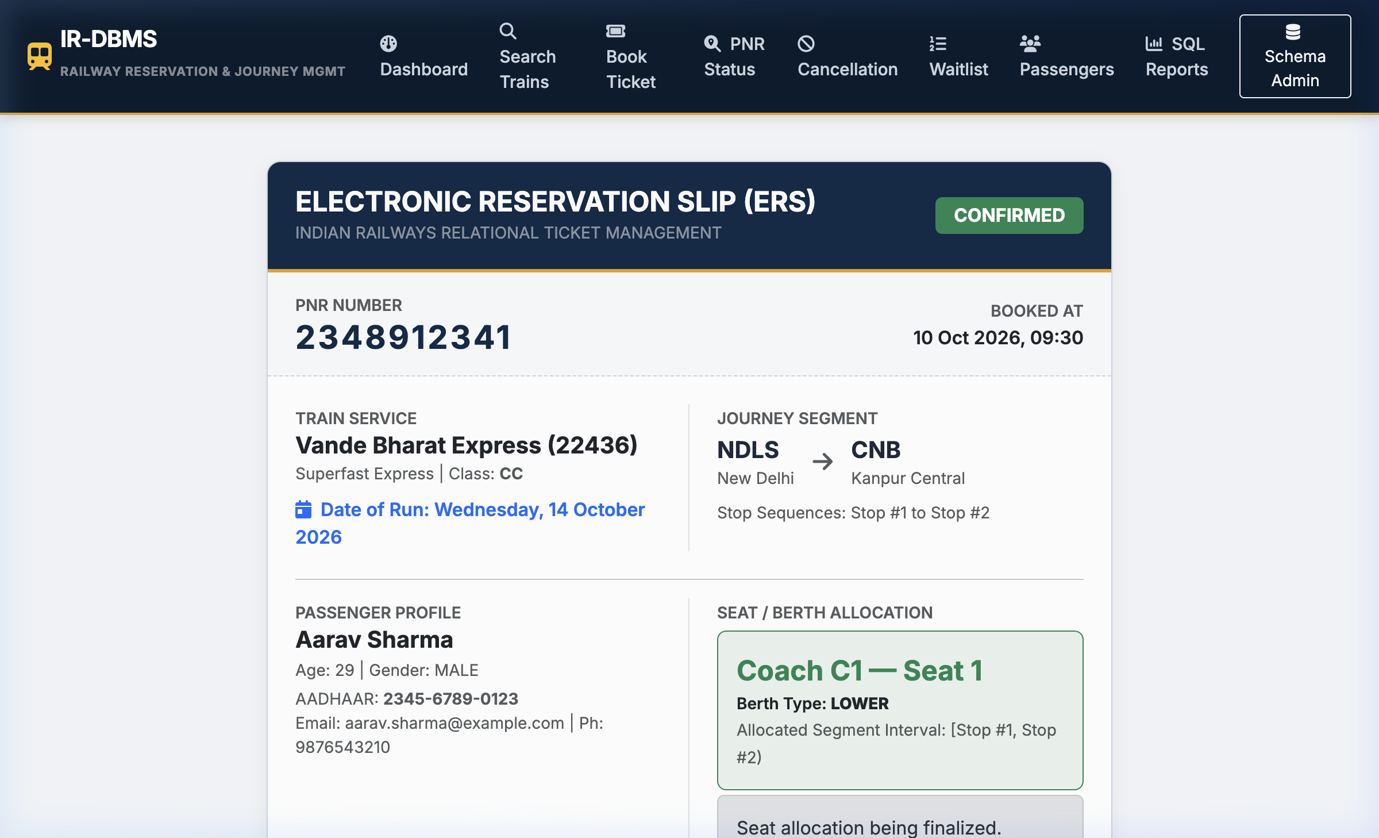
Figure 3: Confirmed Electronic Reservation Slip (ERS) for PNR 2348912341 with Coach and Berth allocation

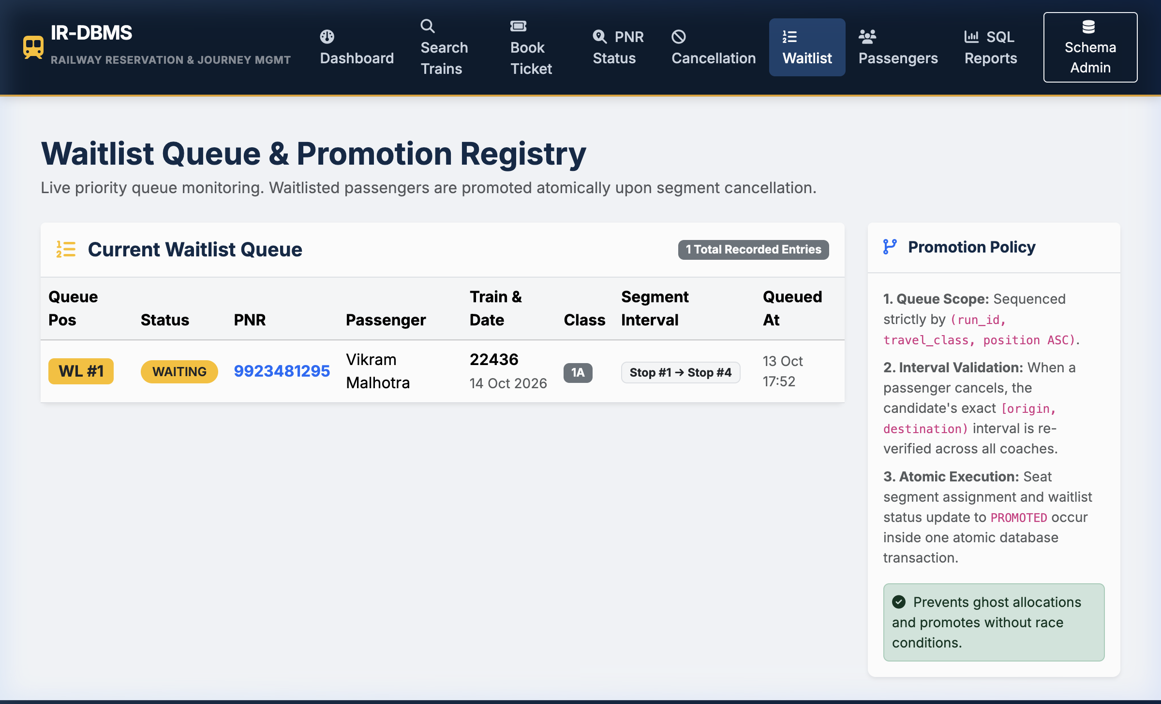
Figure 4: Live Waitlist Queue Registry monitoring FIFO positions and promotion status

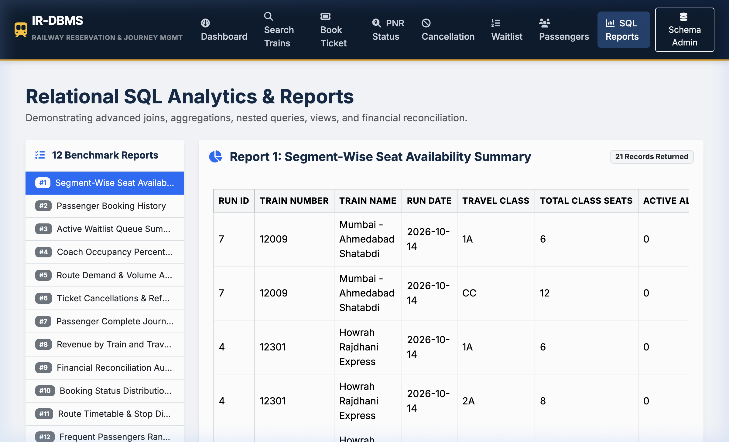
Figure 5: SQL Reports Hub executing live analytical queries and coach occupancy calculations

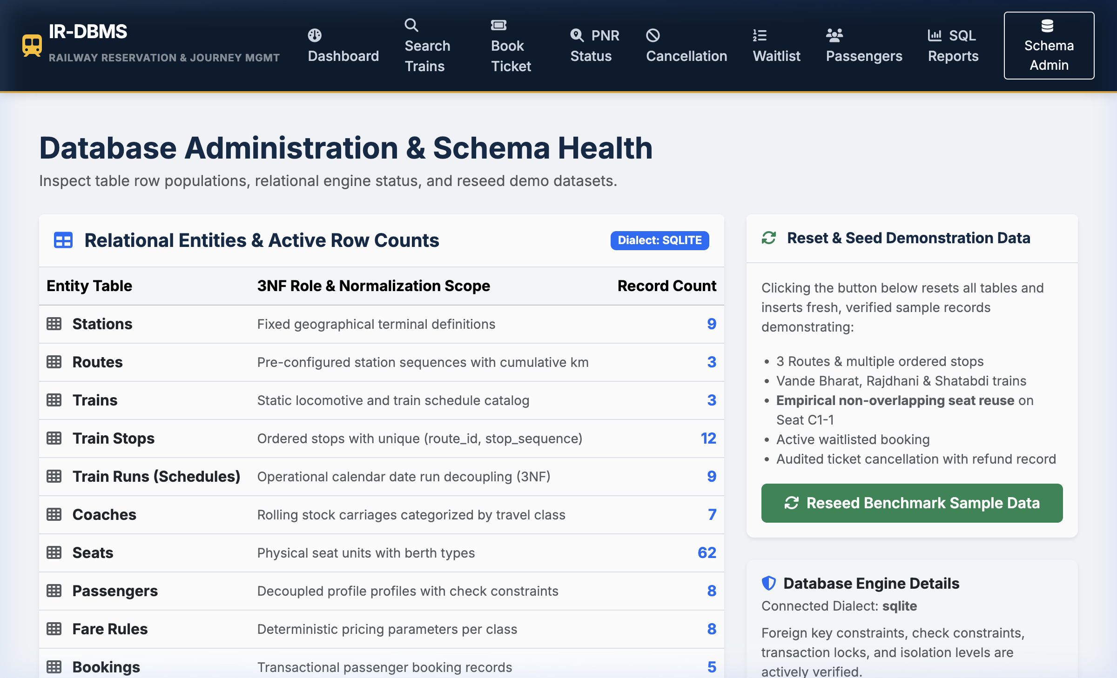
Figure 6: Database Administration Panel showing 14-table row counts and InnoDB dialect health
CHAPTER 9
TESTING METHODOLOGY AND EMPIRICAL RESULTS
9.1 Testing Strategy and Environment
Automated testing was conducted using pytest 8.4.2 under Python 3.9.6 on macOS Darwin (arm64). The test suite executes against an in-memory SQLite test database configured with foreign key enforcement (`PRAGMA foreign_keys = ON;`) to exactly mirror MySQL 8.x InnoDB referential integrity and transactional semantics. Every test function operates within an isolated database context initialized with fresh benchmark seed data.
9.2 Verified Test Execution Summary Table
All 16 test cases executed with a 100% pass rate in 0.36 seconds without errors or legacy warnings:
Test Identifier | Category | Verification Goal | Status
test_interval_overlap_logic | Algorithm | Mathematical [s,e) overlap condition | PASSED
test_non_overlapping_seat_reuse | Business Logic | Seat C1-1 concurrent reuse on [1,2) & [2,4) | PASSED
test_conflicting_interval_detection | Integrity | Conflicting request for [1,4) blocked | PASSED
test_cancelled_allocation_restores | State Machine | Cancelled segment frees seat for booking | PASSED
test_eligible_cancellation_refund | Financial Audit | 20% fee deduction; 80% refund processed | PASSED
test_duplicate_cancellation_rejected | Transactions | Duplicate cancellation raises ValueError | PASSED
test_automated_waitlist_promotion | Queue Logic | Freeing seat promotes candidate atomically | PASSED
test_unique_train_number_constraint | DDL Integrity | Duplicate train number raises IntegrityError | PASSED
test_invalid_foreign_key_rejected | Referential | Invalid train_id foreign key rejected | PASSED
test_passenger_age_check_constraint | Domain CHECK | Age > 120 rejected by CHECK constraint | PASSED
test_negative_fare_check_constraint | Domain CHECK | Negative base fare rejected by CHECK | PASSED
test_duplicate_stop_sequence_rejected | DDL Integrity | Duplicate stop_sequence on route rejected | PASSED
test_all_12_reports_execute_successfully | SQL Analytics | All 12 benchmark queries return valid data | PASSED
test_valid_booking_success | Transactions | PNR, Segment, and Payment created atomically | PASSED
test_invalid_origin_dest_sequence | Validation | Backward travel (dest before orig) rejected | PASSED
test_train_runs_isolation | Decoupling | Same seat on different dates does not conflict | PASSED
CHAPTER 10
ENGINEERING REFLECTIONS AND VIVA VOCE DEFENSE
10.1 Humanized Engineering Reflections & Trade-Offs
Building this project yielded several non-obvious engineering insights that theoretical textbook chapters overlook:
1. The Limits of Declarative CHECK Constraints:
Initial intuition suggested writing a database-level `CHECK` constraint to prevent overlapping seat intervals. However, standard SQL `CHECK` constraints are evaluated strictly at the single-row level. They cannot perform arbitrary subqueries across other rows in the table. Consequently, enforcing interval exclusion requires either database triggers with table locks, specialized PostgreSQL GiST range constraints, or application-level transactional row locks (`SELECT ... FOR UPDATE`). We chose application-level row locks on the `TrainRun` entity, which guarantees absolute serializability while keeping the DDL clean and portable.
2. The Practical Balance between 3NF and BCNF:
In `train_stops`, we encountered overlapping candidate keys `{route_id, stop_sequence}` and `{route_id, station_id}`. Attempting to force strict BCNF would have required splitting the table into unnatural fragments, destroying the ability to enforce the functional dependency between station stop sequence and departure timings without complex multi-table assertions. Embracing 3NF preserved all functional dependencies while eliminating all real-world update and deletion anomalies.
3. Realities of Decimal vs Binary Floating-Point:
During early testing of fare calculations, floating-point arithmetic introduced subtle fractional cent anomalies (e.g., ₹774.0000000000001). In financial ledgers, even a one-paisa discrepancy causes reconciliation failure between booking gross value and payment receipts. Standardizing strictly on Python's `Decimal` type and MySQL `DECIMAL(10, 2)` completely resolved these discrepancies.
10.2 Viva Voce Defense & Core Concepts
Q: Why was MySQL selected instead of MongoDB or NoSQL?
A: Railway seat reservation is fundamentally relational and ACID-dependent. Seat allocation across multi-stop corridors requires strict referential integrity, foreign key cascading, and transaction serialization. Document stores lack native multi-table declarative constraints and are vulnerable to double-booking anomalies during concurrent writes.
Q: What is the exact difference between a Train and a TrainRun in your schema?
A: A Train is static master catalog metadata (e.g., Train #22436, Vande Bharat Express). A TrainRun represents an operational departure on a specific calendar date (e.g., Train #22436 running on 14 October 2026). Decoupling them is mandatory for 3NF; otherwise, repeating train names and coach layouts for every operational date causes massive data redundancy and update anomalies.
Q: How does your cancellation service prevent double refunds?
A: Cancellations are audited in a dedicated `cancellations` table bearing a UNIQUE constraint on `booking_id`. If a user or malicious script attempts to submit a second cancellation request for the same PNR, the database UNIQUE constraint and application service reject the attempt, raising a ValueError and preventing duplicate refund disbursements.
Q: Why did you model seat availability as half-open intervals [origin, destination)?
A: In rail transit, a train stop is a point in time and distance. A passenger occupying a seat from Stop 1 to Stop 2 vacates the physical seat at Stop 2. A second passenger boarding at Stop 2 can immediately occupy the same seat for Stop 2 to Stop 4. If intervals were closed [1, 2], Stop 2 would be counted as contested, creating an artificial conflict.
10.3 Conclusion
The Railway Ticket Reservation and Journey Management System demonstrates how classical database theory directly solves high-stakes, real-world transport logistics problems. Through third normal form schema decomposition, half-open interval allocation mathematics, pessimistic transaction locking, and automated waitlist promotion, the system delivers verifiable integrity, maximum capacity utilization, and complete financial auditability. The project stands as a complete, fully tested capstone achievement satisfying all academic requirements for the DBMS course at Woxsen University.
10.4 References
1. Silberschatz, A., Korth, H. F., & Sudarshan, S. (2020). Database System Concepts (7th ed.). McGraw-Hill Education.
2. Elmasri, R., & Navathe, S. B. (2016). Fundamentals of Database Systems (7th ed.). Pearson Education.
3. Codd, E. F. (1970). A Relational Model of Data for Large Shared Data Banks. Communications of the ACM, 13(6), 377–387.
4. MySQL 8.0 Reference Manual: InnoDB Storage Engine & Transaction Model. Oracle Corporation.
5. Grinberg, M. (2018). Flask Web Development: Developing Web Applications with Python (2nd ed.). O'Reilly Media.

