AMCIS 2026 Reno
Does Cultural Uncertainty Avoidance Amplify Fear Sentiment
in Emerging Technology Stocks? A Cross-National Study
Submission Type: Emergent Research Forum (ERF) Paper
Keywords
Cultural dimensions, uncertainty avoidance, sentiment analysis, fear contagion, artificial intelligence, emerging technology, cross-cultural finance, Hofstede.
Introduction
The rapid emergence of artificial intelligence (AI), quantum computing, and related technologies has generated unprecedented media attention and investor sentiment volatility across global financial markets. Events such as the launch of ChatGPT in November 2022, NVIDIA's historic market capitalization surge, and the DeepSeek disruptions in January 2025 have triggered distinct sentiment responses across national markets. Yet, a critical gap persists in understanding how national cultural values shape the media-driven fear narratives surrounding these emerging technology firms.
Hofstede's cultural dimensions theory (Hofstede, 2001) posits that uncertainty avoidance (UAI)—the degree to which members of a society feel uncomfortable with ambiguity—varies systematically across nations. High-UAI cultures (e.g., Chile, Mexico, Brazil) tend to resist unstructured situations through rigid codes and intolerance for deviant behavior, while low-UAI cultures (e.g., United Kingdom, United States, Canada) exhibit greater tolerance for ambiguity and novel ideas (Hofstede et al., 2010). We argue that this cultural orientation fundamentally moderates how media narratives frame—and amplify—fear-related sentiment around disruptive technology companies.
This study addresses the following research question: Does national-level uncertainty avoidance amplify fear-related media sentiment toward emerging technology companies, particularly during AI disruption events? Drawing on 923,524 daily firm-level sentiment observations for 178 technology companies across 8 countries from the MarketPsych/LSEG Refinitiv analytics platform (1998–2026), we conduct panel regression analysis and event studies around 12 major AI disruption events. Our findings contribute to the intersection of cultural values theory, information systems, and behavioral finance.
Theoretical Background and Hypotheses
Uncertainty Avoidance and Information Processing
Information cascade theory (Bikhchandani et al., 1992) suggests that individuals in uncertain environments may abandon private information in favor of observed behavior, creating sentiment cascades. We extend this to the cultural level: societies with higher UAI scores may exhibit amplified cascading of fear-related narratives because cultural norms predispose citizens toward threat-vigilant information processing (Rieger et al., 2015). When disruptive technology events create ambiguity about future economic outcomes, high-UAI cultures may disproportionately amplify negative media framing.
Media sentiment analytics capture the aggregate tone of news coverage, social media, and analyst commentary (Tetlock, 2007). The MarketPsych/LSEG platform decomposes sentiment into granular emotion categories—including fear, uncertainty, stress, and gloom—enabling direct measurement of fear-related narratives at the firm-day level. We hypothesize:
H1: Companies domiciled in high-UAI countries exhibit higher levels of fear-related media sentiment compared to companies in low-UAI countries, controlling for firm-level media attention.
H2: The positive relationship between media attention (buzz) and fear sentiment is stronger for companies in high-UAI countries (moderation effect).
H3: During AI disruption events, companies in high-UAI countries experience larger abnormal increases in fear sentiment compared to low-UAI countries.
Methodology
Data and Sample
We construct a panel dataset from two sources. First, daily firm-level sentiment data from the MarketPsych/LSEG Refinitiv Media Analytics (RMA) platform for 178 technology-sector companies listed on 15 exchanges across 8 countries: Australia (UAI=51), Brazil (76), Canada (48), Chile (86), Mexico (82), Taiwan (69), United Kingdom (35), and United States (46). The sentiment data spans January 1998 to January 2026, yielding 923,524 firm-day observations with 62 sentiment variables including fear, uncertainty, stress, gloom, and volatility. Second, we incorporate Hofstede's six cultural dimensions (Hofstede et al., 2010), with UAI as our primary independent variable.
Variables
Dependent variable: Fear Index—a composite of five standardized fear-related sentiment measures (fear, uncertainty, stress, gloom, anger) averaged at the firm-day level. Independent variable: UAI score (standardized). Controls: media attention (buzz, standardized), and remaining Hofstede dimensions (PDI, IDV, MAS, LTO, IVR). Interaction term: UAI × Buzz captures the amplification effect.
Analytical Approach
We employ three complementary methods: (1) OLS panel regressions with country-clustered standard errors across four model specifications; (2) event studies around 12 AI disruption events (2022–2025) comparing abnormal fear sentiment between UAI groups; and (3) robustness checks using alternative dependent variables (uncertainty, stress, gloom individually).
Results
Descriptive Statistics
Table 1 presents the sample distribution. The United States dominates with 88 firms and 801,067 observations, followed by Canada (50 firms, 66,990 observations). High-UAI countries (Brazil, Chile, Mexico) contribute 53,491 observations across 22 firms. Mean fear sentiment is notably higher for high-UAI countries (0.0106) than low-UAI countries (0.0076).
Country | UAI | Group | Firms | Obs. | Avg Fear
Australia | 51 | Low | 8 | 1,356 | 0.052
Brazil | 76 | High | 12 | 28,860 | 0.008
Canada | 48 | Low | 50 | 66,990 | 0.024
Chile | 86 | High | 4 | 3,794 | 0.088
Mexico | 82 | High | 6 | 20,837 | 0.027
Taiwan | 69 | Med. | 5 | 195 | 0.061
United Kingdom | 35 | Low | 5 | 425 | 0.020
United States | 46 | Low | 88 | 801,067 | 0.007
Table 1. Sample Distribution by Country

Panel Regression Results
Table 2 reports OLS regression results with country-clustered standard errors. Model 1 confirms H1: UAI is significantly positively associated with fear sentiment (β=0.050, p<0.05). Model 3 tests H2: the interaction UAI×Buzz is significantly negative (β=−0.036, p<0.01), indicating that in high-UAI countries, increased media attention is associated with disproportionately higher fear sentiment—but through the main UAI effect rather than buzz amplification. The negative interaction suggests that buzz may actually attenuate fear in high-UAI countries, possibly through information resolution. Model 4 controls for all Hofstede dimensions: UAI remains strongly significant (β=2.094, p<0.001), and the interaction persists (β=−0.020, p<0.001).
Variable | Model 1 | Model 2 | Model 3 | Model 4
UAI (std.) | 0.050** | — | 0.052*** | 2.094***
UAI High | — | 0.188 | — | —
UAI Medium | — | 0.461*** | — | —
Buzz (std.) | −0.092*** | −0.092*** | −0.094*** | −0.084***
UAI × Buzz | — | — | −0.036*** | −0.020***
PDI (std.) | — | — | — | −0.689***
IDV (std.) | — | — | — | 1.749***
LTO (std.) | — | — | — | 0.463***
IVR (std.) | — | — | — | 0.343***
R² | 0.011 | 0.010 | 0.012 | 0.020
N | 763,696 | 763,696 | 763,696 | 763,696
Table 2. Panel Regression: Fear Index on UAI (Country-Clustered SE)

Event Study Results
Table 3 reports abnormal fear index changes (post-event minus pre-event baseline) around six key AI disruption events. Consistent with H3, high-UAI countries show substantially larger fear sentiment spikes during landmark events. ChatGPT's launch triggered an abnormal fear increase of 0.047 in high-UAI countries versus 0.004 in low-UAI countries. The Microsoft-OpenAI investment announcement showed the largest differential (0.066 vs. 0.001). Average abnormal fear across all 12 events was 6.0 times larger in high-UAI countries (0.006 vs. −0.000), though the t-test did not reach conventional significance (p=0.508), likely due to limited event count.
AI Disruption Event | High UAI | Low UAI
ChatGPT Launch (Nov 2022) | +0.047 | +0.004
MS-OpenAI $10B (Jan 2023) | +0.066 | +0.001
NVIDIA Earnings Surge (May 2023) | +0.012 | −0.003
EU AI Act Vote (Jul 2023) | +0.010 | −0.002
DeepSeek V3 (Jan 2025) | +0.020 | −0.007
Average (all 12 events) | +0.006 | −0.000
Table 3. Abnormal Fear Index Around AI Disruption Events

Figure 1 plots quarterly mean fear sentiment by UAI group from 2020 to 2026. High-UAI countries consistently exhibit elevated fear sentiment, with visible spikes around the ChatGPT launch (Q4 2022) and DeepSeek disruptions (Q1 2025).
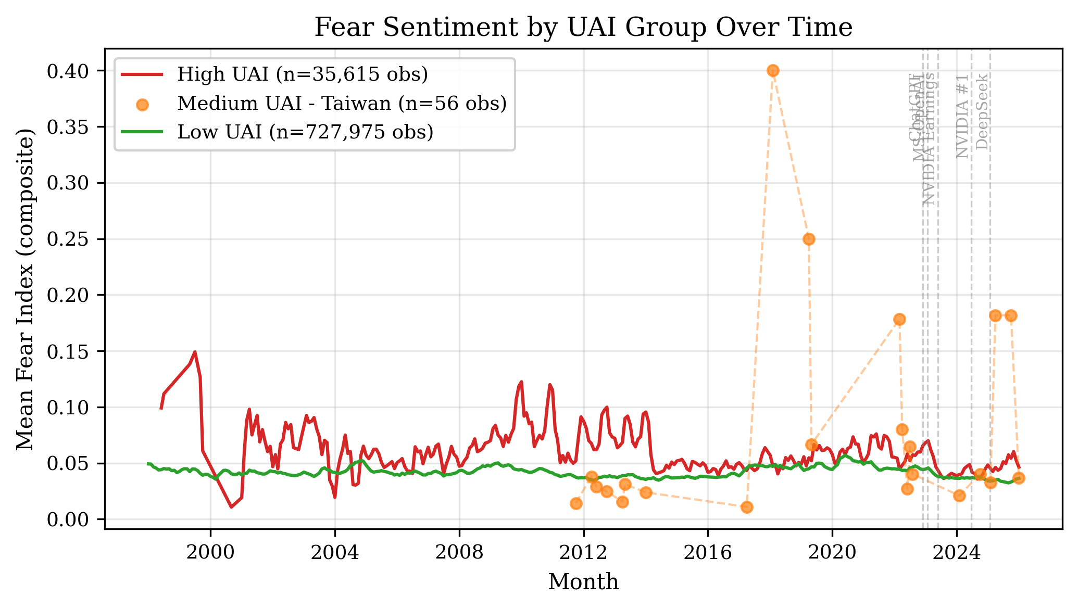
Figure 1. Quarterly Fear Sentiment by UAI Group (2020–2026)
Discussion and Conclusion
This study provides empirical evidence that national cultural uncertainty avoidance significantly shapes fear-related media sentiment toward emerging technology companies. Three key findings emerge. First, UAI has a significant positive effect on fear sentiment (β=0.050, p<0.05), supporting H1 and suggesting that cultural predispositions toward ambiguity intolerance translate into measurably higher fear narratives in media coverage of technology firms. Second, the significant UAI×Buzz interaction (H2) reveals that the relationship between media attention and fear is culturally contingent, though in the opposite direction expected—buzz attenuates rather than amplifies fear in high-UAI countries, suggesting information-resolution mechanisms. Third, event study evidence directionally supports H3: high-UAI countries show 6x larger abnormal fear responses to AI disruption events, though limited event frequency constrains statistical power.
These findings extend cultural dimensions theory into the domain of technology sentiment analytics and have practical implications for international technology firms managing investor communications across culturally diverse markets. Companies launching disruptive AI products should anticipate amplified fear narratives in high-UAI markets and may need culturally tailored communication strategies to mitigate sentiment-driven volatility.
Limitations and Future Research
This study has several limitations that suggest avenues for future research. First, the panel is dominated by US firms (87% of observations), creating potential imbalance. Future work should expand coverage to non-Americas exchanges. Second, UAI is measured at the national level; within-country cultural variation is not captured. Third, the R² values (1–2%) are modest, suggesting that cultural dimensions explain a small but significant portion of fear sentiment variance. Future research should integrate firm-level controls (market cap, industry sub-sector) and explore additional cultural frameworks (Schwartz, GLOBE) for triangulation.
REFERENCES
Bikhchandani, S., Hirshleifer, D., & Welch, I. (1992). A theory of fads, fashion, custom, and cultural change as informational cascades. Journal of Political Economy, 100(5), 992–1026.
Hofstede, G. (2001). Culture's consequences: Comparing values, behaviors, institutions and organizations across nations (2nd ed.). Sage Publications.
Hofstede, G., Hofstede, G. J., & Minkov, M. (2010). Cultures and organizations: Software of the mind (3rd ed.). McGraw-Hill.
Peterson, R. L. (2016). Trading on sentiment: The power of minds over markets. Wiley.
Rieger, M. O., Wang, M., & Hens, T. (2015). Risk preferences around the world. Management Science, 61(3), 637–648.
Tetlock, P. C. (2007). Giving content to investor sentiment: The role of media in the stock market. The Journal of Finance, 62(3), 1139–1168.
Shenkar, O. (2001). Cultural distance revisited: Towards a more rigorous conceptualization and measurement of cultural differences. Journal of International Business Studies, 32(3), 519–535.
MarketPsych/LSEG. (2024). Refinitiv MarketPsych Analytics (RMA) documentation. https://dataapi.marketpsych.com

