1. Implement Rolling median filter with reference to <https://en.wikipedia.org/wiki/Median_filter>

## Example Worked one-dimensional example[[edit](https://en.wikipedia.org/w/index.php?title=Median_filter&action=edit&section=2" \o "Edit section: Worked one-dimensional example)]

To demonstrate, using a window size of three with one entry immediately preceding and following each entry, a median filter will be applied to the following simple one-dimensional signal:

*x* = (2, 3, 80, 6, 2, 3).

So, the median filtered output signal *y* will be:

*y*1 = med(2, 3, 80) = 3, (already 2, 3, and 80 are in the increasing order so no need to arrange them)

*y*2 = med(3, 80, 6) = med(3, 6, 80) = 6, (3, 80, and 6 are rearranged to find the median)

*y*3 = med(80, 6, 2) = med(2, 6, 80) = 6,

*y*4 = med(6, 2, 3) = med(2, 3, 6) = 3,

i.e. *y* = (3, 6, 6, 3).

(3)characterize peak by their central position and half-max-width.

// Note: there are many ways to find out half-max-width reference to https://de.mathworks.com/help/signal/ref/findpeaks.html and https://docs.scipy.org/doc/scipy/reference/generated/scipy.signal.peak_widths.html

    // here I have measured the widths, using the half height as reference. if this does not seem proper for your application let me know, I have 2 other method ((1)we can find width using the half prominence as reference (2)find widths at the relative height of 0.5 (contour line at half the prominence height) and 1 (at the lowest contour line at full prominence height).

Implement as reference to below image

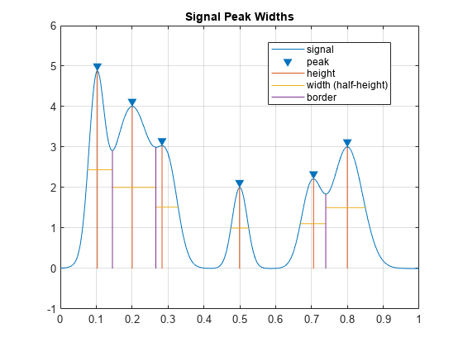

Can be also implemented by prominence as below :

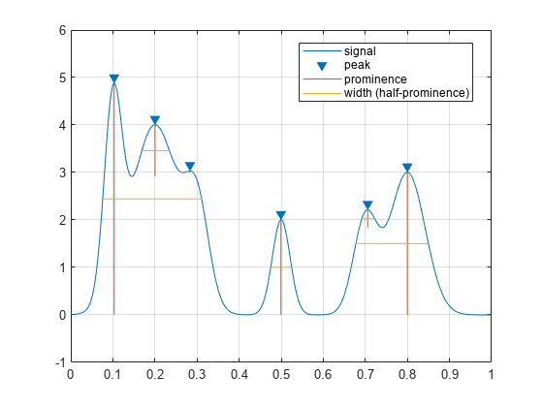or

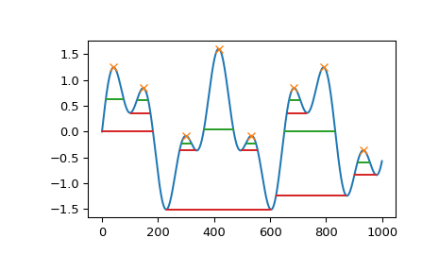

1. Binary positional grating data

As per defination of grating from wiki <https://en.wikipedia.org/wiki/Grating> , A **grating** is any regularly spaced collection of essentially identical, [parallel](https://en.wikipedia.org/wiki/Parallel_(geometry)" \o "Parallel (geometry)), elongated elements.

>>I have calculated grating by comparing distance between peaks and if 3 continuous peaks has same distance in between then signal 1 and 2 can be consider as grating.

>>in case If I misunderstand the defination of grating, please let me know.

**Ploting by gnuplot library**

Here I have plot input signal and peak signals intensity and position into graph and their widths and grating is displayed on command promp table by printf.

