Assignment 1

Insert documents

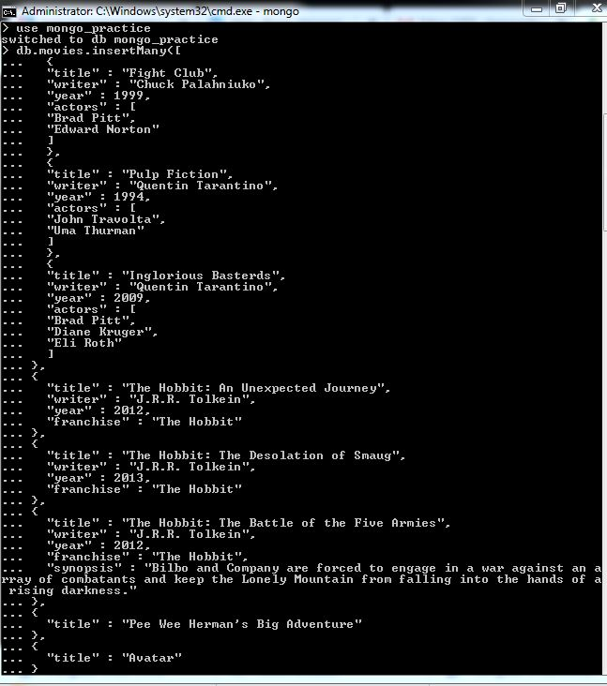

Query/find documents

1. 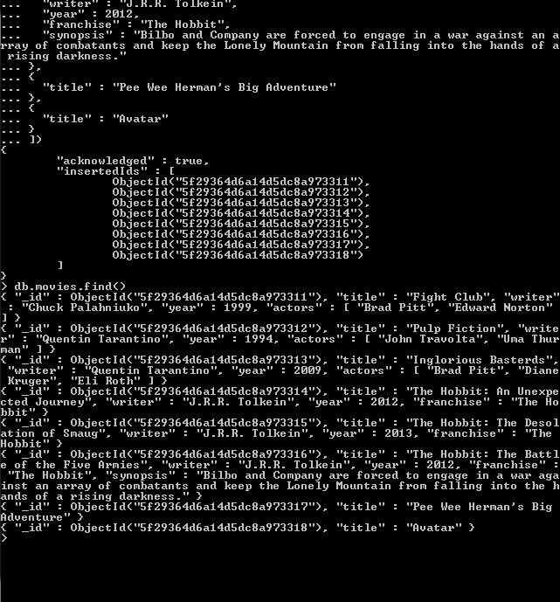
2. 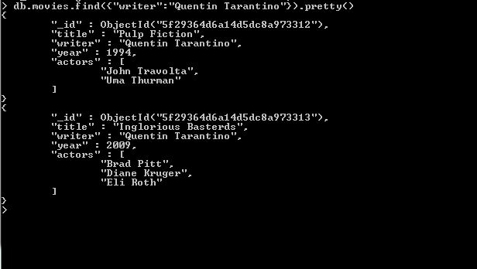
3. 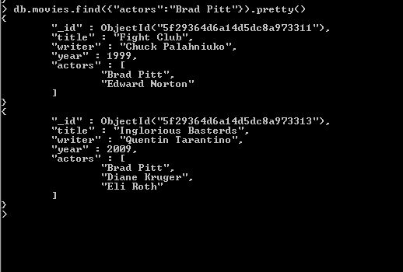
4. 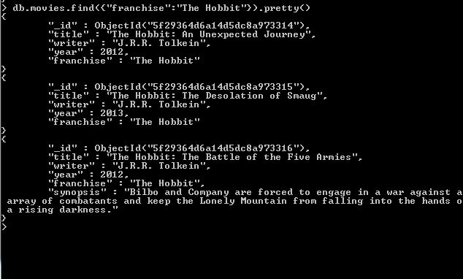
5. 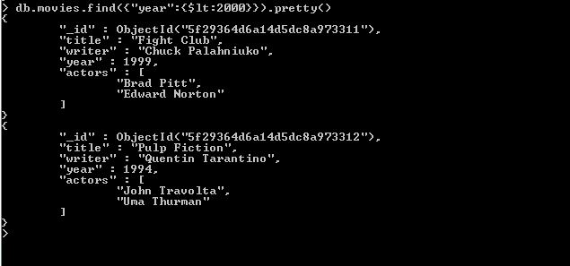
6. 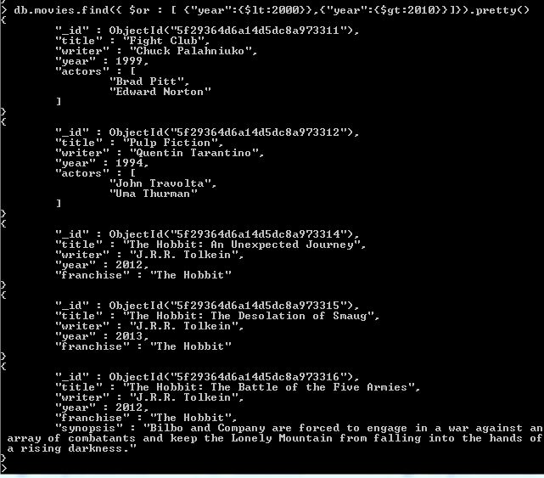

Update documents

1. 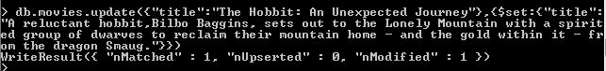
2. 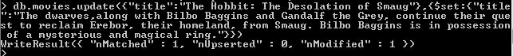
3. C:\Users\ASUS\Desktop\mongo\33.JPG

Text Search

1. 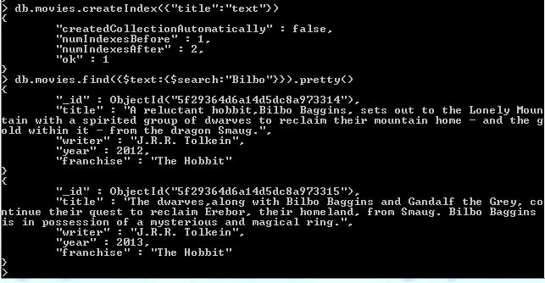
2. 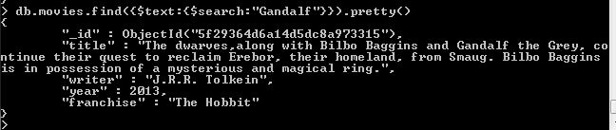

4.

C:\Users\ASUS\Desktop\mongo\43.JPG

5.C:\Users\ASUS\Desktop\mongo\44.JPG

Delete Documents

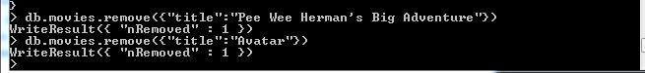

Relationships

Querying related collections

1.

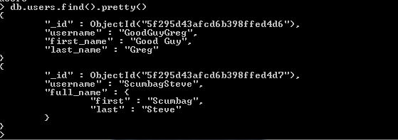

2.

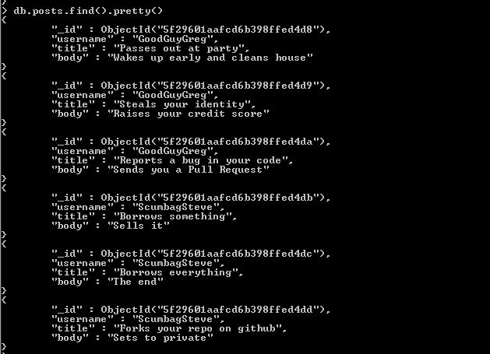

3.

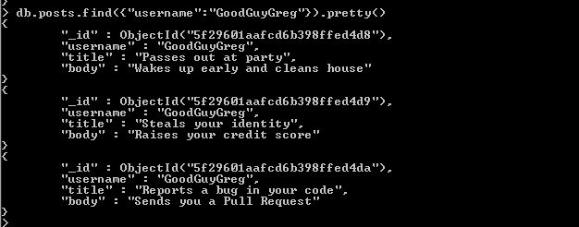

4.

