Hemangi Borse(46016328)

Assignments of Git and Github

Install GIT & make sure it is added into PATH.

Use GIT as local VCS. Steps to follow:

1. Create a directory ‘project_dir’ & cd to ‘project_dir’.

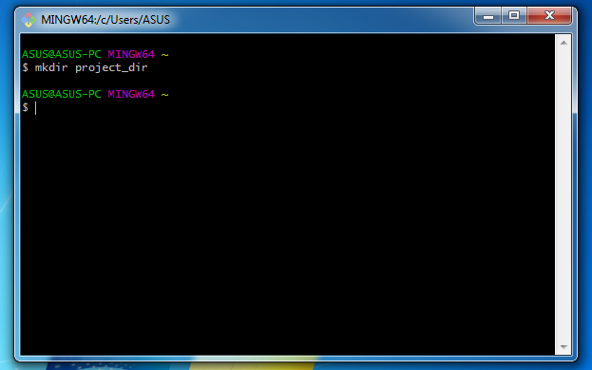

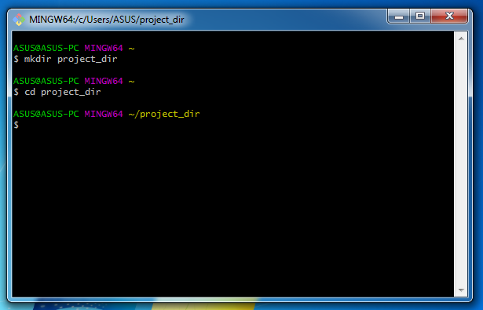

2. Initialize git version database. (git init)

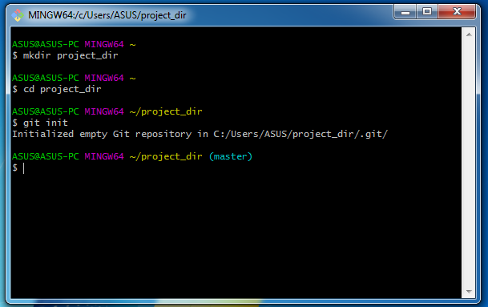

3. Create a new file index.html.

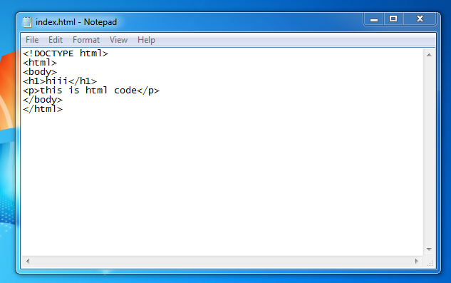

4. Check the git status. You should find index.html as untracked file.

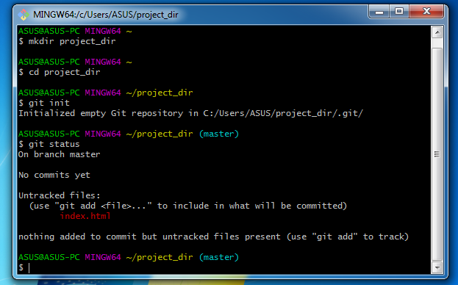

5. Stage the index.html file.

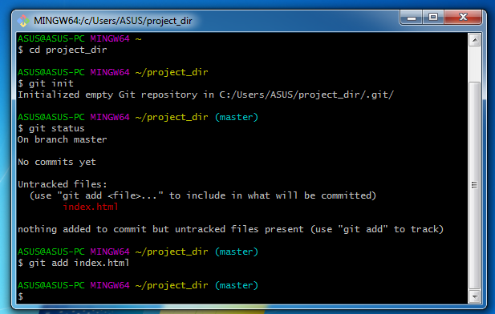

6. Commit index.html

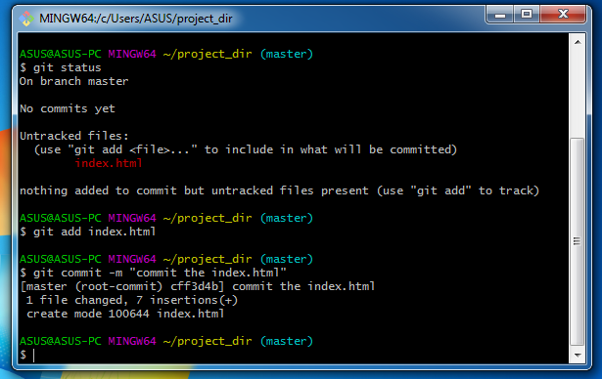

7. Make few changes in index.html & create a new file info.txt file.



Few changes on index.html

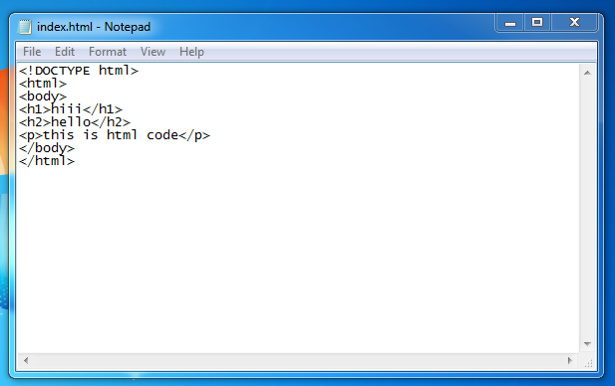

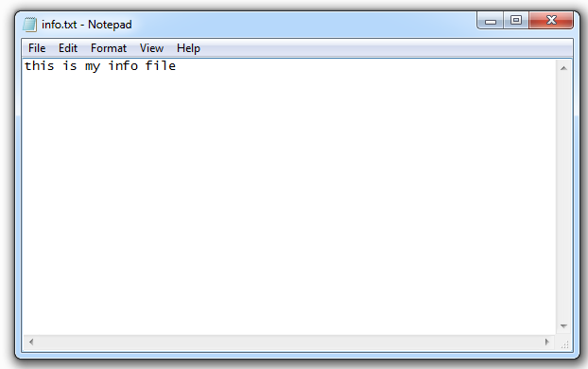

8. Check git status. You should find index.html & info.txt as untracked files.

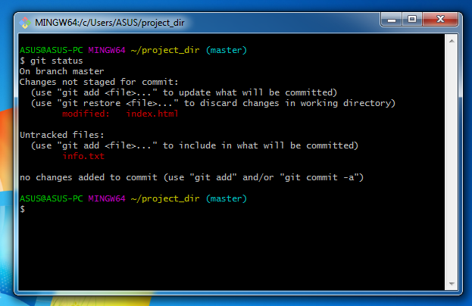

9. Configure GIT to ignore all txt files.

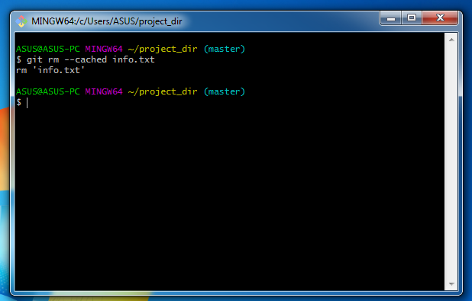

10. Again check the git status. You should find only index.html as untracked file.

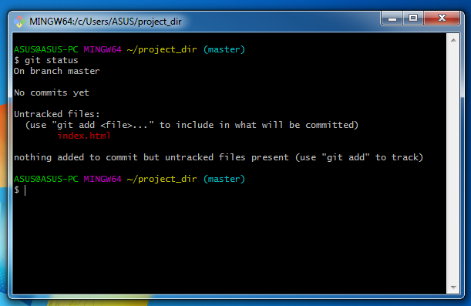

11. State & commit index.html

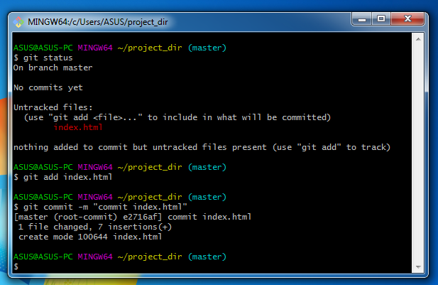

12. Log all your comments so far.

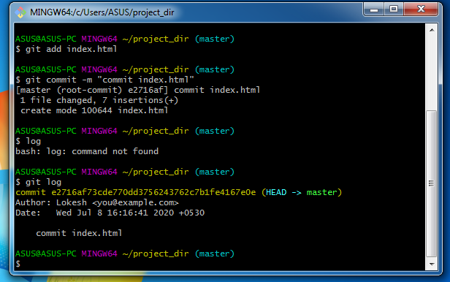

13. Make some changes in index.html.

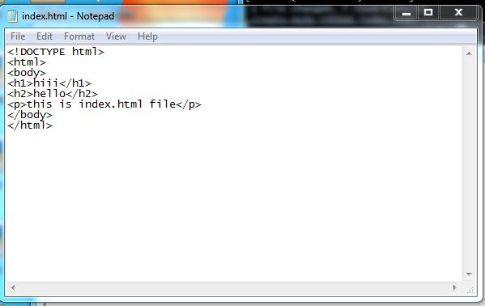

**14.** Revert the change made in the previous step using git command.

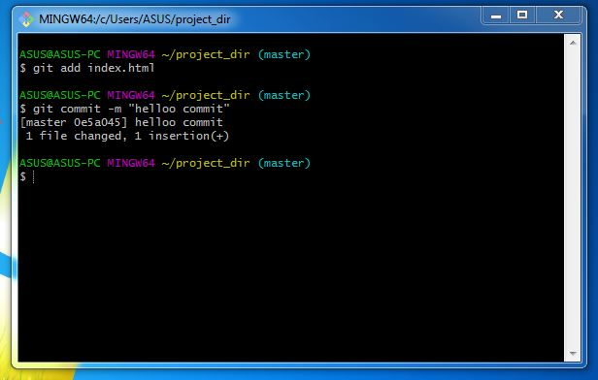

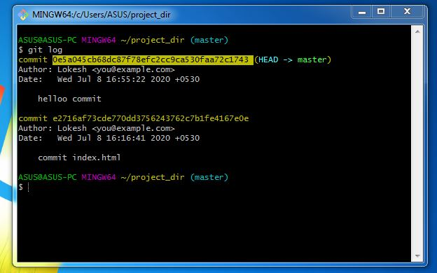

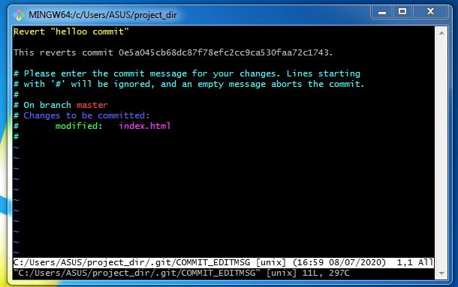

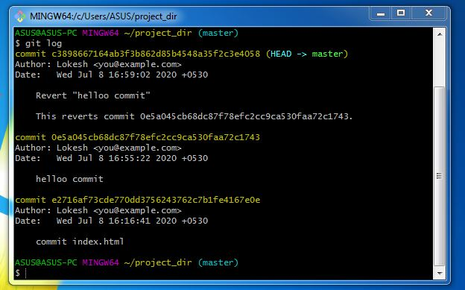

15. Again change index.html.

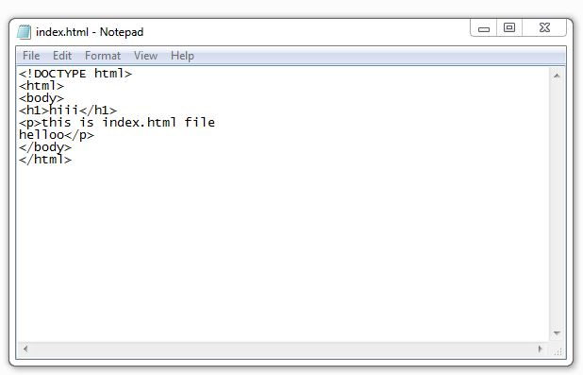

16. Stage index.html

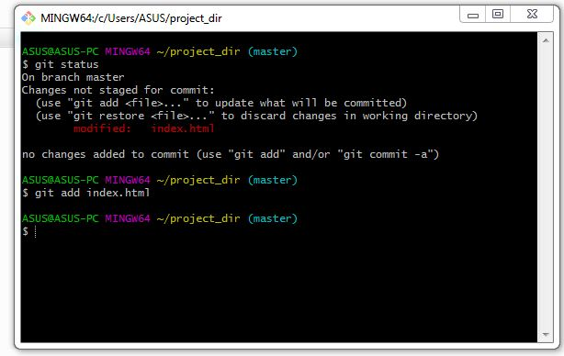

17. Revert back the last stage.

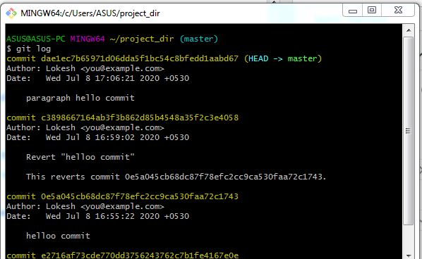

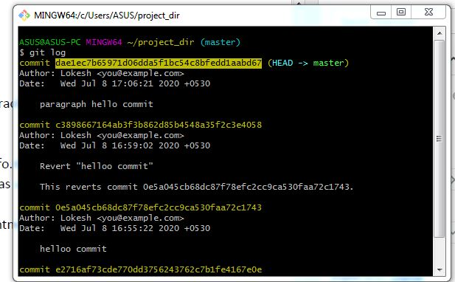

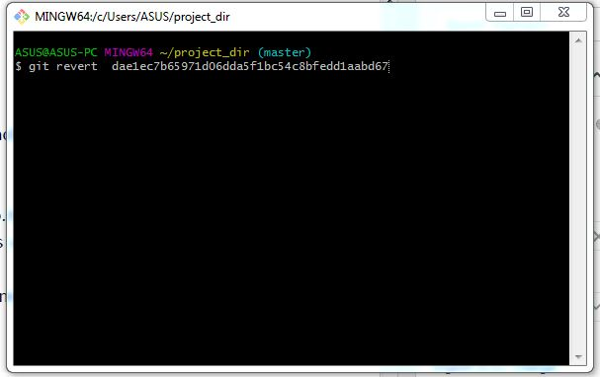

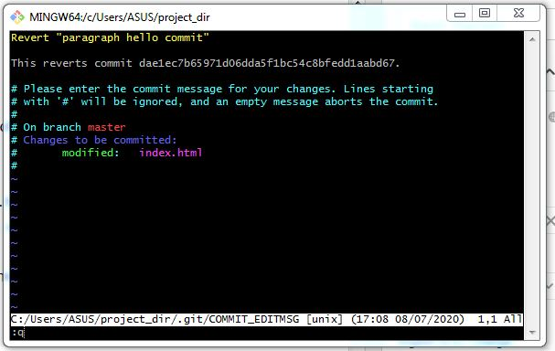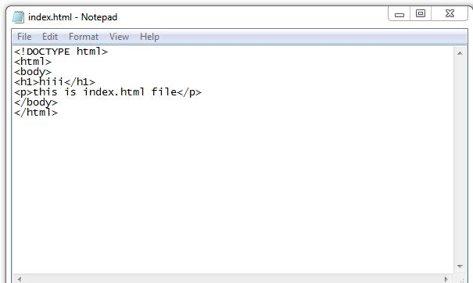

18. Rename ‘add’ command to ‘my-add’.

19. Using my_add command Stage index.html again & commit the changes.

20. Revert the last commit.

*GIT Branching*

Objective: Commit HTML, CSS & JavaScript assignments into GIT.

SECTION-1 (HTML assignments) - Steps to follow:

21. First take a backup of your assignments & projects. This is required because due to incorrect GIT operation you may lose your files.

22. Create an empty directory ‘Assignments’ & cd to ‘Assignments’.

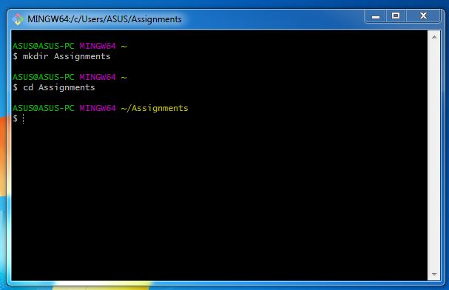

23. Create a file README.txt inside ‘Assignments’ & write few lines about the contents of ‘Assignments’ folder.

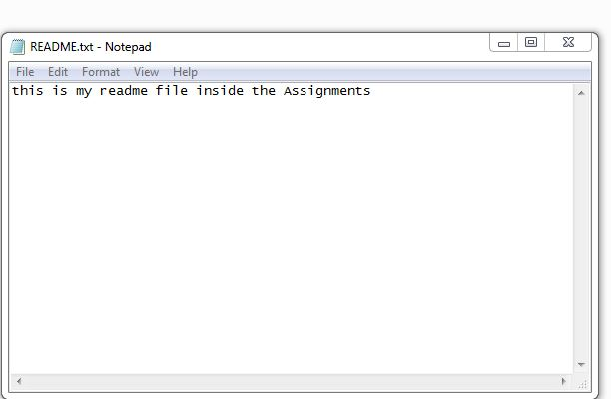

24. Commit README.txt file.

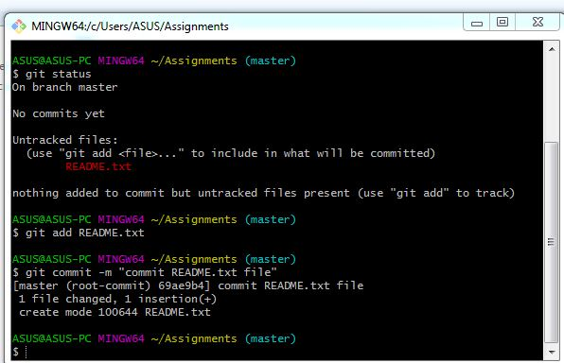

25. Now create a new branch ‘html-assignments’.

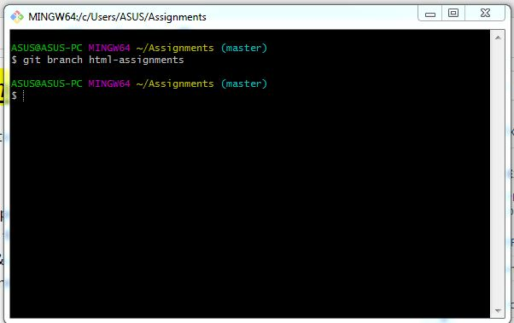

26. Switch to ‘html-assignments’ branch.

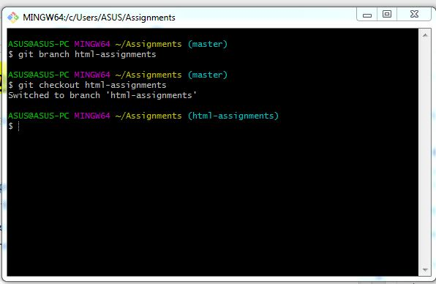

27. Copy all HTML assignments inside ‘Assignments’ folder.

28. Commit HTML assignments into ‘html-assignments’ branch.

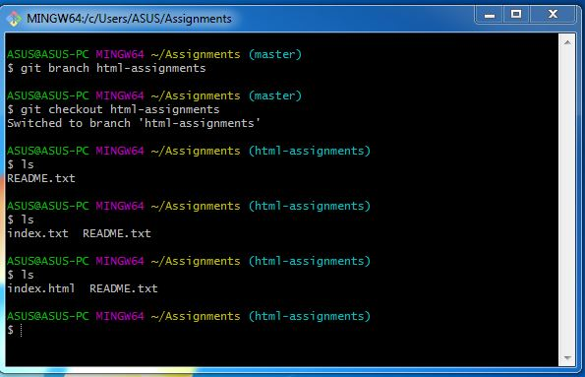

29. Make minor changes into few files belonging to ‘html-assignments’ branch.

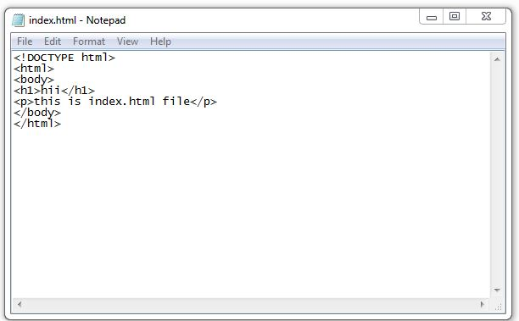

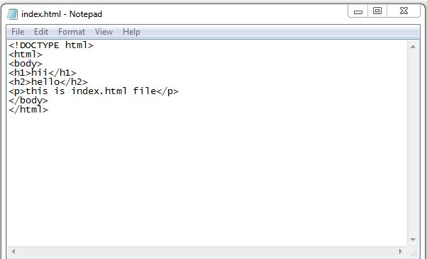

30. Commit those changed files.

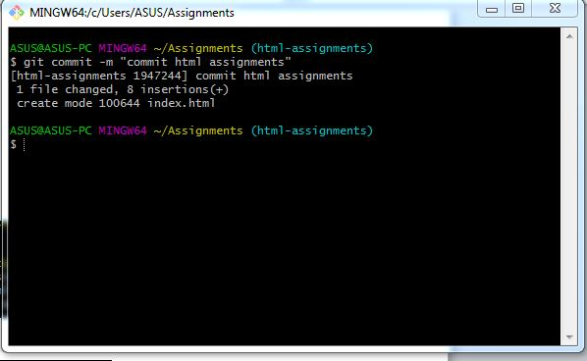

31. Switch to master branch.

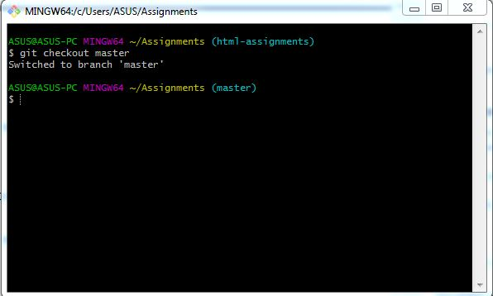

32. Make minor changes into README.txt file & commit those changes into master

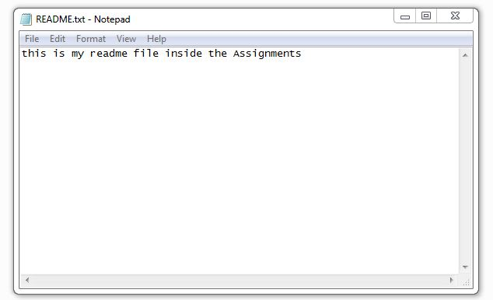

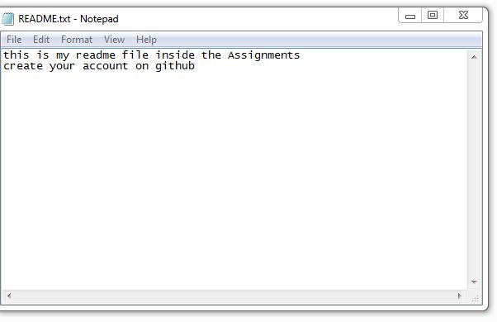

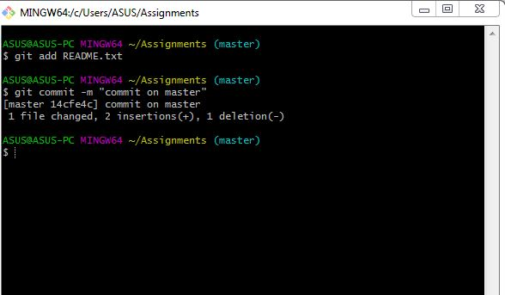

33. Again switch to ‘html-assignments’ branch.

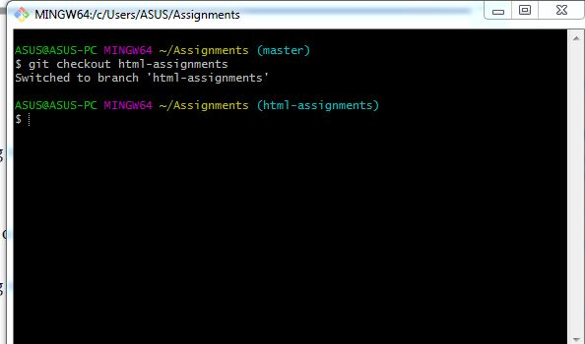

34. Make minor changes into few files belonging to ‘html-assignments’ branch.

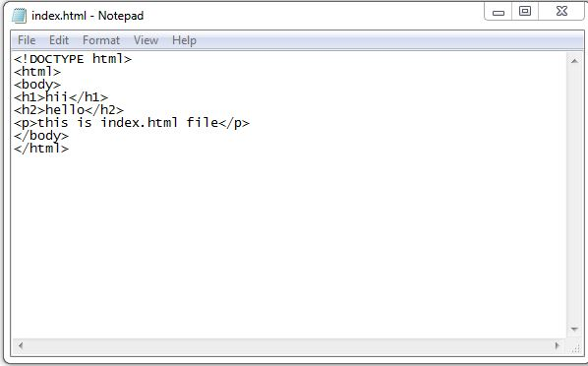

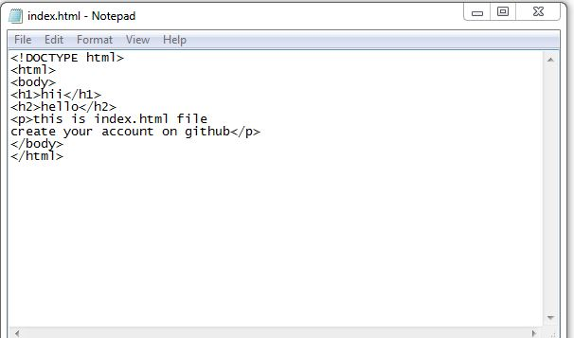

35. Commit those changes.

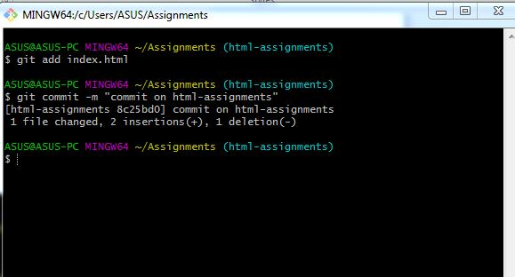

36. Switch to master.

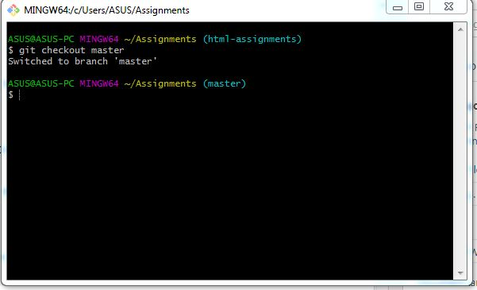

37. Merge ‘html-assignments’ branch into master. Confirm all html assignments are shown in master.

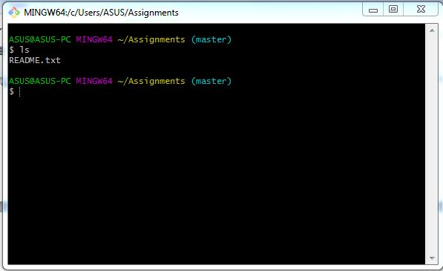

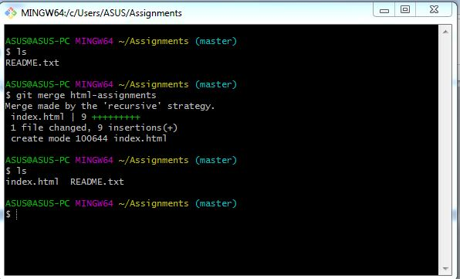

38. Finally delete the ‘html-assignments’ branch.

SECTION-2 - (CSS assignments) Steps to follow:

1. Create a new branch ‘css-assignments’.

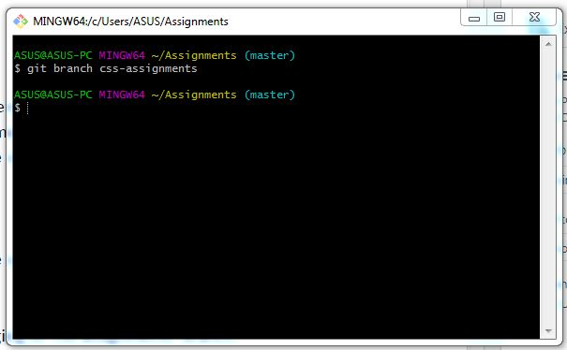

2. Switch to ‘css-assignments’ branch.

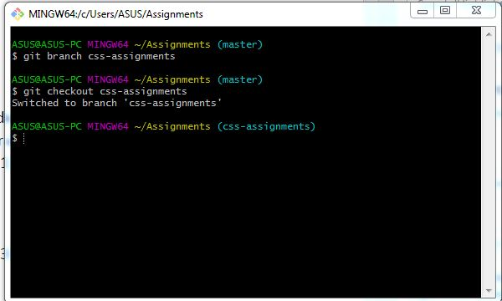

3. Copy all CSS assignments inside ‘Assignments’ folder.

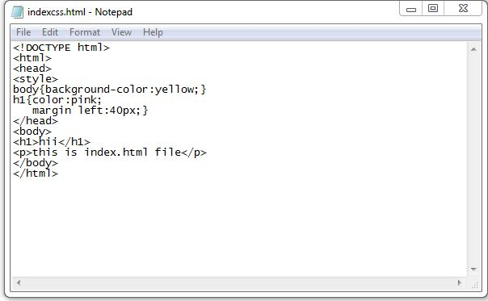

4. Commit CSS assignments into ‘css-assignments’ branch.

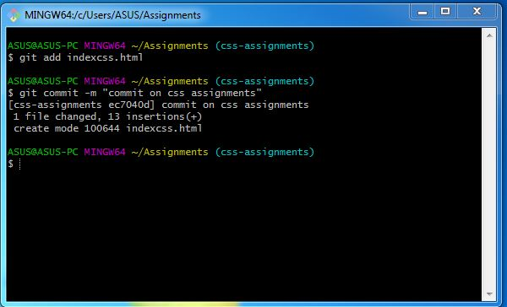

5. Make minor changes into README.txt file on line 1 belonging to ‘css-assignments’ branch.

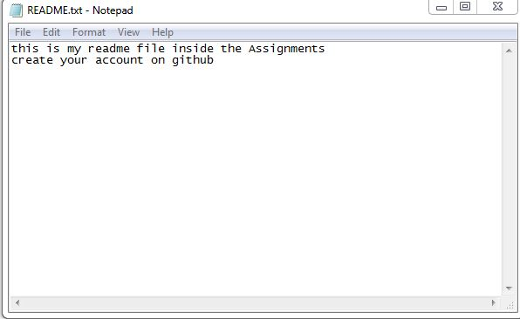

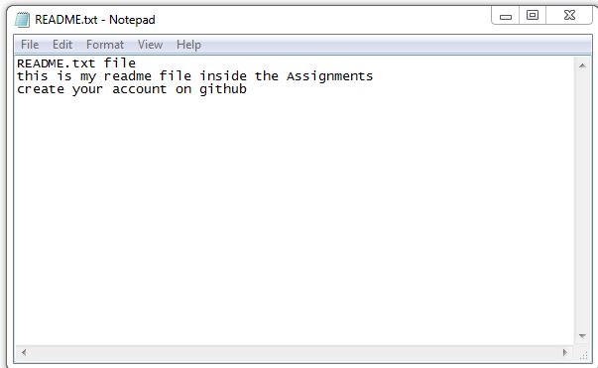

6. Commit those changed files.

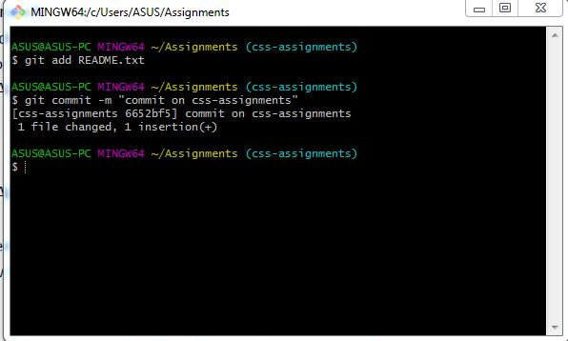

7. Switch to master branch.

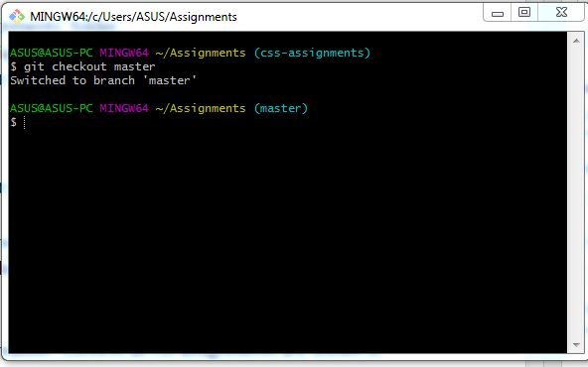

8. Make minor changes into README.txt file on line 3 & commit those changes into master.

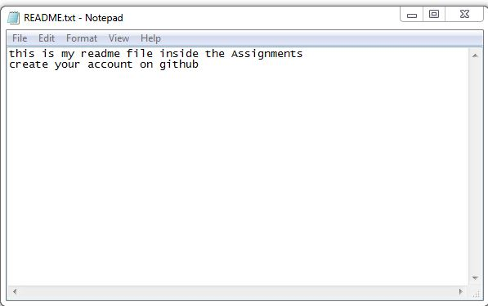

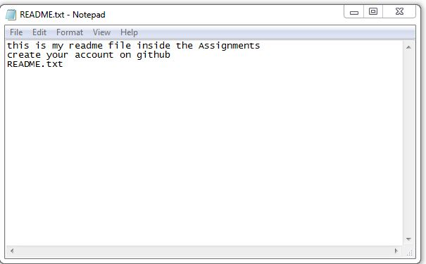

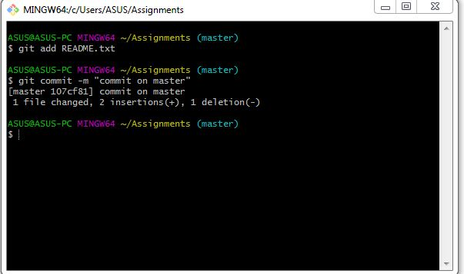

9. Again switch to ‘css-assignments’ branch.

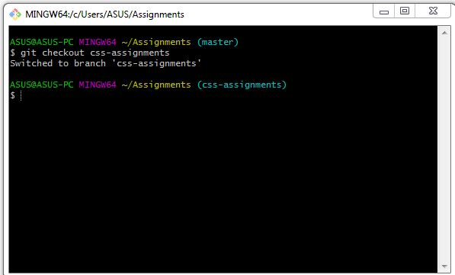

10. Make minor changes into few files belonging to ‘css-assignments’ branch.

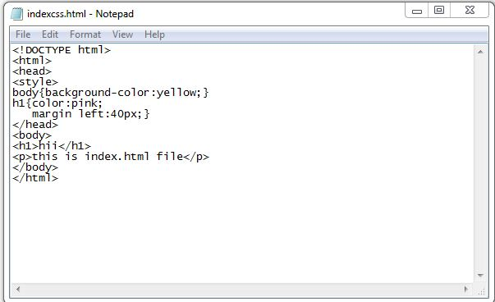

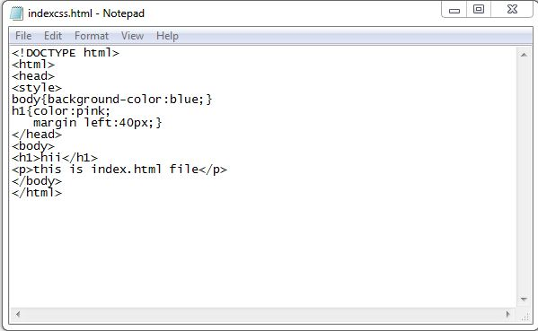

11. Commit those changes.

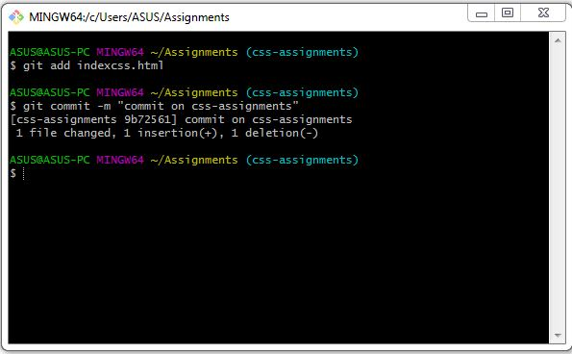

12. Switch to master.

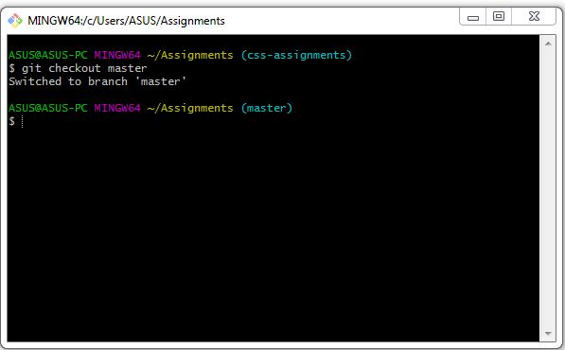

13. Merge ‘css-assignments’ branch into master. Confirm all css assignments are shown in master.

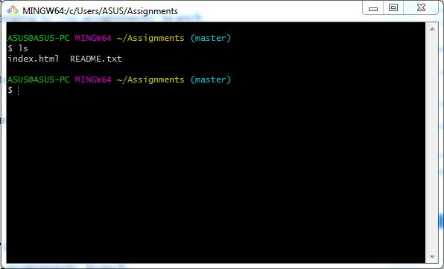

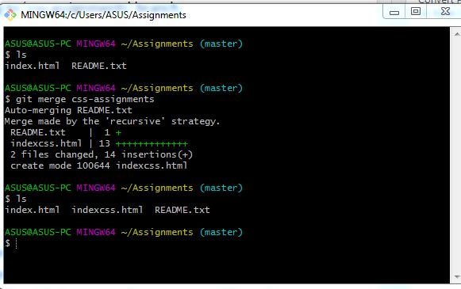

14. Finally delete the ‘css-assignments’ branch.

SECTION-3 - (JavaScript assignments) Steps to follow:

1. Create a new branch ‘js-assignments’.

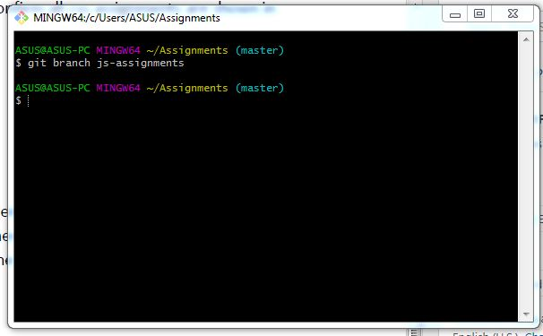

2. Switch to ‘js-assignments’ branch.

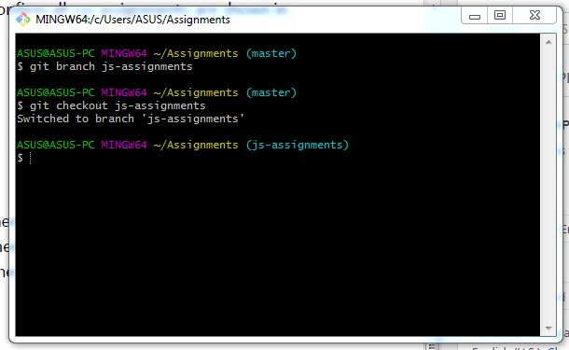

3. Copy all JavaScript assignments inside ‘Assignments’ folder.

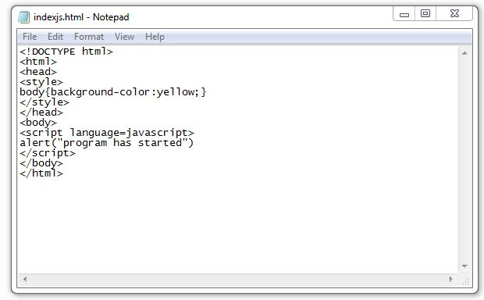

4. Commit JavaScript assignments into ‘js-assignments’ branch.

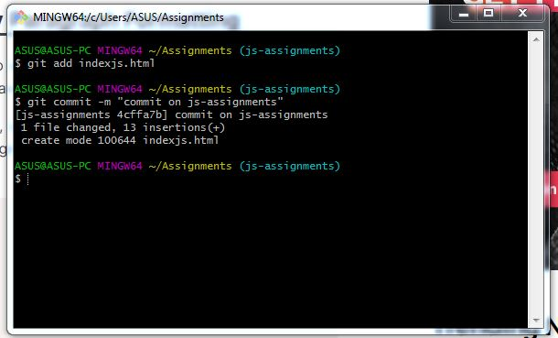

5. Make minor changes into README.txt file on line 1 belonging to ‘js-assignments’ branch.

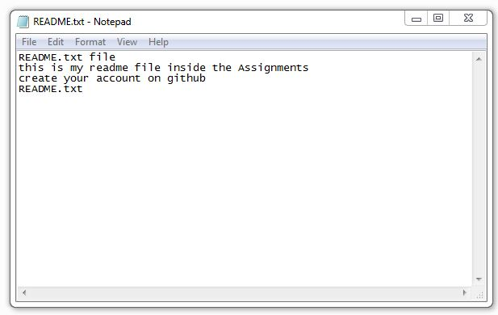

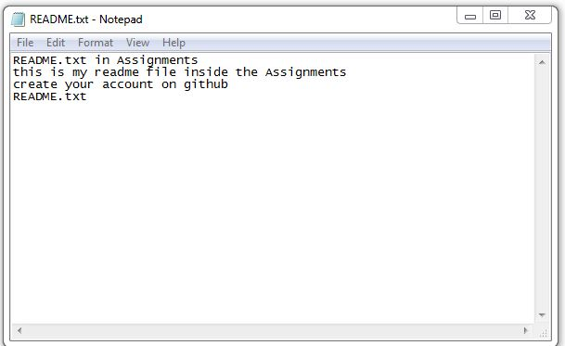

6. Commit those changed files.

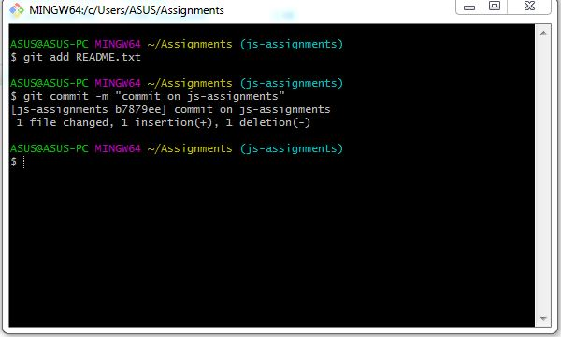

7. Switch to master branch.

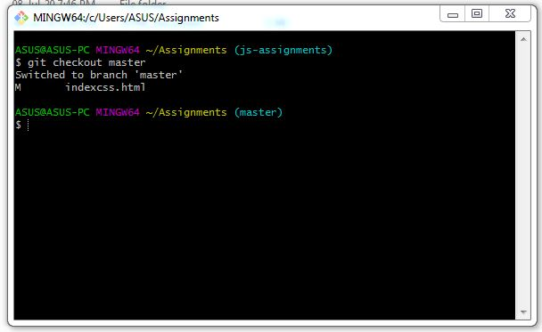

8. Make minor changes into README.txt file on line 1 & commit those changes into master.

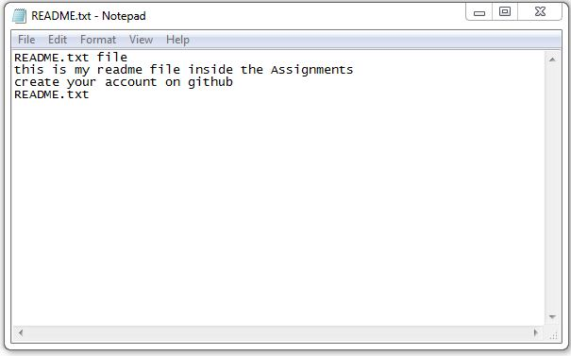

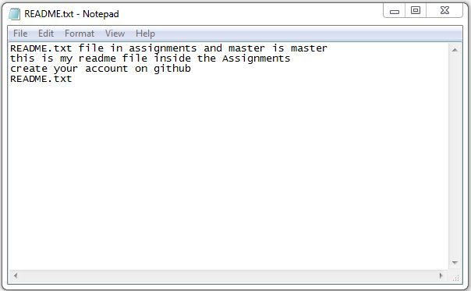

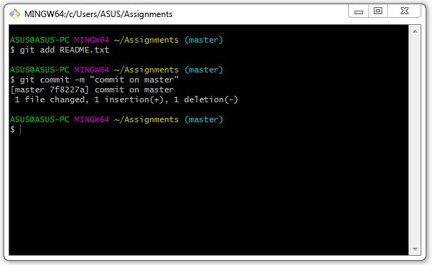

9. Again switch to ‘js-assignments’ branch.

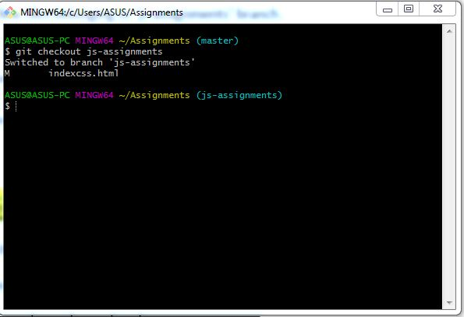

10. Make minor changes into few files belonging to ‘js-assignments’ branch.

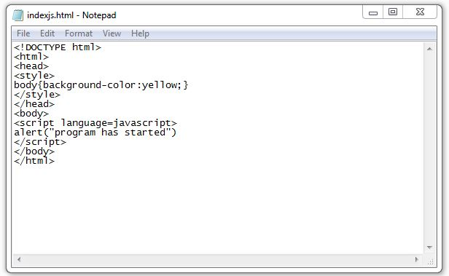

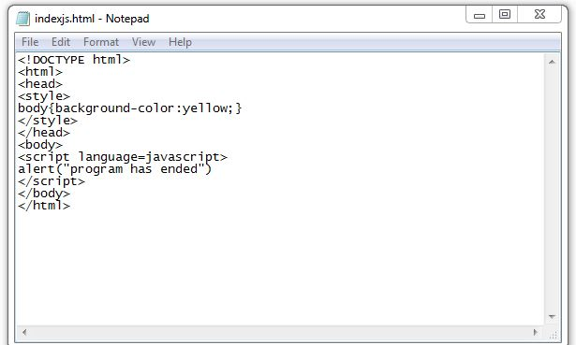

11. Commit those changes.

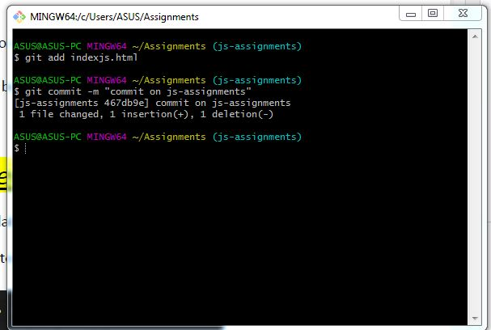

12. Switch to master.

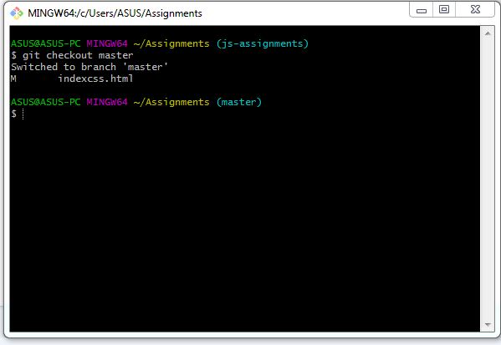

13. Merge ‘js-assignments’ branch into master. Confirm all JavaScript assignments are shown in master.

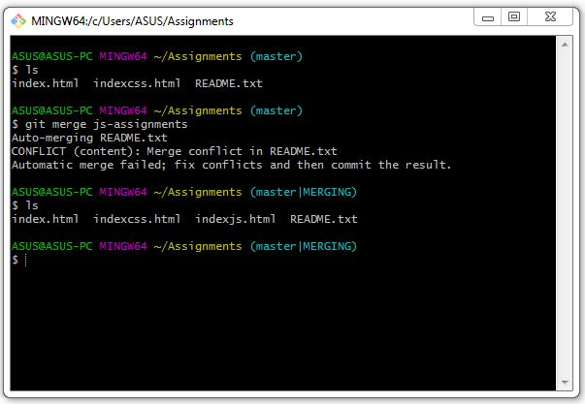

14. Finally delete the ‘js-assignments’ branch.