T17 – Insurance Claim Red-Flag Checker
Business report · Hemang Kubde · MBA (Data Science & Data Analytics), SCIT · 800 synthetic claims; all figures fictional. Rules v1.0.

1. Executive summary
A transparent, rule-based screening tool scored all 800 claims from 0 to 100 using ten explainable red-flag rules. At the screening threshold of 30, 207 claims (25.9%) were flagged for review, of which 59 are High band. Flagged claims account for ₹5,92,22,877 of ₹15,65,98,711 claimed. A red flag is a reason to verify, not proof of fraud.
Evaluation status: PENDING. The frozen v1.0 predictions have not yet been compared with the gold labels in this report; Section 5 will be completed after the blind evaluation.

2. Business problem and objectives
Claims teams must review efficiently. Manual review is slow, but treating unusual claims as fraud can delay or deny genuine customers. The tool aims to (1) produce a reproducible score, (2) explain every point, (3) group claims into Low, Medium and High bands, (4) help managers prioritise review, and (5) measure false positives and false negatives against independent gold labels. It separates three ideas: a suspicious claim (a rule fired), a confirmed fraudulent claim (gold label) and a claim needing further investigation (a human decision).

3. Dataset and preprocessing
The Claims sheet has 800 rows and 12 columns with no missing values, 800 unique claim IDs, no negative values, no claim above its sum insured, and one policy number that appears twice (reported, not removed). Five claim types appear (Motor – Own Damage, Health – Hospitalisation, Health – Day Care, Home – Theft, Motor – Theft). The claim-to-sum-insured ratio is derived safely, with zero or missing sums handled without error. 91 claims have incomplete documents. The gold-label sheet was not opened while the rules were designed.

4. Red-flag rules and scoring method
Points from triggered rules are summed and capped at 100. Bands: Low 0–29, Medium 30–59, High 60–100; flagged if score ≥ 30. Weights are heuristic, set by reasoning rather than tuned to labels, and need validation. City and provider type are deliberately not scored. Overlap remains between R3 and R7; R10 adds a combination bonus.
ID | Rule | Condition | Pts
R1/R2 | Early claim | ≤90 days / ≤30 days from policy start (R2 replaces R1) | 20/30
R3 | High claim ratio | claim ÷ sum insured ≥ 0.80 | 15
R4/R5 | Repeat claimant | ≥3 / ≥5 claims in 3 years (R5 replaces R4) | 15/25
R6 | Address changes | ≥2 changes in last year | 10
R7 | Incomplete documents | FIR/documents marked "No" | 20
R8/R9 | Late reporting | Motor & Home-Theft ≥7 days (15); Health ≥30 days (10) | 15/10
R10 | Early + missing documents | (R1 or R2) and R7 together | +10

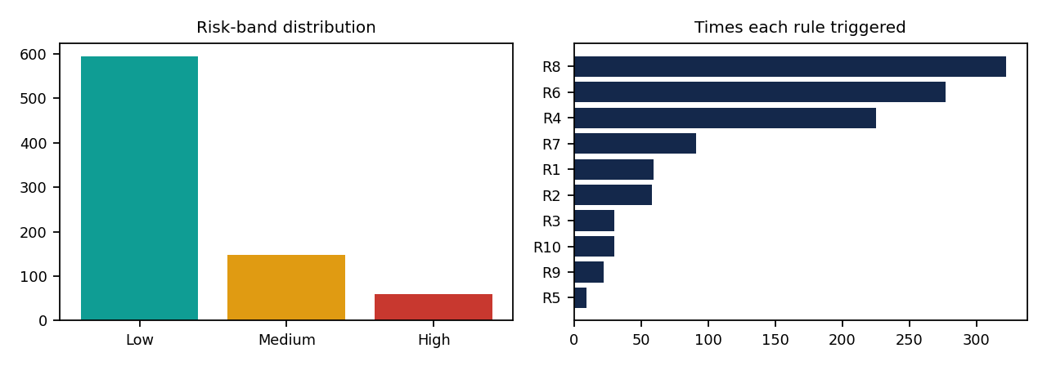
Frequent triggers: late reporting R8 322, address changes R6 277, repeat claimant R4 225. These broad rules are a known limitation and were kept at v1.0 by decision.

5. Evaluation methodology and results
v1.0 rules and predictions are frozen before labels are imported. Labels are matched by claim_id only; each claim is evaluated once; flagged means score ≥ 30. Metrics (precision, recall, specificity, accuracy, F1, % flagged) and the confusion matrix come from matched records. Other thresholds are exploratory, not the blind test.
- Precision: of claims flagged, the share confirmed fraudulent (TP ÷ (TP+FP)).
- Recall: of confirmed fraud, the share flagged (TP ÷ (TP+FN)).
- Specificity: of genuine claims, the share not flagged (TN ÷ (TN+FP)).
- False positive: a genuine claim flagged, causing delay and cost. False negative: fraud not flagged, a possible financial loss.
Results: Not evaluated yet. Insert the confusion matrix and metrics from the app after import.
Metric | Value | Numerator | Denominator
Precision | Not evaluated yet | – | –
Recall | Not evaluated yet | – | –
Specificity | Not evaluated yet | – | –
F1 / Accuracy | Not evaluated yet | – | –

6. Business insights and recommendations
Descriptive findings. Flag rates by claim type: Health - Day Care 12.7% (n=118); Health - Hospitalisation 13.8% (n=269); Home - Theft 35.9% (n=64); Motor - Own Damage 36.4% (n=297); Motor - Theft 46.2% (n=52). Motor and theft types flag more often, partly because their 7-day late-reporting threshold is stricter than the 30-day health threshold, so this is a rule-design effect, not evidence about customers. City differences rest on small samples (23–61 claims each) and are inconclusive.
Interpretation (hypotheses). Broad rules may separate claims weakly; the workload of 207 reviews versus 59 High-band reviews shows the trade-off in the threshold.
Recommendations (need validation).
- Review the 59 High-band claims first, starting with the 30 claims that combine early timing with missing documents.
- Test lower weights or stricter conditions for R8, R6 and R4 on new data before changing v1.0.
- Capture loss descriptions, repair or treatment bills and verified document status to replace weak proxies.
- Record review outcomes so thresholds are chosen on fresh data. Investigation costs, fraud losses and processing times are not in the dataset, so no savings are claimed.

7. Fairness, responsible AI and limitations
- A flag must never alone reject, reduce or delay payment; authorised staff decide and customers need an appeal route.
- False positives delay genuine claims; false negatives let fraud pass. Accuracy alone does not prove effectiveness.
- Performance may differ by claim type and city; small groups give inconclusive evidence. City and provider type are not scored.
- Synthetic data, heuristic weights, missing variables and overlapping indicators limit validity. Associations are not causation.
- Restrict access to claim data and minimise exports.

8. Personal reflection (to be completed by the student)
Write honestly in your own words: what you asked the AI to do and what you changed; the errors you found and fixed (for example the all-Low scoring bug caught by testing); one thing the tool does badly; what you would do differently; and how you kept the evaluation blind.
[Your reflection here]

