**CAPSTONE PROJECT**

**Potential Chinese Restaurant Market In India.**

Hemang Monga

May 10, 2020

1. **Introduction:**

**1.1 Background**

India’s demographics show that it is a large and ethnically diverse country. It is the [second-most populous](https://en.wikipedia.org/wiki/List_of_countries_and_dependencies_by_population" \o "List of countries and dependencies by population) country, the [seventh-largest](https://en.wikipedia.org/wiki/List_of_countries_and_dependencies_by_area" \o "List of countries and dependencies by area) country by area, and the most populous [democracy](https://en.wikipedia.org/wiki/Democracy" \o "Democracy) in the world. With its diverse culture, comes diverse food items.

While the Chinese have been visiting India for millennia in search of Buddhist teachings, Yang Tai Chow was the first recorded Chinese to migrate to India for better material prospects. In 1778, he put down roots in Kolkata. Known at the time as Calcutta.

What is that makes Chinese food so spectacularly popular in India, the answer lies in Indian Food. Quick to figure out that Indians love spicy, oily preparations, the Chinese merely masalafied and greased their cuisine into a glutinous, winning combination.

With so much popularity of Chinese food in India, there are a lot of different Chinese restaurants in different States of India.

**1.2 Problem:**

To find the answers to the following questions:

Q1) List and visualize all major parts of India that has great Chinese restaurants.

Q2) What is best location in India for Chinese Cuisine?

Q3) Which areas have potential Chinese Restaurant Market?

Q4) Which all areas lack Chinese Restaurants?

Q5) Which is the best place to stay if you prefer Chinese Cuisine?

**1.3 Interest**

Restaurant Owners and Potential owners would be very interested in the findings of this report. Also tourists visiting India who are great fan of Chinese cuisine may also be very interested.

1. **Data acquisition and cleaning**

**2.1 Data Sources:**

India's demographics show that it is a large and ethnically diverse country. With its diverse culture, comes diverse food items. There are many restaurants in India, each belonging to different categories like Chinese, Indian, and French etc.

For this project we need the following data:

* India data that contains list States, Cities along with their latitude and longitude.
* Data source : <https://simplemaps.com/static/data/country-cities/in/in.json>
* Description: This data set contains the required information. And we will use this data set to explore various cities of India.
* Chinese restaurants in each City of India.
* Data source : Foursquare API
* Description: By using this API we will get all the venues in each city. We can filter these venues to get only Chinese restaurants.

**2.2 Data Cleaning**

The data collected from the source had a lot of features, so I decided to take only the name of State, City and its Latitude and Longitude would be a great start because the other fields were not as important for the study.

There were a few problems with the data set like ‘a’ was replaced by ‘ā’, ‘i’ was replaced by ‘ī’ and ‘u’ was replaced with ‘ū’ in the columns ‘State’ and ‘city’, so had to replace the letters in those columns.

After Cleaning the data, we were set to move forward to the next step.

**3. Exploratory Data Analysis**

**3.1 Calculation of No. Of cities in each State of India.**

We now had the data of each State and cities in India, so we went forward to plot a graph of total no. Of cities in each State of India.

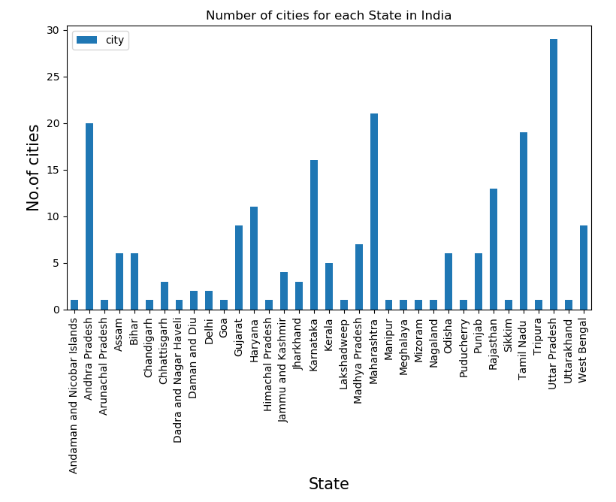

**3.2 Calculating No. Of Chinese Restaurants in Each City.**

So for calculating no. Of Chinese restaurants in each city, I used the Foursquare API to find out different venues of Chinese restaurants in each city using the latitude and longitude information from the data frame which was created using the data from the data source.

So, we found 77 Chinese restaurants in 212 cities of India using the Foursquare API.

Next I created a new Data Frame consisting of names of the restaurant, Restaurant ID, City and State in which they were located and named it Chinese_rest.

Next I plotted a graph for no. Of Chinese Restaurant in each State Of India. And it is clear from the graph that West Bengal has the highest no. Of Chinese Restaurants in India.

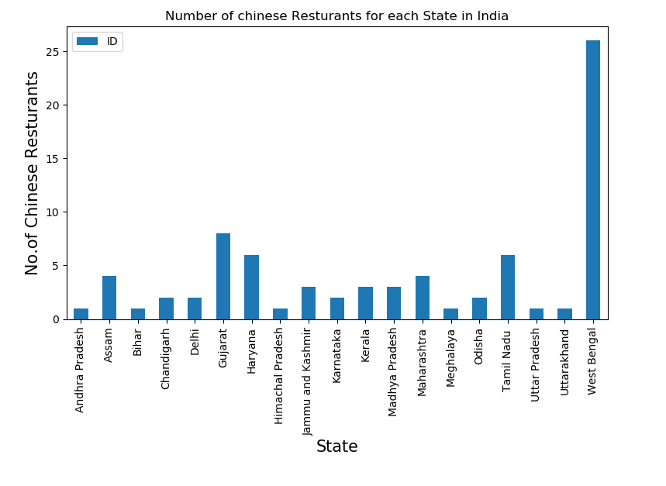

Next I plotted 5 Cities with Max. No. Of Chinese Restaurants in India. And the top 3 cities which had maximum no. Chinese Restaurants are in the State of West Bengal.

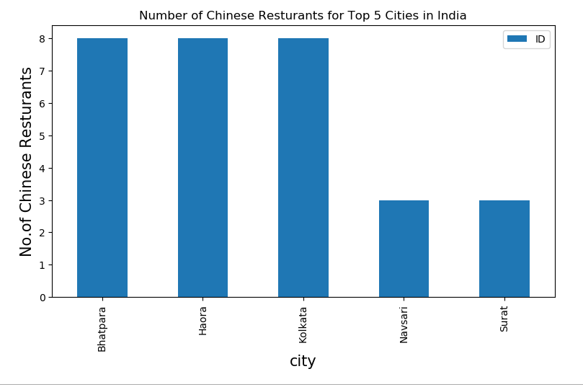

**3.3 Getting Likes, Ratings and Tips for all the Chinese Restaurants In the list**.

So, for getting the likes, Ratings and Tips, I again used the Foursquare API.

For Restaurants, for which we were unable to get the likes, ratings and tips we filled them with 0’s in our Data Frame.

Then I saved the data frame in a csv file because to get Ratings and Tips of a restaurants, it exhausts the total call limit of a personal Foursquare API account. So this Data Frame consists of State, City, ID, Name, Likes, Ratings, and Tips of the Restaurant. And the Data Frame is named as rating_df.

**3.4 Restaurant With Maximum Likes.**

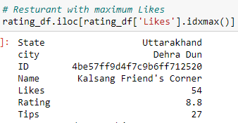

**3.5 Restaurant With Maximum Ratings.**

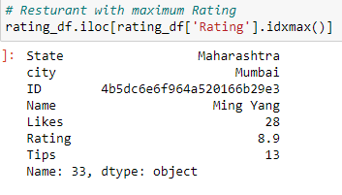

**3.6 Restaurant With Maximum Tips.**

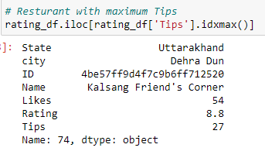

**3.7 List Of Average Rating of Restaurants in all the cities.**

So, to find out Average Rating of all the restaurants in a city, I used the groupby() and selected mean of Rating column to find out the average rating and then created a new Data Frame.

After doing that, I sorted the list in descending order of Rating and found out that Mumbai has the highest Average Rating of Chinese Restaurants among all the other cities.

**3.8 List of Average Rating of Restaurants State-Wise**.

So, to find out Average Rating of all the restaurants in a State, I used the groupby() and selected mean of Rating column to find out the average rating and then created a new Data Frame.

After doing that, I sorted the list in descending order of rating and found out that Uttarkhand has the highest Average Rating of Chinese Restaurants among all the other States.

Then Plotted a Graph for the same.

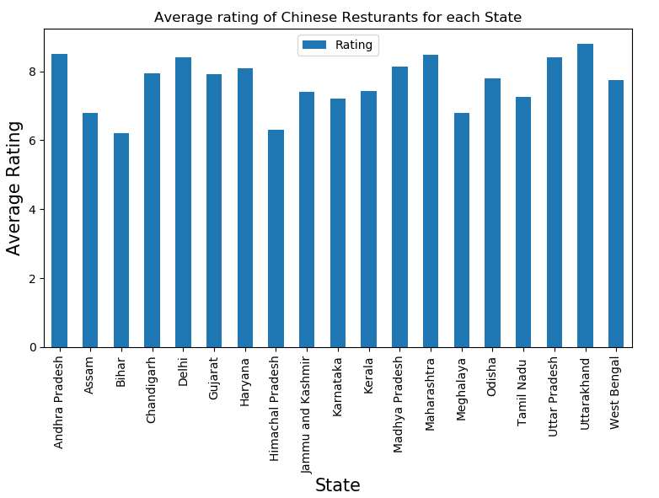

**3.9 Plotting a graph on the map of India for Restaurants having ratings>8.5 .**

So, for doing so, I took out only those Restaurants which had a Rating of more than 8.5 and discarded all the other list of restaurants. There were only 5 Restaurants with Rating of higher than 8.5 . The First one was Bhiwandi, Mumbai, Maharashtra. Second was in Dehra Dun, Uttarkhand, Third was in Hyderabad, Andhra Pradesh, Fourth and Fifth were in Mumbai, Maharashtra.

So out of the top 5 Chinese Restaurants - 3 Were in Mumbai, Maharashtra.

Then I imported the map of India using the python library Folium, with a starting zoom of 6.

Then I put a circle marker to locate the locality where the restaurant was situated in, and also an incident which showed the address when pressed on.

And I then saved the map as an html page.

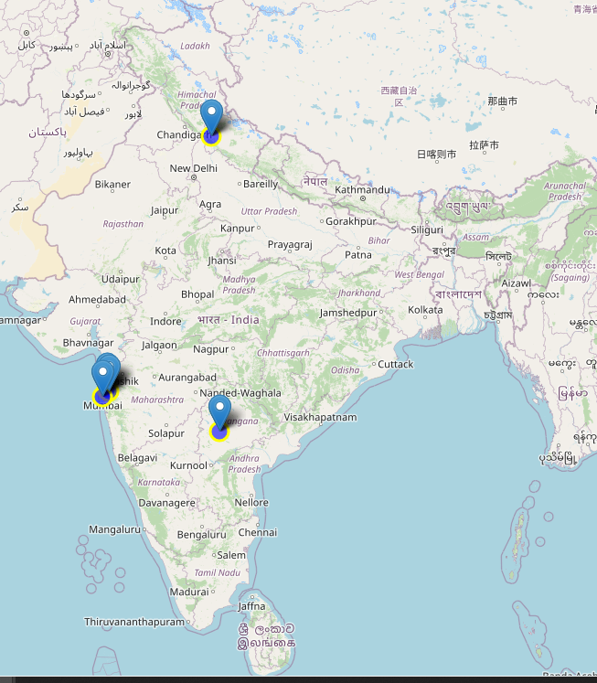

**4.Conclusion.**

We can now answer all the Questions which we had at the starting of the project:

1. Following are the places in India where we can find great Chinese Restaurants:

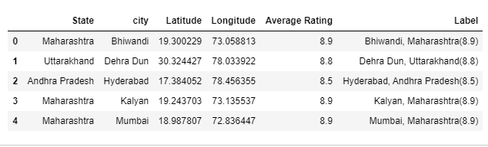

1. Bhiwandi (Maharashtra) , Dehra Dun (Uttarkhand) and Hyderabad (Andhra Pradesh) are some locations in India for good Chinese Restaurants.
2. Andhra Pradesh and Uttarkhand have Potential Chinese Market.
3. Bihar ranks last in average rating of Chinese Restaurants.
4. Mumbai is the best place to stay if you love Chinese restaurants.

There’s always scope for improvements, and hence the above solution I provided can also be improved for better results depending upon the data we have.

Link for the blog post: Please click [here](https://www.linkedin.com/pulse/potential-chinese-restaurant-market-india-hemang-monga).