**CERTIFICATE**

This is to certify that HEMANI CHAUHAN of Class XII has successfully prepared and submitted her Informatics Practices project entitled “A REPORT ON COVID-19” as the partial fulfilment for the Practical Examinationof CBSE, Ajmer for the award of Senior Secondary School Certificate. The report is the result of her efforts and endeavours. All the project work has been done by herself under my guidance and hence the report is found worthy of acceptance.

Principal Teacher Incharge

Sr. M. Elsa Ms. Ruchita Wilfred

Examiner

**ACKNOWEDGEMENT**

I express my deep gratitude to our Principal Sr. M. Elsa for her support in providing me all the possible facilities to complete my project. I also express my sincere gratitude to my teacher, Ms. Ruchita Wilfred who guided me at all stages of the project and gave valuable suggestions to complete the same.

Name: HEMANI CHAUHAN

Date:29/12/2020

**CONTENT**

* INTRODUCTION
* ABOUT THE PROJECT
* HARDWARE AND SOFTWARE
* SCREENSHOT
* SOURCE CODE
* OUTPUT
* REFERENCES

**INTRODUCTION**

* **ABOUT THE PROJECT**

The project is based on “A REPORT ON COVID-19” which handles all the records of patients tested positive or negative during this crucial pandemic situation, according to their current location and ward no. etc.

It is aimed at making the data analysis easier through making a connection between python and dataframe.

Pandas or python pandas library for data analysis is an ecometrics term for multi-dimensional, structured data sets(dataframe,series).

We have usedmatplot library for data visualisation for graphical or visual representation of data and information.

Csv will help in storing data in compact and organised way. Using the read_csvmethod of python we have made a connection between dataframe and csv.

* **HARDWARE AND SOFTWARE REQUIREMENT**

1. Python pandas
2. matplotlib library
3. read_csvmethod
4. Numpy module

**SCREENSHOTS**

**TABLE 1**

# EXCEL SHEET: REFERENCE TABLE

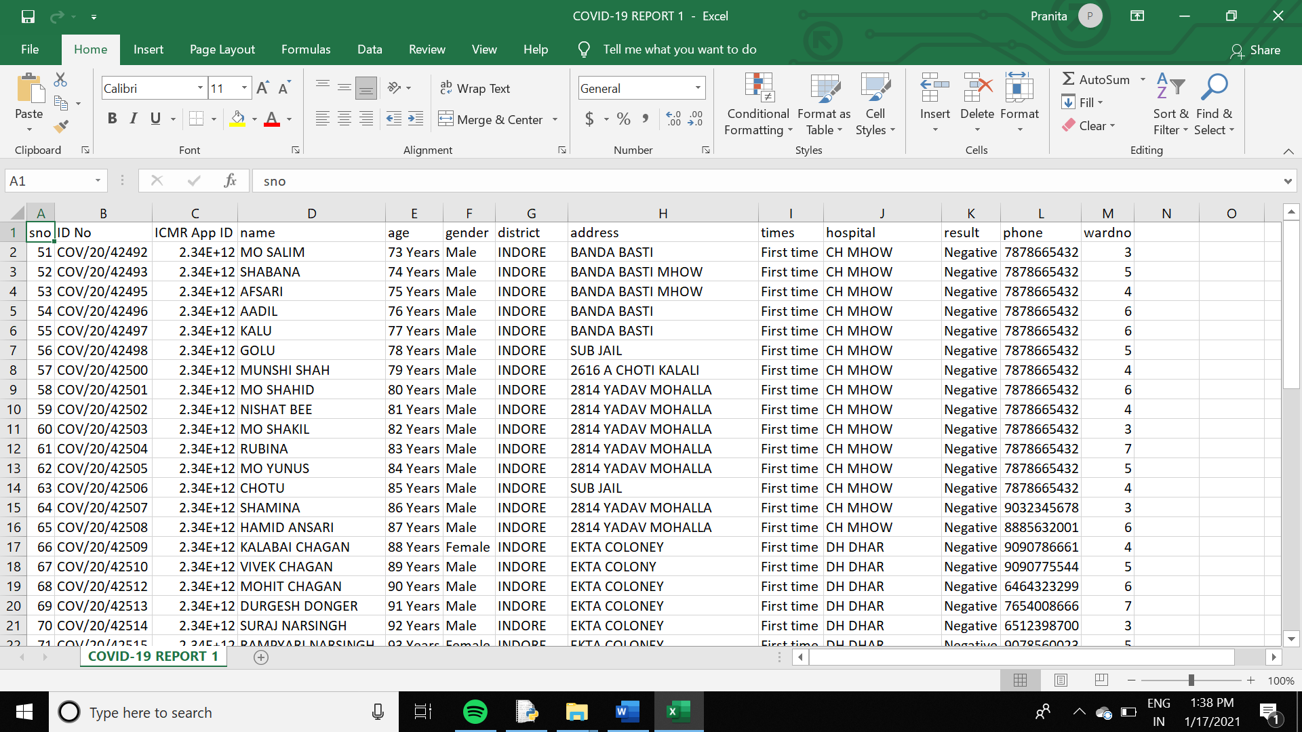

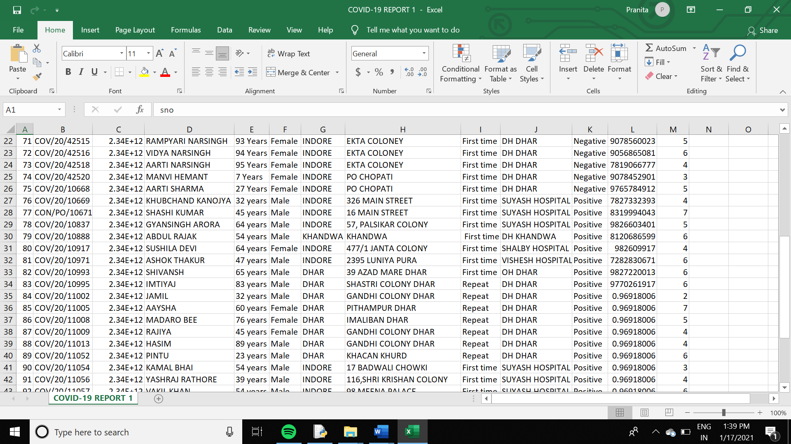

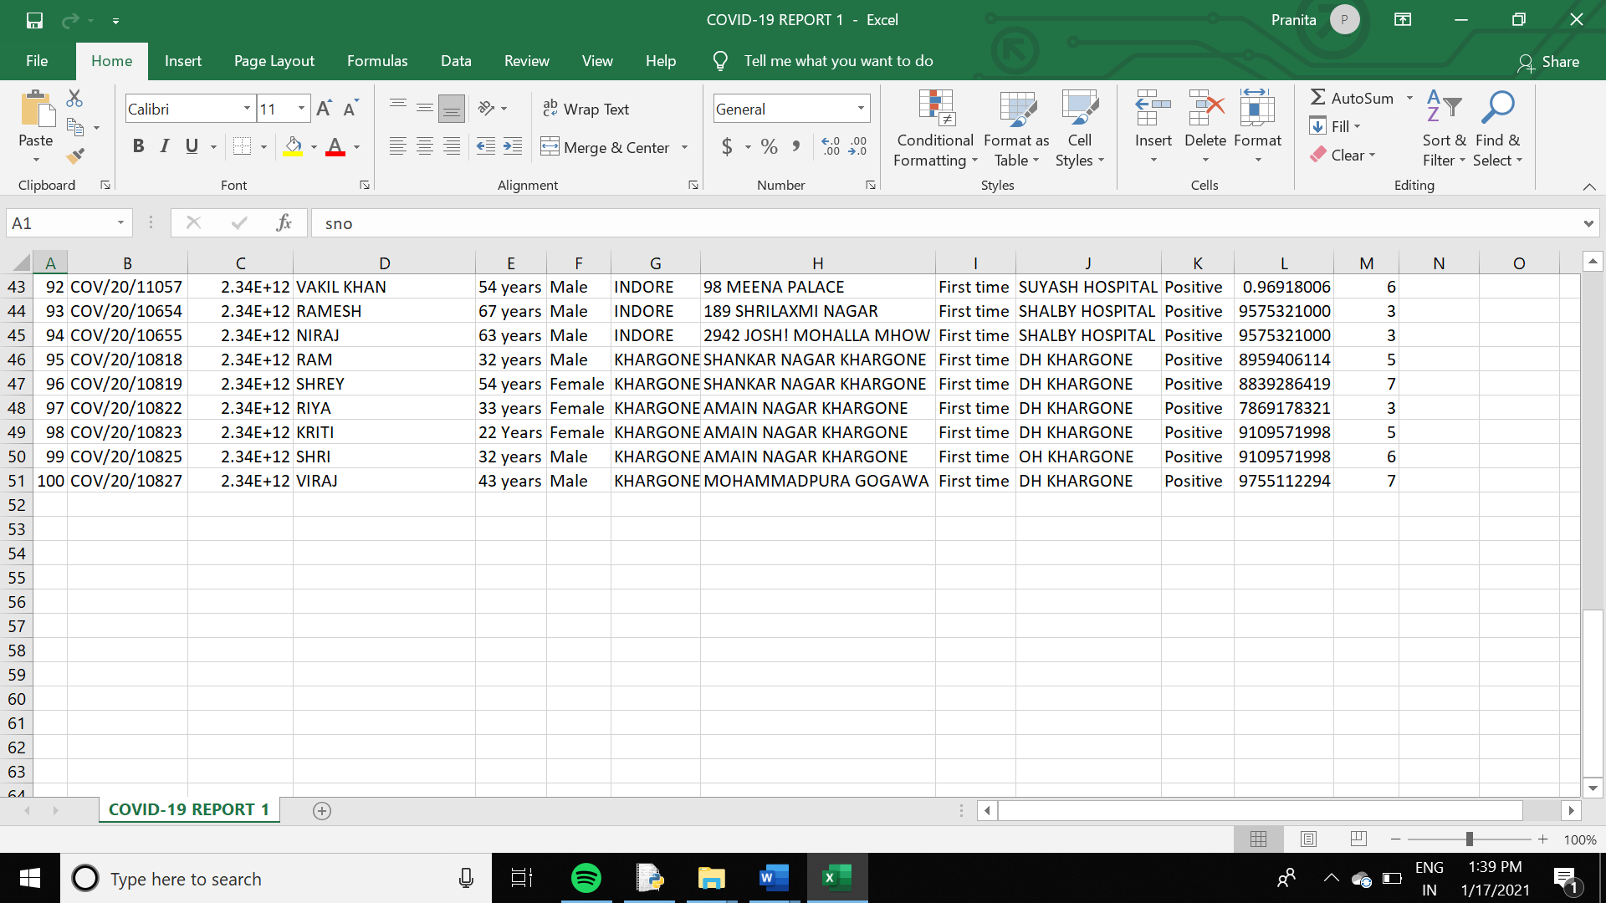

**TABLE 2**

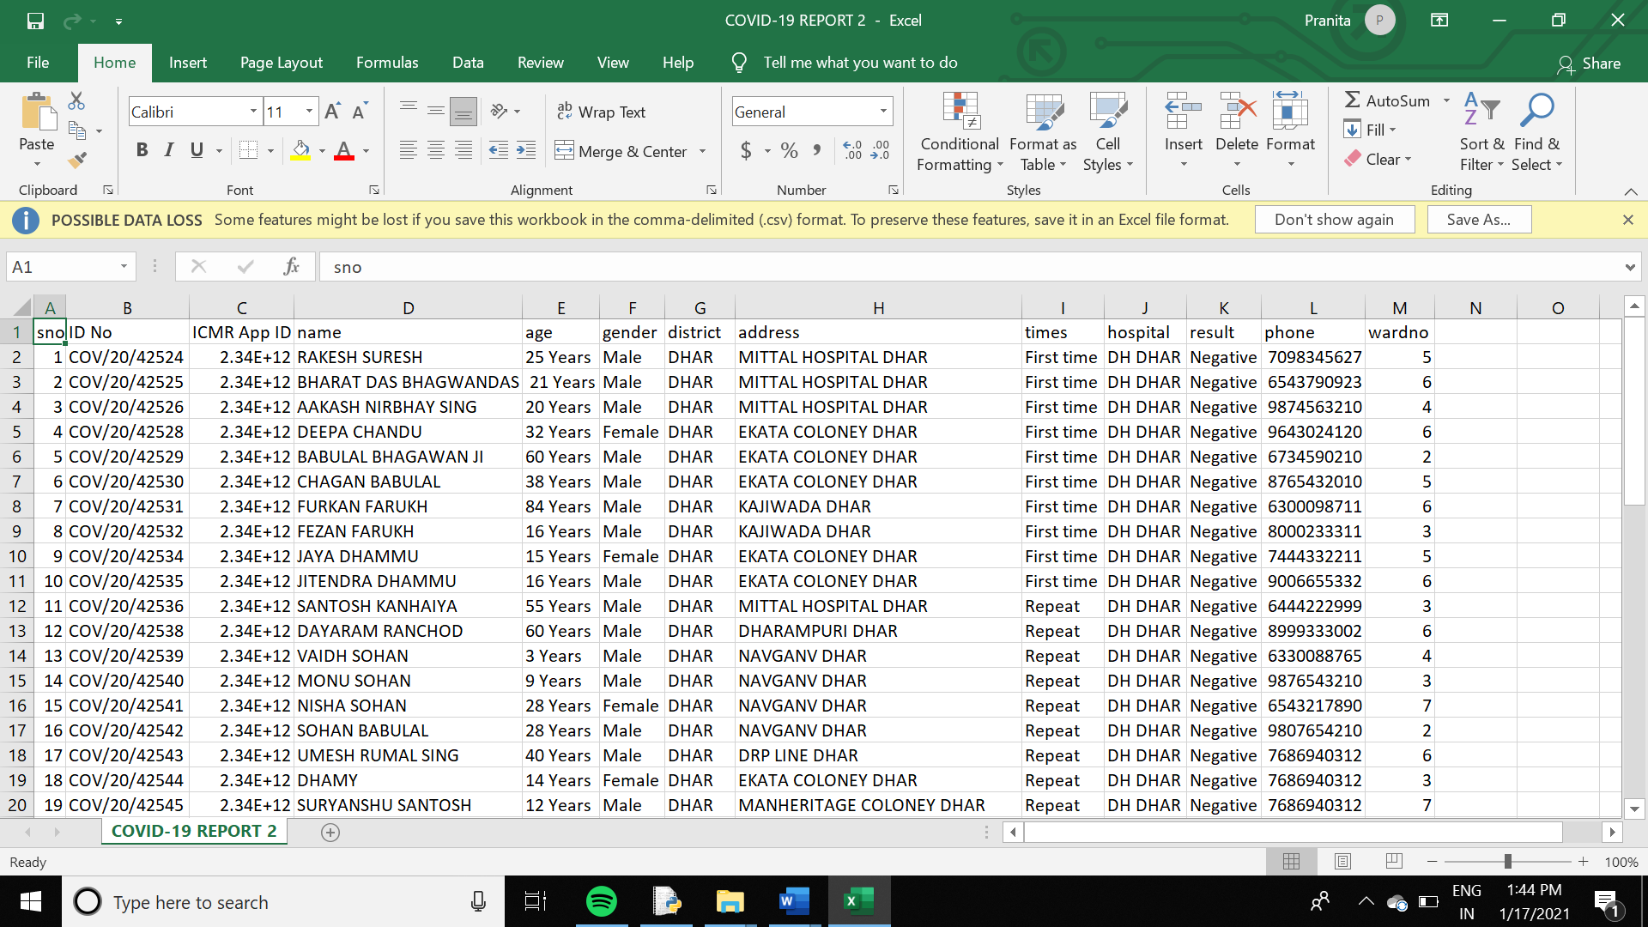

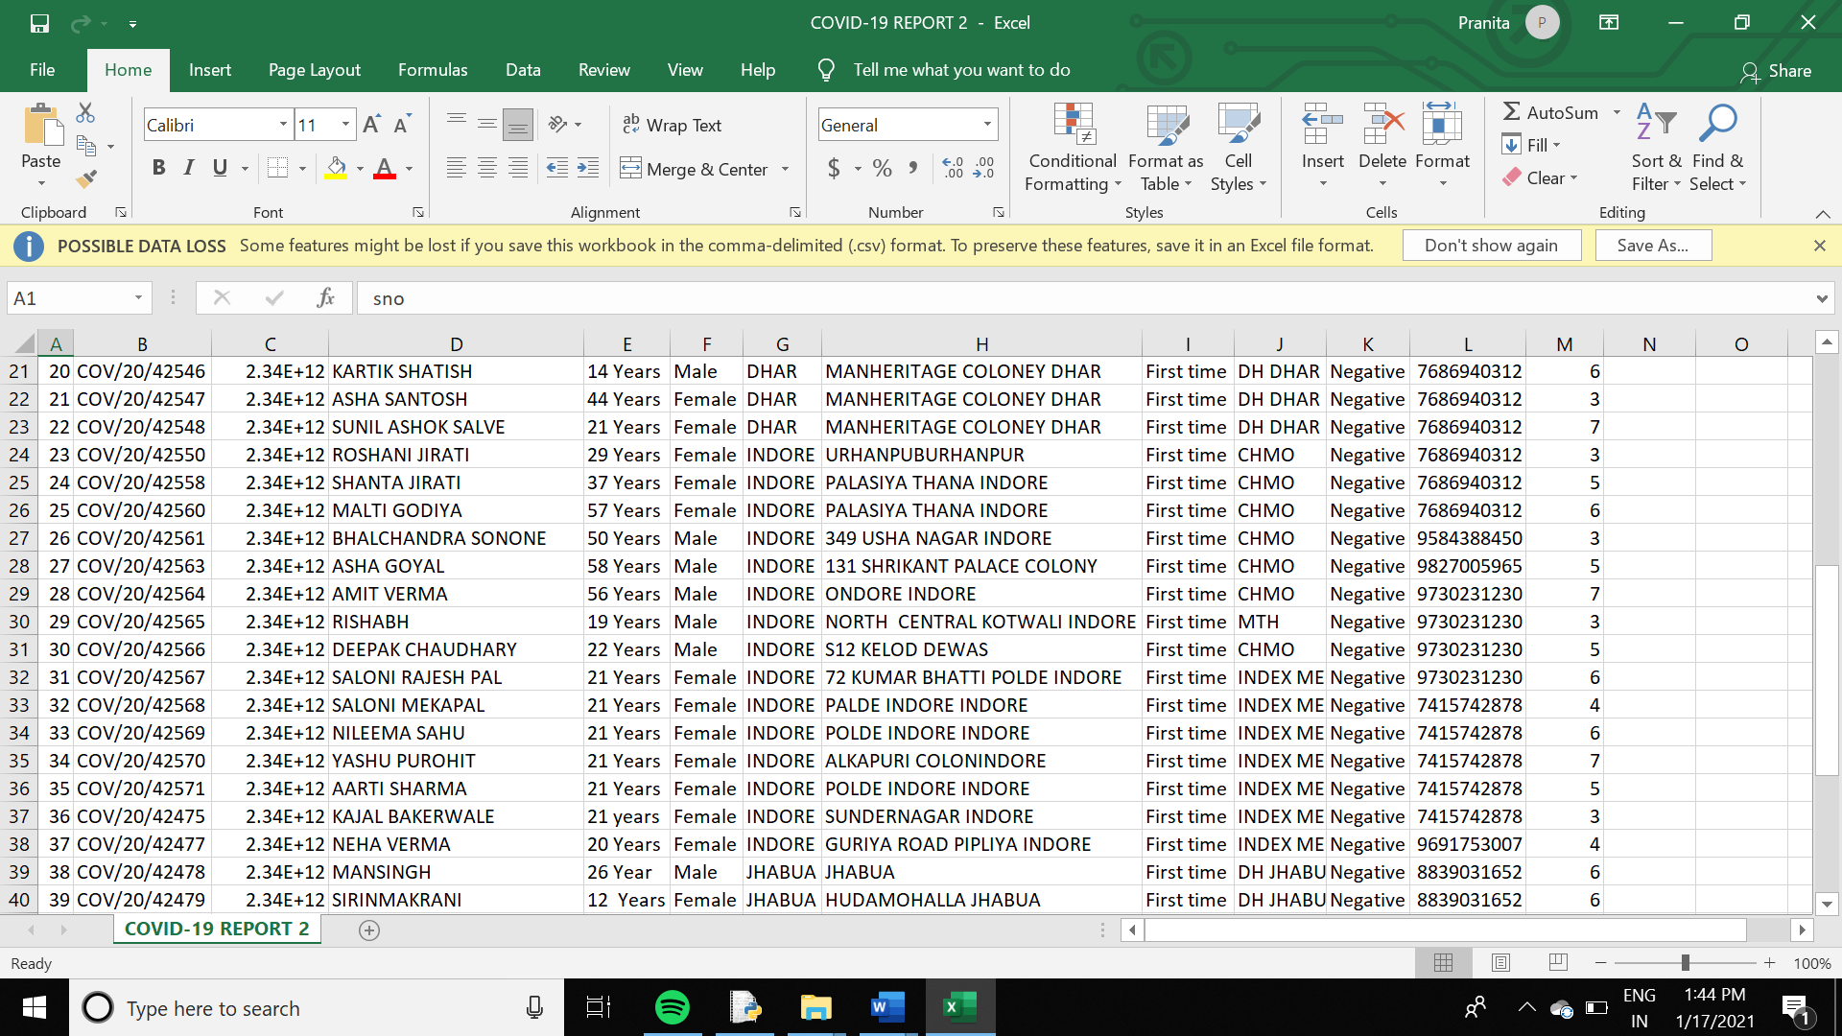

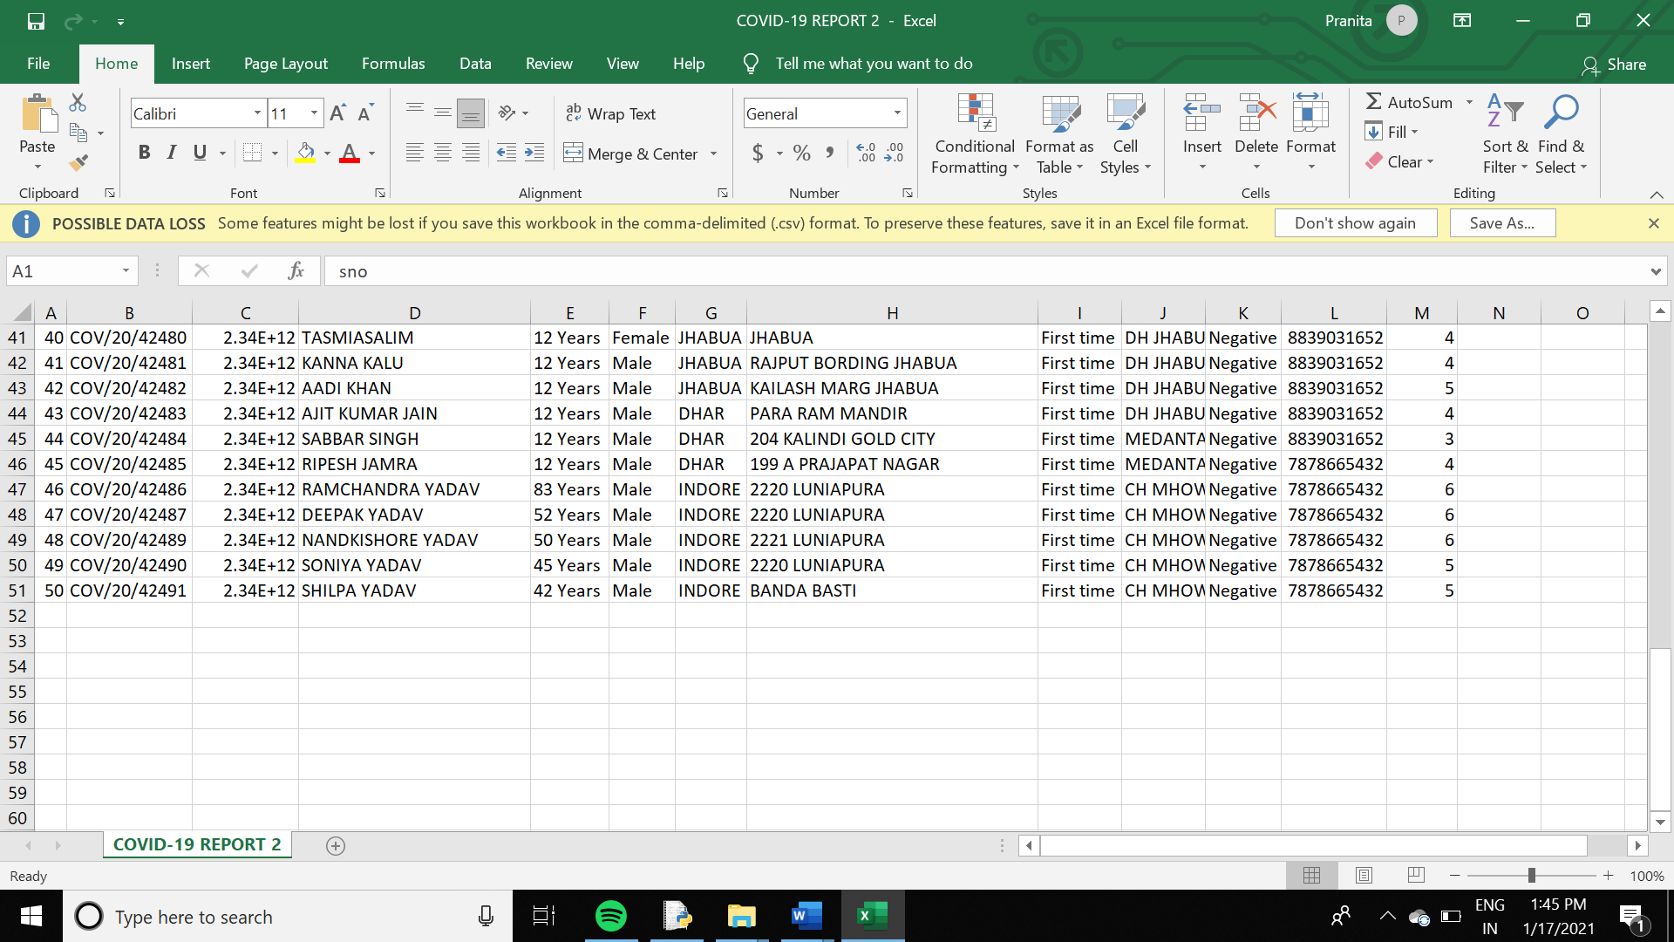

# SCREEN 1

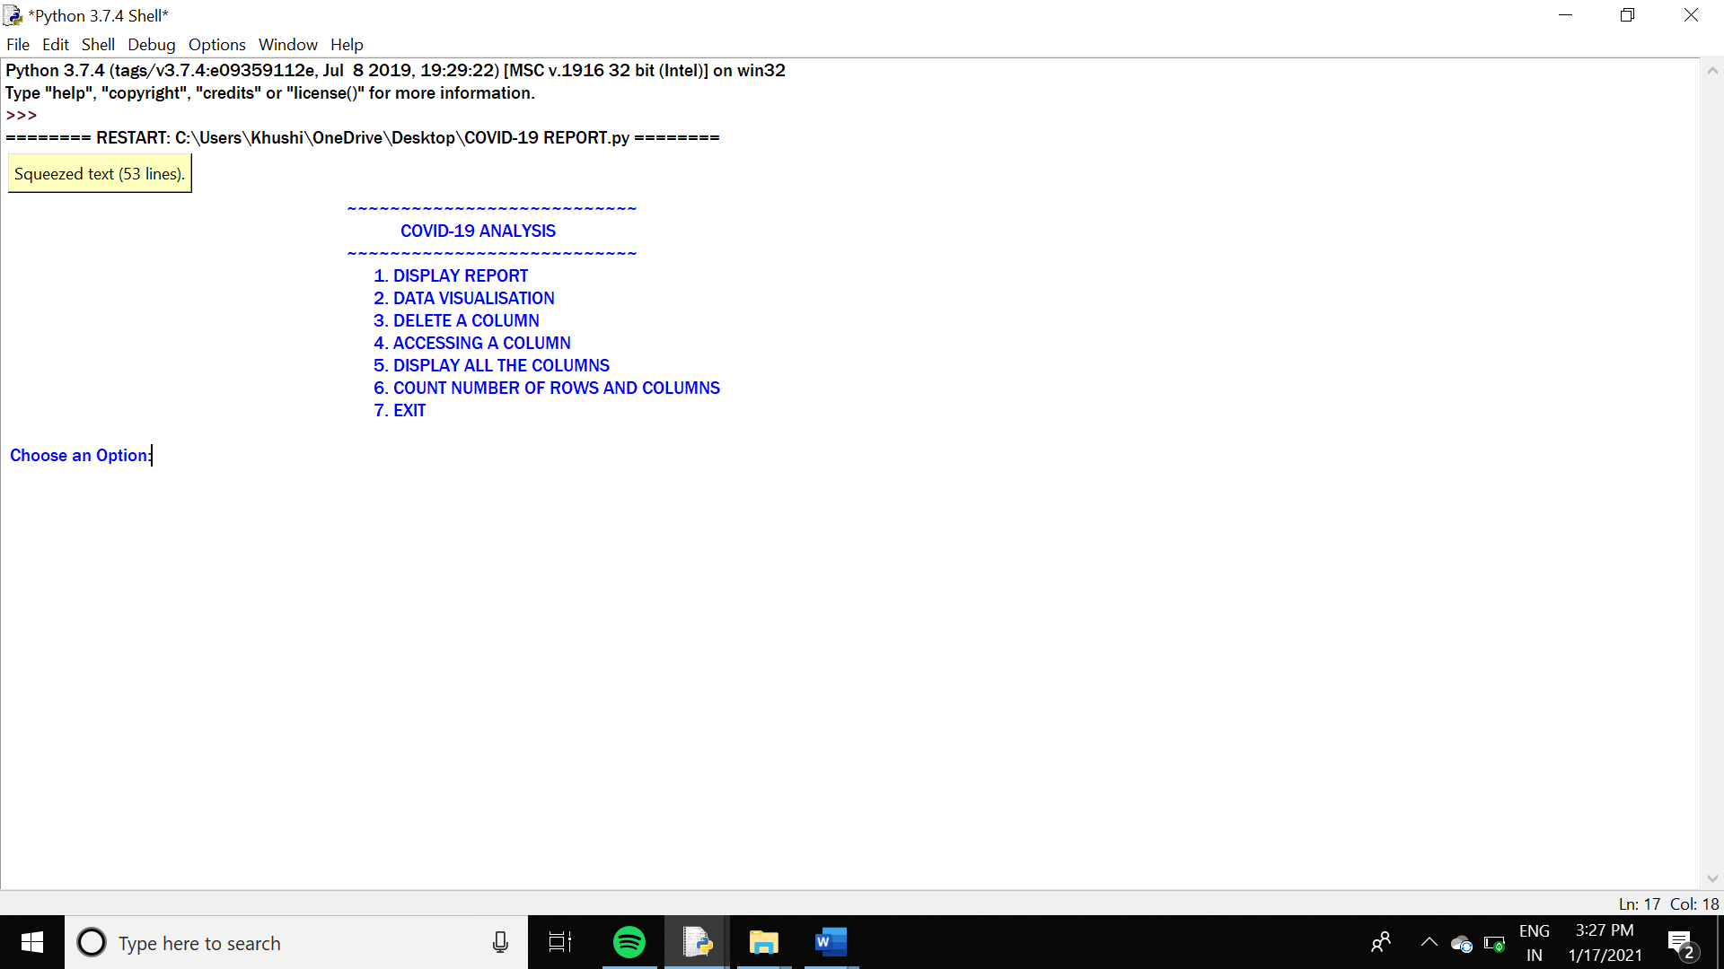

**SOURCE CODE**

***#PROJECT: A REPORT ON COVID-19***

***import pandas as pd***

***import matplotlib.pyplot as plt***

***import numpy as np***

***d=pd.read_csv("C:\\Users\\Khushi\\OneDrive\\Desktop\\final pro max\\COVID-19 REPORT 1.csv")***

***print(d)***

***df=pd.read_csv("C:\\Users\\Khushi\\OneDrive\Desktop\\final pro max\\COVID-19 REPORT 2.csv")***

***def a():***

***choice=0***

***while choice !=8:***

***print("~~~~~~~~~~~~~~~~~~~~~~~~~~~".center(180))***

***print("COVID-19 ANALYSIS".center(195))***

***print("~~~~~~~~~~~~~~~~~~~~~~~~~~~".center(180))***

***print(" 1. DISPLAY REPORT".center(180))***

***print(" 2. DATA VISUALISATION".center(183))***

***print(" 3. DELETE A COLUMN".center(181))***

***print(" 4. ACCESSING A COLUMN".center(183))***

***print(" 5. DISPLAY ALL THE COLUMNS".center(190))***

***print(" 6. COUNT NUMBER OF ROWS AND COLUMNS".center(198))***

***print(" 7. EXIT".center(170))***

***choice=int(input("\n Choose an Option:"))***

***#IF CHOICE1 IS ENTERED THEN FULL TABLE WILL BE DISPLAYED***

***if choice==1:***

***print("DISPLAY DATA")***

***print(df)***

***elif choice==2:***

***#FOR DATA VISUALISATION***

***def a2():***

***choice2=0***

***while choice2 !=5:***

***print("~~~~~~~~~~~~~~~~~~~~~~~~~~".center(180))***

***print("DATA VISUALISATION".center(195))***

***print("~~~~~~~~~~~~~~~~~~~~~~~~~~".center(180))***

***print("1. LINE CHART".center(180))***

***print("2. BAR GRAPH".center(178))***

***print("3. BOX PLOT".center(178))***

***print("4. PIE CHART".center(178))***

***print("5. GO BACK TO MAINMENU a".center(190))***

***choice2=int(input("\n Choose an option for Data Visualisation:"))***

***#IF CHOICE1 IS ENTERED THEN A LINE CHART WILL BE DISPLAYED***

***if choice2==1:***

***sno=[0,1,2,3,4,5,6,7,8,9,10]***

***age=[30,35,50,4,94,60,80,84,63,12,21]***

***plt.plot(sno,age,color='c',marker='p',markersize=8,linestyle='solid',markeredgecolor='m')***

***plt.xlabel("No. of people")***

***plt.ylabel("Age groups")***

***plt.title("LINE CHART B/W TOTAL NO. OF PEOPLE IN PARTICULAR AGE GROUPS")***

***plt.figure(figsize=(15,7))***

***plt.show()***

***#IF CHOICE2 IS ENTERED THEN A BAR CHART WILL BE DISPLAYED***

***elif choice2==2:***

***sno=[0,1,2,3,4,5,6,7,8,9,10]***

***age=[30,35,50,4,32,60,26,12,63,12,21]***

***wardno=np.arange(0,11,1)***

***x=np.arange(11)***

***plt.bar(x+0.00,sno,color='c',width=0.25,label='sno')***

***plt.bar(x+0.25,age,color='y',width=0.25,label='age')***

***plt.bar(x+0.50,wardno,color='r',width=0.25,label='warno')***

***plt.legend(loc='upper right')***

***plt.grid(True)***

***plt.title("MULTIRANGE BAR CHART")***

***plt.figure(figsize=(15,7))***

***plt.show()***

***#IF CHOICE3 IS ENTERED THEN A BOXPLOT WILL BE DISPLAYED***

***elif choice2==3:***

***age=[30,35,50,4,32,60,26,12,63,12,21]***

***wardno=[0,1,2,3,4,5,6,7,8,9,10]***

***final=[wardno,age]***

***plt.boxplot(final,patch_artist=True,notch=True,labels=['AGE','wardno'])***

***plt.title("BOXPLOT OF COLUMN AGE")***

***plt.figure(figsize=(15,7))***

***plt.show()***

***#IF CHOICE4 IS ENTERED THEN A PIECHART WILL BE DISPLAYED***

***elif choice2==4:***

***district=['indore','dhar','jhabua','others']***

***wardno=[4,5,6,7]***

***exp=[0,0,0.2,0]***

***col=['cyan','yellow','violet','red']***

***plt.pie(wardno,labels=district,colors=col,explode=exp,autopct="%5.2f%%")***

***plt.title("PIE CHART ON MAXIMUM AFFECTED AREAS")***

***plt.figure(figsize=(15,7))***

***plt.show()***

***else:***

***print("WRONG INPUT")***

***a2()***

***elif choice==3:***

***#FOR DELETING A COLUMN***

***def a3():***

***choice3=0***

***choice3=int(input("\n Enter an integer to Delete a Column:"))***

***if choice3==1:***

***print(df)***

***else:***

***print("WRONG INPUT")***

***a3()***

***elif choice==4:***

***#FOR ACCESSING A COLUMN***

***def a4():***

***choice4=0***

***choice4=int(input("\n Enter an integer to access a Column:"))***

***if choice4==1:***

***print(df.loc[:,'name':'gender'])***

***else:***

***print("WRONG INPUT")***

***a4()***

***elif choice==5:***

***#FOR DISPLAYING ALL THE COLUMNS***

***def a5():***

***choice5=0***

***choice5=int(input("\n Enter an integer to display all the columns:"))***

***if choice5==1:***

***print(df.columns)***

***else:***

***print("WRONG INPUT")***

***a5()***

***elif choice==6:***

***#FOR COUNTING NUMBER OF ROWS AND COLUMNS***

***def a6():***

***choice6=0***

***while choice !=3:***

***print("~~~~~~~~~~~~~~~~~~~~~~~~~~~~~~~~~~~~~~".center(180))***

***print("COUNTING NUMBER OF ROWS AND COLUMNS".center(192))***

***print("~~~~~~~~~~~~~~~~~~~~~~~~~~~~~~~~~~~~~~".center(180))***

***print("1. COUNT NUMBER OF ROWS".center(180))***

***print("2. COUNT NUMBER OF COLUMNS".center(181))***

***choice6=int(input("\n Enter your choice to count number of Rows & Columns:"))***

***if choice6==1:***

***print(df.count())***

***elif choice6==2:***

***print(df.count(1))***

***else:***

***print("WRONG INPUT")***

***a6()***

***else:***

***print("WRONG INPUT")***

***a()***

***#END***

**OUTPUT**

**TABLE 1**

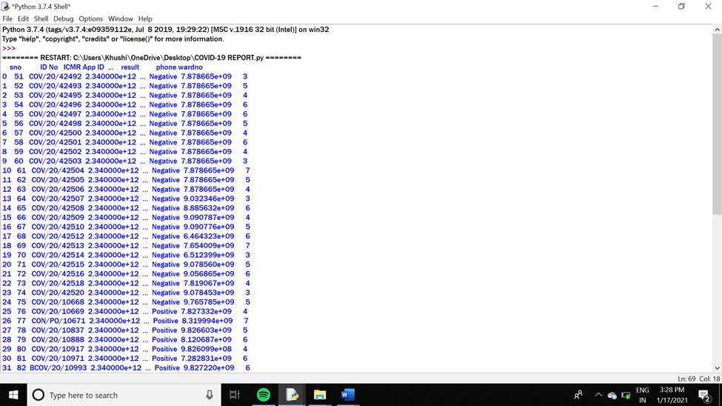

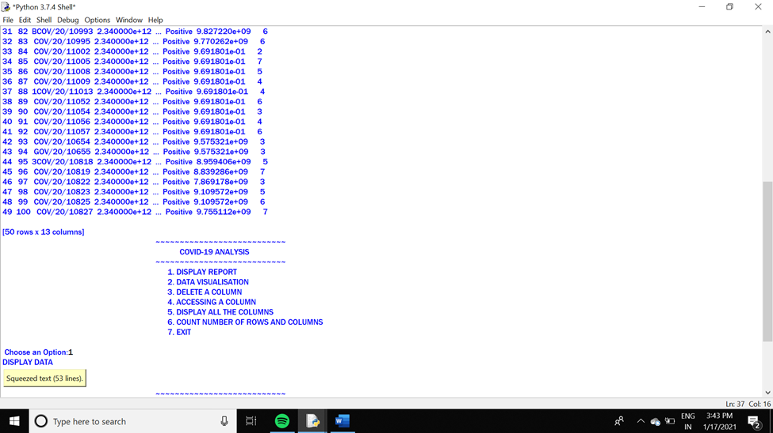

**TABLE 2**

**# CHOICE=1: DISPLAY TABLE 2**

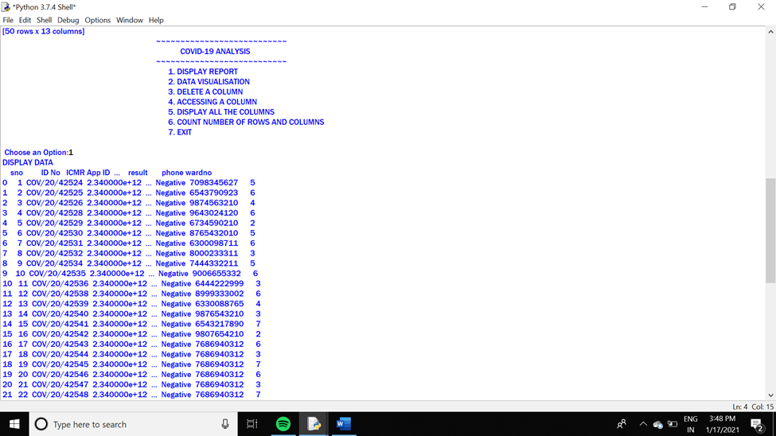

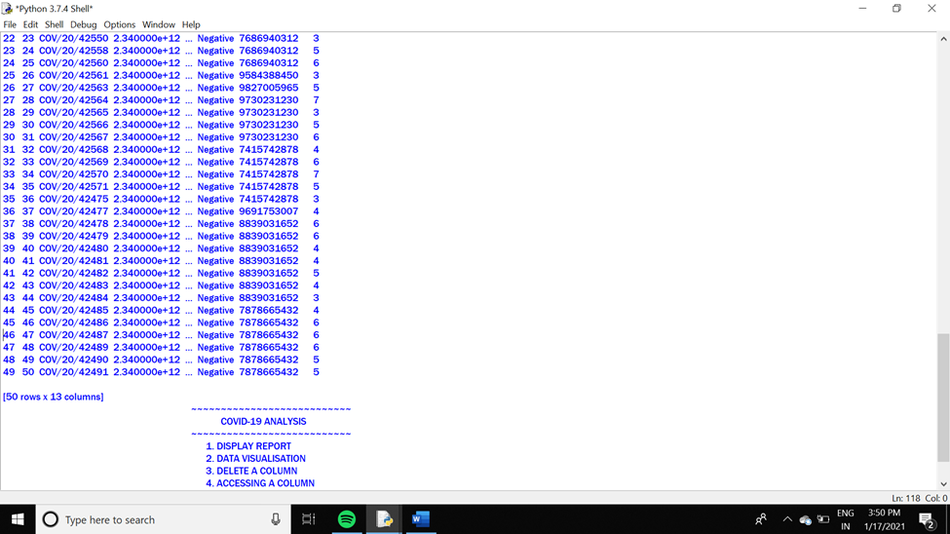

**# CHOICE=2: DATA VISUALISATION**

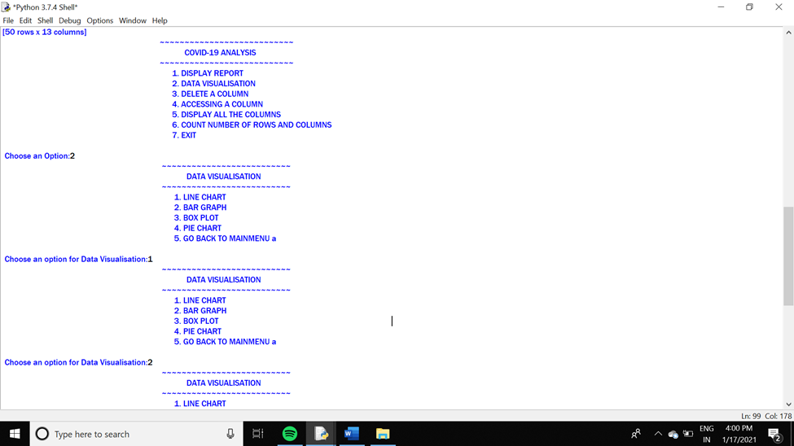

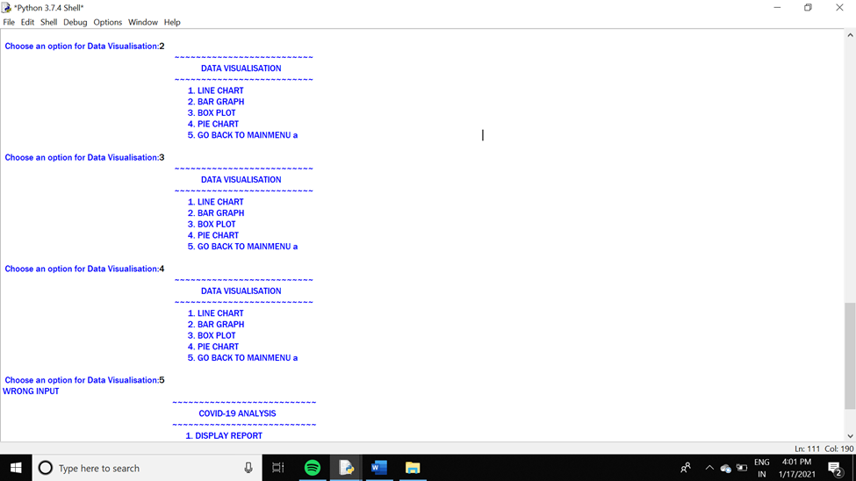

**# CHOICE2=1: LINE CHART**

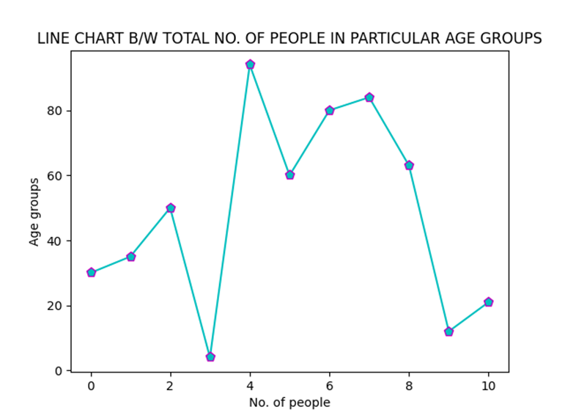

**# CHOICE2=2: BAR GRAPH**

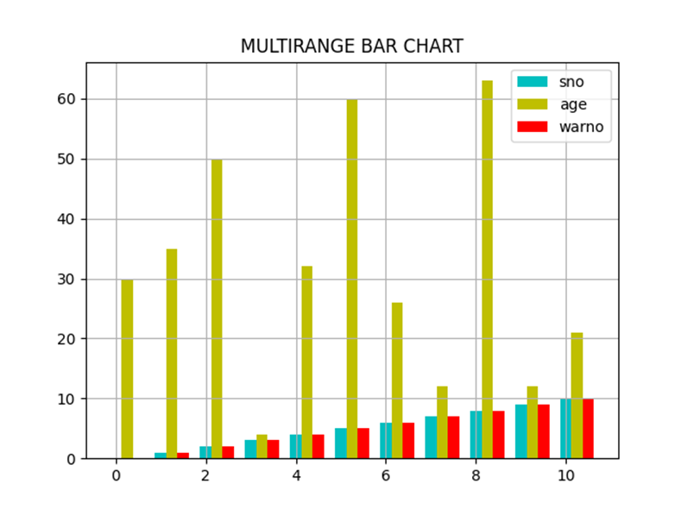

**# CHOICE2=3: BOX PLOT**

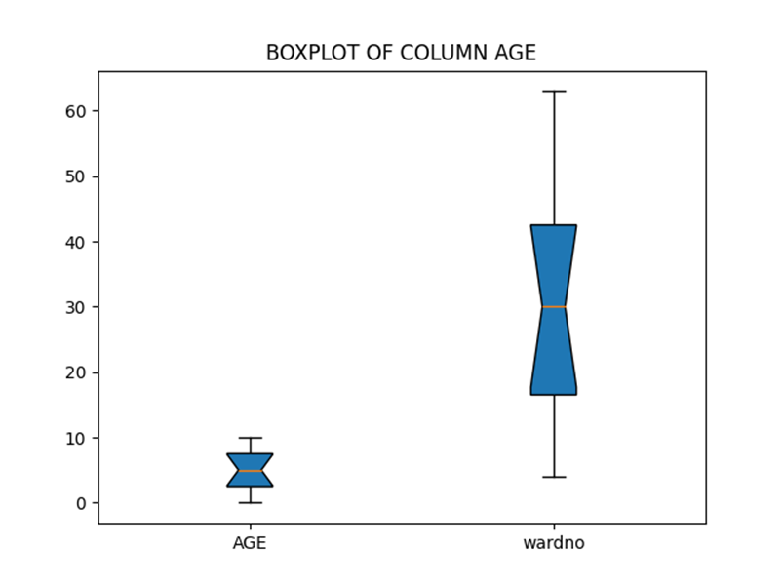

**# CHOICE2=4: PIE CHART**

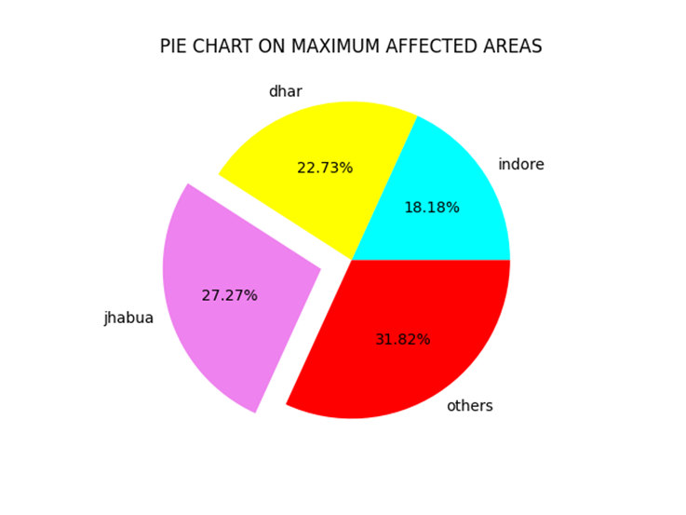

**# CHOICE3: DELETING A COLUMN**

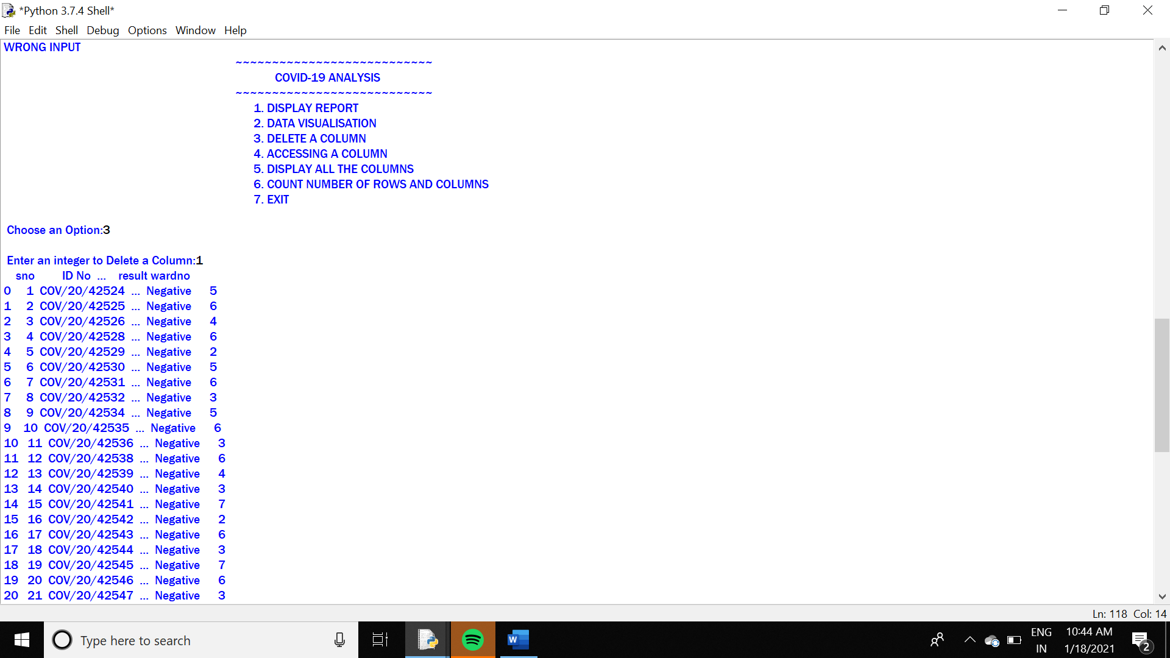

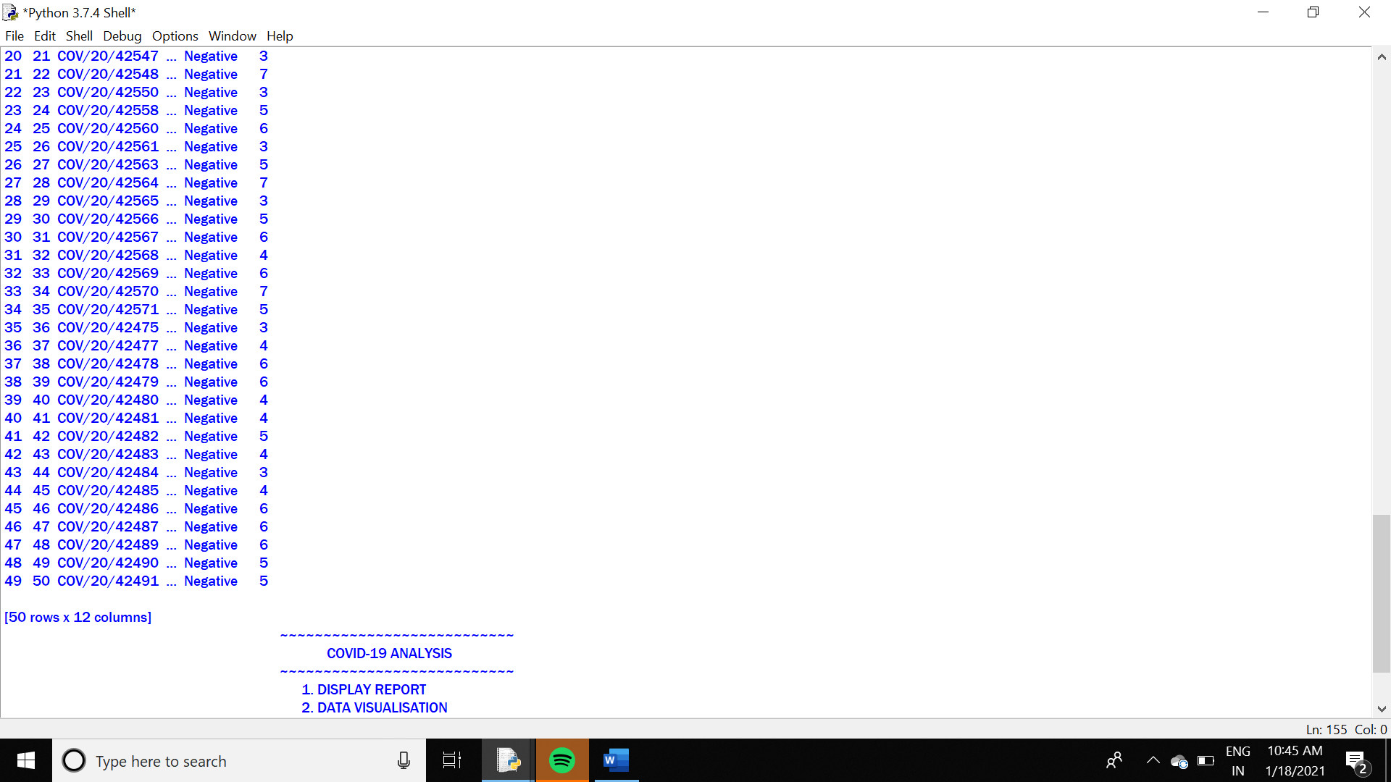

**# CHOICE4=1: ACCESS A COLUMN**

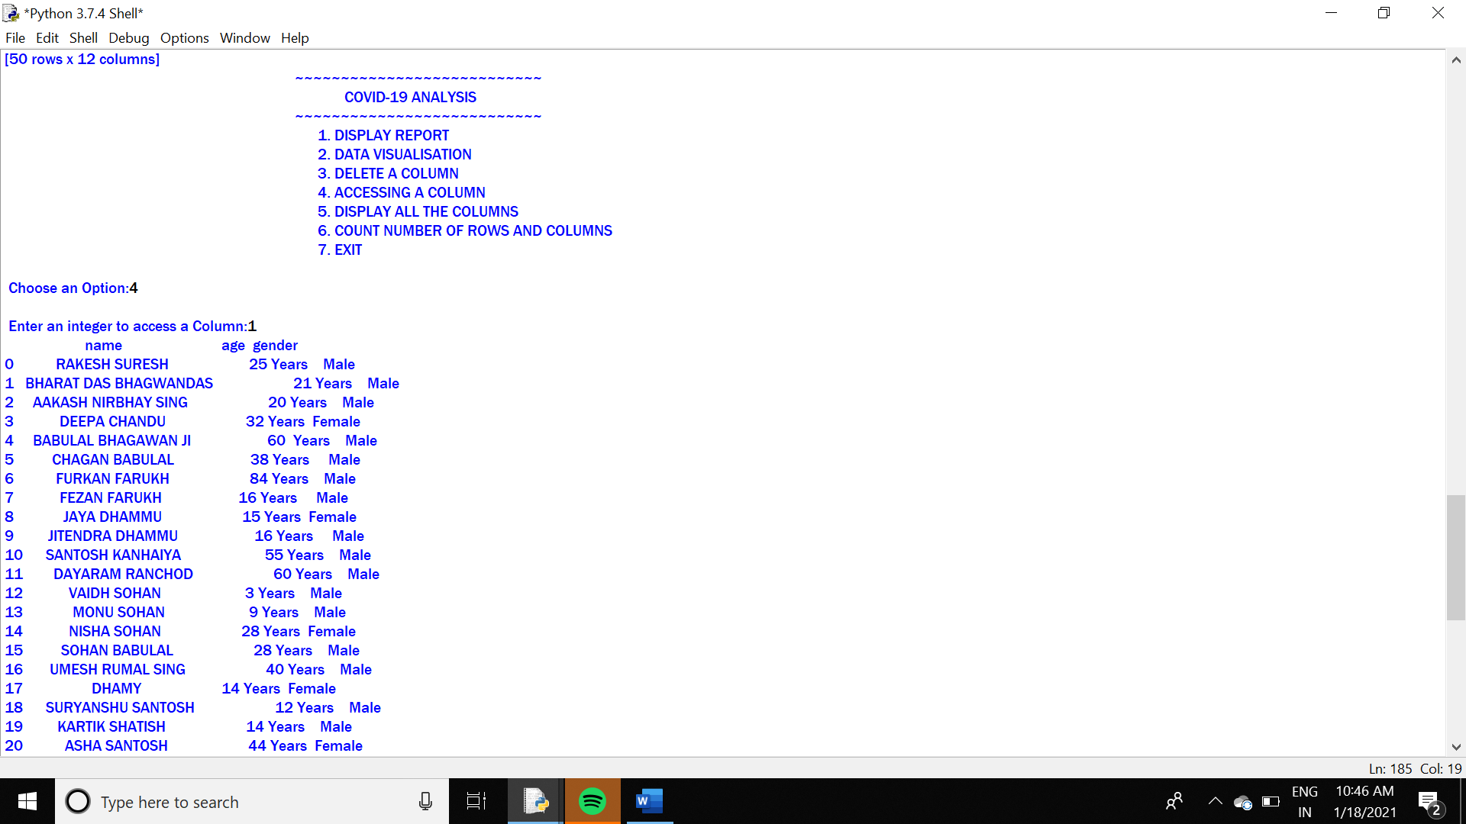

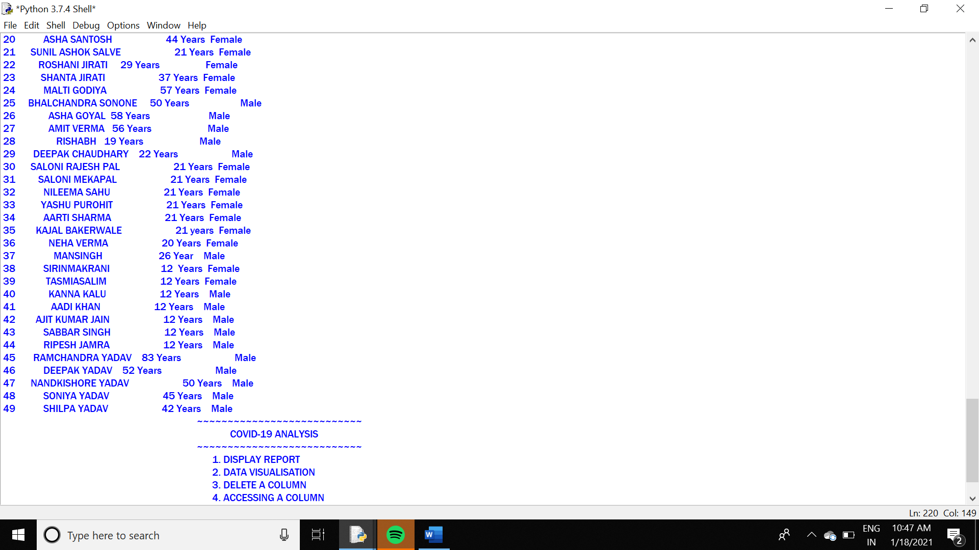

**# CHOICE5: DISPLAY ALL THE COLUMNS**

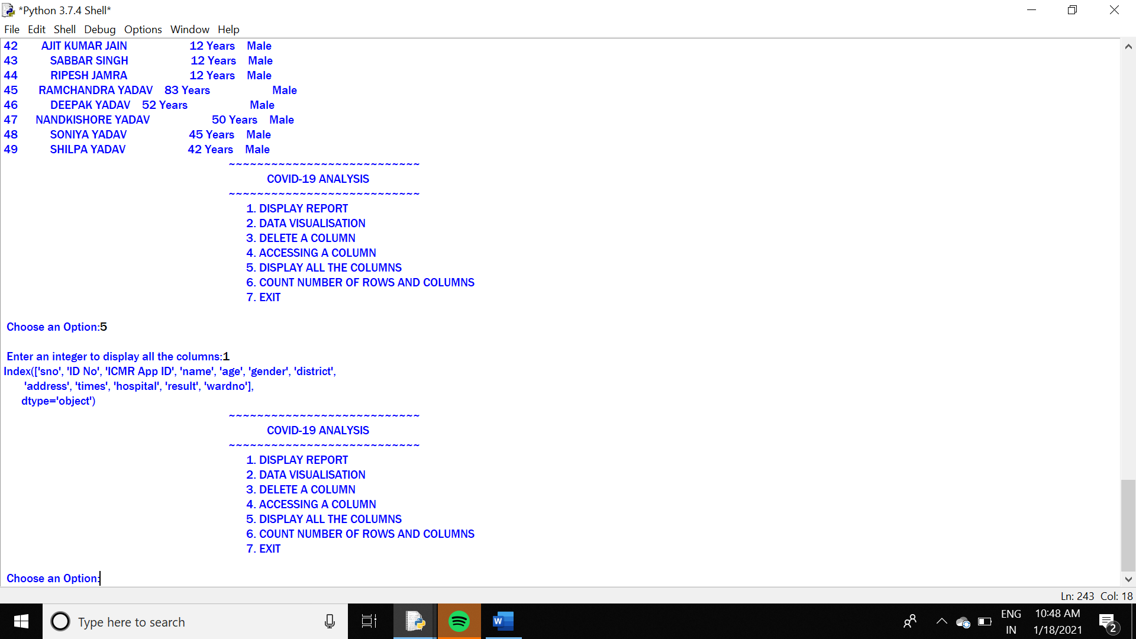

**# CHOICE6=1: COUNT NUMBER OF ROWS**

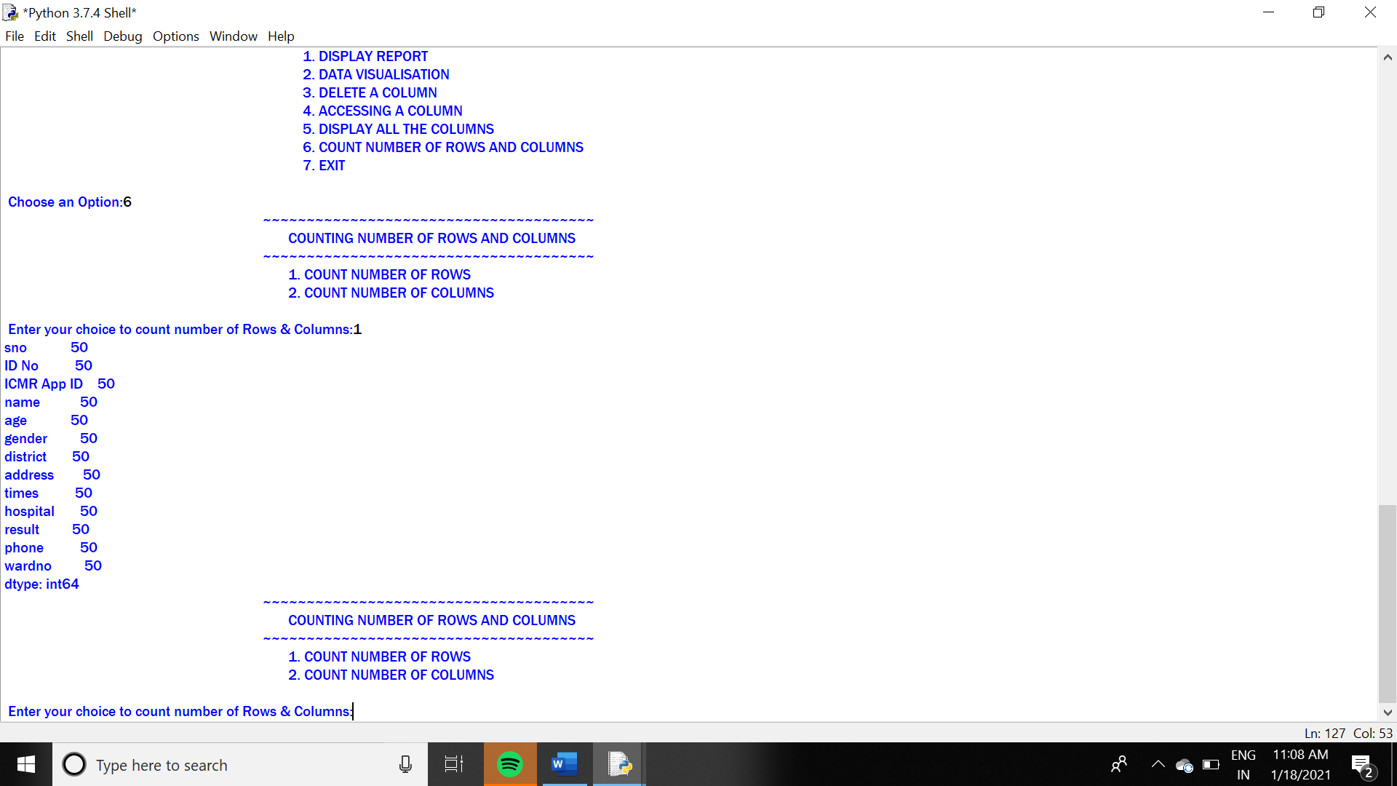

**# CHOICE6=2: COUNT NUMBER OF COLUMNS**

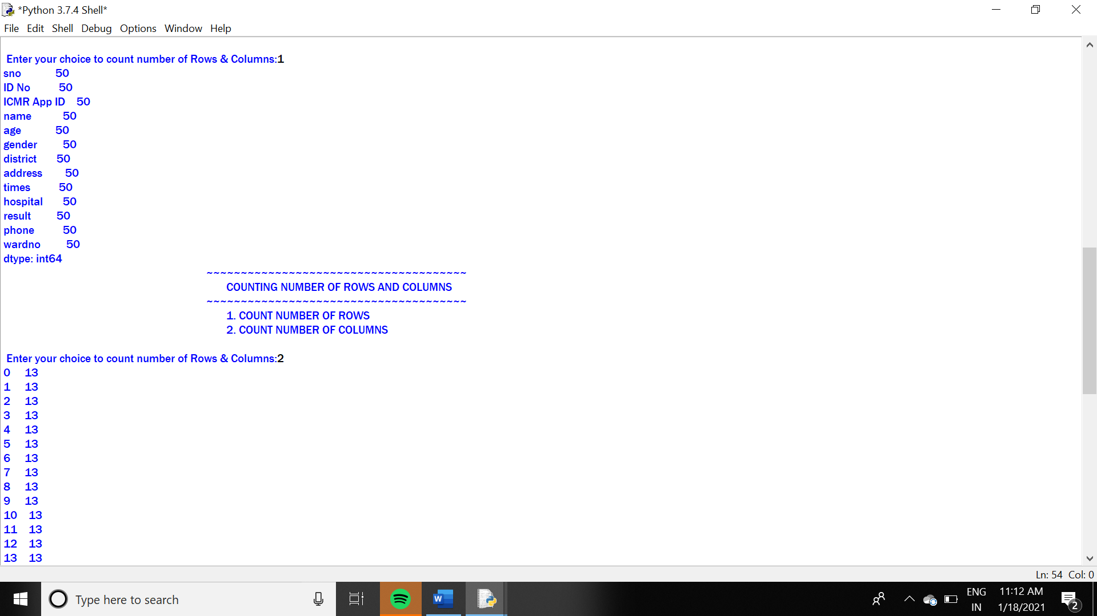

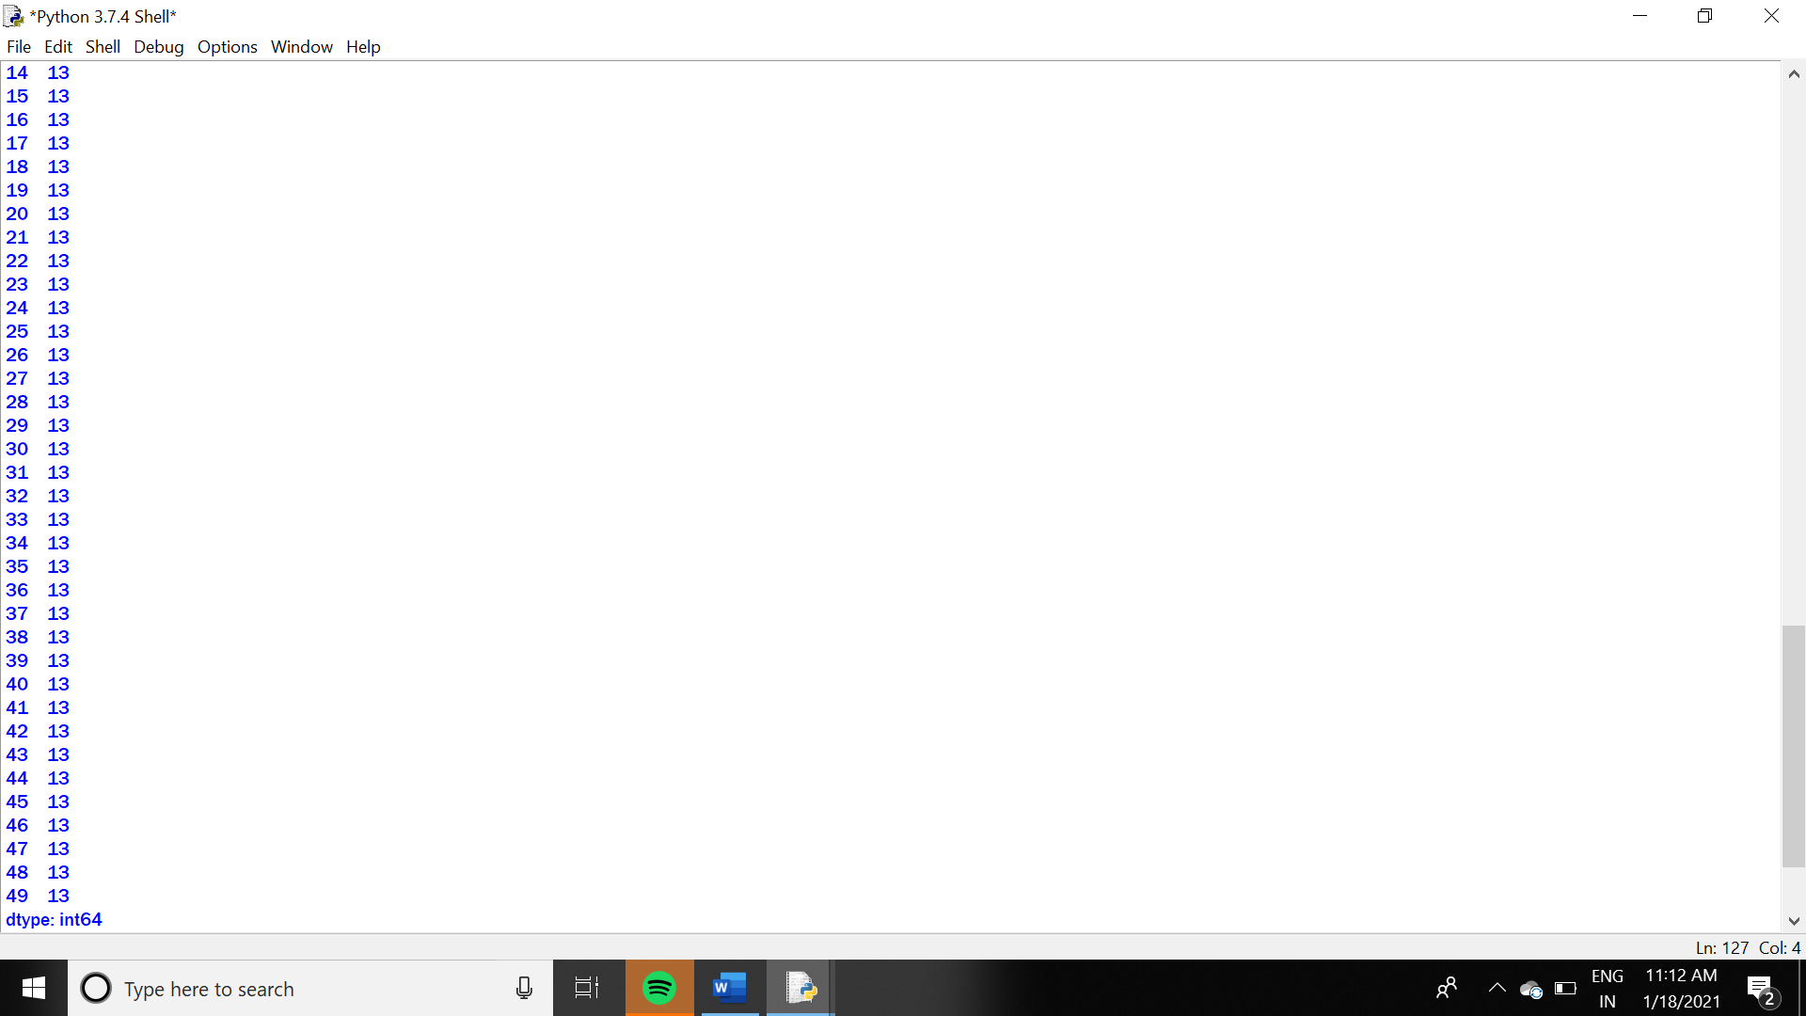

**# END**

**REFERENCES**

1. **INFORMATICS PRACTICES CLASS 12- SUMITAARORA**
2. **INFORMATICS PRACTICES CLASS 12- REETA SAHU**
3. **MAHATMA GANDHI MEMORIAL MEDICAL COLLEGE VIRAL RESEARCH AND DIAGNOSTIC LABORATORY, INDORE- COVID REPORT(PDF)**
4. **REFRENCED FROM CLASS 12 CBSE YOUTUBE LINK:**

**https://youtu.be/o8se00oYaFs**

**CONCLUSION**

**THIS PROJECT IS MADE IN ORDER TO DISPLAY ALL THE BASIC INFORMATION ON THE UPGOING PANDEMIC THAT IS “COVID -19” IN THE FORM OF A REPORT. MAJORLY THIS REPORT WAS PREPARED FOR DISPLAY AND FOR LITERAL AWARENESS ALL OVER THE CITIES COVERED IN THE PROJECT.**

**THE COMPARISION USING LINE CHART, MULTIPLE BARGRAPH,BOXPLOT AND PIECHART WAS NECESSARY TO MAKE AWARENESS ON A VERY STRICT LEVEL AND FOR EASY AND ACCURATE DATA ANALYSIS.BASICALLY THIS REPORT IS MADE ON THE INFORMATION OBTAINED ON STATE LEVEL SO, WE CAN ALSO IMPROVISE THIS REPORT ON A COUNTRY LEVEL BY EXPANDING THE SAME PROJECT THAT ARE MENTIONED ABOVE.**