Mobile App Ideas - Brainstorming Document

Step 1: New App Ideas - List

1. Galactic Databank (Star Wars Lore App)
A comprehensive Star Wars encyclopedia app that allows users to explore characters, vehicles, species, locations, droids, creatures, and organizations from the entire Star Wars universe using the official Star Wars Databank API. Users can search, browse by category, bookmark favorites, and discover detailed lore about any element of the saga.

2. Recipe Remix
A cooking app that helps users create recipes based on ingredients they already have at home. Users can input available ingredients, set dietary restrictions, and get AI-generated recipe suggestions. Includes step-by-step cooking instructions, timer features, and ability to save favorite combinations.

3. Study Buddy Tracker
A productivity app designed for students to track study sessions, create flashcard decks, set study goals, and analyze their learning patterns. Includes Pomodoro timer, progress analytics, and the ability to share study materials with classmates.

4. Fitness Challenge Hub
A social fitness app where users can create and join fitness challenges with friends. Track workouts, share progress photos, compete on leaderboards, and earn badges. Integrates with health apps and includes custom challenge creation.

5. Local Event Finder
A location-based app that shows nearby events, concerts, meetups, and activities happening in real-time. Users can filter by interest categories, RSVP to events, meet other attendees, and discover hidden gems in their area.

6. Budget Buddy
A personal finance tracker that helps users manage expenses, set savings goals, and visualize spending patterns. Features include receipt scanning, bill reminders, category-based budgeting, and financial health scores.

Step 2: Evaluating Top Ideas

Idea 1: Galactic Databank (Star Wars Lore App)
Mobile: 4/5
- Perfect for on-the-go reference while watching Star Wars content
- Offline storage for bookmarked favorites
- Search functionality optimized for mobile
- Could integrate camera-based character recognition
- Push notifications for new content additions
Story: 5/5
- Extremely compelling for Star Wars fans - it's like having the official Star Wars Databank in your pocket
- Clear value proposition: instant access to comprehensive lore
- Appeals to both casual fans and hardcore enthusiasts
- Great conversation starter among fans
- Solves real problem: looking up info while watching movies/shows
Market: 5/5
- Massive global Star Wars fanbase (hundreds of millions)
- Appeals to fans of all ages
- Useful for trivia, education, and entertainment
- Can attract viewers of movies, TV shows, games, and books
- Growing market with new Star Wars content constantly releasing
Habit: 4/5
- Users would open it whenever watching Star Wars content
- Great for settling debates and answering questions
- Encourages exploration and discovery
- Bookmark feature creates return engagement
- "Surprise Me" feature encourages browsing
Scope: 5/5
- API is already available and well-documented
- Core features (browse, search, detail view) are straightforward
- Can start with MVP and add features incrementally
- UIKit provides all necessary components
- Clear technical path: UITableView, UICollectionView, URLSession
- Realistic to complete within capstone timeline
Total Score: 23/25

Idea 4: Fitness Challenge Hub
Mobile: 5/5
- Highly mobile-appropriate (track workouts anywhere)
- Uses camera for progress photos
- Location tracking for running/cycling challenges
- Push notifications for challenge updates
- Integration with HealthKit/step counters
Story: 3/5
- Appeals to fitness enthusiasts
- Social aspect is compelling
- Value is clear but competitive market
- May be hard to get initial user base for social features
Market: 3/5
- Fitness app market is saturated
- Requires critical mass of users for social features
- Appeals mainly to already-active fitness enthusiasts
- Many existing competitors (Strava, Fitbit, etc.)
Habit: 4/5
- Daily workout logging creates habit
- Social pressure from challenges increases engagement
- Leaderboards encourage frequent checking
- Limited appeal if user stops working out
Scope: 2/5
- Requires backend server for user accounts
- Social features add significant complexity
- Need to build workout tracking from scratch
- HealthKit integration can be tricky
- May be too ambitious for capstone timeline
Total Score: 17/25

Step 3: Final Decision
Selected App: Galactic Databank (Star Wars Lore App)
This app scored highest overall (23/25) and best satisfies the evaluation criteria. Here's why it's the winner:

Strengths:
- Universal appeal - Star Wars has a massive, passionate fanbase worldwide
- High engagement potential - Users will reference it while watching content, making it genuinely useful
- Clear technical scope - Using an existing API keeps the project manageable and realistic
- Strong story - Carrying the entire Star Wars universe in your pocket is exciting
- Excellent market size - Millions of potential users across all demographics
- Perfect for mobile - Quick reference lookups are ideal for mobile format
- Achievable timeline - Core features can be built within capstone constraints

Why it beats the alternatives:
- More achievable than Fitness Challenge Hub (no backend/social features needed)
- More universally appealing than Study Buddy (not limited to students)
- Better defined than Local Event Finder (no need for event APIs or location permissions)
- More engaging than Budget Buddy (entertainment vs. chores)
- Existing API provides rich, professional content (vs. Recipe Remix requiring recipe generation)
The app will serve as the go-to mobile reference for Star Wars lore, making it easy to look up any character, vehicle, species, location, droid, creature, or organization on-the-go. It solves the real problem of wanting instant answers about Star Wars content while watching movies/shows or during fan discussions.

Product Spec (Preview)

App Name: Galactic Databank

Tagline: "The Star Wars Universe in Your Pocket"

Description:
Galactic Databank is your comprehensive guide to the Star Wars universe. Explore detailed information about every character, vehicle, species, planet, droid, creature, and organization from the official Star Wars Databank. Whether you're watching your favorite saga, settling a debate with friends, or diving deep into lore, Galactic Databank gives you instant access to the knowledge of a galaxy far, far away.

App Evaluation:
Mobile: How uniquely mobile is the product experience?
- Perfect companion app while watching Star Wars content on TV/tablet
- Quick lookups ideal for mobile format
- Bookmark feature for saving favorites on-the-go
- Search optimized for mobile text input
- Could add camera-based character recognition in future
Story: How compelling is the story around this app once completed?
- Every Star Wars fan wants instant access to lore
- Transforms your phone into a portable Star Wars encyclopedia
- Makes you the "expert" in any Star Wars conversation
- Enhances the viewing experience of movies and shows
Market: How large or unique is the market for this app?
- Star Wars has 100+ million fans worldwide
- Appeals to all age groups (kids, teens, adults)
- Useful for casual viewers and superfans alike
- Growing market with constant new content (shows, movies, games)
Habit: How habit-forming or addictive is this app?
- Used whenever watching Star Wars content
- Perfect for settling trivia debates
- "Surprise Me" feature encourages random exploration
- Bookmark collections create return visits
- Users both consume (read lore) and curate (save favorites)
Scope: How well-formed is the scope for this app?
- Well-defined using existing Star Wars Databank API
- Core MVP includes browse, search, detail, and favorites
- Stripped-down version is still valuable (just browse + detail)
- Technically achievable with UIKit basics (TableView, CollectionView, URLSession)
- Can complete MVP in capstone timeline, with room for stretch features

Required Features (MVP):
- Browse by Category - View paginated lists of all seven content types (Characters, Vehicles, Species, Locations, Droids, Creatures, Organizations)
- Search Functionality - Search across all categories to find specific entries
- Detail View - Display comprehensive information about any selected item including name, description, and image
- Favorites/Bookmarks - Save favorite entries for quick access later

Optional Features (Stretch Goals):
- Advanced Filtering - Filter results within categories (by affiliation, era, etc.)
- Share Functionality - Share interesting facts with friends via social media
- Dark Mode Theme - Space-themed dark UI matching Star Wars aesthetic
- Random Discovery - "Surprise Me" button for random entry exploration
- Recently Viewed - History of browsed items for quick return access
- Offline Mode - Cache viewed content for offline access

Wireframe code (put this in VSCode, save as wireframe.html, then drag the tab from Finder/File Explorer to your browser to see it!) Here are some screenshots of it:
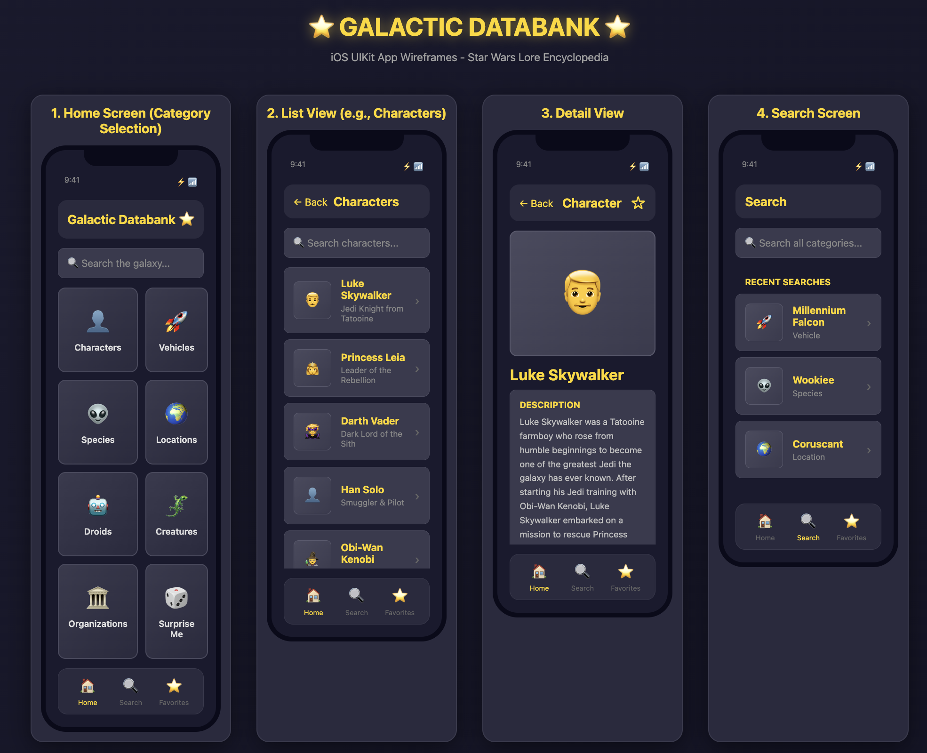
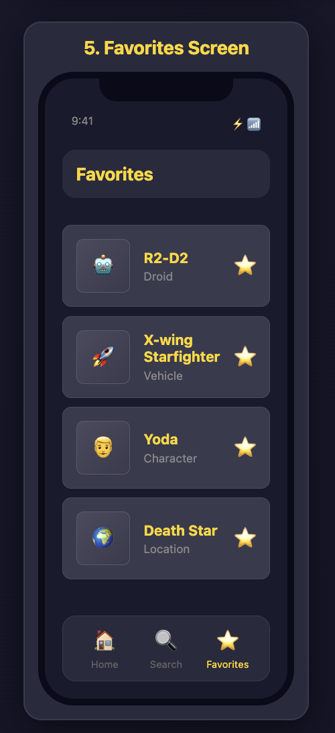
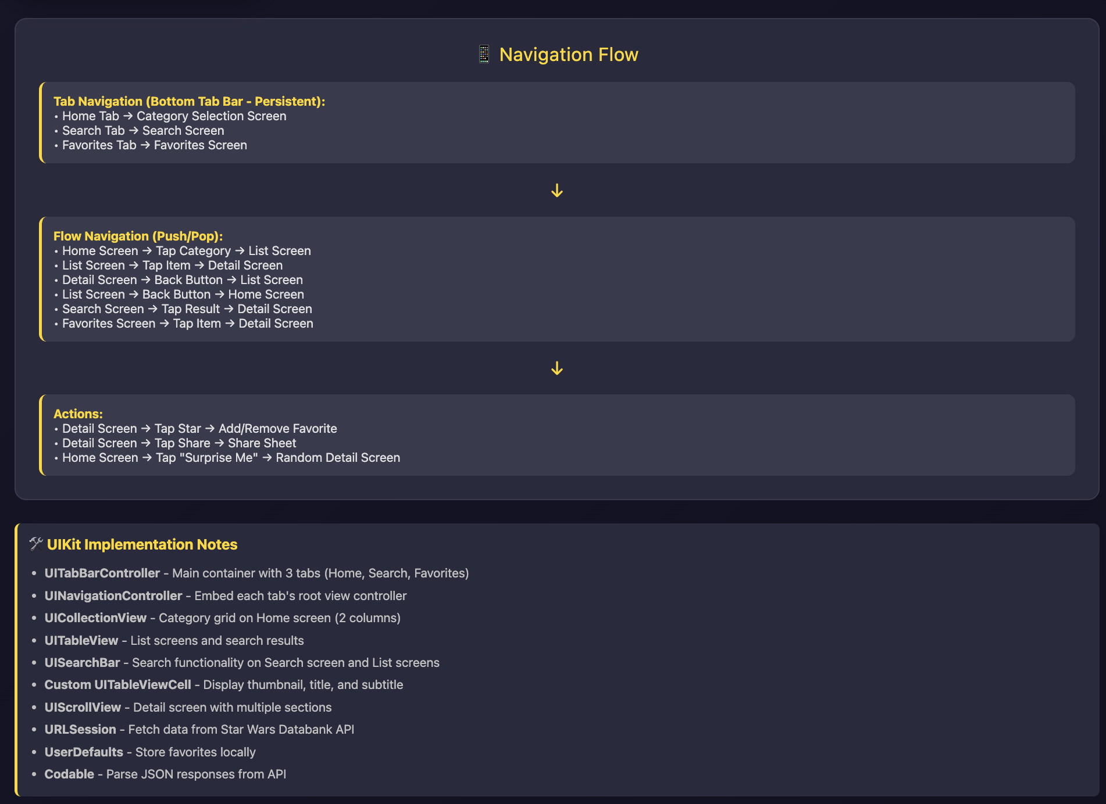
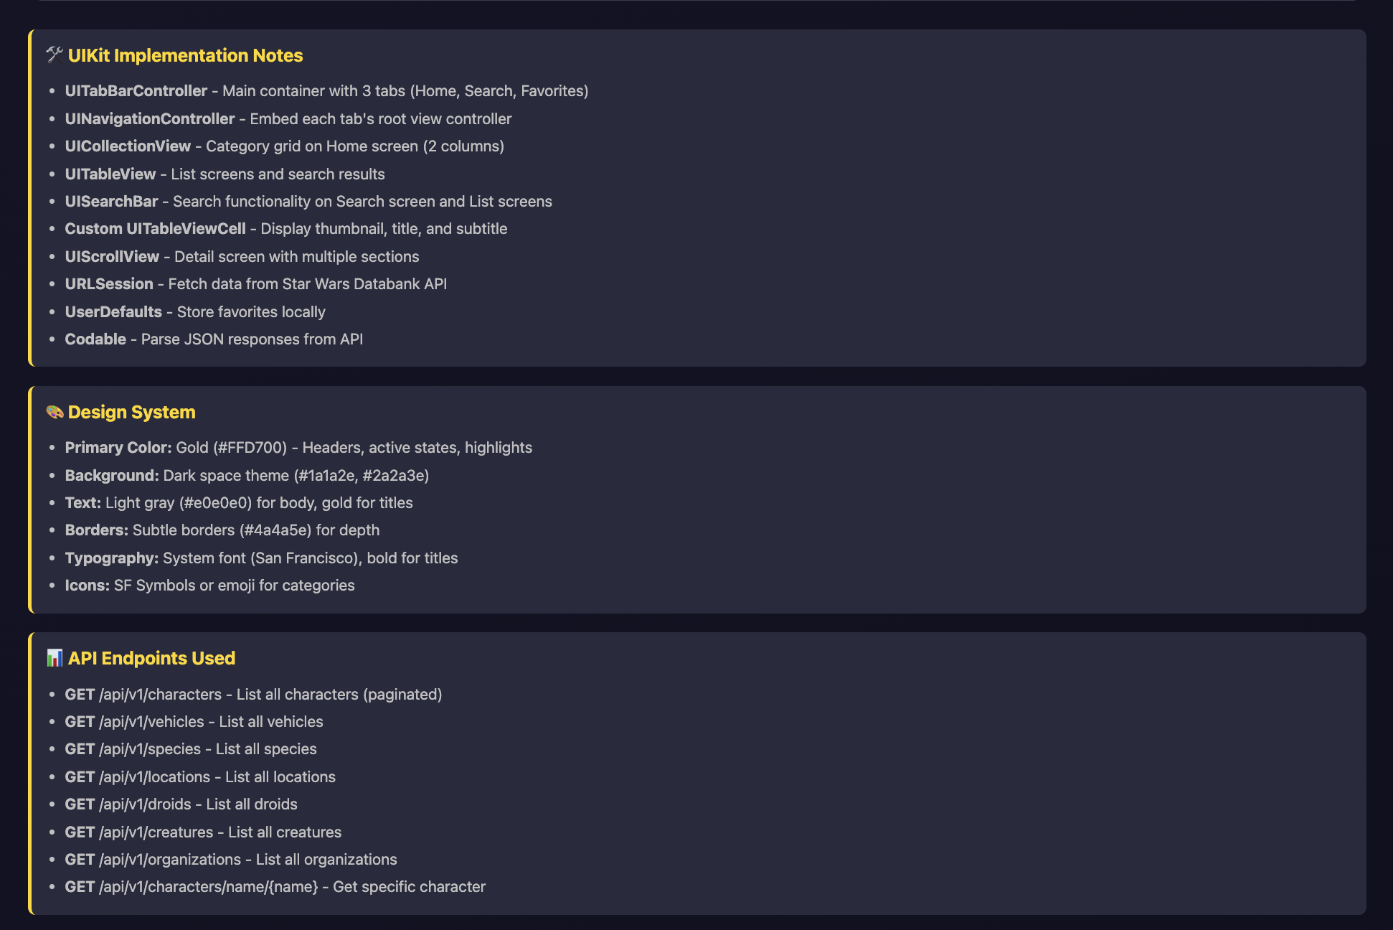
<!DOCTYPE html>
<html lang="en">
<head>
<meta charset="UTF-8">
<meta name="viewport" content="width=device-width, initial-scale=1.0">
<title>Galactic Databank - Wireframes</title>
<style>
* {
margin: 0;
padding: 0;
box-sizing: border-box;
}

body {
font-family: -apple-system, BlinkMacSystemFont, 'Segoe UI', Arial, sans-serif;
background: linear-gradient(135deg, #1a1a2e 0%, #0f0f1e 100%);
color: #e0e0e0;
padding: 40px 20px;
}

.header {
text-align: center;
margin-bottom: 50px;
color: #ffd700;
}

.header h1 {
font-size: 2.5em;
margin-bottom: 10px;
text-shadow: 0 0 20px rgba(255, 215, 0, 0.5);
}

.header p {
color: #a0a0a0;
font-size: 1.1em;
}

.wireframe-container {
display: grid;
grid-template-columns: repeat(auto-fit, minmax(320px, 1fr));
gap: 40px;
max-width: 1400px;
margin: 0 auto;
}

.screen {
background: #2a2a3e;
border-radius: 20px;
padding: 15px;
box-shadow: 0 10px 40px rgba(0, 0, 0, 0.5);
border: 2px solid #3a3a4e;
}

.screen-title {
text-align: center;
color: #ffd700;
margin-bottom: 15px;
font-size: 1.3em;
font-weight: bold;
}

.phone {
width: 100%;
max-width: 375px;
margin: 0 auto;
background: #1a1a2e;
border-radius: 40px;
padding: 20px;
border: 8px solid #0a0a1a;
position: relative;
}

.notch {
width: 150px;
height: 25px;
background: #0a0a1a;
margin: -20px auto 10px;
border-radius: 0 0 20px 20px;
}

.status-bar {
display: flex;
justify-content: space-between;
padding: 5px 10px;
font-size: 12px;
color: #888;
margin-bottom: 15px;
}

.nav-bar {
background: #2a2a3e;
padding: 15px;
border-radius: 15px;
margin-bottom: 15px;
display: flex;
align-items: center;
justify-content: space-between;
}

.nav-title {
font-size: 20px;
font-weight: bold;
color: #ffd700;
}

.search-bar {
background: #3a3a4e;
padding: 12px 15px;
border-radius: 10px;
margin-bottom: 15px;
color: #888;
border: 1px solid #4a4a5e;
}

.category-grid {
display: grid;
grid-template-columns: repeat(2, 1fr);
gap: 12px;
margin-bottom: 15px;
}

.category-card {
background: linear-gradient(135deg, #3a3a4e 0%, #2a2a3e 100%);
padding: 30px 15px;
border-radius: 12px;
text-align: center;
border: 2px solid #4a4a5e;
cursor: pointer;
transition: all 0.3s;
}

.category-card:hover {
border-color: #ffd700;
transform: translateY(-2px);
}

.category-icon {
font-size: 36px;
margin-bottom: 8px;
}

.category-name {
color: #e0e0e0;
font-weight: 600;
font-size: 14px;
}

.list-item {
background: #3a3a4e;
padding: 15px;
border-radius: 10px;
margin-bottom: 10px;
display: flex;
align-items: center;
gap: 15px;
border: 1px solid #4a4a5e;
}

.list-image {
width: 60px;
height: 60px;
background: linear-gradient(135deg, #4a4a5e 0%, #3a3a4e 100%);
border-radius: 8px;
display: flex;
align-items: center;
justify-content: center;
font-size: 24px;
border: 1px solid #5a5a6e;
}

.list-content {
flex: 1;
}

.list-title {
color: #ffd700;
font-weight: bold;
margin-bottom: 4px;
}

.list-subtitle {
color: #888;
font-size: 13px;
}

.chevron {
color: #666;
font-size: 20px;
}

.detail-image {
width: 100%;
height: 200px;
background: linear-gradient(135deg, #4a4a5e 0%, #3a3a4e 100%);
border-radius: 12px;
margin-bottom: 15px;
display: flex;
align-items: center;
justify-content: center;
font-size: 72px;
border: 2px solid #5a5a6e;
}

.detail-title {
font-size: 24px;
font-weight: bold;
color: #ffd700;
margin-bottom: 10px;
}

.detail-section {
background: #3a3a4e;
padding: 15px;
border-radius: 10px;
margin-bottom: 15px;
border: 1px solid #4a4a5e;
}

.section-title {
color: #ffd700;
font-weight: bold;
margin-bottom: 8px;
font-size: 14px;
text-transform: uppercase;
}

.section-content {
color: #c0c0c0;
line-height: 1.6;
font-size: 14px;
}

.tab-bar {
display: flex;
justify-content: space-around;
background: #2a2a3e;
padding: 12px;
border-radius: 15px;
margin-top: 15px;
border: 1px solid #3a3a4e;
}

.tab-item {
text-align: center;
color: #666;
flex: 1;
}

.tab-item.active {
color: #ffd700;
}

.tab-icon {
font-size: 24px;
margin-bottom: 4px;
}

.tab-label {
font-size: 11px;
}

.button {
background: linear-gradient(135deg, #ffd700 0%, #ffed4e 100%);
color: #1a1a2e;
padding: 12px;
border-radius: 10px;
text-align: center;
font-weight: bold;
margin-bottom: 10px;
cursor: pointer;
border: none;
}

.back-button {
color: #ffd700;
font-size: 16px;
cursor: pointer;
}

.favorite-button {
color: #ffd700;
font-size: 24px;
cursor: pointer;
}

.notes {
background: #2a2a3e;
border-left: 4px solid #ffd700;
padding: 15px;
margin-top: 30px;
border-radius: 8px;
max-width: 1400px;
margin-left: auto;
margin-right: auto;
}

.notes h3 {
color: #ffd700;
margin-bottom: 10px;
}

.notes ul {
color: #c0c0c0;
padding-left: 20px;
line-height: 1.8;
}

.flow-diagram {
background: #2a2a3e;
padding: 30px;
border-radius: 15px;
margin-top: 40px;
border: 2px solid #3a3a4e;
max-width: 1400px;
margin-left: auto;
margin-right: auto;
}

.flow-title {
color: #ffd700;
font-size: 1.5em;
margin-bottom: 20px;
text-align: center;
}

.flow-items {
display: flex;
flex-direction: column;
gap: 15px;
}

.flow-item {
background: #3a3a4e;
padding: 15px;
border-radius: 10px;
border-left: 4px solid #ffd700;
}

.flow-item strong {
color: #ffd700;
}

.arrow {
text-align: center;
color: #ffd700;
font-size: 24px;
margin: 5px 0;
}
</style>
</head>
<body>
<div class="header">
<h1>⭐ GALACTIC DATABANK ⭐</h1>
<p>iOS UIKit App Wireframes - Star Wars Lore Encyclopedia</p>
</div>

<div class="wireframe-container">
<!-- Screen 1: Home/Category Selection -->
<div class="screen">
<div class="screen-title">1. Home Screen (Category Selection)</div>
<div class="phone">
<div class="notch"></div>
<div class="status-bar">
<span>9:41</span>
<span>⚡ 📶</span>
</div>

<div class="nav-bar">
<div class="nav-title">Galactic Databank</div>
<div class="favorite-button">⭐</div>
</div>

<div class="search-bar">🔍 Search the galaxy...</div>

<div class="category-grid">
<div class="category-card">
<div class="category-icon">👤</div>
<div class="category-name">Characters</div>
</div>
<div class="category-card">
<div class="category-icon">🚀</div>
<div class="category-name">Vehicles</div>
</div>
<div class="category-card">
<div class="category-icon">👽</div>
<div class="category-name">Species</div>
</div>
<div class="category-card">
<div class="category-icon">🌍</div>
<div class="category-name">Locations</div>
</div>
<div class="category-card">
<div class="category-icon">🤖</div>
<div class="category-name">Droids</div>
</div>
<div class="category-card">
<div class="category-icon">🦎</div>
<div class="category-name">Creatures</div>
</div>
<div class="category-card">
<div class="category-icon">🏛️</div>
<div class="category-name">Organizations</div>
</div>
<div class="category-card">
<div class="category-icon">🎲</div>
<div class="category-name">Surprise Me</div>
</div>
</div>

<div class="tab-bar">
<div class="tab-item active">
<div class="tab-icon">🏠</div>
<div class="tab-label">Home</div>
</div>
<div class="tab-item">
<div class="tab-icon">🔍</div>
<div class="tab-label">Search</div>
</div>
<div class="tab-item">
<div class="tab-icon">⭐</div>
<div class="tab-label">Favorites</div>
</div>
</div>
</div>
</div>

<!-- Screen 2: List View -->
<div class="screen">
<div class="screen-title">2. List View (e.g., Characters)</div>
<div class="phone">
<div class="notch"></div>
<div class="status-bar">
<span>9:41</span>
<span>⚡ 📶</span>
</div>

<div class="nav-bar">
<div class="back-button">← Back</div>
<div class="nav-title">Characters</div>
<div style="width: 24px;"></div>
</div>

<div class="search-bar">🔍 Search characters...</div>

<div style="overflow-y: auto; max-height: 480px;">
<div class="list-item">
<div class="list-image">👨</div>
<div class="list-content">
<div class="list-title">Luke Skywalker</div>
<div class="list-subtitle">Jedi Knight from Tatooine</div>
</div>
<div class="chevron">›</div>
</div>

<div class="list-item">
<div class="list-image">👸</div>
<div class="list-content">
<div class="list-title">Princess Leia</div>
<div class="list-subtitle">Leader of the Rebellion</div>
</div>
<div class="chevron">›</div>
</div>

<div class="list-item">
<div class="list-image">🦹</div>
<div class="list-content">
<div class="list-title">Darth Vader</div>
<div class="list-subtitle">Dark Lord of the Sith</div>
</div>
<div class="chevron">›</div>
</div>

<div class="list-item">
<div class="list-image">👤</div>
<div class="list-content">
<div class="list-title">Han Solo</div>
<div class="list-subtitle">Smuggler & Pilot</div>
</div>
<div class="chevron">›</div>
</div>

<div class="list-item">
<div class="list-image">🧙</div>
<div class="list-content">
<div class="list-title">Obi-Wan Kenobi</div>
<div class="list-subtitle">Jedi Master</div>
</div>
<div class="chevron">›</div>
</div>
</div>

<div class="tab-bar">
<div class="tab-item active">
<div class="tab-icon">🏠</div>
<div class="tab-label">Home</div>
</div>
<div class="tab-item">
<div class="tab-icon">🔍</div>
<div class="tab-label">Search</div>
</div>
<div class="tab-item">
<div class="tab-icon">⭐</div>
<div class="tab-label">Favorites</div>
</div>
</div>
</div>
</div>

<!-- Screen 3: Detail View -->
<div class="screen">
<div class="screen-title">3. Detail View</div>
<div class="phone">
<div class="notch"></div>
<div class="status-bar">
<span>9:41</span>
<span>⚡ 📶</span>
</div>

<div class="nav-bar">
<div class="back-button">← Back</div>
<div class="nav-title">Character</div>
<div class="favorite-button">☆</div>
</div>

<div style="overflow-y: auto; max-height: 500px; padding-bottom: 10px;">
<div class="detail-image">👨</div>

<div class="detail-title">Luke Skywalker</div>

<div class="detail-section">
<div class="section-title">Description</div>
<div class="section-content">
Luke Skywalker was a Tatooine farmboy who rose from humble beginnings to become one of the greatest Jedi the galaxy has ever known. After starting his Jedi training with Obi-Wan Kenobi, Luke Skywalker embarked on a mission to rescue Princess Leia...
</div>
</div>

<div class="detail-section">
<div class="section-title">Affiliation</div>
<div class="section-content">
Jedi Order, Rebel Alliance, New Republic
</div>
</div>

<div class="detail-section">
<div class="section-title">Homeworld</div>
<div class="section-content">
Tatooine
</div>
</div>

<div class="button">Share This Entry</div>
</div>

<div class="tab-bar">
<div class="tab-item active">
<div class="tab-icon">🏠</div>
<div class="tab-label">Home</div>
</div>
<div class="tab-item">
<div class="tab-icon">🔍</div>
<div class="tab-label">Search</div>
</div>
<div class="tab-item">
<div class="tab-icon">⭐</div>
<div class="tab-label">Favorites</div>
</div>
</div>
</div>
</div>

<!-- Screen 4: Search Screen -->
<div class="screen">
<div class="screen-title">4. Search Screen</div>
<div class="phone">
<div class="notch"></div>
<div class="status-bar">
<span>9:41</span>
<span>⚡ 📶</span>
</div>

<div class="nav-bar">
<div class="nav-title">Search</div>
</div>

<div class="search-bar">🔍 Search all categories...</div>

<div style="padding: 15px 0;">
<div class="section-title" style="padding: 0 15px; margin-bottom: 10px;">Recent Searches</div>

<div class="list-item">
<div class="list-image">🚀</div>
<div class="list-content">
<div class="list-title">Millennium Falcon</div>
<div class="list-subtitle">Vehicle</div>
</div>
<div class="chevron">›</div>
</div>

<div class="list-item">
<div class="list-image">👽</div>
<div class="list-content">
<div class="list-title">Wookiee</div>
<div class="list-subtitle">Species</div>
</div>
<div class="chevron">›</div>
</div>

<div class="list-item">
<div class="list-image">🌍</div>
<div class="list-content">
<div class="list-title">Coruscant</div>
<div class="list-subtitle">Location</div>
</div>
<div class="chevron">›</div>
</div>
</div>

<div class="tab-bar">
<div class="tab-item">
<div class="tab-icon">🏠</div>
<div class="tab-label">Home</div>
</div>
<div class="tab-item active">
<div class="tab-icon">🔍</div>
<div class="tab-label">Search</div>
</div>
<div class="tab-item">
<div class="tab-icon">⭐</div>
<div class="tab-label">Favorites</div>
</div>
</div>
</div>
</div>

<!-- Screen 5: Favorites Screen -->
<div class="screen">
<div class="screen-title">5. Favorites Screen</div>
<div class="phone">
<div class="notch"></div>
<div class="status-bar">
<span>9:41</span>
<span>⚡ 📶</span>
</div>

<div class="nav-bar">
<div class="nav-title">Favorites</div>
</div>

<div style="padding: 15px 0;">
<div class="list-item">
<div class="list-image">🤖</div>
<div class="list-content">
<div class="list-title">R2-D2</div>
<div class="list-subtitle">Droid</div>
</div>
<div class="favorite-button">⭐</div>
</div>

<div class="list-item">
<div class="list-image">🚀</div>
<div class="list-content">
<div class="list-title">X-wing Starfighter</div>
<div class="list-subtitle">Vehicle</div>
</div>
<div class="favorite-button">⭐</div>
</div>

<div class="list-item">
<div class="list-image">👨</div>
<div class="list-content">
<div class="list-title">Yoda</div>
<div class="list-subtitle">Character</div>
</div>
<div class="favorite-button">⭐</div>
</div>

<div class="list-item">
<div class="list-image">🌍</div>
<div class="list-content">
<div class="list-title">Death Star</div>
<div class="list-subtitle">Location</div>
</div>
<div class="favorite-button">⭐</div>
</div>
</div>

<div class="tab-bar">
<div class="tab-item">
<div class="tab-icon">🏠</div>
<div class="tab-label">Home</div>
</div>
<div class="tab-item">
<div class="tab-icon">🔍</div>
<div class="tab-label">Search</div>
</div>
<div class="tab-item active">
<div class="tab-icon">⭐</div>
<div class="tab-label">Favorites</div>
</div>
</div>
</div>
</div>
</div>

<!-- Navigation Flow Diagram -->
<div class="flow-diagram">
<div class="flow-title">📱 Navigation Flow</div>
<div class="flow-items">
<div class="flow-item">
<strong>Tab Navigation (Bottom Tab Bar - Persistent):</strong>
<br>• Home Tab → Category Selection Screen
<br>• Search Tab → Search Screen
<br>• Favorites Tab → Favorites Screen
</div>

<div class="arrow">↓</div>

<div class="flow-item">
<strong>Flow Navigation (Push/Pop):</strong>
<br>• Home Screen → Tap Category → List Screen
<br>• List Screen → Tap Item → Detail Screen
<br>• Detail Screen → Back Button → List Screen
<br>• List Screen → Back Button → Home Screen
<br>• Search Screen → Tap Result → Detail Screen
<br>• Favorites Screen → Tap Item → Detail Screen
</div>

<div class="arrow">↓</div>

<div class="flow-item">
<strong>Actions:</strong>
<br>• Detail Screen → Tap Star → Add/Remove Favorite
<br>• Detail Screen → Tap Share → Share Sheet
<br>• Home Screen → Tap "Surprise Me" → Random Detail Screen
</div>
</div>
</div>

<!-- Implementation Notes -->
<div class="notes">
<h3>🛠️ UIKit Implementation Notes</h3>
<ul>
<li><strong>UITabBarController</strong> - Main container with 3 tabs (Home, Search, Favorites)</li>
<li><strong>UINavigationController</strong> - Embed each tab's root view controller</li>
<li><strong>UICollectionView</strong> - Category grid on Home screen (2 columns)</li>
<li><strong>UITableView</strong> - List screens and search results</li>
<li><strong>UISearchBar</strong> - Search functionality on Search screen and List screens</li>
<li><strong>Custom UITableViewCell</strong> - Display thumbnail, title, and subtitle</li>
<li><strong>UIScrollView</strong> - Detail screen with multiple sections</li>
<li><strong>URLSession</strong> - Fetch data from Star Wars Databank API</li>
<li><strong>UserDefaults</strong> - Store favorites locally</li>
<li><strong>Codable</strong> - Parse JSON responses from API</li>
</ul>
</div>

<div class="notes" style="margin-top: 20px;">
<h3>🎨 Design System</h3>
<ul>
<li><strong>Primary Color:</strong> Gold (#FFD700) - Headers, active states, highlights</li>
<li><strong>Background:</strong> Dark space theme (#1a1a2e, #2a2a3e)</li>
<li><strong>Text:</strong> Light gray (#e0e0e0) for body, gold for titles</li>
<li><strong>Borders:</strong> Subtle borders (#4a4a5e) for depth</li>
<li><strong>Typography:</strong> System font (San Francisco), bold for titles</li>
<li><strong>Icons:</strong> SF Symbols or emoji for categories</li>
</ul>
</div>

<div class="notes" style="margin-top: 20px;">
<h3>📊 API Endpoints Used</h3>
<ul>
<li><strong>GET</strong> /api/v1/characters - List all characters (paginated)</li>
<li><strong>GET</strong> /api/v1/vehicles - List all vehicles</li>
<li><strong>GET</strong> /api/v1/species - List all species</li>
<li><strong>GET</strong> /api/v1/locations - List all locations</li>
<li><strong>GET</strong> /api/v1/droids - List all droids</li>
<li><strong>GET</strong> /api/v1/creatures - List all creatures</li>
<li><strong>GET</strong> /api/v1/organizations - List all organizations</li>
<li><strong>GET</strong> /api/v1/characters/name/{name} - Get specific character</li>
</ul>
</div>
</body>
</html>

