RMSC5102 Simulation Methods for Risk Management Science and Finance

Tutorial Notes

Spring, 2020

LEUNG Man Fung, Heman

Contents

I) Probability and statistics 3

Discrete random variables 3

Binomial distribution 3

Poisson distribution 4

Continuous random variables 4

Uniform distribution 4

Normal distribution 5

Some remarks 5

II) Financial derivative 6

Forward 6

Option 6

Binomial tree 6

III) Stochastic calculus 7

Brownian motion 7

Stochastic integral 7

IV) Simulation methods 8

Theoretical support 8

Standard Monte Carlo 8

# I) Probability and statistics

## Discrete random variables

Random variables: numeric quantities that take different values with specified probabilities

Discrete random variable: a R.V. that takes value from a discrete set of numbers

Probability mass function: a pmf assigns a probability to each possible value x of the discrete random variable X, denoted by

(total probability rule)

Cumulative distribution function: a cdf gives the probability that X is less than or equal to the value x, denoted by

Expected value: (the idea is “probability weighted average”)

Variance: , alternatively

Translation/rescale: ,

Linearity of expectation:

## Binomial distribution

Factorial: , note that

Permutation (order is important):

Combination (order is not important): , also denoted as

Binomial distribution: probability distribution on the number of successes in independent experiments, each experiment has a probability of success , then

Pmf: for

Mean:

Variance:

## Poisson distribution

Poisson distribution: probability distribution on the number of occurrence (usually of a rare event) over a period of time or space with rate , then . Useful in modelling jump.

Pmf: for

Mean:

Variance:

## Continuous random variables

Continuous random variable: a R.V. that takes value over an interval of numbers

Probability density function: a pdf specifies the probability of the random variable falling within a particular range of values, denoted by

, which is the area under the curve from a to b

for all

(total probability rule)

Cumulative distribution function: a cdf gives the probability that X is less than or equal to the value x, denoted by

(by the fundamental theorem of calculus)

Expected value:

Variance:

## Uniform distribution

Uniform distribution: if follows uniform distribution on the interval , then it has the same probability density at any point in the interval and we denote it by . Basic R.V. in probability integral transform.

Pdf: for , otherwise 0

Cdf: for

Mean:

Variance:

## Normal distribution

Normal distribution: if follows normal distribution with mean and variance , then . Often used to represent continuous random variable with unknown distributions

Pdf: for

Standard normal distribution:

Cdf of standard normal: denoted as

by symmetric property

Percentile of standard normal:

Standardization: if , then

## Some remarks

Variance of sum:

Tower rule of expectation:

Law of total variance (EVE):

Sum of poisson: if independently, then

Sum of normal: if independently, then

Square of standard normal: if , the

Sum of chi square: if , then

# II) Financial derivative

## Forward

Payoff:

Pricing:

With known cash income:

With known dividend yield:

Minimum variance hedge ratio:

## Option

Upper bounds:

Lower bounds:

Put-call parity: (idea is call – put = forward)

Put call inequality:

European-American relationship: (for non-dividend-paying)

## Binomial tree

Risk neutral probability:

Pricing:

Backward induction: start from payoff as terminal prices (American: take max between payoff and f)

# III) Stochastic calculus

## Brownian motion

Wiener process: is called a Wiener process if the following holds

Stationary increment:

Independent increment:

Starts at zero:

Properties: (quadratic variation), nowhere differentiable

Itô’s process: is an Itô’s process if it is solution to the following stochastic differential equation

Where is known as the drift function and is known as the volatility function. **You may think and (useful in simulation)**

## Stochastic integral

Definition:

Itô’s lemma:

Geometric Brownian motion:

Solving SDE: “guess” a solution and use Itô’s lemma to verify that the solution satisfies the SDE (the following table is borrowed from Prof. Yau Chun Yip’s notes on Stochastic Calculus):

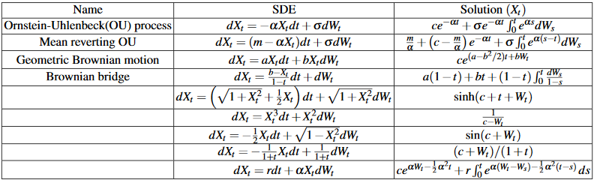

Martingale property:

In particular,

Itô isometry:

Similarly,

Product rule:

Integrating factor: add to both sides of a SDE (target: cancel some terms)

# IV) Simulation methods

## Theoretical support

Sample mean:

Sample variance:

Law of large numbers (WLLN): Let be i.i.d. random variables with mean and variance , then for any given , as

Central limit theorem (CLT, Lindeberg–Lévy): Let be i.i.d. random variables with mean and finite variance , then as

## Standard Monte Carlo

Procedure:

1. Generate random variable
2. Calculate , where is the target function
3. Repeat 1 and 2 for n times
4. (remember to do discounting if necessary)