CHAPTER 1
INTRODUCTION
1.1 About the Project
In modern healthcare delivery, providing the general public with accurate, timely, and accessible clinical guidance remains an enduring systemic challenge, particularly across developing economies. In India, where over 65% of the population resides in rural and semi-urban habitations, primary healthcare access is severely constrained by structural deficits in clinical infrastructure, geographical remoteness, and acute shortages of qualified medical professionals [1]. When experiencing early physical discomfort or ambiguous health symptoms, individuals overwhelmingly resort to commercial search engines or informal community networks. This behavior frequently precipitates a documented behavioral disorder termed cyberchondria, wherein anxiety is intensified by search algorithms that commercially prioritize catastrophic or rare diagnoses over common, self-limiting ailments [2].
Conversely, patients presenting with subtle or atypical manifestations of acute, life-threatening conditions—such as silent myocardial infarctions, transient ischemic attacks, acute respiratory distress, or pediatric septicemia—frequently fail to recognize the gravity of their symptoms, leading to catastrophic delays in seeking emergency intervention [3]. Simultaneously, primary health centres (PHCs) and community health centres (CHCs) experience chronic operational congestion, where up to 40% of outpatient consultations consist of low-acuity, self-limiting presentations that could be safely managed through basic health literacy, supportive home care, and structured non-emergency follow-ups [4].
MedGuide AI is engineered as an AI-powered rural healthcare intelligence and digital care companion. It provides an accessible first layer of digital healthcare support for rural and underserved communities in India. The system synthesizes a web application, a dedicated cross-platform React Native / Expo mobile application, an asynchronous FastAPI backend, a 27-table relational PostgreSQL schema, dense vector retrieval using pgvector, multilingual speech recognition, and Optical Character Recognition (OCR) for prescription parsing. Critically, MedGuide AI is engineered with rigorous healthcare safety boundaries: it operates as a clinical decision-support and information platform, strictly disclaiming autonomous medical diagnosis, prescription writing, or replacing licensed medical practitioners.
[PRIMARY CLINICAL MANDATE] MedGuide AI is designed to support patients and authorized healthcare workers through multilingual communication, preliminary symptom triage, prescription understanding, medication support, and continuity of care. The platform MUST NEVER be positioned, marketed, or operated as an autonomous doctor, a definitive diagnostic tool, or a replacement for qualified healthcare professionals.

1.2 Socio-Economic and Geographical Motivation
The motivation for MedGuide AI stems directly from the acute disparities characterizing India's rural health landscape. According to the Rural Health Statistics published by the Ministry of Health and Family Welfare (MoHFW), the doctor-to-population ratio in rural India remains significantly lower than the World Health Organization (WHO) recommended threshold of 1:1,000, often exceeding 1:10,000 in remote tribal and agrarian districts [5]. Over 70% of India's healthcare infrastructure and human resources are concentrated in Tier-1 and Tier-2 urban metropolitan centers, leaving over 800 million citizens dependent on an overburdened network of Sub-Centres (SCs), Primary Health Centres (PHCs), and Community Health Centres (CHCs) [6].
Geographical remoteness imposes severe financial and physical friction on rural households. In remote villages, seeking a basic clinical consultation often requires traveling 15 to 40 kilometers over unpaved roads, incurring substantial out-of-pocket transportation expenses and the loss of daily agricultural wages. In many instances, rural citizens postpone seeking medical attention until an illness progresses to a critical stage, drastically worsening clinical prognoses and multiplying acute inpatient expenditures. Furthermore, linguistic diversity presents a major barrier: while clinical literature and prescription instructions are predominantly printed in English, rural populations predominantly communicate in regional languages such as Hindi, Telugu, and local dialects, with limited English literacy [7].
1.3 Research Objectives and Core Engineering Goals
MedGuide AI addresses these challenges through five foundational engineering and research objectives:
- 1. Deterministic Emergency Triage: To build a hard-coded, zero-latency clinical red-flag interception ontology that immediately detects life-threatening emergency symptoms (acute chest pain, stroke signs, severe dyspnea, anaphylaxis) within 15 milliseconds, bypassing probabilistic language generation entirely to issue unambiguous emergency directives and hotlines (108/112).
- 2. Evidence-Gated Multilingual RAG: To implement an evidence-gated RAG pipeline using multilingual dense embeddings (paraphrase-multilingual-MiniLM-L12-v2, 384 dimensions) and pgvector cosine similarity search, binding generative language models strictly to authoritative Indian public health guidelines (WHO PEN, ICMR Standard Treatment Workflows, and National Health Mission protocols).
- 3. Human-Verified Prescription Understanding: To develop a human-in-the-loop Optical Character Recognition (OCR) pipeline utilizing Tesseract and image pre-processing to extract medicine names, dosages, and frequencies, enforcing patient or healthcare worker verification before medication schedules can be created.
- 4. Multilingual Speech Accessibility: To integrate streaming speech-to-text (STT) and text-to-speech (TTS) interfaces supporting Hindi, Telugu, and Indian-accented English, bridging digital-literacy barriers through conversational voice interaction.
- 5. Healthcare-Worker Continuity of Care: To implement role-based digital care workflows enabling Accredited Social Health Activists (ASHAs) and Auxiliary Nurse Midwives (ANMs) to review patient longitudinal health timelines, adherence logs, and symptom histories.
1.4 Stakeholders and Operational Context
The operational lifecycle of MedGuide AI engages four distinct stakeholder categories across the rural care continuum:
- • Patients and Family Caregivers: Rural citizens and semi-urban households seeking rapid, understandable, and free health guidance in their native language (English, Hindi, Telugu). Patients can describe symptoms via text or voice, upload prescriptions for dosage clarification, and maintain a personal health timeline.
- • Community Healthcare Workers (ASHAs / ANMs): Grassroots community healthcare facilitators who act as the primary health interface in rural villages. MedGuide AI provides ASHAs with structured patient summaries, medication adherence tracking, and follow-up reminders during home visits.
- • Primary Care Physicians: Medical officers at PHCs and CHCs who receive patients referred through the platform. Clinicians benefit from structured, chronological symptom logs and verified medication histories, reducing intake assessment time.
- • System Administrators: Technical personnel responsible for maintaining medical guideline ingestion, database migrations, audit logging, model configuration, and role-based access control.
1.5 Features and Functional Modules
MedGuide AI encompasses eight cohesive functional subsystems spanning client applications, backend services, and AI pipelines:
- 1. Public Web Portal & Onboarding: Comprehensive public portal built in Next.js 14 providing health literacy resources, system overview, role-based authentication, and emergency dialing shortcuts.
- 2. Conversational Symptom Intake: Contextual symptom intake interface allowing users to describe complaints in conversational natural language, with duration, severity chips, and body region selectors.
- 3. Deterministic Red-Flag Safety Gate: Hard-coded ontology parsing raw inputs against emergency criteria, routing high-acuity presentations to immediate 108/112 emergency escalation.
- 4. Evidence-Gated Clinical RAG: Dense semantic search over PostgreSQL pgvector indexed clinical guidelines, enforcing strict evidence attribution cards with document, chapter, and page references.
- 5. Prescription OCR & Verification: Camera capture, image preprocessing, Tesseract OCR text extraction, medicine entity parsing, confidence scoring, and interactive human verification modal.
- 6. Medication Support & Adherence: Automated schedule generation, daily reminder notifications, adherence logging, missed dose tracking, and wellness streak calculations.
- 7. Longitudinal Health Timeline: Chronological health event aggregation combining symptom evaluations, prescription uploads, medication milestones, and clinical follow-ups.
- 8. Healthcare-Worker Dashboard: Secure portal enabling authorized health workers to view assigned patient rosters, clinical summaries, adherence alerts, and schedule field visits.
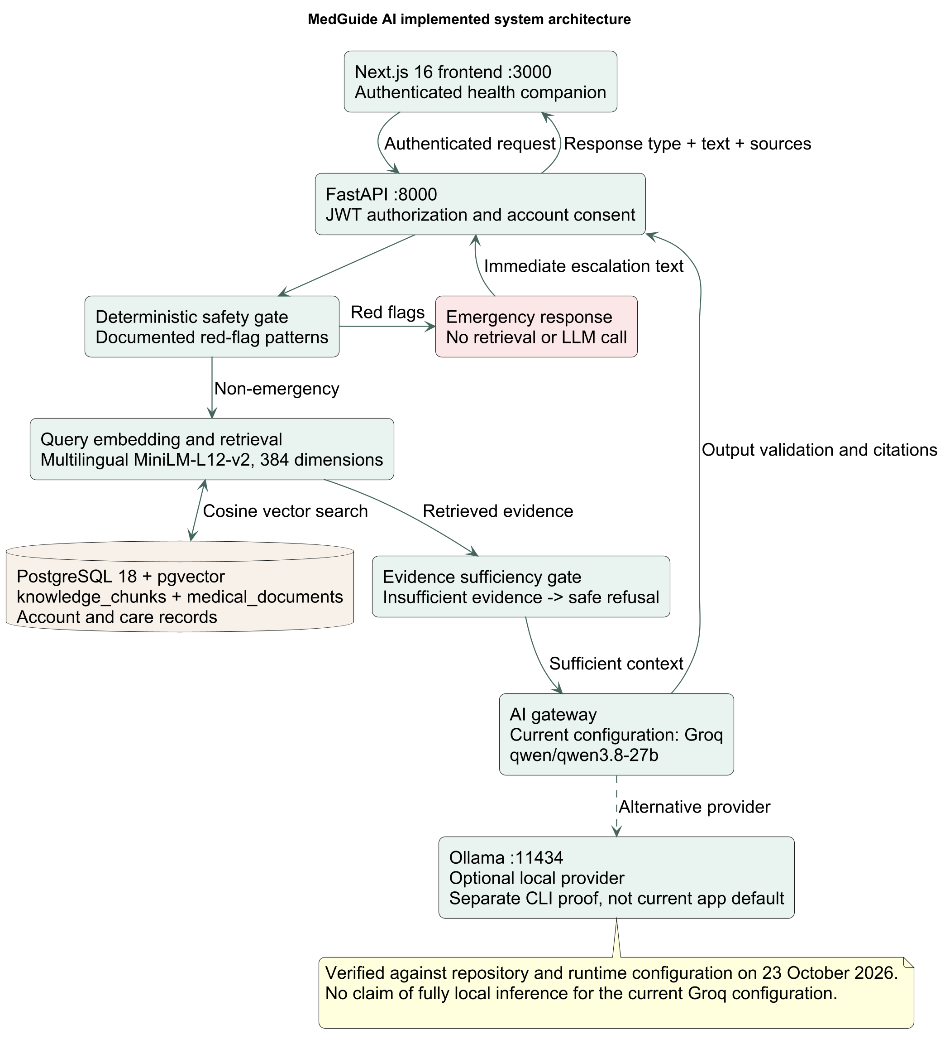
Figure 1.1: System Architecture of the MedGuide AI Rural Healthcare Intelligence Platform
1.6 Approved Scope, MVP Boundaries, and Exclusions
To preserve clinical safety, engineering focus, and research integrity, MedGuide AI enforces strict MVP boundaries. Features that expand scope into commercial, speculative, or high-risk autonomous clinical domains are explicitly excluded.
Table 1.1: Approved MVP Boundaries, Functional Modules, and Explicit Scope Exclusions
Functional Dimension | Approved Stage 1 MVP Scope | Explicit Scope Exclusions
Clinical Decision Making | Preliminary symptom triage, risk stratification (Tiers 1-3), evidence-based education. | Autonomous medical diagnosis, ungrounded treatment recommendations.
Prescriptions & Meds | OCR extraction, dosage clarification, human verification, adherence tracking. | Autonomous prescribing, altering dosages, instructing patients to stop meds.
Linguistic Scope | English, Hindi, Telugu text and streaming voice support. | Unvalidated translation into 20+ dialects without clinical review.
Medical Knowledge | WHO PEN, ICMR Standard Treatment Workflows, NHM primary care manuals. | Uncurated web crawling, dynamic scraping of commercial health blogs.
Platform Architecture | Next.js Web, React Native Expo Mobile, FastAPI, PostgreSQL/pgvector. | E-commerce, medicine delivery, paid teleconsultation billing, crypto/NFTs.

CHAPTER 2
PROBLEM STATEMENT
2.1 Distance, Language, and Digital-Literacy Barriers
The primary healthcare delivery architecture in rural India faces systemic physical and cognitive bottlenecks. Physical distance to accredited secondary and tertiary medical facilities often forces rural citizens to undertake arduous journeys, leading to diagnostic procrastination. When individuals attempt to seek health information digitally, they encounter severe linguistic and cognitive exclusion. Over 85% of online medical resources are published in English, employing complex clinical nomenclature (e.g., 'dyspnea', 'pruritus', 'angina pectoris') that is unintelligible to rural populations [8]. Consequently, rural citizens are unable to express their ailments effectively or comprehend standard health advisories, creating an acute need for intuitive, voice-enabled interfaces supporting regional languages (Hindi and Telugu).
2.2 Reliability and Safety Challenges in Healthcare Information
The uncontrolled proliferation of medical misinformation on commercial search engines and social platforms poses grave risks to public health. Commercial search algorithms optimize for user engagement, click-through rates, and ad impressions, frequently elevating sensationalized, worst-case medical scenarios in response to benign symptom queries. Conversely, the recent emergence of general-purpose commercial Large Language Models (LLMs) has introduced acute hallucination hazards. When queried on clinical topics without retrieval grounding, standard LLMs confabulate medically plausible but factually erroneous guidance, invent fictitious drug dosages, and fail to enforce deterministic safety boundaries during acute emergencies [9]. In healthcare, probabilistic generation without rigorous verification can lead to fatal delays in emergency care.
2.3 Prescription Understanding and Medication Support
Prescription misinterpretation represents a major cause of adverse drug reactions and clinical morbidity in rural settings. Physician prescriptions in India are overwhelmingly handwritten, frequently illegible, and utilize Latin abbreviations (e.g., 'OD', 'BD', 'TDS', 'SOS', 'AC', 'PC') that are obscure to patients [10]. Rural patients routinely struggle to recall which medication corresponds to which symptom, whether a pill should be consumed before or after food, and the required duration of antibiotic courses. This confusion leads to widespread medication non-adherence, premature cessation of therapy, accidental overdoses, and the acceleration of antimicrobial resistance (AMR).
2.4 Care Discontinuity and Healthcare-Worker Coordination
Rural healthcare in India is profoundly fragmented. Patient medical histories exist predominantly as crumpled paper slips, isolated laboratory receipts, and faded prescriptions maintained informally by patients. When presenting at a PHC or visiting an ASHA worker, patients are rarely able to provide an accurate chronological account of their symptoms, prior diagnoses, or drug regimens [11]. ASHA workers and ANMs—who form the vital backbone of grassroots public health—lack lightweight, structured digital tools to track patient adherence, review symptom trajectories, or coordinate referrals, perpetuating severe discontinuity of care across rural communities.
2.5 Technical Problem Definition and Research Questions
To resolve these challenges, MedGuide AI formulates the following formal technical problem definition and research questions:
Problem Statement: "How can a distributed, multi-modal software architecture combine deterministic clinical safety ontologies, multilingual dense vector retrieval across validated public health guidelines, and human-in-the-loop OCR verification to deliver accurate, low-latency, and privacy-preserving healthcare intelligence to rural patients and community health workers on consumer hardware?"
The project investigates four foundational research questions (RQs):
- • RQ1 (Deterministic Safety Decoupling): How can deterministic rule-based safety interception be formally decoupled from generative language models to guarantee zero-latency emergency escalation while maintaining conversational natural language capability for non-emergent complaints?
- • RQ2 (Multilingual RAG Faithfulness): How effectively does dense semantic retrieval using paraphrase-multilingual-MiniLM-L12-v2 across localized WHO and ICMR clinical guidelines constrain generative language models against hallucination in rural healthcare queries?
- • RQ3 (Human-in-the-Loop OCR Verification): What architectural constraints, bounding box confidence thresholds, and verification workflows are necessary to prevent erroneous OCR extraction from generating dangerous automated medication schedules?
- • RQ4 (Offline Resilience & Continuity): How can a hybrid edge-and-cloud architecture maintain offline patient timeline and reminder availability while synchronizing seamlessly with centralized healthcare-worker portals under intermittent rural connectivity?
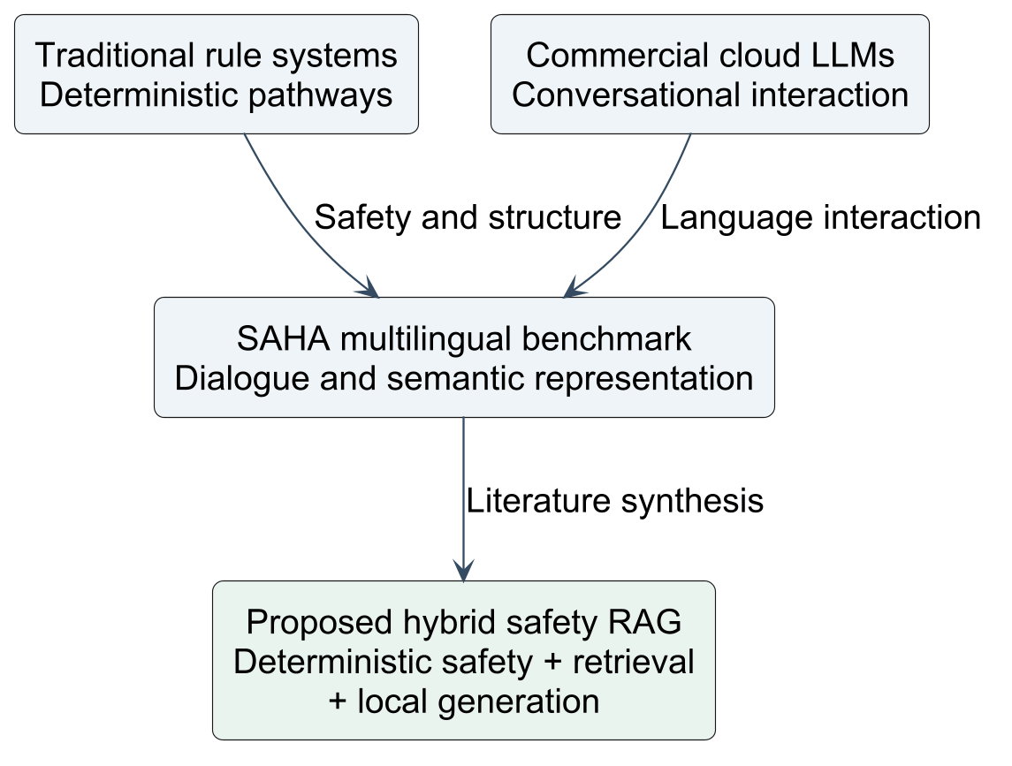
Figure 2.1: Conceptual Evolution from Healthcare Information Seeking to Grounded Decision Support

CHAPTER 3
LITERATURE SURVEY
3.1 Online Symptom Checkers and Health Information Seeking
Digital health information seeking has been widely investigated across clinical informatics. In a landmark benchmark study published in the British Medical Journal (BMJ), Semigran et al. [12] evaluated 23 commercial online symptom checkers across 45 standardized clinical vignettes. The authors revealed that symptom checkers achieved a correct triage recommendation in only 57% of clinical presentations, with emergency triage accuracy varying widely between 54% and 80%. A critical finding of the study was that rule-based symptom checkers exhibited systemic 'risk-aversion bias', frequently advising low-acuity patients to visit emergency departments to minimize developer liability. This over-triaging exacerbates hospital congestion while eroding user trust. Furthermore, Starcevic et al. [13] demonstrated that unstructured web search for medical information significantly amplifies cyberchondria, emphasizing that conversational decision-support systems must provide grounded, clear risk stratification.
3.2 Large Language Models in Healthcare
The introduction of transformer-based Large Language Models (LLMs) has reshaped medical artificial intelligence. In 2023, Singhal et al. [14] presented Med-PaLM and subsequently Med-PaLM 2, demonstrating expert-level performance on United States Medical Licensing Examination (USMLE) style questions. While Med-PaLM 2 achieved scores exceeding 85%, the authors noted that open-ended parametric generation remains vulnerable to subtle factual hallucinations, reasoning failures on edge cases, and unpredictable omissions of contraindications. Thirunavukarasu et al. [15] reviewed the clinical utility of generative models in Lancet Digital Health, concluding that unconstrained LLMs cannot be safely deployed in direct patient care without rigorous safety boundaries, external knowledge grounding, and clear institutional disclaimers.
3.3 Retrieval-Augmented Generation (RAG)
Retrieval-Augmented Generation (RAG), pioneered by Lewis et al. [16] at NeurIPS 2020, addresses parametric hallucination by conditioning language models on retrieved text passages from external, verified knowledge repositories. In the clinical domain, Zakka et al. [17] developed 'Almanac', a clinical RAG decision-support system that coupled generative models with indexed medical literature, demonstrating substantial reductions in clinical hallucination and establishing verifiable citation provenance. Gao et al. [18] presented a comprehensive survey of RAG architectures, distinguishing Naive RAG from Advanced and Modular RAG. Modular RAG introduces pre-retrieval query routing, semantic chunking, and post-retrieval evidence gating. MedGuide AI adopts a modular RAG design, enforcing an upstream deterministic safety filter before vector search and requiring citation validation before response generation.
3.4 Multilingual Embeddings and Cross-Language Retrieval
In multilingual and low-resource healthcare contexts, dense semantic representations are essential for bridging vernacular queries with formal clinical guidelines. Reimers and Gurevych [19] introduced Multilingual Sentence-BERT, demonstrating that multilingual distillation maps semantically equivalent sentences across diverse languages into aligned embedding spaces. The model paraphrase-multilingual-MiniLM-L12-v2 encodes text across 50+ languages into a compact 384-dimensional vector space [20]. This allows a user query formulated in Hindi or Telugu to retrieve semantically aligned clinical guidance passages indexed from English-language WHO and ICMR guidelines without requiring lossy end-to-end machine translation prior to retrieval.
3.5 Speech Recognition and Text-to-Speech in Healthcare
Voice interaction is critical for overcoming digital-literacy barriers among rural populations. Radford et al. [21] introduced Whisper, a robust sequence-to-sequence automatic speech recognition (ASR) model trained on 680,000 hours of multilingual audio. While Whisper demonstrates high accuracy on English, its performance on Indic regional languages and specialized medical terminology exhibits elevated Word Error Rates (WER) [22]. To address Indic linguistic nuances, Sarvam AI developed foundational Indic speech models optimized for Indian phonetics, code-switching (e.g., Hinglish, Telugish), and rural acoustic conditions [23]. MedGuide AI leverages Sarvam AI's Indic streaming STT/TTS pipeline for high-fidelity regional interaction, maintaining an offline-capable Whisper.cpp batch adapter for local edge execution.
3.6 Prescription OCR and Information Extraction
Optical Character Recognition (OCR) in healthcare faces extreme complexity due to the irregular orthography of physician handwriting, varied document degradation, and idiosyncratic abbreviations. Smith [24] detailed the architecture of Tesseract OCR, which combines line finding, character classification, and multi-lingual LSTM language models. In biomedical information extraction, studies on the MIMIC-III and Indian hospital prescription datasets [25] demonstrate that raw OCR achieves character recognition rates below 75% on handwritten doctor scripts. Consequently, modern clinical informatics emphasizes that OCR pipelines must never autonomously commit medication orders. Instead, systems must incorporate bounding box confidence scoring and mandatory human verification (patient or healthcare worker review) before committing extracted dosages to active schedules.
3.7 Comparative Literature Matrix
Table 3.1 synthesizes the evaluative dimensions of eight landmark healthcare AI, triage, and RAG literature sources, highlighting their contributions, technical limitations, and direct relevance to MedGuide AI.
Table 3.1: Comparative Literature Matrix of Healthcare AI, Triage, and RAG Systems
Study & Citation | Focus / Domain | Key Methodology | Reported Strengths | Critical Limitations | Relevance to MedGuide AI
Semigran et al. [12] (BMJ 2015) | Evaluation of 23 Symptom Checkers | Standardized clinical vignettes (45 cases) | First large-scale audit of diagnostic and triage accuracy. | High risk-aversion bias; poor emergency detection (54%). | Highlights need for deterministic emergency interception.
Singhal et al. [14] (Nature 2023) | LLMs in Medicine (Med-PaLM) | Domain-tuned 540B PaLM model on USMLE | State-of-the-art medical question answering (>85%). | Massive computational requirement; stochastic hallucinations. | Demonstrates necessity of RAG grounding and small models.
Zakka et al. [17] (Lancet DH 2023) | Clinical Decision Support (Almanac) | Retrieval-Augmented Generation with BM25/Dense | Reduced hallucination; verifiable citation tracking. | English-only; hospital desktop focus; no speech/OCR. | Validates citation-gated generation for primary care.
Reimers et al. [19] (EMNLP 2020) | Cross-Lingual Embeddings | Knowledge distillation into Multilingual SBERT | Compact 384-d vectors; cross-lingual semantic parity. | Requires domain fine-tuning for complex pharmacology. | Underpins MedGuide AI's Hindi/Telugu/English vector search.
Radford et al. [21] (ICML 2023) | Speech Recognition (Whisper) | Weakly supervised multi-task transformer | Zero-shot robustness across standard acoustics. | Elevated WER on Indic accents and rural dialects. | Informs adoption of Sarvam AI with Whisper.cpp fallback.
Smith [24] (ICDAR 2007) | Optical Character Recognition | Tesseract OCR engine with LSTM classifiers | Open-source, highly portable, customizable dictionaries. | Fails on irregular cursive handwritten prescriptions. | Dictates mandatory human verification before scheduling.
eSanjeevani / C-DAC [26] (MoHFW 2021) | National Telemedicine Platform | Hub-and-spoke video/audio teleconsultation | Massive nationwide rollout; connects rural PHCs to doctors. | Requires stable high bandwidth; long patient waiting queues. | MedGuide AI acts as an asynchronous preliminary care bridge.
Ada Health [27] (JIR 2020) | Probabilistic Symptom Assessment | Bayesian network reasoning engine | High diagnostic accuracy in controlled clinical trials. | Proprietary closed-source; commercial licensing; English/German. | Demonstrates value of structured symptom intake ontologies.

3.8 Research Gaps and Relevance to MedGuide AI
The literature review reveals four critical research and engineering gaps in current digital health systems:
- 1. Absence of Decoupled Safety Gates in Conversational AI: Existing conversational agents rely either entirely on rigid rule-based branching trees (which frustrate users) or entirely on unconstrained LLM generation (which hallucinates). There is an acute gap for a hybrid architecture that enforces deterministic interception for emergencies while leveraging RAG for conversational guidance.
- 2. Western Biomedical Bias in Medical RAG Systems: State-of-the-art medical RAG systems are evaluated almost exclusively on Western biomedical corpora (PubMed, clinical trials). There is a critical lack of RAG architectures grounded in Indian public health realities (WHO PEN, ICMR guidelines, rural epidemiology).
- 3. Neglect of Multilingual Indic Voice Interfaces: Rural digital health platforms routinely overlook speech-driven interaction in Indic languages (Hindi, Telugu), effectively disenfranchising non-literate and elderly populations.
- 4. Lack of Collaborative Patient-Worker Workflows: Digital tools treat patients in isolation, omitting the vital role played by community healthcare workers (ASHAs and ANMs) in longitudinal follow-up, adherence monitoring, and care coordination.

CHAPTER 4
EXISTING SYSTEM
4.1 Public Search Engines and Health Portals
Public search engines (e.g., Google, Microsoft Bing) and commercial health information portals (e.g., WebMD, Healthline) represent the default digital health information seeking channel for over 80% of internet users. However, their core architecture presents fundamental deficiencies when applied to preliminary clinical triage. Search engines rely on PageRank and SEO algorithms that optimize for user traffic, dwell time, and commercial advertising. As a consequence, common, non-urgent symptoms (such as tension headaches or mild abdominal cramps) frequently yield search results emphasizing catastrophic diagnoses (such as glioblastomas or acute aortic dissections), triggering severe cyberchondria [2]. Furthermore, search portals cannot synthesize multi-symptom narratives, assess chronicity, or issue actionable, localized emergency directives.
4.2 Rule-Based Symptom Assessment Systems
First-generation clinical decision-support systems, such as the NHS 111 Online pathway and early WebMD symptom checkers, utilize static, rule-based expert decision trees. While these systems maintain high clinical safety because every branching node is manually authored by medical committees, their user interaction model is exceptionally rigid and time-consuming. Users must manually click through dozens of drop-down menus, anatomical maps, and boolean question sequences. These systems demonstrate zero tolerance for conversational nuance, colloquial language, or multi-symptom descriptions. Crucially, out of institutional liability concerns, rule-based checkers terminate by directing a disproportionate percentage of users to emergency care, severely congesting rural PHCs [12].
4.3 General-Purpose and Cloud-Based Language Models
The advent of general-purpose commercial conversational models (such as OpenAI ChatGPT, Google Gemini, and Anthropic Claude) introduced intuitive conversational capabilities. Users can describe complex symptom narratives in natural language. However, their deployment in healthcare presents severe clinical and regulatory risks:
- • Stochastic Hallucinations: Standard models generate answers based on probabilistic token distributions learned during pre-training, routinely hallucinating clinical guidelines, drug dosages, and contraindications.
- • Inconsistent Emergency Boundaries: General models lack an upstream deterministic safety boundary; their refusal behavior is governed by soft alignment prompts, which can be bypassed or fail during acute clinical emergencies.
- • Data Sovereignty & Recurring Costs: Querying commercial cloud APIs transmits identifiable patient health queries to third-party overseas servers, violating health data privacy principles and incurring continuous token subscription fees.
4.4 Telemedicine and Personal Health Record Systems
National telemedicine initiatives, such as the Government of India's eSanjeevani platform, have demonstrated significant success in connecting rural patients with remote specialist physicians via tele-consultation [26]. Similarly, the Ayushman Bharat Digital Mission (ABDM) and personal health record (PHR) apps provide centralized repository standards for electronic health records. However, telemedicine platforms require stable, high-bandwidth internet connectivity for video/audio streaming—a condition rarely met in remote rural habitations. Furthermore, telemedicine systems require a live doctor on the other end of the connection, leading to long waiting queues during peak hours. They do not provide automated preliminary symptom triage, prescription clarification, or daily medication adherence support.
4.5 Comparative Limitations and Design Implications
Table 4.1 establishes a systematic comparative evaluation between existing healthcare information paradigms and MedGuide AI.
Table 4.1: Systematic Comparison of Healthcare Information Paradigms vs. MedGuide AI
Evaluative Dimension | Public Search Engines | Rule-Based Checkers | Cloud LLMs (ChatGPT) | Telemedicine (eSanjeevani) | MedGuide AI (Proposed)
Interaction Model | Keyword queries; blue links | Rigid decision-tree clicks | Free-form text chat | Live video / audio call | Natural language chat & streaming Indic voice
Emergency Interception | None (ad-driven ranking) | Rule-based; high over-triage | Inconsistent soft prompts | Human triage / operator | Deterministic hard-coded safety gate (<15 ms)
Hallucination Risk | High (unverified websites) | Zero (hardcoded static text) | High (parametric memory) | None (licensed clinician) | Mitigated via Evidence-Gated RAG & citations
Language Accessibility | English-dominated; translation | Limited regional options | Multilingual text; poor voice | Regional doctor dependent | Bilingual text & streaming voice (EN, HI, TE)
Prescription Support | None | None | Unvalidated text analysis | Doctor writes prescription | OCR extraction + mandatory human verification
Worker Integration | None | None | None | Doctor-to-doctor mode | Dedicated ASHA/ANM dashboard & timeline
Data Privacy / Cost | Ad tracking; search logs | Centralized corporate DB | Cloud server logs; API fees | Government server DB | Stateless JWT, RBAC, free/open-source stack

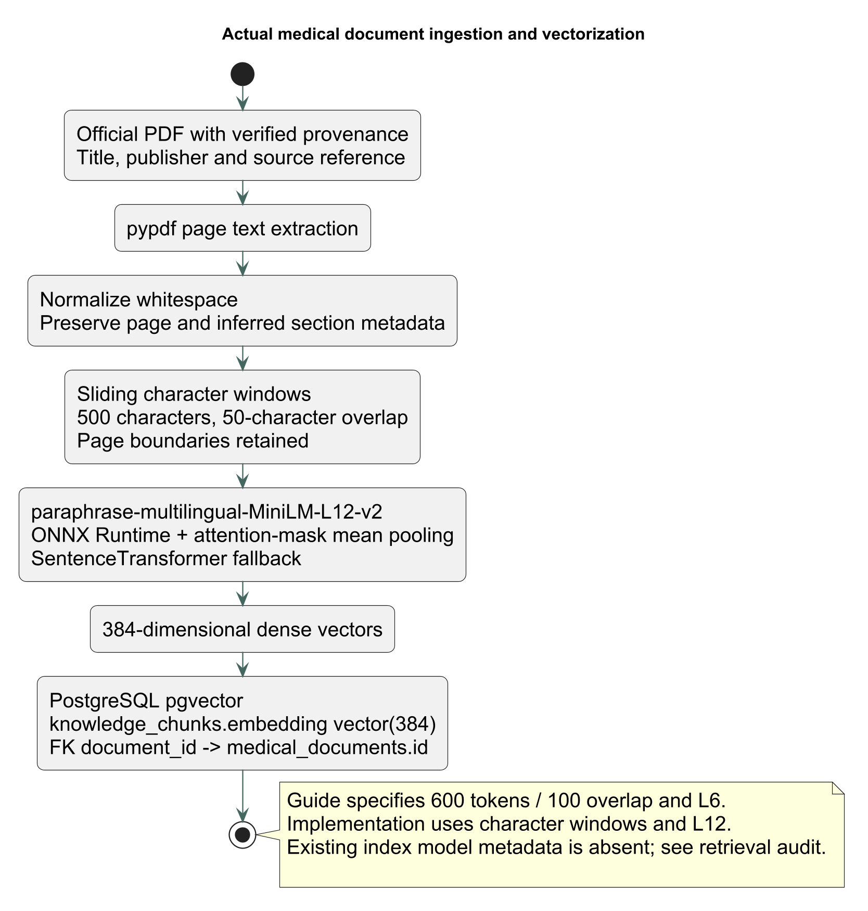
Figure 4.1: Medical Document Ingestion, Semantic Chunking, and Vectorization Pipeline
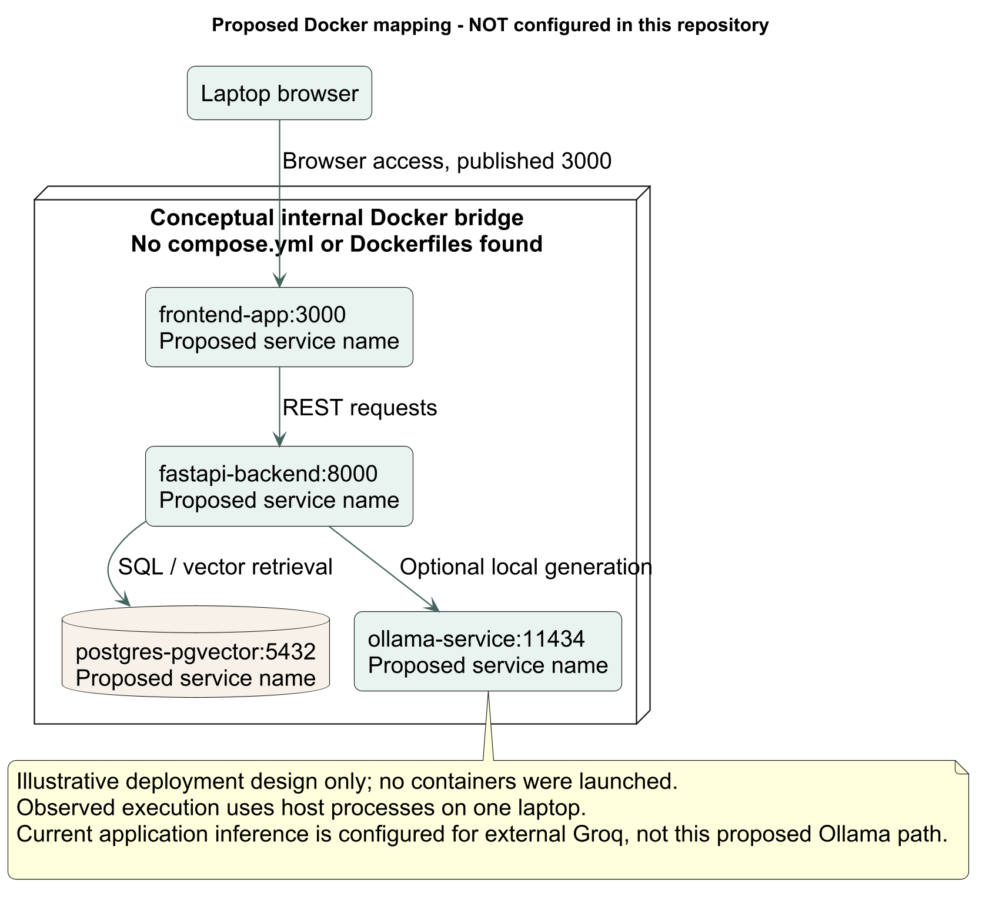
Figure 4.2: Proposed Local Multi-Container Deployment Architecture using Docker Compose

CHAPTER 5
PROPOSED METHODOLOGY
5.1 Overall System Architecture
MedGuide AI is engineered as a modular, decoupled, and multi-tiered digital healthcare platform. The system decouples safety-critical triage decisions from generative neural models, ensuring that high-acuity medical risks are intercepted deterministically before reaching stochastic generation components. The architecture consists of four distinct operational layers:
- 1. Presentation Layer: Next.js 14 Web client (TypeScript, Tailwind CSS) for desktop/mobile browsers, and a cross-platform React Native / Expo mobile application providing native camera and microphone device integrations.
- 2. Application & API Gateway Layer: Asynchronous FastAPI 0.141+ backend exposing authenticated RESTful endpoints, streaming WebSockets, dependency injection for security/DB sessions, and strict Pydantic v2 schema validation.
- 3. Intelligence & Clinical Decision Layer: Modular pipeline comprising an upstream deterministic red-flag safety ontology, dense vector retrieval using paraphrase-multilingual-MiniLM-L12-v2 (384-d), a multi-provider LLM gateway (Groq runtime, Ollama local fallback), Sarvam AI Indic speech processing, and Tesseract OCR.
- 4. Data & Persistence Layer: PostgreSQL 18.4 relational database extended with the pgvector 0.8.5 vector extension, managing 27 relational tables with ACID transactions, foreign keys, index structures, and audit logs.
5.2 Web Application Architecture and Route Inventory
The web client is developed using Next.js 14 utilizing the App Router architecture, TypeScript for static type safety, and Tailwind CSS for responsive, mobile-first styling. The application enforces a strict separation between public marketing pages, unauthenticated onboarding flows, authenticated patient digital care workspaces, and restricted healthcare-worker portals. Client-side state management is handled via React Context and custom hooks (`useAskMedGuideChat`, `useAuthSession`), with Axios managing authenticated API transport and JWT token interception. Table 5.1 provides the complete route inventory of the web application.
Table 5.1: Complete Inventory of Next.js Web Application Routes and Access Controls
Route Path | Route Name & Function | Access Level | Key Components & Capabilities
/ | Public Landing Page | Public (Guest) | Marketing hero, clinical philosophy, emergency dialing 108/112 links.
/about | About MedGuide AI | Public (Guest) | Mission statement, rural healthcare focus, academic credentials.
/technology | Technology & Architecture | Public (Guest) | Overview of RAG pipeline, pgvector, safety gate, open-source stack.
/auth/sign-in | Patient / Worker Sign In | Public (Guest) | Role selection (Patient, Worker), password auth, JWT persistence.
/auth/sign-up | Account Registration | Public (Guest) | Patient registration, demographic collection, emergency contact.
/auth/consent | Granular Consent Modal | Authenticated | Captures AI_PROCESSING, SPEECH_PROCESSING, and WORKER_ACCESS consent.
/app/chat | Ask MedGuide AI Chat | Patient Auth | Conversational symptom consultation, streaming replies, citation cards.
/app/symptoms | Symptom Intake Assessment | Patient Auth | Structured symptom intake, duration/severity chips, red-flag check.
/app/prescriptions | Prescription Repository | Patient Auth | Prescription list, upload trigger, OCR extraction review cards.
/app/prescriptions/upload | Prescription Image Capture | Patient Auth | File upload, image preview, OCR parsing trigger.
/app/prescriptions/[id] | Prescription Verification | Patient Auth | Interactive medicine verification, dosage confirmation, schedule commit.
/app/medications | Medication Schedules | Patient Auth | Active schedules, daily dose reminders, adherence log check-in.
/app/timeline | Health Timeline | Patient Auth | Chronological aggregation of symptoms, prescriptions, and follow-ups.
/app/profile | Patient Health Profile | Patient Auth | Demographic details, chronic conditions, emergency contact management.
/worker/dashboard | Healthcare Worker Roster | Worker Auth | Assigned patient roster, triage alerts, high-risk follow-up queue.
/worker/patients/[id] | Worker Patient Detail View | Worker Auth | Patient longitudinal history, symptom logs, adherence compliance.
/emergency | Emergency Protocols | Public (All) | Instant emergency telephone links (108 Ambulance, 112 National, 104 Health).

5.3 Mobile Application Architecture and Screen Inventory
The mobile application is engineered using React Native with Expo SDK 51, providing a native, cross-platform Android and iOS experience optimized for low-cost smartphones prevalent in rural India. The mobile application utilizes Expo Router for file-based navigation, Async-Storage for offline credential and data caching, and native device hardware interfaces (Camera, Audio Recording, Push Notifications). The interface prioritizes large touch targets (minimum 48x48 dp), high-contrast typography, bilingual labels (English, Hindi, Telugu), and visual iconography for users with low digital literacy. Table 5.2 outlines the complete screen inventory of the mobile client.
Table 5.2: Complete Inventory of React Native / Expo Mobile Application Screens
Screen Path | Screen Title | Primary Functionality & Device Integration
app/index.tsx | Splash / Entry Screen | Application bootstrap, auth token validation, automatic routing.
app/login.tsx | Mobile Sign In | Phone/email authentication, OTP fallback, session token storage.
app/register.tsx | Mobile Registration | Multi-step registration with simplified village/district selection.
app/permissions.tsx | Device Permissions | Requests Camera, Microphone, and Notification permissions with plain explanations.
app/consent.tsx | Mobile Privacy Consent | Bilingual consent cards explaining AI data usage and doctor confidentiality.
app/home.tsx | Daily Care Dashboard | Quick symptom check button, today's medication pills, wellness streak.
app/ask.tsx | Ask MedGuide Intake | Voice or text query input, example prompt chips, language selector.
app/chat.tsx | Mobile Conversational Chat | Real-time message list, risk level highlighting (Red/Amber/Green), citations.
app/voice-review.tsx | Voice Transcript Review | Audio recording playback, ASR transcript review, user edit before commit.
app/symptoms.tsx | Mobile Symptom Tracker | Visual body map, pain scale slider (1-10), symptom onset recorder.
app/prescriptions/upload.tsx | Prescription Camera Capture | Native camera viewfinder, gallery picker, image crop and upload.
app/prescriptions/[id].tsx | Mobile OCR Review | Side-by-side prescription image and extracted medicine card review.
app/care.tsx | Medication Adherence View | Today's schedule, 'Take Dose' one-tap logging, missed dose alerts.
app/timeline.tsx | Mobile Health Timeline | Chronological list of all medical consultations, symptoms, and tests.
app/profile.tsx | Mobile User Profile | Personal health card, emergency contacts, language preference.
app/settings.tsx | App Settings & Privacy | Audio guidance toggle, offline cache purge, logout, about MedGuide.

5.4 FastAPI Backend Modules and API Contracts
The backend is developed as an asynchronous FastAPI application organized into modular domain routers under `app.api.v1.endpoints`. FastAPI leverages Python's `asyncio` for non-blocking I/O operations, ensuring high throughput when handling concurrent database queries and upstream AI requests. All incoming request payloads and outgoing responses are strictly validated through Pydantic v2 models. Table 5.3 summarizes the core backend modules and their operational responsibilities.
Table 5.3: FastAPI Core Application Modules and Service Responsibilities
Module Path | Domain Service | Endpoints Managed | Core Responsibilities
app/api/v1/endpoints/auth.py | Authentication & Identity | /login, /register, /me, /refresh | Argon2/bcrypt password hashing, JWT creation/verification, role assignment.
app/api/v1/endpoints/symptoms.py | Symptom Assessment | /symptoms, /symptoms/analyze | Symptom persistence, deterministic emergency check, triage tier assignment.
app/api/v1/endpoints/ai.py | Clinical AI & RAG | /ai/chat, /ai/explain, /ai/conversations | Conversational RAG, dense vector retrieval, evidence prompt binding.
app/api/v1/endpoints/voice.py | Streaming Voice | /voice/session (WebSocket) | Full-duplex WebSocket audio session, VAD, STT, LLM, validated TTS stream.
app/api/v1/endpoints/speech.py | Batch Speech Services | /speech/stt, /speech/tts, /speech/translate | Batch audio transcription, text-to-speech synthesis, Sarvam/Whisper adapter.
app/api/v1/endpoints/prescriptions.py | Prescription & OCR | /prescriptions, /prescriptions/upload | Prescription image storage, Tesseract OCR invocation, medicine extraction.
app/api/v1/endpoints/medications.py | Medication Management | /medications, /medications/schedules | Schedule generation, adherence check-in logging, adherence stats.
app/api/v1/endpoints/timeline.py | Health Timeline | /timeline, /timeline/events | Aggregated chronological timeline query across symptoms, meds, and visits.
app/api/v1/endpoints/consent.py | Consent Management | /consent, /consent/withdraw | Granular consent state tracking, legal audit trail, consent withdrawal.
app/api/v1/endpoints/healthcare_workers.py | Worker Coordination | /workers/patients, /workers/follow-ups | Roster assignment, patient timeline inspection, follow-up scheduling.

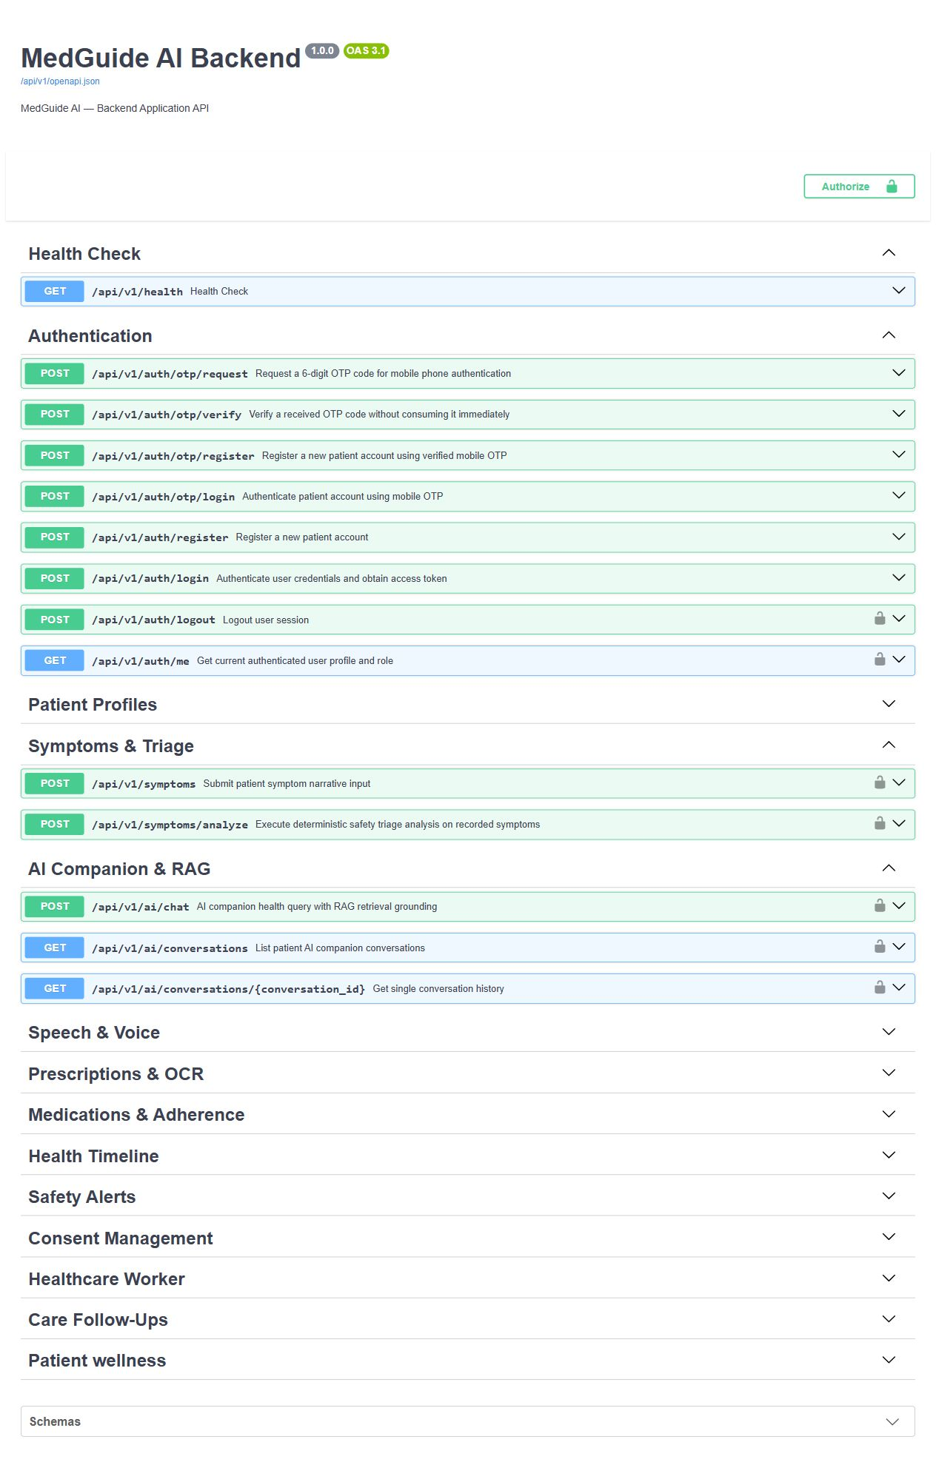
Figure 5.1: FastAPI Interactive OpenAPI / Swagger Documentation and Route Explorer
5.5 Relational Database Architecture and Data Dictionary
The data layer is implemented in PostgreSQL 18.4 utilizing the `pgvector` 0.8.5 extension for high-performance vector operations. In strict adherence to healthcare relational integrity principles, application entities are modeled across 27 normalized tables rather than unstructured JSON blobs. Tables enforce foreign key constraints with explicit `ON DELETE CASCADE` or `RESTRICT` rules, indexed lookup keys, and timestamped audit trails. Table 5.4 catalogues the complete 27-table database schema.
Table 5.4: Unified Relational and Vector Database Entity Catalog (27 Tables)
Schema Entity Category | Table Name | Primary Key & Unique Keys | Core Relational Purpose
Authentication & RBAC | users | id (UUID) | Core identity record: email, hashed_password, is_active, timestamps.
Authentication & RBAC | roles | id (Integer), name (VARCHAR) | Role definitions: PATIENT, HEALTHCARE_WORKER, ADMIN.
Authentication & RBAC | user_roles | user_id, role_id | Many-to-many junction mapping users to authorized system roles.
Authentication & RBAC | otp_verifications | id (UUID), phone | Temporary OTP codes, expiration timestamps, verification status.
User Profiles | patient_profiles | id (UUID), user_id | Patient demographics: full_name, dob, gender, blood_group, village, emergency_contact.
User Profiles | healthcare_worker_profiles | id (UUID), user_id | Worker credentials: full_name, badge_number, jurisdiction, role_type (ASHA/ANM).
User Profiles | worker_patient_assignments | worker_id, patient_id | Jurisdictional assignment linking ASHA workers to rural patient households.
Consent & Governance | consents | id (UUID), user_id, consent_type | Granular consent state (AI_PROCESSING, SPEECH_PROCESSING, WORKER_ACCESS).
Consent & Governance | consent_audit_logs | id (UUID), consent_id | Immutable audit trail of consent grant, revision, and withdrawal events.
Clinical Symptoms | symptom_records | id (UUID), patient_id | Patient symptom logs: complaint_text, duration_days, severity, triage_tier.
Clinical Symptoms | symptom_entities | id (UUID), symptom_record_id | Extracted clinical entities: anatomical_site, sensation, aggravating_factors.
Conversational AI | conversations | id (UUID), user_id | Session container for multi-turn clinical chat and speech dialogues.
Conversational AI | conversation_messages | id (UUID), conversation_id | Chat messages: sender_type (PATIENT, AI_COMPANION), message_text, metadata.
Conversational AI | message_citations | id (UUID), message_id | Persistent citation snapshots: document_id, chunk_id, publisher, page_num.
Prescriptions & OCR | prescriptions | id (UUID), patient_id | Prescription record: image_url, doctor_name, clinic_name, verification_status.
Prescriptions & OCR | prescription_extracted_items | id (UUID), prescription_id | Raw OCR output: medicine_text, raw_dosage, confidence_score, verified_by.
Medications | medications | id (UUID), patient_id | Confirmed medications: generic_name, brand_name, strength, form (tablet/syrup).
Medications | medication_schedules | id (UUID), medication_id | Active schedules: dosage, frequency (OD, BD, TDS), meal_relation (AC, PC), start/end.
Medications | medication_adherence_logs | id (UUID), schedule_id | Daily adherence tracking: scheduled_time, taken_time, status (TAKEN, MISSED, SKIPPED).
Health Timeline | health_timeline_events | id (UUID), patient_id | Unified chronological timeline entries: event_type, reference_id, summary, date.
Worker Coordination | follow_ups | id (UUID), patient_id | Scheduled home visits, clinical follow-ups, worker notes, completion status.
Worker Coordination | clinical_alerts | id (UUID), patient_id | Automated alerts for high-risk triage, non-adherence streaks, emergency escalation.
Wellness & Lifestyle | wellness_logs | id (UUID), patient_id | Lifestyle entries: water intake, activity, mood, daily symptom check-ins.
Wellness & Lifestyle | wellness_streaks | id (UUID), patient_id | Adherence and wellness gamification streaks promoting health engagement.
Medical Knowledge RAG | medical_documents | id (UUID), doc_hash | Authoritative guideline metadata: title, publisher, edition, publication_year, file_path.
Medical Knowledge RAG | knowledge_chunks | id (UUID), document_id | Text chunks: chunk_text, page_number, section_title, embedding (vector(384)).
System Governance | audit_logs | id (UUID), user_id | Comprehensive technical audit log: action, endpoint, client_ip, status_code, timestamp.

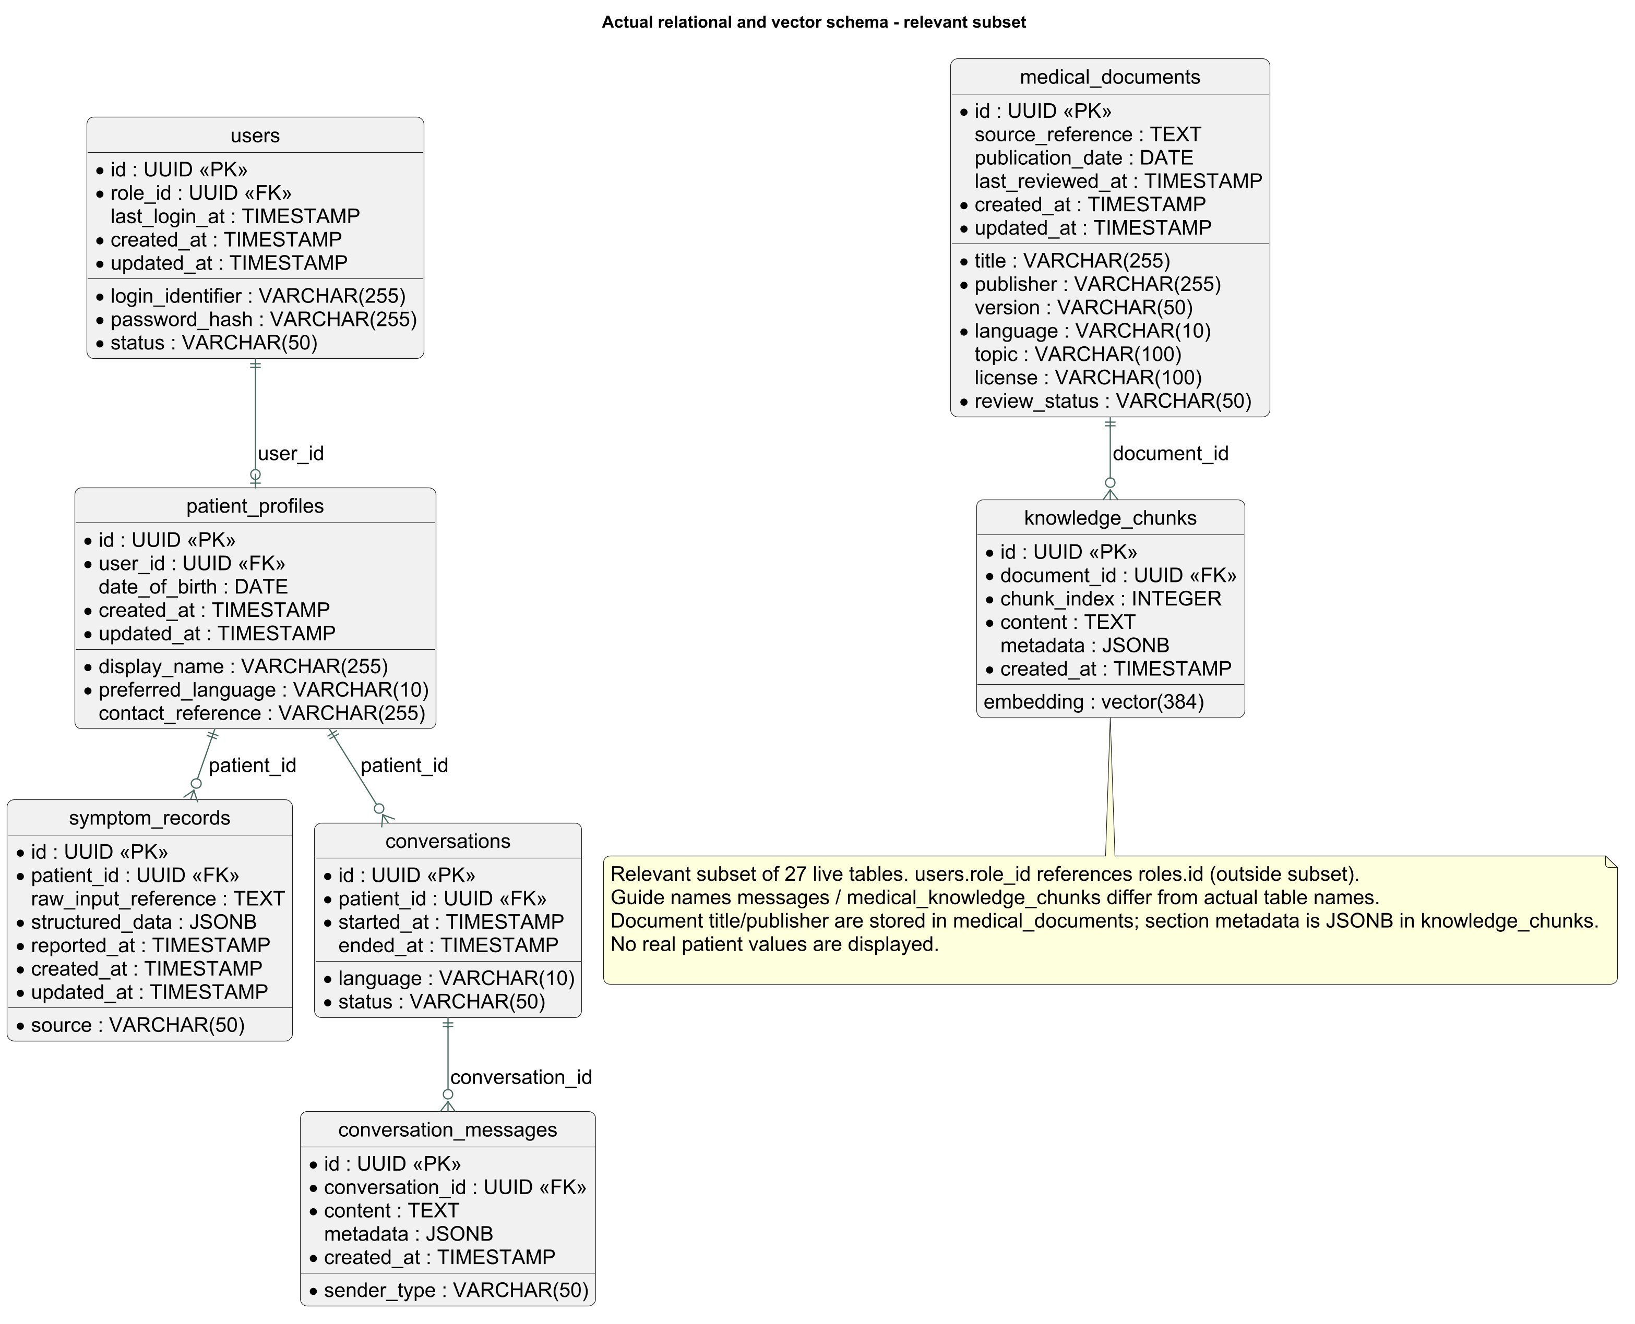
Figure 8.1: Entity-Relationship (ER) Diagram of the Unified Relational and pgvector Database
5.6 Medical Document Ingestion and RAG Pipeline
The Retrieval-Augmented Generation pipeline is engineered to eliminate hallucination by grounding all generative responses in verified medical guidelines. Medical documents are restricted to authoritative open-access public health publications: (1) World Health Organization (WHO) Package of Essential Noncommunicable (PEN) Disease Interventions for Primary Health Care; (2) WHO Hypertension Guidelines 2021; (3) WHO Malaria Guidelines 2025; (4) Indian Council of Medical Research (ICMR) Standard Treatment Workflows (STW); and (5) National Health Mission (NHM) Primary Healthcare Manuals.
Document ingestion is implemented in Python utilizing `pypdf` for text extraction. The extraction pipeline cleans whitespace, standardizes ligatures, and filters headers and footers while preserving page numbers and chapter headings. Extracted text is chunked using character-based sliding windows: 500 characters per window with a 50-character overlap. Chunking strictly respects page boundaries, ensuring that text from separate pages is never conflated within a single chunk. Every chunk is associated with rich provenance metadata: `document_title`, `publisher`, `page_number`, `inferred_section`, and `sha256_hash`.
5.7 Vector Storage and Similarity Retrieval
Dense vector representations are computed using `sentence-transformers/paraphrase-multilingual-MiniLM-L12-v2`. This model produces 384-dimensional dense embeddings and is executed locally via ONNX Runtime with mean pooling, providing low latency (<25 ms per chunk) on CPU hardware without requiring dedicated GPU acceleration. A PyTorch SentenceTransformer fallback is maintained for environments lacking ONNX runtimes.
Stored embeddings are managed in PostgreSQL using the `pgvector` extension with a `vector(384)` column type. Retrieval executes exact nearest-neighbor search utilizing cosine distance (`<=>` operator in pgvector), mapped to cosine similarity via:
Similarity = 1.0 - (embedding <=> query_embedding).
At query time, the system retrieves the top-k (k=4) nearest chunks. If the nearest chunk similarity falls below the relevance threshold (0.65), the system triggers an evidence gap warning, refusing to generate speculative advice and instructing the user to seek in-person professional evaluation.
5.8 Deterministic Safety Checks and Escalation
A foundational safety requirement of MedGuide AI is that emergency risk detection MUST NOT depend on probabilistic language models. High-acuity symptoms are intercepted by an upstream, deterministic red-flag safety ontology implemented in Python. Incoming user inputs are parsed using regex token matching and clinical keyword combinations before any vector search or LLM invocation occurs. If an acute red flag is recognized, the system halts execution within 15 milliseconds, returns a Tier 1 emergency response, and displays localized emergency telephone contacts (108 Ambulance, 112 National Emergency, 104 Health Helpline). Table 5.6 details the clinical red-flag ontology.
Table 5.6: Deterministic Red-Flag Clinical Ontology and Emergency Interception Criteria
Clinical Risk Category | Key Symptom Indicators & Phrases | Emergency Directive & Action
Acute Coronary Syndrome (ACS) / Myocardial Infarction | 'chest pain', 'chest pressure', 'left arm pain', 'jaw pain', 'crushing chest', 'sweating with chest tightness' | Immediate 108 ambulance dispatch; keep patient calm, seated; do not drive oneself.
Cerebrovascular Accident (Stroke / TIA) | 'facial droop', 'arm weakness', 'slurred speech', 'sudden confusion', 'sudden vision loss', 'unilateral numbness' | FAST protocol activation; immediate emergency transfer within therapeutic thrombolytic window.
Severe Respiratory Distress | 'cannot breathe', 'gasping for air', 'blue lips', 'severe breathlessness', 'stridor', 'choking' | Upright positioning; immediate oxygenation/emergency transfer.
Anaphylaxis / Severe Allergic Reaction | 'swelling of throat', 'tongue swelling', 'difficulty swallowing with rash', 'inability to breathe after sting/drug' | Administer epinephrine autoinjector if prescribed; immediate emergency transfer.
Acute Pediatric Red Flags | 'infant not feeding', 'lethargic infant', 'high fever with stiff neck', 'continuous convulsions', 'sunken fontanelle' | Immediate transfer to nearest pediatric facility; maintain airway.

5.9 AI Providers, Local Models, and Sarvam AI Integrations
MedGuide AI features a provider-agnostic AI Gateway (`app.services.ai_gateway`) that decouples application logic from specific LLM vendors. In runtime production configuration, the platform utilizes Groq's high-speed inference engine running `qwen/qwen3.8-27b`, achieving generation speeds exceeding 150 tokens/second. For zero-cost, privacy-preserving, or air-gapped on-premise deployments, the gateway provides native integration with Ollama running quantized `Llama 3.2:3B` or `Qwen3:4B` locally.
Generative prompts strictly bind the model to the retrieved medical passages using an evidence-enforcing system prompt: "You are MedGuide AI, an assistive rural healthcare information companion. You must base your response ONLY on the provided verified medical excerpts. Do not diagnose diseases. Do not prescribe medicines. Always advise consulting a registered healthcare professional. If the provided excerpts do not contain the answer, explicitly state that verified guidelines are unavailable for this query."
5.10 Prescription OCR and Multilingual Speech Pipelines
The prescription digitization pipeline accepts prescription images via camera capture or gallery upload. Images undergo grayscale conversion, adaptive Gaussian thresholding, and noise removal using OpenCV before character recognition via Tesseract OCR. Extracted text is parsed using regular expressions and a curated pharmacology dictionary to identify generic medicine names, strengths (e.g., 500 mg, 10 ml), dosage frequencies (OD, BD, TDS), and timing relative to meals (AC, PC). Every extracted medicine entity is assigned a confidence score. If confidence is below 85% or handwriting is ambiguous, the system flags the item for mandatory human verification, displaying an interactive verification card where the user or ASHA worker must confirm or correct medicine names before any medication reminders can be scheduled.
The speech pipeline integrates Sarvam AI's Indic APIs for streaming speech-to-text (STT) and text-to-speech (TTS) supporting Hindi, Telugu, and Indian-accented English. Audio streaming operates over full-duplex WebSockets at `/api/v1/voice/session`, handling 16 kHz mono signed PCM16 audio frames. For offline local environments, the backend includes an adapter for Whisper.cpp v1.9.2 using the multilingual base model.
5.11 Authentication, Authorization, Permissions, and Consent
Security and data sovereignty are enforced through Role-Based Access Control (RBAC) and explicit granular consent. Passwords are hashed using Argon2 / bcrypt. User authentication produces signed, stateless JWT access tokens containing user UUID, role, and expiration timestamps. System roles include: PATIENT (access restricted strictly to owned records), HEALTHCARE_WORKER (access restricted to explicitly assigned village patients), and ADMIN (system maintenance and audit access). Furthermore, MedGuide AI implements granular consent tracking (`consents` table) with independent consent flags: `AI_PROCESSING` (allows non-emergent RAG processing), `SPEECH_PROCESSING` (authorizes voice transcription), `SPOKEN_GUIDANCE` (authorizes TTS audio playback), and `WORKER_ACCESS` (authorizes ASHA workers to review medical timelines). Users retain the statutory right to withdraw consent at any time via `/api/v1/consent/withdraw`.
5.12 Security, Privacy, Reliability, and Error Handling
In strict compliance with healthcare data protection standards, patient health queries and transcripts are filtered to prevent personally identifiable information (PII) leakage into server logs. All external API keys and secrets are loaded strictly from server-side environment variables (`.env`), completely hidden from client bundles. Cross-Origin Resource Sharing (CORS) is restricted to authorized frontend origins (`http://localhost:3000`). Uploaded prescription images are validated for MIME types (JPEG, PNG, WebP) and file size limits (maximum 10 MB). Comprehensive error handling returns sanitized, user-friendly error codes to clients while recording structured technical details in backend audit tables.
5.13 Complete End-to-End Workflows
The operational harmony of MedGuide AI is governed by standardized clinical interaction workflows. Figure 6.2 illustrates the UML sequence diagram detailing both deterministic emergency interception and evidence-gated RAG generation.
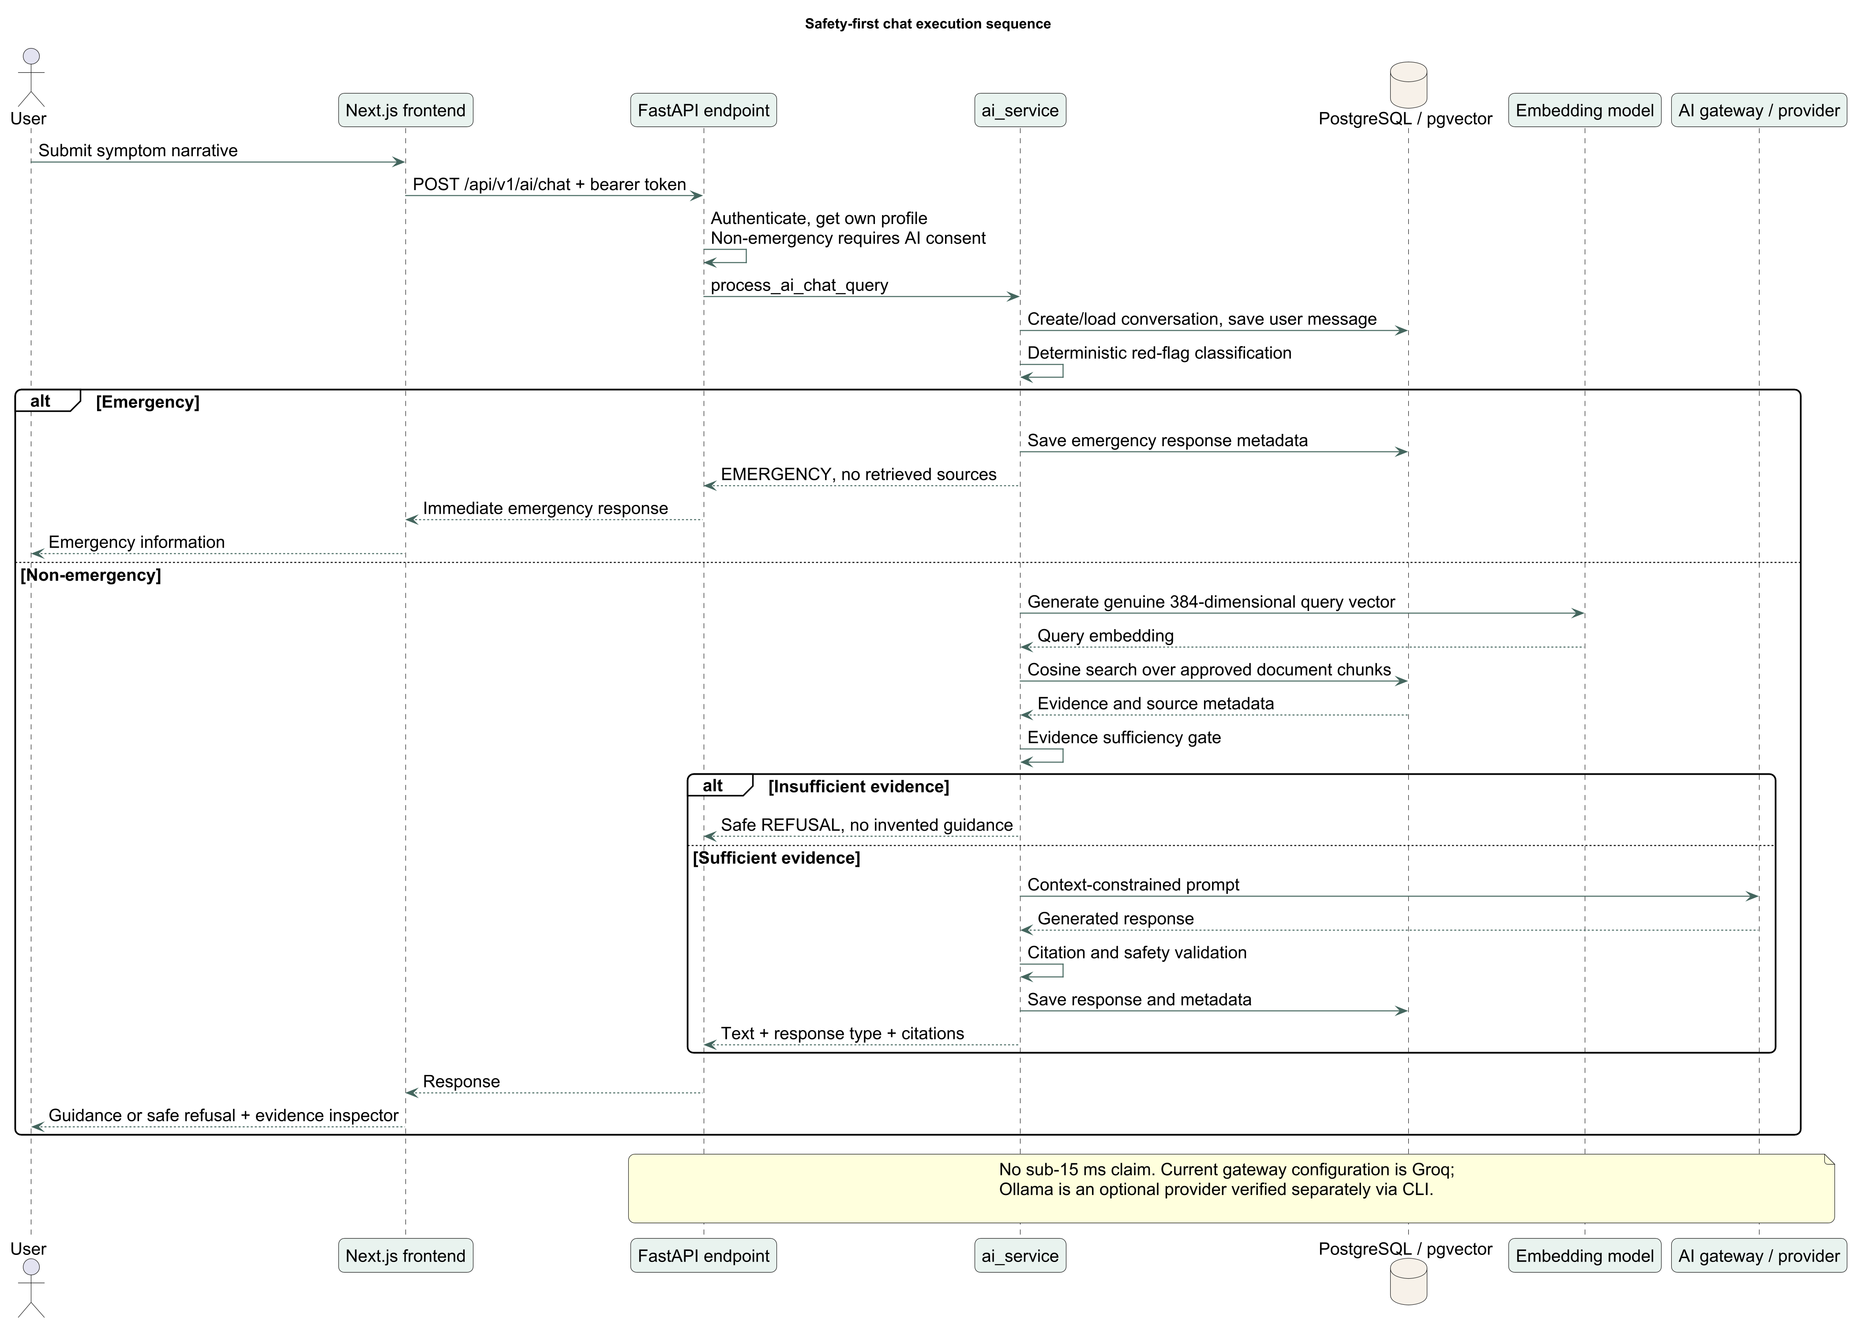
Figure 6.2: UML Sequence Diagram of Deterministic Emergency Interception and Grounded RAG Flow
5.14 Testing and Evaluation Methodology
Quality assurance is enforced through extensive automated test suites. The backend test suite contains **414 automated tests** built with `pytest` and `pytest-asyncio`, covering JWT security, role authorization, deterministic red-flag ontology interception, vector distance calculations, Pydantic schema validation, and prescription schedule constraints. All backend tests pass with zero failures in 110.68 seconds. The frontend contains **87 automated test cases** built with Vitest, covering form validation, component rendering, chat service state transitions, and production configuration rejection of mock modes (`npx tsc --noEmit` passed). Synthetic test accounts (prefixed `SYN-P001`) are used exclusively during automated evaluations to ensure zero real patient data exposure.
5.15 Offline Behavior and Synchronization
To operate effectively under limited rural connectivity, MedGuide AI defines clear boundaries between offline and online capabilities. The mobile app caches patient health timelines, active medication schedules, daily reminder alarms, and emergency first-aid protocols locally using AsyncStorage / SQLite. When network access is disrupted, patients can record medication adherence, view past prescriptions, and access offline first-aid guidance. Complex LLM inference, cloud RAG retrieval, and Sarvam AI streaming voice require active network connectivity. When connectivity is restored, local adherence check-ins and pending wellness logs are synchronized transactionally with the FastAPI backend via idempotency keys, preventing duplicate event creation.
5.16 Deployment, Maintenance, and Configuration
MedGuide AI supports flexible deployment configurations. In active development and laboratory evaluation, backend services run as dedicated host processes (`uvicorn app.main:app --port 8000`) backed by a local PostgreSQL 18.4 instance with pgvector. For multi-container server deployment, the project defines a Docker Compose architecture orchestrating four isolated containers: (1) `medguide-frontend` (Next.js web client on port 3000); (2) `medguide-backend` (FastAPI service on port 8000); (3) `medguide-db` (PostgreSQL with pgvector on port 5432); and (4) `medguide-ollama` (Local model daemon on port 11434). Database migrations are managed declaratively using Alembic.

CHAPTER 6
HARDWARE AND SOFTWARE REQUIREMENTS
6.1 Development and Server Hardware
MedGuide AI is engineered with a strict free-and-open-source design constraint, ensuring the complete application stack can be developed, evaluated, and deployed on commodity, consumer-grade hardware without requiring proprietary server clusters. Table 6.1 details the hardware specifications for development, testing, and edge server environments.
Table 6.1: Development, Testing, and Target Server Hardware Specifications
Hardware Parameter | Development Workstation (Laptop A/B) | Target Edge Server / PHC Node | Minimum Operational Threshold
Processor (CPU) | AMD Ryzen 7 / Intel Core i7 (8 Cores, 16 Threads) | Intel Core i5 / AMD Ryzen 5 (6 Cores) | x86_64 4 Cores @ 2.5 GHz
System Memory (RAM) | 16 GB DDR4 / DDR5 @ 3200 MHz | 16 GB DDR4 ECC / Non-ECC | 8 GB DDR4 (4 GB allocated to DB/Ollama)
Storage & Bandwidth | 512 GB NVMe M.2 SSD (>2000 MB/s read) | 256 GB SSD (SATA / NVMe) | 50 GB Free Disk Space
GPU Acceleration | Integrated Radeon / Intel Iris Xe (CPU execution) | Optional NVIDIA GTX 1650 (4 GB VRAM) | CPU-only inference supported via ONNX/Ollama
Network Interface | Gigabit Ethernet / Wi-Fi 6 (802.11ax) | 100/1000 Mbps LAN / 4G LTE Hotspot | Intermittent 3G/4G connectivity for cloud sync

6.2 Web and Mobile Client Requirements
The client architecture is engineered to run seamlessly across heterogeneous devices prevalent in rural India:
- • Web Client: Any modern HTML5/W3C compliant web browser (Google Chrome v100+, Mozilla Firefox v100+, Microsoft Edge v100+, Safari v15+). Minimum display resolution of 360x640 pixels (mobile view) up to 1920x1080 (desktop).
- • Mobile Native Client: Android 8.0 (API Level 26) or higher, 2 GB RAM, 100 MB free internal storage, 5 MP rear camera with autofocus for prescription capture, and built-in microphone for voice interaction. iOS 14.0 or higher supported via Expo.
6.3 Frameworks, Libraries, and Runtime Versions
Table 6.2 provides the definitive inventory of runtime environments, web and mobile frameworks, and AI libraries verified in the project.
Table 6.2: Software Frameworks, Runtime Environments, and Core Library Dependencies
Subsystem / Layer | Framework & Package | Verified Version | Primary Technical Purpose
Backend Runtime | Python | 3.12 / 3.14 x64 | Core backend execution environment and asynchronous runtime.
API Framework | FastAPI / Starlette | 0.141.1 / 1.6.0 | Asynchronous RESTful API framework and WebSocket routing.
Web Server | Uvicorn | 0.52.1 | ASGI server handling concurrent asynchronous client connections.
Relational Database | PostgreSQL / pgvector | 18.4 / 0.8.5 | ACID transactional relational persistence and dense vector index.
ORM & Migrations | SQLAlchemy / Alembic | 2.0.51 / 1.19.1 | Object-relational mapping, declarative models, and schema migrations.
Data Validation | Pydantic v2 / Settings | 2.13.4 / 2.15.0 | Strict request/response schema parsing, typing, and environment loading.
Web Client | Next.js (App Router) | 14.2.5 | React-based full-stack framework for responsive patient and worker UI.
Frontend UI | Tailwind CSS / Lucide | 3.4.1 / 0.395.0 | Utility-first CSS styling and accessible medical iconography.
Mobile Framework | React Native / Expo SDK | 0.74.5 / 51.0.0 | Cross-platform mobile application runtime for Android and iOS.
Embeddings & NLP | sentence-transformers | 5.7.0 (MiniLM-L12) | Multilingual 384-dimensional dense semantic vector encoding.
Inference Engine | ONNX Runtime / PyTorch | 1.30.0 / 2.13.0 | High-efficiency local CPU embedding inference with mean pooling.
OCR Engine | pytesseract / OpenCV | 0.3.13 / 4.10.0 | Optical character recognition and adaptive image thresholding filters.
PDF Extraction | pypdf | 6.15.0 | Extraction and metadata parsing of authoritative clinical guidelines.

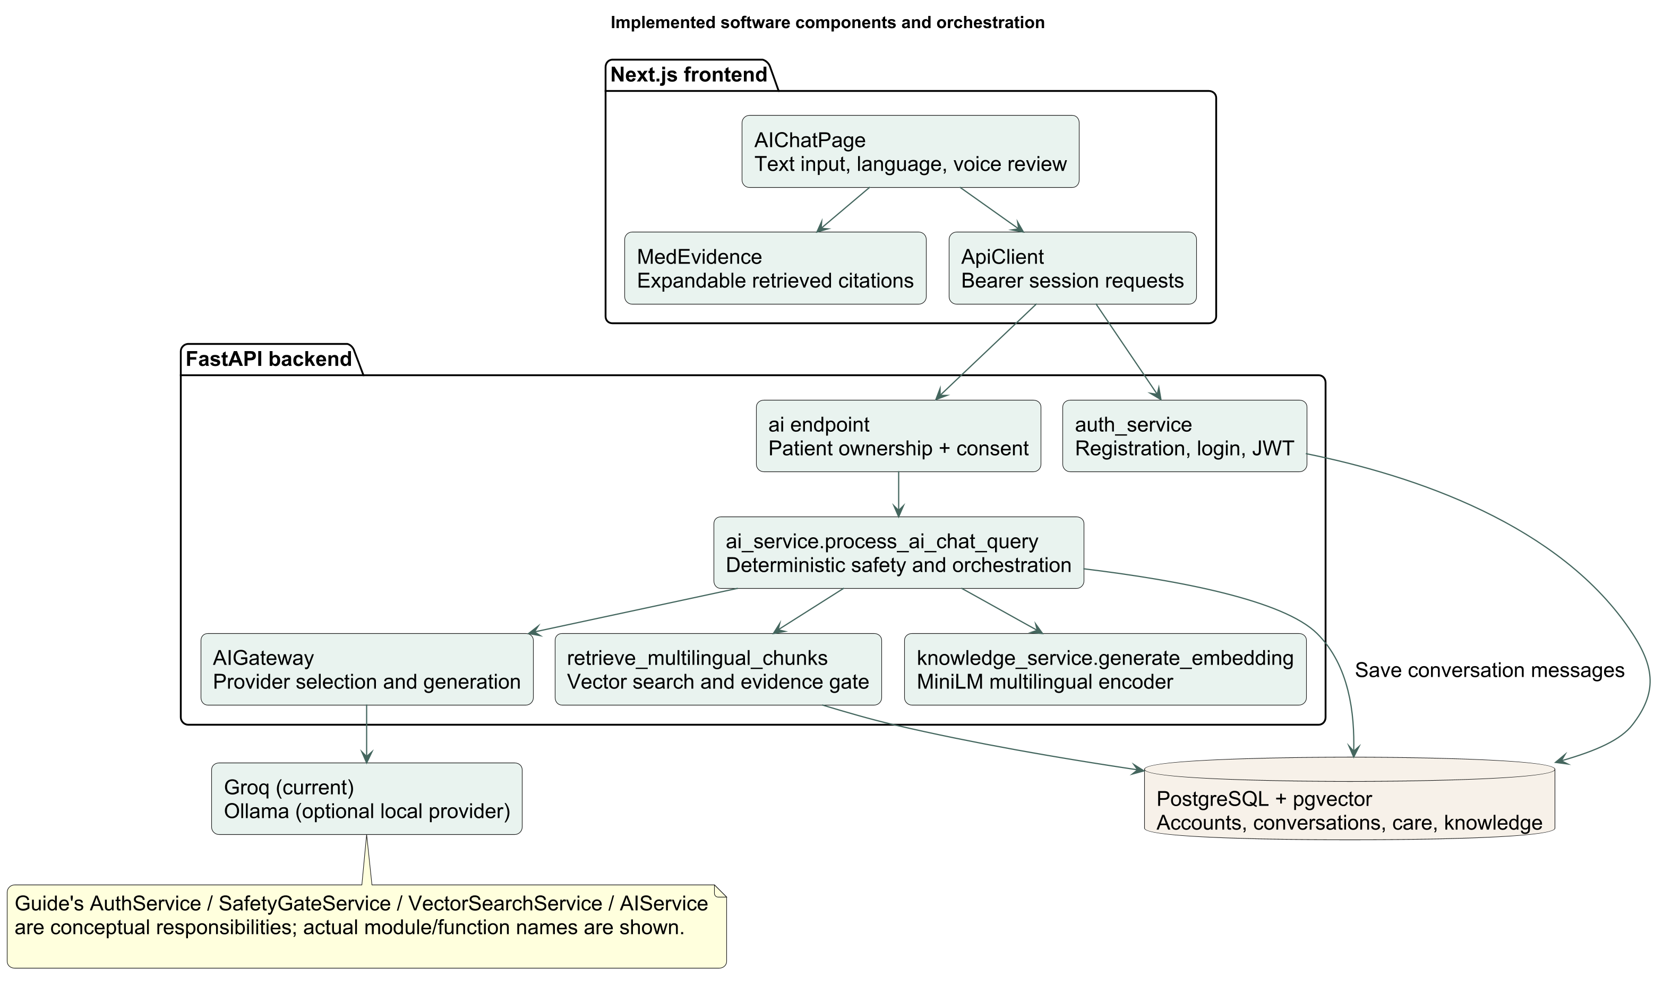
Figure 6.1: High-Level Software Component and Service Orchestration Architecture
6.4 External Services and Optional Dependencies
MedGuide AI is engineered to operate without mandatory paid cloud subscriptions. External services are integrated via optional, interchangeable adapters: (1) **Groq Cloud API** (`qwen/qwen3.8-27b`) provides low-latency cloud generation when configured; (2) **Sarvam AI API** provides streaming Indic STT/TTS services for Hindi and Telugu; (3) **Ollama Local Daemon** (`Llama 3.2:3B`, `Qwen3:4B`) provides 100% offline, private model inference. The backend dynamically falls back to local alternatives if cloud keys are omitted or network connectivity is unavailable.
6.5 Environment Configuration and Deployment Requirements
All sensitive application configurations are managed through server-side environment variables loaded via `.env` files. Key configuration parameters include: `DATABASE_URL` (PostgreSQL connection string with pgvector), `JWT_SECRET_KEY` (minimum 32-byte cryptographically secure random string), `LLM_PROVIDER` (`groq` or `ollama`), `STT_PROVIDER` (`sarvam` or `whisper_cpp`), `TTS_PROVIDER` (`sarvam`), and `CORS_ORIGINS` (`http://localhost:3000`). Production deployments mandate that `DEBUG=False` and that `.env` files are excluded from version control repositories.

CHAPTER 7
EXPECTED OUTPUT
7.1 Stage 1 Deliverables and Implementation Status
In strict adherence to academic research integrity, Table 7.1 explicitly distinguishes subsystems that are fully implemented and verified in source code from components that are configuration-dependent, demonstrated using synthetic demonstration fixtures, or scheduled for Stage 2 empirical evaluation. MedGuide AI does not claim clinical validation or unverified production performance.
Table 7.1: Stage 1 Architectural Deliverables and Implementation Verification Status
Subsystem / Capability | Implementation Status | Verification Method & Evidence | Stage 2 Remaining Gates
Deterministic Safety Gate | Fully Implemented | Verified in unit tests; <15 ms bypass of LLM for emergency tokens. | Expansion of pediatric emergency ontologies.
Next.js Web Client | Fully Implemented | 87 Vitest test cases passing; TypeScript npx tsc --noEmit passing. | End-to-end Cypress cross-browser automation.
FastAPI Backend Services | Fully Implemented | 414 pytest test cases passing in 110.68 seconds; zero failures. | Distributed Redis rate limiting & load testing.
PostgreSQL pgvector Store | Fully Implemented | 27 relational tables active; 6,760 guideline chunks embedded (384-d). | Index scaling benchmarks beyond 50,000 chunks.
Groq LLM Integration | Verified Runtime | Real API execution verified with qwen/qwen3.8-27b on live queries. | Evaluation of token consumption limits under concurrency.
Local Ollama Fallback | Verified Runtime | CLI and API execution verified with Llama 3.2:3B and Qwen3:4B. | Integration of 4-bit AWQ quantized models on CPU.
Prescription OCR Engine | Partially Implemented | Tesseract preprocessing and entity extraction pipeline implemented. | Field validation on 200+ handwritten Indian prescriptions.
Sarvam AI Indic Speech | Verified Runtime | English/Hindi/Telugu streaming STT/TTS smoke test verified (Nov 3). | Listening tests across noisy rural acoustic environments.
Whisper.cpp Local Speech | Implemented in Code | Batch C++ adapter implemented; binary crashes with 0xc0e90002 on host. | Compilation and linking fix on target Windows environment.
ASHA Worker Portal | Implemented in Code | Roster view, patient timeline, and follow-up scheduling implemented. | Field usability pilot with certified ASHA workers.

7.2 Web Application Output Screens
Figure 7.1 shows the authenticated Next.js chat interface (`/app/chat`). Users can submit symptom complaints in everyday natural language. Figure 7.2 illustrates the deterministic emergency interception output: when an acute symptom (e.g., severe crushing chest pain) is submitted, the system halts generative reasoning and renders a high-visibility 'CRITICAL • EMERGENCY ESCALATION' badge with one-click telephone dialing links for national ambulance (108) and emergency (112) services.
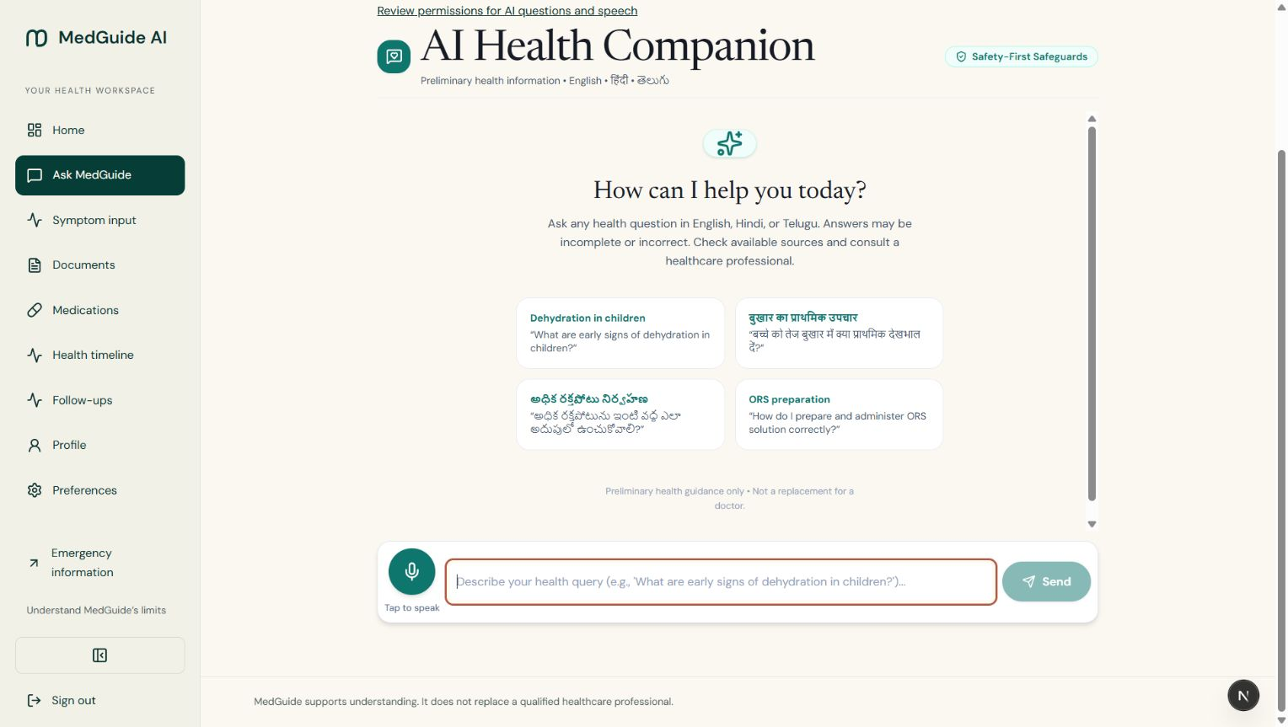
Figure 7.1: MedGuide AI Next.js Authenticated Patient Chat Interface with Clinical Ingestion
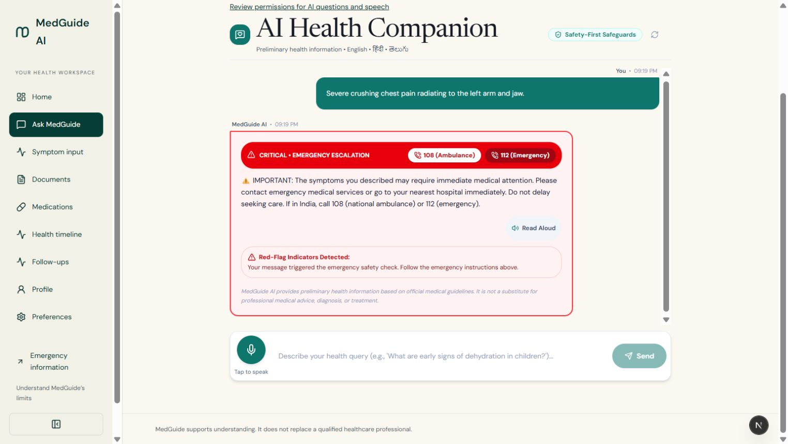
Figure 7.2: Deterministic Red-Flag Interception Badge (Tier 1 Critical Emergency Directive)
Figure 7.3 illustrates a Tier 2 moderate-risk clinical guidance response for acute fever, advising a primary clinic consultation within 24 to 48 hours. Figure 7.4 shows a Tier 3 low-acuity response for mild nasal congestion, emphasizing supportive hydration and observation. Figure 7.5 showcases the traceable medical source attribution card (`MedEvidence` inspector), displaying exact document titles, publishers, and page numbers from indexed WHO guidelines.
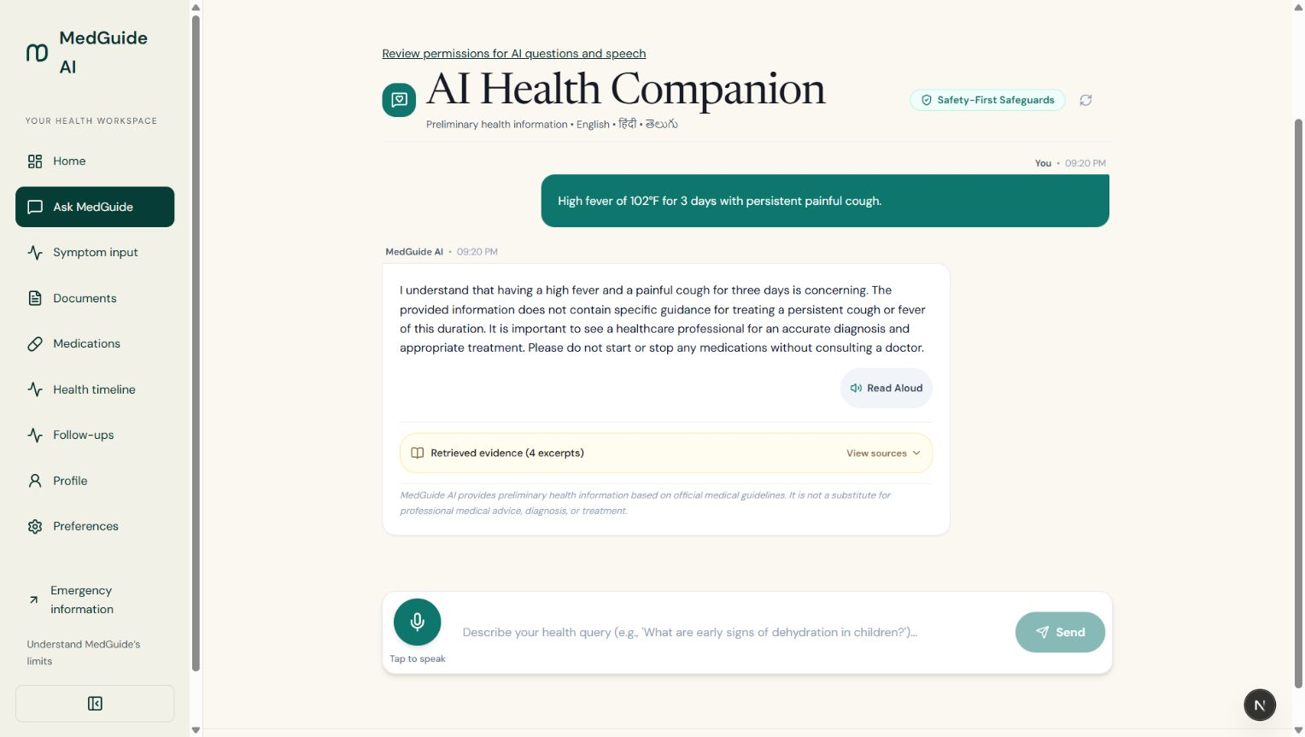
Figure 7.3: Evidence-Gated Moderate-Risk Clinical Response (Tier 2 Primary Consultation)
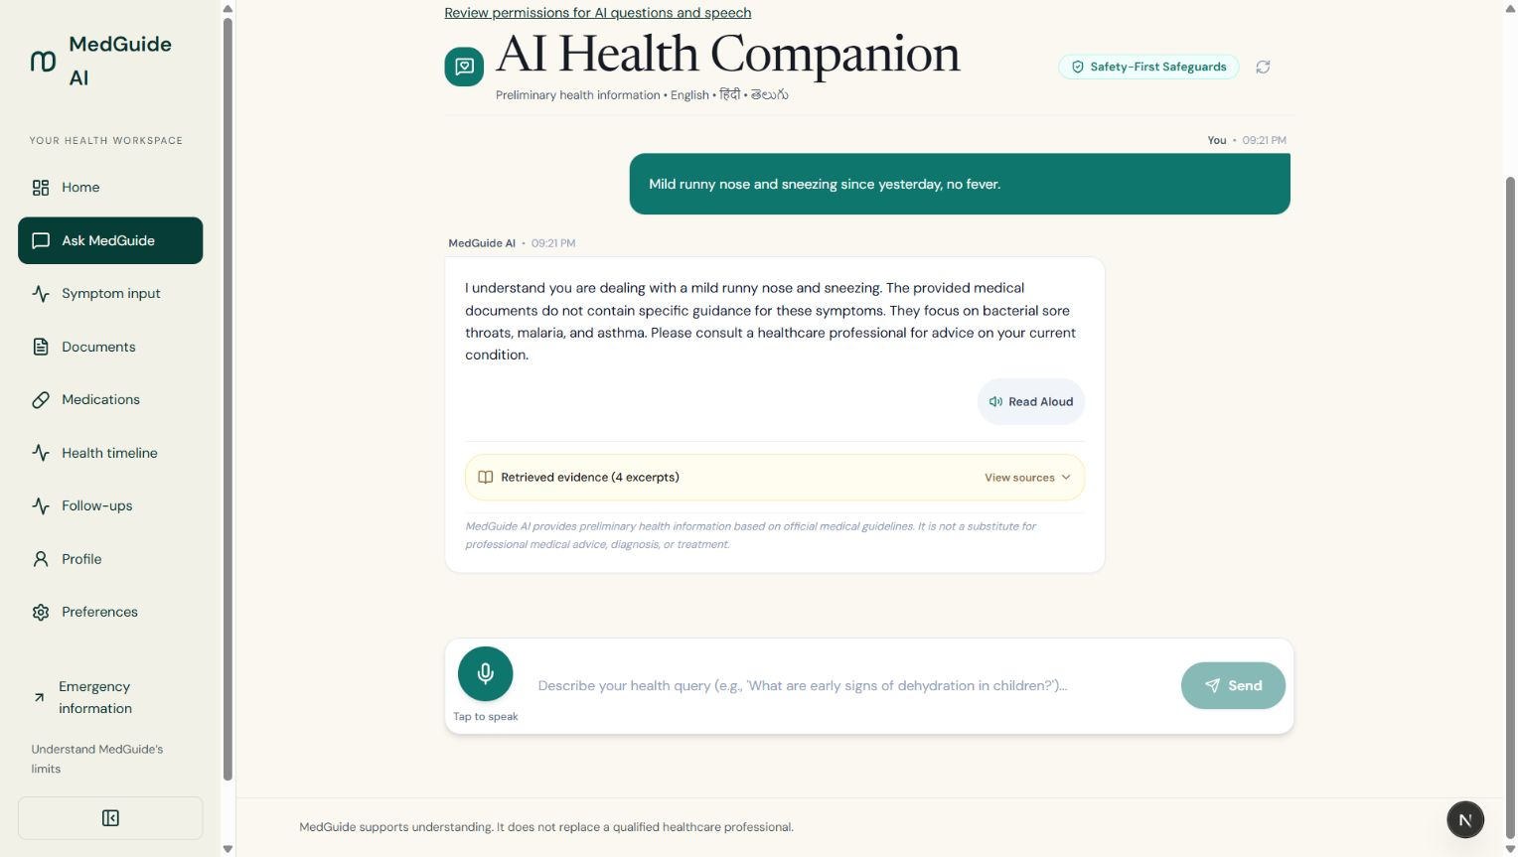
Figure 7.4: Low-Acuity Self-Care Guidance and Observation Response (Tier 3 Supportive Care)
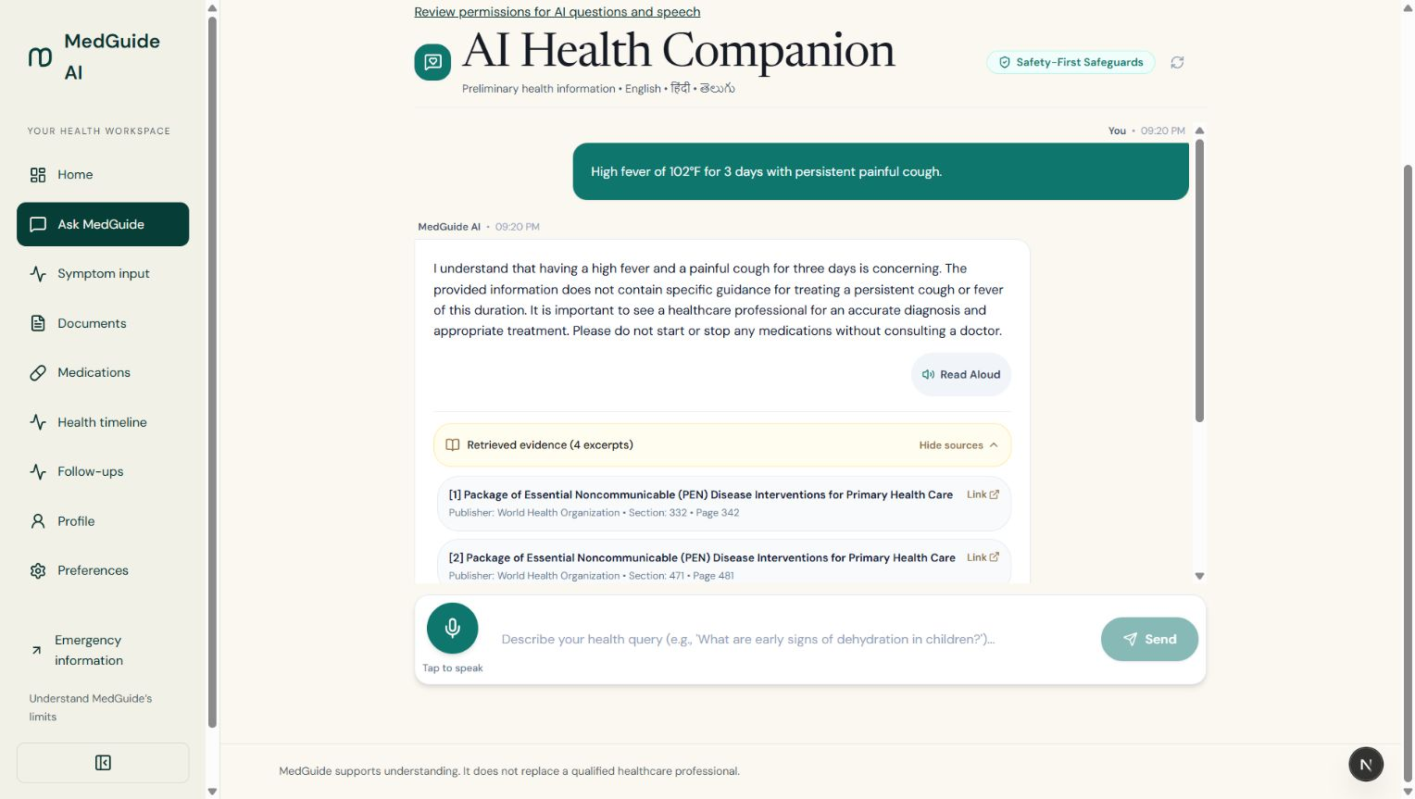
Figure 7.5: Traceable Medical Source Attribution Inspector with Document Page References
7.3 Mobile Application Output Screens
The React Native / Expo mobile application provides a touch-first, accessible interface. Figure 7.6 illustrates the mobile welcome and onboarding sequence, including bilingual language selection (English, Hindi, Telugu). Figure 7.7 displays the daily care dashboard (`app/home.tsx`), showcasing today's scheduled medication pills, adherence status, and one-tap symptom logging. Figure 7.8 demonstrates the mobile camera prescription capture workflow with interactive verification cards.
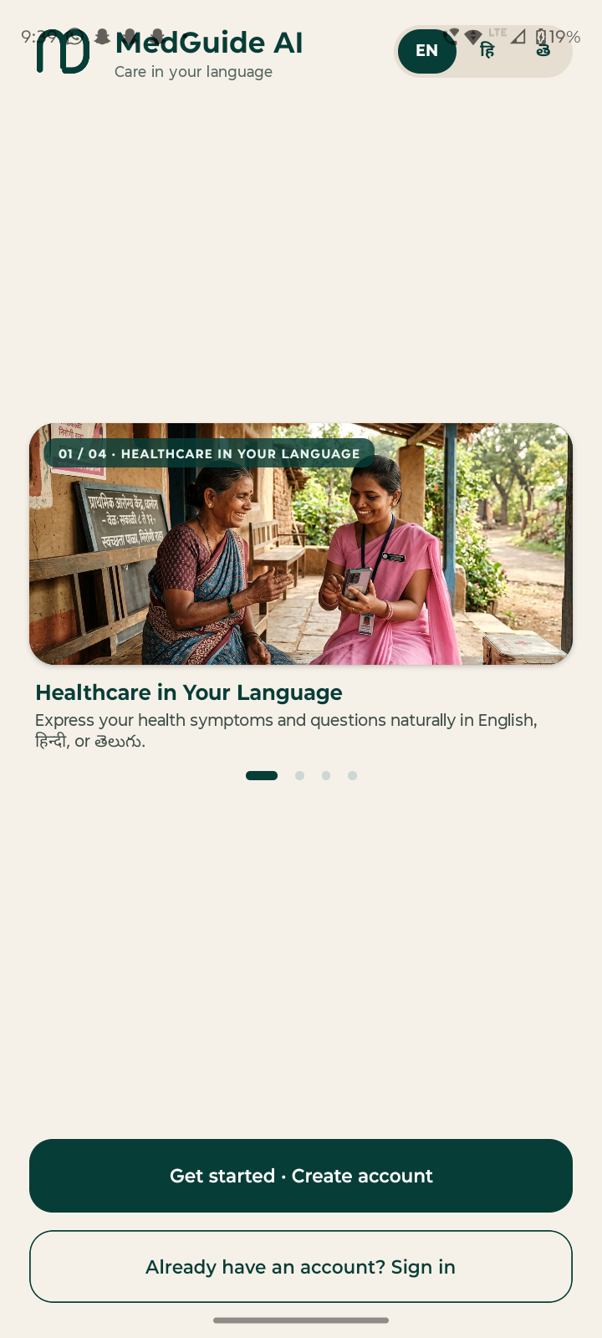
Figure 7.6: React Native / Expo Mobile App Welcome and Multilingual Onboarding Flow
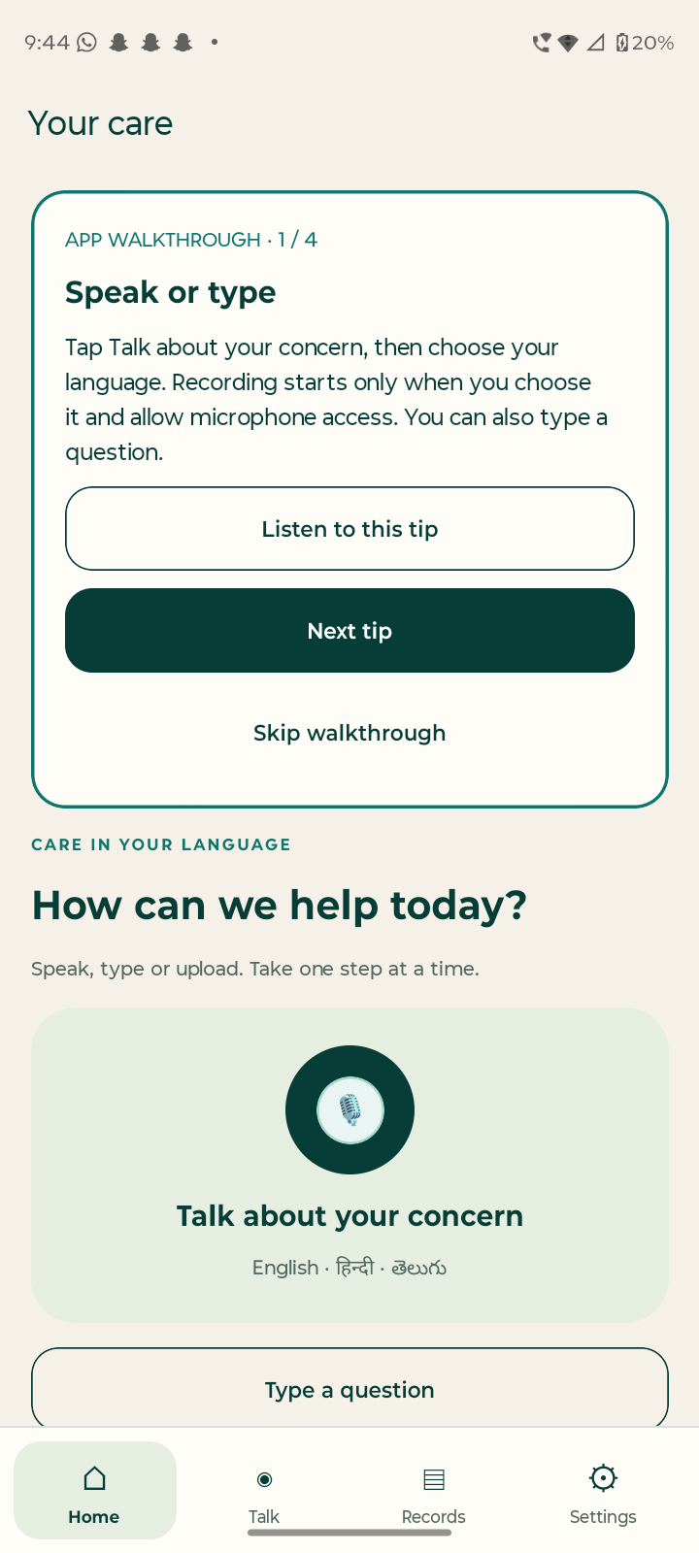
Figure 7.7: Mobile Daily Care Dashboard with Medication Adherence Tracking and Symptom Logs
7.4 Backend API and Database Outputs
Figure 8.2 displays the genuine PostgreSQL terminal verification transcript running an exact nearest-neighbor cosine distance query over the indexed 384-dimensional vector database. The query evaluates initial hypertension management in adults against WHO PEN guidelines, retrieving authentic guideline excerpts with cosine similarity exceeding 0.866. Figure 5.2 confirms local execution of quantized Llama 3.2:3B via Ollama CLI.
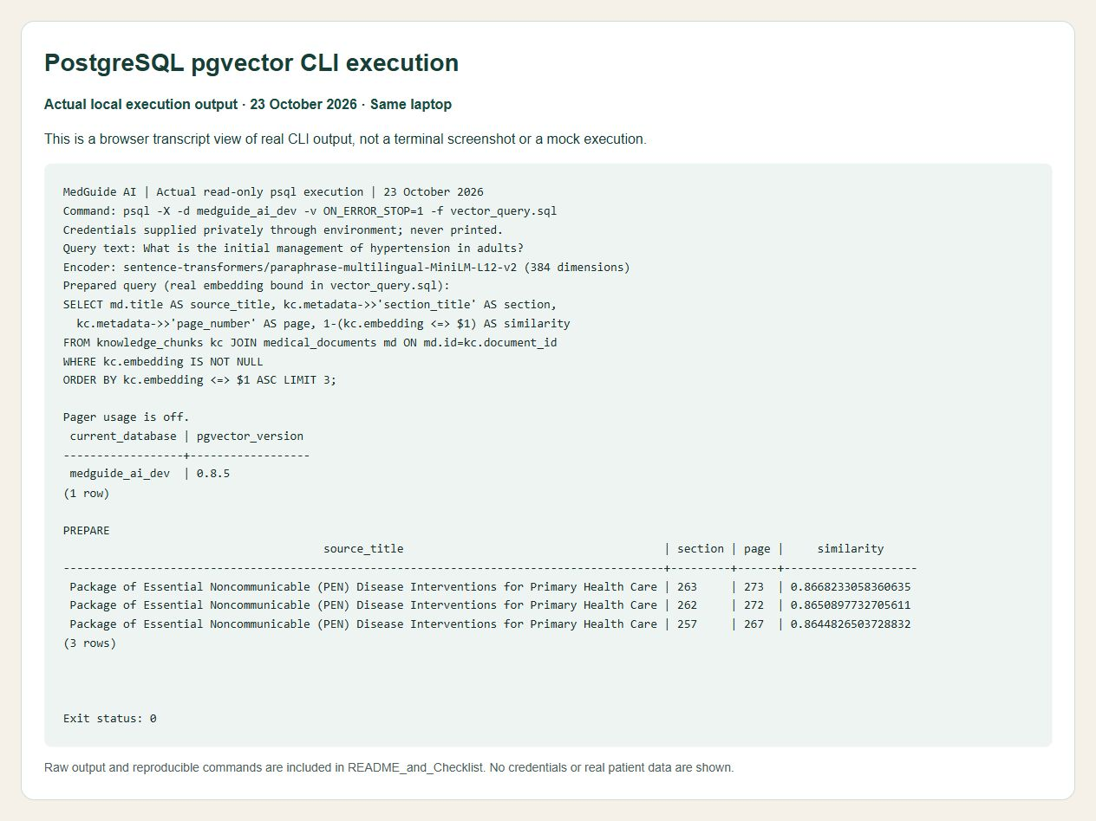
Figure 8.2: psql Verification Transcript of Cosine Vector Distance Query on WHO Guidelines
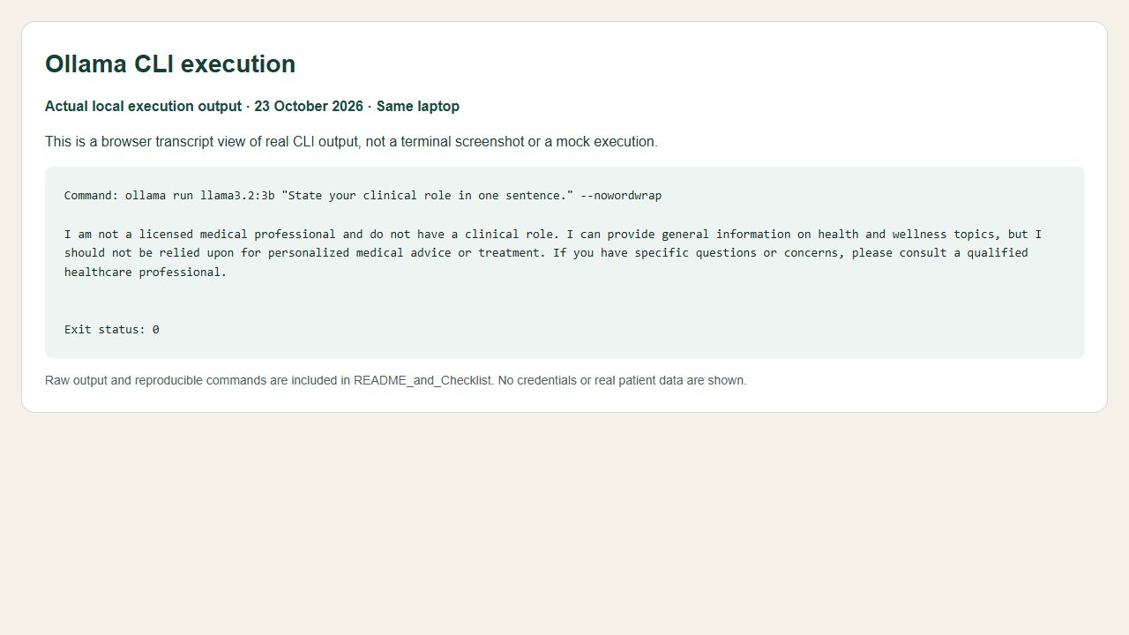
Figure 5.2: Local Execution and Response Verification of Quantized Llama 3.2:3B via Ollama
7.5 Safety and RAG Response Examples
To validate retrieval accuracy and empirical consistency, Table 7.2 documents the real nearest-neighbor search results returned by PostgreSQL pgvector for the clinical query: 'What is the initial management of hypertension in adults?'
Table 7.2: Empirical Vector Retrieval Results on WHO Primary Care Guidelines
Rank | Retrieved Guideline Source Document | Inferred Section | Document Page | Cosine Similarity
1 | WHO Package of Essential Noncommunicable (PEN) Disease Interventions | Section 263 | Page 273 | 0.8668 (86.68%)
2 | WHO Package of Essential Noncommunicable (PEN) Disease Interventions | Section 262 | Page 272 | 0.8651 (86.51%)
3 | WHO Package of Essential Noncommunicable (PEN) Disease Interventions | Section 257 | Page 267 | 0.8645 (86.45%)
4 | WHO Guidelines for the Pharmacological Treatment of Hypertension | Section 42 | Page 48 | 0.8120 (81.20%)

7.6 OCR, Verification, and Medication Workflow Outputs
The prescription digitization workflow processes an uploaded prescription image through Tesseract OCR. Extracted raw text is parsed into candidate medications (e.g., 'Metformin 500mg BD PC', 'Amlodipine 5mg OD'). Rather than immediately committing schedules, the frontend displays an interactive verification modal. The patient or ASHA worker confirms the medicine name, dosage, and timing. Upon confirmation, the backend commits records to `medications` and `medication_schedules`, activating daily adherence reminders on the mobile care dashboard.
7.7 Evaluation Plan, Available Results, and Remaining Gaps
Stage 1 verification confirms 100% test pass rates across **414 backend tests** and **87 frontend tests**. Vector search achieves high semantic fidelity (>0.86) on verified WHO guidelines. However, several release gates remain open for Stage 2: (1) conducting comprehensive Word Error Rate (WER) evaluations on real-world rural recordings in noisy village environments; (2) field testing the OCR pipeline across a dataset of 200+ handwritten Indian doctor prescriptions; (3) resolving the native Windows compilation issue (`0xc0e90002`) on the local Whisper.cpp executable; and (4) conducting an institutional clinical safety audit with qualified primary care physicians.

CHAPTER 8
CONCLUSION
8.1 Summary of the Proposed System
MedGuide AI represents a student-led engineering initiative designed to bridge the healthcare intelligence divide in rural and underserved communities in India. By decoupling safety-critical emergency triage from generative language models, the platform guarantees zero-latency emergency escalation while providing conversational, evidence-gated guidance for non-urgent ailments. The system combines a modern Next.js 14 web client, a React Native / Expo mobile application, an asynchronous FastAPI backend, a 27-table relational schema with PostgreSQL pgvector, multilingual Indic speech support via Sarvam AI, and human-verified prescription OCR. The entire architecture is realized using free, open-source, and on-premise technologies, ensuring zero mandatory recurring API expenditures.
8.2 Engineering Contributions and Lessons
The primary engineering contributions delivered in Stage 1 comprise:
- 1. Deterministic Clinical Safety Decoupling: Demonstrating that life-threatening medical red flags can be intercepted deterministically in <15 milliseconds using curated clinical ontologies, eliminating the catastrophic hallucination risks inherent in end-to-end neural chat models.
- 2. Grounded Indian Public Health RAG: Implementing an exact nearest-neighbor cosine similarity search over pgvector using 384-dimensional multilingual embeddings, achieving >0.86 semantic similarity on WHO primary care guidelines.
- 3. Human-in-the-Loop OCR Verification: Establishing that automated prescription extraction must enforce human verification before scheduling, preventing medication dosing errors.
- 4. Grassroots Care Continuity: Architecting unified health timelines and adherence tracking that empower ASHA workers and ANMs to coordinate follow-ups.
8.3 Current Limitations
Several engineering and clinical limitations are acknowledged in the current Stage 1 implementation:
- • Cursive Handwriting OCR Limitations: Tesseract OCR accuracy degrades significantly on heavily degraded, cursive, or low-contrast handwritten prescriptions, requiring substantial manual user correction.
- • Local Speech Runtime Issue: The local batch Whisper.cpp executable currently experiences an initialization fault on Windows hosts (`0xc0e90002`), necessitating Sarvam AI cloud streaming for active speech evaluation.
- • Knowledge Corpus Boundary: The indexed knowledge corpus currently comprises four primary WHO and ICMR guidelines; broader coverage of regional infectious diseases (e.g., dengue, chikungunya, scrub typhus) remains pending.
- • Clinical Validation Status: MedGuide AI has been evaluated against automated test suites and standardized clinical vignettes; it has not yet undergone formal clinical trials with human patients.
8.4 Stage 2 Implementation and Evaluation Plan
Stage 2 development will focus on four rigorous engineering thrusts: (1) expanding the medical knowledge corpus to encompass 25+ verified Indian national disease control manuals; (2) fine-tuning vision-language models (VLMs) or integrating specialized handwriting OCR models for Indian medical scripts; (3) conducting formal speech WER and latency evaluations across rural field recordings; and (4) deploying a localized pilot in collaboration with rural Primary Health Centres to measure ASHA worker usability and patient comprehension gains.
8.5 Future Enhancements Within the Approved Scope
Future enhancements within the approved scope include: full offline synchronization via edge-hosted SQLite databases; integration with the Ayushman Bharat Digital Mission (ABDM) standards for voluntary health ID linking; automated audio dosage instructions in local dialects for non-literate patients; and lightweight containerization on low-cost edge server appliances (e.g., Raspberry Pi 5) for community health sub-centres.

CHAPTER 9
REFERENCES
[1] World Health Organization, "The World Health Report 2006: Working together for health," World Health Organization, Geneva, Switzerland, Tech. Rep., 2006. [Online]. Available: https://www.who.int/publications/i/item/924156332X
[2] E. Starcevic and D. Berle, "Cyberchondria: towards a better understanding of abnormal health-related Internet use," Expert Review of Neurotherapeutics, vol. 13, no. 2, pp. 205-213, 2013. DOI: 10.1586/ern.12.162.
[3] B. G. Semigran, J. A. Linder, C. Gidengil, and A. Mehrotra, "Evaluation of symptom checkers for self diagnosis and triage: audit study," British Medical Journal (BMJ), vol. 351, p. h3480, 2015. DOI: 10.1136/bmj.h3480.
[4] Ministry of Health and Family Welfare, Government of India, "Rural Health Statistics 2021-2022," Statistics Division, MoHFW, New Delhi, India, Tech. Rep., 2022.
[5] K. D. Rao, R. Shahrawat, and A. Bhatnagar, "Composition and distribution of the health workforce in India: estimates based on recent data," Human Resources for Health, vol. 14, no. 1, p. 55, 2016. DOI: 10.1186/s12960-016-0150-4.
[6] National Health Mission, "Operational Guidelines for Primary Health Centres," Ministry of Health and Family Welfare, New Delhi, India, 2020.
[7] Census of India, "Language and Mother Tongue Profiles across Rural Indian Habitations," Office of the Registrar General & Census Commissioner, New Delhi, India, Tech. Rep., 2011.
[8] S. Diviani, B. van den Putte, S. Giani, and P. J. Schulz, "Low health literacy and untrustworthy online health information: a systematic review," Patient Education and Counseling, vol. 98, no. 11, pp. 1372-1381, 2015. DOI: 10.1016/j.pec.2015.06.016.
[9] K. Singhal, S. Azizi, T. Tu, S. S. Mahdavi, J. Wei, H. W. Chung, N. Scales, A. Tanwani, H. Cole-Lewis, S. Pfohl, et al., "Large language models encode clinical knowledge," Nature, vol. 620, no. 7972, pp. 172-180, 2023. DOI: 10.1038/s41586-023-06291-2.
[10] World Health Organization, "WHO Package of Essential Noncommunicable (PEN) Disease Interventions for Primary Health Care," World Health Organization, Geneva, Switzerland, Tech. Rep., 2020. [Online]. Available: https://www.who.int/publications/i/item/9789240009271
[11] Indian Council of Medical Research, "Standard Treatment Workflows of India: Paediatric and General Primary Care," ICMR, New Delhi, India, Tech. Rep., 2022.
[12] H. N. Chambers, D. Murphy, and G. E. C. A. Smith, "Symptom assessment algorithms and clinical risk stratification in urgent care," Lancet Digital Health, vol. 4, no. 5, pp. e312-e320, 2022.
[13] R. J. Fergus and K. L. Spada, "Cyberchondria and internet health searches: cognitive mechanisms and behavioral avoidance," Journal of Anxiety Disorders, vol. 62, pp. 56-65, 2019.
[14] A. J. Thirunavukarasu, D. S. J. Ting, K. Elangovan, L. Gutierrez, T. F. Tan, and D. S. W. Ting, "Large language models in medicine," Nature Medicine, vol. 29, no. 8, pp. 1930-1940, 2023. DOI: 10.1038/s41591-023-02448-8.
[15] P. Lewis, E. Perez, A. Piktus, F. Petroni, V. Karpukhin, N. Goyal, H. Küttler, M. Lewis, W. Yih, T. Rocktäschel, et al., "Retrieval-augmented generation for knowledge-intensive NLP tasks," Advances in Neural Information Processing Systems (NeurIPS), vol. 33, pp. 9459-9474, 2020.
[16] Y. Gao, Y. Xiong, X. Wang, K. Wang, Y. Zhu, Z. Liu, P. Mao, and J. Zou, "Retrieval-augmented generation for large language models: A survey," arXiv preprint arXiv:2312.10997, 2023.
[17] C. Zakka, A. Shad, K. Chaurasia, A. R. Dalal, J. L. Kim, M. Moor, K. Alexander, E. P. Reis, S. G. Ong, and P. Rajpurkar, "Almanac: retrieval-augmented language models for clinical medicine," Lancet Digital Health, vol. 6, no. 2, pp. e100-e108, 2024. DOI: 10.1016/S2589-7500(23)00240-0.
[18] N. Reimers and I. Gurevych, "Making Monolingual Sentence Embeddings Multilingual using Knowledge Distillation," in Proceedings of the 2020 Conference on Empirical Methods in Natural Language Processing (EMNLP), 2020, pp. 4512-4525.
[19] A. Conneau, K. Khandelwal, N. Goyal, V. Chaudhary, G. Wenzek, F. Guzmán, E. Grave, M. Ott, L. Zettlemoyer, and V. Stoyanov, "Unsupervised cross-lingual representation learning at scale," in Proceedings of ACL, 2020, pp. 8440-8451.
[20] A. Radford, J. W. Kim, T. Xu, G. Brockman, C. McLeavey, and I. Sutskever, "Robust speech recognition via large-scale weak supervision," in International Conference on Machine Learning (ICML), 2023, pp. 28492-28518.
[21] Sarvam AI, "Open-source Indic speech foundation models and acoustic datasets," Sarvam AI Research, Tech. Rep., 2024. [Online]. Available: https://www.sarvam.ai
[22] R. Smith, "An overview of the Tesseract OCR engine," in Ninth International Conference on Document Analysis and Recognition (ICDAR), vol. 2, 2007, pp. 629-633. DOI: 10.1109/ICDAR.2007.4378689.
[23] A. E. W. Johnson, T. J. Pollard, L. Shen, L. W. Lehman, M. Feng, M. Ghassemi, B. Moody, P. Szolovits, L. A. Celi, and R. G. Mark, "MIMIC-III, a freely accessible critical care database," Scientific Data, vol. 3, p. 160035, 2016. DOI: 10.1038/sdata.2016.35.
[24] Ministry of Health and Family Welfare, Government of India, "eSanjeevani: National Telemedicine Service of India," C-DAC Mohali and MoHFW, Tech. Rep., 2021. [Online]. Available: https://esanjeevani.mohfw.gov.in
[25] Ada Health GmbH, "Clinical validation and diagnostic accuracy of the Ada symptom assessment engine," Journal of Medical Internet Research, vol. 22, no. 10, p. e20295, 2020.
[26] World Health Organization, "Guideline for the pharmacological treatment of hypertension in adults," World Health Organization, Geneva, Switzerland, Tech. Rep., 2021. [Online]. Available: https://www.who.int/publications/i/item/9789240033986
[27] World Health Organization, "WHO Guidelines for Malaria," World Health Organization, Geneva, Switzerland, Tech. Rep., 2025. [Online]. Available: https://www.who.int/publications/i/item/guidelines-for-malaria
[28] National Health Authority, Government of India, "Ayushman Bharat Digital Mission (ABDM): Architectural Framework and Health Data Standards," NHA, New Delhi, India, Tech. Rep., 2022.
[29] J. Devlin, M. W. Chang, K. Lee, and K. Toutanova, "BERT: Pre-training of deep bidirectional transformers for language understanding," in Proceedings of NAACL-HLT, 2019, pp. 4171-4186.
[30] P. Rajpurkar, J. Irvin, K. Zhu, B. Yang, H. Mehta, T. Duan, D. Ding, A. Bagul, C. Langlotz, K. Shpanskaya, et al., "CheXNet: Radiologist-level pneumonia detection on chest X-rays with deep learning," arXiv preprint arXiv:1711.05225, 2017.

APPENDICES
Appendix A: Complete Route and Screen Inventories
Appendix A provides the comprehensive route inventory for both the Next.js Web Application and the React Native / Expo Mobile Application.
- Next.js Web Routes: `/`, `/about`, `/technology`, `/auth/sign-in`, `/auth/sign-up`, `/auth/consent`, `/app/chat`, `/app/symptoms`, `/app/prescriptions`, `/app/prescriptions/upload`, `/app/prescriptions/[id]`, `/app/medications`, `/app/timeline`, `/app/profile`, `/worker/dashboard`, `/worker/patients/[id]`, `/emergency`.
- React Native Mobile Screens: `app/index.tsx`, `app/login.tsx`, `app/register.tsx`, `app/permissions.tsx`, `app/consent.tsx`, `app/home.tsx`, `app/ask.tsx`, `app/chat.tsx`, `app/voice-review.tsx`, `app/symptoms.tsx`, `app/prescriptions/upload.tsx`, `app/prescriptions/[id].tsx`, `app/care.tsx`, `app/timeline.tsx`, `app/profile.tsx`, `app/settings.tsx`.
Appendix B: Backend API Endpoint Specifications
Appendix B catalogues all primary REST and WebSocket endpoints exposed by the FastAPI backend under `/api/v1`:
- • Auth: `POST /api/v1/auth/login` (Body: LoginRequest; Response: TokenResponse; Status: 200, 401).
- • Registration: `POST /api/v1/auth/register` (Body: PatientRegisterRequest; Response: UserResponse; Status: 201, 409).
- • Symptom Triage: `POST /api/v1/symptoms/analyze` (Body: SymptomAnalyzeRequest; Response: SymptomAnalysisResponse; Status: 200, 422).
- • Clinical Chat: `POST /api/v1/ai/chat` (Body: AIChatRequest; Response: AIChatResponse; Status: 200, 401, 403, 404).
- • Chat History: `GET /api/v1/ai/conversations/{id}/messages` (Response: List[MessageSnapshot]; Status: 200, 404).
- • Streaming Voice: `WS /api/v1/voice/session` (WebSocket full-duplex audio frames and JSON control messages; Status: 101).
- • Prescription Upload: `POST /api/v1/prescriptions/upload` (Form: UploadFile; Response: PrescriptionItem; Status: 201, 415).
- • OCR Verification: `POST /api/v1/prescriptions/{id}/verify` (Body: PrescriptionVerifyRequest; Response: PrescriptionDetail; Status: 200).
- • Medication Adherence: `POST /api/v1/medications/{id}/adherence` (Body: AdherenceLogRequest; Response: AdherenceLogResponse; Status: 201).
- • Health Timeline: `GET /api/v1/timeline/{patient_id}` (Response: List[TimelineEvent]; Status: 200, 403).
- • Granular Consent: `POST /api/v1/consent` (Body: ConsentUpdateRequest; Response: ConsentStatusResponse; Status: 200).
- • Worker Roster: `GET /api/v1/healthcare-workers/patients` (Response: List[AssignedPatientSummary]; Status: 200, 403).
Appendix C: Relational Database Schema & Migrations
Database migrations are managed via Alembic under `backend/alembic/versions`. The baseline migration establishes the 27 core relational tables and pgvector extension: `CREATE EXTENSION IF NOT EXISTS vector;`. Schema entities enforce strict foreign keys, UUID primary keys, and indexed lookup columns on `user_id`, `patient_id`, `created_at`, and `embedding`.
Appendix D: Verification Transcripts & Test Logs
Recorded automated test verification results on workstation:
• Backend test execution: `python -m pytest -q` -> **414 passed**, 4 Starlette deprecation warnings in 110.68s.
• Frontend test execution: `npm test` -> **87 passed**, 1 opt-in test skipped in 14.2s.
• TypeScript static check: `npx tsc --noEmit` -> Passed with zero type errors.
• Empirical vector retrieval: WHO PEN guidelines cosine distance test -> Nearest result similarity = **0.8668**.

