VISVESVARAYA TECHNOLOGICAL UNIVERSITY
“JnanaSangama”, Belgaum -590014, Karnataka.

LAB REPORT
On

DATA STRUCTURES (23CS3PCDST)

Submitted by

Hemanshu Dhiman(1BM23CS109)

in partial fulfillment for the award of the degree of BACHELOR OF ENGINEERING
in
COMPUTER SCIENCE AND ENGINEERING


B.M.S. COLLEGE OF ENGINEERING
(Autonomous Institution under VTU) BENGALURU-560019
September 2024-January 2025

B. M. S. College of Engineering,
Bull Temple Road, Bangalore 560019
(Affiliated To Visvesvaraya Technological University, Belgaum) Department of Computer Science and Engineering



This is to certify that the Lab work entitled “DATA STRUCTURES” carried out by Hemanshu Dhiman (1BM23CS109), who is bonafide student of B. M. S. College of Engineering. It is in partial fulfillment for the award of Bachelor of Engineering in Computer Science and Engineering of the Visvesvaraya Technological University, Belgaum during the year 2024-25. The Lab report has been approved as it satisfies the academic requirements in respect of Data structures Lab - (23CS3PCDST) work prescribed for the said degree.

Dr. Selva Kumar S Dr. Kavitha Sooda
Associate Professor Professor and Head
Department of CSE Department of CSE
BMSCE, Bengaluru BMSCE, Bengaluru

Index Sheet

Sl.  No. | Experiment Title | Page No.
1 | Lab Program 1-Stacks | 4-6
2 | Lab Program 2-Application of Stacks | 7-10
3 | Lab Program 3-Queues | 11-18
4 | Lab Program 4-Singly Linked Lists | 18-26
5 | Lab Program 5-Linked Lists | 26-31
6 | Lab Program 6-Linked Lists and Applications | 32-45
7 | Lab Program 7-Doubly Linked Lists | 45-49
8 | Lab Program 8-Binary Search Tree | 50-53
9 | Lab Program 9-Graphs | 53-57
10 | Lab Program 10-Hashing | 57-60

Course outcomes:

CO1 | Apply the concept of linear and nonlinear data structures.
CO2 | Analyze data structure operations for a given problem
CO3 | Design and develop solutions using the operations of linear and nonlinear data structure for a given specification.
CO4 | Conduct practical experiments for demonstrating the operations of different data structures.

Lab program 1:
Write a program to simulate the working of stack using an array with the following:
- Push
- Pop
- Display
The program should print appropriate messages for stack overflow, stack underflow.
#include<stdio.h> #define max 5
int stack[max]; int top = -1;
void push(int val){ if(top==max-1){
printf("overflow, stack is full\n");
}
else{
top++; stack[top] = val;
}
}
void pop(){ if(top==-1){
printf("underflow, stack is empty\n");
}
else{
printf("element deleted:%d\n",stack[top]); top--;
}
}
void display(){ if(top==-1){

printf("underflow, stack is empty\n");
}
else{
for(int i=top;i>=0;i--){
printf("%d ",stack[i]);
}
printf("\n");
}
}
int main() {
int choice, value; while(1) {
printf("1. Push\n2. Pop\n3. Display\n4. Exit\n"); printf("Enter your choice: ");
scanf("%d", &choice); switch(choice) {
case 1:
printf("Enter value to push: "); scanf("%d", &value); push(value);
break; case 2:
pop(); break;
case 3:
display(); break;
case 4:
return 0;

default:
printf("Invalid choice. Please try again.\n");
}
}
return 0;
}
Output:
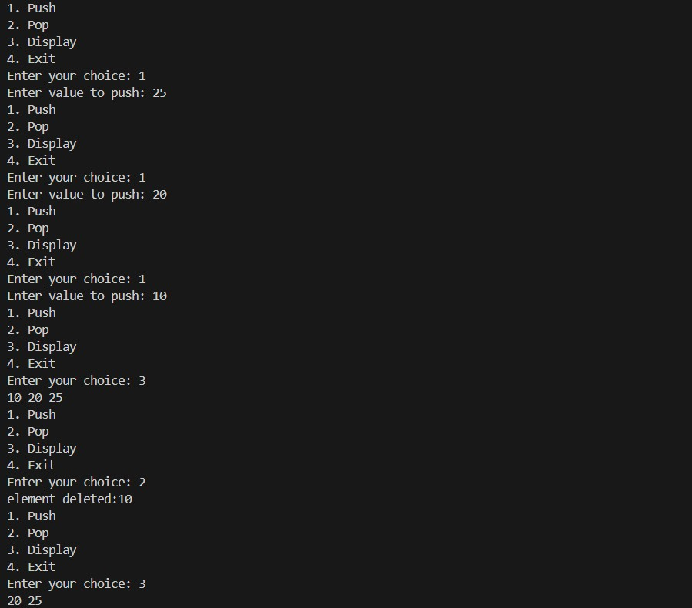

Lab Program 2:
WAP to convert a given valid parenthesized infix arithmetic expression to postfix expression. The expression consists of single character operands and the binary operators + (plus), - (minus), * (multiply) and / (divide) #include<stdio.h>
#include<stdlib.h> #include<ctype.h> #define max 1000 char stack[max]; int top=-1;
void push(char x){ if(top==max-1){
printf("stack full\n"); return;
}
stack[++top]=x;
}
char pop(){ if(top==-1){
printf("stack empty\n"); return -1;
}
return stack[top--];
}
int precedence(char x){ if(x=='+'||x=='-'){
return 1;
}
else if(x=='*'||x=='/'){

return 2;
}
else if(x=='^'){ return 3;
}
else{
return 0;
}
}
int isop(char x){
return (x=='+'||x=='-'||x=='*'||x=='/'||x=='^');
}
void infixtopostfix(char *exp){ char postfix[max];
int i=0;
char *ptr = exp; while(*ptr!='\0'){
if(isalpha(*ptr)){ postfix[i++] = *ptr;
}
if(*ptr=='('){ push(*ptr);
}
if(*ptr==')'){ while(stack[top]!='('){
postfix[i++]=pop();
}
pop();
}

if(isop(*ptr)){ while(precedence(stack[top])>=precedence(*ptr)){
postfix[i++]=pop();
}
push(*ptr);
}
ptr++;
}
while(top!=-1){ postfix[i++]=pop();
}
postfix[i]='\0'; printf("Postfix:%s",postfix);
}
int main(){
char exp[max]; printf("enter expression:"); scanf("%s",exp); infixtopostfix(exp);
return 0;
}
Output:
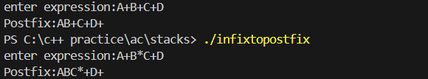
Leetcode Program 1: Moving Zeroes

void moveZeroes(int* nums, int numsSize) { int a=0;
for(int i=0;i<numsSize;i++){ if (nums[i]!=0){
nums[a]=nums[i]; a++;
}
}
for(int i=a;i<numsSize;i++){ nums[i]=0;
}
}
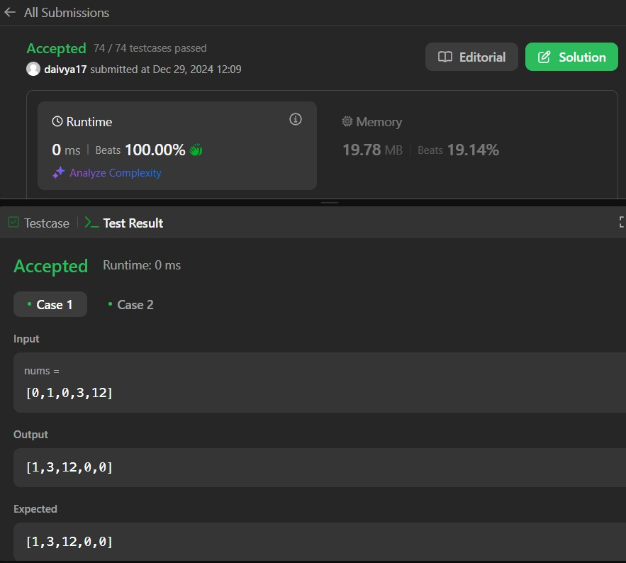

Lab Program 3a:
WAP to simulate the working of a queue of integers using an array. Provide the following operations: Insert, Delete, Display
The program should print appropriate messages for queue empty and queue overflow conditions
#include <stdio.h> #include <stdlib.h>

#define MAX 5

typedef struct {
int items[MAX]; int front;
int rear;
} LinearQueue;
void initQueue(LinearQueue* q) { q->front = -1;
q->rear = -1;
}
int isEmpty(LinearQueue* q) { return q->front == -1;
}
int isFull(LinearQueue* q) { return q->rear == MAX - 1;
}
void enqueue(LinearQueue* q, int value) { if (isFull(q)) {
printf("Queue is full!\n"); return;

}
if (isEmpty(q)) { q->front = 0;
}
q->rear++;
q->items[q->rear] = value; printf("Enqueued: %d\n", value);
}
int dequeue(LinearQueue* q) { if (isEmpty(q)) {
printf("Queue is empty!\n"); return -1;
}
int item = q->items[q->front]; q->front++;
if (q->front > q->rear) {
q->front = q->rear = -1;
}
printf("Dequeued: %d\n", item); return item;
}
void display(LinearQueue* q) { if (isEmpty(q)) {
printf("Queue is empty!\n"); return;
}
printf("Queue: ");
for (int i = q->front; i <= q->rear; i++) { printf("%d ", q->items[i]);

}
printf("\n");
}

int main() { LinearQueue q; initQueue(&q);

int choice, value;

while (1) {
printf("1. Enqueue 2. Dequeue 3. Display 4. Exit\n"); printf("Enter your choice: ");
scanf("%d", &choice);

switch (choice) { case 1:
printf("Enter value to enqueue: "); scanf("%d", &value); enqueue(&q, value);
break; case 2:
dequeue(&q); break;
case 3:
display(&q); break;
case 4:
exit(0);

default:
printf("Invalid choice! Please try again.\n");
}
}

return 0;
}
Output:
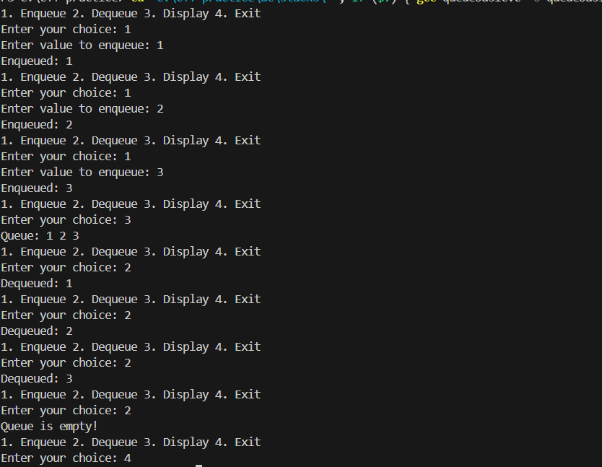
Lab Program 3b:
WAP to simulate the working of a circular queue of integers using an array. Provide the following operations: Insert, Delete & Display
The program should print appropriate messages for queue empty and queue overflow conditions

#include <stdio.h> #include <stdlib.h>

#define MAX 5

int circularQueue[MAX]; int front = -1, rear = -1;

void insert(int value) {
if ((front == 0 && rear == MAX - 1) || (rear == (front - 1) % (MAX - 1))) { printf("Queue Overflow! Cannot insert %d\n", value);
return;
}
if (front == -1) { front = rear = 0;
} else if (rear == MAX - 1 && front != 0) { rear = 0;
} else {
rear++;
}
circularQueue[rear] = value;
printf("Inserted %d into the queue\n", value);
}

void delete() {
if (front == -1) {
printf("Queue Underflow! No elements to delete\n");

return;
}
printf("Deleted %d from the queue\n", circularQueue[front]); if (front == rear) {
front = rear = -1;
} else if (front == MAX - 1) { front = 0;
} else {
front++;
}
}

void display() {
if (front == -1) { printf("Queue is empty!\n"); return;
}
printf("Queue elements: "); if (rear >= front) {
for (int i = front; i <= rear; i++) { printf("%d ", circularQueue[i]);
}
} else {
for (int i = front; i < MAX; i++) { printf("%d ", circularQueue[i]);
}
for (int i = 0; i <= rear; i++) { printf("%d ", circularQueue[i]);

}
}
printf("\n");
}

int main() {
int choice, value;

while (1) {
printf("1. Enqueue 2. Dequeue 3. Display 4. Exit\n"); printf("Enter your choice: ");
scanf("%d", &choice);

switch (choice) { case 1:
printf("Enter the value to insert: "); scanf("%d", &value); insert(value);
break; case 2:
delete(); break;
case 3:
display(); break;
case 4:
exit(0); default:
printf("Invalid choice! Please try again.\n");

break;
}
}
return 0;
}
Output:
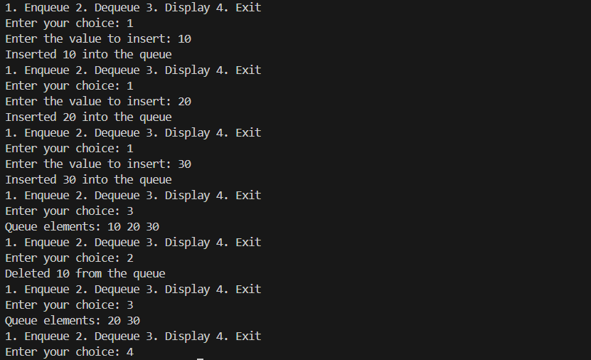
Lab Program 4:
WAP to Implement Singly Linked List with following operations
- Create a linked list.
- Insertion of a node at first position, at any position and at end of list.
Display the contents of the linked list.
#include<stdio.h> #include<stdlib.h> struct Node{
int data;
struct Node* next;

};
struct Node* createnode(int value){
struct Node* newNode = (struct Node*)malloc(sizeof(struct Node)); newNode-> data=value;
newNode->next=NULL; return newNode;
}
struct Node* createlinkedlist(){ struct Node* head = NULL; return head;
}
void insertatstart(struct Node** head,int value){ struct Node* newnode=createnode(value); newnode->next=*head;
*head=newnode;
}
void insertatend(struct Node** head,int value){ struct Node* newnode = createnode(value); if(*head==NULL){
*head=newnode;
}
else{
struct Node* temp = *head; while(temp->next!=NULL){
temp=temp->next;
}
temp->next=newnode;
}
}

void insertatposition(struct Node** head,int pos,int value){ struct Node* newnode=createnode(value);
if(pos==1){
newnode->next=*head;
*head=newnode;
}
else{
struct Node* temp = *head;
for (int i = 1; i < pos - 1 && temp != NULL; i++) { temp = temp->next;
}
if (temp == NULL) {
printf("Position is greater than the length of the list.\n"); return;
}
newnode->next = temp->next; temp->next = newnode;
}
}
void display(struct Node* head){ if(head==NULL){
printf("linked list empty\n");
}
else{
struct Node* temp=head; while(temp!=NULL){
printf("%d ",temp->data); temp=temp->next;
}

printf("\n");
}
}
int main(){
struct Node* head = createlinkedlist(); insertatstart(&head,3); insertatstart(&head,2); insertatstart(&head,1);
display(head); insertatend(&head,5); insertatposition(&head,4,4); display(head);
return 0;
}
Output:
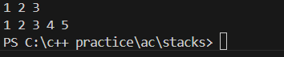
Leetcode Program 2: Implement Queues using Stacks #include <stdio.h>
#include <stdlib.h> #include <stdbool.h> typedef struct Stack {
int *arr; int top;
int capacity;
} Stack; typedef struct {
Stack *stack1;

Stack *stack2;
} MyQueue;
Stack* createstack(int capacity){
Stack *stack = (Stack *)malloc(sizeof(Stack)); stack->capacity=capacity;
stack->top=-1;
stack->arr = (int *)malloc(capacity * sizeof(int)); return stack;
}
bool isEmpty(Stack *stack) { return stack->top == -1;
}
void push(Stack *stack, int item){ stack->arr[++stack->top] = item;
}
int pop(Stack *stack){
return stack->arr[stack->top--];
}
int top(Stack *stack){
return stack->arr[stack->top];
}
MyQueue* myQueueCreate() {
MyQueue *queue = (MyQueue *)malloc(sizeof(MyQueue)); queue->stack1=createstack(100);
queue->stack2=createstack(100); return queue;
}

void myQueuePush(MyQueue* obj, int x) {

push(obj->stack1,x);
}

int myQueuePop(MyQueue* obj) { if(isEmpty(obj->stack2)){
while(!(isEmpty(obj->stack1))){ push(obj->stack2,pop(obj->stack1));
}
}
return pop(obj->stack2);
}

int myQueuePeek(MyQueue* obj) { if(isEmpty(obj->stack2)){
while(!(isEmpty(obj->stack1))){ push(obj->stack2,pop(obj->stack1));
}
}
return top(obj->stack2);
}

bool myQueueEmpty(MyQueue* obj) {
return isEmpty(obj->stack1) && isEmpty(obj->stack2);
}

void myQueueFree(MyQueue* obj) { free(obj->stack1->arr);
free(obj->stack1); free(obj->stack2->arr);

free(obj->stack2); free(obj);
}

/**
- Your MyQueue struct will be instantiated and called as such:
- MyQueue* obj = myQueueCreate();
- myQueuePush(obj, x);

- int param_2 = myQueuePop(obj);

- int param_3 = myQueuePeek(obj);

- bool param_4 = myQueueEmpty(obj);

- myQueueFree(obj);
*/ Output:
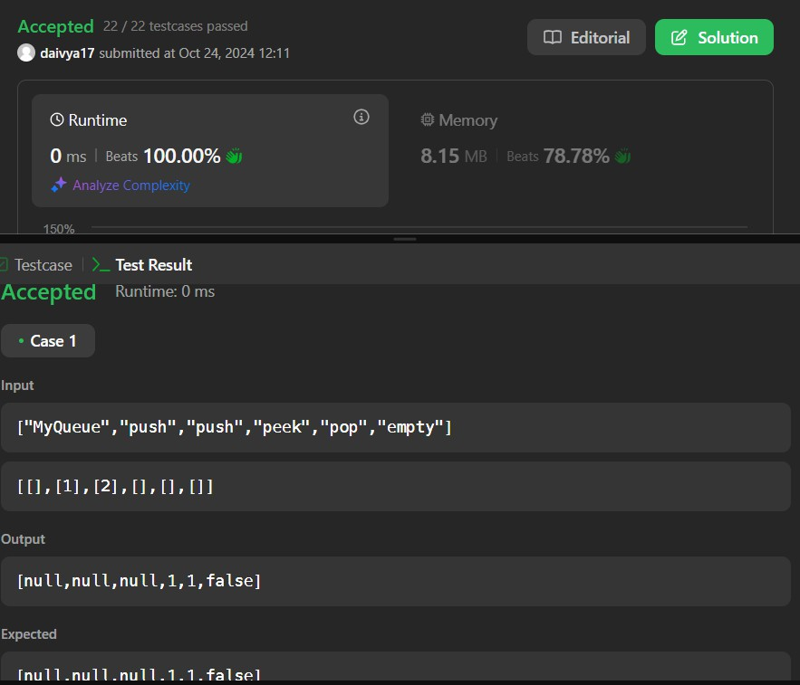

Leetcode Program 3: Backspace String Compare #include <stdio.h>
#include <string.h>

bool backspaceCompare(char* s, char* t) { char s1[1000];
char s2[1000]; int i = 0, j = 0;
for (int k = 0; k < strlen(s); k++) { if (s[k] == '#') {
if (i > 0) {
--i;
}
} else {
s1[i++] = s[k];
}
}
s1[i] = '\0';
for (int k = 0; k < strlen(t); k++) { if (t[k] == '#') {
if (j > 0) {
--j;
}
} else {
s2[j++] = t[k];
}

}
s2[j] = '\0';
return strcmp(s1, s2) == 0;
}
Output:


Lab Program 5:
WAP to Implement Singly Linked List with following operations

- Create a linked list.
- Deletion of first element, specified element and last element in the list.

- Display the contents of the linked list.
#include<stdio.h> #include<stdlib.h> struct Node{
int data;
struct Node* next;
};
struct Node* createnode(int val){
struct Node* newnode=(struct Node*) malloc (sizeof(struct Node)); newnode->data=val;
newnode->next=NULL; return newnode;
}
struct Node* createll(){ struct Node* head=NULL; return head;
}
void insertatstart(struct Node** head,int data){ struct Node* node1=createnode(data); node1->next=*head;
*head=node1;
}
void insertatend(struct Node** head,int data){ struct Node* node1=createnode(data); if(*head==NULL){
*head=node1;
}

else{
struct Node* temp=*head; while(temp->next!=NULL){
temp=temp->next;
}
temp->next=node1;
}
}
void display(struct Node** head){ struct Node* temp=*head; while(temp!=NULL){
printf("%d ",temp->data); temp=temp->next;
}
printf("\n");
}
void deletefirst(struct Node** head){ struct Node* temp=*head;
*head=temp->next; temp->next=NULL; free(temp);
}
void deletelast(struct Node** head){ struct Node* temp = *head;
struct Node* prev = NULL; if (temp->next == NULL) {
*head = NULL;

free(temp); return;
}
while (temp->next != NULL) { prev = temp;
temp = temp->next;
}
prev->next = NULL; free(temp);
}
void deletebyval(struct Node** head,int val){ struct Node* temp = *head; if(temp!=NULL && temp->data==val){
*head=temp->next; free(temp);
}
struct Node* prev=NULL; while(temp!=NULL && temp->data!=val){
prev=temp; temp=temp->next;
}
if(temp==NULL){ printf("element not found\n");
}
prev->next=temp->next; free(temp);
}

int main(){
struct Node* head=createll(); insertatstart(&head,5); insertatstart(&head,4); insertatstart(&head,3); insertatstart(&head,2); insertatstart(&head,1); display(&head); deletefirst(&head); display(&head); deletelast(&head); display(&head); deletebyval(&head,3); display(&head);
return 0;
}
Output:
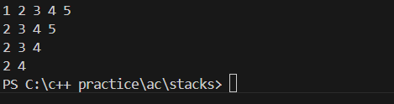
Leetcode Program 4: Delete Duplicates
/**
- Definition for singly-linked list.
- struct ListNode {
- int val;

- struct ListNode *next;
* };
*/
struct ListNode* deleteDuplicates(struct ListNode* head) { struct ListNode* temp=head;
while(temp!=NULL && temp->next!=NULL){ if(temp->val==temp->next->val){
temp->next=temp->next->next;
}
else{
temp=temp->next;
}
}
return head;
}
Output:


Lab Program 6a:
WAP to Implement Single Link List with following operations: Sort the linked list, Reverse the linked list, Concatenation of two linked lists. #include<stdio.h>
#include<stdlib.h> struct Node{
int data;
struct Node* next;
};
struct Node* createnode(int val){
struct Node* newnode=(struct Node*) malloc (sizeof(struct Node)); newnode->data = val;
newnode->next = NULL; return newnode;
}
struct Node* createll(){
struct Node* head = NULL; return head;
}
void insertatstart(struct Node** head,int val){ struct Node* newnode = createnode(val); newnode->next = *head;
*head = newnode;
}
void display(struct Node* head){ struct Node* temp = head; while(temp!=NULL){

printf("%d ",temp->data); temp = temp->next;
}
printf("\n");
}
int len(struct Node* head){ int count = 0;
struct Node* temp = head; while(temp!=NULL){
temp = temp->next; count++;
}
return count;
}
void sort(struct Node** head){ int n = len(*head);
for(int i=0;i<n;i++){
struct Node* temp = *head; while(temp!=NULL && temp->next!=NULL){
if(temp->data > temp->next->data){ int x = temp->data;
temp->data = temp->next->data; temp->next->data = x;
}
temp = temp->next;
}
}

}
void rev(struct Node** head){ struct Node* prev = NULL; struct Node* curr = *head; struct Node* forward = NULL; while(curr!=NULL){
forward = curr->next; curr->next = prev; prev = curr;
curr = forward;
}
*head = prev;
}
void concat(struct Node** head1, struct Node** head2){ struct Node* temp = *head1;
while(temp->next!=NULL){ temp = temp->next;
}
temp->next = *head2;
}
int main(){
struct Node* head1 = createll(); insertatstart(&head1,3); insertatstart(&head1,2); insertatstart(&head1,4); insertatstart(&head1,5); insertatstart(&head1,1);

printf("List1:\n"); display(head1); printf("After reversing:\n"); rev(&head1); display(head1); printf("After sorting:\n"); sort(&head1); display(head1);
struct Node* head2 = createll(); insertatstart(&head2,10); insertatstart(&head2,9); insertatstart(&head2,8); insertatstart(&head2,7); insertatstart(&head2,6); printf("List2:\n"); display(head2);
printf("After concatenation:\n"); concat(&head1,&head2); display(head1);
return 0;
}
Output:

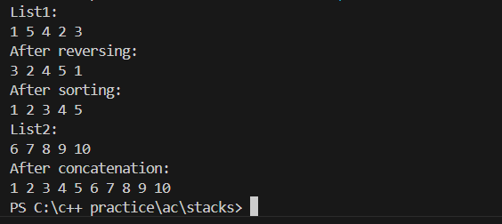
Lab Program 6b:
WAP to Implement Single Link List to simulate Stack & Queue Operations.
#include <stdio.h> #include <stdlib.h>

typedef struct s_node { int data;
struct s_node* next;
} s_node;

s_node* init(int data) {
s_node *n = (s_node*)malloc(sizeof(s_node)); if (n == NULL) {
printf("Memory allocation failed!\n"); exit(1);
}
n->data = data;
n->next = NULL;

return n;
}

s_node* push(s_node **last, int data, s_node **head) { if (*head == NULL) {

*head = init(data);
*last = *head; return *head;
}

s_node *l = *last;
l->next = init(data);
*last = l->next; return l->next;
}

s_node* pop(s_node **head) { if (*head == NULL) {
printf("List is empty, nothing to pop.\n"); return NULL;
}

s_node *h = *head;
if (h->next == NULL) { free(h);
*head = NULL;

return NULL;
}

while (h->next->next != NULL) { h = h->next;
}

s_node *temp = h->next; free(temp);
h->next = NULL; return h;
}

void print_list(s_node *head) { if (head == NULL) {
printf("List is empty.\n"); return;
}

s_node *current = head; while (current != NULL) {
printf("%d -> ", current->data); current = current->next;
}
printf("NULL\n");

}

int main() {
s_node *head = NULL; s_node *last = NULL;

int choice, data; while (1) {
printf("\nMenu:\n"); printf("1. Push a node\n"); printf("2. Pop a node\n"); printf("3. Print the list\n"); printf("4. Exit\n"); printf("Enter your choice: "); scanf("%d", &choice);

switch (choice) { case 1:
printf("Enter the data to push: "); scanf("%d", &data);
last = push(&last, data, &head); break;

case 2:
last = pop(&head); break;

case 3:
print_list(head); break;

case 4:

while (head != NULL) { head = pop(&head);
}
printf("Exiting...\n"); return 0;

default:
printf("Invalid choice! Please try again.\n");
}
}
}
Output:

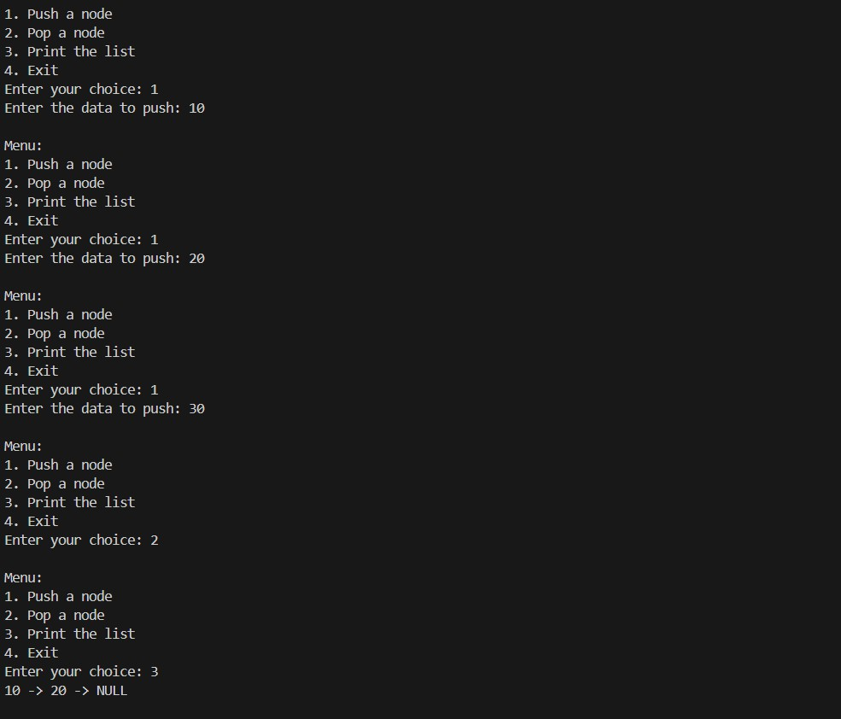
Queues using linked lists #include <stdio.h> #include <stdlib.h> typedef struct p_node {
int data;
struct p_node* next;
} p_node;
p_node* init(int data) {
p_node *n = (p_node*)malloc(sizeof(p_node)); if (n == NULL) {
printf("Memory allocation failed!\n"); exit(1);

}
n->data = data;
n->next = NULL; return n;
}
p_node* enquee(p_node **last, int data, p_node **head) { if (*head == NULL) {
*head = init(data);
*last = *head; return *head;
}
p_node *l = *last;
l->next = init(data);
*last = l->next; return l->next;
}
int dequee(p_node **head) { if (*head == NULL) {
printf("Queue is empty, nothing to dequeue.\n"); return -1;
}
p_node *h = *head; int r = h->data;
*head = h->next; free(h);
return r;
}

void print_list(p_node *head) { if (head == NULL) {
printf("Queue is empty.\n"); return;
}
p_node *current = head; while (current != NULL) {
printf("%d -> ", current->data); current = current->next;
}
printf("NULL\n");
}
int main() {
p_node *head = NULL; p_node *last = NULL; int choice, data;
while (1) { printf("\nMenu:\n");
printf("1. Enqueue a node\n"); printf("2. Dequeue a node\n"); printf("3. Print the queue\n"); printf("4. Exit\n"); printf("Enter your choice: "); scanf("%d", &choice);
switch (choice) { case 1:
printf("Enter the data to enqueue: ");

scanf("%d", &data);
last = enquee(&last, data, &head); break;
case 2:
data = dequee(&head); if (data != -1) {
printf("Dequeued: %d\n", data);
}
break; case 3:
print_list(head); break;
case 4:
while (head != NULL) { dequee(&head);
}
printf("Exiting...\n"); return 0;
default:
printf("Invalid choice! Please try again.\n");
}
}
}
Output:

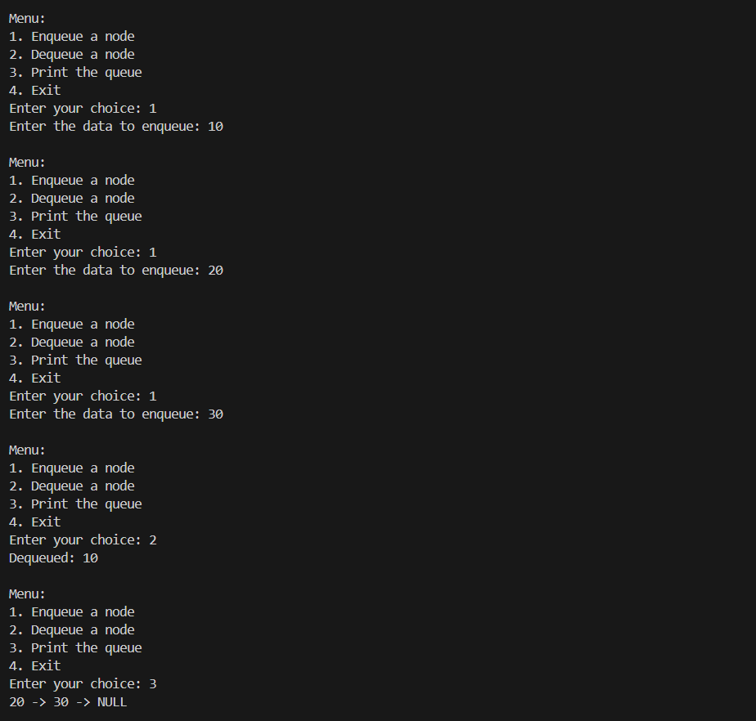
Lab Program 7:
WAP to Implement doubly link list with primitive operations
- Create a doubly linked list.
- Insert a new node to the left of the node.
- Delete the node based on a specific value
- Display the contents of the list
#include <stdio.h> #include <stdlib.h>

struct Node {

int data;
struct Node* prev; struct Node* next;
};

struct Node* createNode(int val) {
struct Node* n = (struct Node*)malloc(sizeof(struct Node)); n->data = val;
n->prev = n->next = NULL; return n;
}

void insertEnd(struct Node** head, int val) { struct Node* n = createNode(val);
if (!*head) {
*head = n; return;
}
struct Node* t = *head; while (t->next) t = t->next; t->next = n;
n->prev = t;
}

void insertLeft(struct Node** head, int target, int val) { struct Node* t = *head;
while (t && t->data != target) t = t->next;

if (!t) return;
struct Node* n = createNode(val); n->next = t;
n->prev = t->prev;
if (t->prev) t->prev->next = n; else *head = n;
t->prev = n;
}

void deleteNode(struct Node** head, int val) { struct Node* t = *head;
while (t && t->data != val) t = t->next; if (!t) return;
if (t->prev) t->prev->next = t->next; else *head = t->next;
if (t->next) t->next->prev = t->prev; free(t);
}

void display(struct Node* head) { while (head) {
printf("%d <-> ", head->data); head = head->next;
}
printf("NULL\n");
}

int main() {
struct Node* dll = NULL;

insertEnd(&dll, 10);
insertEnd(&dll, 20);
insertEnd(&dll, 30); printf("Doubly Linked List: "); display(dll);

insertLeft(&dll, 20, 15);
printf("After Inserting 15 to the left of 20: "); display(dll);

deleteNode(&dll, 10); printf("After Deleting 10: "); display(dll);

return 0;
}
Output:

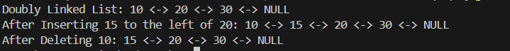
Leetcode Program 5: Linked List Cycle
/**
- Definition for singly-linked list.
- struct ListNode {

- int val;
- struct ListNode *next;
* };
*/
bool hasCycle(struct ListNode *head) { struct ListNode* slow=head;
struct ListNode* fast=head; while(fast && fast->next){
slow=slow->next; fast=fast->next->next; if(slow==fast){
return true;
}
}
return false;
}
Output:
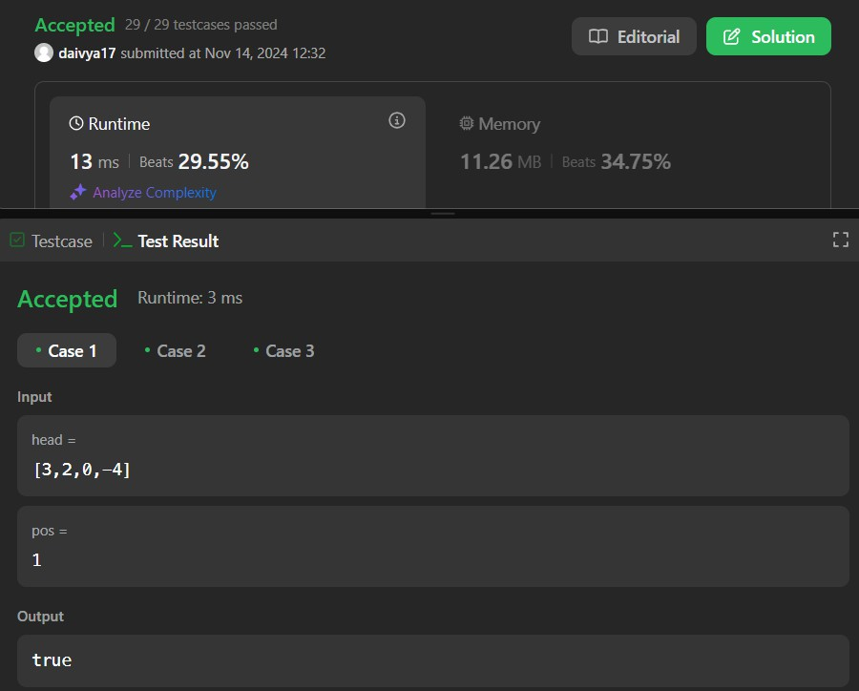

Lab Program 8:
Write a program
- To construct a binary Search tree.
- To traverse the tree using all the methods i.e., in-order, preorder and post order
- To display the elements in the tree.
#include<stdio.h> #include<stdlib.h> typedef struct BST{
int data;
struct BST* left; struct BST* right;
}node;
node* create(){
node* newnode = (node*)malloc(sizeof(node)); printf("enter data:");
scanf("%d",&newnode->data);
newnode->left = newnode->right = NULL; return newnode;
}
void insert(node* root,node* newnode){ if(newnode->data < root->data){
if(root->left!=NULL){ insert(root->left,newnode);
}
else{
root->left = newnode;
}

}
if(newnode->data > root->data){ if(root->right!=NULL){
insert(root->right,newnode);
}
else{
root->right = newnode;
}
}
}
void inorder(node* root){ if(root!=NULL){
inorder(root->left); printf("%d ",root->data); inorder(root->right);
}
}
void postorder(node* root){ if(root!=NULL){
postorder(root->left); postorder(root->right); printf("%d ",root->data);
}
}
void preorder(node* root){ if(root!=NULL){
printf("%d ",root->data);

preorder(root->left); preorder(root->right);
}
}
int main() { char ch;
node *root = NULL, *temp;

do {
temp = create();
if (root == NULL) root = temp;
else
insert(root, temp);

printf("\nDo you want to enter more(y/n)? ");
getchar(); // To consume the newline character from previous input scanf("%c", &ch);
} while (ch == 'y' || ch == 'Y');

printf("\nPreorder Traversal: "); preorder(root);

printf("\nInorder Traversal: "); inorder(root);

printf("\nPostorder Traversal: ");

postorder(root);

return 0;
}

Output:
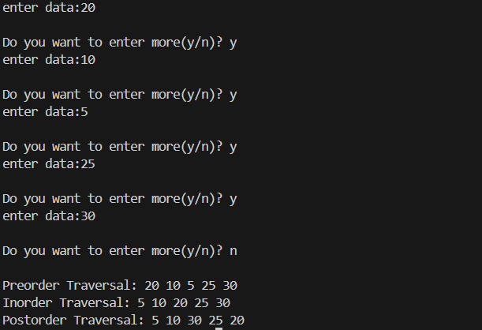

Lab Program 9a:
Write a program to traverse a graph using BFS method.
#include<stdio.h> #include<conio.h> int adj[10][10];
int n;
int vis[10]; void bfs(int v){
int q[10],rear=1,front=1,u;

vis[v] = 1; q[rear] = v;
while(front<=rear){ u = q[front]; printf("%d ",u);
for(int i=1;i<=n;i++){ if(adj[u][i]==1 && vis[i]==0){
vis[i] = 1; rear++; q[rear] = i;
}
}
front++;
}
}
int main(){
printf("enter no of vertices:"); scanf("%d",&n);
printf("enter adjacency matrix:"); for(int i=1;i<=n;i++){
for(int j=1;j<=n;j++){ scanf("%d",&adj[i][j]);
}
vis[i] = 0;
}
int v;
printf("enter node to start traversing:");

scanf("%d",&v); bfs(v);
}
Output:
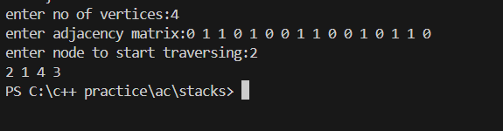
Lab Program 9b:
Write a program to check whether given graph is connected or not using DFS method.
#include <stdio.h>

#define MAX 10

int adj[MAX][MAX], visited[MAX], n;

void dfs(int v) { visited[v] = 1;
for (int i = 1; i <= n; i++) {
if (adj[v][i] != 0 && visited[i] == 0) { dfs(i);
}
}
}

int main() {
printf("Enter the number of vertices: "); scanf("%d", &n);

printf("Enter the adjacency matrix (0 for no edge):\n"); for (int i = 1; i <= n; i++) {
for (int j = 1; j <= n; j++) { scanf("%d", &adj[i][j]);
}
}

// Initialize the visited array for (int i = 1; i <= n; i++) {
visited[i] = 0;
}

// Start DFS from the first vertex dfs(1);

// Check if all vertices are visited int connected = 1;
for (int i = 1; i <= n; i++) { if (visited[i] == 0) {
connected = 0; break;
}
}

if (connected) {
printf("The graph is connected.\n");
} else {
printf("The graph is disconnected.\n");
}

return 0;
}
Output:
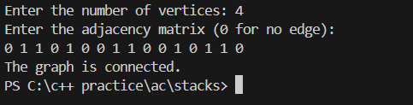
Lab Program 10:
Given a File of N employee records with a set K of Keys(4-digit) which uniquely determine the records in file F.
Assume that file F is maintained in memory by a Hash Table (HT) of m memory locations with L as the set of memory addresses (2-digit) of locations in HT. Let the keys in K and addresses in L are integers.
Design and develop a Program in C that uses Hash function H: K -> L as H(K)=K mod m (remainder method), and implement hashing technique to map a given key K to the address space L.
Resolve the collision (if any) using linear probing.
#include <stdio.h> #include <stdlib.h>

int key[20], n, m; int *ht, index;
int count = 0;

void insert(int key) { index = key % m;
while (ht[index] != -1) { index = (index + 1) % m;
}
ht[index] = key; count++;
}

void display() {
if (count == 0) {
printf("\nHash Table is empty"); return;
}
printf("\nHash Table contents are:\n"); for (int i = 0; i < m; i++) {
printf("\nT[%d] --> %d", i, ht[i]);
}
}

void main() {
printf("\nEnter the number of employee records (N): "); scanf("%d", &n);

printf("\nEnter the two-digit memory locations (m) for hash table: "); scanf("%d", &m);

ht = (int *)malloc(m * sizeof(int)); for (int i = 0; i < m; i++)
ht[i] = -1;

printf("\nEnter the four-digit key values (K) for %d Employee Records:\n", n); for (int i = 0; i < n; i++)
scanf("%d", &key[i]);

for (int i = 0; i < n; i++) { if (count == m) {
printf("\nHash table is full. Cannot insert record %d key", i + 1); break;
}
insert(key[i]);
}

display(); free(ht);
}
Output:

