B.M.S. COLLEGE OF ENGINEERING BENGALURU
Autonomous Institute, Affiliated to VTU


Lab Record
Computer Networks – 23CS5PCCON
Submitted in partial fulfillment for the 5th Semester Laboratory

Bachelor of Engineering in
Computer Science and Engineering

Submitted by:
Hemanshu Dhiman
(1BM23CS109)

Department of Computer Science and Engineering
B.M.S. College of Engineering
Bull Temple Road, Basavanagudi, Bangalore 560 019 August 2025-December 2025

B.M.S. COLLEGE OF ENGINEERING
DEPARTMENT OF COMPUTER SCIENCE AND ENGINEERING



CERTIFICATE

This is to certify that the Computer Networks (23CS5PCCON) laboratory has been carried out by Hemanshu Dhiman(S1BM23CS109) during the 5th Semester August 2025-December 2025

Signature of the Faculty Incharge:

Rashmi H
Assistant Professor
Department of Computer Science and Engineering
B.M.S. College of Engineering, Bangalore

Table of Contents

PART - A
Serial No. | Name of Experiment
1. | Create a topology and simulate sending a simple PDU from source to  destination using hub and switch as connecting devices and demonstrate ping message.
2. | Configure DHCP within a LAN and outside LAN.
3. | Configure Web Server, DNS within a LAN.
4. | Configure IP address to routers in packet tracer. Explore the following  messages: ping responses, destination unreachable, request timed out, reply.
5. | Configure default route, static route to the Router.
6. | Configure RIP routing Protocol in Routers.
7. | Configure OSPF routing protocol.
8. | To construct a VLAN and make the PC’s communicate among a VLAN.
9. | To construct a WLAN and make the nodes communicate wirelessly.
10. | Demonstrate the TTL/ Life of a Packet.
11. | To understand the operation of TELNET by accessing the router in  server room from a PC in IT office.
12. | To construct simple LAN and understand the concept and operation of  Address Resolution Protocol (ARP).

PART – B
Serial No. | Name of Experiment
1. | Write a program for congestion control using Leaky bucket algorithm.
2. | Using TCP/IP sockets, write a client-server program to make client sending the file name and the server to send back the contents of the  requested file if present.
3. | Using UDP sockets, write a client-server program to make client sending the file name and the server to send back the contents of the requested  file if present.
4. | Write a program for error detecting code using CRC-CCITT (16-bits).

PART - A
Program 1: Create a topology and simulate sending a simple PDU from source to destination using hub and switch as connecting devices and demonstrate ping message.
Network diagram:
Bus

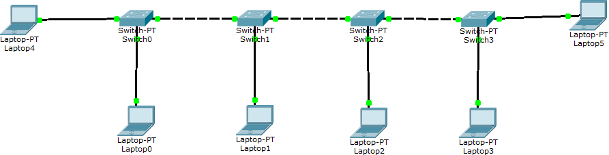

Hub

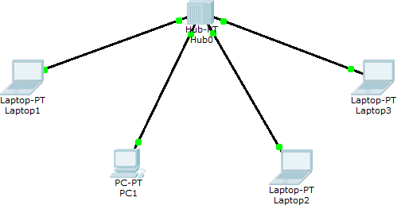

Switch

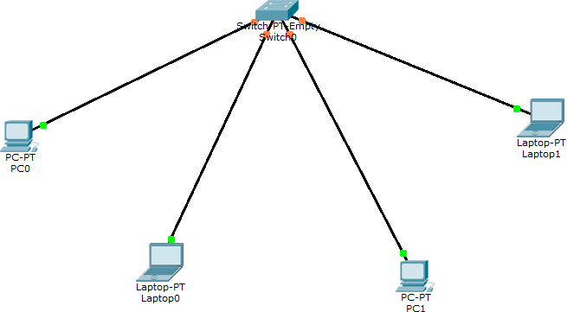

Mesh

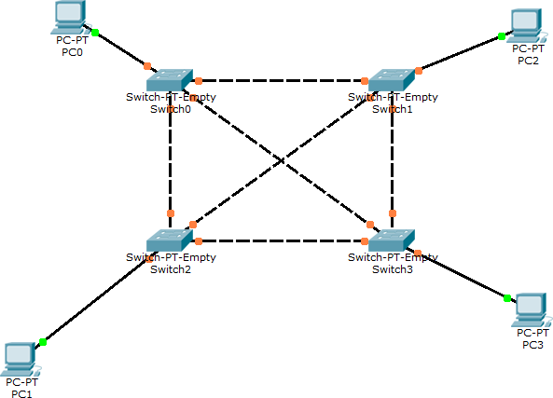

Program 2: Configure DHCP within a LAN and outside LAN. Network diagram:
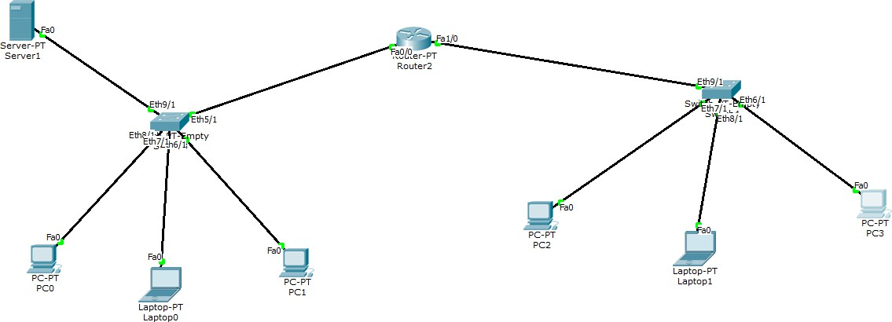

Configuration:
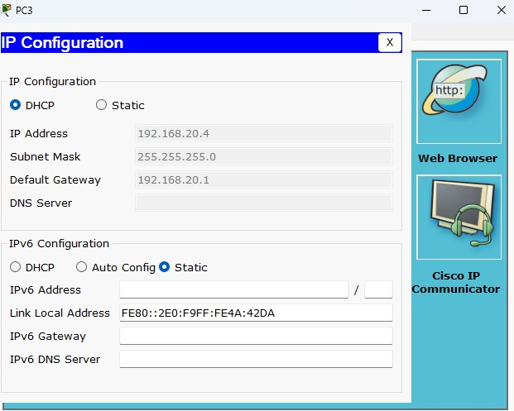
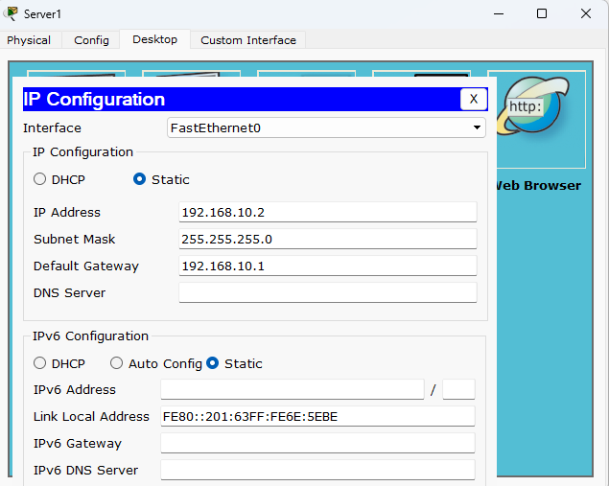

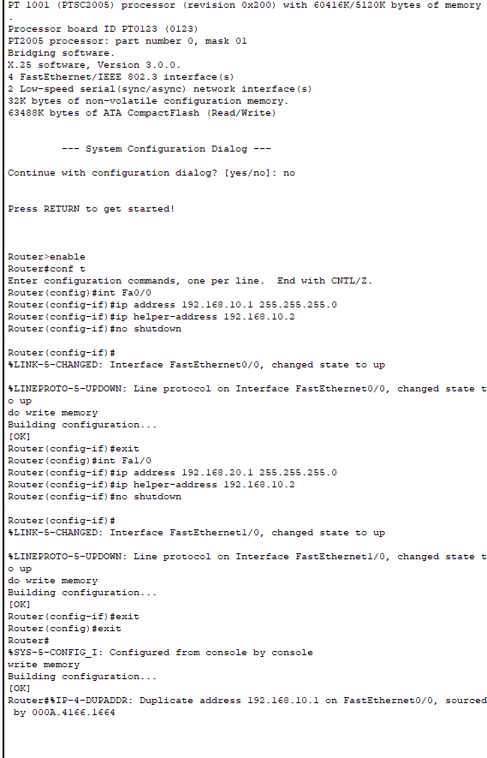

Program 3: Configure Web Server, DNS within a LAN. Network diagram:
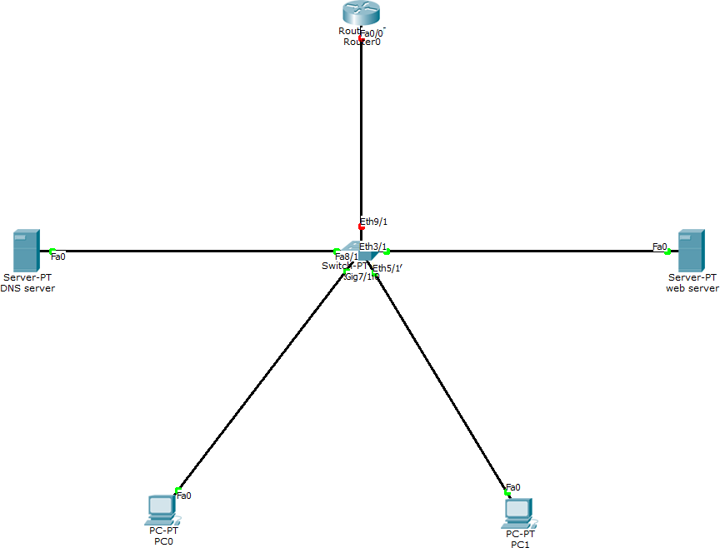

Configuration:
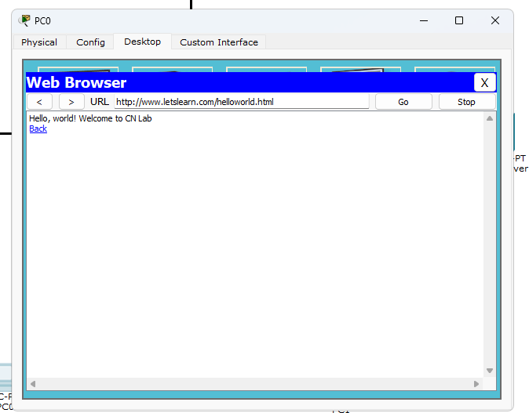
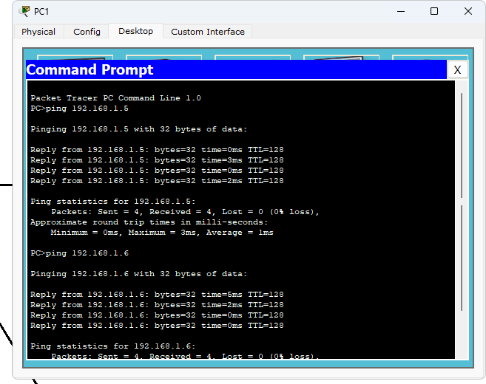

Program 4: Configure IP address to routers in packet tracer. Explore the following messages: ping responses, destination unreachable, request timed out, reply.
Network diagram:

Configuration:
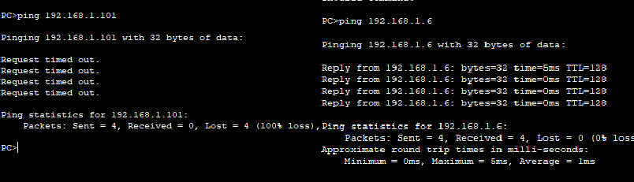

Program 5: Configure default route, static route to the Router. Network diagram:
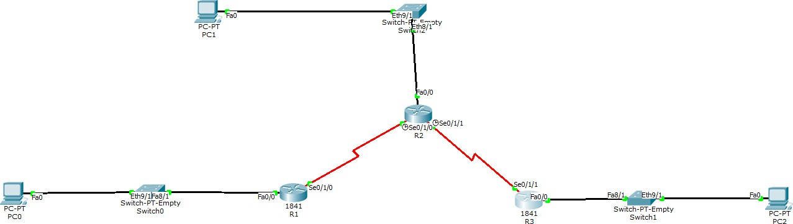

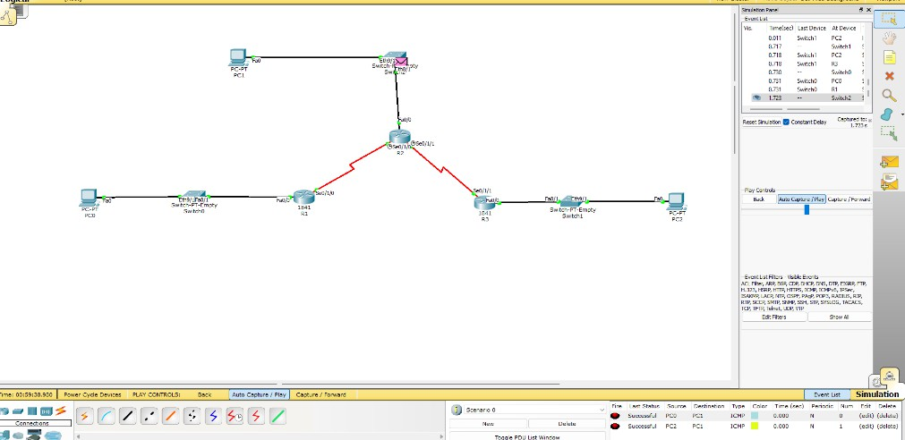

Configuration:
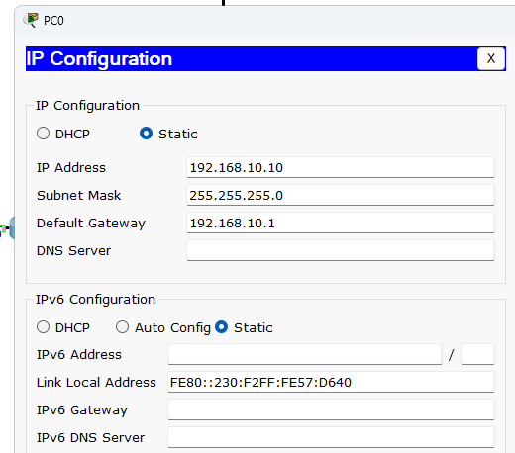
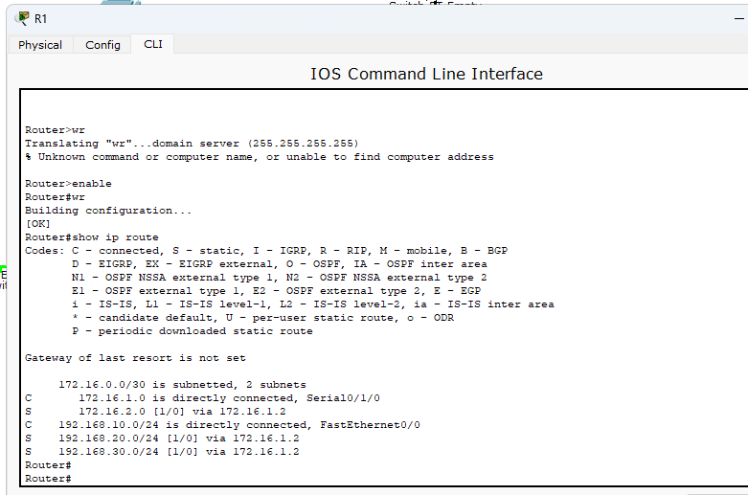
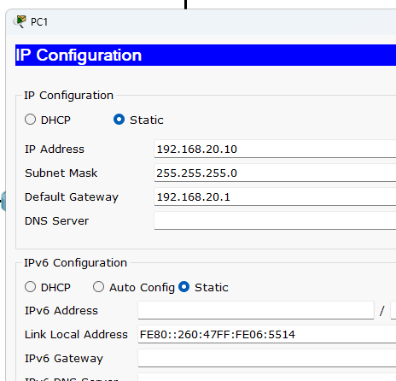
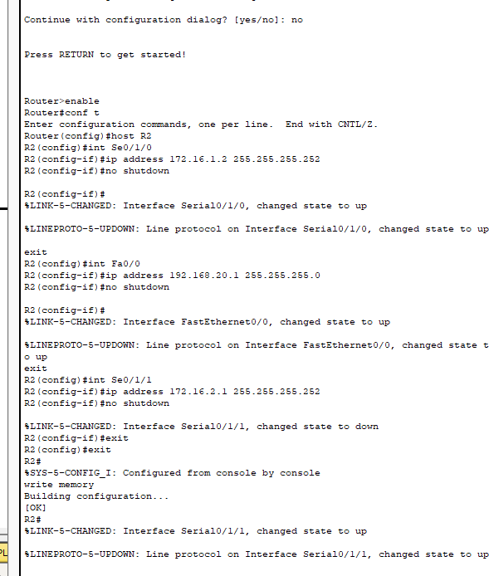

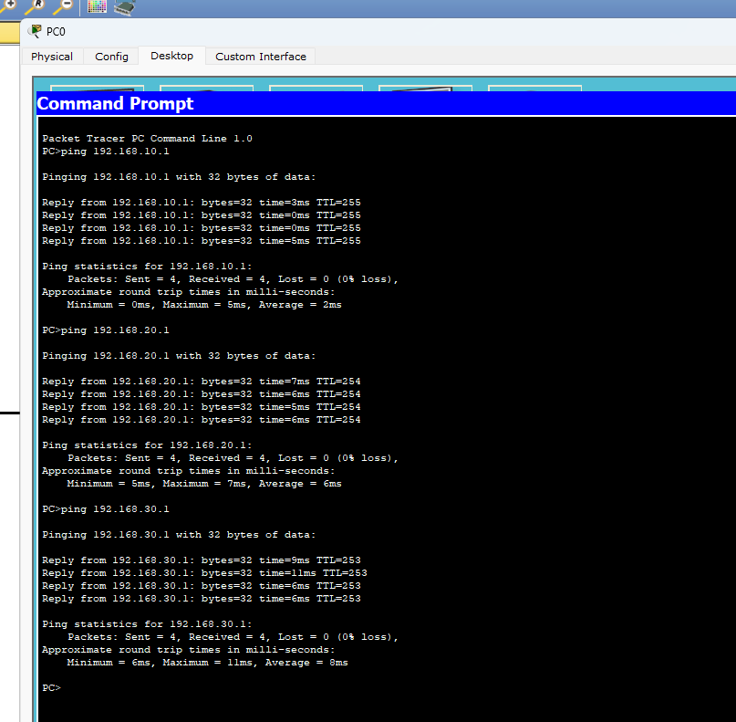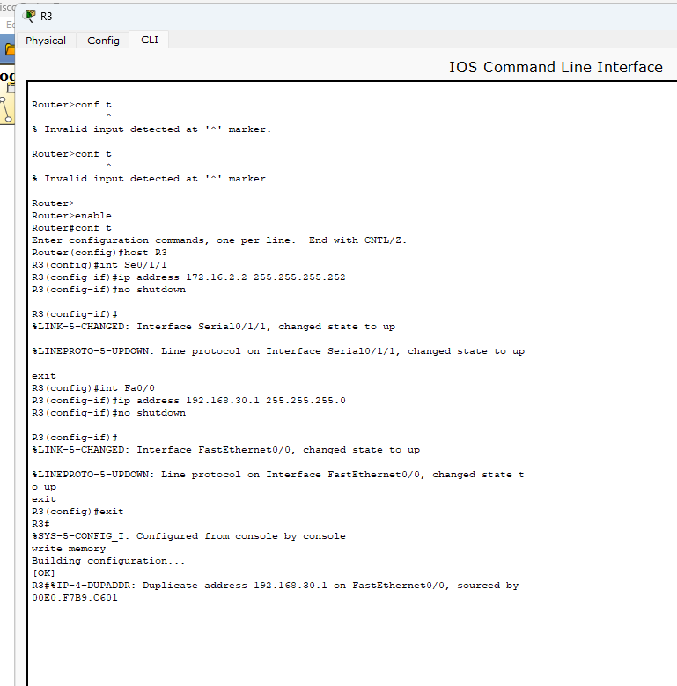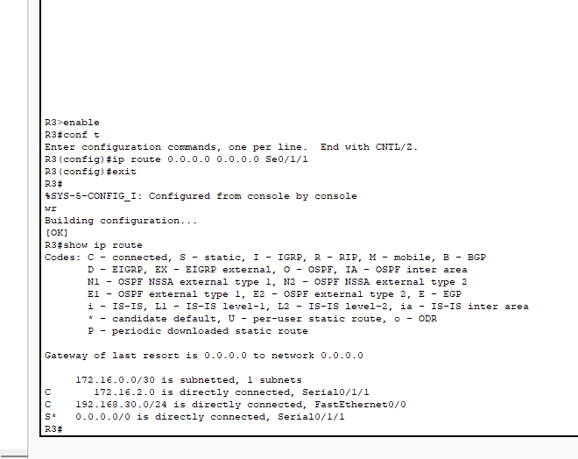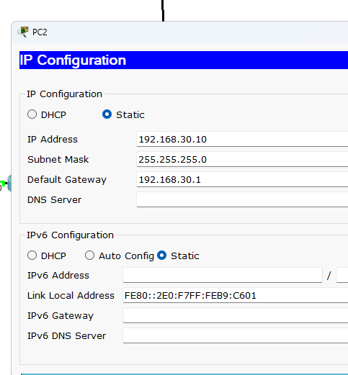

Program 6: Configure RIP routing Protocol in Routers. Network diagram:
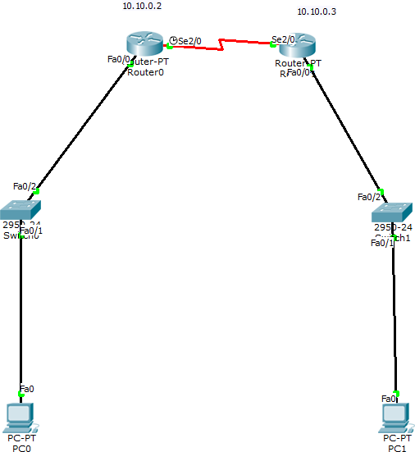

Configuration:
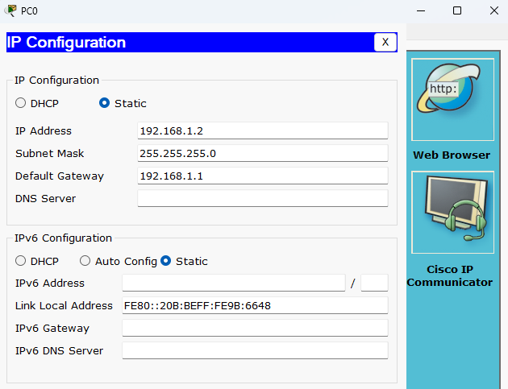
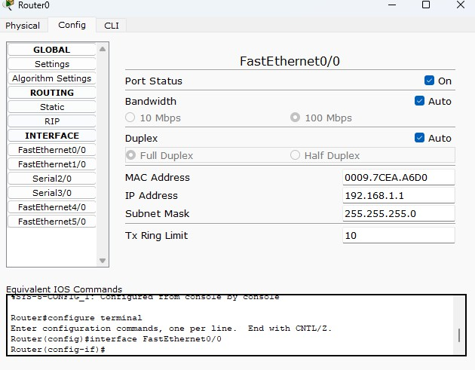
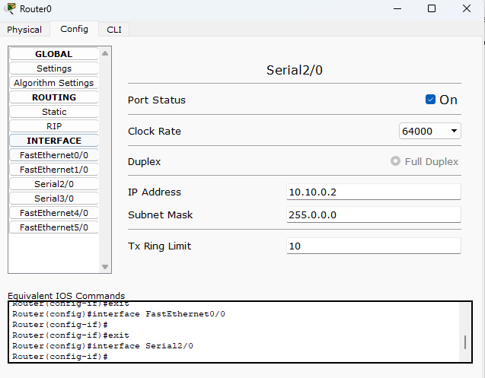
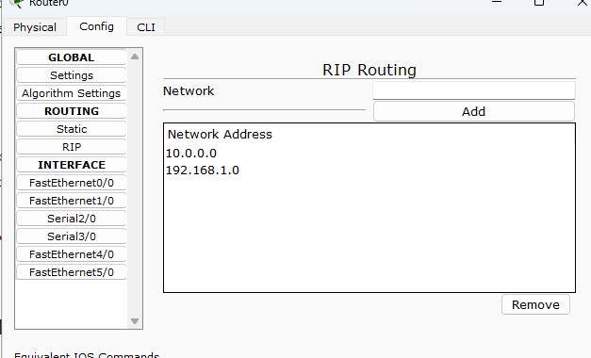

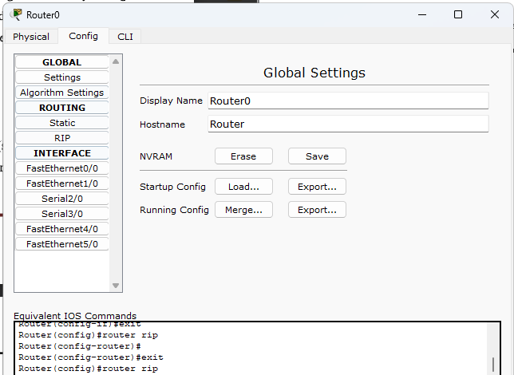

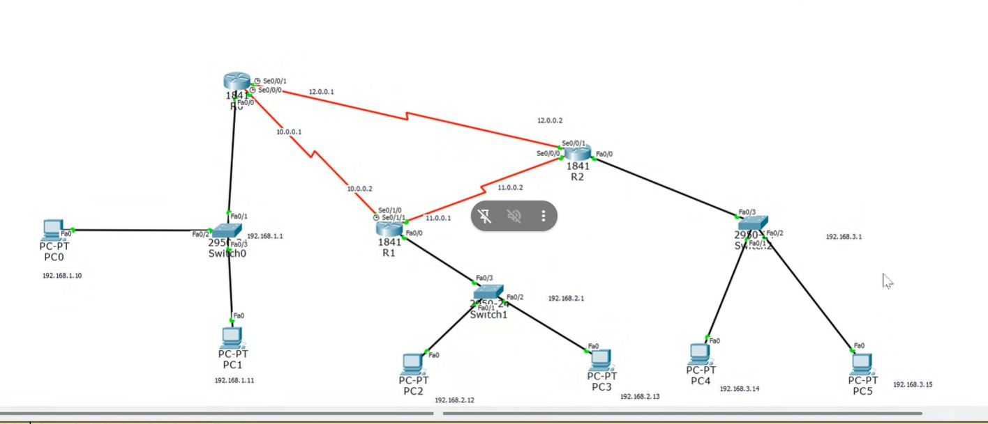
Program 7: Configure OSPF routing protocol. Network diagram:

Configuration:
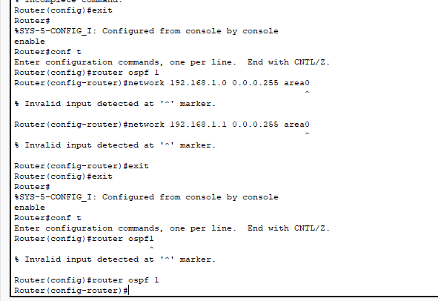
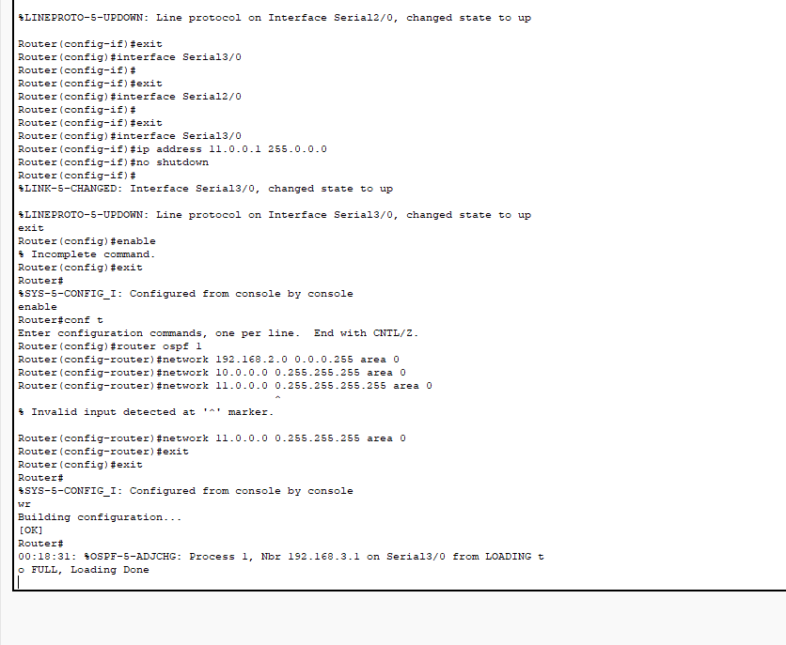

Program 8: To construct a VLAN and make the PC’s communicate among a VLAN.
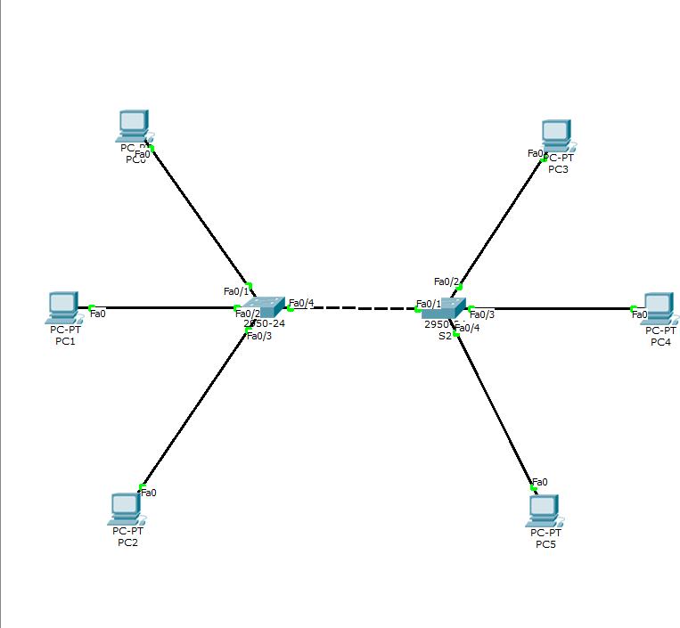
Network diagram:

Configuration:
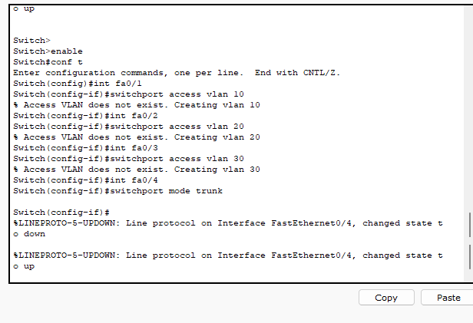
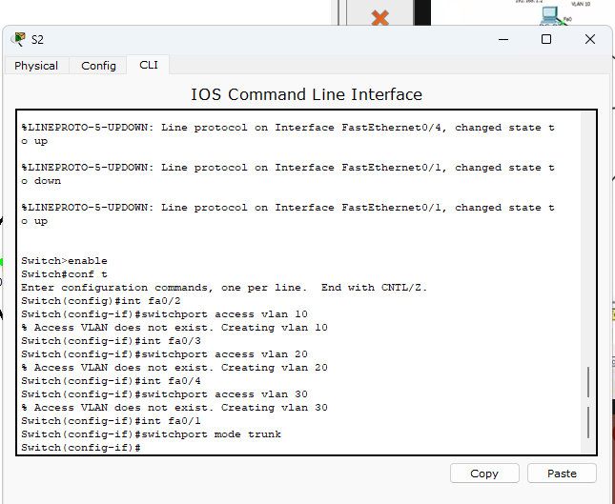
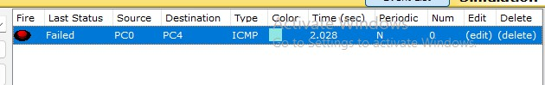

Program 9: To construct a WLAN and make the nodes communicate wirelessly. Network diagram:

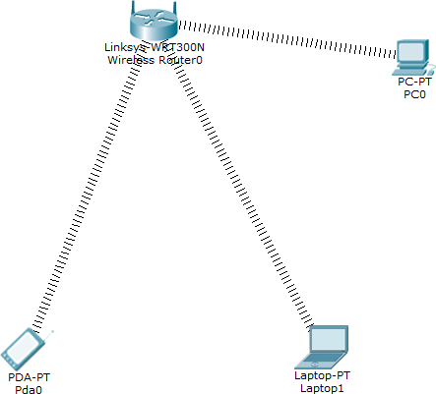

Configuration:
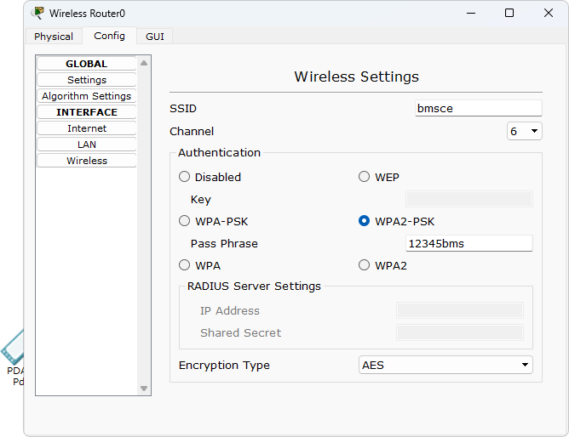
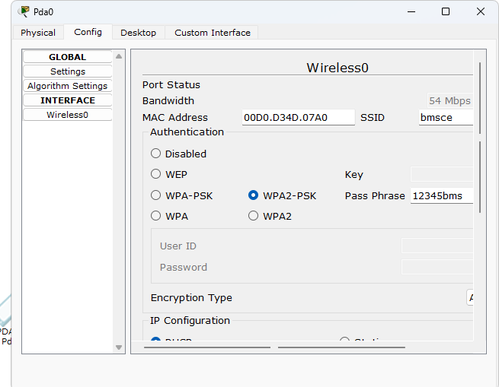

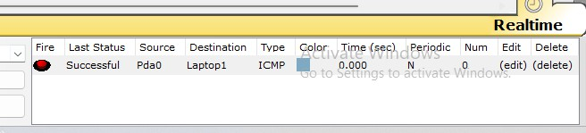

Program 10: Demonstrate the TTL/ Life of a Packet. Network diagram:
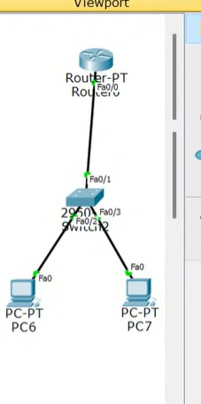
Configuration:
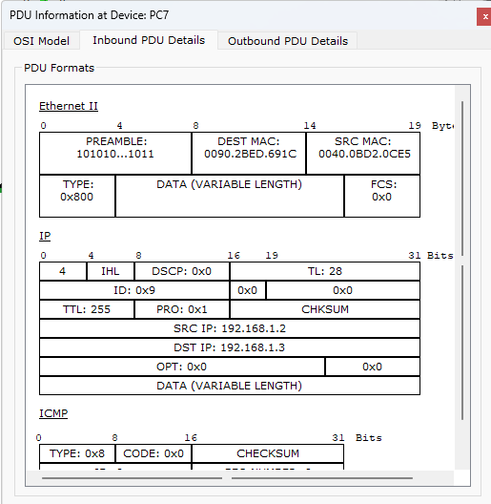
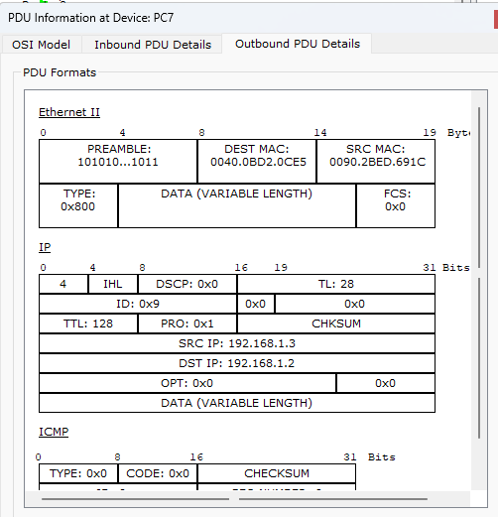

Program 11: To understand the operation of TELNET by accessing the router in server room from a PC in IT office.
Network diagram:

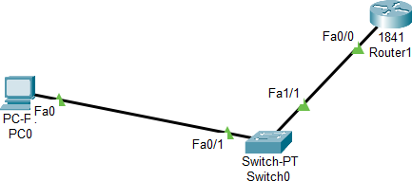

Configuration:
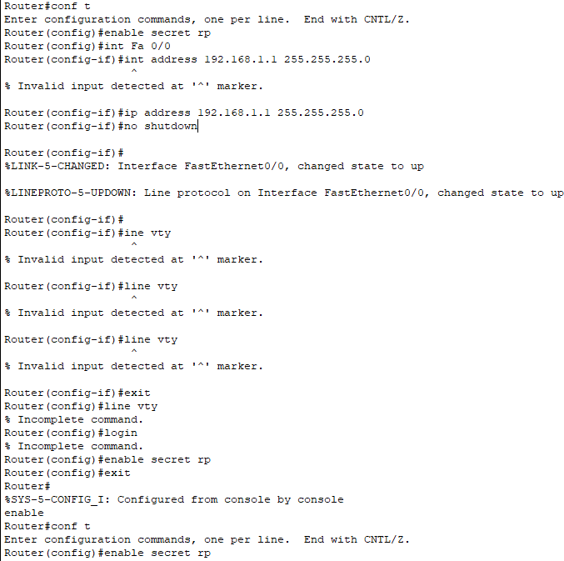

Program 12: To construct simple LAN and understand the concept and operation of Address Resolution Protocol (ARP).
Network diagram:

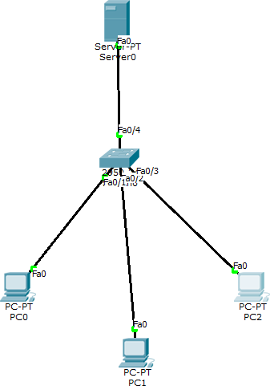

Configuration:
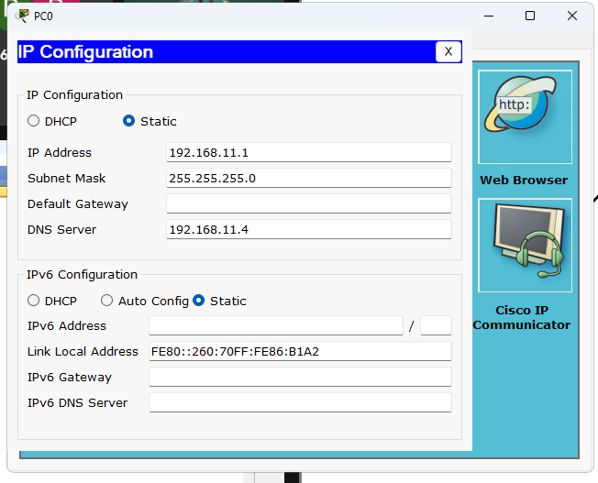
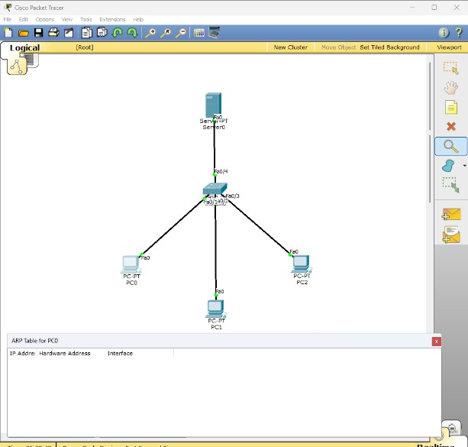

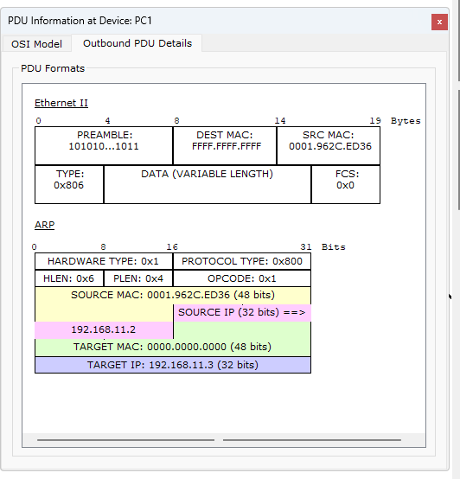
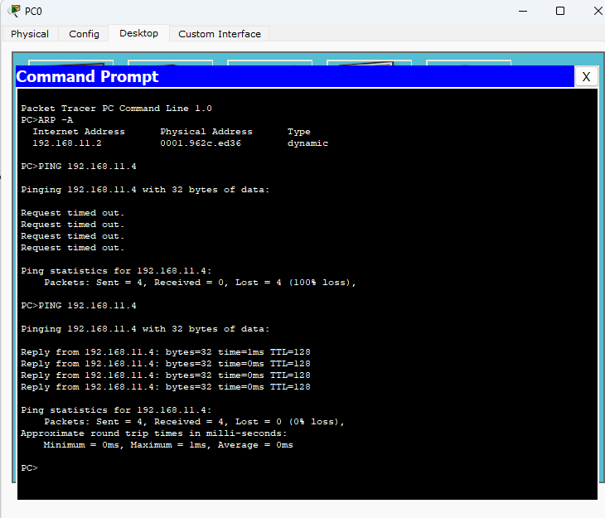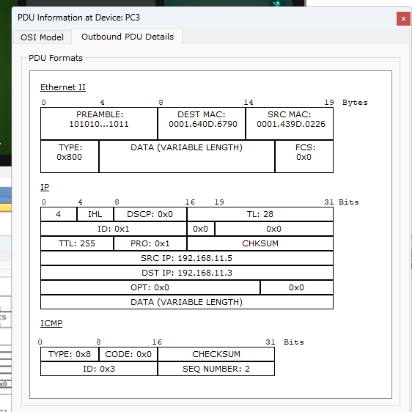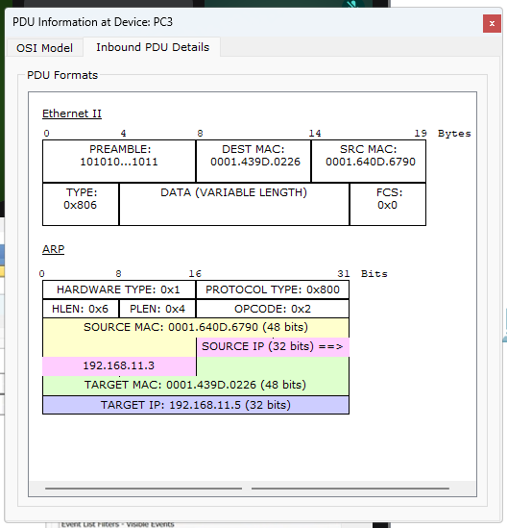

PART - B
Program 1: Write a program for congestion control using Leaky bucket algorithm. Code: #include<stdio.h>
int min(int x, int y) { return (x < y) ? x : y;
}
int main() {
int drop = 0, mini, nsec, cap, count = 0, i, inp[25], process; printf("Enter the bucket size: ");
scanf("%d", &cap);
printf("Enter the processing rate: "); scanf("%d", &process);
printf("Enter the number of seconds you want to simulate: "); scanf("%d", &nsec);
for (i = 0; i < nsec; i++) {
printf("Enter the size of the packet entering at %d sec: ", i + 1); scanf("%d", &inp[i]);
}
printf("\n Second | Packet Received | Packet Sent | Packet Left | Dropped \n"); printf(" \n");
for (i = 0; i < nsec; i++) { count += inp[i];
if (count > cap) { drop = count - cap; count = cap;
}
printf("%6d | %15d |", i + 1, inp[i]); mini = min(count, process);
printf(" %11d |", mini);

count -= mini;
printf(" %11d | %7d\n", count, drop);

drop = 0;
}
while (count != 0) { i++;
if (count > cap) { drop = count - cap; count = cap;
}
printf("%6d | %15d |", i, 0); mini = min(count, process); printf(" %11d |", mini);

count -= mini;
printf(" %11d | %7d\n", count, drop);

}
return 0;
}
OUTPUT:
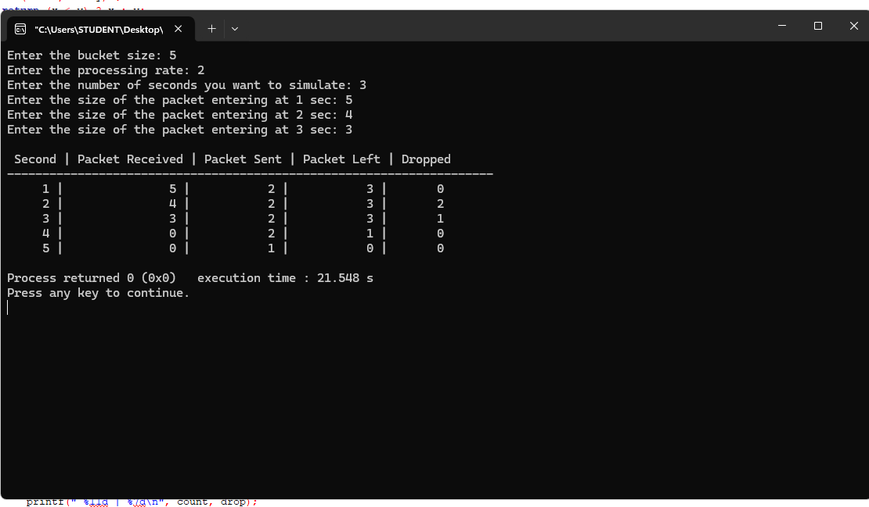

Program 2: Using TCP/IP sockets, write a client-server program to make client sending the file name and the server to send back the contents of the requested file if present.
Code:
Server:
#include <stdio.h> #include <stdlib.h> #include <string.h> #include <unistd.h> #include <sys/types.h> #include <sys/socket.h> #include <netinet/in.h>
int main(int argc, char *argv[])
{
int sockfd, newsockfd, portno, n;
char buffer[256], line[2000], filedata[20000]; struct sockaddr_in serv, cli;
socklen_t len;

FILE *fp;
if (argc < 2) {
printf("Error: No port number provided.\nUsage: ./server <port>\n"); exit(1);
}
sockfd = socket(AF_INET, SOCK_STREAM, 0); if (sockfd < 0) {
perror("Socket creation failed"); exit(1);
}
memset(&serv, 0, sizeof(serv)); portno = atoi(argv[1]); serv.sin_family = AF_INET;
serv.sin_addr.s_addr = INADDR_ANY; serv.sin_port = htons(portno);
if (bind(sockfd, (struct sockaddr *)&serv, sizeof(serv)) < 0) { perror("Bind failed");
exit(1);
}
listen(sockfd, 5);
printf("Server: Waiting for connection...\n"); len = sizeof(cli);
newsockfd = accept(sockfd, (struct sockaddr *)&cli, &len); if (newsockfd < 0) {
perror("Accept failed"); exit(1);
}

memset(buffer, 0, sizeof(buffer));
n = read(newsockfd, buffer, sizeof(buffer) - 1); if (n < 0) {
perror("Error reading file name"); exit(1);
}
printf("Server received file request: %s\n", buffer); fp = fopen(buffer, "r");
if (fp == NULL) {
printf("Server: File not found.\n"); write(newsockfd, "File not found", 15); close(newsockfd);
close(sockfd); return 0;
}
printf("Server: File found. Reading...\n"); memset(filedata, 0, sizeof(filedata));
while (fgets(line, sizeof(line), fp) != NULL) { strcat(filedata, line);
}
fclose(fp);
n = write(newsockfd, filedata, strlen(filedata)); if (n < 0)
perror("Error writing to socket"); printf("Transfer complete.\n");

close(newsockfd); close(sockfd); return 0;
}
Client:
#include <stdio.h> #include <stdlib.h> #include <string.h> #include <unistd.h> #include <sys/types.h> #include <sys/socket.h> #include <netinet/in.h>
int main(int argc, char *argv[])
{
int sockfd, portno, n;
char filename[256], filedata[20000]; struct sockaddr_in serv;
if (argc < 2) {
printf("Error: No port number provided.\nUsage: ./client <port>\n"); exit(1);
}
sockfd = socket(AF_INET, SOCK_STREAM, 0); if (sockfd < 0) {
perror("Socket creation failed"); exit(1);
}
memset(&serv, 0, sizeof(serv));

portno = atoi(argv[1]); serv.sin_family = AF_INET; serv.sin_port = htons(portno);
serv.sin_addr.s_addr = INADDR_ANY; // connecting to same machine if (connect(sockfd, (struct sockaddr *)&serv, sizeof(serv)) < 0) {
perror("Server not responding"); exit(1);
}
printf("Enter file path: "); scanf("%s", filename);
n = write(sockfd, filename, strlen(filename)); if (n < 0)
perror("Error writing filename"); memset(filedata, 0, sizeof(filedata));
n = read(sockfd, filedata, sizeof(filedata) - 1); if (n < 0)
perror("Error reading data from server"); printf("\n--- File Content ---\n%s\n", filedata); close(sockfd);
return 0;
}
Output:
$ cc socketserver.c
$ ./a.out 1025 server:
waiting for connection
server received:/home/aps/cse.txt

server:/home/aps/cse.txt found opening and reading.. reading..
..reading complete transfer complete
$ cc socketclient.c
$ ./a.out 1025
Enter the file with complete path
/home/aps/cse.txt Reading..
..
client: display content of /home/aps/cse.txt
..
Welcome to the CSE department.......... 2)
$ cc fserver.c
$ ./a.out error:no port no usage:
/server port no
$ cc fclient.c
$./a.out
Err:no port no. usage:
./client portno ex:./client 7777

Program 3: Using UDP sockets, write a client-server program to make client sending the file name and the server to send back the contents of the requested file if present.
Code:
Server:
#include <stdio.h> #include <stdlib.h> #include <string.h> #include <unistd.h> #include <sys/types.h> #include <sys/socket.h> #include <netinet/in.h>

int main(int argc, char *argv[])
{
int sockfd, portno, n; char buffer[1024];
struct sockaddr_in servaddr, cliaddr; socklen_t len;

if (argc < 2) {
printf("Usage: ./server <port>\n"); exit(1);
}

portno = atoi(argv[1]);

sockfd = socket(AF_INET, SOCK_DGRAM, 0); if (sockfd < 0) {
perror("Socket creation failed"); exit(1);
}

memset(&servaddr, 0, sizeof(servaddr));
memset(&cliaddr, 0, sizeof(cliaddr));

servaddr.sin_family = AF_INET; servaddr.sin_addr.s_addr = INADDR_ANY; servaddr.sin_port = htons(portno);

if (bind(sockfd, (struct sockaddr *)&servaddr, sizeof(servaddr)) < 0) { perror("Bind failed");
exit(1);
}

printf("UDP Server: Waiting for data...\n");

len = sizeof(cliaddr); memset(buffer, 0, sizeof(buffer));

n = recvfrom(sockfd, buffer, sizeof(buffer)-1, 0, (struct sockaddr *)&cliaddr, &len);
if (n < 0) { perror("Receive failed");

exit(1);
}

printf("Received from client: %s\n", buffer);

// Echo back the same data
n = sendto(sockfd, buffer, strlen(buffer), 0, (struct sockaddr *)&cliaddr, len);
if (n < 0)
perror("Send failed");

close(sockfd); return 0;
}
Client:
#include <stdio.h> #include <stdlib.h> #include <string.h> #include <unistd.h> #include <sys/types.h> #include <sys/socket.h> #include <netinet/in.h>

int main(int argc, char *argv[])
{
int sockfd, portno, n; char buffer[1024];

struct sockaddr_in servaddr; socklen_t len;

if (argc < 2) {
printf("Usage: ./client <port>\n"); exit(1);
}

portno = atoi(argv[1]);

sockfd = socket(AF_INET, SOCK_DGRAM, 0); if (sockfd < 0) {
perror("Socket creation failed"); exit(1);
}

memset(&servaddr, 0, sizeof(servaddr));

servaddr.sin_family = AF_INET; servaddr.sin_port = htons(portno);
servaddr.sin_addr.s_addr = INADDR_ANY; // local machine

printf("Enter message to send: "); scanf("%[^\n]", buffer);

len = sizeof(servaddr);

n = sendto(sockfd, buffer, strlen(buffer), 0, (struct sockaddr *)&servaddr, len);
if (n < 0) { perror("Send failed"); exit(1);
}

memset(buffer, 0, sizeof(buffer));

n = recvfrom(sockfd, buffer, sizeof(buffer)-1, 0, (struct sockaddr *)&servaddr, &len);
if (n < 0) { perror("Receive failed"); exit(1);
}

printf("Server replied: %s\n", buffer); close(sockfd);
return 0;
}
Output:
1)
UDP Server: Waiting for data... Received from client: Hello UDP Server! 2)
Enter message to send: Hello UDP Server! Server replied: Hello UDP Server!

Program 4: Write a program for error detecting code using CRC-CCITT (16-bits).
Code: #include <stdio.h> #include <string.h> #include <stdlib.h>
int main() {
char rem[50], a[50], s[50], c, msj[50], gen[30]; int i, genlen, t, j, flag = 0, k, n;

printf("Enter the generator polynomial: "); fgets(gen, sizeof(gen), stdin); gen[strcspn(gen, "\n")] = '\0';
printf("Generator polynomial is CRC: %s\n", gen);

genlen = strlen(gen); k = genlen - 1;

printf("Enter the message: "); n = 0;
while ((c = getchar()) != '\n') { msj[n] = c;
n++;
}
msj[n] = '\0';

for (i = 0; i < n; i++) { a[i] = msj[i];
}
for (i = 0; i < k; i++) { a[n + i] = '0';
}
a[n + k] = '\0';

printf("\nMessage polynomial appended with zeros:\n"); puts(a);

for (i = 0; i < n; i++) { if (a[i] == '1') {
t = i;
for (j = 0; j <= k; j++) {
a[t] = (a[t] == gen[j]) ? '0' : '1'; t++;
}
}
}

for (i = 0; i < k; i++) { rem[i] = a[n + i];
}

rem[k] = '\0';

printf("The checksum appended:\n"); puts(rem);
printf("\nThe message with checksum appended:\n"); for (i = 0; i < n; i++) {
a[i] = msj[i];
}
for (i = 0; i < k; i++) { a[n + i] = rem[i];
}
a[n + k] = '\0'; puts(a);

n = 0;
printf("Enter the received message: "); while ((c = getchar()) != '\n') {
s[n] = c; n++;
}
s[n] = '\0';
for (i = 0; i < n; i++) { if (s[i] == '1') {
t = i;
for (j = 0; j <= k; j++, t++) {
s[t] = (s[t] == gen[j]) ? '0' : '1';
}
}
}

for (i = 0; i < k; i++) { rem[i] = s[n + i];
}
rem[k] = '\0';
for (i = 0; i < k; i++) { if (rem[i] == '1') {
flag = 1;
}
}

if (flag == 0) {
printf("Received polynomial is error-free.\n");
} else {
printf("Received polynomial has an error.\n");
}

return 0;
}
OUTPUT:

