J&J Supplier Rationalization: Business Case
Oct 29, 2026 · @Hemant

Executive summary
Recommendation: small cut, big impact. Every supplier cut has to be justified and defended with the people who buy from it, so start with the cuts that are easiest to defend: merge duplicate records and move one-time vendors to catalogs. That cuts 27% of active suppliers and still captures $356M a year, 86% of the base-case value, for $34M one-time. Then re-tender the ~150 largest Leverage suppliers, who hold 80% of the spend the re-tender saving applies to.
Where J&J is today: J&J was quoted at 80,000 suppliers (around 2021, before the Kenvue spin-off) and reports ~39,000 for FY2025. The 2023 Kenvue spin-off took an estimated 12,600–24,000 suppliers; the rest is a 30–42% reduction, the size our rules produce on 344,504 real purchase orders. From ~39,000, a category-level target model takes J&J to ~32,100.
- Measured vs assumed: in the base plan (−44%) savings are $414M a year, of which $134M is measured in the data; the $300M goal needs a re-tender saving of at least 0.89% (1.2% in the conservative plan). These are cost savings, so they show up in operating profit, not revenue.
- Cutting deeper adds little: going from 27% to 44% cuts 13,700 more suppliers for $58M a year; going to 52% adds 6,200 more for $12M, and adds supply risk.
Strategic suppliers are never cut. Real J&J examples from SEC filings (Alkermes, MeiraGTx, Mersana) are sole-source manufacturers that move to partnership agreements; Emergent BioSolutions, whose contract J&J ended in 2022 over quality breaches, shows why critical products need a qualified second source.
Student case study: methods run on real public procurement data (State of California purchase orders, FY2012–15) and are scaled to J&J's published totals. J&J's internal supplier data is not public.

Goal and method
Goal: decide which suppliers J&J should keep, consolidate or exit, with a data reason behind every decision; find the plan that captures most of the value with the fewest cuts; and measure any supply risk the plan adds.
We answer four questions, one method each. Each answer feeds the next; together they produce the exit list and the business case numbers.
# | Decision question | Method | Tool | Output
1 | Where does the spend sit? | Spend cube + Pareto / ABC analysis | SQL | A / B / C segment per supplier
2 | How should each category be handled? | Kraljic matrix (value vs supply risk) | Python | Quadrant per category, which sets the agreement type
3 | Which suppliers stay and which go? | Duplicate detection + weighted scorecard + rules 1–5 | Python (rapidfuzz), SQL | Keep / consolidate / exit list, one reason code per supplier
4 | What is it worth? | Savings model, low / base / high scenarios | Python | Savings, one-time cost, NPV
The one AI/ML piece: fuzzy name matching to find duplicate suppliers (for example "Acme Lab Supply Inc" and "ACME Laboratory Supplies"). Duplicates are the easiest exits to justify, so this is where ML directly supports the recommendation.
One dashboard (Power BI or Tableau), one view per question: Pareto curve, Kraljic 2x2, exit list by reason code, savings bridge.
Deliberately left out, because none of them would change the recommendation:
Method | Why it is out
NLP spend classification | Our synthetic data is already categorized; it solves a real-data problem we don't have
Supplier risk prediction (random forest, XGBoost) | Needs real failure history; on synthetic data it would only learn our own assumptions
K-means clustering | The scorecard and Kraljic matrix already group suppliers in ways a reader can explain
Linear programming optimization | Rules 1–5 already encode the constraints; an optimizer adds complexity, not a different list
Monte Carlo simulation | Three scenarios show the range clearly enough
Data needed: five tables (suppliers, spend transactions, categories, scorecards, contracts), generated synthetically and calibrated to J&J's public totals.

Current state
J&J's supplier count has moved a lot, with the business and with how suppliers are counted:
When | Suppliers | Source
After 2014 (undated) | 80,000 | State of Flux case study
2021 | 78,000+ | ArcGIS StoryMap (individual author, no source given)
2023 | 38,500+ | 2023 Health for Humanity Report; Kenvue separated (IPO May, completed 23 Aug)
2024 | 29,000+ | 2024 Health for Humanity Report
FY2025 | ~39,000 | Global Modern Slavery Statement 2025 (new counting method)
This case starts from 80,000. Kenvue publishes no supplier count, so its share is estimated: 15.7% if in line with Consumer Health's share of J&J's 2022 sales ($14,953M of $94,943M), 30% as a high case. That leaves 56,000–67,400 J&J suppliers and a reduction of 30–42% to reach ~39,000.

The problem
Most of J&J's suppliers carry little spend but full overhead. In a typical Pareto-shaped base, about 85% of suppliers hold under 10% of spend, yet each one still needs onboarding, master data, compliance screening, invoices and payments.
- Lost leverage: the same category (lab supplies, MRO, IT services, travel, packaging) is bought from many vendors at many prices.
- Process cost: every active supplier costs an estimated ~$2,000 a year to maintain, before any audits.
- Risk blind spots: with tens of thousands of suppliers, risk monitoring (financial, ESG, cyber, sanctions) cannot go deep on each one.
- Compliance exposure: more suppliers means more third-party due diligence under anti-bribery and supply chain due-diligence rules.
The opportunity is not to squeeze strategic suppliers; it is to consolidate the long tail and the duplicated mid-tier.

Proposed approach
Count one year of active suppliers (the basis of J&J's reported counts) and sort the reductions into three tiers, from easiest to hardest to defend. Same savings rates in every tier:
Tier | What changes | Suppliers cut (of 80,000) | Savings a year | One-time cost
Conservative (recommended first) | Merge duplicate records; move one-time vendors to catalogs | 21,800 (−27%) | $356M | $34M
Base | + consolidate within Leverage and Non-critical categories | 35,500 (−44%) | $414M | $73M
Aggressive | + consolidate in Strategic and Bottleneck categories | 41,700 (−52%) | $427M | $91M
Rationalization rules (applied supplier by supplier in the data phase):
- Never exit a regulated sole source (FDA-validated API, excipient, component or contract manufacturer) without a qualified alternative and a requalification plan.
- Keep at least two qualified sources for anything patient-critical.
- Protect diverse and small suppliers: they are consolidated into preferred-supplier and Tier 2 programs, not dropped, so Tier 1 diverse spend stays at or above $3B.
- Exit first where a supplier is inactive (no PO in 18 months), duplicated (same category, same site, lower score) or below a minimum spend threshold.
- Score the rest on cost, quality, delivery, risk, ESG and diversity; the lowest-scoring supplier in a category exits first.

What the real data shows
The approach was tested on 344,504 real State of California purchase lines (FY2012–15). After removing pass-through and procurement-exempt spend, 278,632 lines remain: $21.9B over 3 years across 16,933 suppliers. Every assumption above held or was corrected.
Step | Question | Result on real data | vs. assumption
2 Pareto / ABC (SQL) | Where does the spend sit? | Top 1.9% of suppliers = 70% of spend; top 10.7% = 92% | Assumed 2% / 15%: holds
2 Spend cube | How much of the tail is dead weight? | 59% of tail suppliers are inactive 18+ months or one-time vendors | Assumed 60% tail cut: holds
3 Kraljic | How should each category be handled? | Leverage 59% of spend (20 categories); strategic 21%; bottleneck 13%; non-critical 7% but 21,991 supplier relationships | Sets the agreement type per category
4 Duplicates (ML) + rules | Which suppliers stay? | 858 duplicate records found (TF-IDF name matching); 4,649 of 16,933 supplier records kept over three years. On one year of active suppliers (8,226): −27% conservative, −44% base, −52% aggressive | Assumed −54%: real −59% of active base
5 Price-gap test | Do exiting suppliers charge more? | Same goods item: +9.8% in leverage, +5.2% in non-critical, but −10% in bottleneck and −7% in strategic | Assumed 5–8% everywhere: corrected
The key correction: consolidation only saves money in leverage and non-critical categories. In bottleneck and strategic categories the small suppliers were cheaper, so the plan secures supply there instead of squeezing price.

Real J&J strategic suppliers
Read from the suppliers' own SEC 10-K filings:
Supplier | Supplies J&J with | Lesson
Alkermes | Sole manufacturer of RISPERDAL CONSTA (Ohio plant) | Sole-source, regulated: never cut; partnership MOU + supply and quality agreements
MeiraGTx | RPGR gene therapy, 4+1-year supply agreement (Dec 2023) | Long-term supply agreement, not a tender
Mersana | Clinical ADC manufacturing, with a technology-transfer right for J&J | A second-source path written into the contract
Emergent BioSolutions (former) | COVID-19 vaccine drug substance; J&J ended it in 2022 over GMP breaches, settled for $50M in 2024 | Why a qualified second source is a rule, not an option

Small cut, big impact
The savings depend little on how many suppliers are cut. The conservative tier keeps 86% of the base-case value with 61% of the cuts, because most of the value is the re-tender of suppliers J&J keeps: 152 of the 1,649 kept Leverage suppliers hold 80% of that spend. Negotiating with about 150 large suppliers is worth more than cutting thousands of small ones.

Phase 2: going further from ~39,000
Once the easy cuts are made, most remaining suppliers are legitimate, so a different model is needed: a target count per category. Keep the fewest suppliers covering 90% of the category's spend, with at least two in Strategic and Bottleneck categories, and always keep strategic, sole-source and small/diverse suppliers.
Spend coverage target | Reduction | J&J suppliers
80% | −22% | ~30,500
90% (recommended) | −18% | ~32,100
95% | −14% | ~33,700
Only 1.5% of the year's spend changes supplier, and the number of categories dominated by one supplier does not change. Phase 2 saves about $14M a year in supplier management, not big price savings.

Financial case
Original top-down estimate (before the real data): $385M a year at full run-rate against $59M one-time cost. The real-data model below replaces it.
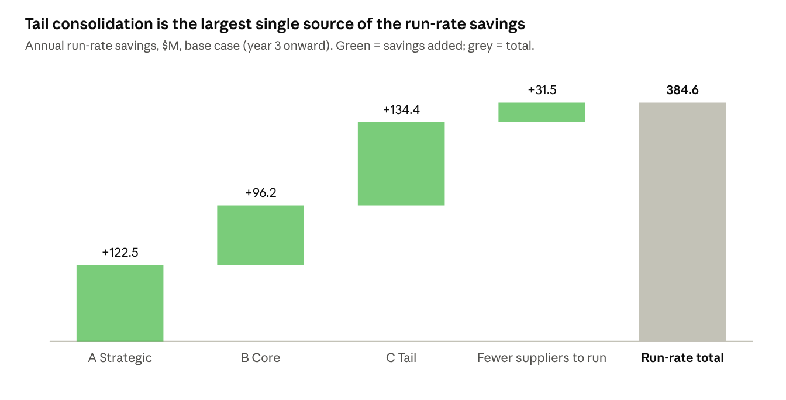
Business case model (model.py), base case assumptions
Price savings make up $353M of the total; the remaining $31.5M comes from no longer maintaining ~15,700 exited suppliers.
One-time cost: $58.6M, made up of program team, analytics and tools ($15M), contracting and legal ($5M), supplier transition and requalification ($31M) and a 15% contingency. Core-segment exits carry most of the transition cost ($25k each) because some need quality requalification.
Scenarios (savings ramp 30% / 70% / 100% over years 1–3, 8% discount rate):
Scenario | Savings vs base | Cost vs base | Run-rate ($M/yr) | 3-yr savings ($M) | 3-yr NPV ($M) | ROI
Low | 50% | 125% | 192 | 385 | 248 | 4.3x
Base | 100% | 100% | 385 | 769 | 584 | 12.1x
High | 130% | 90% | 500 | 1,000 | 783 | 18.0x
Run-rate savings of 1.1% of addressable spend sit at the conservative end for a consolidation program, which is what makes the case defensible.

Real-data savings model (replaces the estimate)
Each step-4 decision is tied to one lever, using the price gap measured in the data where it exists. Inactive suppliers count as $0 because their spend had already stopped.
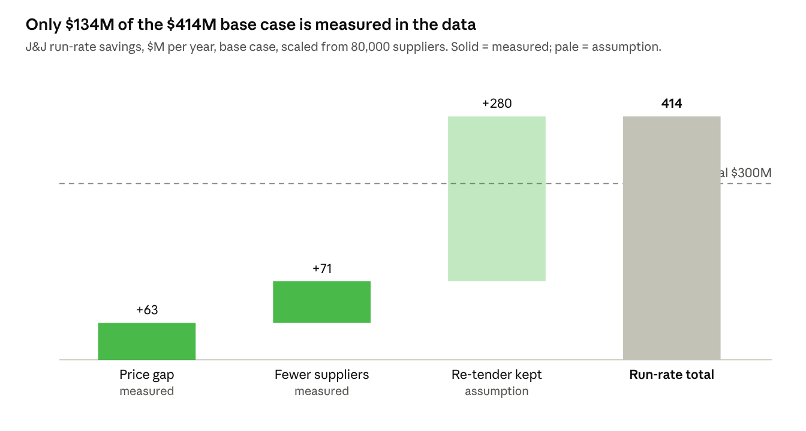
scripts/05_savings.py on the real supplier list, scaled to J&J ($35B spend; 80,000 suppliers ÷ 8,226 active in one year)
J&J scale, $M | Low | Base | High
Price gap on re-routed spend (measured) | 0 | 63 | 126
Fewer suppliers to manage (scaled from 80,000) | 22 | 71 | 125
Re-tender of kept leverage suppliers (assumption) | 93 | 280 | 561
Run-rate savings per year | 115 | 414 | 811
One-time cost | 34 | 73 | 91
3-year NPV (8%, ramp 30/70/100%) | 158 | 619 | 1,265
Meets $300M goal? | No | Yes | Yes
What has to be true: the re-tender of kept leverage suppliers must save at least 0.89% for the base case to clear $300M (1.2% in the conservative plan). The MSA template's volume tiers and benchmark clause are how that saving is captured and measured.

Agreements for retained suppliers
Each retained supplier gets the agreement its role needs. An MOU fits strategic partners because it records shared intent, but it is not binding on price or supply, so it always sits on top of a binding contract.
Kraljic quadrant | Typical J&J categories | Agreement | What it locks in | Term
Strategic (high value, high risk) | APIs, biologics inputs, contract manufacturers | MOU / strategic partnership + supply agreement + quality agreement | Joint roadmap, capacity reservation, quality and change-control terms | 3–5 yrs
Bottleneck (low value, high risk) | Specialty excipients, single-source components | Long-term supply agreement + dual-sourcing plan | Safety stock, notice of discontinuation, second source qualification | 3–5 yrs
Leverage (high value, low risk) | Packaging, lab supplies, IT services, logistics | Master supply / services agreement (MSA) | Volume-tiered pricing, SLAs, rebates, payment terms | 2–3 yrs
Non-critical (low value, low risk) | MRO, office supplies, travel, small services | Catalog / marketplace / P-card | Fixed catalog pricing, punch-out ordering | 1–2 yrs
Regulated suppliers also keep their GMP quality agreements regardless of commercial terms. In the project phase, I will draft a template MOU and an MSA term sheet.
Templates built (step 7), one per quadrant, applied to the step-4 keep list:
Template | Applies to | Suppliers
Strategic partnership MOU | Strategic | 417
MSA term sheet with volume tiers and benchmark clause | Leverage | 1,648
Long-term supply agreement with second-source plan | Bottleneck | 1,061
Catalog / purchasing-card terms | Non-critical | 1,522
Transition notices (closure, consolidation, duplicate merge) | Not kept | 12,285
The clauses mirror real J&J contracts read in the SEC filings: notice periods (Alkermes), fixed term with extension option (MeiraGTx) and technology transfer (Mersana). Full text: docs/agreements.

Risks and guardrails
The largest risk is supply continuity in regulated categories; the rules above exist mainly to contain it.
Risk | Impact | Guardrail
Supply disruption after exiting a source | Patient supply, revenue | Rules 1–2: no regulated sole-source exits; dual sourcing for critical items
Requalification takes longer than planned | Savings delayed 12–24 months | Regulated changes scheduled in later waves; savings ramp assumes delay
Breaking diversity commitments | Reputation, Billion Dollar Roundtable status | Rule 3: diverse spend floor of $3B tracked monthly
Over-concentration on fewer suppliers | Pricing power shifts to suppliers | Max share of wallet per category; supplier financial health monitoring
Savings leakage (maverick buying) | Benefits not realized | Catalog and PO controls; spend compliance KPI
Supplier relationship damage | Credo values, goodwill | Clear exit notices, transition support, 90-day wind-down

Roadmap and KPIs
The rollout runs 36 months in four waves, ordered from lowest risk to highest so savings fund the harder work.
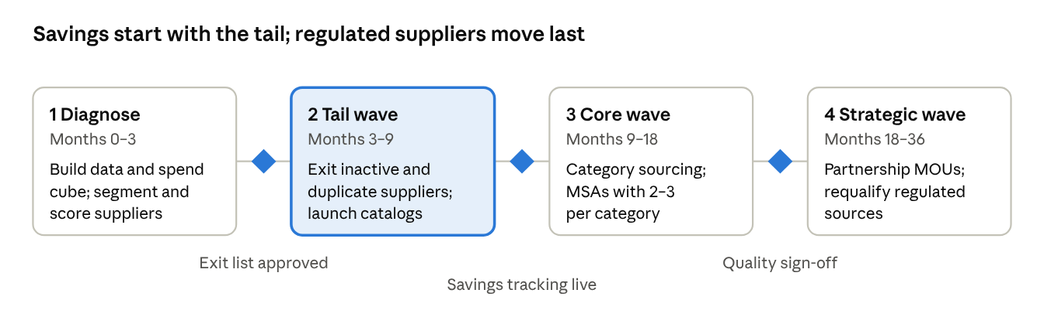
Rollout plan · 4 phases, 3 gates (diamonds)
KPI | Baseline | Year 3 target
Active suppliers | ~39,000 (FY2025) | ~32,100 (Phase 2)
Run-rate savings | $0 | $356M a year (conservative plan); $414M base
Spend under contract (MOU / MSA / catalog) | Not public | 95% of addressable spend
Tier 1 diverse supplier spend | $3B (2022) | ≥ $3B
Critical items with 2+ qualified sources | Not public | 100%
Supply disruptions caused by exits | n/a | 0

Deliverables
Deliverable | Where
Code, SQL, step write-ups, agreements | GitHub repo
All step outputs with live formulas and a Files_and_Sources tab | Outputs workbook
4-page Power BI dashboard (21 DAX measures) | powerbi/
Verified J&J suppliers from SEC filings | docs/07_real_jnj_suppliers.md
Raw data to decision trace (344,504 rows) | Rebuilt with scripts/build_data_workbook.py (100 MB, outside git)

Assumptions and sources
All figures not linked below are modeling assumptions, chosen to be conservative and easy to change.
Assumption | Value
Addressable spend | $35B
Suppliers | 80,000 (earlier); ~39,000 (FY2025)
Segment split (suppliers / spend) | A 2% / 70%, B 13% / 22%, C 85% / 8%
Price savings on addressed spend | A 0.5%, B 5%, C 8%
Annual cost to maintain one supplier | $2,000
Transition cost per exited supplier | B $25,000, C $500
Program + legal | $15M + $5M, plus 15% contingency
Savings ramp | 30% / 70% / 100% (years 1–3)
Discount rate | 8%
Sources:
- J&J 2024 Health for Humanity Report
- J&J 2023 Health for Humanity Report
- J&J careers: Director, Procurement Global Process Owner
- J&J: DEI in our supply base (2022)
- J&J 2023: Supplier diversity and inclusion

