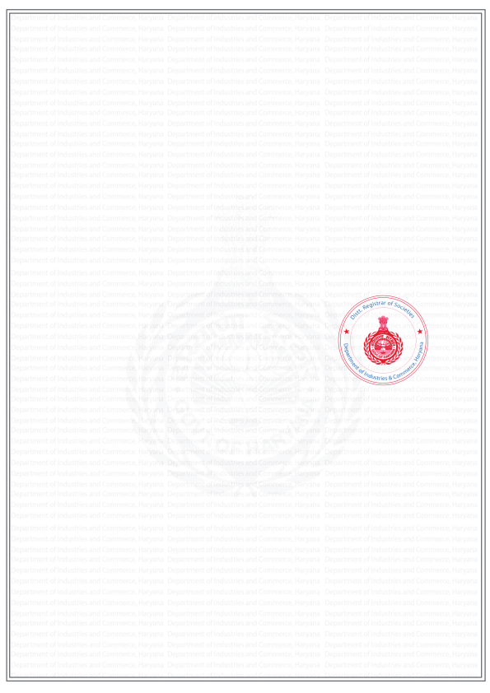
Department of Industries & Commerce, Haryana
“Approval of Elected Governing Body”
(See Section 33 & rule 19 of Societies Act, 2012)
To
[HOUSE OWNERS WELFARE ASSOCIATION, ASHOKA ENCLAVE-1, Faridabad]
[H.NO.283, ASHOKA ENCLAVE,PART-1, SECTOR-34, FARIDABAD]
[Faridabad (M Corp.)] [Faridabad]
Memo Number : [2017-05-0000335] Dated : [24/01/2025]
Subject : Approval of Elected Governing Body u/s 33 & rule 19 of Soceities Act, 2012
Kindly refer to your application dated [24/01/2025] for approval of list of Governing Body of your society. Having examined the same, I am pleased to inform you that list of office bearers of Governing Body submitted by returning officer is hereby approved.
The list of approved governing body is attached here with.
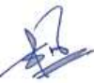
Issuing Authority
District Registrar,
Faridabad, Haryana.
Powered by TCPDF (www.tcpdf.org)
