Complete Gerrit Repository Deletion Guide (Linux Based Gerrit 3.9)

Overview
This guide explains how to:
- Verify Gerrit installation
- Understand Gerrit running mode (systemctl vs manual)
- Install and verify delete-project plugin
- Configure administrator access
- Test Gerrit SSH commands
- Delete repositories using Gerrit REST API
- Bulk delete repositories using shell scripts
- Handle repositories with nested paths (test/apps/hello-app)
- Avoid common Gerrit deletion issues
This guide is based on a Gerrit 3.9 Linux setup.

1. Verify Gerrit Installation
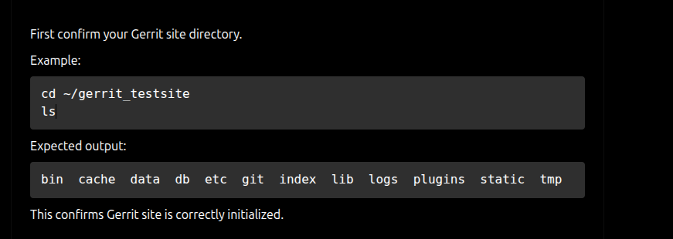

2. Check Whether Gerrit Is Running
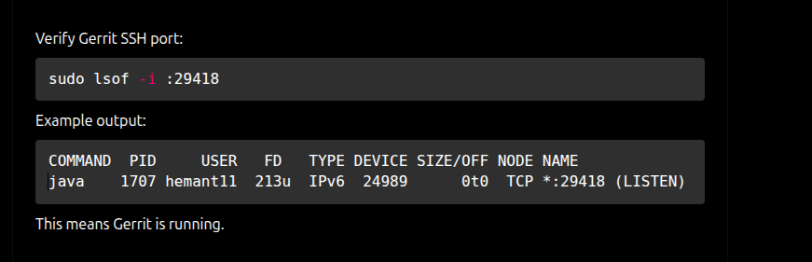

3. Understand Gerrit Startup Method:

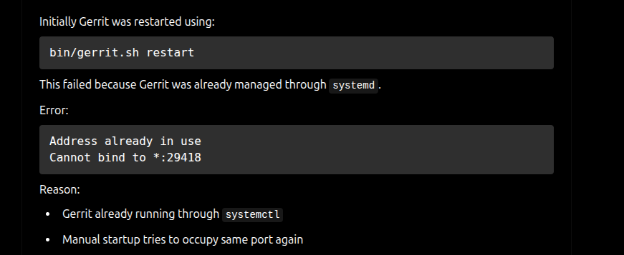

4. Correct Way To Manage Gerrit:

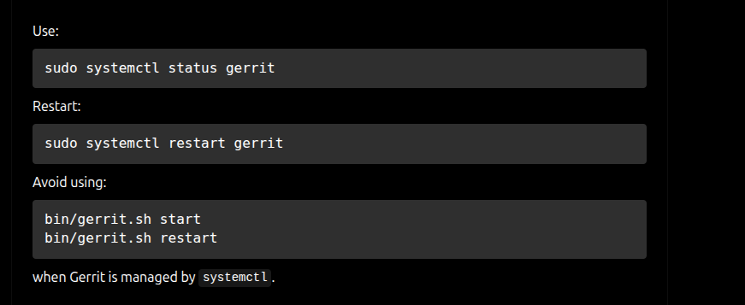

5. Verify Plugin Directory:
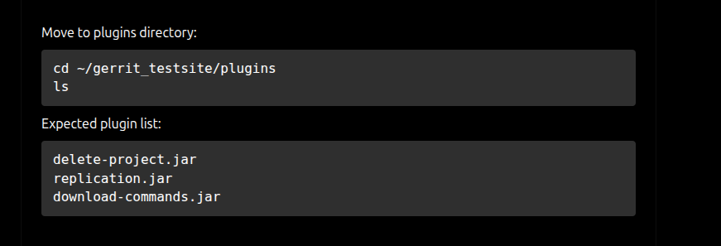

6. Verify Delete Plugin:

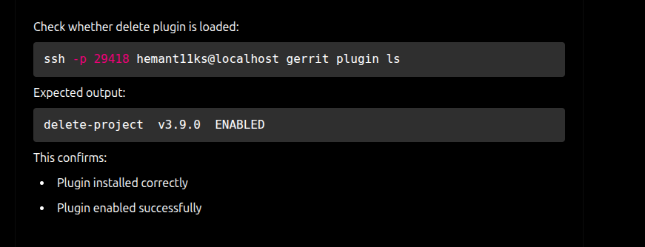

7. Verify SSH Access:

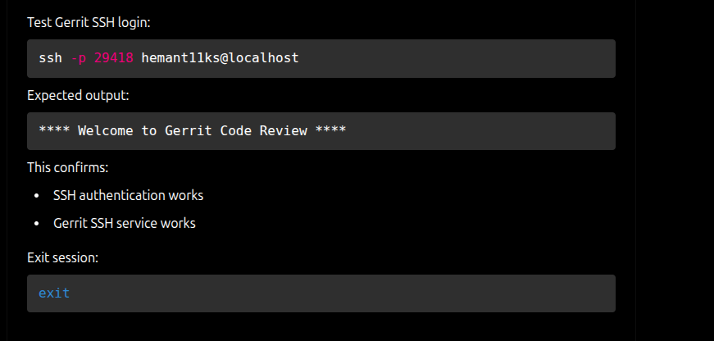

8. Verify Gerrit Commands:
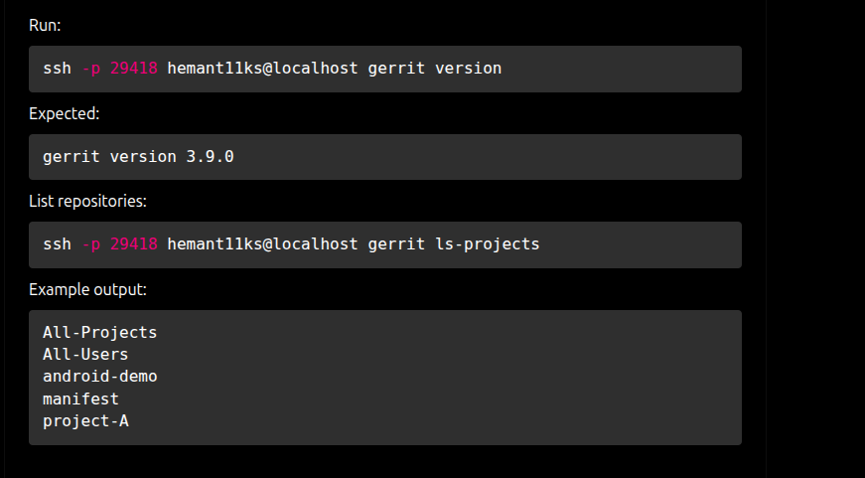

9. Add Administrator Access:

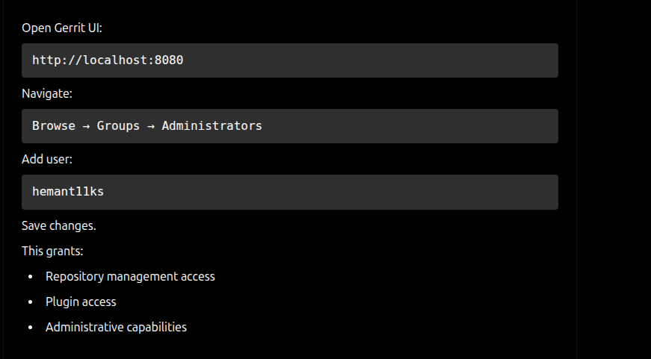

10. Problem With SSH Delete Command

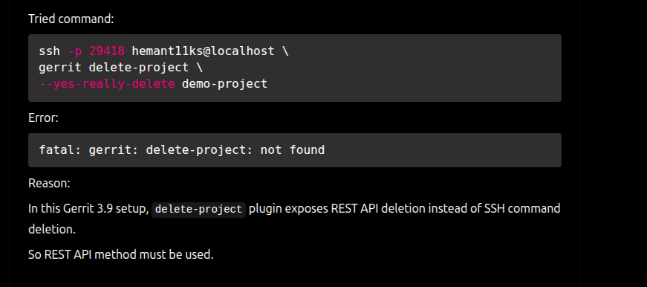

11. Generate Gerrit HTTP Password:

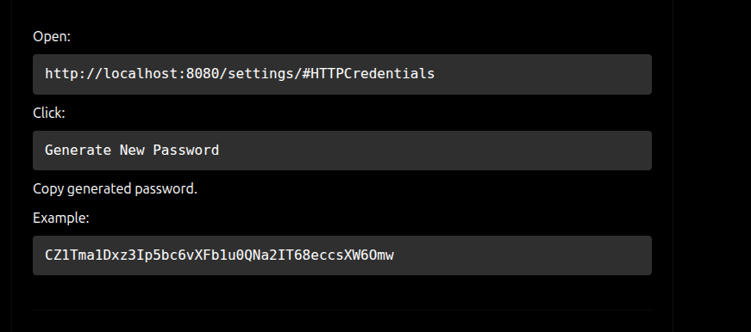

12. Delete Single Repository Using REST API:

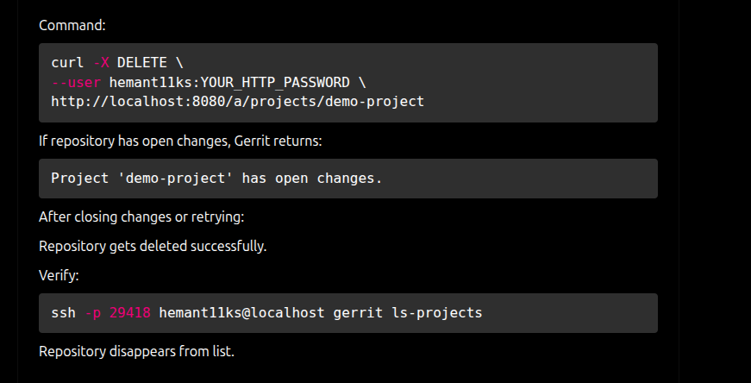

curl -X DELETE \
--user hemant11ks:YOUR_HTTP_PASSWORD \
http://localhost:8080/a/projects/demo-project

ssh -p 29418 hemant11ks@localhost gerrit ls-projects

13. Install jq Utility:

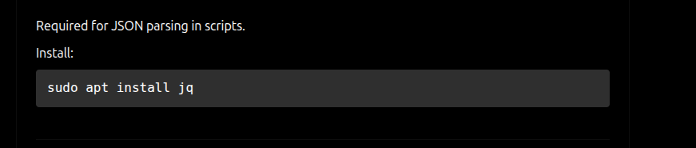

14. Initial Bulk Delete Script:

Created script:

nano delete_all_repos.sh

#!/bin/bash

GERRIT_URL="http://localhost:8080"
GERRIT_USER="hemant11ks"
GERRIT_PASS="YOUR_HTTP_PASSWORD"

PROTECTED_REPOS=(
"All-Projects"
"All-Users"
)

REPOS=$(curl -s \
--user $GERRIT_USER:$GERRIT_PASS \
"$GERRIT_URL/a/projects/" \
| sed '1d' \
| jq -r 'keys[]')

for repo in $REPOS
do

SKIP=false

for protected in "${PROTECTED_REPOS[@]}"
do
if [[ "$repo" == "$protected" ]]; then
SKIP=true
break
fi
done

if [ "$SKIP" = true ]; then
continue
fi

curl -s -X DELETE \
--user $GERRIT_USER:$GERRIT_PASS \
"$GERRIT_URL/a/projects/$repo"

done

15. Execute Script
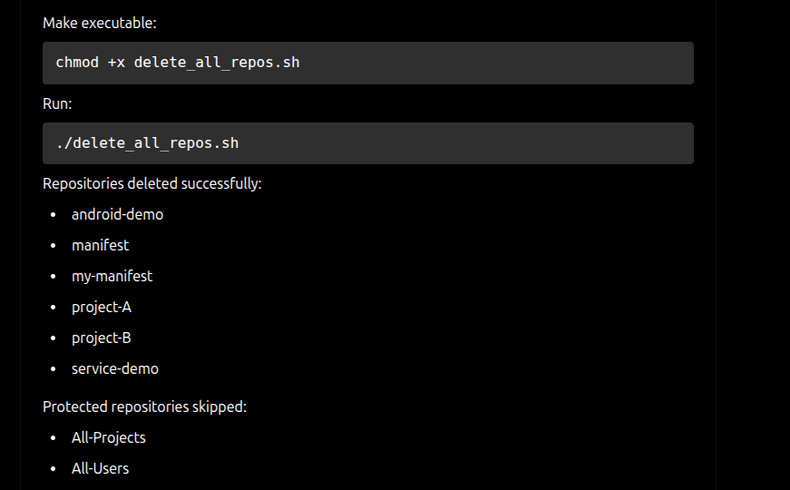

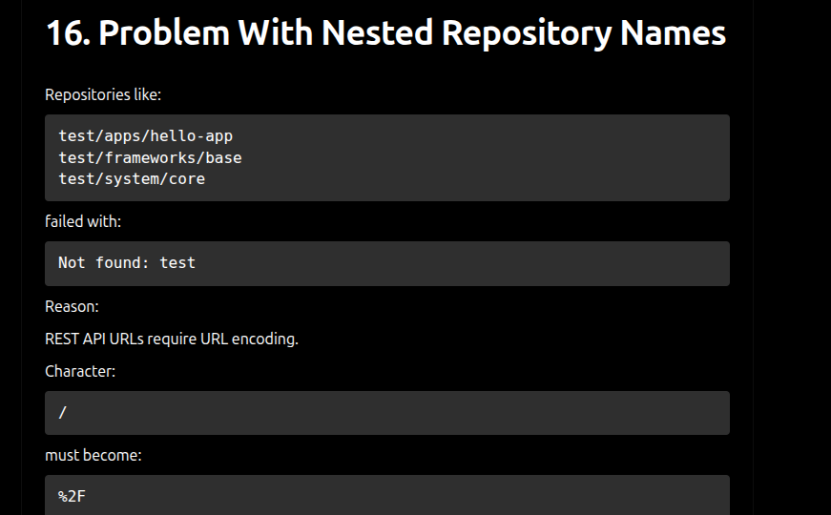

17. Correct Nested Repository Delete Commands:

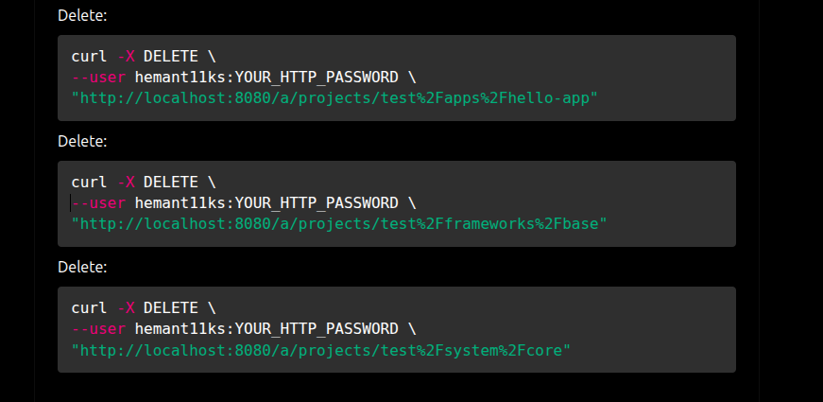

18. Final Correct Bulk Delete Script

#!/bin/bash

GERRIT_URL="http://localhost:8080"
GERRIT_USER="hemant11ks"
GERRIT_PASS="YOUR_HTTP_PASSWORD"

PROTECTED_REPOS=(
"All-Projects"
"All-Users"
)

echo "Fetching repositories..."

REPOS=$(curl -s \
--user $GERRIT_USER:$GERRIT_PASS \
"$GERRIT_URL/a/projects/" \
| sed '1d' \
| jq -r 'keys[]')

for repo in $REPOS
do

SKIP=false

for protected in "${PROTECTED_REPOS[@]}"
do
if [[ "$repo" == "$protected" ]]; then
echo "Skipping protected repository: $repo"
SKIP=true
break
fi
done

if [ "$SKIP" = true ]; then
continue
fi

ENCODED_REPO=$(echo "$repo" | sed 's/\//%2F/g')

echo "Deleting repository: $repo"

curl -s -X DELETE \
--user $GERRIT_USER:$GERRIT_PASS \
"$GERRIT_URL/a/projects/$ENCODED_REPO"

echo ""
echo "Deleted: $repo"
echo "-----------------------------------"

done

echo ""
echo "All repositories processed."

