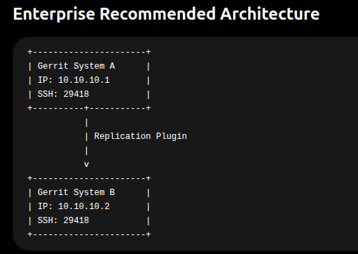

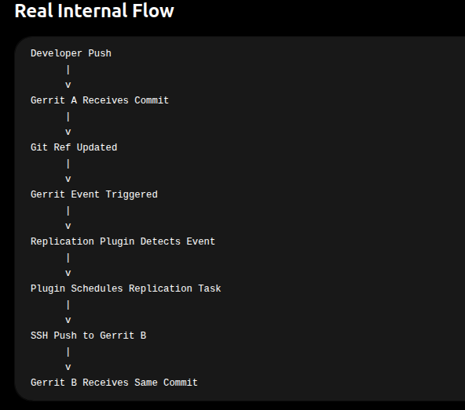
Implementation Approach -

Step 1 — Check Gerrit Version
Run:
java -jar ~/gerrit/bin/gerrit.war version
OR
ssh -p 29418 hemant11ks@localhost gerrit version
Example output:
gerrit version 3.9.2
This is VERY important because plugin version MUST match Gerrit version.

Step 2 — Download Correct Replication Plugin
Now download from official Gerrit plugin site:

Official Plugins
Gerrit Replication Plugin Releases

Step 3 — Easiest Installation Method (Recommended)
Go inside Gerrit site:
cd ~/gerrit
Then install plugin using Gerrit itself:
java -jar bin/gerrit.war init -d .
During init:
- select replication plugin
- enable plugin
OR directly copy plugin jar into:
~/gerrit/plugins/

Step 4 — Alternative Direct Download
If your Gerrit version is for example 3.9.2, use:
wget https://repo1.maven.org/maven2/com/googlesource/gerrit/plugins/replication/3.9.2/replication-3.9.2.jar
Then:
cp replication-3.9.2.jar ~/gerrit/plugins/replication.jar

Step 5 — Restart Gerrit
~/gerrit/bin/gerrit.sh restart
OR
systemctl restart gerrit

Step 6 — Verify Plugin Installed
Run:
ssh -p 29418 hemant11ks@localhost gerrit plugin ls
Expected:
replication version_xxx ENABLED

Step 7 — Create replication.config
Location:
~/gerrit/etc/replication.config
Example:
[remote "mirror-server"]
url = ssh://hemant11ks@SYSTEM_B:29418/${name}.git

push = +refs/heads/*:refs/heads/*
push = +refs/tags/*:refs/tags/*
push = +refs/changes/*:refs/changes/*
push = +refs/meta/config:refs/meta/config

threads = 8
replicationDelay = 0

Step 8 — Reload Plugin
ssh -p 29418 hemant11ks@localhost gerrit plugin reload replication

Step 9 — Test Replication
Create test commit in:
test/apps/hello-app
Then verify repo appears in second Gerrit.

Important for Bidirectional Setup
If you later configure:
- System A → System B
- System B → System A
DO NOT directly allow unrestricted loop replication.
Otherwise:
- infinite replication loop
- duplicate refs
- patchset conflicts

Recommended Enterprise Setup

Safer Model
A -> B
B -> A
BUT:
Use:
- separate replication filters
- replication exclusions
- Jenkins validation layer

Your Current Gerrit Setup Looks Good
You already have:
✅ SSH access working
✅ Gerrit command access working
✅ Multiple repositories created
✅ Gerrit user configured correctly

What Exactly Triggers Replication?
When any Git reference changes:
Example:
refs/heads/main
refs/changes/xx
refs/tags/v1
Gerrit generates internal event:
GitReferenceUpdatedListener
The replication plugin listens to this.

Real Internal Mechanism
Inside Gerrit:
Commit Arrives
|
v
Ref Update Event
|
v
Replication Queue
|
v
Worker Threads
|
v
git push --mirror

Example Scenario

STEP 1 — Developer Pushes Commit
Developer pushes:
git push origin HEAD:refs/for/main

STEP 2 — Gerrit Receives Patchset
Gerrit creates:
refs/changes/45/12345/1

STEP 3 — Merge Happens
After review:
Commit merged to:
refs/heads/main

STEP 4 — Gerrit Fires Event
Internally:
Ref updated:
refs/heads/main

STEP 5 — Replication Plugin Detects Event
Plugin checks:
push = +refs/heads/*:refs/heads/*
Match found.

STEP 6 — Plugin Adds Replication Task
Inside Gerrit queue:
ReplicationTask(main)

STEP 7 — Worker Thread Executes Push
Internally:
git push ssh://gerrit-b:29418/project.git

STEP 8 — Gerrit B Receives Commit
Now Gerrit B contains:
Commit A
Commit B
Commit C
same as Gerrit A.

Important Internal Components
Component | Purpose
GitReferenceUpdatedListener | detects changes
Replication Queue | stores tasks
Worker Threads | parallel replication
SSH Transport | communication
replication.config | routing rules

How Gerrit Identifies Which Repo Changed
Suppose repo:
test/apps/hello-app
received commit.
Gerrit internally knows:
Repository Name
Updated Ref
Commit SHA
Replication plugin receives all this metadata automatically.

Real Internal Example
Event generated:
Repository: test/apps/hello-app
Ref: refs/heads/main
Old SHA: abc123
New SHA: def456
Plugin says:
OK -> replicate this ref

How Fast Replication Happens
Usually:
within milliseconds
depending on:
- thread count
- network
- repo size

replication.config Controls Everything
Example:
[remote "mirror"]
url = ssh://gerrit-b:29418/${name}.git

push = +refs/heads/*:refs/heads/*
push = +refs/tags/*:refs/tags/*
This tells plugin:
Whenever refs/heads changes,
push to Gerrit B.

VERY IMPORTANT
Replication plugin does NOT:
- compare commits manually
- scan repositories continuously
Instead:
- Gerrit itself tells plugin immediately.
This makes replication:
- scalable
- real-time
- efficient
even for:
1000+ AOSP repos

Where Jenkins Fits
Jenkins is usually NOT used to trigger replication.
Instead Jenkins is used for:
Purpose | Example
Validation | compare refs
Health Check | detect failed repos
Retry Sync | recover failed push
Monitoring | dashboards
DR Automation | failover

Enterprise Production Flow
Developer
|
v
Gerrit A
|
| Event Trigger
v
Replication Plugin
|
| SSH Push
v
Gerrit B
|
v
Jenkins Validation

MOST IMPORTANT TAKEAWAY
The actual trigger is:
Git Reference Update Event
NOT Jenkins.
NOT polling.
NOT cron jobs.
This is why Gerrit replication scales very efficiently for large AOSP environments.

