**Assignment 1a: SQL Database Admin Commands**

In this assignment, you’ll need to create a MySQL database that stores information about 10 different people and their educational experience.

1. Create a database named people_education.

2. Show that the database has been created.

3. Create the following tables. Be sure to make the columns the correct data types:

a)  Create a table named people_info.

It should have the following columns: name, age, high school attended, and height.

b) Create a table named school_info.

It should have the following columns: school name, zip code.

c) Create a table named school_mascot.

It should have the following column: school name, the school mascot.

4. Show all tables using the show tables; command.

5. Delete the school_mascot table.

6. “Poll” at least 4 different people and record the information about them:

Name, age, high school name, height (in meters), and high school zip code.

For each person, populate the people_info tables with some made-up data.

**Assignment 1b: Create, Insert, select and where**

In this assignment, you’ll need to create a MySQL database that stores information about 8 different employee details.

1. Create a database named company_db.

2. Show that the database has been created.

3. Create the **employee** table. Be sure to make the columns the correct data types:

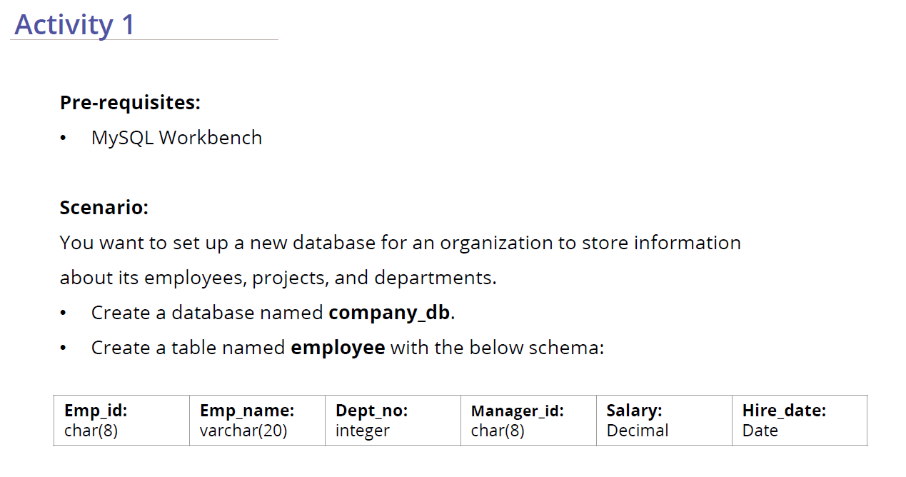

4. Populate the employee table with below data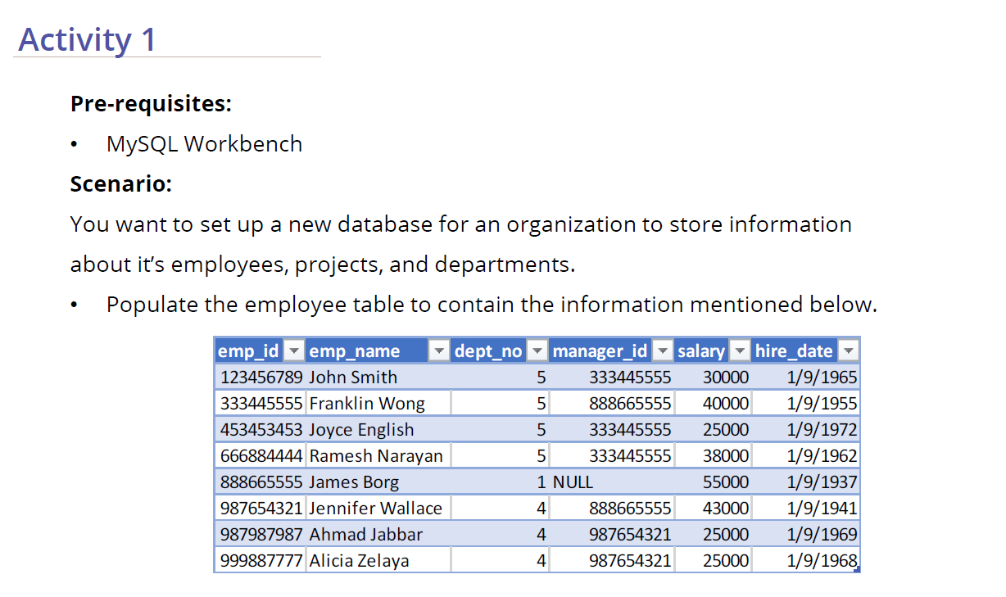

5. Retrieve all the rows from employee table

6. Retrieve all the employee id, employee name, department no and salary of employees who are in dept_no 5 from employee table