**Instruction**

**Capstone Project - Healthcare Analytics**  
  
**Instructions**

* Use [Healthcare.xls](https://kh3-ls-storage.s3.us-east-1.amazonaws.com/Tableau/Capstone%20Project%203.zip) data.
* Note that you can use either Tableau Public or Desktop to find the answer.
* If you are using Tableau Desktop, the Sample Superstore dataset should be present in the Saved Data sources and will also be present in your My Tableau Repository folder on your local machine.
* Data should be an Extract and not a ‘Live’ connection.

**Tableau Project Requirement**

* The workbook should have two dashboards.
* The Workbook should have a Story consisting of several Story points based on the requirement.
* Each worksheet/view/chart should meet the business requirement.
* All worksheets should be hidden.
* Workbook should be published to Tableau Public if possible.

**Submission Guidelines**

* Copy-Paste the screenshots for every view in a word document and upload the document for verification.

**Business Requirement**  
  
Connect to the CSV file Healthcare dataset, which includes the data regarding patients’ blood pressure, BMI, glucose, insulin, and diabetes for patients from the 20+ age group. Build 2 dashboards and then create a story using the 2 dashboards and a worksheet.  
  
**Dashboard 1 Requirements**

* Take any image regarding healthcare and drag it to the dashboard.
* Using Text object, give it a meaningful name based on your data analysis of the file.

**Dashboard 2 Requirements**  
  
View 1: Diabetic/Non-diabetic using Shapes

* Use Shapes to show the distribution between diabetic/non-diabetic patients.
* Using the “Outcome” field, write a calculated field by classifying 1 as Diabetic patients and 0 as Non-diabetic patients.
* Show the percent distribution as shown in the expected view.
* Use the color of your choice to differentiate Diabetic Vs. Non-diabetic patients.
* Tooltip should display patient count.
* You can use shapes of your choice or use the below one.
* Format as per your choice.
* Enable Action filters.

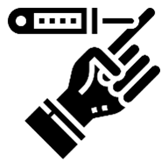View 2: Patient summary by Blood Pressure category

* Use any shape of your choice to show patient summary by blood pressure category.
* Show the Patient count and BP category type on the labels.
* Use the color of your choice to differentiate Diabetic Vs. Non-diabetic patients.
* Format as per your choice.
* Enable Action filters.

View 3: Create a Histogram to show Body Mass Index (BMI) by Age Groups.

* Since we need to build a Histogram, using the Age field, let’s create bins using size 5.
* In a Histogram, you will have bins 20, 25, 30, etc. So, the bin size 20 will include age groups between 20-24, and size 25 will include 25-29. So, to be clear let’s edit the aliases of the age groups as it might confuse the users. So, let’s use aliases as shown below or you can create a calculated field for the Age groups.
* 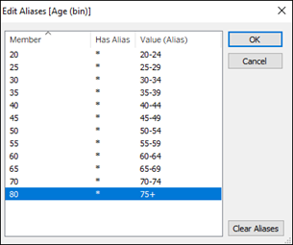In case, there are missing values, hide them.
* Display the average BMI value on top of each bar and round it to 2 decimals.
* Use the average BMI to color the palette using shades of Red.

View 4: Single Bar showing percent distribution of patients by BMI type

* Create a calculated field to classify Patients by BMI types.
  + [BMI]<18.5= 'Underweight'
  + [BMI]>=18.5 and [BMI]<25 ='Healthy Weight'
  + [BMI]>=25 and [BMI]<30 = 'Overweight'
  + [BMI]>=30 ='Obese'
* Enable Action filters.

**Expected Final View**  
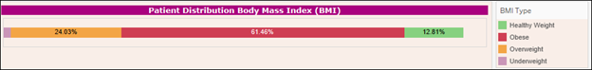  
View 5: Bar Chart showing Patient break down by Blood Pressure and Diabetes

* Create a calculated field to only highlight Diabetic patients with High and Low blood pressures.

View 6: Build a HEAT MAP showing several health factors by Age group  
  
**Story Requirements**

* Story Name: Healthcare
* Story Title: Healthcare Summary Report
* Story description: Add one if you wish to
* Story size:  Custom Size (best choice)
* Story Layout: Navigator style should be set to Numbers
* Story Point 1: Should contain Dashboard 1
* Story Point 2: Should contain Dashboard 2
* Story Point 3: Should contain Heat Map Worksheet