* **About Us/ About Techdeal** -
* **Company Overview**--->

Welcome to Techdeal. Techdeal has skills and expertise to facilitate complex business solutions. We are specialized in MS CRM, SAP, BI, Microsoft & Mainframe technologies.

We have a squad of experts, who are working on modern technologies and tools with vast experience to carry out web based projects, e-commerce, mobile applications and programming scripting.

We are helping clients to grow their businesses, by providing our clients highly differentiated, industry-based, end-to-end business services that combine our IT consulting, technology and business process outsourcing capabilities.

We enable clients in India and other countries to stay ahead with innovations. Techdeal is founded on the principle of implementing innovative ideas.

* **Vision & Mission ---->**

**Our vision is to help and support organizations in sustaining and growing the businesses by partnering with them and understanding their needs in terms of technology and business consulting.** Our aim is to deliver high quality products, services and support and to maintain good partnership with our clients.



* **Why Techdeal (principles)🡪**

Techdeal aims at bridging the gap between clients and businesses. Businesses need proficiency and we are the platform that look to create value in their businesses.

Businesses don’t usually find the expertise they need and this creates cracks in the system. We strive to mend these cracks and improve the state of businesses.

* **Why Techdeal (benefits)---->**

We partner with our clients by providing consulting services and are accountable for improving the overall process, technical framework and project execution methods. We have extensively strong expertise in Data-warehousing and Business Intelligence technologies, ERP Technologies such as SAP, Microsoft CRM, Acepta, Programming and application development technologies such as Mainframes, Oracle, DB2, SQL Server, Sybase Teradata, .net, Java and various other technologies.

* **Services-🡪**
* **Application Development & Maintenance-->**

Our Application Development, Enhancement & Support services help our esteemed clients to maintain businesses’ critical applications. With years of experience in Support and maintenance assignments, our inclination is towards Continual Improvements (CI) which helps our clients in reduction of overall maintenance costs by removal of defects/gaps in their existing systems.

* **Development, Migration, Retrofitting and up gradation projects-->**
* **Technology -->**
* **MS CRM Dynamics**
* **SAP-->**

SAP is the today's growing technology developing innovations that improves the lives of people everywhere. SAP services provide a simple path to innovation. We have SAP expertise.

Our SAP Services includes:

-- **SAP IS Oil and Gas**

**-- SAP SD, CS, MM & FI-AR**

**-- SAP ABAP**

**-- SAP BI & BO(BI)**

* **BI-->**

**BI** is the broad category of software solutions that enables to gain insights into critical operations through reporting applications and analysis tools. BI Applications help to make better decisions by quick understanding.

We also have expertise in **WebFOCUS**, **Tableau**, **Spotfire** & **Qlikview**

* **Data Warehousing-- High Quality information to meet reporting requirements**

Techdeal helps you extend your data warehouse investment so that at low cost your organization can get deeper insights.

With the help of our impeccable logistics and statistics we take raw data and polish it into the reports that drive your business further.

We can help you meet the needs of today .

Contains Informatica ETL, Data profiling, Data Modeling.

* **Microsoft Technologies --**

We provide Web applications, Gaming, Mobile applications & Networking services.

* **Mainframe**

Mainframes are the standards for business critical systems.

We provide Mainframe services to grow your business.

Our Mainframe services include:

AS400

PL/1

Enterprise COBOL, PL/1

DB2, IMS/DB, IDMS

CICS, IMS/DC

* **Trainings-->**
* **SAP**
* **BI**
* **Mainframe**



* **Application Testing -->**

**Techdeal** testing services ensure your product is ready by deadline. We meet customer expectations and deliver defect-free products.

We deliver quality product in minimal time at lower cost & ensure end user satisfaction.

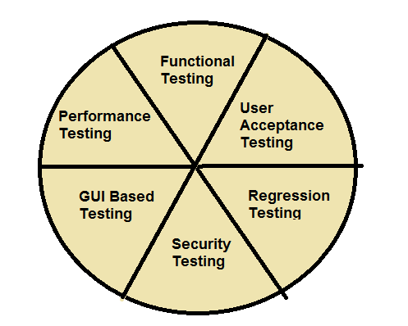

* **Client Speak** ----->

**Client: Resoneuronance Software Solutions Pvt. Ltd.**  
**Industry:** Software  
Anand Kore, CEO, at India, talks about how Techdeal helped manage their business processes.

* **Clients**--->**Resoneuronance Software Solutions Pvt. Ltd.**

**Pune, India.**



* **Careers**🡪 **Current Openings**
* **Contact US**

Thank you for your interest in Techdeal’s services. Please provide the following information about your business needs to help us serve you better. This information will enable us to route your request to the appropriate person. You will receive a response within 48 hours. (We will get back to you within 48 hours.)

* **Fields marked by an asterisk ( *) are required fields**

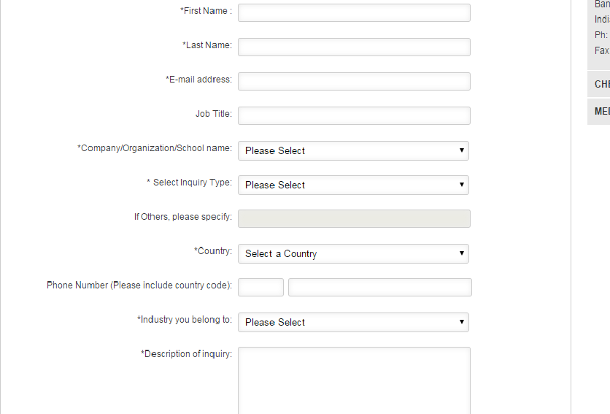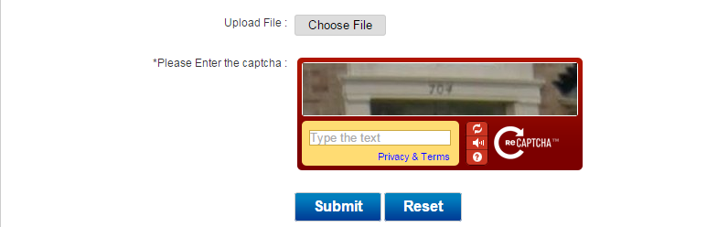

* **Locations**

Techdeal has offices in Bangalore & Pune, located strategically to help us serve our clients and deliver the best expertise effectively and efficiently.

Techdeal Software Solutions Pvt. Ltd. Techdeal Software Solutions Pvt. Ltd.

Bangalore Pune

Phone : +91 Phone : +91

Email :



