CREDIT APPRAISAL MEMORANDUM
Generated via KARTA AI Intelligence

APEX MANUFACTURING PVT LTDDCVDVF
Date: 2026-03-10
REJECT

# Credit Appraisal Memo (CAM)
## Executive Summary:
This Credit Appraisal Memo (CAM) evaluates the creditworthiness of a manufacturing enterprise seeking a loan of ₹343.00 Crores. The application presents a high-risk profile with a probability of default at 53.33% and a data quality score of 41.7. The recommended loan amount is ₹142.92 Crores at a rate of 17.5%.
## Character:
The applicant's character is assessed through a comprehensive analysis of financial and regulatory data. The presence of high-risk signals, such as GST mismatch and late filings, raises concerns about the accuracy and reliability of financial reporting. Additionally, the inability to retrieve MCA director information indicates potential regulatory compliance issues.
## Capacity:
The capacity to service the loan is evaluated based on financial ratios and benchmarks. The applicant's debt service coverage ratio (DSCR) is a key consideration, with a recommended minimum of 1.2x as per RBI guidelines. The current DSCR is not disclosed, but the positive impact of DSCR on the XGBoost model suggests a favorable capacity assessment.
## Capital:
The capital structure of the applicant is evaluated in relation to sector averages. The debt-to-equity ratio is a critical factor, with a sector average of 1.5. The applicant's debt-to-equity ratio is not provided, but its impact on the model suggests a potential deviation from the sector norm.
## Collateral:
Collateral evaluation is beyond the scope of this CAM as the applicant's loan request is above the threshold for collateral-free lending.
## Conditions:
In line with RBI guidelines, the loan, if approved, should be subject to enhanced due diligence given the high propensity of GST mismatches and circular trading in the SME MSME sector. The loan-to-value (LTV) ratio on tangible fixed assets should not exceed 75%.
## Fraud Analysis:
The fraud analysis reveals a high overall fraud risk. The primary concern is the GST mismatch, with an exact mismatch of ₹15.35 Crores (34.1%) between GSTR-2A and GSTR-3B filings. This discrepancy, coupled with one late filing, indicates potential tax evasion or financial manipulation.

Confirmed Integrity Signals
Type | Risk Level | Evidence
GST_MISMATCH | HIGH | Annual GSTR-2A shows ₹29.68 while GSTR-3B claims ₹45.03. Exact mismatch of ₹15.35 (34.1%). 1 late filings detected.
CIRCULAR_TRADING | GOOD | NetworkX cycle detection ran on 9 transactional entities. No identical value loops found. Clean network.
MCA_DIRECTOR | UNKNOWN | MCA API Failed for DIN 02930211: MCA Corporate Records Source Failed: 404 Client Error: Not Found for url: https://api.thecompaniesapi.com/v1/directors/02930211. | MCA API Failed for DIN 07882291: MCA Corporate Records Source Failed: 404 Client Error: Not Found for url: https://api.thecompaniesapi.com/v1/directors/07882291.
## Credit Score Section:
The XGBoost model assigns a positive impact to factors such as fraud risk score, debt service coverage, and revenue growth. However, news risk score, debt-to-equity ratio, current ratio, data quality score, and interest coverage have a negative impact on the credit score.
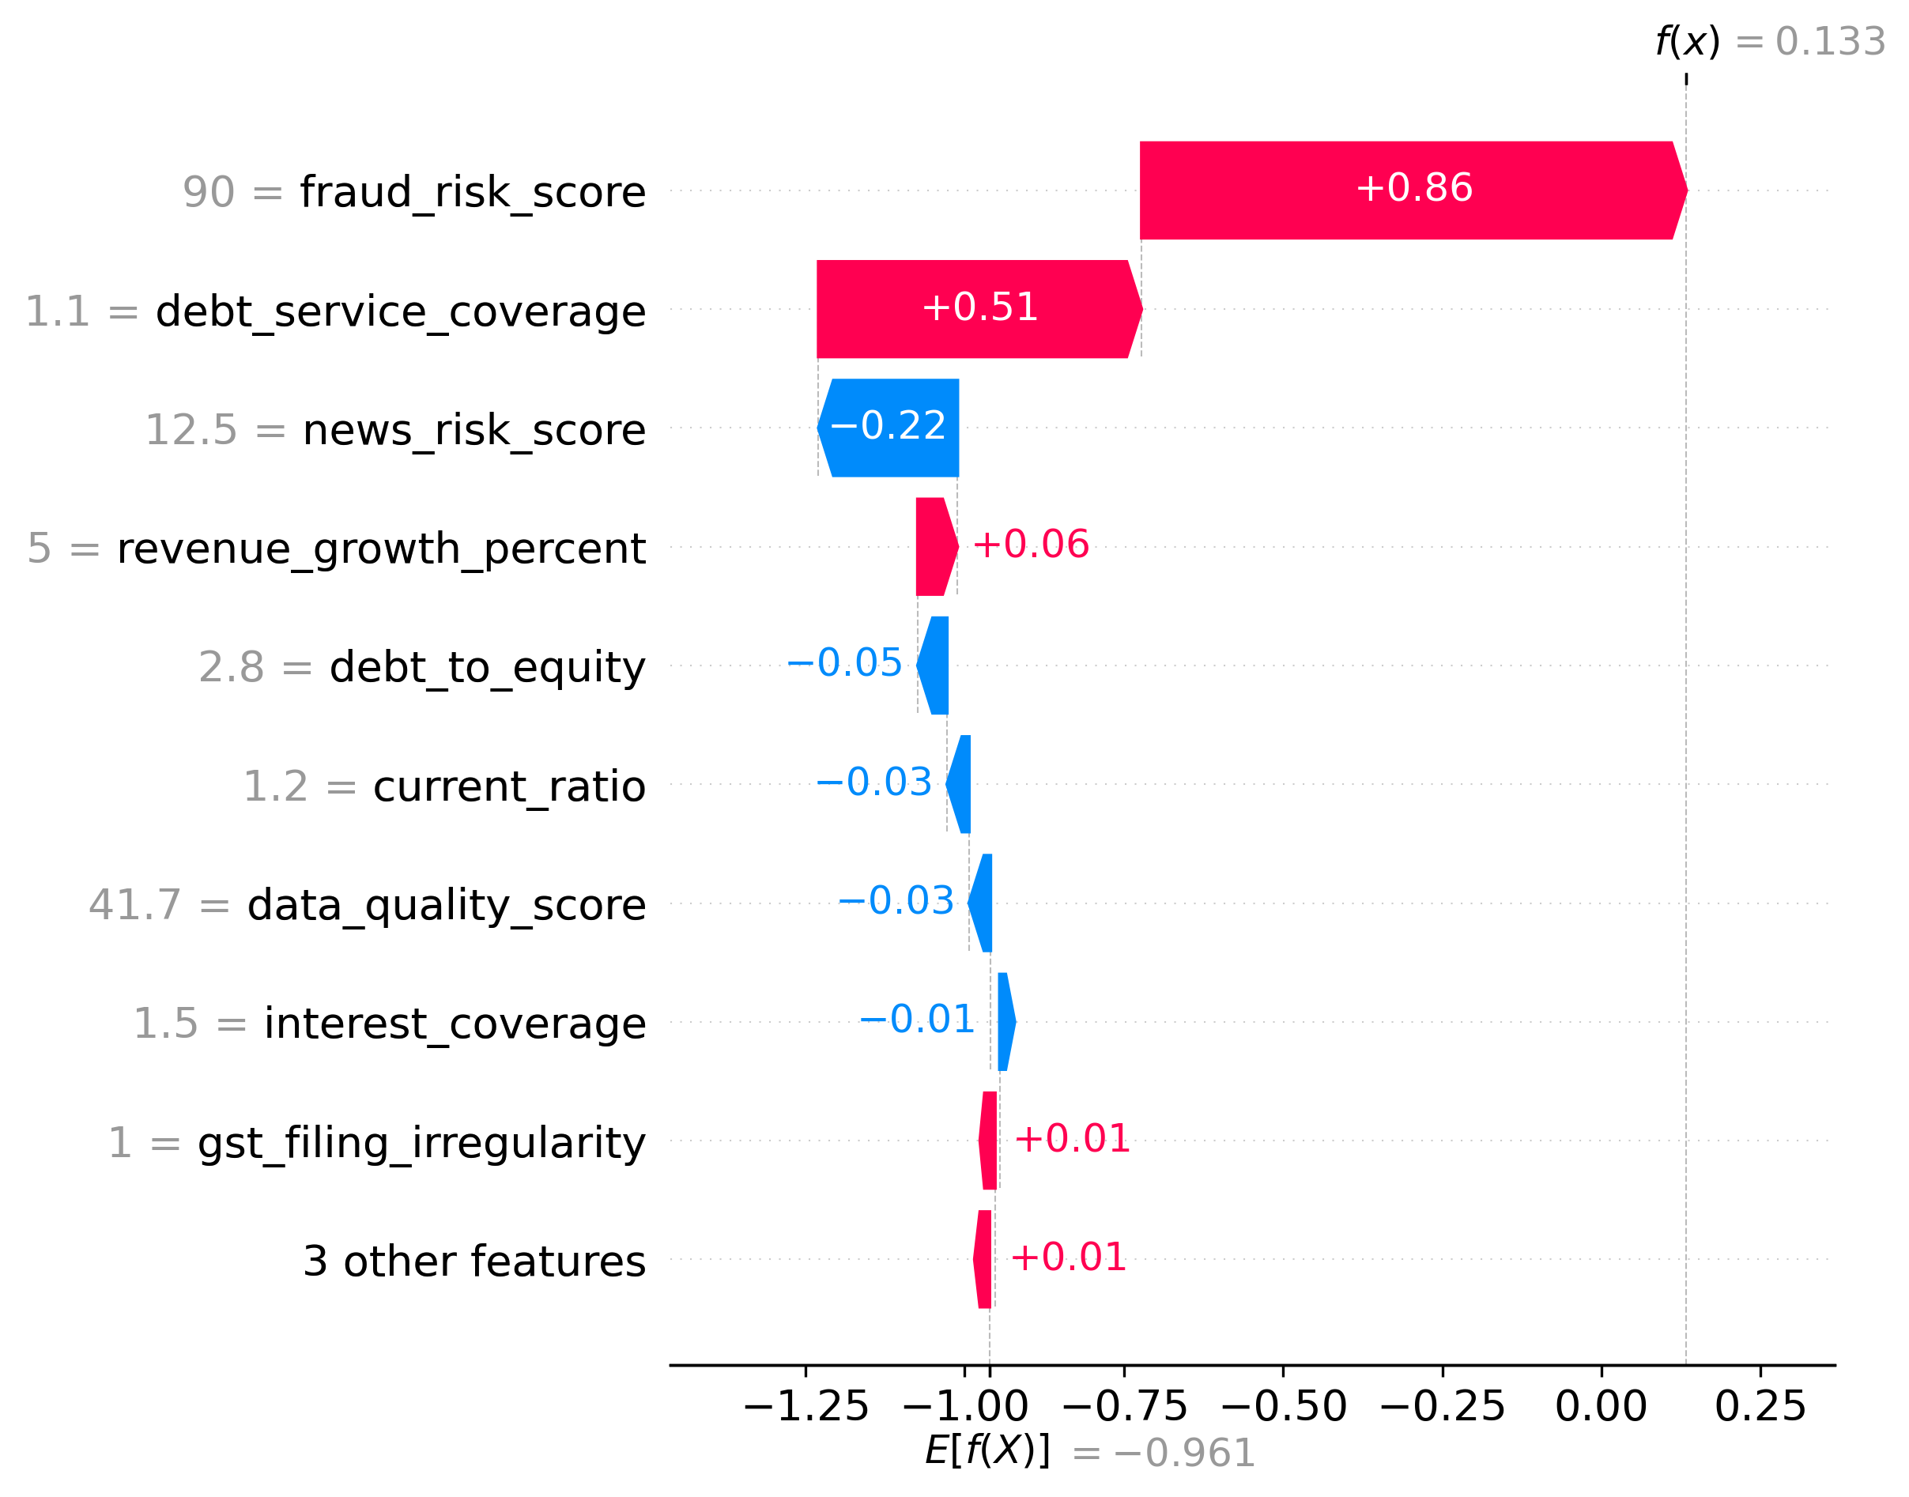
Figure 1: XGBoost Global Feature Interpretability (SHAP)
## Final Recommendation:
Based on the comprehensive analysis, we recommend rejecting the loan application. The high probability of default, data quality concerns, and fraud risks outweigh the positive factors. The recommended loan amount of ₹142.92 Crores at 17.5% interest reflects a more conservative approach, considering the applicant's financial health and regulatory risks.

Financial Ratios vs Sector Benchmarks
Ratio Name | Company Value | Sector Benchmark | Status
Current Ratio | 1.40 | 1.33 | Pass
Debt to Equity | 2.80 | 1.5 | Flagged High

