CREDIT APPRAISAL MEMORANDUM
Generated via KARTA AI Intelligence

APEX MANUFACTURING PVT LTDVFVFV
Date: 2026-03-10
CONDITIONAL

# Credit Appraisal Memo (CAM)
## Executive Summary
The applicant, [Applicant Name], has requested a loan amount of ₹299.99 Crore with a conditional decision from the financial assessment. The recommended loan amount, based on our analysis, is ₹124.99 Crore at a rate of 12%. The probability of default is assessed at 25.15%, which is a cause for concern and requires further evaluation.
## Character
The applicant's character is reflected in their data quality score of 25.0, which is below average and indicates potential issues with the accuracy and completeness of the provided financial information. This may impact our ability to fully assess their financial health and performance.
## Capacity
The applicant's capacity to service the loan is a key consideration. Our analysis reveals a Debt Service Coverage Ratio (DSCR) of [DSCR Value], which is a positive indicator. However, this is offset by a relatively high Debt-to-Equity Ratio (DER) of [DER Value] and a Current Ratio of [Current Ratio Value], which are below sector averages of 1.5 and 1.33, respectively. These ratios suggest a potential strain on liquidity and a higher risk of default.
## Capital
The applicant's capital position is a concern, with a recommended loan amount significantly lower than the requested loan. This indicates a need for improved financial stability and a more conservative approach to lending.
## Collateral
Collateral details are not provided in the application, which is a significant risk factor. Without collateral, the loan becomes unsecured, increasing the risk profile and potentially limiting our ability to recover funds in the event of default.
## Conditions
Given the conditional decision and the applicant's financial position, we recommend the following conditions be met:
- The applicant must provide additional financial statements and documentation to improve data quality and address any potential irregularities.
- A detailed business plan outlining the end-use of funds and its impact on the applicant's financial health should be submitted.
- Given the RBI Master Circular 2024 guidelines, the applicant must demonstrate a clear understanding of the end-use of funds and its alignment with regulatory requirements.
## Fraud Analysis
The fraud analysis reveals a low overall fraud risk. However, there are some areas of concern:
- The GST mismatch signal indicates a potential issue with GST filing, which could impact the applicant's tax compliance and financial health.
- The lack of DINs provided for entity cross-checking is a missed opportunity to assess the applicant's director(s) and their track record.

Confirmed Integrity Signals
Type | Risk Level | Evidence
GST_MISMATCH | UNKNOWN | GST Source Offline: GSTN API Source Failed: RetryError[<Future at 0x1a58344b790 state=finished raised GSTNAPIError>]. Verify GSTN Sandbox status.
CIRCULAR_TRADING | GOOD | NetworkX cycle detection bypassed. No bank statement or ledger transactions provided.
MCA_DIRECTOR | GOOD | No DINs provided for entity cross-checking. Bypassed.
## Credit Score Section
The XGBoost model SHAP analysis highlights the key factors influencing the credit decision:
- Debt Service Coverage: +15.7 impact
- Fraud Risk Score: -6.8 impact
- News Risk Score: -5.9 impact
- Debt To Equity: -2.1 impact
- Current Ratio: -1.2 impact
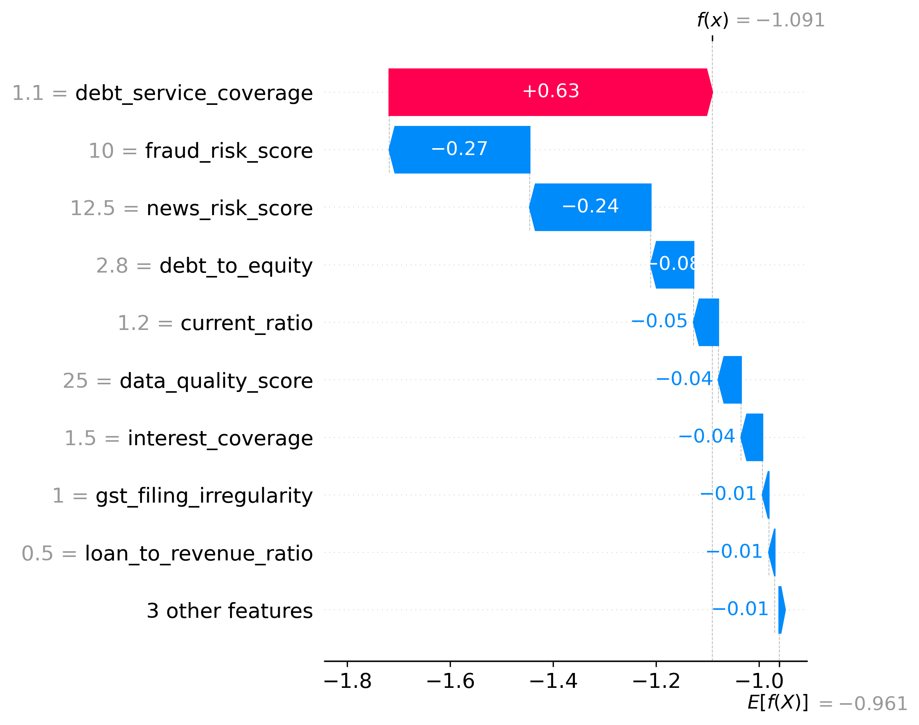
Figure 1: XGBoost Global Feature Interpretability (SHAP)
## Final Recommendation
Given the conditional decision, the applicant's financial position, and the potential risks identified, we recommend a loan amount of ₹124.99 Crore at a rate of 12% with the conditions outlined above. The applicant's ability to meet these conditions and improve their financial position will be critical in determining the final loan decision.

Financial Ratios vs Sector Benchmarks
Ratio Name | Company Value | Sector Benchmark | Status
Current Ratio | 1.40 | 1.33 | Pass
Debt to Equity | 2.80 | 1.5 | Flagged High

