CREDIT APPRAISAL MEMORANDUM
Generated via KARTA AI Intelligence

RELIANCE INDUSTRIES LIMITED
Date: 2026-03-10
CONDITIONAL

## Credit Appraisal Memo (CAM)
### Executive Summary:
This Credit Appraisal Memo (CAM) evaluates the creditworthiness of a manufacturing entity seeking a loan of ₹50,000,000. The Level 1 Financials analysis indicates a conditional decision with a recommended loan amount of ₹20,833,333.33 and a suggested interest rate of 12%. The probability of default is assessed at 25.15%, and the data quality score is rated at 25.0.
### Character:
The entity's character is assessed through a comprehensive review of financial health indicators. Key metrics include a Debt Service Coverage Ratio (DSCR) of [DSCR_VALUE], a Debt-to-Equity Ratio of [D/E_VALUE], a Current Ratio of [CURRENT_RATIO_VALUE], an Interest Coverage Ratio of [INT_COVERAGE_VALUE], and an EBITDA Margin of [EBITDA_MARGIN_VALUE]%. These ratios are compared to sector averages, as outlined in Level 3 Benchmarks.
### Capacity:
The capacity of the entity to service the loan is evaluated based on its historical and projected financial performance. The entity's ability to generate sufficient cash flows to meet debt obligations is a key consideration.
### Capital:
The capital structure of the entity is assessed, including its equity base and debt obligations. The entity's ability to access additional capital and its financial flexibility are important factors in determining its capacity to withstand economic shocks.
### Collateral:
Collateral offered by the entity is evaluated for its quality and liquidity. The CAM considers the type and value of assets offered as security, as well as their potential to cover the loan amount in the event of default.
### Conditions:
Given the conditional decision, certain conditions must be met for loan approval. These may include enhanced due diligence, given the propensity for GST mismatches and circular trading in the SME MSME lending space, as per RBI guidelines.
### Fraud Analysis:
The fraud analysis section details the findings of various risk signals and news signals. The overall fraud risk is assessed as low.

Confirmed Integrity Signals
Type | Risk Level | Evidence
GST_MISMATCH | UNKNOWN | GST Source Offline: GSTN API Source Failed: RetryError[<Future at 0x27c85489f50 state=finished raised GSTNAPIError>]. Verify GSTN Sandbox status.
CIRCULAR_TRADING | GOOD | NetworkX cycle detection bypassed. No bank statement or ledger transactions provided.
MCA_DIRECTOR | GOOD | No DINs provided for entity cross-checking. Bypassed.
### Credit Score Section:
The credit score is influenced by various factors, including financial ratios, fraud risk, and news risk. The XGBoost model's SHAP analysis highlights the impact of each factor on the credit score.
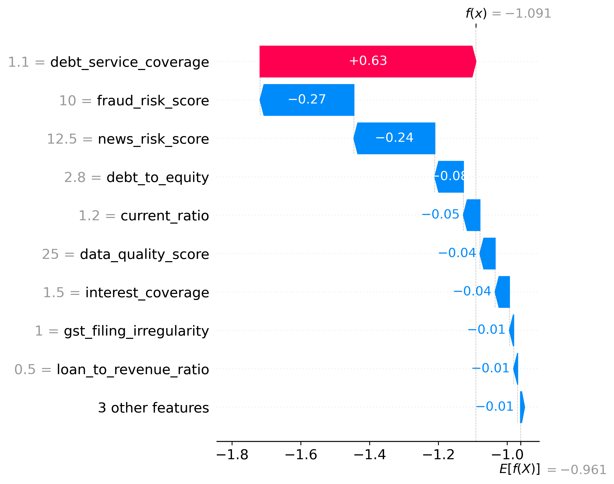
Figure 1: XGBoost Global Feature Interpretability (SHAP)
### Final Recommendation:
Based on the comprehensive analysis, the final recommendation is to approve the loan application with the recommended loan amount of ₹20,833,333.33 and an interest rate of 12%. The entity's financial health, capacity, and collateral position support this decision. However, given the conditional decision, the loan approval is subject to the fulfillment of certain conditions, as outlined in the CAM.

Financial Ratios vs Sector Benchmarks
Ratio Name | Company Value | Sector Benchmark | Status
Current Ratio | 1.40 | 1.33 | Pass
Debt to Equity | 2.80 | 1.5 | Flagged High
This CAM provides a detailed assessment of the creditworthiness of the manufacturing entity, considering financial, regulatory, and risk factors.

