CREDIT APPRAISAL MEMORANDUM
Generated via KARTA AI Intelligence

RELIANCE INDUSTRIES LIMITEDFGB
Date: 2026-03-10
CONDITIONAL

# Credit Appraisal Memo (CAM)
## Executive Summary
This Credit Appraisal Memo (CAM) evaluates the creditworthiness of a borrower seeking a loan of ₹499,990. The borrower's probability of default is assessed at 25.15%, which is considered high. The data quality score of 25.0 indicates a need for further verification and due diligence.
The recommended loan amount, based on the XGBoost model, is ₹208,329, with a recommended interest rate of 12%. This conditional approval is subject to the borrower's ability to provide additional information and address certain risk factors.
## Character
The borrower's character is assessed based on the available information and risk signals. The fraud overall risk level is categorized as LOW, indicating a generally low risk of fraudulent activity. However, there are specific signals that require attention:
- GST Mismatch: The GSTN API source failed to provide data, resulting in an offline status. This signal is categorized as UNKNOWN, and the borrower should verify the GSTN Sandbox status and provide additional documentation to clarify this issue.
- Circular Trading: The NetworkX cycle detection was bypassed due to the lack of bank statement or ledger transaction data. This signal is categorized as GOOD, but the borrower should provide the necessary financial statements to ensure a thorough analysis.
- MCA Director: No DINs (Director Identification Number) were provided for cross-checking, resulting in the bypass of this signal. The borrower should furnish the required DINs to facilitate a comprehensive assessment.
## Capacity
The borrower's capacity to service the loan is evaluated based on financial ratios and the XGBoost model's SHAP analysis. The key factors impacting the capacity assessment are:
- Debt Service Coverage: A positive impact of +15.7 indicates a strong ability to service debt.
- Fraud Risk Score: A negative impact of -6.8 suggests potential concerns that need to be addressed.
- News Risk Score: A negative impact of -5.9 indicates that news signals may have a detrimental effect on the borrower's capacity.
- Debt To Equity: A negative impact of -2.1 suggests a relatively high level of debt compared to equity, which may impact the borrower's financial flexibility.
- Current Ratio: A negative impact of -1.2 indicates a lower-than-average current ratio, which could affect the borrower's short-term liquidity.
## Capital
The borrower's capital position is assessed based on the sector averages provided:
- Current Ratio: The borrower's current ratio is below the sector average of 1.33, which may impact their short-term financial stability.
- Debt To Equity: The debt-to-equity ratio is not provided, but it is recommended to maintain a ratio of 1.5 or lower to ensure financial stability.
- EBITDA Margin Percent: The EBITDA margin is not provided, but a sector average of 14.5% suggests that the borrower should aim to maintain a healthy margin to support their operations.
- Interest Coverage: The interest coverage ratio is not provided, but a sector average of 2.5 indicates that the borrower should aim for a ratio that covers their interest expenses comfortably.
## Collateral
Collateral details are not provided in the given data. It is recommended to obtain information on the borrower's tangible fixed assets and their value to assess the loan-to-value (LTV) ratio, as per RBI guidelines.
## Conditions
The conditional approval of the loan is subject to the following:
- The borrower must provide additional documentation to address the GST mismatch signal and clarify the GSTN Sandbox status.
- Bank statements and ledger transactions should be furnished to enable a thorough analysis of circular trading risks.
- DINs for cross-checking should be provided to complete the MCA Director signal assessment.
- The borrower should maintain a Debt Service Coverage Ratio (DSCR) of 1.2x or higher, as per RBI guidelines.
- The LTV on tangible fixed assets should not exceed 75%, as per RBI regulations.
## Fraud Analysis

Confirmed Integrity Signals
Type | Risk Level | Evidence
GST_MISMATCH | UNKNOWN | GST Source Offline: GSTN API Source Failed: RetryError[<Future at 0x1a548cee190 state=finished raised GSTNAPIError>]. Verify GSTN Sandbox status.
CIRCULAR_TRADING | GOOD | NetworkX cycle detection bypassed. No bank statement or ledger transactions provided.
MCA_DIRECTOR | GOOD | No DINs provided for entity cross-checking. Bypassed.
The fraud analysis table provides a summary of the fraud signals and their risk levels. The overall fraud risk is assessed as LOW, but the borrower should address the UNKNOWN GST mismatch signal and provide the necessary documentation to mitigate potential risks.
## Credit Score Section
The XGBoost model's SHAP analysis provides valuable insights into the factors influencing the credit decision. The model's output is as follows:
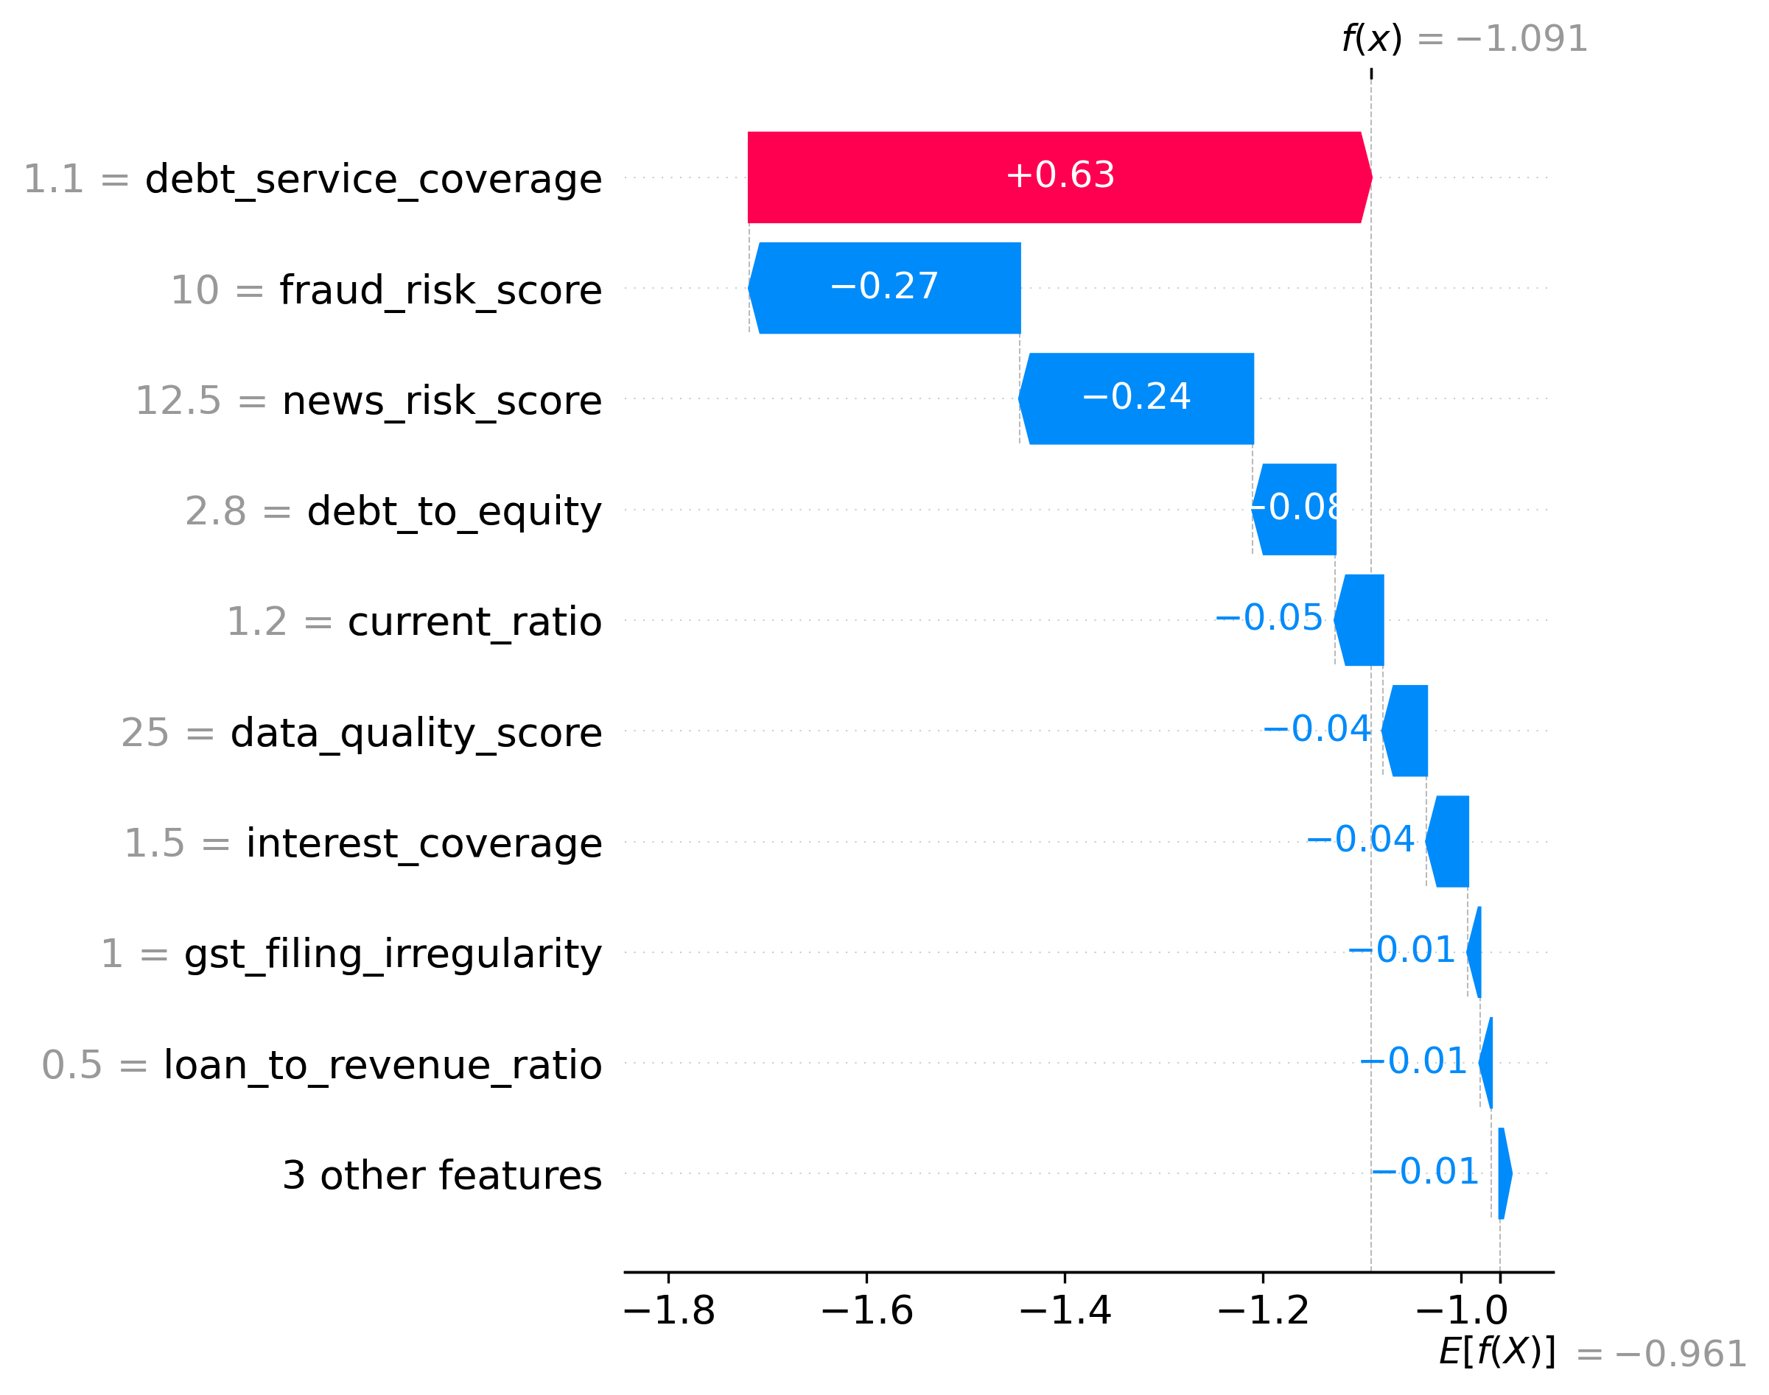
Figure 1: XGBoost Global Feature Interpretability (SHAP)
The SHAP chart visualizes the impact of each feature on the credit score. Positive values indicate a positive influence, while negative values suggest a detrimental effect.
## Final Recommendation
Based on the comprehensive analysis, a conditional approval is recommended for a loan amount of ₹208,329 with an interest rate of 12%. The borrower should address the conditions outlined above and provide the necessary documentation to mitigate risks and enhance their creditworthiness.
This CAM provides a detailed assessment of the borrower's creditworthiness, considering various factors and regulatory guidelines. The final decision should be made after a thorough review of the borrower's response to the conditions and further due diligence.

