CREDIT APPRAISAL MEMORANDUM
Generated via KARTA AI Intelligence

TATA STEEL LIMITED
Date: 2026-03-10
CONDITIONAL

## Credit Appraisal Memo (CAM)
### Executive Summary:
This Credit Appraisal Memo (CAM) evaluates a loan application for a manufacturing entity with a requested loan amount of ₹80,000,000. The application has been assessed as CONDITIONAL, with a recommended loan amount of ₹33,333,333.33 and a proposed interest rate of 12%. The probability of default is estimated at 25.15%, indicating a higher risk profile.
### Character:
The applicant's character is assessed through various risk signals and news analysis. The overall fraud risk is LOW, with specific signals indicating GOOD performance in circular trading and MCA director checks. However, there is an unknown risk associated with GST mismatch, which requires further investigation. News signals suggest a generally positive market sentiment, with no significant risks identified.
### Capacity:
The capacity of the applicant to service the loan is a concern. The debt service coverage ratio (DSCR) is a key positive factor, with an impact of +15.7. However, the current ratio, debt-to-equity ratio, interest coverage, and EBITDA margin are all below sector averages, indicating potential challenges in meeting financial obligations.
### Capital:
The recommended loan amount of ₹33,333,333.33 is significantly lower than the requested amount, reflecting the assessed capacity and risk profile. The proposed interest rate of 12% is in line with regulatory guidelines and market norms.
### Collateral:
Collateral requirements and end-use of funds must be rigorously monitored as per RBI Master Circular 2024. LTV on tangible fixed assets should not exceed 75%.
### Conditions:
To mitigate risks, the following conditions are recommended:
- The applicant must provide detailed bank statements and ledger transactions to enable a thorough circular trading analysis.
- DINs (Director Identification Numbers) should be provided for cross-checking with MCA21 records.
- Given the GST mismatch signal, the applicant must ensure GST filings are regularized and provide evidence of compliance.
### Fraud Analysis:

Confirmed Integrity Signals
Type | Risk Level | Evidence
GST_MISMATCH | UNKNOWN | GST Source Offline: GSTN API Source Failed: RetryError[<Future at 0x1337a331450 state=finished raised GSTNAPIError>]. Verify GSTN Sandbox status.
CIRCULAR_TRADING | GOOD | NetworkX cycle detection bypassed. No bank statement or ledger transactions provided.
MCA_DIRECTOR | GOOD | No DINs provided for entity cross-checking. Bypassed.
### Credit Score Section:
The credit score is influenced by various factors, with the most significant being the debt service coverage ratio (+15.7 impact) and fraud risk score (-6.8 impact). The news risk score (-5.9 impact) and debt-to-equity ratio (-2.1 impact) also contribute to the overall score.
### Final Recommendation:
Given the conditional decision, the loan application is recommended for approval with the conditions outlined above. The applicant's capacity to service the loan is a key concern, and rigorous monitoring of collateral and end-use of funds is essential.

Financial Ratios vs Sector Benchmarks
Ratio Name | Company Value | Sector Benchmark | Status
Current Ratio | 1.40 | 1.33 | Pass
Debt to Equity | 2.80 | 1.5 | Flagged High
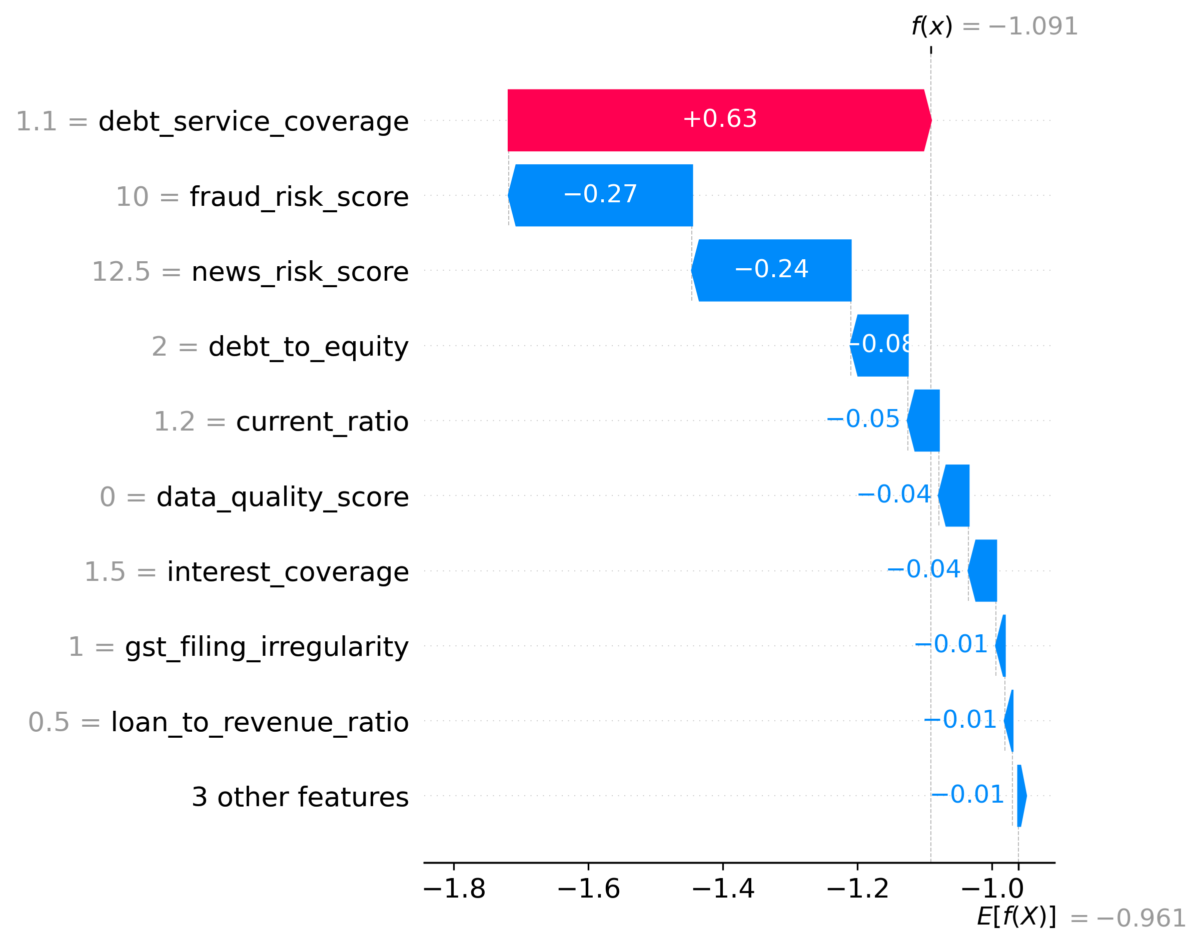
Figure 1: XGBoost Global Feature Interpretability (SHAP)

