FRAMEWORK

WHAT IS FRAMEWORK?

 Selenium Framework is **a suite of automation testing tools that is based on the JavaScript framework**. It could run the tests directly on the target browser, drive the interactions on the required web page and rerun them without any manual input.

Framework Architecture:

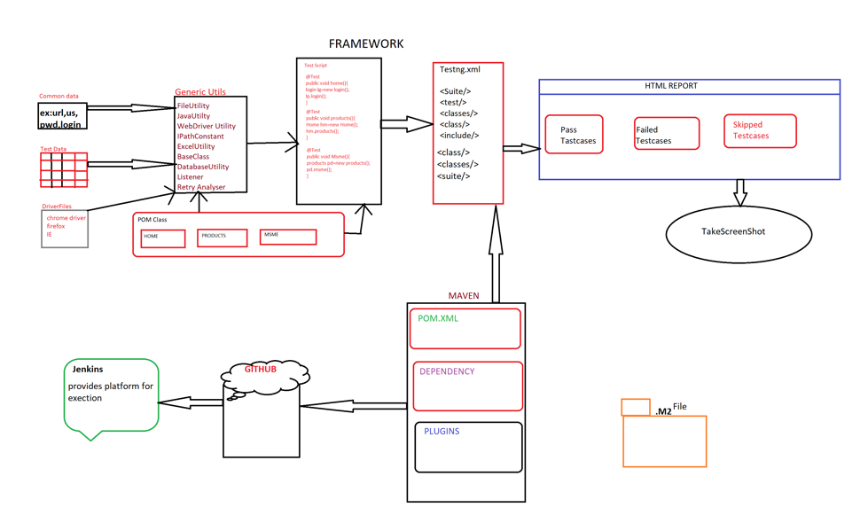

1.commonData:it is a property file(like browser related info,login credintials etc).

2.TestData:it is test specific data in EXCEL file.

3.Generic Utilites:

a)FileUtility:it is a class and it helps us to read common data from property file and JSON file.

b)Java Utility:it Is a class and it has two methods of Random class and Date class which will be later used for prevent duplicity and for taking screenshot.

c)WebDriverUtility:it It’s a class that consists of all the generic methods to handle web elements, popups and to perform different actions.

d)IPathConstant: It is an interface and consists of different paths like property file path, excel file path etc. which are final and static in nature.

e)BaseClass: It is a class and it implements the IpathConstant interface and other classes in the src/main/java package and creates their objects that can be later on used by the TestScript class, along with that all the important annotations of TestNG are declared here.

f)DataBaseUtility:it is a class and used to read and write data from database.

g)Listener:it is an interface and it consists of @Listener annotation that helps us to take screenshot.

h)RetryAnalyser:itis an interface and consists of @RetryAnalyser and this helps up to rerun fail test cases where there is a synchronisation issue.

**4.pom class(Object Repository):**

**Page Object Model**, also known as POM, is a design pattern in Selenium that creates an object repository for storing all web elements. ... In Page Object Model, consider each web page of an application as a class file.

5.**TestScripts**:

The test scripts are written inside the src/test/java. All the testcases related to the different modules are present inside different packages. All the test scripts extends BaseClass to access all the configurations of the application.

6.**TestNG.XML**:it is an .xml file that is generated when the test scripts are converted to TestNG file.

7.**Maven**: Maven provides information present in pom. It provides Unit test reports, list of mailing lists, dependency lists, cross-referenced sources,etc. It will manage your Selenium test project's build compilation, documentation and other related project tasks itself.

8.**HTML Report**: The seleniumhtmlreport plugin scans the selenium test results directory for html files created by selenium tests and creates an overview of the executed tests.All html result files will be copied into the subdirectory "seleniumReports" of the build root directory.All results will be read from the html result files. In the overview is for each html result file a link to it.it will give pass,failed and skipped testcases.

9.**ScreenShot**: To take a screenshot in framework, we use an interface called TakesScreenshot, which enables the Selenium WebDriver to capture a screenshot and store it in different ways. It has a got a method "getScreenshotAs() " which captures the screenshot and store it in the specified location.

10.**JenKins**:  Running Selenium tests in Jenkins allows you to run your tests every time your software changes and deploy the software to a new environment when the tests pass. Jenkins can schedule your tests to run at specific time. You can save the execution history and Test Reports

11**.GitHub**: It allows you to keep both local and remote copies of your project.

PHASES OF FRAMEWORK:

1. **Design of the framework** : Designing the generic utilities, object repository and the test data is called as designing of the framework.
2. **Implementation of the framework** : The test scripts creation by utilizing the basic components of the framework is called as the implementation of the framework.
3. **Exceution of the framework** : The execution of the xml file of all the test scripts in one batch is called as the execution of the framework.

Types Of FrameWorks:

1.**Data driven framework**:Reading Data from external resources like Excel,jsonfile,.XML,propertyfile,database and running the TestScripts.

2.**Modular driven framework**: maintance of the framework module wise is called as Modular Driven Framework.

3.**Method driven framework**: developing Genric methods for all repeative actions is called as Method Driven Framework.

4.**Keyword driven framework**: developing special keys for every action manual engineer to perform automation is called as Keyword driven framework

5.**Hybrid framework**:Combination of two or more framworks is called as Hybrid Framework.