CineEase: Online Movie Ticket Booking System

A PROJECT REPORT
Submitted by

ANSH CHOPRA (24MCI10105)

in partial fulfillment for the award of the degree of

MASTER OF COMPUTER APPLICATION

IN
ARTIFICIAL INTELLIGENCE AND MACHINE LEARNING


Chandigarh University

ACKNOWLEDGEMENT

I would like to express my sincere gratitude to Mr Ajay Yadav , my project supervisor, for his invaluable guidance, support, and encouragement throughout the duration of this project. His expertise and insights were instrumental in the successful completion of the project, "CineEase: Online Movie Ticket Booking System ."
I am also thankful to Chandigarh University for providing the resources and a conducive environment . This project has been a significant learning experience, enhancing both my theoretical knowledge and practical skills.

TABLE OF CONTENTS

- Introduction 1
2. Literature Review 2
3. Methodology 3
- 3.1 System Architecture
- 3.2 Technology Stack
- 3.3 Frontend Interface Design
4. Results 4-7
5. Conclusion 7-8
6. Future Scope 8
- 6.1 Improved Content Management
- 6.2 Deployment and Hosting Enhancements
- 6.3 SEO & Accessibility Improvements

1. Introduction
In the digital age, the entertainment industry has seen a significant shift in the way services are delivered to consumers. From streaming platforms to online reservations, the emphasis is on accessibility, speed, and user experience. One of the most common and widely adopted trends is online ticket booking for movies. With the growing number of multiplexes and digital theaters, manual ticket booking has become obsolete. Users now demand a platform that can offer real-time booking, seat selection, QR code-based entry, and virtual ticket storage.
CineEase is a web-based solution designed with simplicity and elegance to facilitate online movie ticket bookings. Built entirely on frontend technologies (HTML, CSS, JavaScript), this system allows users to register, login, select movies, choose preferred showtimes and seats, and download or store digital tickets in the form of QR codes and PDFs. It also maintains a personal booking history for each user. The project acts as a blueprint for building scalable, user-friendly, and interactive web applications.

2. Literature Review
Many platforms, such as BookMyShow, Fandango, AMC Theatres, and PVR Cinemas, have transformed movie booking into a seamless digital process. They provide extensive features like location-based suggestions, payment integration, and real-time availability. These platforms have also demonstrated the importance of:
- Responsive design for mobile and desktop devices
- Real-time backend systems to manage seats and user data
- Ticket verification via QR codes or OTPs
CineEase takes inspiration from these platforms but is tailored as an educational, frontend-only prototype. It eliminates the need for server-side technologies by using localStorage for data persistence, enabling learners to understand system flow without a backend setup.

3. Methodology

3.1 System Architecture
CineEase follows a modular and component-based client-side architecture. Each page or component is isolated by responsibility:
- Login/Signup Pages: Authenticate users using email credentials stored in localStorage.
- Dashboard: Displays a dynamic list of movies and showtimes.
- Book-Movie Page: Allows users to select seats using a visual grid and book them.
- Booking.js: Handles seat selection, QR generation, and stores booking data.
- My Bookings Page: Shows past booking history and allows PDF downloads of tickets.
All components communicate via the localStorage data layer and utilize Bootstrap classes for responsive UI.

3.2 Technology Stack

Layer | Technology Used
Frontend | HTML5, CSS3, JavaScript (ES6)
UI Framework | Bootstrap 5
QR Code | QRCode.js
PDF Export | html2pdf.js
Data Storage | Browser localStorage
This stack provides a modern development experience while remaining entirely frontend-based for simplicity and quick deploymen

3.3 Frontend Interface Design
The UI/UX design of CineEase focuses on dark themes, minimalistic layouts, and visual clarity. Each element is styled using Bootstrap 5, ensuring responsiveness across all devices. Key features:
- Dark Mode UI: User-friendly for late-night browsing and consistent with modern movie apps.
- Grid Layout for Seat Selection: Easy to interact with and visually intuitive.
- QR Code Generation: For contactless ticket verification.
- PDF Ticket Download: Enables offline access to movie tickets.
- Personalized Dashboard: Welcomes the user with their name and avatar.

4. Results
CineEase enables full booking functionality including registration, login, movie selection, seat booking, QR code generation, and viewing of past bookings. All data persists via localStorage.
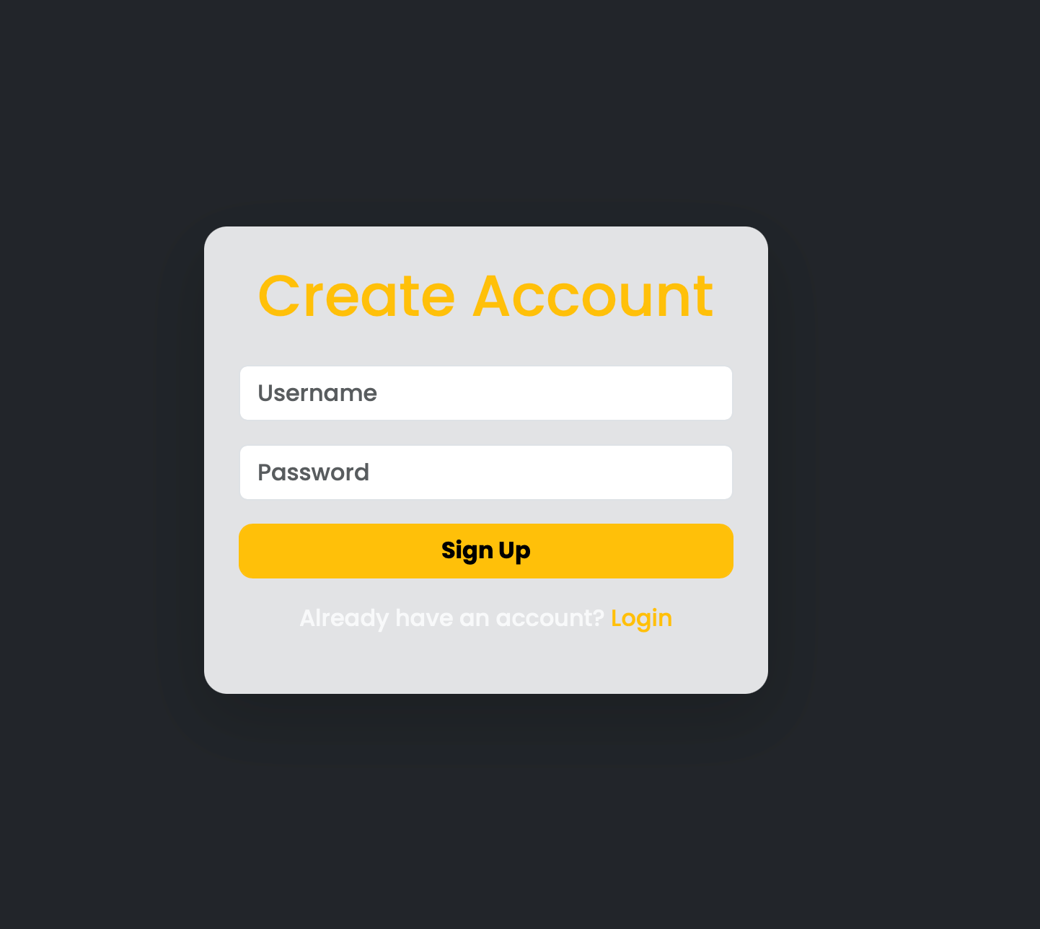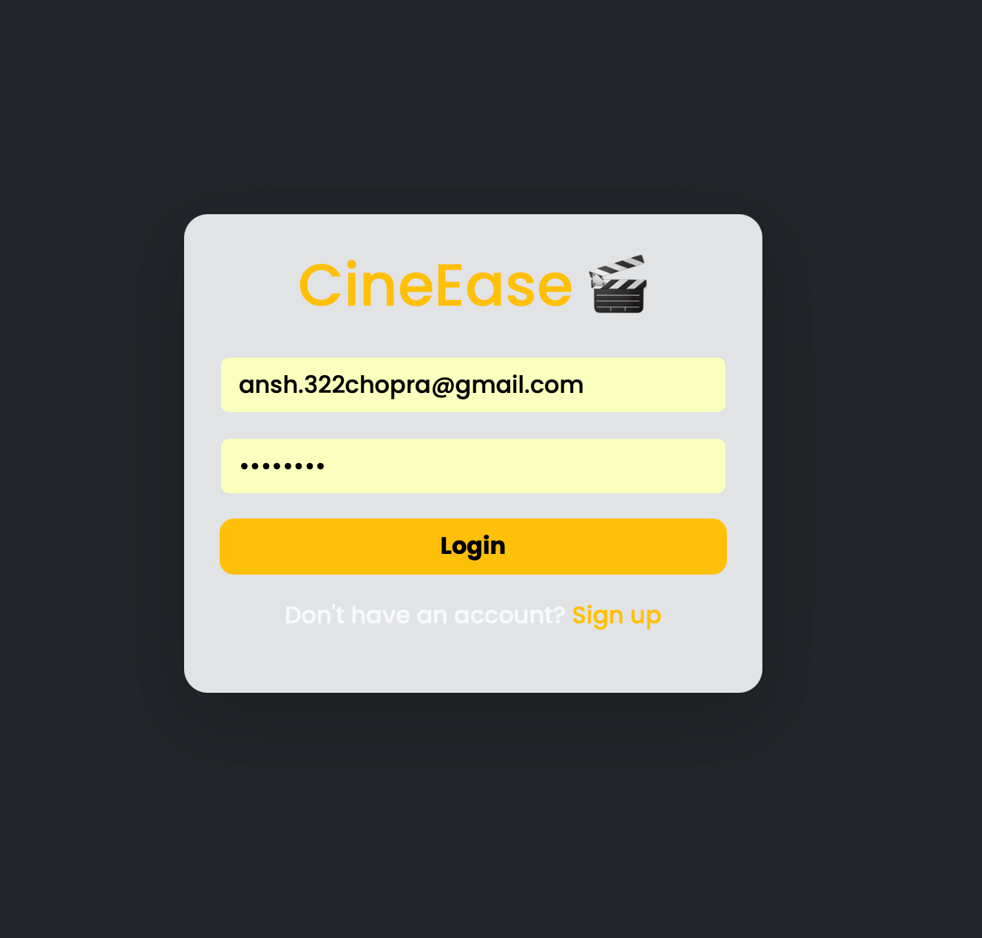

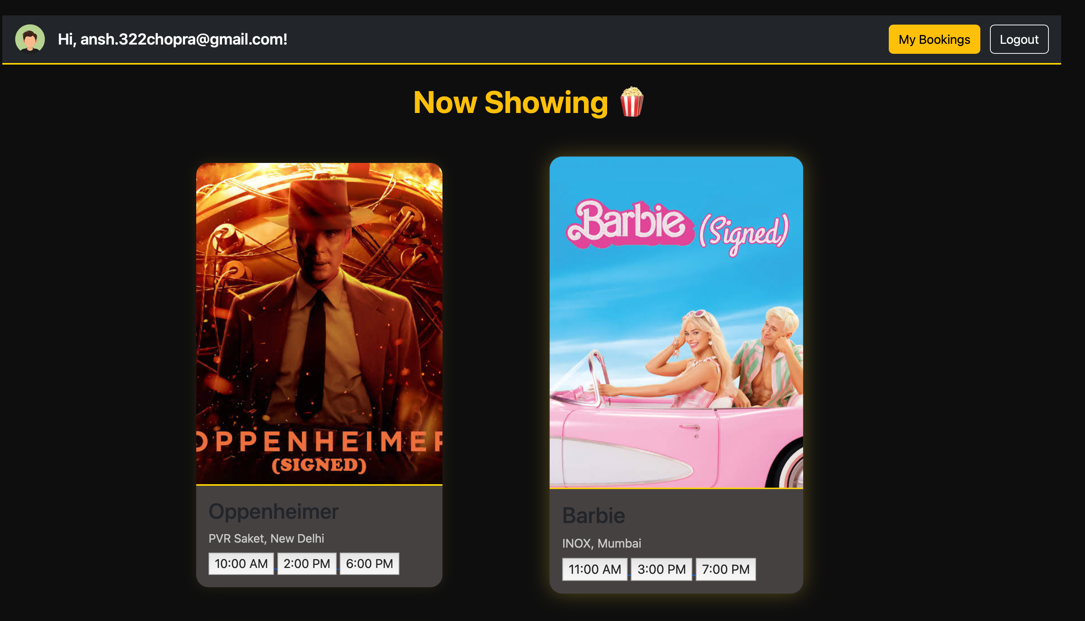
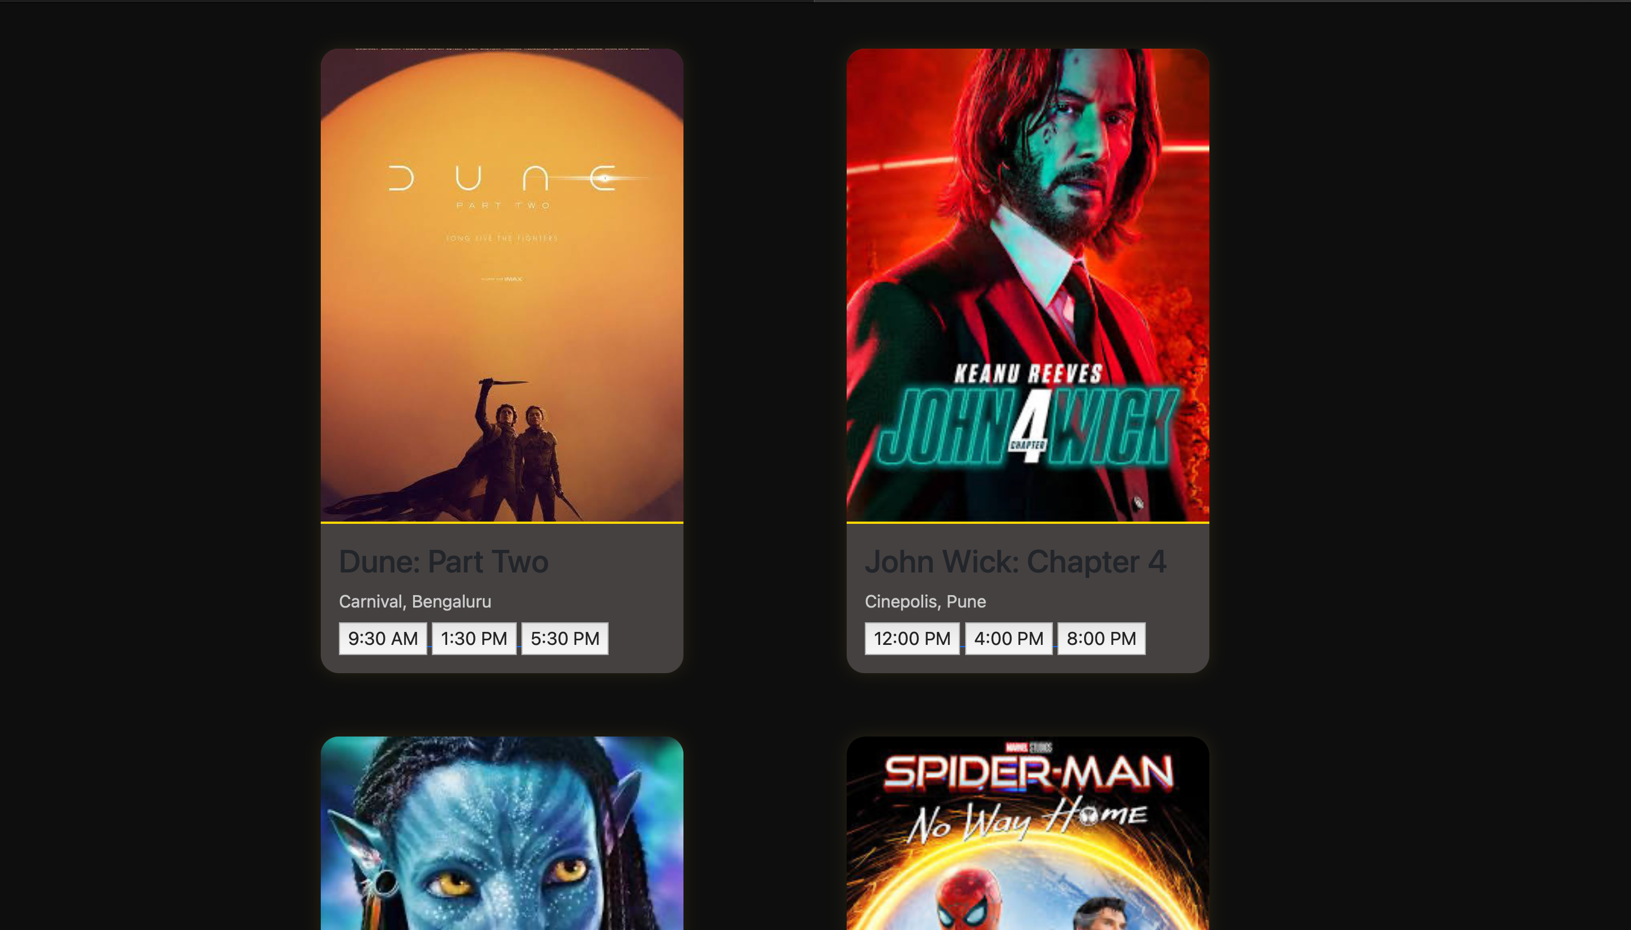
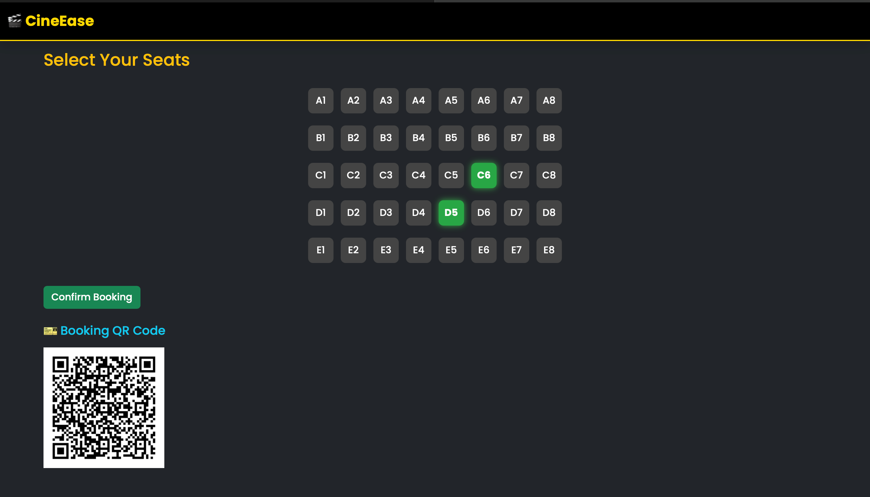
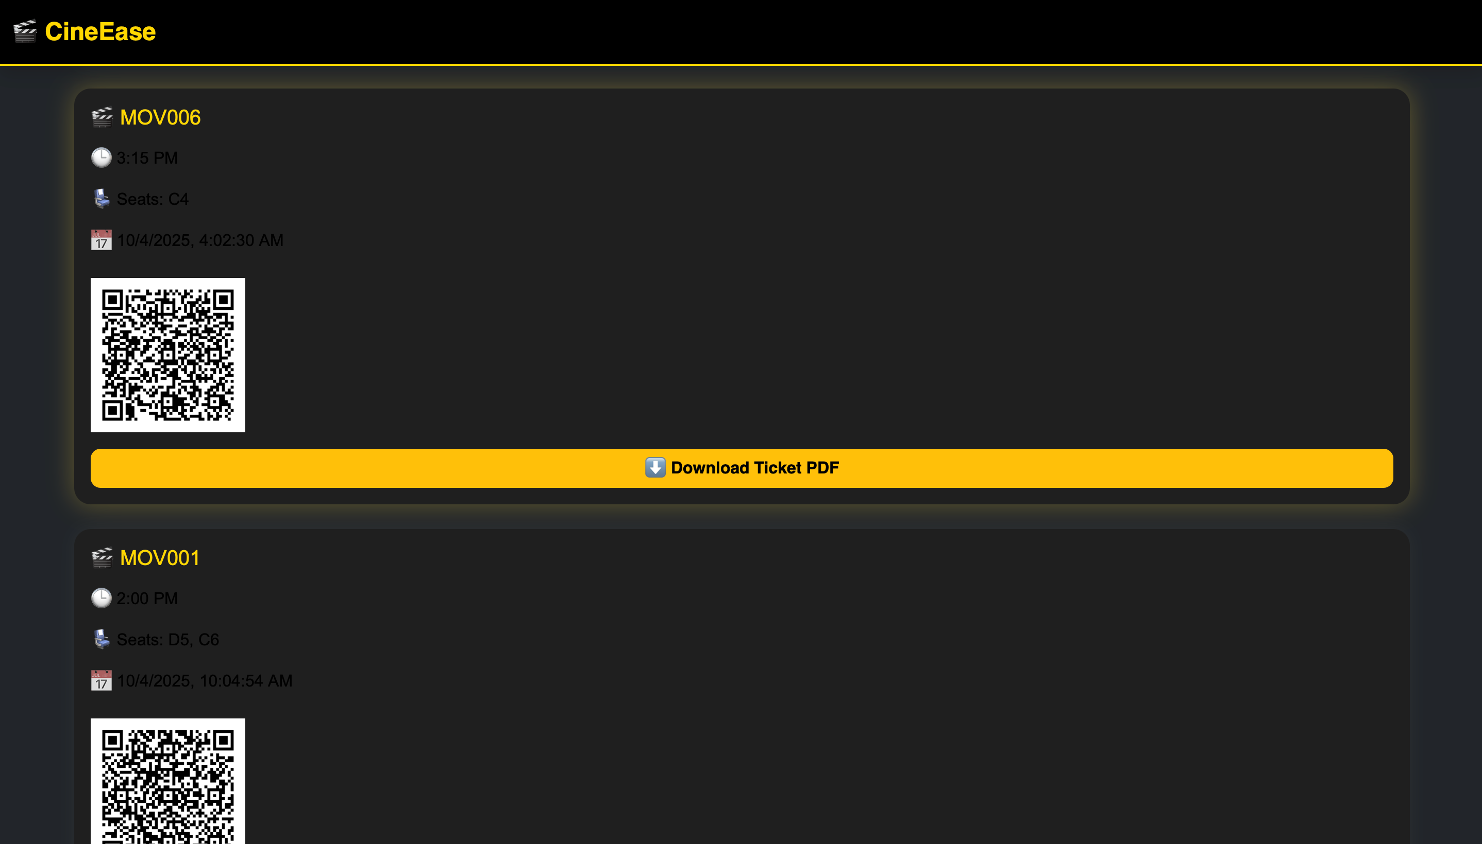
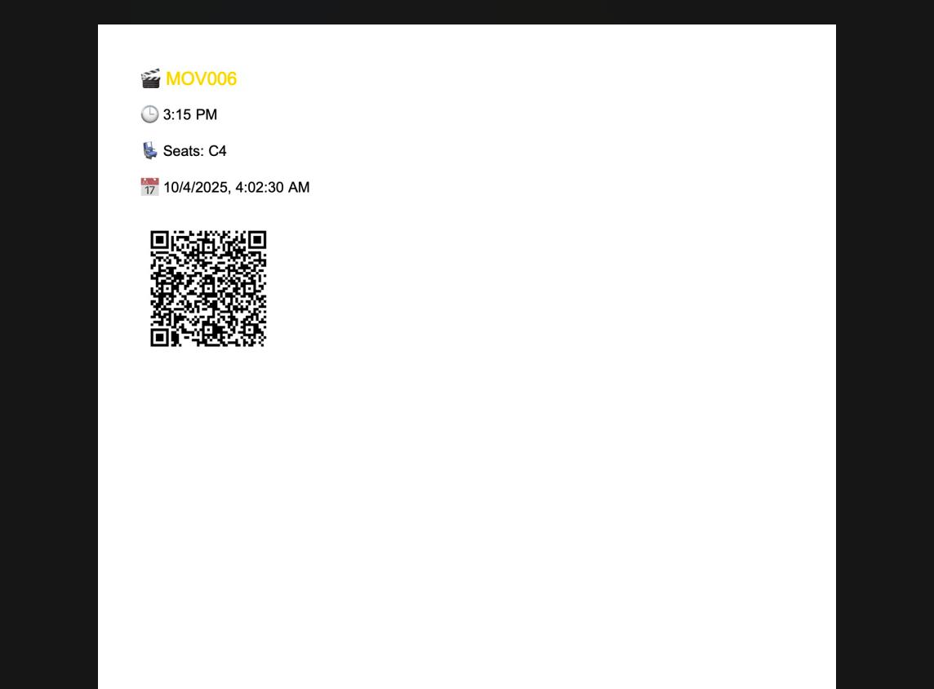

Conclusion
CineEase represents a successful attempt at building a fully functional frontend-only web application for movie ticket booking. Despite the absence of a backend, it showcases robust features such as:
- Data persistence using localStorage
- Dynamic DOM manipulation
- Real-time feedback using QR and PDF
- Responsive design with Bootstrap
It proves that modern frontend technologies are powerful enough to deliver complex applications for prototyping or MVP development. CineEase can also be used as a foundational template for building scalable, full-stack applications in the future.

6. Future Scope

6.1 Improved Content Management
Add an admin panel for managing movie content and show timings in real-time.

6.2 Deployment and Hosting Enhancements
Host via GitHub Pages or Vercel; add backend with Node.js and MySQL for production readiness.

6.3 SEO & Accessibility Improvements
Enhance semantic HTML, add ARIA roles, alt tags, screen reader support, and improve load performance.

6.4 Add-on Feature Ideas
- Loyalty rewards,
- PWA version,
- multilingual support,
- two-factor authentication,
- analytics dashboard.

