**GraphQL:- By Facebook**

1. GraphQL seems to be alternative of RestApi’s.
2. GraphQL is not any database like SQL, it is a language
3. RestApi is dumb but GraphQL ni h

Difference b/w graphQl and RestApi

restApi:- /players/{id}:- we get player all details but we are only intreted in name and marks

graphQL:- we can fetch directly only required data

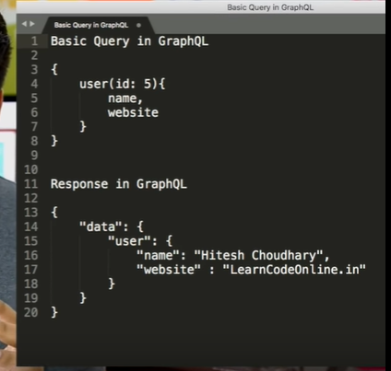

**Spring With GraphQL:-**

(After watching techprimer video, ye baat smjh aayi)

1. In rest,Suppose I have api player/{id} then hmesha we will written whole player object, suppose I have 2 cases, in case one I needed player name and and age and in second scenario I needed playername, address toh kya toh hum player/{id} vali api se dono case m pura player return kr de, ya phir hum 2 nyi api bnaye jo

Api :- /Player/nameAndMarks/{id}

GetplayerNameAndMarks()

Api :- /Player/nameAndAddress/{id}

GetplayerNameAdress()

Solution is **GraphQl**

1. GraphQL m bs 1 hi api bnani hogi, and depending on Request in parameter, vo object with only those field hme mil jayega

Jaise:-

Api:- /player

RequestObject

Case1:-

{

Player(id:1){

Name

marks

}

}

Case2 RequestObject

{

Player(id:1){

Name

Adress

}

}

GraphQL k fayde:-

1. Jitna data chaiye utna hi aayega
2. 3 call ko mila k 1 hi call kr skte h,, excess call hat jayenge jaise

Like:-

REST_API_URL/authors --> GET all authors  
REST_API_URL/posts --> GET all posts  
REST_API_URL/author/12 --> GET all details of authorId: 12

But in GraphQL you could just make **one query and get all required data**:

{  
 authors {  
 name  
 },  
 posts {  
 content   
 },  
 getAuthor(id: 12){  
 name,  
 email  
 }  
}

Resources:-

<https://www.youtube.com/watch?v=X3QM6Ap6u-4> Hitesh Choudhary

<https://www.youtube.com/watch?v=zX2I7-aIldE> – Tech Primers

<https://medium.com/@chathuranga94/introduction-to-graphql-3e0142879aba> Medium Article