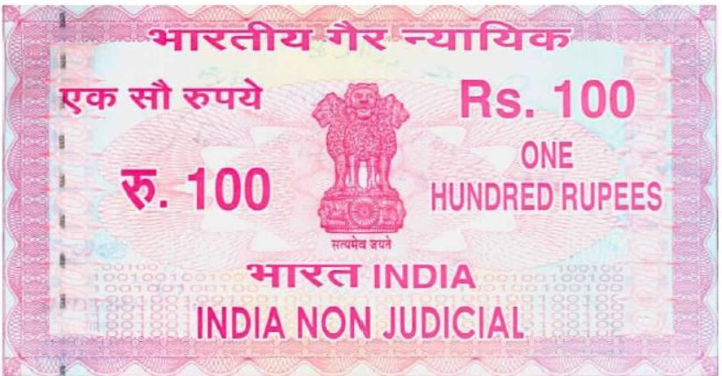

THIS AGREEMENT made at Mumbai on this 1. 06___________ day of 2. 05__________, Two thousand and 3. 2021_________ between TATA CONSULTANCY SERVICES LIMITED,

Signature of the Employee Signature of the Surety

a company incorporated under the Companies Act 1956 (hereinafter referred to as “TCS”) and having its Corporate office at TCS House, Corner of Hazarimal Somani Marg & Raveline Street, Near Sterling Cinema, Fort, Mumbai 400 001 of the First Part and 4. Hemant Gupta___________________________ S/o D/o W/o 5. Kailash Gupta_____ aged 6.23__________ years, Occupation 7. Student_______________, an (Indian /8._________________________________) nationality residing at

9. Bijawar , Chhatarpur(M.P.)_____ and having permanent address at

10._Ward No. 06 near old post office , Bijawar , Chhatarpur(M.P.) ___

(hereinafter referred to as “Mr./Ms. 11.__Hemant Gupta______________________________”) of the Second Part AND 12.____Sanyog Singh_________ (hereinafter referred to as “The Surety”) which expression shall be deemed to include his/her executor, heir and administrator of the Third Part.

WHEREAS TCS is involved in the business of problem solving or consultancy and as of present and the foreseeable future specifically in the business of Computer and Management Consultancy – offering services and products both in India and abroad. WHEREAS the possession of the above problem solving techniques and effective use of high technologies equipment can be acquired mainly through special training and / or specific on the job training (“Training”).

WHEREAS the said Training is of a duration of Twelve Months and is liable to be extended by a further duration based on the performance of Mr. /Ms. 13Hemant Gupta during the training, of which TCS shall be the sole judge.

WHEREAS the above mentioned Training involves considerable expenditure – both direct and Indirect, financial and unliquidated – related to faculty, computer time, support facilities, Salary of Mr. /Ms.

14 Hemant Gupta while under Training.

WHEREAS this Training substantially improves the professional standing of Mr. /Ms. 15.__Hemant Gupta ______ and it has been imparted by TCS at considerable expenditure as an investment, TCS expects a commitment (elaborated below) from the employee to recover its expenditure or seek a penalty for non-fulfillment of the same.

WHEREAS the expenditure involved in imparting the said Training to Mr. /Ms. 16._Hemant Gupta____ is several times in excess of the penalty demanded from him/her.

IT IS NOW HEREBY AGREED AS UNDER:

1. In consideration of the Training to be imparted by TCS, Mr./Ms.

17.__Hemant Gupta___________ undertakes irrevocably to serve TCS or any of its associated or affiliated companies to which he/she may be transferred for a minimum period of **1(ONE)** year (excluding Leave without pay period and/or unauthorized absence, if any) from the date of joining TCS.

Signature of the Employee Signature of the Surety

Mr. /Ms. 18._Hemant Gupta____ is giving this undertaking in view of the considerable expenditure incurred by TCS on him/her.

1. Mr./Ms. 19.__Hemant Gupta____ agrees not to take employment with any other person, firm or company during the period of applicability of this agreement.

1. By way of guarantee for due performance of all terms and conditions contained in this agreement, Mr./Ms. 20.__Hemant Gupta_____ provide herein below the name of his/her near relative/person in order of preference and who have consented by signing herein below to stand as Surety on his/her behalf to ensure compliance of the aforesaid covenant, and that in the event of failure/neglect by Mr./Ms. 21._Hemant Gupta_ to fulfill any of the terms of this undertaking of which TCS shall be the sole judge the Surety shall be liable to pay TCS Rs.50,000 (Rupees Fifty Thousand Only) as compensation with interest thereon as applicable and the Surety hereby agree, confirm and accept that the Surety shall be liable jointly and severally with Mr./Ms. 22.__Hemant Gupta_______ to pay the same to TCS.

# Name, Address, Occupation (of the Surety)

__________________________________ ____________________________

__________________________________ ____________________________

__________________________________ ____________________________

__________________________________ ____________________________

4. In the event of any dispute or disagreement over the interpretation of any of the terms hereinabove contained or any claim of liability of any part including the Surety the same shall be referred to a person to be nominated by TCS whose decision shall be final and binding upon the parties hereto. Such reference shall be deemed to a submission to arbitration under The Arbitration and Conciliation Act, 1996 or of any modification or re-enactment thereof. The venue of arbitration shall be Mumbai.

# Signature of the Employee Signature of the Surety

1. During the period of **1(ONE)** year (excluding Leave without pay period and/or unauthorized absence, if any) from the date of joining, if Mr./Ms. 23._______________________________ leaves/resigns/abandons the services or violates the terms of this Agreement, Mr./Ms. 24._________________________________ will have to pay liquidated damages amounting to Rs.50,000 (Rupees Fifty Thousand Only) and give Three calendar months’ written notice or salary in lieu thereof. Mr./Ms. 25._____________________________ agrees that the said amount of Rs.50,000/- can be recovered/adjusted by TCS from the legal dues, if any, payable to him. On being absorbed as an Employee of TCS, after completion of the said Training period, TCS would be entitled to terminate the services of the Employee with Three Calendar Months’ written notice during the tenure of service agreement.

The provisions stated herein for breach by Mr./Ms. 26.________________________ of the provisions of this agreement shall be without prejudice to other remedies available to TCS.

ADDRESS FOR THE PURPOSE OF SERVICE:

1. All communications between Mr./Ms. 27.____________________________ or TCS and Surety shall be deemed to have effectively served if addressed to the following address:

TCS (TATA CONSULTANCY SERVICES LIMITED) at:

TCS HOUSE, Corner of Hazarimal Somani Marg & Raveline Street, Near Sterling Cinema, Fort, Mumbai 400 001.

(Dr./Mr./Miss/Mrs.)28._________________________________________________________ __________________

(At)29.______________________________________________________________________ ___________________________________________________________________________

_________________________________________________________________________

Surety(Dr./Mr./Miss/Mrs.)30.___________________________________________________ ________________________

(At)31.______________________________________________________________________ ___________________________________________________________________________

_________________________________________________________________________

**Signature of the Employee Signature of the Surety** Any change in the above addresses of any of the concerned parties i.e. TCS, Mr./Ms. 32._________________________________ or Surety, shall be intimated to the other parties by the party whose address has changed within a period of seven days of such change. If no such change has been intimated or received, the addresses mentioned above shall be deemed to be the addresses of the concerned parties.

As a token of his/her consent, he/she has signed this agreement as surety :) 33. ___________________

Dated this: 34.___________________

Signed and delivered by Mr./Ms: 35.______________________________

Accepted for and behalf )

Of TATA CONSULTANCY SERVICES LIMITED)

By their constituted Attorney )

# Signature of the Employee Signature of the Surety Surety Verification

This is to certify that I, ___________________________________________________ (**Name of the Surety**) am standing surety for _______________________________________ (**Name of the Employee**) who is my ____________________________ (**Relationship**). Mr. /Ms.

______________________________________________ (**Name of the Employee**) has joined TATA Consultancy Services Ltd. On ___________________________________________ (**Employee’s date of joining**) and executed an agreement on ___________________________________ (**Candidate’s date of joining**). In the event that Mr./Ms. ________________________________________ (**Name of the Employee**) does not fulfill the terms of the agreement, I stand guarantee and will be liable to the liquidated damages of Rs.50,000/-. My permanent address is as follows:

Name **(of the Surety**): ________________________________________________________

Address (**of the Surety**):

_____________________________________________________________________________________

_____________________________________________________________________________________ _____________________________________________________________________________________

_____________________________________________________________________________________

Phone (**of the surety**):

____________________________________________________________________ (With country and area code)

**(Signature of the Surety)**

# (Signature verification by competent authority)

Office Seal: Signature: Designation:

Date: Name: Office: